A GUIDE TO SKY MUSTER SERVICES

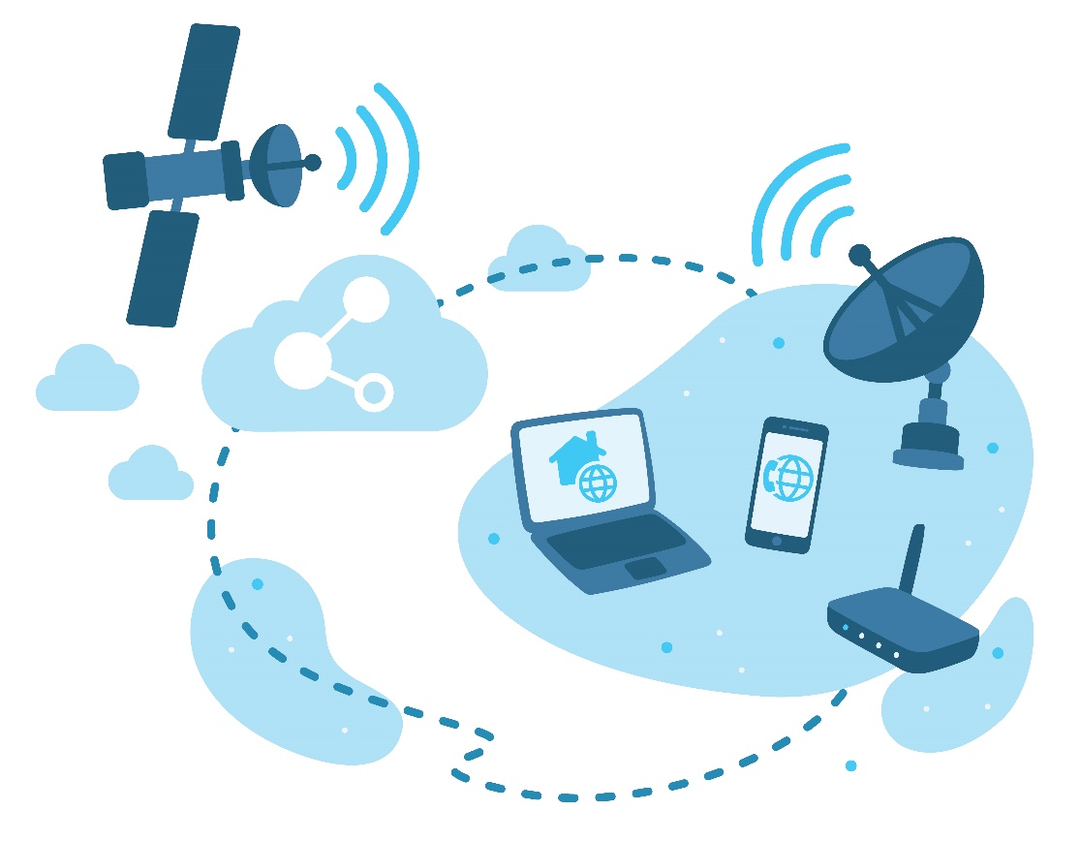

THIRD EDITION - Published July 2020
SECOND EDITION – Published November 2016
FIRST EDITION – Published April 2016
Australian Communications
Consumer Action Network
WEBSITE: accan.org.au
EMAIL: info@accan.org.au
FACEBOOK: facebook.com/accanau
TWITTER: twitter.com/accan_au
TELEPHONE: +61 (0)2 9288 4000
ACCAN is the peak body that represents all consumers on communications issues including telecommunications, broadband and emerging new services. We provide a strong, unified voice to industry and government as we work towards availability, accessibility and affordability of communications services for all Australians.
This work is copyright, licensed under the Creative Commons Attribution 3.0 Australia Licence. You are free to cite, copy, communicate and adapt this work, so long as you attribute “Australian Communications Consumer Action Network”. To view a copy of this license, visit http://creativecommons.org/licenses/by/3.0/au. This guide has been prepared on the basis of information available at the time of publishing. Information is subject to change and further refinement. Check for current information with service providers when making decision about phone or broadband services.

CONTENTS

A GUIDE TO SKY MUSTER SERVICES 1
CONTENTS 2
The Basics 4
Am I eligible for services? 4
What if my address is not on the nbn website but I think it should be? 4
How do satellite broadband services work? 4
What is the difference between Sky Muster and Sky Muster Plus? 4
How do I order a service? 5
What services will work over Sky Muster? 5
IMPORTANT QUESTIONS TO CONSIDER AND ASK YOUR PROVIDER 6
Will nbn be offering services for children’s education and community use? 7
What do I do if something goes wrong? 7
I am due to get satellite, but I would rather have fixed wireless. What are my options for alternative nbn networks? 7
What to expect from a Sky Muster broadband service 8
Are there things I will not be able to do? 8
Will Sky Muster work during all weather conditions? 8
What speeds can I expect? 8
Choosing a retail service provider 10
Will there be a difference in the level of performance between providers? 10
How can I compare providers? 10
Choosing a plan that suits your needs 11
The key things to look out for in a plan: 11
Voice services 15
What is VoIP? 15
What costs are associated with VoIP? 15
Can I contact Triple Zero (000) and 106 Emergency Call Services using VoIP? 15
Can I get priority assistance services? 16
Can I use disability equipment over VoIP? 16
Can I keep my number with a VoIP service? 16
Will there be a difference in the quality of service between VoIP and my current voice service? 16
Can I bundle Sky Muster services with my current voice service? 16
Can I just get a VoIP service and not a broadband plan? 16
Getting Connected 17
What rules must my internet provider follow? 17
Do I contact nbn about a connection? 17
What is the process for getting connected? 17
How do I prepare for the installation? 18
What happens on installation day? 19
How big are the satellite dishes? 19
Is there a waiting list available to see how long it takes to get a service before signing up? 20
Can I use my current equipment? 20
What power is required to run the equipment? 20
What if my house is not a standard installation? 20
Interruptions, faults and repairs 21
What if the service stops working? 21
Who is responsible for services; nbn or the service provider? 21
What if I don’t get the speeds and performance that I was expecting? 21
Is there equipment that I can purchase that will improve my experience of the service? 21
What if the dish or wiring gets damaged? 21
What are my consumer rights? 22
Remote and Isolated Communities and Distance Education 24
My child receives distance education, what service will they receive and when? 24
Is this available for other education services, such as university? 24
Is this available with Sky Muster Plus? 25
Who to contact, complaints and further information 26
How to effectively complain and ensure your rights 29
Where do I get more information? 29
Privacy and Security 30

The basics
Sky Muster and Sky Muster Plus (or nbn’s Satellite Services) provide fast broadband coverage to three per cent (or around 430,000) of homes and small businesses across regional, rural and remote Australia and its islands.

Am I eligible for nbn Sky Muster services?
Eligibility to obtain these services can be checked on the nbn website.

What if my address is not on the nbn website but I think it should be?
You should contact a retail service provider (RSP), also known as a telco or internet provider, and discuss your eligibility with them.

How do satellite broadband services work?
The Sky Muster satellites provide a connection between homes and businesses and RSPs. When you try to connect to the internet from your home or business the request is sent from your satellite dish to the satellite 35,786kms above the equator. The signal then travels to one of nbn’s ground stations which connect to your RSP, and finally the internet.
To find out more information, read ‘What to expect from a Sky Muster broadband service’.
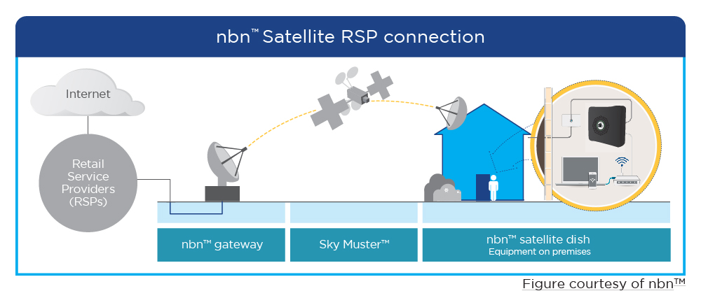

What is the difference between Sky Muster and Sky Muster Plus?
The difference between Sky Muster and Sky Muster Plus is how the data is metered. With Sky Muster plans all activities are metered, and use your plan data allowance. For Sky Muster Plus plans you use the monthly metered data allowance for video streaming and virtual private network (VPN) traffic only, and everything else is unmetered and does not count towards your plan’s data allowance.
Metered video streaming can include Netflix, ABC iView, Stan and YouTube. If you use products like Nord VPN, Norton Secure VPN or VPNs owned by your workplace to access the internet, any data used will be metred.
Video streaming on certain social media platforms, such as Facebook, Twitter and Instagram are not metered. Video calling applications such as FaceTime, Skype, WhatsApp and Zoom are also unmetered.
 | Sky Muster | Sky Muster Plus
Speeds | Two wholesale speed tiers are available, 12/1 Mbps and 25/5 Mbps | 25/5 Mbps
Monthly metered data allowance (includes upload and download data) | Contact your internet provider for available plans. | Can be between 25 GB - 150 GB peak and off peak. Contact your internet provider for available plans.
Data top ups | Some internet providers allow data top-ups if you use all your metred data allowance for the month. Speak to your internet service provider to learn more. | If you run out of metered data during the month, data top-ups may be available. Speak to your internet service provider about data top-ups.
Metered activities | All online activities are metered by nbn. | Only video streaming and activity via a VPN is metered.
Time of Day Shaped activities | Not applicable | Peer to peer traffic, uploads and downloads to cloud storage platforms (e.g. Dropbox, Google Drive), computer and smartphone operating systems updates, software updates, gaming updates and activity related to applications which nbn cannot identify may be shaped between 4pm – 11 pm to wholesale speeds of 256 Kbps.

How do I order a service?
To get connected to an nbn Sky Muster service:
- Check if you are eligible (nbn website)
- Choose a retail service provider (see ‘Choosing a retail service provider’) and plan that suits your needs (see ‘Choosing a plan that suits your needs’)
- Get connected (see 'Getting Connected' for more information).

What services will work over Sky Muster?
Broadband internet services will work over Sky Muster.
You may be offered other services, such as phone services (called VoIP). See ‘Voice services’ for more details.
Existing phone services delivered over copper, radio and wireless technologies will continue to be offered and you can keep these services. Internet delivered over copper, or ADSL, may continue to be available depending on your location. Speak to your RSP to learn more.

IMPORTANT QUESTIONS TO CONSIDER AND ASK YOUR PROVIDER
- Can I use all my current services with this plan?
- How long will it take to get connected?
- What do I need to do to prepare my property for connection?
- When will the billing start?
- What speedswill I get on average with this plan during peak and
off peak hours?
- Apart from the monthly charge, what other fees do I need to pay?
- Do I need to purchase a new router?
- Can I get VoIP services? Is the router set to ensure quality voice services?
- How do I track my my data usage?
- Will there be any additional charges for connecting or fault repairs?
- Is my property a standard installation? Can I cancel the service, without
charge, if I am not a standard installation?
- Do you offer service guarantees for fixing faults and outages?

Will nbn be offering services for children’s education and community use?
Currently internet plans are available for distance education children using Sky Muster only. See ‘Remote and Isolated Communities and Distance Education’ for more information.

What do I do if something goes wrong?
You should contact your RSP if something goes wrong. See 'Interruptions, faults and repairs' for further information on what to do if something goes wrong and 'Who to contact, complaints and further information for contact details.

I am due to get satellite, but I would rather have fixed wireless. What are my options for alternative nbn technologies?
If you wish to consider an alternative technology rather than satellite, nbn offers a ‘technology choice’ program. There are three possibilities. The first is area switch. This is for entire local government areas or body corporates who want to change nbn technology The second is individual switch, where an individual property pays to switch technology type. Lastly, there is an option for group switch, where a group of neighbours of any number can collectively apply for a change to nbn FTTP and the group share the cost of the infrastructure.
New nbn technology offering | Type of application available
Fixed wireless | Available for area switch
Fibre to the Node (FTTN) | Available for area switch
Fibre to the Basement (FTTB) | Available for area switch
Fibre to Curb (FTTC) | Under review for area switch
Fibre to the Premises (FTTP) | Available for all application types
Individual premises and group switch applications can only be accepted when an area is ready for service on the nbn network. Area switch applications can be accepted at any time.
These options can cost a significant amount of money. Costs range from a few hundred thousand dollars to millions of dollars, depending on the complexity and size of the switch required.

What to expect from a Sky Muster broadband service
The Sky Muster satellite was purpose-built to provide a fast broadband connection to regional, rural and remote Australian homes and businesses, so it is expected to perform to a higher standard than previous satellite services.
With Sky Muster services you will be able to take advantage of a broader range of services available over the internet, such as listening to radio, data voice calls (called Voice over IP or VoIP), telehealth and streaming movies as well as checking email, browsing the internet, banking online, and accessing government websites.
Note: Care must be taken with activities requiring high levels of data to ensure usage caps are not exceeded.

Are there things I will not be able to do?
Due to the distance of the satellite, services which require instant communication may be not as responsive as an earth-based network. This time delay is called latency. Activities such as voice calls and online auctions can be affected.

Will Sky Muster work during all weather conditions?
Sky Muster, like all satellite services, is impacted by weather conditions. The weather at your house and at the ground station, such as rain, storms, cloud cover and dust may all affect services. Nbn has specially designed the dishes to adapt to different circumstances, such as storms. However, you might experience lower performance levels during some weather conditions and there may be periods where the service does not work.
You should be aware of this if Sky Muster is your only source of communication. Alternative options should be considered in cases of emergencies, such as a copper landline or charged mobile phone.

What speeds can I expect?
The speeds you experience over the nbn will depend on many factors, what time of day you are using the internet, equipment quality, software, your chosen broadband plan and the Wi-Fi ‘band’ you are connected to. There are typically two Wi-Fi bands, 2.4 Ghz and 5 Ghz which you can select when you connect your device to the internet over Wi-Fi. 2.4Ghz covers more range but at a lower speed, whilst 5 Ghz has a lower range but higher speeds.
Sky Muster: NBN Sky Muster offers two wholesale speed tiers, 12/1 Mbps and 25/5 Mbps.
Note that data is metered on Sky Muster; if your data allowance is exceeded your speeds may be reduced.
Sky Muster Plus: All plans for Sky Muster Plus are based on a wholesale 25 Mbps download and 5 Mbps upload speed.

Choosing a retail service provider
Currently you can choose from 11 different retail service providers for Sky Muster. They are: Activ8me, ANT communications, Bordernet, Clear Networks, Harbour ISP, iinet, IPSTAR, Reachnet, Sky Mesh, Southern Phone, WestNet
You can choose from 8 different retail service providers for Sky Muster Plus. They are: Activ8me, ANT communications, Clear Networks, Harbour ISP, IPSTAR, Reachnet, Sky Mesh, Southern Phone

Will there be a difference in the level of performance between providers?
Yes, providers differ on the level of performance offered depending on the number of customers they have and how much they have invested in their service. It is not expected that each retail service provider will offer the same level of service. Therefore, you should check that the level of service offered matches what you need.

How can I compare providers?
There are a number of sites which you can use to compare retail providers:
- Product Review
- Whistle Out
- Finder
For video streaming, Google Video Quality Report

Choosing a plan that suits your needs
It is important to pick a plan that matches your needs. Consider what services you are currently using and what you want your broadband plan to deliver.
You should make sure that all the services you want will work over Sky Muster satellite. Some services such as medical or security alarms may not work and you may need to keep an existing telecommunications service. Check with your retail service provider if you are unsure.
IMPORTANT!
nbn Services will not work in power outages.
Consider what alternative arrangements you need in case of power outages.

The key things to look out for in a plan:

Speeds
Sky Muster is available with speeds of 12 (download) /1 (upload) Mbps and 25/5 Mbps.
Sky Muster Plus has a wholesale speed of 25/5 Mbps.

WHAT ARE DOWNLOAD AND UPLOAD SPEEDS?
Speed is a measurement of the amount of data that can be sent to and from you in a second.
The quoted levels are the maximum speed that is achievable for the connection. Speed levels are not consistent, and they often vary. The actual speed that you receive will vary depending on a number of factors, such as the type of information you are sending, the time of day, the number of applications sending and receiving files on your devices, your retail service provider and the number of other customers using the service.
For further information on performance, check out our information.

TIPS ON PICKING A SPEED TIER THAT SUITS YOU
If you download a lot of information (for example high definition movies or gaming), then the faster speed will likely mean that you are waiting less time for this information to be received.
If you only need the internet to access basic information (for example news websites, emails, individual songs, telephone calls), then the entry speed level might suit you perfectly.
If you are sending lots of files (for example if you operate a small business that updates websites or regularly sends important documents), then fast upload speeds will be important for you.

EXAMPLE
The following graphic gives an estimate in the difference higher speeds might make for an activity. These times are estimates and may be affected by other factors, such as other people being online.

Downloading a standard definition movie (1.5GB)
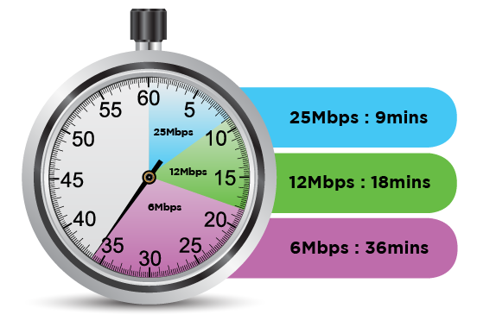

Data
There are a many plans available, offering allowances up to 300 GB per month, divided into peak and off-peak usage.
Note that both sent and received data (i.e. uploads and downloads) is counted in the allowance.

TIPS FOR PICKING A DATA ALLOWANCE THAT SUITS YOU
How much data you need depends on what you do and how long you spend online.
You should check your previous bills to see how much data you have used for the last few months to calculate how much data you will need.
Checking email and browsing the internet uses very little data, watching videos uses large data amounts, while gaming can quickly use up a lot of data.
Here are some estimated usages by activity as a guide: [note: 1024MB = 1GB]
Activity | Data usage
Email (100 sent/received without attachments) | 2.5MB
Music streaming (3 minutes) | 3MB
Radio streaming (10 minutes) | 15MB
Email (10 sent/received with attachments) | 18MB
General web browsing (30 minutes) | 10 - 20MB
YouTube video streaming (5 minutes) | 25MB
Audiobook (9 hours) | 110MB
Downloading standard definition TV show  (45 minutes) | 200MB
Downloading standard definition movie  (2 hours) | 1 - 1.5GB
Downloading high definition movie (2 hours) | 3 - 4.5GB
Downloading a game (e.g. for Xbox or PS4) | 20 - 50GB
Consumers who have an nbn connection tend to use more data, so it may be worthwhile considering a plan with more data than your existing plan when switching over to nbn. The average nbn user uses 258 GBs of data a month (December 2019)

Peak / Off peak
Plans divide the data allowance between peak and off peak times. Peak hours are between 7am and 1am at your local time (18 hours of the day). Off peak hours are between 1am and 7am at your local time (6 hours of the day).
Plans that offer data usage in off peak times are often better value for money, but may be at a time that does not suit your needs. Peak hours are likely to be the hours when you most want to use the internet.

Set up, equipment and other fees
Your retail service provider may charge other costs, besides the monthly cost, such as for set-up, equipment (router or Analogue Telephone Adaptor (ATA) for VoIP) or early termination fees. You should carefully check all the possible fees that apply with each plan as they differ with each retail service provider.

Length of contract
Some contracts are available month to month, while others have a minimum duration (such as one or two years). Longer contracts may not have up front equipment and connection fees, but will charge if you terminate the service early.

I run a small business from home; will there be special plans available for me?
Sky Muster serves homes and small businesses. If you require a plan to be used for your business also, contact a retail service provider to discuss your options. Some plans are available to both residential and small business consumers. Business-grade satellite internet often includes bigger data plans, faster speeds and business service level agreements.

What is nbn’s fair usage policy?
Nbn has set out a number of limitations on how much data each service can use in any four week period. This is designed to ensure that the service is shared equitably and not degraded for everyone.
Your retail service provider should ensure that you do not breach these conditions. You should discuss any concerns with your retail service provider.

Will I lose my current services?
If you have voice, broadband or alarm services through other fixed line, wireless or satellite services, it is likely you will be able to continue to use them.

How do I track my usage?
Retail service providers allow you to check your data usage and alert you if you are close to using all of your allowance.
If you use all of your allowance your retail service provider is likely to significantly slow your speed until the next billing cycle.

Will the bill from my current service end the same day as my new service?
Perhaps. You should check with your retail service provider when the billing periods will begin for Sky Muster and end for other services. This may depend on whether or not you are switching retail service providers.

Voice services
There are a number of options to get voice services:
- You can continue to use your current voice services.
- You may be able to use voice over broadband (called Voice over IP or VoIP) from your retail service provider.
IMPORTANT!
Consumers in satellite areas can continue to use existing phone and internet services.

What is VoIP?
VoIP is a service that uses the internet to make voice calls, instead of the traditional copper/fixed voice connection.
VoIP offered through retail service providers may be of comparable quality to your current voice service. However, you are likely to experience a delay if calls are between two Sky Muster services. If you use medical alarms, faxes or are priority assistance then you will not be able to use Sky Muster for these services and should continue to use your current service.
VoIP works by connecting your current telephone to your router. This may require the use of an additional piece of equipment, called an Analogue Telephone Adapter or ATA.
VoIP can also be offered online through over the top providers, such as Skype. They usually work through your computer or devices and use microphone headphones. However, these are not as reliable, and you may experience some poor performance.

What costs are associated with VoIP?
Calls are charged in a similar way to your current voice services, but may cost less.
Note: Calls are unmetered.

Can I contact Triple Zero (000) and 106 Emergency Call Services using VoIP?
A VoIP service from your retail service provider should be able to contact emergency services.
Online VoIP services, such as Skype, are not able to access emergency services.

Can I get priority assistance services?
No. Sky Muster services do not offer priority assistance services. You will need to continue to use your current voice services to access priority assistance.

Can I use disability equipment over VoIP?
Disability equipment, such as TTYs may work with Sky Muster. You should check with your retail service provider and ask them to test it to see if the equipment works before arranging disconnection of existing services.

Can I keep my number with a VoIP service?
You may be able to keep your number. Ask your retail service provider.

Will there be a difference in the quality of service between VoIP and my current voice service?
To prevent any loss in performance of voice service you should ask your retail service provider to ensure that Quality of Service settings are enabled across all your equipment.
Satellites are known to experience delay (latency) issues. This can impact services such as VoIP. This is likely to affect calls between two satellite phones.

Can I bundle Sky Muster services with my current voice service?
Yes, some providers are offering a bundle of current voice services with Sky Muster broadband.

Can I just get a VoIP service and not a broadband plan?
No, you have to purchase a broadband plan in order to get a VoIP service.

IMPORTANT!
VoIP services will not work in power outages.
Consider what alternative arrangements you need in case of power outages.

Getting Connected
Connection will be arranged by your retail service provider after you have ordered and agreed to a service. A standard nbn installation is free of charge. However, it’s important to know that retail service providers may charge connection fees for their plans.
Retailers must supply services within a reasonable timeframe under Australian Consumer Law and other rules. How long it takes to get connected will depend on your location and retail service provider. Currently, there is a waiting list for connections.

What else must my retail service provider do ?
When connecting to the nbn, your retail service provider must:
- Give you information you need to choose an nbn plan, including a: key facts sheet about speeds you can get from the service, advice on keeping your phone number, and information on medical or security alarms.
- Keep you connected to your internet and phone service when switching to the nbn. They should not turn off your old service unless necessary to get the new service working. They should provide an alternative service if your service is not working during the move to the nbn and put in place a plan if there are any long delays in connecting you to the nbn.
- Confirm that your nbn service is working.

Do I contact nbn about a connection?
No. When you order a plan from a retail service provider, they will organise your connection to the Sky Muster satellite

What is the process for getting connected?
There are six easy steps to get connected:
- Choose a retail service provider and a plan which suits your needs
- Your chosen provider will inform you if you are eligible and give you an estimated installation date
- nbn will contact you to confirm an installation time and date
- You can purchase, or your retail service provider can provide you with, a router
- The nbn technician will install the equipment (satellite dish, internal and external equipment, modem, and the required wiring); this may take a few hours and you will need to be at home.
- Plug your computer or the router into the nbn modem to begin using Sky Muster services.
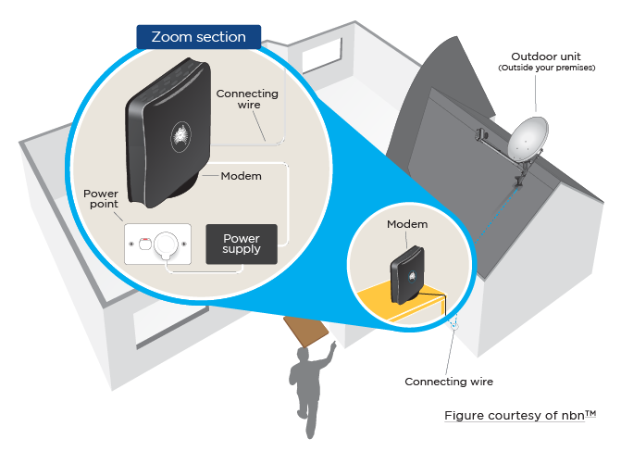

What is the difference between a modem and a router?
nbn will supply a modem which turns the signal coming into your home through the satellite into data you can use. You can use an ethernet cord to connect this and your device to the internet.
A router may be purchased or supplied to you from your retail provider. This lets you connect your laptop, mobile phone or other device wireless to the internet wireless over Wi-Fi.

How do I prepare for the installation?
There are a number of things that you can do to prepare.
- Permissions - on installation day the technician will need to check that there is permission to carry out the installation. This means that an adult (18+) needs to be home to sign the documents. If you rent the property, you must get permission from the landlord.
- Equipment location – you should consider where you want the equipment to be installed. This may require some preparation of the area.
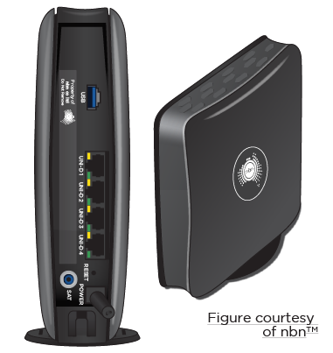
  - The satellite dish – this should have clear line of sight of the north sky. The dish may be attached to the roof or the wall of your property.
Left image: router Right image: modem
  - Wiring – the satellite dish is connected by wiring to the internal modem
  - The internal modem– this is installed inside your premises and needs a power source to work.
  - The router – this plugs into the modem and should be located near the place that you will be using the internet connection the most (e.g. home office). The closer the router is to the computers or devices that you use the better the performance is likely to be. Walls, ceilings and floors may affect the signal, especially in some older buildings. Your Wi-Fi signal might have some interference problems if it is located near other appliances or household electronics, such as fridges or microwaves.

What happens on installation day?
Prior to installation nbn will confirm that the appointment time and date still suits you.
When the nbn technician arrives, they will inform you where they are from and show you their I.D.
The nbn technician will then examine your property and recommend the best location for the equipment. They will also confirm any other satellite dishes that require removal.
The equipment location should also suit your use, so you should clearly explain to the technician where you use the internet in your house to ensure that the location work for you.
Before work starts, they will need your permission to carry out the work.
The technician will then install the equipment. This may take a few hours and you will need to remain on your premises for the duration of the installation. Your property should be left in a good condition.
After installation, your retail service provider must test to see if the nbn service is working.

How big are the satellite dishes?
Most houses will receive the standard satellite dish which is 80cm in diameter. A few houses may need a larger 1.2m dish.

Is there a waiting list available to see how long it takes to get a service before signing up?
No, there is no published waiting list. Your retail service provider can give you an indication of the earliest possible connection date but is not able to guarantee it. Nbn will guarantee your installation date once your retail service provider has processed your order.

Can I use my current equipment?
If this is your first Sky Muster service, you will need to check with your retail service provider.
If you are switching from Sky Muster to Sky Muster Plus you do not need to change your equipment.

What power is required to run the equipment?
The nbn equipment is powered by 240V AC. If your premises is not connected to the electrical grid, ask your retail service provider about a 12/24 V DC option, which may be more suitable.
The router supplied by your retail service provider will also require power to function.

What if my house is not a standard installation?
Some properties will be a ‘non- standard installation’. This means that they require a variation to the standard set up. Non-standard installations may incur additional costs.
When the nbn technician assesses your house, they will discuss any variations that are required. At this stage you can cancel your service at no cost if there are additional charges which you were not aware of.

IMPORTANT
Any additional costs will be paid through your retail service provider, not the nbn technician.
nbn technicians will never ask for money and you should never pay them directly.

Interruptions, faults and repairs
You should first report all problems to your retail service provider.

What if the service stops working?
You should report any services problems to your retail service provider who will investigate the cause of the problem. Retail service providers should try to repair all faults in a reasonable timeframe.

Who is responsible for services- nbn or the retail service provider?
The retail service provider is responsible for the service that they deliver to you under the contract that you agreed to.

What if I don’t get the speeds and performance that I was expecting?
There are a number of factors that may affect your service.
If you exceeded your data allowance for the month then your retail service provider may slow your service, usually to 128kbps.
You should contact your retail service provider if the performance is below expectation. Outline the service issues that you are having and how it is not meeting your expectation. If they are unable to improve your service, you can take your complaint to the Telecommunications Industry Ombudsman (1800 062 058 or tio.com.au).

Is there equipment that I can purchase that will improve my experience of the service?
There are a number of products, such as specialised satellite boosters for routers, which claim to improve the performance of the service and reduce data consumption for satellite connections.
These can be very costly and may offer little to no improvement. You should check your performance with your retail service provider before making expensive purchases. There may be other solutions to improve performance issues you are experiencing.

What if the dish or wiring gets damaged?
The satellite dish and related equipment up to and including the modem remains the property of nbn. If damage occurs immediately contact your retail service provider. An nbn technician may visit your premises if any damages occur. If the damage was caused by you then you may have to pay for the repair. If damage is caused by weather events, then you might be able to recover the costs from your home and contents insurance. It is recommended that the nbn equipment is listed on your insurance policy.

What are my consumer rights?
As a consumer you have a number of rights under the Australian Consumer Law and other rules. In particular your retail service provider must:
- Provide clear and accurate information in advertising, contracts and bills. This means providing you with key fact sheets, information on speed and usage, advice on moving to the nbn and information on medical and security alarms.
  - The key fact sheet will tell you what ‘busy period’ download speeds you can expect, the things you can do on your plan, advice on factors that may affect service speed and which services won’t work during a power failure.
- Give you help if you’re having problems paying bills and take steps before disconnecting your service. A retail service provider will publish details on their websites on how to contact them if you are having trouble paying a bill and how to find a local financial counsellor. They should have a financial hardship policy and will work with you to find a solution.
  - If your retail service provider has accepted that you are in hardship and you have a complaint which contributes to that financial hardship, your RSP cannot take action on the amount you owe until they resolve your complaint.
- Provide good service and deal quickly with complaints. This includes trying to fix your complaint when they first speak to you, fixing urgent complaints within two working days, telling you how they will fix your problem within 15 working days and having a written complaint handling process available for you to read.
  - If there is a delay in resolving your complaint, the provider must tell you the cause of the delay, how long it will take to fix the problem and that you can contact the Telecommunications Industry Ombudsman to help resolve the problem (where delays are over 10 days).
- Provide a repair, replacement, refund, compensation or cancellation, depending on the circumstances. Once you have moved to the nbn, if the service isn’t working your retail service provider has three days to fix the problem. If they can’t fix the problem, they must provide you with access to a working service or a form of compensation.
  - If you have agreed to an alternative service (such as mobile broadband) your retail service provider must provide this within three-five days depending on your location. Your retail service provider cannot charge you for a service that isn’t working.
If your retail service provider is unable to help, you can escalate your complaint with the Telecommunications Industry Ombudsman.

CHECK!
There may be costs associated with repairing damaged equipment. Ask your retail service provider what costs might apply.

Remote and Isolated Communities and Distance Education
The Sky Muster Educational Service allows students who study via distance education to receive a separate internet service port, allowing them additional allocated data for educational purposes.

My child receives distance education, what service will they receive and when?
Premises with geographically isolated children who receive distance education and are on Sky Muster may be eligible to receive a second service to their premises which offers an additional 50GB per month per student (up to 150GB for three students – special arrangements may be made for sites with more than three students).
Your RSP will be able to verify the process required to place an application.
There are currently six providers offering education services over Sky Muster, with a choice of speed tiers (12/1Mbps and 25/5Mbps) and port options (all children’s education through the same port or different ports).
- ACTIV8ME
- Clear
- IP STAR
- Harbour ISP
- Sky Mesh
- ReachNet

Is this available for other education services, such as university?
No, educational services are only available to distance education primary and high school students.

Is this available with Sky Muster Plus?
Currently there are no education services delivered specifically over Sky Muster Plus, however, the NSW Department of Education is set to trial use of Sky Muster Plus during 2020.

Who to contact, complaints and further information
As a customer you will deal mainly with your retailer service provider.
Below is a list of steps that you might take, who to contact, and what might happen.
Issue | Who to contact | Details
Check eligibility for service | nbn / retail service provider | nbn website allows you to check if you are eligible for services.  Retail service providers will also be able to advise if you are eligible for services
Purchase a service | Retail service provider | Retail service providers sell plans to consumers and small businesses. They will also organise for an nbn technician to connect your premises
Get connected | Retail service provider | After purchasing a service with a retail service provider they will arrange for equipment to be installed at your premises.
Delay in getting connected | Retail service provider | If the technician missed an appointment or connection is taking longer than expected contact your retail service provider.
Property damage during installation | nbn | If the nbn technician caused damage to your property during installation you should contact nbn, who will repair this damage at no charge.
Service does not work after installation | Retail service provider | If your service does not work after nbn have installed the equipment contact your retail service provider
Complaint of faulty services | Retail service provider | If there are any problems with your connection, such as unusable services, dropouts, delays, slow speeds etc. you should raise the issue with your retail service provider.
Question bill charges | Retail service provider | If you experience any unexpected charges you should raise these with your retail service provider.
Service outage | Retail service provider | If your service stops working for any reason, contact your retail service provider.
Disconnecting your nbn service | Retail service provider | If you no longer want a Sky Muster service, contact your retail service provider to cancel.
Moving your nbn service | Retail service provider | If you are moving to a new house, contact your retail service provider about changing your service to different premises. Fees may apply to move a service.
Damaged or moved equipment | Retail service provider | If the equipment gets damaged (for example during storms or an object hitting the satellite dish) contact your retail service provider. An nbn technician may be required to visit your premises to correct the position or replace the equipment. There may be a cost, check with your provider.
Complaint about retail provider or nbn not addressing problems encountered | Telecommunications Industry Ombudsman (TIO) | If your complaint to your retail service provider or nbn has not been dealt with, contact the TIO. The TIO will refer your complaint to your provider or nbn and give them 10 days to fix your problem. If this does not solve your problem the TIO will work with you and the provider to see if you can agree on how to fix the problem. Finally, if the issue is still not resolved then the TIO can investigate your complaint.
Changing retail service provider | Retail service provider of choice | Switching between retail service providers is easy with Sky Muster. Just make sure there are no early termination fees with your current retail service provider.
Think you have seen a scam | Scam Watch | Internet scams may attempt to take your money, steal your identity, or access your personal information.  If you think you have seen a scam contact Scam Watch.

How to effectively complain and apply your rights
- Outline your problem and the outcome that you want to your retail service provider. Ask for a response in a reasonable timeframe (e.g. two weeks). Make a note of all your contacts with your retail service provider for future reference.
- If your issue is not resolved, contact the Telecommunications Industry Ombudsman.

Where do I get more information?
Contact details
Retail service providers:
- Activ8me: 13 22 88 or www.activ8me.net.au
- ANT Communications: 1300 268 266 or www.ant.com.au
- BorderNet: 1300 730 302 or www.bordernet.com.au
- Clear Networks: 1300 855 215 or www.clear.com.au
- Harbour ISP: 1300 366 169 or www.harbourisp.com.au
- iiNet: 13 19 17 or www.iinet.net.au
- IPSTAR: 1300 464 778 or www.ipstarbroadband.com.au
- Reach Net: 1300 477 800 or www.reachnet.com.au
- Sky Mesh: 1300 759 637 or www.skymesh.net.au
- Southern Phone: 01 14 64 or www.southernphone.com.au
- Westnet: 13 19 60 or www.westnet.com.au
Escalating a complaint:
- TIO: 1800 062 058 or https://www.tio.com.au/
- ACCC: 1300 302 502 or www.acc.gov.au
Issues with nbn Sky Muster satellite equipment:
- nbn: 1800 687 626 or www.nbnco.com.au
Further consumer tips can be found on our website.

Privacy and security
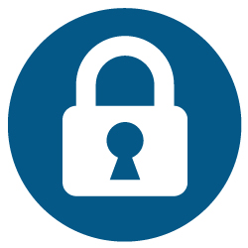
Everyone should have measures in place to protect themselves online. Here are some useful tips:
- Use strong passwords
Passwords should be hard to guess but easy to remember. Some things to consider:
  - Use long passwords (eight-12 characters)
  - Use a variety of lower and upper cases, special characters (e.g. $, #, *), and numbers
  - Avoid using common names and places.
- Keep your devices, application software and operating system up to date.
- Secure your home and office Wi-Fi with encryption and a password.
- Install a firewall to stop unwanted internet traffic that may be harmful for your computer.
- Back up your data regularly.
- Do not provide personal or financial information over emails.
- Do not open or respond to emails if you do not know the sender.

