12 April 2013

Committee Secretary
Joint Committee on the National Broadband Network
Parliament House
CANBERRA ACT 2600
Via email: jcnbn@aph.gov.au; peter.banson.reps@aph.gov.au

ACCAN thanks the Joint Committee for the opportunity to contribute to its review. We would like to update the Committee on our engagement on issues relating to the NBN. This submission addresses the following consumer issues:
- Quality of voice services over the NBN;
- Quality of service reporting for NBN services;
- The NBN Co’s Special Access Undertaking;
- The NBN Co’s Public Information on Migration (PIM) working group;
- “Pull through” processes;
- Battery backups; and
- Consumer complaint processes.

Quality of voice services over the NBN
Consumers require some assurance that the quality of voice services will not be negatively impacted by the transition to the NBN. While there may be a range of IP-based telephony options available over the NBN, there needs to be a clear option for consumers who wish to have a voice service with quality at least as good as they have come to expect from voice services on our existing copper network.
In our view the best way to achieve this is for a code to be developed that sets out minimum standards of quality for IP-based telephony. These should be similar to the standards contained in the current ACIF Code C519:2004, which sets out quality requirements for Standard Telephone Services such as:
- Connection delays and failure rates;
- Transmission loss;
- Circuit noise;
- Echo control; and
- Transmission delay.
Similar standards—with the relevant technical parameters appropriate for IP networks—should be introduced for voice services over the NBN.
We believe this is an area which demands a precautionary approach, with robust regulation in place early to prevent poor quality voice services from becoming established in the market. We do not believe that it is appropriate for regulators to wait for poor quality voice services (and consumer detriment) to become commonplace before taking action.

Quality of service reporting for NBN-based internet services
It is in the consumer interest for there to be monitoring and reporting by a regulator or other neutral body on the performance of broadband service plans over the new network. Such transparency both enables consumers to make informed choices and creates competitive discipline by driving up service quality among providers. Precedent exists in other superfast broadband-enabled countries for this level of transparency and accountability.

Singapore’s consumer-friendly monitoring
ACCAN believes a laudable performance monitoring approach has been taken by Singapore’s regulator, the Infocomm Development Authority (iDA), which publishes on its web site a monthly report of the price and performance of residential broadband offerings from the three major broadband providers. The testing is conducted with devices installed in the homes of volunteer testers along with anonymous test servers deployed with the three major service providers. The iDA conducts the testing in a uniform manner in order to achieve fairness and comparability of results.
The monthly report, laid out with easy to understand bar charts, shows performance of multiple product offerings according to the criteria of download throughput, upload throughput, latency and packet loss. An example of one of these charts is provided below.

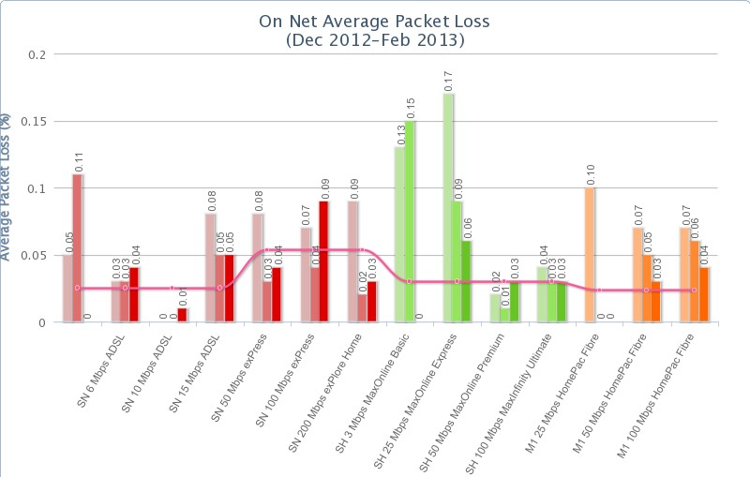
Figure 1: Sample broadband performance chart from the Infocomm Development Authority of Singapore. Different bar colours (red, green, orange) correspond to different service providers.

NBN Co Special Access Undertaking
In January 2013 ACCAN submitted our comments to the ACCC’s consultation on NBN Co’s Special Access Undertaking (SAU). Our submission argued that NBN Co’s SAU will be important for consumers because price and quality factors which will be determined by the SAU are often at the forefront of consumers’ minds when choosing communications services. We therefore urged the ACCC play a stronger role in monitoring the SAU and guarding against price rises.
We also raised a number of issues in relation to end user connection service levels:
- Relatively lengthy migration connection timeframes under the SAU;
- An arbitrary and low cap of 10 percent on “accelerated connections”;
- The need to allow for the time required to activate and repair priority assistance services, and the need for a requirement that faulty priority assistance services are identified and repaired; and
- The need for assurances of voice call quality over the NBN, as discussed above in the current submission.
We note the ACCC’s recently released draft decision on the NBN Co’s SAU, and while we find the draft decision broadly acceptable, we note below some key concerns raised in ACCAN’s submission.

Connection timeframes during migration
Currently, the Customer Service Guarantee (CSG) means that consumers are entitled to have new connections delivered and faults repaired within particular timeframes and receive financial compensation (detailed below) if these timeframes are not met. Under the SAU however, consumers will apparently not benefit from the guaranteed connection timeframes promised by the CSG. For urban areas, instead of 5 working days for a new connection, consumers could be waiting 14 working days (around 3 weeks). We suggest that this timeframe be reduced as far as practicable.

Customer Service Guarantee compensation levels: residential customers
Services delayed | Compensation for first 5 working days (per working day) | Compensation after first 5 working days (per working day)
Connection or repair of standard telephone service | $14.52 | $48.40
Connection or repair of enhanced call handling features to an existing service | $7.26 | $24.20
Connection or repair of two or more enhanced call handling features to an existing service | $14.52 | $48.40
Not keeping an appointment | $14.52 for each missed appointment | $14.52 for each missed appointment

Customer Service Guarantee compensation levels: business customers
Services delayed | Compensation for first 5 working days (per working day) | Compensation after first 5 working days (per working day)
Connection or repair of the standard telephone service | $24.20 | $48.40
Connection or repair of enhanced call handling features to an existing service | $12.10 | $24.20
Connection or repair of two or more enhanced call handling features to an existing service | $24.20 | $48.40
Not keeping an appointment | $24.20 for each missed appointment | $24.20 for each missed appointment

New connection timeframes
NBN Co has introduced the concept of “accelerated connections” where CSG connection timeframes do apply. This is likely to apply for example in circumstances where a person has moved house and there is no working copper service. NBN Co has applied a cap of 10 percent on these connections for each connectivity serving area. ACCAN is concerned that this is an arbitrary and low cap and we would urge that the cap be removed.

Pull through processes
ACCAN has previously noted its concerns about the so-called “pull through” processes in its response to the ACCC’s discussion paper on required measures for migration. We are pleased to see that the ACCC has rejected Telstra’s draft required measures 1(a) and 1(b), largely on the grounds that the draft measures do not sufficiently ensure that customers will receive adequate notice of service disruptions or that service disruptions will be minimised.

NBN backup battery
The NBN rollout has raised the question of whether backup batteries should be supplied to all consumers. ACCAN’s National Consumer Perceptions Survey conducted in 2012 revealed that only 38% of respondents currently have a fixed line phone at home that does not rely on mains power. This suggests that most people have either not considered the issue of power blackouts or have made a decision to rely on their mobiles in such an event. As backup power for their fixed-line phone does not appear to be a high priority for the majority of consumers, it is appropriate that consumers have a choice about whether or not to take a backup power unit.
We also note our concerns about the battery backup unit for users of priority assist services. While the battery backup may offer several hours of power, users of priority assist services will, after this time, find that their service is unavailable. This is not an acceptable result, and the problem must be addressed.

Consumer complaint processes
In relation to new NBN connections, monitoring of some NBN-related threads on Whirlpool reveals there appear to be some problems either with NBN Co’s systems or with the coordination of NBN Co systems with service providers systems resulting in consumers being inconvenienced by multiple delays and/or multiple technician visits. ACCAN has also received direct queries from consumers who have faced such problems. We would hope these are only teething problems as we would be very concerned if these types of problems and delays were the norm during the volume rollout.
Such problems do, however, point to the need for clearer avenues of complaint for consumers. There is at present no obvious contact point for a consumer to complain about migration or connection difficulties, although from a consumer’s perspective there are multiple possibilities—it may be the consumer’s current service provider, the NBN Co, or the TIO—and this situation should be rectified.

NBN Co PIM Industry and Consumer working group
ACCAN and NBN Co have continued to engage through the regular Public Information on Migration (PIM) Industry and Consumer Working Group. ACCAN has provided its input into NBN Co’s consultation on the letters that will be sent to the public at various stages of the rollout.

ACIF C519:2004, End-to-end network performance for the standard telephone service, 2004, <http://www.acma.gov.au/webwr/telcomm/industry_codes/codes/c519_2004(1).pdf>.
<http://www.ida.gov.sg/>
<http://www.ida.gov.sg/applications/rbs/chart.html>
ACCAN, NBN Co 2012 Special Access Undertaking (SAU) Consultation Paper, Submission to the Australian Competition and Consumer Commission (ACCC), January 2013, <http://accan.org.au/files/ACCAN%20submission_SAU.pdf>.
<http://www.acma.gov.au/scripts/nc.dll?WEB/STANDARD/1001/pc=PC_1712>
<http://transition.accc.gov.au/content/index.phtml?itemId=1100316>
ACCC, Assessment of Telstra's draft Migration Plan Required Measures 1(a) and 1(b), final decision, April 2013, <http://transition.accc.gov.au/content/index.phtml/itemId/1082236>.
ACCAN, National consumer perceptions survey, November 2012, <http://accan.org.au/files/ACCAN%20National%20Survey-1.pdf>.
Whirlpool thread: Lidcombe

