[Twitter Icon](https://twitter.com/ACCAN_AU)[Facebook icon](https://www.facebook.com/accanau)[Linked in icon](https://www.linkedin.com/company/accanau/)[Instagram icon](https://www.instagram.com/accan_au)[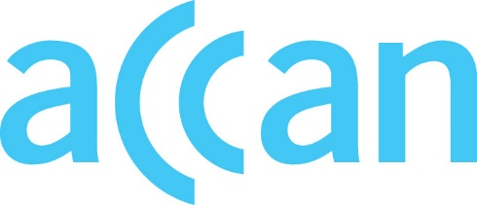](http://www.accan.org.au/)www.accan.org.au

info@accan.org.au

02 9288 4000

**Submission** 17 February 2025

Department of Infrastructure, Transport, Regional Development and Communications and the Arts

By email: [Internetgovernance@communications.gov.au](mailto:Internetgovernance@communications.gov.au)

**Re:** **Discussion Paper: 2025 auDA Terms of Endorsement Review**

The Australian Communications Consumer Action Network (**ACCAN**) thanks the Department of Infrastructure, Transport, Regional Development and Communications and the Arts **(the Department)** for the opportunity to comment on the *Discussion Paper: 2025 auDA Terms of Endorsement Review* (**the Review**).

ACCAN is the peak national consumer advocacy organisation for communications working to achieve trusted, accessible, inclusive, affordable and available communications and digital services for all Australians.

The .au domain is a useful resource for local businesses and organisations to indicate where they are based and do business. It is also useful for consumers seeking to find local businesses and organisations in their country. ACCAN supports the proposed changes to the Terms of Endorsement. ACCAN agrees that auDA should be explicitly encouraged to work with key Australian Government departments and agencies to ensure the resilience and safety of the Australian internet. We also support the provision for fair and transparent multi-stakeholder engagement.

auDA is in a unique position to drive knowledge and capacity to engage with internet governance in the community and consumer sector. We encourage them to continue this capacity building and engagement to support fair participation in multi-stakeholder governance.

We thank the Department for the opportunity to comment on the Review. Should you wish to discuss any of the issues raised in this submission further, please do not hesitate to contact me at [samuel.kininmonth@accan.org.au](mailto:samuel.kininmonth@accan.org.au).

Yours sincerely,

Sam Kininmonth

Senior Policy Adviser

The Australian Communications Consumer Action Network (ACCAN) is Australia’s peak communication consumer organisation. The operation of ACCAN is made possible by funding provided by the Commonwealth of Australia under section 593 of the Telecommunications Act 1997. This funding is recovered from charges on telecommunications carriers. ACCAN is committed to reconciliation that acknowledges Australia’s past and values the unique culture and heritage of Aboriginal and Torres Strait Islander peoples. [Read our RAP](https://accan.org.au/about-us/reporting/reconcilitiation-action-plan).