**Opportunities in the circular economy**

**November 1, 2024**

# Recommendations

This submission recommends the Government:

* Reform national policy settings to facilitate a competitive independent repair sector and develop a national repairability labelling scheme for consumer products.
* Legislate a Right to Repair following the recommendations of the Right to Repair inquiry report and taking into account the European Union’s Right to Repair Directive.
* Develop an information standard for refurbished devices to facilitate consumers effectively comparing the quality of refurbished internet devices.

# About this submission

The Australian Communications Consumer Action Network (**ACCAN**) is pleased to provide this submission to the Productivity Commission (**PC**) concerning its inquiry into the Opportunities in the Circular Economy (**the Inquiry**).

ACCAN’s submission compliments our previous submission to the Department of Climate Change, Energy, The Environment and Waters’ Circular Economy Ministerial Advisory Group (**CEMAG**).[1]

Contents

Recommendations 1

About this submission 1

Introduction 3

Circular economy success stories and measures of success 3

Priority opportunities to progress the circular economy 4

Hurdles and barriers to a circular economy 5

Governments’ role in the circular economy 5

Conclusion 6

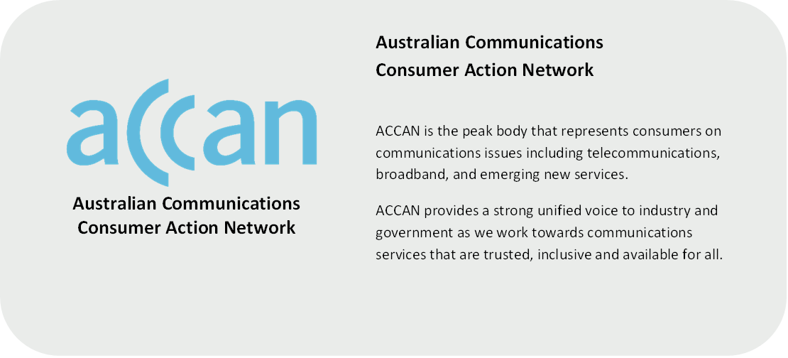

# Introduction

To help achieve an Australian Circular Economy by 2030, ACCAN recommends the Australian Government reform national policy settings to facilitate a competitive independent repair sector and develop a national repairability labelling scheme for consumer products. Supporting these initiatives would ease cost of living pressures on consumers and reduce the environmental impact of the communications sector.[2]

# Circular economy success stories and measures of success

**The Australian repair sector is already embracing the circular economy**

The independent device repair sector in Australia embraces circular economy practices, reducing the demand for new internet devices purchases and extending the life of existing internet devices. This sector can improve the self-sufficiency of communities and provide an affordable repair solution to consumers, often during times of unexpected expense.

The way consumers are using their mobile devices is changing, as ‘consumers are holding on to their phones for longer’.[3] Mobile Muster noted:

* 41% of consumers’ reason for upgrading their phone is because their existing phone has stopped working.[4]
* ‘Australians are slower to upgrade their devices, which means mobile phones are being used for longer by the same owner.’[5]
* ‘72% of children receive their first phone as a hand-me down from their parents.’[6]

Many Australians already choose to repair their digital devices. 38% of Australians repaired a mobile phone in the year 2020, with 60% of those who have used a repair service being between the ages of 16-24.[7] According to Mobile Muster, 67% of surveyed consumers have had a mobile device repaired at an independent repair shop. Mobile Muster noted that independent repair services respond to local market gaps and provide convenient and affordable repairs with quick turnarounds.[8]

According to a survey conducted by the Financial Counsellors Association of Western Australia; ‘37% of surveyed respondents said they do not have enough in their accounts to cover an unexpected bill of $500 without borrowing, selling something or putting it on a credit card’.[9] Further, ‘recent Vodafone research noted that Apple users struggle with repair costs, with more than a third (35.2%) spending up to $250, and almost 12% of respondents paying as much as $500 to fix their smashed phone screens’.[10]

Large manufacturers of mobile phones and laptops often offer screen repairs for popular mobile devices at comparative prices.[11] Independent repair technicians (**IRTs**) can offer similar services at more affordable prices for a wide variety of consumer cohorts and are often located closer to consumers, meaning that repairs can be undertaken in a timely manner. During a cost-of-living crisis, IRTs can facilitate affordable and timely repairs for a wide variety of consumers during instances where consumers unexpectedly encounter significant expenses. A well facilitated independent repair sector can promote competition in the repair market, driving down prices for consumers and reducing the market power of incumbents.

A legislated right to repair would further facilitate the independent repair sector in Australia by decreasing the barriers that the sector faces in operating their businesses. Such legislation would also better allow consumers to retain their internet devices for longer and improve environmental outcomes from increased internet device recycling and reduced e-waste.[12] ACCAN therefore recommends the Australian Government follow the recommendations of the Productivity Commissions’ inquiry report into the Right to Repair as well as the European Union (**EU**)’s Right to Repair Directive (**the R2R Directive**).[13]

# Priority opportunities to progress the circular economy

**The Australian government should consider the implications of EU’s Right to Repair directive**

The adoption of the R2R Directive in the European Union presents an opportunity to harmonise Australian consumer protections with those of the EU.[14] ACCAN encourages the PC to consider the implications of the directive on products made available to consumers in both jurisdictions.

The R2R Directive introduces requirements which would provide significant benefits to Australia’s economy and communications consumers in general. These include:

* Requiring manufacturers supply spare parts and tools at reasonable prices.
* Prohibiting manufacturers from using contractual clauses, hardware or software techniques that impede the repair of goods.
* The introduction of an obligation for manufacturers to repair defects at a reasonable price.
* Requirements for manufacturers to inform consumers of their obligation to repair goods.[15]

The R2R directive requires EU member states to implement at least one measure designed at incentivising consumers to engage with repair.[16] Noting that EU member states are likely to engage with a variety of the R2R directive’s measures, the PC should examine the benefits to the Australian economy of each measure and consider its application into Australian law. As EU member states have until July 2026 to apply these rules, we would encourage the PC to give significant consideration to the recommendation of equivalent reforms to the Australian economy.

# Hurdles and barriers to a circular economy

The barriers experienced by IRTs repairing consumer devices include:

* IRTs being unable to access the schematics and the diagnostics of devices they work with.
* IRTs lacking access to component supply chains.
* The use of serialisation (commonly called part pairing) in the manufacture of communications devices.[17]

In its Inquiry Report into the Right to Repair, the PC identified ‘significant and unnecessary barriers’ to consumers’ right to repair, finding that:

* Consumers’ decision to repair or replace a broken product is primarily driven by price.[18]
* Some manufacturers are limiting IRTs’ access to repair supplies.[19]
* Manufacturer justifications for limiting the access of these resources are overstated.[20]

# Governments’ role in the circular economy

ACCAN recommends the Australian Government:

* Ensure that consumer rights related to the circular economy are cohesive with best practice in other jurisdictions including the United States of America and the EU.
* Examine the approaches of international jurisdictions to the circular economy, particularly the approach of the Welsh Government in facilitating a whole-of-government approach to the circular economy.[21]
* Develop an information standard to facilitate consumers to effectively compare the quality of refurbished internet devices including laptops and mobile phones.

**Facilitating comparison of refurbished internet devices**

Consumers are already engaging with refurbished products and the circular economy.

* Two thirds (64%) of survey consumers say that they have bought a refurbished or repaired electrical item in the past.[22]
* More than a third (38%) of surveyed consumers bought a refurbished or repaired electrical item in the past 12 months.[23]
* One in six (14%) surveyed consumers have bought a refurbished smartphone.[24]

An information standard concerning the quality of refurbished internet devices in Australia would improve consumer confidence in the quality of refurbished internet devices. Currently, one refurbisher’s “excellent” rating for a device may not be equivalent to another’s. Therefore, ‘implementing product quality standards and certifications can play a crucial role in enhancing consumer knowledge and trust regarding the quality of circular [economy] products’.[25]

An information standard would address this problem through providing clear distinctions to existing ratings such as “excellent”, “very good” and “good” to improve consumer visibility and confidence. ACCAN considers that it is critical to collaborate with a wide variety of market participants to ensure that developments effectively facilitate comparison while not being overly burdensome on existing refurbishers or new market entrants. As ‘consumers currently perceive refurbished mobile phones as inferior products in comparison to new ones’, the development of an information standard would improve consumer perception and uptake of refurbished products.[26]

Any information standard concerning refurbished internet devices rating should:

* Facilitate easy and effective comparison by consumers across refurbished products.
* Not unnecessarily restrict refurbishers, including small businesses, from entering the market.

# Conclusion

ACCAN urges the PC to consider the implications of circular economy developments in comparative jurisdictions and the impact they will have on the Australian markets. ACCAN considers there is significant potential to improve the sustainability of the consumer devices market through improving the repairability of devices and further facilitating consumers purchasing refurbished devices.

We thank PC for the opportunity to submit to this consultation. Should you wish to discuss any of the issues raised in this submission further, please do not hesitate to contact me at [con.gouskos@accan.org.au](mailto:con.gouskos@accan.org.au).

The Australian Communications Consumer Action Network (ACCAN) is Australia’s peak communication consumer organisation. The operation of ACCAN is made possible by funding provided by the Commonwealth of Australia under section 593 of the Telecommunications Act 1997. This funding is recovered from charges on telecommunications carriers. ACCAN is committed to reconciliation that acknowledges Australia’s past and values the unique culture and heritage of Aboriginal and Torres Strait Islander peoples. [Read our RAP](https://accan.org.au/about-us/reporting/reconcilitiation-action-plan).

1. ACCAN, Circular Economy Ministerial Advisory Group Interim Report (Submission, 2024) <<https://accan.org.au/accans-work/submissions/2342-circular-economy-ministerial-advisory-group-interim-report>>.
2. ACCAN, Circular Economy Ministerial Advisory Group Interim Report (Submission, 2024) 1.<<https://accan.org.au/accans-work/submissions/2342-circular-economy-ministerial-advisory-group-interim-report>>.
3. Mobile Muster, Insights into mobile phone use, reuse and recycling, (Report, 2020) 1< <https://www.mobilemuster.com.au/mobile-phone-use-reuse-and-recycling/>>.
4. Ibid 1.
5. Ibid 5.
6. Ibid 9.
7. Ibid 14.
8. Ibid 14.
9. Financial Counselling Association of Western Australia, Cost of living Survey report (Report, 2024) 10 <<https://www.wacoss.org.au/wp-content/uploads/2024/08/WA-Cost-of-Living-Survey-Report-Sept-2024.pdf>>.
10. Mendoza, K. *Australians would rather live with smashed phone screens than shell out cash for repair*. Commswire Afternoon, 26 August 2024. 2.
11. For example, as of October 18, 2024, the estimated screen repair cost of an iPhone 12, 13, 14, 15 and 16 is $465. Apple, iPhone Screen Repair (Webpage, 2024). <<https://support.apple.com/en-au/iphone/repair/screen-replacement>>
12. ACCAN, Circular Economy Ministerial Advisory Group Interim Report (Submission, 2024) 3 <<https://accan.org.au/accans-work/submissions/2342-circular-economy-ministerial-advisory-group-interim-report>>
13. European Commission. Directive on repair of goods (Webpage, 2024) <<https://commission.europa.eu/law/law-topic/consumer-protection-law/directive-repair-goods_en>>
14. Ibid.
15. Ibid.
16. Ibid.
17. European Commission, Directive on repair of goods (Webpage, 2024) <<https://commission.europa.eu/law/law-topic/consumer-protection-law/directive-repair-goods_en>>
18. Productivity Commission, Inquiry Report - Right to Repair Overview & Recommendations (Report, 2021) 6. Available at: <<https://www.pc.gov.au/inquiries/completed/repair/report/repair-overview.pdf>.>
19. Ibid 29.
20. Ibid 31.
21. Welsh Government, Beyond Recycling - A strategy to make the circular economy in Wales a reality (Report, 2021). <<https://www.gov.wales/sites/default/files/publications/2021-03/beyond-recycling-strategy-document.pdf>> Examples of the implementation of circular economy case studies can be found here: University of Greenwich. Circular Economy Implementation Case Studies in Wales (Report, 2023) <<https://gala.gre.ac.uk/id/eprint/46738/>>
22. Trojan Electronics, The rise of refurbished electronics: exploring consumer attitudes (Report, 2023) 3. <<https://trojanelectronics.co.uk/wp-content/uploads/2023/08/Trojan-Report_The-rise-of-refurbished-electronics_exploring-consumer-attitudes.pdf>>
23. Ibid.
24. ibid.
25. Karelia University of Applied Sciences International Business, Circular Economy of Refurbished Smartphones in the European Union Research on Drivers and Barrier (Report, 2023) 56. <<https://www.theseus.fi/bitstream/handle/10024/801292/Hapuli_Kumpulainen.pdf?sequence=2&isAllowed=y>.>
26. Ibid 29.