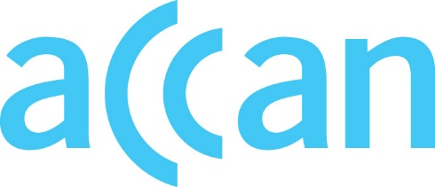
www.accan.org.au
info@accan.org.au
02 9288 4000

Submission 5th April 2023
Via email: superfastbroadbandinquiry@accc.gov.au
Re: Superfast broadband access service final access determination inquiry 2021
The Australian Communications Consumer Action Network (ACCAN) thanks the Australian Competition and Consumer Commission (ACCC) for the opportunity to comment on its Superfast Broadband Access Service (SBAS) Final Access Determination Draft Instrument (the draft instrument). ACCAN is the peak body that represents consumers on communications issues including telecommunications, broadband, and emerging new services. ACCAN provides a strong unified voice to industry and government as we work towards communications services that are trusted, inclusive and available for all.
ACCAN supports the draft instrument which:
- Requires carriage or carriage service provider (CSP) to supply 25/10 Mbps and 50/20 Mbps upon request from an access seeker, and benchmarks the price against equivalent NBN services.
- Regulates non-recurring charges such as standard installation, non-standard installation, service transfers, transfer reversal prices and service management activity.
- Requires Access Providers to measure, monitor and report on their performance, including against its service standards and benchmark level of performance.
The forementioned changes to the Instrument will work to protect consumers on non-NBN networks against price shocks and poor service standards.
ACCAN notes that the benchmark pricing has been set regardless of whether the network is exempt from paying the Regional Broadband Scheme (RBS) levy. As NBN’s charges are inclusive of the levy, we consider it unfair and distortionary for exempt networks to pass a cost onto households which is not being imposed on the network operator. We recommend that the Instrument be amended to account for the RBS levy exemption.
If you have any further questions regarding our response, please do not hesitate to contact me at 02 9288 4000.
Yours sincerely,
Megan Ward
Senior Economic Adviser
The Australian Communications Consumer Action Network (ACCAN) is Australia’s peak communication consumer organisation. The operation of ACCAN is made possible by funding provided by the Commonwealth of Australia under section 593 of the Telecommunications Act 1997. This funding is recovered from charges on telecommunications carriers.
ACCAN is committed to reconciliation that acknowledges Australia’s past and values the unique culture and heritage of Aboriginal and Torres Strait Islander peoples. Read our RAP

SBAS Final Access Determination Draft Instrument, section 4.3(b)(ii) and section 4.3(b)(iii).
SBAS Final Access Determination Draft Instrument, schedule 2, section 2.3.
SBAS Final Access Determination Draft Instrument, schedule 2, section 2.4.
SBAS Final Access Determination Draft Instrument, schedule 13, sections 13.1 – 13.7.
Carriers with less than 2,000 potentially chargeable premises are exempt from paying the RBS levy on those premises. During the first five years of the scheme, for carriers only serving non-greenfield premises, the first 25,000 residential and small business premises receive a concession, for network operators connected to greenfield premises, the first 55,000 recently connected greenfield premises are exempt from the levy.

