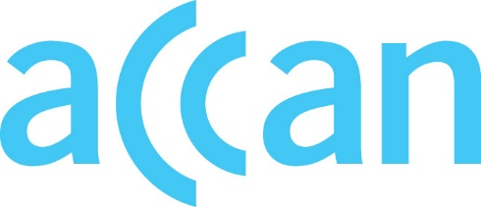
www.accan.org.au
info@accan.org.au
02 9288 4000

Submission 14 March 2023

Craig Purdon Project Manager Communications Alliance Level 12/75 Miller Street North Sydney NSW 2060
Re: C540:2023 Local Number Portability Industry Code
Dear Mr Purdon,
The Australian Communications Consumer Action Network (ACCAN) thanks Communications Alliance for the opportunity to provide feedback on C540:2023 Local Number Portability (the draft Code).
ACCAN is the peak body that represents consumers on communications issues including telecommunications, broadband, and emerging new services. ACCAN provides a strong unified voice to industry and government as consumers work towards communications services that are trusted, inclusive and available for all.
ACCAN is pleased to see updated service metrics around porting times for Cat A and C ports in the revised draft Code.
However, ACCAN is disappointed by the lack of progress to modernise Australia’s number porting infrastructure to facilitate competition and bring consumers’ experiences in line with their expectations. Prompt number porting is important to consumers, but it is unclear when the industry will finish rolling out long anticipated projects such as Converged Number Portability Service (CoNPortS).
In 2021, Communications Alliance conducted a number portability feasibility study. The study found that upgrades to the number portability systems would provide “maximum benefit” to local number portability. A new system would be “expected to enable more rapid service activation and the associated number porting”. Without investment in a new system, the report warned that local number portability is “expected to be increasingly less likely to meet service provider and customer expectations in the future”.
Despite improvements to the draft Code, residential and small business consumers still face a risk that their local number ports could take far longer than expected, causing significant inconvenience and potential detriment and business loss. Number porting infrastructure needs to be progressed as a matter of priority to support small businesses, better enable competition, and prevent undue harm to consumers.
ACCAN calls for a public implementation commitment from industry with routine reporting and regulatory oversight. In addition, ACCAN recommends the draft Code be amended in two key areas:
- Consumers’ entitlements in the LNP process should be explicitly set out in the Code, as it is currently difficult for consumers to understand what to expect and what level of service they should be receiving.
- The Code should set obligations (or note obligations that sit in other industry Codes or Guidelines) for keeping consumers informed about the status of their ports at regular intervals.
Please do not hesitate to get in touch if you wish to discuss our feedback further.
Sincerely,
Samuel Kininmonth
Policy Adviser

The Australian Communications Consumer Action Network (ACCAN) is Australia’s peak communication consumer organisation. The operation of ACCAN is made possible by funding provided by the Commonwealth of Australia under section 593 of the Telecommunications Act 1997. This funding is recovered from charges on telecommunications carriers.

Communications Alliance, 2023. Local Number Portability Draft For Public Comment. Available at: https://commsalliance.com.au/__data/assets/pdf_file/0005/92075/C540_2023.pdf
Communications Alliance, 2022. Number Portability Feasibility Study. Available at: https://www.commsalliance.com.au/__data/assets/pdf_file/0009/81990/IGN022-Number-Portability-Feasibility-Study-V2.pdf
Ibid., p.3.
Ibid., p.3.

