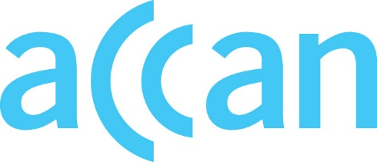
www.accan.org.au
info@accan.org.au
02 9288 4000

Submission 22 August 2022
By web portal: https://www.arts.gov.au/have-your-say/new-national-cultural-policy

Re: National Cultural Policy Consultation
The Australian Communications Consumer Action Network (ACCAN) thanks the Office for the Arts for the opportunity to contribute to a new National Cultural Policy. ACCAN is Australia’s peak communications consumer organisation representing consumers of communications products and services, including the internet and mobile telecommunications. As audio-visual content has become increasingly distributed using digital platforms via broadband internet and mobile telecommunications services, ACCAN has represented consumer interests on a case-by-case basis.
We are writing to support the submission made by the ARC Centre of Excellence for Automated Decision-Making and Society (ADM+S). ACCAN agrees with the ADM+S that digital technology is an important enabler for Australia’s arts and culture. ACCAN supports digital inclusion measures that allow all Australians to participate in the nation’s cultural life.
We can also offer a consumer perspective in relation to Pillar Five of the consultation: “Reaching the audience: ensuring our stories reach the right people at home and abroad”.
While streaming and other internet distributed media have grown in importance to consumers, many Australians, including those from CALD and Indigenous communities, people with disabilities, seniors, and people living in regional, rural, and remote areas still rely on broadcast television to connect with news and entertainment. In recent research, ACCAN found that broadcast television is still important to 81% Australians, but especially those who tend to be less digitally included. Changes to media distribution infrastructure in Australia must be approached carefully and in close consultation with communities who rely on the current infrastructure for their news and entertainment.
Accessibility to cultural content for people with a disability should be a priority so that Australian stories can reach everyone. The growth of streaming, combined with developments in broadcasting, presents an opportunity to legislate standards that ensure that media in Australia features captions and audio description. Research has found that accessibility features are desirable for many consumers of streaming services and not just people with a disability. Forward looking cultural policy that requires equitable accessibility features would benefit the community as a whole.
In closing, ACCAN commends the submission by the ADM+S regarding the issues paper and reiterates the need to consider digital inclusion as a core aspect of cultural policy. Please do not hesitate to contact us should you require any further information.
Yours sincerely,
Samuel Kininmonth
Policy Advisor
Australian Communication Consumers Action Network
The Australian Communications Consumer Action Network (ACCAN) is Australia’s peak communication consumer organisation. The operation of ACCAN is made possible by funding provided by the Commonwealth of Australia under section 593 of the Telecommunications Act 1997. This funding is recovered from charges on telecommunications carriers.

ACCAN 2021, ACCAN response to Media Reform Green Paper, Available: https://accan.org.au/accanswork/submissions/1854-media-reform-green-paper
ACCAN 2022, ACCAN Research Snapshot: How Australians watch TV, Available: https://accan.org.au/files/Reports/ACCAN%20Research%20Snapshot%20How%20Australians%20Watch%20TV.pdf
Ellis, K., Locke, K., Peaty, G., Hersinta & Kao, K. 2021, Access on Demand: An analysis of the accessibility options on streaming television, Australian Communications Consumer Action Network, Sydney. Available: https://accan.org.au/AccessOnDemand_Curtin_CCAT_web.pdf

