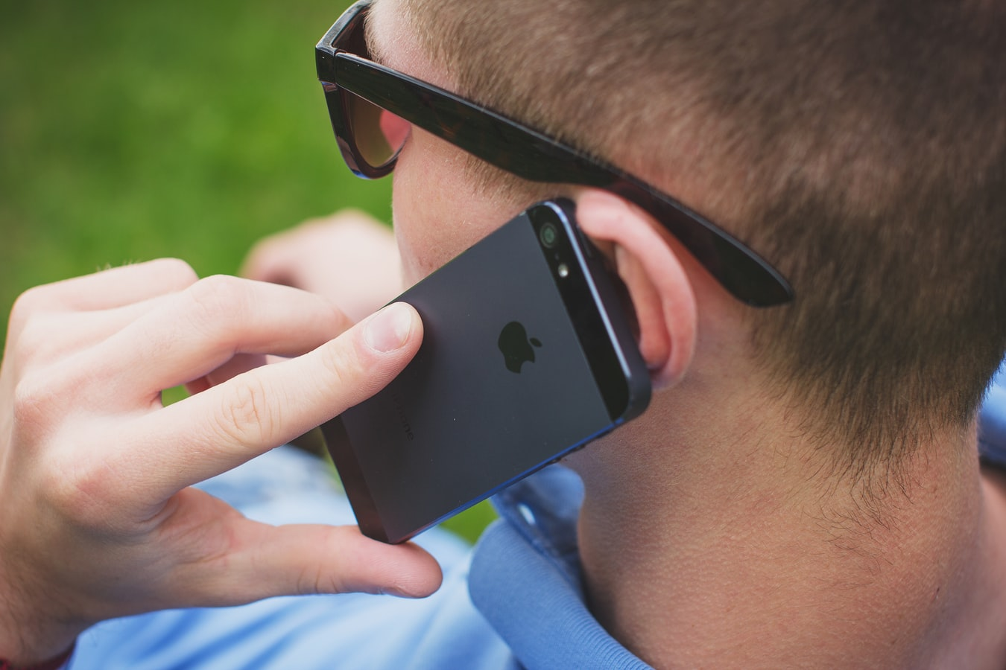
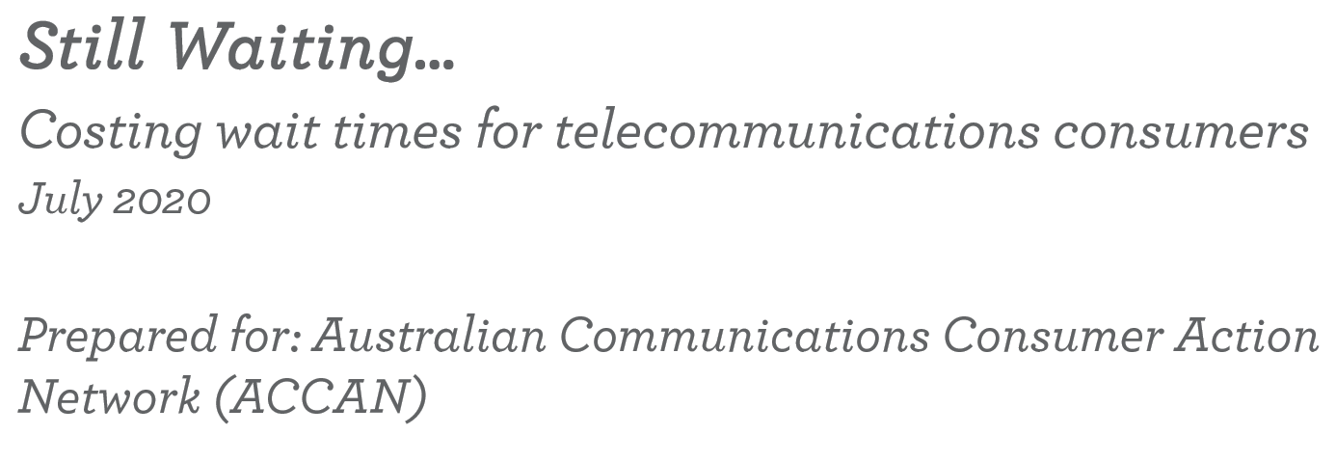
“Still waiting… Costing wait times for telecommunications consumers”
Hannah Wood
Published in 2020
The operation of the Australian Communications Consumer Action Network is made possible by funding provided by the Commonwealth of Australia under section 593 of the Telecommunications Act 1997. This funding is recovered from charges on telecommunications carriers.
Colmar Brunton
Website: https://www.colmarbrunton.com.au/
Email: hannah.wood@colmarbrunton.com
Telephone: +61 2 9568 8368
Australian Communications Consumer Action Network
Website: www.accan.org.au
Email: research@accan.org.au
Telephone: +61 2 9288 4000
If you are deaf, or have a hearing or speech impairment, contact us through the National Relay Service: https://www.communications.gov.au/what-we-do/phone/services-people-disability/accesshub/national-relay-service/service-features/national-relay-service-call-numbers.
This work is copyright, licensed under the Creative Commons Attribution 4.0 International License. You are free to cite, copy, communicate and adapt this work, so long as you attribute “Colmar Brunton and the Australian Communications Consumer Action Network (ACCAN)”. To view a copy of this licence, visit http://creativecommons.org/licenses/by/4.0/
.

Table of Contents

Executive summary 1
Research background 1
Methodology 1
Key findings 2
Phone contact 2
Live chat 2
Other contact methods 3
Conclusions 3
Introduction 4
Research Background 4
Research Objectives 5
Methodology 6
Research design 6
Questionnaire 6
Sample 7
Tests of statistical significance and their reliability 8
Calculation of total time spent 8
Interpreting this report 8
Results 9
Contact with provider 9
Most recent issue 10
NBN related issues 11
Issue resolution 20
Conclusions 21
Areas for further research 22
Appendix: Questionnaire 23

Figures
Figure 1: Providers contacted between February 2019 and February 2020 9
Figure 2: Subject of most recent service issue 10
Figure 3: NBN related issues 11
Figure 4: Methods of contact 12
Figure 5: Number of contact methods used 13
Figure 6: Number of phone calls with provider 14
Figure 7: Average time spent on most recent call 15
Figure 8: Other activities undertaken while on the most recent call 16
Figure 9: Number of live chat conversations with provider 17
Figure 10: Average time spent on last live chat with service provider 17
Figure 11: Other activities undertaken while on the most recent live chat 18
Figure 12: Number of times contacted by method 19
Figure 13: Issue resolved 20

Executive summary

Research background
The Australian Communications Consumer Action Network (ACCAN) is Australia’s peak body for consumer representation in telecommunications. In response to consumers experiencing long wait times and other significant customer service issues when contacting their telecommunications providers. ACCAN commissioned Synergies Economics to develop a model to estimate the cost of consumer time that is spent trying to resolve issues with their telecommunications provider.
To extend this work, ACCAN has commissioned Colmar Brunton to collect data for use in the economic modelling prepared.
The specific objectives of the current research were to:
- Establish the incidence of consumers that are contacting their provider to resolve issues relating to various telecommunications services, including the proportion that are NBN related.
- Calculate the average amount of time a consumer spends resolving an issue with their provider
- Determine the average number of contacts it takes to resolve an issue

Methodology
The research uses an online survey conducted among 1,035 consumers.
To qualify for the survey, consumers had to be solely or jointly responsible for communicating with their telecommunications provider and have contacted their provider within the last 12 months regarding a problem or issue with their service.
Where a respondent was jointly responsible for an account, the respondent was only asked about the contacts they had personally made with their provider. Therefore, any contacts made by the other party on the same issue were not captured.
The respondents were then asked to think about their most recent issue and where relevant, their most recent phone call or live chat.

Key findings
The most recent telecommunications issue respondents had experienced varied widely: 34% were related to their mobile phones, while a further 32% were related to their fixed line internet service.
- The majority (71%) of internet or landline issues were related to services on NBN’s network.
- To contact their provider, the majority (73%) of consumers only used one contact method.
- Phone (74%) was the most commonly used contact method, followed by live chat (24%) and email (14%).
- The vast majority (84%) of issues were resolved, while 9% are currently ongoing and 7% were never resolved.

Phone contact
On average, respondents contacted their provider 2.4 times by phone about their most recent issue. Over one third (37%) only needed to phone their provider once, a further 24% phoned twice.
The average length of call was 27 minutes and 7 seconds. Just over half (52%) of this time was spent on hold, waiting to speak to a customer service representative (14 minutes and 6 seconds).
This equates to an average total of 65 minutes and 5 seconds to resolve an issue by telephone.
Nearly half (48%) were doing something else while on the phone with their provider. Most commonly this was general internet browsing (37%) or using social media (32%).

Live chat
On average, respondents who used live chat contacted their provider 2.3 times via this method. Two in five (42%) only used live chat once to contact their provider.
The average length of live chat conversations was 16 minutes and 6 seconds. The majority (63%) of the time was spent chatting with a customer service representative (10 minutes 1 second).
This equates to an average total of 37 minutes and 2 seconds to resolve an issue via live chat.
Over half (53%) of respondents were doing something else while on live chat. Most commonly this was using social media (41%) or general internet browsing (40%).

Other contact methods
The total average time consumers spent contacting their provider varied greatly by other contact methods:
- In person at a store – 32 minutes and 5 seconds
- Email – 19 minutes and 8 seconds
- Web-form – 18 minutes and 8 seconds
- Crowd support / community help forum - 15 minutes and 11 seconds
- Social media – 13 minutes and 8 seconds

Conclusions
Consumers remain subject to long wait times, particularly those who contact their providers via telephone to resolve issues. On average they spend a total 1 hour and 5 minutes per issue on the phone. Half (52%) of this time is spent on hold, waiting to speak to a customer service representative.
In comparison, total average time spent on live chats is almost half that, at 37 minutes 2 seconds. Considerably less time (37%) is spent on live chat waiting for the initial response from a customer service representative.
The majority (84%) of issues had been resolved and 9% were ongoing at the time of the survey. However, it is concerning 7% of issues were abandoned by consumers without resolution.
The number of calls it took to resolve an issue did not vary significantly between retail providers. However, calls to Vodafone were significantly shorter compared to other providers. The number and length of live chat conversations did not vary significantly by provider either.

Introduction

Research Background
ACCAN is concerned that consumers continue to be subjected to poor customer service outcomes. In particular, consumers often face extended wait times, as well as being passed between various customer service representatives when attempting to resolve a problem. In order to quantify the cost to consumers, the Synergies report identified three key areas where wait times can be measured:
- before the first contact with a customer service representative (e.g. Waiting on hold, or waiting for a reply);
- the time spent explaining a problem to the initial customer service representative,
- time spent being transferred to another customer service representative, if the first was unable to resolve the issue.
The Telecommunications Industry Ombudsman (TIO) also recognises that issue resolution continues to be a problem for consumers. While the number of complaints to the TIO has decreased over time, the complexity of complaints continues to increase. The TIO has identified that because these issues are more difficult to resolve, this has a direct knock-on effect in terms of consumer wait-times.
The extended periods of time that are forgone by consumers to resolve these issues represent an economic loss to not only the individual consumer, but the wider Australian economy. Time spent resolving an issue represents an opportunity cost as the individual could have been carrying out an alternative activity for which they value. Currently there is limited research to show how much time consumers spend trying to resolve an issue with their telecommunications provider. Research is therefore needed to establish the average amount of time consumers spend in an attempt to resolve service issues. This data will then be used by ACCAN to calculate the estimated economic cost of this time.

Research Objectives
This research will establish the average amount of time consumers spend seeking to resolve service issues with their telecommunications provider. This data will be used by ACCAN to produce a set of statistically robust and defensible estimates of the cost of consumer time wasted, based on the modelling framework developed by Synergies Economics.
The specific objectives of this research were to establish:
- the incidence of consumers contacting their provider to resolve issues relating to various telecommunications services
  - including the proportion that are NBN related.
- The average amount of time a consumer spends resolving an issue with their provider
- The average number of contacts it takes to resolve an issue

Methodology

Research design
This study was conducted via an online survey between 2nd April – 6th April 2020 with a total of 1,035 respondents. These respondents indicated they were solely or jointly responsible for communicating with their telecommunications provider and had contacted their provider within the last 12 months regarding a problem or issue with their service.
Due to the closure of many call centres caused by the COVID-19 pandemic, respondents were asked to comment on issues that occurred in the 12 months prior to March 2020.

Questionnaire
The questionnaire covered a number of key aspects relating to wait times and issue resolution. To aid recall, respondents were asked to focus on their most recent issue and where relevant, the most recent phone call or live chat relating to this issue.
The structure of the questionnaire was as follows:
- Demographics
- Services used
- Service provider
- Most recent issue
- Provider
- Service that the issue related to
- Contact methods used
- Number of contacts made
- Time spent contacting provider
- Whether or not other activities were undertaken
- Issue resolution

Sample
The distribution of the survey was representative of the Australian general population. However, given the variable nature of provider contact no quotas were placed on survey responses allowing us to accurately capture who in the population is contacting their respective provider. As a result, the final sample shows that provider contact is skewed slightly among younger people. However, provider contact in terms of gender and location are both representative of the Australian population.
Table 1: Sample structure
Demographic group |  | N= | %
Age | 18-34 | 330 | 32%
 | 35-44 | 210 | 20%
 | 45-64 | 331 | 32%
 | 65+ | 164 | 16%
Location | Metro | 689 | 67%
 | Regional | 346 | 33%
NBN connection | Yes | 639 | 62%
 | No | 382 | 37%
 | Don’t know | 14 | 1%
Gender | Male | 512 | 49%
 | Female | 518 | 50%
 | Other | 3 | 0.3%
 | Prefer not to say | 2 | 0.2%
Provider of most recent issue | Telstra | 414 | 40%
 | Optus | 204 | 20%
 | TPG / iiNET | 104 | 10%
 | Vodafone | 80 | 8%
 | Belong | 54 | 5%
 | Dodo / iPrimus | 48 | 5%
 | Other | 131 | 13%

Tests of statistical significance and their reliability
Where appropriate, tests for statistical significance have been conducted on particular subgroups of interest including:
- Provider (most recent issue)
- Age group
- Gender
- Location (metro or regional)
- Non-English-speaking background
- Disability or impairment

Unless stated otherwise in the report, significance testing has been conducted against the total rather than within sub-groups.
Tests have been undertaken at a 95% confidence level. The margin of error associated with the sample size of n=1035, is ±3.1 with a 95% confidence interval. If there is a statistically significant difference between the result for a particular group and the result for the wider population, we can be confident that this difference has not occurred by chance, rather that it reflects a genuine difference among that group compared to the wider population.

Calculation of total time spent
By taking an approach that only required respondents to recall their most recent telephone call or live chat, total time spent per contact method has been extrapolated using the average time spent on the most recent contact and multiplied by the average number of contacts via telephone or live chat.
For other contact methods, total estimated time was captured in the survey.

Interpreting this report
Please note results in figures may not sum to 100% due to rounding. Likewise, commentary referencing sums of figure proportions may differ by +/- 1% due to rounding.

Results

Contact with provider
Over one third (35%) of consumers contacted their service provider about a problem or issue in the period between February 2019 and February 2020. Customers of Belong (37%) were the most likely to have contacted their provider. While Vodafone (23%) and Amaysim (23%) customers were significantly less likely to have contacted these providers.
Figure 1: Providers contacted between February 2019 and February 2020

A8. Between February 2019 and February 2020 which, if any, of your providers did you contact with a problem or issue relating to your service? Base: All respondents, including those who screened out of survey for not making contact with their provider(s) n=2994. Note only providers with n=50 or more respondents displayed on chart.

Most recent issue
The most recent issue respondents had experienced varied greatly by technology: 34% were related to their mobile phones, while a further 32% were related to their fixed line internet service.
One in ten (10%) of the most recent issues were related to landline services.
Figure 2: Subject of most recent service issue

B1. Was this issue related to your…? Base: All respondents n=1,035
Young people (18-34), were significantly more likely to have most recently experienced an issue with their mobile service (44%). While those aged over 65 were significantly more likely to have experienced their most recent issue with their fixed line internet service (48%) or their landline (18%).

NBN related issues
Among those who experienced an issue with their landline phone, fixed line, fixed wireless, or fixed satellite internet service, 71% of issues were related to the NBN.
Figure 3: NBN related issues

B2. And was the issue about the NBN? Base: Experienced an issue with landline phone, fixed line, fixed wireless, or fixed satellite internet service n=572
It should be noted the prevalence of NBN issues did not vary significantly by provider or location.

Contact methods used
Speaking over the phone was the most commonly used contact method, with three quarters (74%) of respondents indicating they contacted their provider by phone.
Phone contact was significantly higher among TPG/iiNet customers (88%) and lower among Optus customers (68%).
Live chat was used by 25% to contact their provider, increasing significantly among Optus customers to 43%.
One in ten (10%) visited a store, although this was significantly higher among Vodafone customers (25%).

Figure 4: Methods of contact

B3. Which method(s) did you use to contact [PROVIDER] about your most recent issue? Base: All respondents n=1,035
Young people, aged 18-34, were less inclined to contact their provider by phone (69%) than other respondents. Instead they were significantly more likely to use the following online methods:
- Email (19%)
- Web-form (12%)
- Crowd support or community forum (8%)
- Social media (7%)
While not statistically significant, use of live chat was slightly higher among those aged 18-34 (29%) and 35-44 (30%).

Number of different contact methods used
When contacting their provider about their most recent issue, the majority (73%) of respondents only utilised one contact method.
Figure 5: Number of contact methods used

DATA IS A SUM OF QUESTION B3 (Which method(s) did you use to contact [PROVIDER] about your most recent issue0)? Base: All respondents n=1,035
TPG/iiNET customers were significantly more likely to contact the provider by one method only (88%), which was typically phone (88%).
Optus customers were significantly more likely to contact the provider via two different methods (24%).

Number of times provider was contacted
On average, consumers contacted their provider 2.3 times about their most recent issue. Fewer than half (40%) were able to resolve their issue in the first contact. Eighteen percent reported contacting their provider 5 or more times to resolve their issue.
Figure 6: Number of contacts made about the issue

DATA IS A SUM OF QUESTION B4 How many times did you contact your provider about your most recent issue via…? Base: All respondents n=1,032 (Excluding outliers)

Of concern, those with a disability or impairment contacted their provider 4.1 times on average, significantly higher than those without, who made 2.7 contacts.

There were no significant differences between providers.

Phone contact
On average, respondents contacted their provider 2.4 times by phone about their most recent issue. Over one third (37%) only needed to phone their provider once.
One in ten (11%) were unable to recall how many times they contacted their provider.
Figure 6: Number of phone calls with provider

B4. How many times did you contact [PROVIDER] about your most recent issue via…? Base: Contacted provider by phone n=771
It should be noted the number of calls did not vary significantly by provider or demographic subgroup.

Time spent on the phone
Respondents who contacted their provider via phone spent an average of 27 minutes and 7 seconds on their most recent call. Just over half (52%) of the time was spent on hold, waiting to speak to a customer service representative.
With an average 2.4 calls made, this equates to a total of 1 hour and 5 minutes spent on the phone to resolve an issue.
Figure 7: Average time spent on most recent call
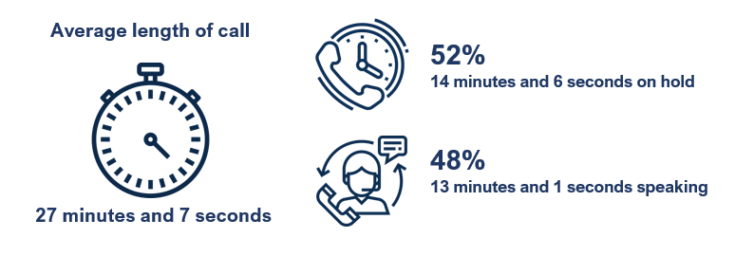
B6. Thinking about your most recent phone call, approximately how many minutes did you spend on the call? Base: Contacted provider by phone n=771
B7. And during this phone call, approximately how much time did you spend on hold, waiting to speak with a customer service representative? Base: Contacted provider by phone n=771
On average, calls to Vodafone were significantly shorter, with their customers spending just 15 minutes and 8 seconds on their most recent call, as displayed in the table below.
Table 2: Average length of call by provider
Provider | Average hold time per call | Average length of call | Total average time spent on phone with provider*
TPG / iiNET | 14:05 | 31:06 | 1:14:38
Telstra | 15:06 | 30:06 | 1:12:14
Optus | 16:05 | 27:06 | 1:07:45
Belong | 15:05 | 25:07 | 1:02:47
Dodo / iPrimus | 13:05 | 23:07 | 1:00:06
Vodafone | 9:08 | 15:08 | 0:34:48
Note: Table only displays providers with n=30 or more respondents
*Total based on average number of calls to provider

Other activities while on the phone
Nearly half (48%) of respondents indicated they were doing something else while they were on the phone with their provider. Among those who were doing something else this commonly included general internet browsing (37%), using social media (32%) and working (29%).

Figure 8: Other activities undertaken while on the most recent call
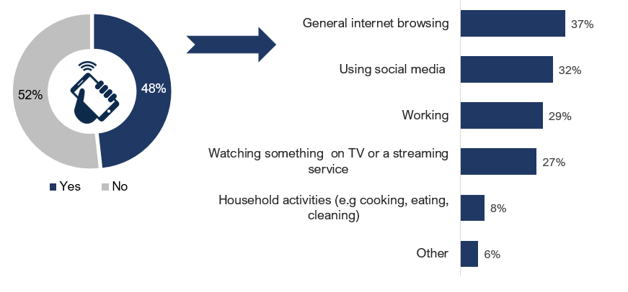
B8. Were you doing anything while you were on the phone with [PROVIDER]? Base: Contacted provider by phone n=771
B9. What were you doing? Base: Was doing something else while on the phone n=372
Young people aged 18-34 were more likely to be doing something else while the phone with their provider (62%), with this most common activity being using social media (47%).
Women were also significantly more likely to indicate they were doing something else while on the phone with their provider (53%), with this most likely to be using social media (38%). Whereas men were significantly more likely to have been working while on the call (35%) compared to 24% of women.

Live chat
On average, respondents who used live chat contacted their provider 2.3 times via this method. Two in five (42%) had only one live chat with their provider
Figure 9: Number of live chat conversations with provider

B4. How many times did you contact [PROVIDER] about your most recent issue via…? Base: Used live chat to contact provider n=261
The number of live chat conversations required did not vary significantly by provider.

Length of live chat
Respondents who contacted their provider via live chat spent an average of 16 minutes and 6 seconds on their most recent chat. Of this time, an average of 6 minutes and 7 seconds was spent waiting for the initial customer service reply.
With an average 2.3 live chat conversations, this equates to a total of 37 minutes and 2 seconds spent on live chat to resolve an issue.
Figure 10: Average time spent on last live chat with service provider
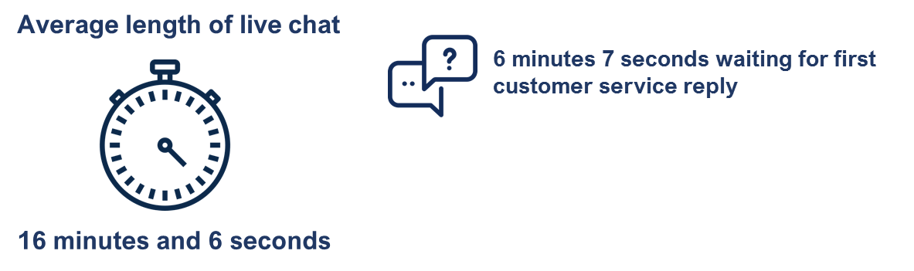
B10. Thinking about your most recent live chat, approximately how many minutes did you spend on the chat? Base: Used live chat to contact provider n=261
B11. And during this live chat, approximately how long did you spend waiting to get the first message back from a customer service representative? Base: Used live chat to contact provider n=261
It should be noted the average length of live chats did not vary significantly by provider.

Other activities while on live chat
Over half (53%) indicated they were doing something else while on a live chat with their provider. Among those who were doing something else while on the live chat, this commonly included using social media (41%) general internet browsing (40%) and working (38%).
Figure 11: Other activities undertaken while on the most recent live chat
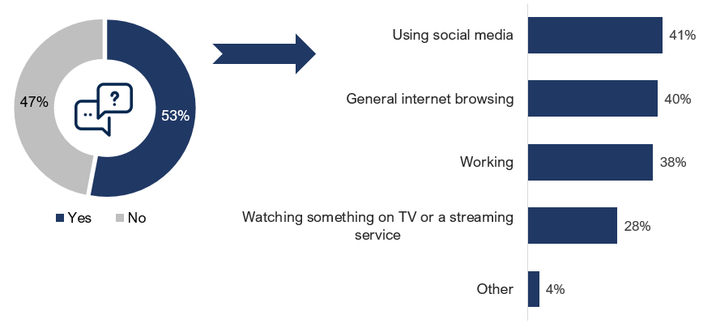
B12. Were you doing anything else at the same time as the live chat? Base: Contacted provider by live chat n=261
B13. What were you doing? Base: Was doing something else while on the live chat n=138
Young people aged 18-34 were significantly more likely to have been doing something else while on their live chat (61%), and that something else was more likely to be social media (54%).
Men were significantly more likely to indicate they were working while on the live chat (48%), than women (31%).

Other contact methods

Number of contacts via other methods
Over half of those who visited a store (53%) or filled in a web-form (56%) only did so once to contact their provider about their issue. Whereas, nearly one quarter used social media (24%) or crowd support (23%) four or more times to contact their provider.
Figure 12: Number of times contacted by method
2.7
2.4
2.6
1.9
1.9
Average
B4. How many times did you contact [PROVIDER] about your most recent issue via…? Base: Displayed on chart

There were no significant differences by provider or demographic subgroup.

Time spent on other contact methods
The average time spent using these contact methods varied greatly. Visiting a store took the longest on average, while considerably less time was spent on social media than any other method.
Table 3: Average time spent using other contact methods
Method | Average time spent
In person at a store (n=101) | 32:05
Email (n=142) | 19:08
Web-form (n=88) | 18:08
Crowd support / community help forum (n=47) | 15:11
Social media (n=40) | 13:08
B5. And approximately how long in total did you spend contacting your provider via…? Base displayed in table.

Issue resolution
The vast majority (84%) of issues were resolved, while 9% are currently ongoing.

Figure 13: Issue resolved

B14. Was this issue with [PROVIDER] ever resolved? Base: All respondents n=1,035

Among the issues on NBN services, 83% were resolved and 10% were ongoing at the time of survey.
Of concern, respondents with a disability or impairment were significantly less likely to have had their issue resolved (77%).
Issue resolution did not vary significantly by provider.

Conclusions
This research has calculated the average time it takes for consumers to contact their telecommunications provider in order to resolve an issue.
Consumers remain subjected to long wait times when contacting their provider, particularly via phone. Consumers who phoned their provider to resolve an issue, spend over half (52%) of the call time on hold. In addition to this, on average, they need to call their provider 2.4 times before an issue is resolved. This equates to an average total time of 65 minutes and 5 seconds spent on the phone with their provider, to resolve one issue.
Considering that calling is the most popular means of contact and the preferred method of many consumers, the time it takes to resolve an issue via phone represents an enormous amount of time forgone.
In comparison, those who contacted their provider via live chat spent half the time of those who used phone. The total time spent on live chat was 37 minutes and 2 seconds, split over 2.3 chat sessions.
The survey revealed significant differences between young people and older people when resolving a telecommunications issue. Young people are more likely to have an issue with their mobile service, less inclined to contact their provider by phone and carry out other tasks whilst contacting their provider. Older people are more likely to have issues with their fixed line internet service or their landline.
The results were fairly uniform amongst retail providers; the number of calls it took to resolve an issue did not vary significantly between retail providers. However, calls to Vodafone were significantly shorter compared to other retailers. The number and length of live chat conversations did not vary significantly by provider either.
There was some variation between retailers and how consumers contacted them. For example, Optus customers were more likely to use live chat as a contact method and use two types of methods of contact. Vodafone customers were more likely to go into a store to resolve an issue compared to other retailers. TPG/ iiNet customers were more likely to contact their provider using one method only.

Areas for further research
The results show that when consumers use live chat, it takes less time and is more effective than phoning a provider. More research is required to understand the reasons behind this. Are consumers using different means of contact depending on the complexity of their issue or is it simply a preference to one method over another? If it is possible to resolve complex issues over live chat, and this can be done quicker, perhaps more could be done to encourage consumers to use this particular method of contact. If only complex issues can be solved by talking over the phone, this highlights the need to reduce phone call wait times.
The results highlight how much time consumers spend trying to resolve a telecommunications issue. Analysis is necessary to quantify the economic cost this creates. Being able to quantify the cost of time in this way will be a useful measure of consumer harm caused by poor customer service.
Lastly, it is not only consumers who are harmed by time wasted trying to resolve an issue, but small businesses as well. Future research should explore the impacts of time wasted trying to resolve a telecommunications issue for small businesses.

Appendix: Questionnaire
SURVEY INTRODUCTION
[ALL] Thank you for agreeing to participate in this research project. The survey should take no more than 10 minutes to complete.
Please take your time completing the survey. Read each question carefully and follow the instructions provided to record your responses. Please use the buttons at the bottom of each page to move through the survey, do not use the back or forward buttons in your browser.
We would like to remind you that there are no right or wrong answers – it’s your own thoughts and opinions that matter.
All the answers that you provide will be treated as confidential with results only reported on in a de-identified and aggregated format.
Please click on “next” to enter the survey.
SCREENER
To start, we would like to ask some questions about you.
ASK ALL
- Please indicate your gender…[S/R]
- Male
- Female
- Other
- Prefer not to say
ASK ALL
- Which of the following age brackets do you belong in? [S/R]
- Under 18 - TERMINATE
- 18-24
- 25-34
- 35-44
- 45-54
- 55-64
- 65+
- Prefer not to say- TERMINATE

ASK ALL
- Please enter your postcode…[O/E]
HIDDEN QUESTION – RECODE A3 INTO A4
- Location classification
- Sydney
- Rest of NSW
- Melbourne
- Rest of VIC
- Brisbane
- Rest of QLD
- Perth
- Rest of WA
- Adelaide
- Rest of SA
- Tasmania
- NT
- ACT
ASK ALL
- Which if any of the following types of telecommunications services do you have? Please select all that apply. [M/R]
- Landline phone
- Mobile phone - not including satellite phones
- Satellite phone
- Fixed line internet service - where internet access is received via a physical line or cable connecting your home to the Internet
- Fixed wireless internet service - where internet access is received via an antenna on your home
- Fixed satellite internet service – where internet access is received via a satellite dish on or nearby your home
- Mobile internet service - where internet access is received via a portable wireless device (3G/4G modem or laptop dongle/adapter) and not including mobile data simply accessed via your mobile phone
- None of the above TERMINATE
ASK ALL
- For each of the services you have – are you the one who contacts your provider about any questions or problems with your service?
POPULATE LIST ONLY WITH THOSE RESPONSES CODED AT A5 – S/R PER ROW | Yes | No
- Landline phone | 1 | 2
- Mobile phone - not including satellite phones | 1 | 2
- Satellite phone | 1 | 2
- Fixed line internet service | 1 | 2
- Fixed wireless internet service | 1 | 2
- Fixed satellite internet service | 1 | 2
- Mobile internet service | 1 | 2
TERMINATE IF A6=2 FOR ALL CODES
ASK ALL
- For the [INSERT A5 SERVICE], service you have, who is your provider? – If you have more than one of a given service with different providers, please indicate all providers.
 | POPULATE COLUMNS ONLY WITH THOSE RESPONSES CODED YES @A6
 | Landline phone [S/R] | Mobile phone [M/R] | Satellite phone [M/R] | Fixed line internet service [S/R] | Fixed wireless internet service [S/R] | Fixed satellite internet service [S/R] | Mobile internet service [M/R]
- Activ8me | 1 | 2 | 3 | 4 | 5 | 6 | 7
- ALDI Mobile | 1 | 2 | 3 | 4 | 5 | 6 | 7
- Amaysim | 1 | 2 | 3 | 4 | 5 | 6 | 7
- Aussie BroadBand | 1 | 2 | 3 | 4 | 5 | 6 | 7
- Belong | 1 | 2 | 3 | 4 | 5 | 6 | 7
- Boost Mobile | 1 | 2 | 3 | 4 | 5 | 6 | 7
- Dodo / iPrimus | 1 | 2 | 3 | 4 | 5 | 6 | 7
- Exetel | 1 | 2 | 3 | 4 | 5 | 6 | 7
- MyRepublic | 1 | 2 | 3 | 4 | 5 | 6 | 7
- Optus | 1 | 2 | 3 | 4 | 5 | 6 | 7
- Skymesh | 1 | 2 | 3 | 4 | 5 | 6 | 7
- Southern Phone | 1 | 2 | 3 | 4 | 5 | 6 | 7
- Telstra | 1 | 2 | 3 | 4 | 5 | 6 | 7
- TPG / iiNET | 1 | 2 | 3 | 4 | 5 | 6 | 7
- Vodafone | 1 | 2 | 3 | 4 | 5 | 6 | 7
- Other | 1 | 2 | 3 | 4 | 5 | 6 | 7
ASK ALL
- Between February 2019 and February 2020 which, if any, of your providers did you contact with a problem or issue relating to your service (e.g. service interruptions, outages, installations, incorrect billing etc.)
Please do not include any contact made during March 2020 as the COVID-19 pandemic has impacted the response times of customer service centres.

POPULATE ROWS ONLY WITH THOSE RESPONSES CODED AT A7  S/R PER ROW | Yes | No | Don’t know
- Activ8me | 1 | 2 | 3
- ALDI Mobile | 1 | 2 | 3
- Amaysim | 1 | 2 | 3
- Aussie BroadBand | 1 | 2 | 3
- Belong | 1 | 2 | 3
- Boost Mobile | 1 | 2 | 3
- Dodo / iPrimus | 1 | 2 | 3
- Exetel | 1 | 2 | 3
- MyRepublic | 1 | 2 | 3
- Optus | 1 | 2 | 3
- Skymesh | 1 | 2 | 3
- Southern Phone | 1 | 2 | 3
- Telstra | 1 | 2 | 3
- TPG / iiNET | 1 | 2 | 3
- Vodafone | 1 | 2 | 3
- Other | 1 | 2 | 3
IF CODE 2 or 3 ALL PROVIDERS @ A8 - TERMINATE
ASK IF CODE 1 TO TWO OR MORE @ A8
- And which provider did you contact most recently (before or during February 2020) about an issue? [S/R]
SHOW PROVIDERS SELECTED AT A8

RECODE A8/A9 INTO HIDDEN QUESTION. I.E. USE A8 IF ONLY 1 PROVIDER SELECTED OTHERWISE PROVIDER SELECTED AT A9
HQ1. PROVIDER AUTOFILL
- Activ8me
- ALDI Mobile
- Amaysim
- Aussie BroadBand
- Belong
- Boost Mobile
- Dodo / iPrimus
- Exetel
- MyRepublic
- Optus
- Skymesh
- Southern Phone
- Telstra
- TPG / iiNET
- Vodafone
- Other [SHOW AS ‘your provider’ IN QUESTION TEXT]

MAIN QUESTIONNAIRE

The following questions relate to your most recent issue before or during February 2020 with your provider [INSERT HQ1 PROVIDER].
ASK ALL
SHOW SERVICES SELECTED FOR HQ1 PROVIDER AT A7
- Was this issue related to your…? [S/R]
- Landline phone
- Mobile phone
- Satellite phone
- Fixed line internet service
- Fixed wireless internet service
- Fixed satellite internet service
- Mobile internet service

ASK IF B1 = CODE 1,4, 5 OR 6
- And was the issue about the NBN? [S/R]
- Yes
- No
ASK ALL
- Which method(s) did you use to contact [INSERT HQ1 PROVIDER] about your most recent issue? Please select all that apply. [M/R]
- By phone
- Using a live chat feature on their website or mobile app
- By submitting a web-form on their website
- By posting in their online Crowd Support/community help forum
- By email
- Via social media such as Twitter or Facebook
- In person / in a store
- Some other way (please specify)

- How many times did you contact [INSERT HQ1 PROVIDER] about your most recent issue via…? [O/E]
ONLY SHOW ITEMS SELECTED IN B3
Please enter number
[MAX RANGE 1-10]
If you don’t know/can’t remember please leave the box blank
1 | Phone
2 | Live chat
3 | Web-form
4 | Crowd Support/community help forum
5 | Email
6 | Social media
7 | In person / in a store

- And approximately how long in total did you spend contacting [INSERT HQ1 PROVIDER] via…? [O/E]
ONLY SHOW ITEMS SELECTED IN B3 3-7
Please enter the number of minutes and/or seconds into the box. Please leave the minute or second box blank if the answer is 0, or if you don’t know/cannot remember.
 |  | MINUTES  [MAX 300] | SECONDS  [MAX 60]
3 | Web-form
4 | Crowd Support/community help forum
5 | Email
6 | Social media
7 | In person / in a store

ASK IF B3=1
SHOW B6 AND B7 ON THE SAME PAGE

- Thinking about your most recent phone call with [INSERT PROVIDER], in total approximately how many minutes did you spend on the call? [O/E]
Please enter the number of minutes and/or seconds into the box. Please leave the minute or second box blank if the answer is 0 or if you don’t know/cannot remember.
MINUTES  [MAX 300] | SECONDS  [MAX 60]

ASK IF B6≠9999
- And during this phone call, approximately how much time did you spend on hold, waiting to speak with a customer service representative?
Please note this includes any time spent selecting automated options, being on hold, etc. but does not include time between separate calls or waiting for a call back
Please enter the number of minutes and/or seconds into the box. Please leave the minute or second box blank if the answer is 0 or if you don’t know/cannot remember.

MINUTES  [MAX 300] | SECONDS  [MAX 60]

- Were you doing anything while you were on the phone with [INSERT PROVIDER]? [S/R]
- Yes
- No
ASK IF B8=1
- What were you doing? [M/R]
- Working
- Using social media (e.g. Facebook, Instagram, Twitter, LinkedIn etc.)
- General internet browsing (e.g. reading news, online shopping etc.)
- Watching something either on TV or a streaming service
- Other (please specify)

ASK IF B3=2
SHOW B10 AND B11 ON THE SAME PAGE

- Thinking about your most recent live chat with [INSERT PROVIDER], approximately how many minutes did you spend on the chat? [O/E]
Please enter the number of minutes and/or seconds into the box. Please leave the minute or second box blank if the answer is 0 or if you don’t know/cannot remember.
MINUTES  [MAX 300] | SECONDS  [MAX 60]

ASK IF B10≠9999

- And during this live chat with [INSERT PROVIDER] approximately how long did you spend waiting to to get the first message back from a customer service representative?
Please enter the number of minutes and/or seconds into the box. Please leave the minute or second box blank if the answer is 0 or if you don’t know/can’t remember
MINUTES  [MAX 300] | SECONDS  [MAX 60]

- Were you doing anything else at the same time as the live chat? [S/R]
- Yes
- No
ASK IF B12=1
- What were you doing? [M/R]
- Working
- Using social media (e.g. Facebook, Instagram, Twitter, LinkedIn etc.)
- General internet browsing (e.g. reading news, online shopping etc.)
- Watching something either on TV or a streaming service
- Other (please specify)

ASK ALL
- Was this issue ever resolved with [INSERT HQ1 PROVIDER]? [S/R]
- Yes
- No - the issue is ongoing i.e. still in contact with provider
- No - the issue was never resolved i.e. stopped contacting provider about it

DEMOGRAPHICS

And finally…
ASK IF A5=4, 5 OR 6 (HAS HOME INTERNET CONNECTION)
- Are you connected to the NBN? [S/R]
- Yes
- No
- Don’t know/ not sure
ASK ALL
- Do you have any of the following? [M/R]
- Deafness or hearing impairment
- Blindness or visual impairment
- Difficulty in reading or understanding written materials
- Difficulty in communicating in English
- None of the above / prefer not to say
ASK ALL
- Do you mainly speak a language other than English at home? [S/R]
- Yes (please specify)
- No

                - FINAL CLOSE/TERMINATION
Thank you, you have completed the survey.
As this is market research, it is carried out in compliance with the Privacy Act and the information you provided will be used only for research purposes.
For questions about the Market Research Industry as a whole, you can call the Market and Social Research Society's Survey Line on 1300 364 830.
Please click “SUBMIT” to send your responses

https://accan.org.au/media-centre/hot-issues/1628-please-hold-costing-telco-customer-wait-times (2019)
This is approximately reflective of the proportion of the population with an NBN connection.
Telecommunications Industry Ombudsman (2019). Annual Report 2018-19. https://www.tio.com.au/sites/default/files/2019-09/TIO%20Annual%20Report%202018-19.pdf
Can You Hear Me? Ranking the customer service of Australia’s phone and internet companies (2018) https://accan.org.au/our-work/research/1523-can-you-hear-me-ranking-the-customer-service-of-australia-s-phone-and-internet-companies

