

Pre-paid calling cards: advertising, use and complaints processes in Australia



Funded and produced by the Australian Communications Consumer Action Network (ACCAN)
ACCAN’s activities are supported by funding from the Commonwealth Department of Broadband, Communications and the Digital Economy. Visit www.accan.org.au for more information.
Authored by Erin Turner
Australian Communications Consumer Action Network
Website: www.accan.org.au
E-mail: erin.turner@accan.org.au
Telephone: +61 2 9288 4000
TTY: +61 2 9281 5322

Data for this report was collected by ACA Research
Website: www.acaresearch.com.au

Published in 2013
ISBN: 978-1-921974-13-7.
Cover image: ©iStockphoto.com/accan


This work is copyright, licensed under the Creative Commons Attribution 3.0 Australia Licence. You are free to cite, copy, communicate and adapt this work, so long as you attribute Erin Turner and the Australian Communications Consumer Action Network. To view a copy of this license, visit http://creativecommons.org/licenses/by/3.0/au/
“This work can be cited as: Turner, Erin 2013, Pre-paid calling cards: advertising, use and complaints processes in Australia, Australian Communications Consumer Action Network, Sydney.

Contents

Executive summary 4
BACKGROUND 5
The regulatory environment 5
Past regulatory action and research on pre-paid calling cards 6
Identifying problems with calling cards - are TIO statistics the right indicator? 7
THE RESEARCH 9
Research aims 9
Sample and methodology 9
STAGE ONE: Advertising and the in-store experience 11
Availability of information at point-of-sale 11
Quality of in-store information 11
Quality of online and over-the-phone information 14
STAGE TWO: The user experience 15
Value delivered by cards 15
Advertised and actual rates per minute 17
Terms and conditions 18
Activation and call quality 21
STAGE THREE: Customer service 22
CONCLUSIONS 24
Impact of ACCC enforcement action 24
Alternative regulatory options 25
APPENDIX ONE: Cards tested 29

Executive summary
Pre-paid calling cards allow consumers to purchase credit for phone calls, which they access via a PIN printed on a card. Primarily this product is used to make international calls. This product has received very little attention from regulators and academics.
Complaints statistics from the Telecommunications industry Ombudsman (TIO) are usually used to identify problem products in the telecommunications market but complaints for calling cards remain low. A close examination of qualitative evidence shows that TIO statistics are a poor indication of consumer detriment experienced with pre-paid calling cards due to the nature of the product, difficulty of lodging a complaint and key groups of consumers who use calling cards. Noting a lack of quantitative evidence on calling card advertising, use and customer service, ACCAN commissioned this work to explore the consumer experience of calling cards.
Research was conducted in three stages, built around different stages of the product cycle: point-of-sale, use of the product and complaints mechanisms. ACCAN commissioned ACA Research, a market research consultancy company, to conduct market research, product testing and desk research for this project, with ACCAN staff compiling the research that makes up this report.
Findings show that consumers looking to buy a pre-paid calling card are essentially participating in a lottery. With little quality information available at the point-of-sale there is a chance that they will purchase a good quality card which offers hundreds of minutes of talk time but it is more likely that they will end up with a card that offers poor value for money.
Key findings include:
- Only 28% cards had any sort of in-store information about rates, terms and conditions. Only 17% of cards had easy-to-find information in stores.
- 94% of salespeople could not give the customer any information about calling rates, 100% of salespeople could not provide information about terms and conditions.
- 40% of cards had significant quality problems including failure to activate, poor call quality and instances where the number of minutes provided was significantly less than the number advertised.
- No cards’ actual rate per minute matched the advertised headline per-minute rate. The average actual rate per minute was 46.78 cents with an average of 22.04 cents difference between the advertised and the actual rate.
This research paints a picture of a market in need of intervention.
The non-compulsory Pre-Paid Calling Card Industry Guideline has failed to protect consumers and sporadic ACCC enforcement action, while effective in some ways, is insufficient to ensure that all calling cards advertise products in a clear manner. The final section of this paper explores alternative regulatory options, drawing on international examples in the hope of starting a discussion about the best way to move forward.
Ultimately, the market should work well not just for consumers but also for calling card providers who offer quality products. Currently it is difficult for consumers to identify some of the cards on the market which offer exceptional value, sometimes greater value than online VoIP products, with simple terms and conditions.

BACKGROUND

The regulatory environment
The current regulatory landscape for telecommunications is complex, with responsibility for various sections of the industry shared between a government department, two regulatory bodies, an industry ombudsman and an industry peak body.
Consistent with the policy commitment to self-regulation, programs tend to be the responsibility of industry with oversight from regulators. One regulator, the Australian Competition and Consumer Commission (ACCC), is an independent statutory authority which, under the Competition and Consumer Act 2010 (previously Trade Practices Act 1974) has some powers relevant to telecommunications and general responsibility for competition issues. The other regulator is the Australian Communications and Media Authority (ACMA), whose scope and purpose is laid out in the Telecommunications Act 1997 and Telecommunications (Consumer Protection and Service Standards) Act 1999. The ACMA is responsible for overseeing technical and consumer issues, often taking a “co-regulatory” approach through approving and overseeing industry codes. Within the self-regulatory scheme the industry peak body, the Communications Alliance, uses working groups to develop industry codes and guidelines. The ACMA is able to register codes but also has the power to create an industry standard if codes are lacking; compliance with an industry standard is mandatory.
Looking at international comparisons, Australia has created a relatively strong regulatory system for telecommunications in a stable and transparent political environment. Still, government departments, regulators, consumer groups and some industry members have identified significant systemic problems resulting from current regulation. This has been most recently canvassed in the ACMA’s Reconnecting the Customer inquiry, which criticised the quality of customer care, confusing and misleading products, confusing billing systems and poor internal complaints processes. The Chair of the ACMA, Chris Chapman, has stated that this inquiry took place because ''It was an overt intent to … redress the deficiencies of the current [consumer protection] code where, frankly, the telcos had taken their co- and self-regulatory rights for granted.”
In September 2012, the ACMA registered a new version of the Telecommunication Consumer Protection (TCP) Code. This is the primary document regulating telecommunications services and the ACMA can direct Carriage Service Providers (CSPs) to comply with the code.
Consumer advocates have argued that industry codes are often insufficient to protect consumers because they lack significant enforceability and compliance measures that would require all service providers to play by the rules. Compliance with most industry codes is technically voluntary. The ACMA can issue warnings about code breaches and directions to comply but this takes a significant amount of time and has little commercial impact.

Past regulatory action and research on pre-paid calling cards
The ACCC has initiated and won three federal court cases against specific pre-paid calling card providers for misleading and deceptive advertising. These actions have focused on headline advertising claims including that cards had “flat rates” or “service fees”, which implied that no fees other than minimal timed call charges applied when this was not the case.
Prior to ACCC initiated legal action, no industry-developed initiative existed for pre-paid calling cards. In 2009 peak industry body Communications Alliance facilitated the creation of an industry guideline, a non-mandatory document with no legal effect. The Industry Guideline for Pre-paid Calling Cards was developed by just two industry members, GoTalk and Telstra. The Guideline aims to establish a base line of information needed so that customers will have “sufficient information enabling them to make informed decisions about the costs and benefits of using any particular Calling Card.”
There is no formal record of the number of businesses offering pre-paid calling card services but there are hundreds of different products supplied by many providers. There does appear to be some consolidation in the market, as three of the largest providers of calling cards, Card Call, World Telecom and Tel.Pacific, are owned by a single parent company, GoTalk. As the industry is not actively monitored by a regulatory body, it is unknown if all providers are aware of the guideline, let only comply with it.
The TCP Code applies to pre-paid calling card services. Still, the ACMA has taken very limited action against calling card providers. In 2007 the ACMA worked with the TIO to warn consumers about calling cards sold by Global Networks, a company that failed to comply with the TIO scheme. Other than this, the ACMA has taken no enforcement or compliance action against calling card providers.
Consumers using calling cards are able to use the Telecommunications Industry Ombudsman (TIO) scheme for external dispute resolution if their service provider does not resolve a complaint to their satisfaction. However, it must be noted that, while all CSPs supplying telecommunications services are required to be members of the TIO scheme, in practice many small or emerging providers have not yet become TIO members. A consumer will not be able to use the TIO until the CSP they are complaining about joins the TIO Scheme.
Other than sporadic attention from the ACCC, regulators have paid little attention to calling cards. This should be rectified because, as outlined below, key groups of vulnerable consumers rely on the product. Pre-paid calling cards also deserve more regulatory attention because of the nature of the product and widespread sales. With cards available in newsagencies, convenience stores, supermarkets and a range of general stores around the country, they are more widely available than mobile and landline phone products. Due to lax regulatory arrangements, it is extremely easy for new providers to enter the calling card market, increasing the chance of fraudulent or poor quality products.

Identifying problems with calling cards - are TIO statistics the right indicator?
Regulators and industry typically use complaints data from the TIO to identify issues with telecommunications products. A spike in complaints for certain services has resulted in threats of more active regulation or specific industry-led measures to reduce complaints.
Complaints made to the TIO about pre-paid card services are low in comparison to other service types. They have dramatically decreased in the past three years, from 667 new complaints in 2008-09 to only 163 new complaints in 2010-11.
It is common practice for regulators to rely on TIO statistics as a basis for further regulatory action but in the case of calling cards, this is not appropriate. TIO complaints data is not an accurate indication of detriment experienced by consumers using calling cards because of the nature of the product, general difficulty consumers experience making complaints and the behaviour and attitudes of key groups of consumers.
Firstly, TIO complaint numbers are low because of the nature of the product. While some products offer instant top-up services when credit is depleted, most calling cards are pre-paid products requiring a small cash outlay. If a product is faulty or offers poor value consumers may find it easier to try a different product rather than complain. This difficulty is compounded as most cards do not provide a transparent breakdown of how credit is exhausted, for example, with an itemised bill, so it can be difficult for a consumer to identify in what ways a product may be faulty. This is supported by qualitative evidence; researchers studying the use of telecommunications services amongst refugees found that many users had problems with calling cards but, instead of complaining, they tried different cards or talked to friends or family about better cards to try.
“Any one I buy if it [the calling card] does what I want it to do then I’ll buy it. If it doesn’t do the job I want it to do, I don’t buy it... If it doesn’t work I change it... Sometimes in Call Mama [the calling card] just they hang, just after one minute it finished.”
- Quote from participant in the Mind the Gap research project

It is well established that TIO complaints are significantly more likely to come from resilient consumers. The majority of people who lodge a complaint with the TIO have contacted the service provider about the problem more than six times over a period of three months, with over 20% of all complainants spending more than nine hours trying to resolve their complaint before escalating it to the TIO. As few as one in twenty consumers lodge complaints at all because they believe complaining won’t work or they don’t want to engage in what they perceive to be a difficult process.
Finally, specific groups are less likely to engage in complaints processes. Recent migrants, refugees and people from Culturally and Linguistically Diverse (CALD) backgrounds are regular users of phone cards. These groups are classified by regulators and the TIO as vulnerable. These consumers face language barriers that make understanding complex product conditions and accessing complaints services very difficult. They have a relatively low awareness of external dispute resolution schemes like the TIO and are more likely to switch products than formally complain. Consumers who come from cultures that emphasise collectivism over individualism are even less likely to complain. In addition, these consumers seem to regularly face problems with phone card products. Problems identified through qualitative research include not receiving the number of minutes advertised or expected, getting cut off from calls, recharges not working, issues with the quality of calls and difficulty lodging complaints.

THE RESEARCH

Research aims
Based on the evidence outlined above and the lack of other quantitative data on pre-paid calling cards, ACCAN identified a need for further research. ACCAN worked with ACA Research to examine the consumer experience with pre-paid calling cards. The research was inspired by Ofcom’s International Calling Cards Evaluation report.
This research project aimed to determine if pre-paid calling cards are working well for consumers. The research objectives were to determine if:
- terms and conditions are made easily available to consumers
- the service provided is of a reasonable quality
- products offer the number of minutes advertised
- complaints mechanisms are easy to use when something goes wrong
Ultimately, it was hoped that research could indicate if current regulatory measures were protecting consumers of calling cards.

Sample and methodology
Three research methods were used in combination: mystery shopping, product testing and market research (desk-based research). The research was conducted in three stages, built around different stages of the product cycle: point-of-sale, use of the product and complaints mechanisms. ACCAN commissioned ACA Research, a market research consultancy company, to conduct mystery shopping, product testing and some market research. Other market research was completed by ACCAN staff. Data was collected from August to November 2012.
For the first stage, researchers were instructed to purchase a statistically significant number of different $10 pre-paid calling cards from a cross-section of providers in the market. Providers covered by the research were CardCall,Tel.Pacific, World Telecom, Pre Paid Services (PPS) and a sample of independent providers.
100 callings cards were purchased from 30 different stores across 11 different suburbs in Sydney. Multiple store types were represented in the research including newsagents, supermarkets, tobacconists, convenience stores, DVD rental stores and telecommunications specialty outlets. Suburbs covered by the mystery shopping exercise were Blacktown, Bondi Junction, Broadway, Campsie, Chatswood, City (Central Sydney), Haymarket, Hurstville, North Sydney, Parramatta and Ultimo.
Mystery shoppers recorded if terms and conditions for the card were available in store via posters, leaflets or from information from salespeople. Where possible, researchers took copies or photographs of the leaflets and posters in-store. While 100 individual calling cards were purchased, two cards of each brand were purchased to prepare for the second stage of research. A full list of all cards can be found in appendix one.
The second stage of the research focused on the use of calling cards, assessing the quality of service and if claims made matched the rates advertised on official calling card websites. Researchers exhausted the credit of the calling cards by calling overseas, measuring the number of minutes delivered, quality of the call and any issues (problems with card activation or call drop outs). With the two cards of each brand that had been purchased in stage one, each brand of card was used to call the same country with one card dedicated to making long calls (over 30 minutes) and the other card dedicated to making short calls (under 10 minutes), allowing researchers to measure if additional fees (disconnection fees, charging blocks etc) used credit quickly. In order to make accurate comparisons, all calls were made from mobile phones to mobile phones and each card was used to call only one country. Where possible, cards marketed for calls to particular regions of the world were tested by calling that region. For example, the China Gold was tested with calls to China, the Hello South America card was tested with calls to Chile.
In the final stage, researchers tried to contact 32 different customer service lines to enquire about card problems. Researchers used problems identified in the second stage of research, these included cards which were unable to be activated and the number of minutes promised being drastically different from the advertised rate. Researchers assessed the customer service experience, examining how easy it was to contact customer service, the service received and the quality of any resolution offered.

STAGE ONE: Advertising and the in-store experience
Highlights:
- Little reliable information is available at point of sale; the current system relies on consumer knowing the best card for them before purchase.
- When available, the quality of information in print material can be poor with headline claims contradicted by fine print terms and conditions.
- Information available about terms and conditions can be difficult to access online or via calls to customer service.

Availability of information at point-of-sale
While purchasing 100 pre-paid phone cards at different stores across Sydney, mystery shoppers recorded what kind of information, if any, was provided to them at the point-of-sale. In 10% of cases a leaflet was available and in 20% of cases a poster was displayed in store. In two cases both a poster and leaflet was available, so print information about terms and rates was only available for 28% of cases and unavailable for 72% of cases.
As seen in image one, 17% of the time information was easy to find – posters were displayed at a level where fine-print was easy to read or leaflets were on display. In 11% of cases information was difficult to find, meaning that either information on posters was unreadable or that leaflets had to be requested.

Quality of in-store information
When information was provided, high-level claims on advertising could be contradicted by terms and conditions in the fine print. Table Three shows that posters would claim in large print, for example, that a calls were charged at a “flat base rate” but in the fine print state that “a disconnection fee of 50 cents applies to all calls with a duration longer than 3 minutes” and list other conditions that a consumer may not expect to apply to a “flat base rate” product.
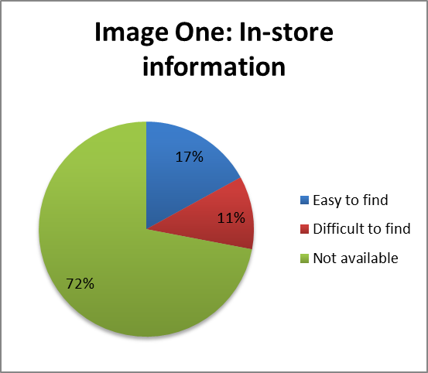

Table One: Headline claims and fine print conditions on in-store advertising
Card | High level advertising claim | Fine print condition
Anahaw (poster) | Flat base rate. No connection fee. | A 8 cents daily service fee applies  Disconnection fee of 50 cents applies to all calls with a duration longer than 3 minutes  A 35% assessment fee applies to all fees and charges on calls with a duration longer than 10 minutes  All calls incurs a 10 cents surcharge after 2 minutes except Philippines Mobile where it is 60 cents after 2 minutes
Bayani (poster) | No connection fee. No daily service fee. | All calls incur a 60 cents surcharge after 2 minutes.
Daybreak (poster) | Our promise – no surprises. Honest rates. No connection fee. No daily service fees. | All calls are charged in periods of 4 minutes.  All calls incur a 25 cent surcharge after 5 minutes  At peak times a surcharge of 4 cents per minute applies (off-peak rates apply from 2am-6am).
Oasis (leaflet) | Our promise – no surprises. Honest rates. No connection fee. | All calls incur a 20c surcharge every 10 minutes and countries marked with the following symbols incur surcharges after 1 minute: >40c, *80c  Calls are charged in blocks of 1 minute then subsequent 12 minute periods  50c service fee applies every 2 days after first use
WorldTalk (poster) | No connection fee. No tricks or catches. No extra fees. | 1300 & 1800 Australia wide access numbers available (5c per minute & 20c per minute surcharge apply)  All calls rounded up to the next 5 cents  Calls are charged in blocks of 1 minute, then subsequent 5 minute periods

Advertising was often out-of-date, with posters and leaflets dated from 2007-2012. There appears to be a widespread failure of service providers to update and replace any out-of-date advertising material within three months, as recommended by the Industry Guideline.
In one case, mystery shoppers found a copy of a “Hello China” calling card poster from 2007. This same poster was found to be false, misleading and deceptive in the Australian Competition & Consumer Commission v Tel.Pacific Limited (2009) Federal Court case. The judgement required that Tel.Pacific “take all reasonable steps to effect the removal from display and further publication by all retailers” of the advertising material.
Mystery shoppers recorded any information provided by the salesperson at the point-of-sale. Generally, salespeople could only provide generic information such as what cards sold well. In 6% of cases the salesperson was able to provide generic information about call rates, specifically that cards may not offer as many minutes as claimed by advertising. In 2% of cases the salesperson warned the purchaser that calls from mobiles may be more expensive than calls from landlines and in 5% of cases the salesperson provided information about the card expiry date.
In 100% of cases the salesperson did not provide any information about connection fees or additional charges. Instead, in 46% of cases salespeople directed shoppers to a website for card terms and conditions.
The Industry Guideline states that product terms must be available on at least a website and via a toll free (1800) number and details of where complete terms can be found must be included in any advertising material. Information printed on the physical plastic cards or receipts provided after purchase did not include terms and conditions but in most cases, cards provided a website and a customer service (1300) number where a consumer could access up-to-date full terms and conditions. One card provided only a website to access further information, five cards only provided a number to call for further information and six cards provided no indication of what to do to access accurate terms and conditions but did list a phone number and website in other contexts.
Two Federal Court rulings have ordered that certain calling cards contain specific information on the card provided to consumers at the point of sale, requiring that a number and website be made available to provide full terms and conditions. In Australian Competition & Consumer Commission v Tel.Pacific Limited (2009) the Federal Court required the following statement to be printed prominently on cards for one year: “Timed charges and other fees apply to calls using this card. For further details please call customer service or visit www.telpacific.com.au” When ACCAN examined cards covered by this ruling, it was found that statements directing consumers to further information deviated from the Federal Court mandated statement. The Hello China card noted on the back of the card that “Timed charges and other fees may apply to calls using this card” and on the front of the card was “For enquiries, please call 1300 369 888 or visit www.telpacific.com.au.” The Hello Middle East Card only had the warning on the back of the card that “Terms and conditions apply. Please call customer service 1300 652 184.” While the requirement that cards display the information statement provided by the Federal Court has expired, it is disappointing that Tel.Pacific has reverted to poorer practices, making it more difficult for consumers to locate accurate terms and conditions.

Quality of online and over-the-phone information
It may be practically difficult to find out about terms and conditions by calling a customer service number. ACCAN staff randomly selected four cards and called customer service for card terms and conditions. In two cases the caller navigated an automated phone system only to be disconnected when transferred to a live customer service representative. In one case, the customer service line was not functional. In only one case was the caller able to contact a customer service representative and receive accurate information about terms and conditions.
It can be equally difficult to access card terms and conditions online. A simple Google search of a card will often lead to the top search results linking to a sales website rather than the official card website. In assembling results, ACA researchers found that terms and conditions on unofficial sales sites were out-of-date or contradicted details on official sites. Some consumers will have difficulty finding accurate information about terms and conditions online; this is reflected in the complaints escalated to the TIO.
Further consideration also needs to be given to whether websites are the most appropriate way to communicate with consumers using calling cards. With the proliferation of online communications methods, from email to VoIP face-to-face call services, consumers with internet access and computer skills are able to communicate very cheaply or for free with people from all over the world. It’s hardly surprising that over four million Australian households have a VoIP service in the home and 78% of consumers used the internet to communicate (using email, messaging or VoIP services) in June 2012. But a sizeable proportion of Australians are not frequent users of the internet. As of June 2012, 7% of Australians had never used the internet and 12% of Australians went online less than once a month. Low-users of the internet are more likely to have low annual incomes. Given the low-cost of using online communications services, it is likely that regular users of calling cards are low or non-users of the internet. This makes it even more important that clear, accurate information for calling cards is available at the point-of-sale.

STAGE TWO: The user experience
Highlights:
- Some cards provide excellent value, others offer very poor value.
- There are a number of hidden fees and charges that eat up card credit, especially if more short calls are made or if calls are made over a number of days.
- Call quality can vary. Researchers reported calls getting disconnected and noise in the background of calls.
The second stage of the research focused on the user experience of calling cards, testing exactly how much credit was provided by cards in a typical-use situation and the quality of calls. With two cards of each brand that had been purchased in stage one, each brand of card was used to call the same country with one card dedicated to making long calls (over 30 minutes) and the other card dedicated to making short calls (under 10 minutes).

Value delivered by cards
On average, cards delivered 88.90 minutes of call time for $10. There was extreme variation in the total number of minutes delivered before call credit was exhausted. At the high end, the Great Aussie Calling Card provided the tester with 491 minutes of calling time but several cards delivered two to five minutes of calling time. 7% of cards delivered zero minutes of value due to activation or technical faults. Image Two shows the variation in the total number of minutes delivered by different cards, with the blue diamond symbols representing cards tested with the long-call method and the red square symbols representing cards tested with the short-call method. Most cards (65%) delivered below 50 minutes of call time, a fair amount of cards (28%) delivered between 50-300 minutes of call time and a very small number of cards (7%) delivered over 300 minutes of call time.
The average number of minutes delivered for cards tested using the short-call method was slightly lower, 77.18 minutes, than those tested using the long-call method, 88.18 minutes. Generally, cards using the long-call method delivered more value than the same card used to call the same country using the short-call method. Table Two shows that in 72% of cases, the same card would deliver better value if long calls were made. In must be noted that for 4% of cards, the total call time for long and short calls was equal because both cards delivered zero minutes of talk time. As well as measuring the number of minutes delivered, researchers recorded the number of calls they were able to make with each $10 card. Again, results varied significantly, from 0 to 67 calls placed per card. On average, researchers made 3.36 calls from cards tested with the long-call method and 9.7 calls made from cards using the short-call method.
Table Two: Value of cards by short or long call method
Significantly better value to make short calls | 10%
Better value to make short calls | 12%
Exact same value delivered for short and long calls | 6%
Better value to make long calls | 48%
Significantly better value to make long calls | 24%
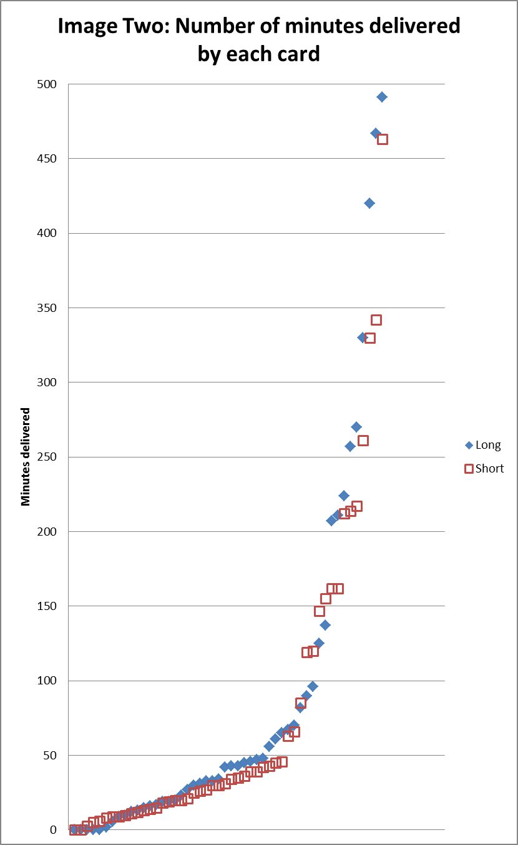

Advertised and actual rates per minute
Part of the variation in call time delivered can be explained by the difference in rates offered to call different parts of the world. Researchers looked at the most up-to-date rates for cards on the official provider website and found that the average advertised rate for cards tested in the project was 23.89 cents per minute but, again, there was a great deal of variation. Some cards advertised rates as low as 0.1 cents per minute while others advertised $1.60 per minute for calls. Very broadly, the cards examined advertised cheaper rates to call Asia but more expensive rates for other areas, such as Africa and Europe.
Advertised rates varied dramatically even within the same region. For example the Hello Africa card advertised rates of 27.72 cents per minute but the It’s Green card advertised rates of $1.60 per minute to call a mobile phone number in Ghana.
After exhausting call credit, researchers calculated the “actual rate” per minute delivered by dividing the total value ($10) by the total number of minutes delivered. No cards actual rate per minute matched the advertised headline per-minute rate. The average actual rate per minute was 46.78 cents with an average of 22.04 cents difference between the advertised and the actual rate. Cards tested with the long-call method were more likely to deliver actual rates closer to the advertised rate than those tested with the short-call method.
The cards with the lowest and highest difference between the advertised (online) and actual rate can be seen in Table Three. Cards with little difference between the advertised and actual rate tended to also provide more calling time. The difference between advertised rates was very small for the best performing cards, from 0.04 of a cent to 1.36 cents difference. The Genuine Aussie Phonecard deserves special mention as the only card which performed well using the long and short call method. This card has no connection, disconnection or service fees and charges in one minute blocks. It also delivered exceptional value – at an actual rate of 2.04 cents to call a USA mobile number, it is cheaper to use the Genuine Aussie Phonecard than some online calling services like Skype.
Table Three: Cards with the smallest and greatest difference between the advertised and actual rate per minute.
Best cards | Calling method | Number of minutes delivered | Advertised rate (cents) | Actual rate (cents) | Difference (cents)
The Genuine Aussie | Long | 491 | 2 | 2.04 | 0.04
The Genuine Aussie | Short | 463 | 2 | 2.16 | 0.16
Go Bananas | Long | 33 | 29.9 | 30.30 | 0.40
Hot | Long | 137 | 6.5 | 7.30 | 0.80
Click | Short | 217 | 3.63 | 4.61 | 0.98
Yes Optus | Long | 43 | 21.9 | 23.26 | 1.36
Worst cards | Calling method | Number of minutes delivered | Advertised rate (cents) | Actual rate (cents) | Difference  (cents)
Say G’Day | Short | 2.5 | 160 | 400 | 240
Greek City | Short | 5 | 50 | 200 | 150
Ozcall | Short | 6 | 49 | 166.67 | 117.67
Call Mama | Short | 8.32 | 16.5 | 120.19 | 103.69
Rate Saver | Short | 9 | 46 | 111.11 | 65.11
Talk Tomato | Short | 14 | 18.1 | 71.43 | 53.33

In 23% of cases the number of minutes provided was significantly less than the number expected based on headline advertised rates. Cards that performed poorly in this test tended to have complex terms and conditions which exhausted card credit quickly, for example, the Call Mama card has the following terms and conditions:
- All call charges rounded up to the next 5 cents
- All calls are charged in blocks of 15 minute/s. Minimum charge of 1 minute/s.
- 75c every 2 days Service Fee applies
- All calls incur a 20c surcharge after 1 Minute, except those marked with a
~ which incur a $1.5 surcharge after 1 Minute
^ which incur a $1.2 surcharge after 1 Minute
* which incur a 50c surcharge after 1 Minute
# which incur a $1.25 surcharge after 1 Minute
- All calls incur a $2 surcharge applied after 4 Minute/s.
Some researchers recorded instances where the calling card phone system calculated the number of minutes that were left prior to a call connection. Sometimes these calculations were extremely inaccurate:
“When I first dialed, I got a message saying my balance is 89 min, I made 5 calls in total and the total number of minutes I got was 31 which is much less than promised.”
- ACA researcher testing the Supersaver card.

Terms and conditions
Terms and conditions made a significant difference to the total value delivered. There was no one condition that applied to every card, meaning that consumers could not predict what complex conditions would apply. There are no consistent industry practices for pre-paid calling cards.
48% of cards applied a daily service charge or fee. In some cases, the service fee was relatively low. For example, the Call Everywhere card charged 6 cent service fee every two days. However, six cards charged service fees so high that $10 worth of credit would have been used up in daily service fees well before the three month credit expiry period. Table Four outlines these cards.
Table Four: Cards with service/administrative fees that negate credit expiry period
Card | Service fee | Credit expiry period | Time it would take to exhaust $10 credit in only service fees
Hot | 50c every 2 days | 3 months | 40 days
Oasis | 50c every 2 days | 3 months | 40 days
Talk Tomato | 50c every 2 days | 3 months | 40 days
Call Mama | 75c every 2 days | 3 months | 28 days
Hello Middle East | 20¢ charged on the day of first used and every 1 day thereafter | 3 months | 50 days after first use
Islander Talk | 20¢ charged on the day of first used and every 1 day thereafter | 3 months | 50 days after first use

78% of cards rounded up call charges rather than charging the exact per minute rate. Most of these cards rounded all calls up to the nearest five cents, even when headline rates were half a cent per minute. 4% of cards rounded all calls up to the nearest 10 cents. The Call Everywhere card had the exceptional rounding condition where all calls were ”billed with additional 120 seconds on top of actual duration after 60 seconds of call.”
In some cases, cards included highly unusual terms and conditions that appeared to be unique to that product. Examples include:
- The maximum call duration is one hour (Ratesaver card)
- Rates shown are off peak 2am – 6am AEST. All calls incur a 0c Surcharge during peak times, except those marked with the following which receive:
* 4c per minute during peak times
^ 7c per minute during peak times
# 14c per minute during peak times
~ 22c per minute during peak times (Day Break card)
- All rates displayed are available during the Off Peak times of 1am to 6am. Outside of these terms a surcharge applies per minute (surcharge not specified, Pay Peanuts card).
38% of cards applied a disconnection fee. The rates for disconnection fees varied significantly and applied to calls of different lengths. For example, the Hello Africa card applied applied a 15 cent disconnection fee for calls over ten minutes but the Call Islander card applied a 94 cent disconnection fee for calls over five minutes.

58% of cards applied flagfall or surcharge fees. Fees varied significantly and applied at different, seemingly random, points of a call. Some charges applied instantly to all successful calls (a typical flagfall surcharge), with other fees applying at one, four, 15 or 20 minutes of the call. 36% of cards applied surcharge fees at multiple points of a call, as can be seen in Image Three. The Long River card applied a 30 cent fee for every 120 seconds of call time.

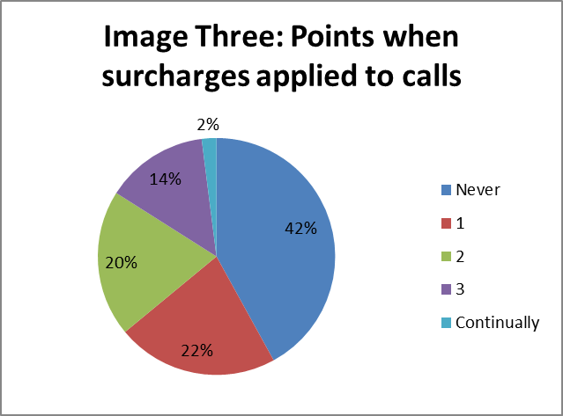

Surcharge fees varied from a one-off cost of 10 cents applied at the beginning of the call to a $1.50 charge applied after five minutes of calling time. These fees made a significant difference to the total value delivered by cards. For example, the Bayani card charges either a 50 cent or $1 fee at 1 and 16 minutes (depending on call destination) and an additional $1 fee at 5 minutes. This means that a 16 minute call could attract $3 in fees, 30% of the total value of the card.
Cards also applied irregular charging method to calls. Only 34% of cards charged in 1 minute blocks even though it is common industry practice to advertise headline rates as a per-minute charge. A large number of cards (22%) charged in 5 minute blocks, with other charging blocks ranging from 2 minutes (4% of cards) to 15 minutes (12%) of cards. 6% of cards applied irregular charging methods such as charging in “5 then 15 minute” blocks and charging in 1 minute blocks but applying a minimum 5 minute charge for all calls.
Some cards explained call charging in a confusing manner. For example, the Hot card terms and conditions states that “All calls are charged in blocks of 15 minute/s. Minimum charge of 1 minute/s.” If calls are genuinely charged in 15 minute blocks, it is unclear how the minimum charge of one minute could ever apply.

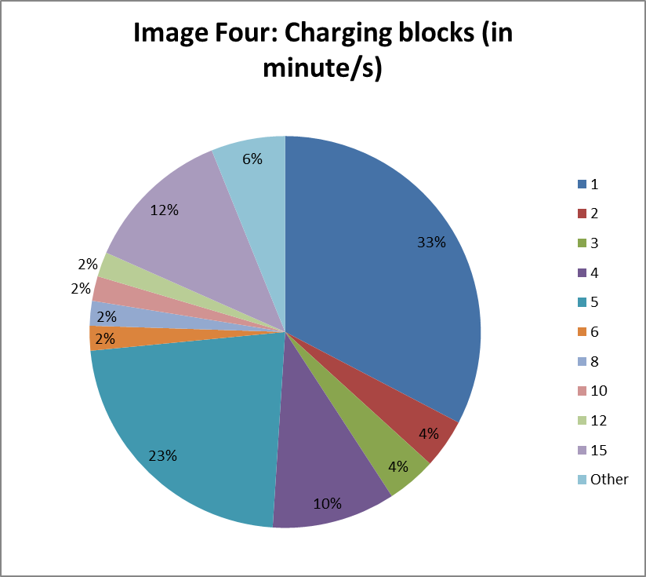
Activation and call quality
7% cards could not be activated. The experience of non-functional cards varied. Some would not activate at the initial dialing stage, others would allow researchers to enter a phone number but would not place the call.
“The calls didn’t go through, phone was ringing and the balance got deducted. Tried calling again and the balance got deducted to $0. [I] Didn’t make any actual calls” – Quote from researcher using the Saffron card.
For 28% of cases, researchers had a call unexpectedly disconnect even though credit was still left on the card. In 71% of cases there was a signal, either a beep or a recorded statement, warning when credit was about to run out. Researchers rated 9% of cards as having poor call quality, where the person on the other end of the line could not be heard. 22% of cards were rated as “OK/average” for call quality.
“On the third call attempt once connected through the call there is some quiet background noise, like a whooshing sound, but both parties were able to hear each other.” – ACA researcher using the Call Islander card.
98% of the time researchers rated instruction on the cards as “easy to follow.” This positive result needs to be qualified, as all researchers spoke English and were of working age. Older consumers may have difficulty following the small print instructions on the back of calling cards. Other complaints about call quality covered unexpected charges and instances where an additional call could not be placed even when there was credit remaining.
“I was charged 4 minutes for an engaged number. I had 3.6 minutes left and was told I did not have enough credit for another call.” - ACA researcher using the RateSaver card.

STAGE THREE: Customer service
Highlights:
- Most complaints were dealt with quickly and efficiently leaving the majority of researchers satisfied with the customer service experience.
- A small number of cards which had significant performance issues also had non-functional customer service systems, raising the possibility that a small number of cards are fraudulent.
Researchers chose 32 cards with problems arising in stage two of the research to test customer service quality. It must be emphasised that researchers had good English skills and more information available to support a complaint than what would be expected of ordinary consumers, having logged exact information about the number of calls made and minutes received. The results of this section of the research are only reflective of the experience of well-informed consumers, not all and especially not vulnerable consumers who may be more likely to use pre-paid calling cards.
The type of complaints that were escalated to customer service included poor quality calls, cards failing to activate, the number of minutes delivered being less than expected and technical faults. In 87.5% of cases, researchers found that the contact details for customer service were “quite easy” or “very easy” to find. While many cards appear to offer multi-lingual IVR systems to assist customers when placing a call, only one card, Hong Bao, offered a multilingual option for complaints.
Two cards had non-functional customer service systems. The Lebanon calling card could not be activated in stage two of the research. Printed on the card was a customer service number but no website for further information. When researchers attempted to call the customer service number they could only deal with an Interactive Voice Response (IVR) system which stated that no message could be left and to call back later. Calls were made repeatedly by ACA researchers and ACCAN staff, at no time could a message be left or was a call connected to a customer service representative. It is possible that this card was fraudulent. The Salamat Kaibigan card, which provided significantly less value than expected, also only provided a customer service number for further information. When the researcher called they were asked to leave a message with their details, several messages were left but the call was never returned.
With the exception of the Lebanon and Salamat Kaibigan customer service lines, all calls were answered within 10 minutes, with most callers only having to wait 1-2 minutes on-hold before a call was answered. Calls took between 5 and 30 minutes to complete and in 78% of cases the researcher only needed to place one call in order to speak with someone who could assist them.
28% of callers received a refund after lodging a complaint, with the amount refunded ranging from 28 cents to the full $10 worth of credit. In one case, the refund was merely a symbolic victory as the credit could not be used:
“0.50 was refunded, but it was consumed through the daily service fee charges on the card.”
– ACA researcher testing the Hello Europe card
When a refund wasn’t offered, the customer service representative explained that card credit had been depleted with fees and charges such as connection fees, charging blocks or daily/service fees. In one instance, the customer service representative said that call credit was depleted quickly on the Oceania card due to GST applied to headline rates and fees. ACCAN has been unable to confirm if this is correct but the Oceania card website makes no mention of any GST being applied on top of advertised rates.
While some researchers were happy with customer service representatives providing a more thorough break-down of card terms and conditions, other researchers were frustrated that these terms were not made clear at the point of sale or before placing calls:
“The Customer Service Representative explained the call rates (terms and conditions) for using the card vividly. However, the customer would have preferred a more proactive provision of these rates on the cards or on the advertisements in order to have a good knowledge of how to effectively use the card without having to go online to read them.” – ACA researcher testing the Talk Tomato card
63% of researchers were satisfied with the explanations or solutions provided by customer service. 41% of customer service representatives were considered to be helpful. In 34% of cases the issue could not be resolved immediately and had to be forwarded to a technical assistant for action. In one case, the caller was told to return to the card to the shop it was purchased from for a refund.
“The problem was completely resolved with just one call. The Customer Service Representative also explained to the customer what to do when faced with a similar problem.” – ACA researcher testing the World Talk card.
Overall, 69% of researchers rated their overall customer experience as “satisfactory” or “very satisfactory.” Based on the customer service experience, 67% of researchers involved in stage three of the research stated they would be “likely” or “extremely likely” to use the same card in the future.

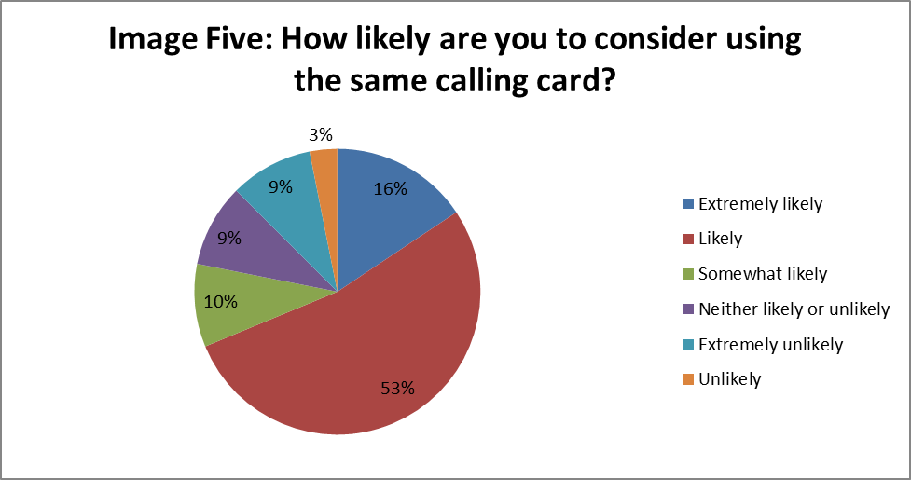

“Based on the Customer experience, I am more likely to use the same card again. I am happy about the fact that he went out of his way to call China to verify the problem. It was well explained and a solution will be provided in 24 hours.” – ACA researcher testing the Click China card

CONCLUSIONS
At the point-of-sale a consumer has very little idea of which calling card will be the best for their situation. Essentially, they are participating in a lottery. There is a slim chance a consumer could end up with an exceptionally good value card but a greater likelihood that they will purchase a card that offers poor value for money.
The current Pre-Paid Calling Card Industry Guideline, which aims to establish a base line of information needed so that customers will have “sufficient information enabling them to make informed decisions about the costs and benefits of using any particular Calling Card”, is not providing adequate protection for consumers. With only 17% of cards offering easy-to-find information in-stores, and much of that information is insufficient, consumers are unable to make an informed choice.
There is a quality issue with many cards in the market - 40% of cards had significant problems covering activation, card value and call quality. Many of the cards with onerous terms and conditions, such as 15 minute billing blocks or multiple surcharges, would become more unpopular if terms and conditions were prominently displayed in store, allowing consumers the opportunity to identify some of the cards offering exceptional value with simple terms and conditions.
However, greater information provision may not be enough to stem all poor practices. There appears to be a small proportion of cards in the market that are fraudulent. The ACMA have addressed this issue in the past and this study captured one card which offered no value and no way of contacting the company to lodge a complaint (the Lebanon calling card). The Illinois regulatory system discussed below, which requires all calling card providers to be certified by the regulator, could offer a solution to fraudulent pre-paid cards. Depending on the assessment methods used, this system could also potentially curb poor practices such as high daily service fees which negate credit expiry conditions.
For individual consumers, it’s positive to note that if they are able to complain about a calling card, it is likely they will get a satisfactory resolution. With short-wait times and quick resolutions, calling card customer service representatives offer better quality of service than many mobile or landline providers. With many complaints stemming from a poor understanding of call terms and conditions, problems could be prevented with clearer information available at the point-of-sale.

Impact of ACCC enforcement action
While the ACCC has pursued cases of misleading and deceptive advertising amongst calling card providers, the long-term impact of these actions across all calling card providers is questionable. The ACCC has only the time and resources to take sporadic action against some calling card providers, providing intense periods of scrutiny on some providers resulting in some change.
Australian Competition & Consumer Commission v Tel.Pacific Limited (2009) and Australian Competition & Consumer Commission v Cardcall Pty Ltd (2009) found advertising to be misleading, deceptive or false because the following approaches were used:
- “No Fee Representation” – advertising claims including “No Connection Fee[s]” and/or “Flat Rate” represented that no fees other than timed call charges applied to use of the cards but service fees, disconnection fees and surcharges applied.
- “Call Duration Representation” – advertising claimed that a number of minutes of calls were available without adequately disclosing that this number of minutes could only be achieved by one continuous phone call.
- “Call Cost Representation” – advertising claimed that calls to certain locations were charged at certain rates per minute without adequately disclosing that calls were charged in incremental periods, and service fees, disconnection fees and surcharges applied, resulting in a high call charge than the stipulated call cost per minute.
Looking at the available advertising and calling provider websites, the “call duration representation” appears to no longer be commonly used in advertising, although call duration representations do appear to occur after purchase when consumers dial-in to the calling card system. Only one advertisement was found to claim that a card offered ‘x’ number of minutes and this advertisement was extremely out-of-date. However, the practices of “No Fee Representation” and “Call Cost Representation” appear to be continuing in one form or another.
Many of the headline advertising claims made by calling card providers, either online or in the limited information provided in-store, were contradicted by fine print terms and conditions. It is impossible or extremely difficult for consumers to receive the headline rate. For example, Gia Dinh states that it charges ½ a cent per minute to call a mobile number in Vietnam but this charge is nearly impossible to achieve because of a 50 cent connection fee after five minutes, all charges are rounded up to the nearest five cents, a disconnection fee of 20 cents that applies to calls over 10 minutes, calls are charged in 10 minute blocks with a minimum charge of five minutes and the card applies a 10 cent daily service fee after first use.
In Australian Competition & Consumer Commission v Boost Tel Pty Ltd and Prepaid Services PTY Limited (2009), the Federal Court considered the validity of “asterisked claims” made by calling card providers, where high-level claims of calls costing, for example, ½ a cent per minute then, were qualified with an asterisk linked to fine print which outlined terms and conditions that made the rate near-impossible to achieve. The court found that:
“This is not the case of asterisked information fairly qualifying the primary representation. This is a case of the fine print seriously undermining the substance and integrity of the primary message. By portraying the highly exceptional as the norm, as Boost has done in the dominant representation in these advertisements, Boost has engaged in highly misleading conduct.”
The ACCC has not taken public enforcement action against a pre-paid calling card provider since the introduction of the Australian Consumer Law (ACL) in 2010. Further enforcement action using the new ACL provisions could lead to commercially significant penalties and a greater impact on poor industry practices.

Alternative regulatory options
While similar action to that initiated by the ACCC in 2009 would certainly have an impact on the calling card market in 2013, it is also worth exploring alternative regulatory options that move beyond sporadic and focused action. The ACMA has the option of requiring an industry-specific code or industry standard for pre-paid calling cards but without actively monitoring the calling card industry, this document may not deliver any tangible changes in industry practice. Communications Compliance, the body responsible for monitoring industry compliance with the TCP Code, could turn its attention to calling cards but this body is new and may not yet have the resources to focus on calling card compliance. The TCP Code is not necessarily the best instrument to deal with this distinct section of the telecommunications industry.
Other countries have taken different approaches to regulate pre-paid calling cards and similar products. These are presented in the hope of inspiring further discussion about more effective ways to regulate and deliver quality pre-paid calling card products to consumers.
All three programs discussed below come from OECD countries which, like Australia, have committed to privatisation and regulatory regimes across the economy since the 1980’s. In this sense, all three, very broadly speaking, come from a similar regulatory culture.
Illinois pre-paid phone card regulation
The state legislature of Illinois in the United States has put in place a program to curb misleading and deceptive advertising practices and poor quality products in the pre-paid card industry. This state-level program was enacted in August 2004 by the Phone Card Fraud Act. The measures outlined in the legislation came into effect from 1 July 2005, leaving some time for industry to adjust to the new regulatory regime.
The Illinois program was designed to address “hidden charges” - fees that reduced the value of the card that the consumer was not necessarily aware of including disconnection, connection, operation, mobile phone and payphone fees. The program requires all companies in the state providing phone-card services to be certified by the Illinois Commerce Commission, an independent regulatory body. The certification process aims to assess whether applicants have appropriate technical, financial and managerial resources to provide the services they are selling. These companies must provide a phone number to customers to resolve issues. The number must be free to call and is listed on the Commerce Commission website. Retailers face penalties if they sell cards from uncertified companies. The Commission has the power to create service provider rules as they see fit, these include but are not limited to “service number, reporting requirements, fines, penalties, customer credits, remedies, and other enforcement mechanisms to ensure compliance with the service quality standards.” While the registration and certification of all card providers has been operating successfully since 2005, to date, the Commission has not used its power to create service provider rules.
Ontario gift card regulation
The regulation of gift cards in Ontario, Canada, does not directly deal with pre-paid cards but the issues it aims to address are very similar, so much so that the introduction of the new measures in Ontario prompted the Consumers Council of Canada to consider how the program could be extended to pre-paid calling cards. The program addresses misleading and deceptive advertising practices and confusing and unfair terms and conditions.
The Ontario Ministry of Government Services, a state government ministry which with the support of the Minister is able to amend legislation, introduced an amendment to the 2002 Ontario Consumer Protection Act which came into effect on 1st October 2007. This amendment places significant restrictions on activation and dormancy fees (fees applied once a card is activated, regardless of whether it is used). The law does not apply to pre-paid calling cards as telecommunications products fall under federal jurisdiction in Canada, not state. The responsibility for enacting the reforms outlined in the legislation, including undertaking education projects about the new law, was administered by a different Ontario state ministry - the Ministry of Consumer Services.
The amendment bans expiry dates on gift cards. Gift cards are not permitted to be issued for less than the value of the payment made by the consumer entering the agreement and no fees can be charged except in the case of replacing a lost or stolen card or to customise a card. In cases where fees have been wrongly applied, consumers have the right to demand a full refund. If gift card issuers are convicted of breaking the law a fine applies - up to $50,000 or two years jail for individual issuers and up to $250,000 for corporations. No conviction or penalty has been made public. There is no active monitoring of how retailers are complying with new rules, leaving individual consumers responsible for being aware of the rules and reporting breaches.
United Kingdom pre-paid phone card regulation
In the United Kingdom, the independent communications regulator, Ofcom, is responsible for creating and implementing the regulatory program for pre-paid phone cards. Ofcom’s regulatory powers are provided by the Communications Act 2003 (UK). The regulator is directly accountable to the United Kingdom Parliament and has responsibility for regulating, implementing law and enforcing law related to, among other things, telecommunications.
The pre-paid calling card market has similarities to Australia. Consumers with ethnic backgrounds with lower incomes were more likely to use and rely on these products and there are many providers offering many different products.
In 2003 Ofcom launched an investigation into pre-paid calling cards to examine possible misleading and deceptive advertising practices, focusing on instances where cards did not offer the minutes or value as advertised. The year-long investigation found that many advertisements and terms and conditions for pre-paid calling card breached the Control of Misleading Advertisements Regulations 1988 and the Unfair Terms in Consumer Contracts Regulations 1999. Ofcom obtained formal undertakings from three card providers to ensure future advertisements included all charges, terms and conditions. Since 2004 Ofcom has continued to target a small number of individual pre-paid calling card operators, obtaining legal undertakings from providers to ensure they correct breaches and issue clearer advertising in the future. No fines or penalties have been issued to providers found breaching regulation.
In 2010 a report examining the United Kingdom pre-paid calling card industry showed that there were still wide spread issues with advertising, terms and conditions and card quality. Of a test of 130 calling cards only 5% had terms and conditions available and legible at the point of purchase, 10% of cards could not be used at all and only 28% of the overall advertised minutes were provided. Three companies, two of which had committed to undertake better advertising practices in 2004, sold cards which gave the purchaser a quarter or less of the minutes advertised. In short, the sporadic enforcement action undertaken by Ofcom has failed to curb poor practices.

APPENDIX ONE: Cards tested

Anhaw
Amigos
Bayani
Blessing Card
Call Everywhere'
Call Islander
Call Mama
China Gold
China GPS
Chit Chat
Click
Click China
Crystal
Day Break
Fast Trek
Gas
Gia Dinh
Go Bananas
GPS
Greek City
Hello
Hello Africa
Hello China
Hello Europe
Hello Middle East
Hello South America
Hong Bao
Hot
Islander Talk
It's Green
Joy
Le Tou
Lebanon calling card
Long River
Lotus
Oasis
Oceania
Ozcall
Pay Peanuts
RateSaver
Ring-Around
Saffron
Salamat
Say G Day
Supersaver
Talk Tomato
The Genuine Aussie
The Nextra
World Talk
Yes Optus

A good overview of the current landscape can be found in Robi, Sabinus (2007), “Telecommunications – fast and furious”, Law Institute Journal, 81(11), p 46.
For a comprehensive discussion of telecommunications regulation see Grant, Alisdair (2012), “Industry Structure and Regulatory Bodies” in Grant, Alasdair and David Howarth (eds.), Australian Telecommunications Regulation, Communications Law Centre UTS, Sydney pp 3-48.
Communications Alliance, (2011) “About Us”, Communications Alliance website last accessed 17th January 2013. http://www.commsalliance.com.au/about-us/overview
ACMA (2012), “About industry codes and standards”, ACMA, last accessed 10th January 2013: http://www.acma.gov.au/scripts/nc.dll?WEB/STANDARD/1001/pc=PC_2080
Australia rated tenth internationally and tied first in the region in the TRGI index in Waverman, Leonard & Pentelis Koutroumpis (2011), “Benchmarking telecommunications regulation - The telecommunications regulatory governance index”, Telecommunications Policy, 35, pp 450-468.
ACMA (2011) “Reconnecting the Customer”. Last accessed 17th January 2013: http://www.acma.gov.au/scripts/nc.dll?WEB/STANDARD/1001/pc=PC_312222
Kermond, Clare and Lucy Battersby (16 March 2012) “Media watchdog set for broader role” Sydney Morning Herald, Last accessed 17th January 2013: http://www.smh.com.au/business/media-and-marketing/media-watchdog-set-for-broader-role-20120315-1v84f.html#ixzz1q7dn1OL1
See ACCAN (2011), “Industry tinkering with voluntary code won’t fix customer woes”, ACCAN, Sydney last accessed 17th January 2013: http://accan.org.au/index.php?option=com_content&view=article&id=349:industrys-tinkering-with-voluntary-code-wont-fix-customers-woes&catid=107:your-rights&Itemid=237
Grant, Alasdair and Holly Raiche (2012), “Chapter 7: Consumer Protection and Universal Service” in Grant, Alisdair and David Howarth (eds.), Australian Telecommunications Regulation, Communications Law Centre UTS, Sydney p 360.
For example see a determination with no financial penalty issued over 12 months after the code breach ACMA, (2011), “Investigation Report: Compliance with provisions of the Telecommunications Consumer Protections Code C628:2007” Last accessed 20 March 2012: http://www.acma.gov.au/webwr/_assets/main/lib310632/investigation_report_c628-2007-vodafone_hutchison_aust-16dec2011.pdf
Kelly, Mitch (2009), “Pre-paid Calling Cards Industry Update: Federal Court Proceedings, ACCC Investigations and Recent Communications Alliance Industry Guidelines”, Communications Law Bulletin, 28(2) pp. 14
Australian Communications Authority, (2003), Developing Telecommunications Codes For Registration – A guide, ACA Melbourne. P 16.
Communications Alliance (2012), Prepaid Calling Card Industry Guideline (G640:2009), Communications Alliance, Sydney p 12.
Ibid p i.
See www.gotalk.com.au and http://in.reuters.com/finance/stocks/TPC.AX/key-developments/article/2456676 last accessed 15th January 2013
ACMA (2012), “New telecommunications consumer protections” last accessed 10 January 2013 http://www.acma.gov.au/scripts/nc.dll?WEB/STANDARD/1001/pc=PC_600025
ACMA (2007) “ACMA and the TIO warn consumers about phone card retailer”, last accessed 9 January 2013 http://www.acma.gov.au/scripts/nc.dll?WEB/STANDARD/1001/pc=PC_310081
Grant, Alasdair and Holly Raiche (2012), “Chapter 7: Consumer Protection and Universal Service” in Grant, Alisdair and David Howarth (eds.), Australian Telecommunications Regulation, Communications Law Centre UTS, Sydney pp361-363.
ACMA (2011) “Reconnecting the Customer”. Last accessed 17th January 2013: http://www.acma.gov.au/scripts/nc.dll?WEB/STANDARD/1001/pc=PC_312222
Lui, Spandas (26 March 2012), “ACMA: Mobile Premium Services code led to plunge in complaints”, ARN last accessed 15th January 2013 http://www.arnnet.com.au/article/419584/acma_mobile_premium_services_code_led_plunge_complaints/
TIO (2012), Submission on Review of the Prepaid Calling Card Industry Guideline (G640:2009), TIO p 4.
Leung, L. (2011) Mind the Gap: refugees and communications technology literacy, Australian Communications Consumer Action Network, Sydney pp17-19.
Ibid p 18.
TIO (2011), Resilient Consumers Report, TIO, Melbourne pp 4-5.
Chebat, Jean-Charles, Moshe Davidow and Isabelle Codjovi, (2005) “Silent Voices: Why Some Dissatisfied Consumers Fail to Complain”. Journal of Service Research, 7, p 328.
Leung (2011) Mind the Gap, p 16.
See TIO (2011), “Position statement: Disadvantaged and vulnerable consumers”, Last accessed 15th January 2013http://www.tio.com.au/__data/assets/pdf_file/0017/9026/Disadvantaged-and-vulnerable-consumers.pdf & Australian Competition and Consumer Commission, (2011) Taking advantage of disadvantage: A compliance guide for businesses dealing with disadvantaged or vulnerable consumers, Commonwealth of Australia, Canberra, last accessed 15th January 2013: http://www.accc.gov.au/content/item.phtml?itemId=704340&nodeId=a372b4f5e79c8e75c25a6e22999bfeeb&fn=BS%20Don%27t%20take%20advantage%20.pdf
ACCAN (2009), Informed consent research report, ACCAN, Sydney p 26.
Footscray Community Legal Centre & ACCAN (2011) Taking Advantage of Disadvantage: Case Studies of Refugee and New Migrant Experiences in the Communications Market, ACCAN, Sydney p 6.
Leung (2011) Mind the Gap, p 18.
Liu, Raymond R and Peter McClure, (2001),"Recognizing cross-cultural differences in consumer complaint behavior and intentions: an empirical examination", Journal of Consumer Marketing, 18(1) pp. 54 - 75.
Leung (2011) Mind the Gap & Wadiwel, D and Hayter, C, National Ethnic Disability Alliance. (2010) Understanding Communications Consumers from Non English Speaking Backgrounds (NESB), ACCAN, Sydney.
Synovate (2010), International calling cards evaluation, Ofcom, London.
Communications Alliance (2012), Prepaid Calling Card Industry Guideline (G640:2009), para 3.7, p 8.
Australian Competition & Consumer Commission v Tel.Pacific Limited (2009) FCA (Gordon, J 30 March 2009), Schedule 3
Ibid, para 5
Communications Alliance (2012), Prepaid Calling Card Industry Guideline (G640:2009), para 3.4.2, p 8.
The Genuine Aussie Phonecard
Lebanon Calling Card, Joy Phonecard, Hello Africa, Hello Middle East, Salamat Kaibigan,
Hello Europe, Hello China, Hello Phonecard, Gia Dinh, Call Every Where, Chit Chat.
Australian Competition & Consumer Commission v Tel.Pacific Limited (2009) & Australian Competition & Consumer Commission v CardCall Pty Ltd (2009) FCA (Lindgren J 22 May 2009)
Australian Competition & Consumer Commission v Tel.Pacific Limited (2009) para 7 and Schedule 2
TIO (2012), Submission on Review of the Prepaid Calling Card Industry Guideline (G640:2009), pp 6-7.
ACMA (2012) Communications report 2011-12, ACMA, Melbourne, p 31, 118.
Ibid p 20, 116.
ACMA (2011), The internet service market and Australians in the online environment, ACMA , Melbourne p 28.
Cards with “significantly better value” delivered 30 or more minutes of call time than the same card tested with the alternative short or long call method. Cards with “better value” delivered between 1-29 minutes of call time than the same card tested with the alternative short or long call method.
See http://www.accessphonecards.com.au/?action=product_aussie last accessed 15th January 2012
The Skype pay-as-you-go rate is 3 cents/minute for calls to a mobile phone in the USA, plus 6.9 cent connection fee. See http://beta.skype.com/en/rates/ last accessed 15th January 2012
NB: Only cards where a call could be connected were included in this list.
See Cardcall, (2012) “Call mama phonecard”: http://www.cardcall.com.au/phonecards/Pages/callmama.aspx?ID=W_CALL_MAMMA last accessed 15th January 2013
Limetelecom, “Call Everywhere” https://www.limetelecom.com.au/showproduct.php?pro_id=17 last accessed 15th January 2013.
World Telecom (2011) “Pay Peanuts Phone Card” http://www.worldtelecom.com.au/phonecards/Pages/PayPeanuts.aspx?ID=W_WT_PAY_PEANUTS_PREPAID last accessed 15th January 2013
CardCall (2011), “Hot Phone Card” http://www.cardcall.com.au/phonecards/Pages/hot.aspx?ID=W_HOT last accessed 15th January 2013
Leung (2011) Mind the Gap, p 17.
World Telecom (2010) “Oceania Phone Card” http://www.worldtelecom.com.au/phonecards/Pages/Oceania.aspx?ID=W_OCEANIA last accessed 15th January 2013
Communications Alliance (2012), Prepaid Calling Card Industry Guideline (G640:2009), p i.
ACMA (2007) “ACMA and the TIO warn consumers about phone card retailer”, last accessed 9 January 2013 http://www.acma.gov.au/scripts/nc.dll?WEB/STANDARD/1001/pc=PC_310081
Australian Competition & Consumer Commission v Tel.Pacific Limited (2009) FCA (Gordon, J 30 March 2009), para 1-3 and Australian Competition & Consumer Commission v CardCall Pty (2009) FCA (Lindgren J 22 May 2009) para 1-3
See p 18 of this report.
Tel.Pacific “GiaDinh”, http://www.telpacific.com.au/phonecard_main.asp#RateForm last accessed 15th January 2013
Australian Competition & Consumer Commission v Boost Tel Pty Ltd and Prepaid Services PTY Limited (2010), FCA (Siopis J 5 July 2010) p 16 para 80.
The Act was an amendment to the Illinois Public Utilities Act, it can be found at Illinois General Assembly, (2009), Public Utilities Act, s 220 ILCS 5/13-230 last accessed 15th January 2013 http://www.ilga.gov/legislation/ilcs/ilcs4.asp?DocName=022000050HArt.+XIII&ActID=1277&ChapterID=23&SeqStart=22500000&SeqEnd=32900000
Illinois Government News Network (23 August 2004), “Quinn joins Atty. Gen. Lisa Madigan, Sen. Martin Sandoval, Rep. William Delgado, ICC Commissioner Lula Ford and Consul General of Mexico Jose Castro to celebrate the passage of a consumer protection bill to stop prepaid calling card providers from selling deceptive calling cards”, last accessed 15th January 2013: http://www.illinois.gov/pressreleases/ShowPressRelease.cfm?SubjectID=1&RecNum=3328
Registration occurs and is stored online at Illinois Commerce Commission (2012), Pre-Paid Services last accessed 15th January 2013: http://www.icc.illinois.gov/telecommunications/PrePaidServices.aspx
Illinois Government News Network (2004), “Quinn joins Atty. Gen. Lisa Madigan, ... to celebrate the passage of a consumer protection bill to stop prepaid calling card providers from selling deceptive calling cards”
Illinois General Assembly, (2009), Public Utilities Act, s 220 ILCS 5/13-404.1 (c)
Illinois Government News Network (2004), “Quinn joins Atty. Gen. Lisa Madigan, ... to celebrate the passage of a consumer protection bill to stop prepaid calling card providers from selling deceptive calling cards”
Illinois General Assembly, (2009), Public Utilities Act, s 13-404.2.
Consumers Council of Canada (2009) Long Distance Phone Cards: Are Consumers Satisfied p 7.
For a full list of Ministry powers For a full list of Ministry powers Ontario Ministry of Government Services (2012), “About the Ministry” last accessed 15th January 2013http://www.mgs.gov.on.ca/en/AbtMin/109669.html
Consumers Council of Canada (2009) Long Distance Phone Cards: Are Consumers Satisfied p 23.
Ibid p 24.
Ontario State, Consumer Protection Act 2002, s 25.3, last accessed 15th January 2013 http://www.e-laws.gov.on.ca/html/statutes/english/elaws_statutes_02c30_e.htm
Ibid s 25.4 (2).
Ibid s 25.4 (2).
Ontario Ministry of Consumer Services (2011), “Gift Cards: Information for retailers”, last accessed 15th January 2013 http://www.sse.gov.on.ca/mcs/en/Pages/Gift_Card_Info_for_Retailers.aspx
Ofcom (2012), “What is Ofcom?” last accessed 15th January 2013 http://www.ofcom.org.uk/about/what-is-ofcom/
Ibid.
Ofcom (2004) Pre-paid calling cards - Market Research Annex, Ofcom, London p 3.
Ofcom, (2004), Investigation into potential over-charging on pre-paid calling cards, Ofcom, London, last accessed 15th January 2013 http://stakeholders.ofcom.org.uk/enforcement/competition-bulletins/closed-cases/all-closed-cases/cw_729/
Ibid.
Ofcom, (2004), Ofcom completes investigation of pre-paid calling cards, Ofcom, London, last accessed 15th January 2013: http://media.ofcom.org.uk/2004/10/11/ofcom-completes-investigation-of-pre-paid-calling-cards/
See for example, Ofcom (2005), Investigation into the accuracy of Cheers International’s billing system and/or failure to publish full details of its tariffs and charges, Ofcom, London, last accessed 15th January 2013: http://stakeholders.ofcom.org.uk/enforcement/competition-bulletins/closed-cases/all-closed-cases/cw_794/
Synovate (2010), International calling cards evaluation, Ofcom, London.
Ibid p 3.
Ibid p 4.

