Community Position Statement on CAPTCHA

[Completely Automated Public Turing Test to tell Computers and Humans Apart]
The alliance of organisations listed below represents the interests of Australians with disability. Our unified position recommends that all governments, businesses and organisations immediately remove all inaccessible CAPTCHAs from their websites and replace them with accessible alternatives.
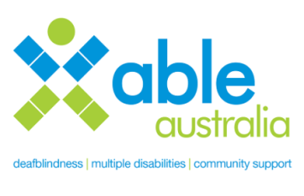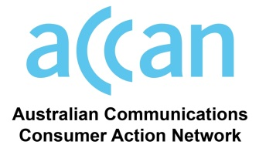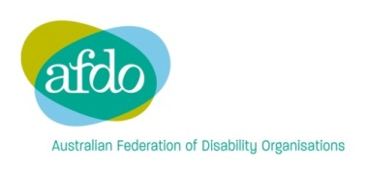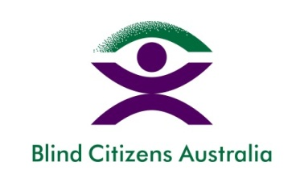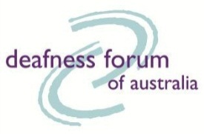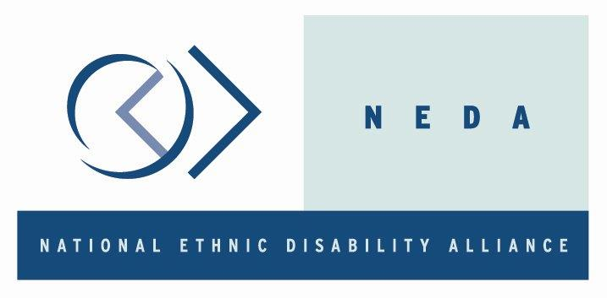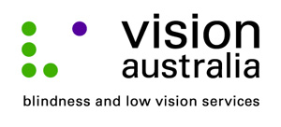
What are CAPTCHAs?
CAPTCHAs are used on many websites as a way to protect against unwanted computer generated interaction. They are designed to ensure that only humans are able to access the content of a website. Text or sound is usually distorted with the rationale that humans can understand these images or recordings, but automated text readers or voice recognition systems cannot. Most commonly, CAPTCHA will be in the form of wavy letters in an image file or sounds embedded in a set of whispers in an audio file).
- Visual CAPTCHAs require you to decipher a distorted string of letters and numbers before you can make a purchase, post messages, sign up to services like Skype and Gmail, subscribe to email lists, access online government services and even contact elected officials.
- Audio CAPTCHAs are designed as an alternative for people who have trouble reading a visual CAPTCHA. They require the user to enter the characters or numbers spoken in an audio clip.

Why are CAPTCHAs a problem?
These CAPTCHA tests are frustrating and difficult for all internet users, but for many people who have a disability, CAPTCHA tests are a barrier that prevent access to websites and online services.
- Visual CAPTCHA: For many people these distorted characters are not easy to identify. People who are blind and use screen reading software to access the web are not able to identify the characters in visual CAPTCHAs because screen reading software cannot read images. Visual CAPTCHAs create similar barriers for many more people who have vision impairment or for people who have cognitive impairments that make it hard to read distorted characters.
- Audio CAPTCHA: Many of these audio alternatives use distorted sounds which are difficult and often impossible to decipher. For people with hearing loss they are a barrier to accessing websites. For people who are Deafblind or who have both vision and hearing impairments, neither CAPTCHA options are accessible.
- Logic CAPTCHA: The use of simple logic questions as CAPTCHA challenges create barriers for people with cognitive or intellectual impairments.
Why does it matter?
Unfettered access to web content is becoming increasingly necessary to conduct day-to-day business, access government and public services, access a myriad of other online services and to connect with family, friends and colleagues. In order that all people can participate in our online society it is important that websites and online services are universally accessible.
In Australia, as with many other countries, the population is aging, with increased numbers of people over the age of 65. Statistics tell us that the incidence of disability increases with age, particularly age-related vision or hearing loss. Inaccessible CAPTCHAs will mean that this growing proportion of our community will encounter increasing difficulty accessing online services.
While website security is essential in order to protect against computerised attacks, there are alternative security methods available which do not exclude people with disability or frustrate other web users who have difficulty deciphering distorted characters or sounds.
Recommendations
We recommend that all governments, businesses and organisations immediately remove all inaccessible CAPTCHAs from their websites and replace them with accessible alternatives.
The following are examples of security alternatives which can be used to protect website content without barring access for people with disability:
- Email verification: Requesting website visitor’s reply to an email sent to their email address.
- Honey Pots: Honey Pot fields can be used on websites to identify bots and non-human interaction. Honey Pot fields are invisible to human web users and can be tagged to alert screen reader users to leave the field blank. Any interaction with the Honey Pot indicates malicious or machine interaction and access to the website can accordingly be blocked.

This position statement has been endorsed by:
- Able Australia www.ableaustralia.org.au
- Australian Communications Consumer Action Network www.accan.org.au
- Australian Blindness forum www.australianblindnessforum.org.au
- Australian Federation of Disability Organisations www.afdo.org.au
- Blind Citizens Australia www.bca.org.au
- Deaf Australia www.deafau.org.au
- Deafness Forum www.deafnessforum.org.au
- Media Access Australia www.mediaaccess.org.au
- People with Disability Australia www.pwd.org.au

The World Wide Web Consortium (W3C) Web Content Accessibility Guidelines (WCAG) 2.0 recommends in Guideline 144 “ensuring that the web page contains another CAPTCHA serving the same purpose using a different modality” as a ‘technique’ for meeting Success Criterion 1.1.1 (Non-text Content). http://www.w3.org/TR/WCAG-TECHS/G144.html

