Fact Check: Communication Alliance and nbn media releases
In the flurry of media this week about the TIO Annual Report and 41 per cent increase in telecommunication complaints received, Communication Alliance and nbn both made reassuring comments about the state of the problem.
But how reassured should we be?
Communications Alliance is “pleased” that in the last three months the rate of complaints slightly decreased (from 9 per 10,000 services in operation between Apr-Jun 2017 to 8.3 per 10,000 Jul- Sept 2017).
While there was a decrease it was from the worst quarter for complaints in a long time, so hardly a good starting point.
This time of the year usually sees a dip in complaints. The same period last year saw a much lower number of complaints, a rate of 6.2 per 10,000 services. This period is the worst July – September number we’ve seen in the last 4 years.
Figure 1: Telecommunications Complaints in Context, source Communications Alliance
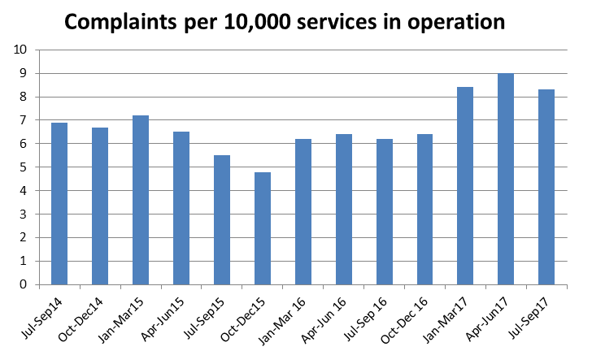
Verdict: Hold off on pats on the back Communication Alliance.
nbn’s media release states “fewer than 15% of ‘nbn’ complaints” land with NBN Co” suggesting that they are only responsible for a relatively small number of TIO complaints. Good news for nbn? Maybe, but the TIO can only direct complaints to nbn “where the complaint is about damage to property or access required to a property for the purposes of installing or repairing the network.”
Generally when a consumer rings the TIO they complain about their retail service provider (Telstra, Optus, TPG and so on). For example: if an nbn technician never turns up this counts as a complaint against the retail service provider, not nbn.
The TIO is proposing a change to its Terms of Reference so it can require all parties in the supply chain to participate in the resolution of complaints about nbn services, so next time round these figures may tell a different story. We think this change is needed.
Verdict: True, but when consumers are limited in what nbn issues they can complain about to the TIO, the full story isn’t quite being told.

