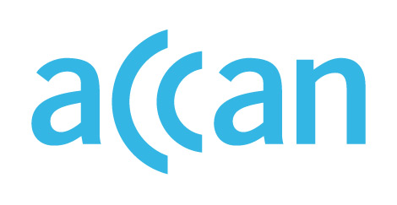

ONLINE LEARNING AND ACCESS TO DEVICES

DURING THE COVID-19 OUTBREAK

Device access programs in Western Australia
No device loan scheme.
Face-to-face schooling or online learning encouraged.

Public schools
Schools in WA are open to any student wishing to attend, but parents are encouraged to keep their children at home. The WA Education Minister has said that schools are able to lend devices if needed. However, there is no public information available about a formal device loan scheme. State School Teachers' Union of WA has said it’s not clear whether additional state government resourcing will be made available to support face-to-face and online learning in state schools.

Private schools
Private and independent schools can choose whether learning will be delivered predominantly online or face-to-face. No clear public guidance on the provision of devices from the independent or Catholic school peaks.

Where to find out more

WA Department of Education website
https://www.education.wa.edu.au/coronavirus-school-update

https://www.watoday.com.au/national/western-australia/back-to-school-in-term-2-for-wa-teachers-and-students-20200417-p54kww.html
https://www.abc.net.au/news/2020-04-17/wa-schools-reopen-amid-coronavirus-students-encouraged-to-attend/12129064

