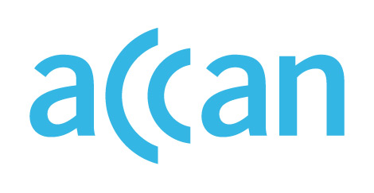

ONLINE LEARNING AND ACCESS TO DEVICES

DURING THE COVID-19 OUTBREAK

Device access programs in Victoria
Device loan scheme in place.
Online learning encouraged.

Public schools
The VIC Department of Education has said that any students who can study from home, must study from home. Only students whose parents cannot work from home and students experiencing vulnerability will be able to attend school in person.
The Victorian government is facilitating a device loan scheme and has supported the lending of thousands of devices, mobile dongles and SIM cards to families without existing access to learning equipment. 48,000 laptops and tablets have been granted to primary and secondary school students from publics schools and the Department directly.

Private schools
COVID-19 Guidelines for the delivery of online learning in independent schools are not publicly available.

Where to find out more

VIC Department of Education and Training website
https://www.education.vic.gov.au/about/department/Pages/coronavirus.aspx

https://www.education.vic.gov.au/school/Pages/coronavirus-advice-schools.aspx
https://www.itnews.com.au/news/telstra-to-provide-21k-more-dongles-to-victorian-students-for-remote-learning-547108

