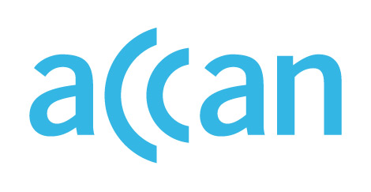

ONLINE LEARNING AND ACCESS TO DEVICES

DURING THE COVID-19 OUTBREAK

Device access programs in Queensland
Device loan scheme in place.
Online learning encouraged.

Public schools
The QLD Department of Education has required all students to study from home over Term 1, except for pupils in exceptional circumstances or those whose parent/s are essential workers. Over Term 2 2020, students will gradually re-integrate into face-to-face learning.
The Department has purchased additional devices for schools and is running a device loan scheme. Telstra has donated 5,000 SIM cards to the Department of Education to support families’ internet access needs.

Private schools
Independent schools will be open for vulnerable students or children of essential workers. No public guidance on the provision of devices to students in Catholic or other independent schools.

Where to find out more

QLD Department of Education website
https://qed.qld.gov.au/about-us/news-and-media/novel-coronavirus

https://qed.qld.gov.au/about-us/news-and-media/novel-coronavirus/frequently-asked-questions-for-parents
https://www.couriermail.com.au/news/queensland/schools-charging-students-to-hire-laptops-for-homeschool/news-story/a974f0064e726cdff825d6a96110a6c1
https://www.isq.qld.edu.au/media-resources/independent-schools-rise-to-challenges-of-covid-19

