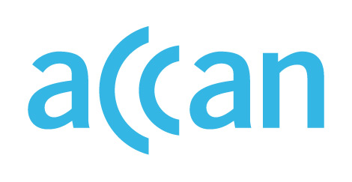

ONLINE LEARNING AND ACCESS TO DEVICES

DURING THE COVID-19 OUTBREAK

Device access programs in New South Wales
Device loan scheme in place.
Online learning encouraged, face-to-face to be re-introduced during Term 2 2020.

Public schools
Students have been pre-dominantly learning from home over Term 1. The NSW Department of Education has announced that students are to gradually re-integrate into face-to-face learning over Term 2.
Parents are encouraged to contact their principal for assistance in arranging access to online learning during COVID-19. Optus has committed to providing prepaid SIM cards to 6,000 students experiencing disadvantage.
The NSW has established a device loan scheme where public schools struggling to procure equipment may order it directly from the Department. Principals may order devices according to the level of student needs via an online portal. More information on the scheme is here, and a detailed guide on what is available is here.
The Department has made available six types of equipment available to public families needing support:
- Windows Notebook
- Apple iPad Tablet
- ChromeBook
- Telstra mobile dongles
  - Telstra 4G Hot Spot
  - Telstra 4GNightHawk
  - Telstra 4GUSB

Private schools
Private schools are encouraged to loan devices to students needing access. In late March, Catholic Schools NSW wrote to the State Minister for Education to seek clarity on what online learning supports were available to Catholic schools. The Association of Independent Schools NSW has encouraged its member schools to develop their own device loan scheme.

Where to find out more

NSW Department of Education website

https://education.nsw.gov.au/news/latest-news/nsw-students-to-transition-back-to-the-classroom-in-term-2
https://www.itwire.com/telecoms-and-nbn/optus,-business-and-community-network-partner-on-disadvantaged-school-students-program.html
https://www.smh.com.au/national/nsw-teachers-union-to-demand-school-closures-if-safety-measures-not-met-20200323-p54d3r.html
https://www.aisnsw.edu.au/learning-from-home/technology/delivering-ict-services-remotely

