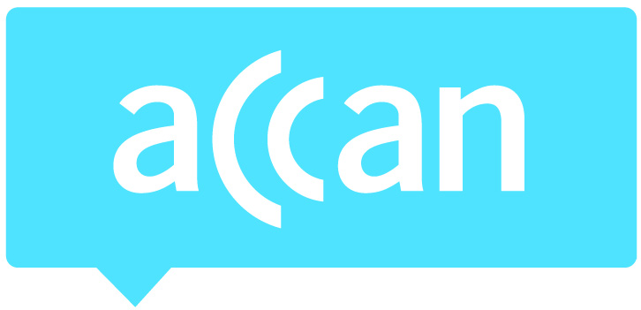
For immediate release 18 May, 2017

ACCAN calls for more accessibility on free-to-air TV

The Australian Communications Consumer Action network (ACCAN), with support from Disability Discrimination Commissioner, Alastair McEwin, calls on the Turnbull Government to increase access services for people of all abilities across free-to-air television – which is still our foremost medium for news, information and entertainment. ACCAN is calling for increased captioning across free-to-air multi-channels (like Go and 7Mate) and for the introduction of 14 hours of audio description on ABC and SBS. The call for more accessible television coincides with Global Accessibility Awareness Day.
“The government’s recently announced proposal to eliminate television broadcast licence fees, resulting in a $90 million per year windfall for broadcasters, should be contingent on broadcasters providing greater access services for viewers with disability,” said ACCAN Disability Policy Advisor, Wayne Hawkins. “We have been told for many years that these access services are just not sustainable from both the industry and the government. However, this huge windfall should allow broadcasters to finally make television more accessible to Australians.”
Disability Discrimination Commissioner, Alastair McEwin, highlighted that much of the television broadcast in Australia is inaccessible to many people with a disability.
“Access to communication is a fundamental human right for all people. Unfortunately, much of what is broadcast in Australia is still inaccessible to many people with disability, in particular those who are deaf, blind or have low vision,” said Mr McEwin. “The government’s recent announcement to eliminate television broadcast licence fees provides an excellent opportunity for savings from this to be re-invested in access solutions for people with disability. Such investment will result in all Australians with disability able to access broadcast services on an equal basis as others.”
Captions have been incrementally provided on free-to-air primary channels over several years and are currently mandated to be provided on all programming between 6am and midnight as well as on all news and current affairs programming. However, on the broadcasters’ multi-channels, captions are only required on programs which were previously broadcast on the primary channel with captions.
Audio description, a secondary audio channel describing important visual aspects on screen, is available in all comparable English-speaking countries but is not available on any broadcast television in Australia. Last month the Federal Government announced the formation of a working group that will investigate how audio-described programs can be delivered on Australian television. The blindness sector is calling for action on this issue now.
“Without audio description, hundreds of thousands of Australians with vision impairment are unable to enjoy television with their families, friends and colleagues,” added Mr Hawkins. “Previous trials of audio description on ABC and iview received positive feedback. We’re asking for 14 hours of audio description per week on ABC and SBS.”
Media contacts:
ACCAN:
Luke Sutton on luke.sutton@accan.org.au or 0409 966 931.
Alastair McEwin:
Sarah Bamford, media adviser, on 0417 957 525.

