30 November, 2016
MEDIA RELEASE

New Coalition formed to end the data drought
A group of like-minded advocacy groups have come together to end the data drought by forming the Regional, Rural and Remote Communications Coalition to champion better communications services for consumers and small businesses living in rural, remote or regional areas.
The Coalition includes the Australian Communications Consumer Action Network (ACCAN), the National Farmers’ Federation (NFF), the Country Women’s Association of NSW, the Isolated Children’s Parents’ Association and AgForce Queensland.
“The Coalition was formed to highlight the collective concerns of families, businesses and communities in rural and regional Australia about the lack of equitable access to reliable and quality telecommunications services in regional, rural and remote Australia,” ACCAN CEO, Teresa Corbin said.
“2017 must be the year of delivering real improvements to digital connectivity in the bush.”
The Coalition has developed five fundamental outcomes as measures of equitable connectivity for regional and remote consumers. They are ambitious and achievable, and they reflect the pressing need for change.
The five outcomes are:
- A universal service obligation that is technology neutral and provides access to both voice and data;
- Customer service guarantees and reliability measures to underpin the provision of voice and data services and deliver more accountability from providers and nbn;
- Long term public funding for open access mobile network expansion in rural and regional Australia;
- Fair and equitable access to Sky Muster satellite services for those with a genuine need for the service, and access which reflects the residential, educational and business needs of rural and regional Australia; and
- Fully resourced capacity building programs that build digital ability, and provide learning and effective problem solving support for regional, rural and remote businesses and consumers.
NFF CEO, Tony Mahar, said that the organisation is pleased to be a member of the Coalition. “Our members include some of the most innovative businesses and individuals in Australia. Yet we remain locked out of future economic growth and prosperity through the digital divide which is undermining Australia’s productivity.
“Without leadership and change, Australia risks growing and entrenching the digital divide between urban and rural telecommunications users. We risk undermining the opportunities presented by digital innovation to the farming community and rural Australia as a whole.”
“Beyond growing productivity, ending the data drought is also immensely valuable for rural, regional and remote communities,” Country Women’s Association of NSW President, Annette Turner said. “Getting better digital connectivity in the bush can have such a positive impact on people’s lives and also assist in overcoming the tyrannies of distance. With good connectivity, educational outcomes are improved, health services can be streamlined and business can flourish.”
Wendy Hick, Federal President of the Isolated Children’s Parents’ Association of Australia, said: “Access, reliability and affordability of service are the most pressing communication issues for our families residing in rural and remote Australia. ICPA welcomes the opportunity to work with those advocating for a fair go when it comes to accessing communication services. We look forward to contributing to discussions to ensure families living and working in rural and remote Australia have equity of access to a continuing and appropriate education."
AgForce Queensland Vice-president, Georgie Somerset, said putting an end to the data drought was one of the highest priorities for regional, rural and remote Australians. “Effective and affordable mobile phone and internet services provide an economic and social lifeline for people in the bush. It’s an essential part of everyday life and is vitally important for community safety, to support business development, enhance children’s education and maintain social connections.
“That’s why it’s so important for all levels of government and all sides of politics to collaborate with the telecommunications industry to extend and improve services in the bush as quickly as possible.”
ENDS
For more information please see: www.australianfarmers.org.au
Hashtag: #datadrought

Members of the Coalition are:
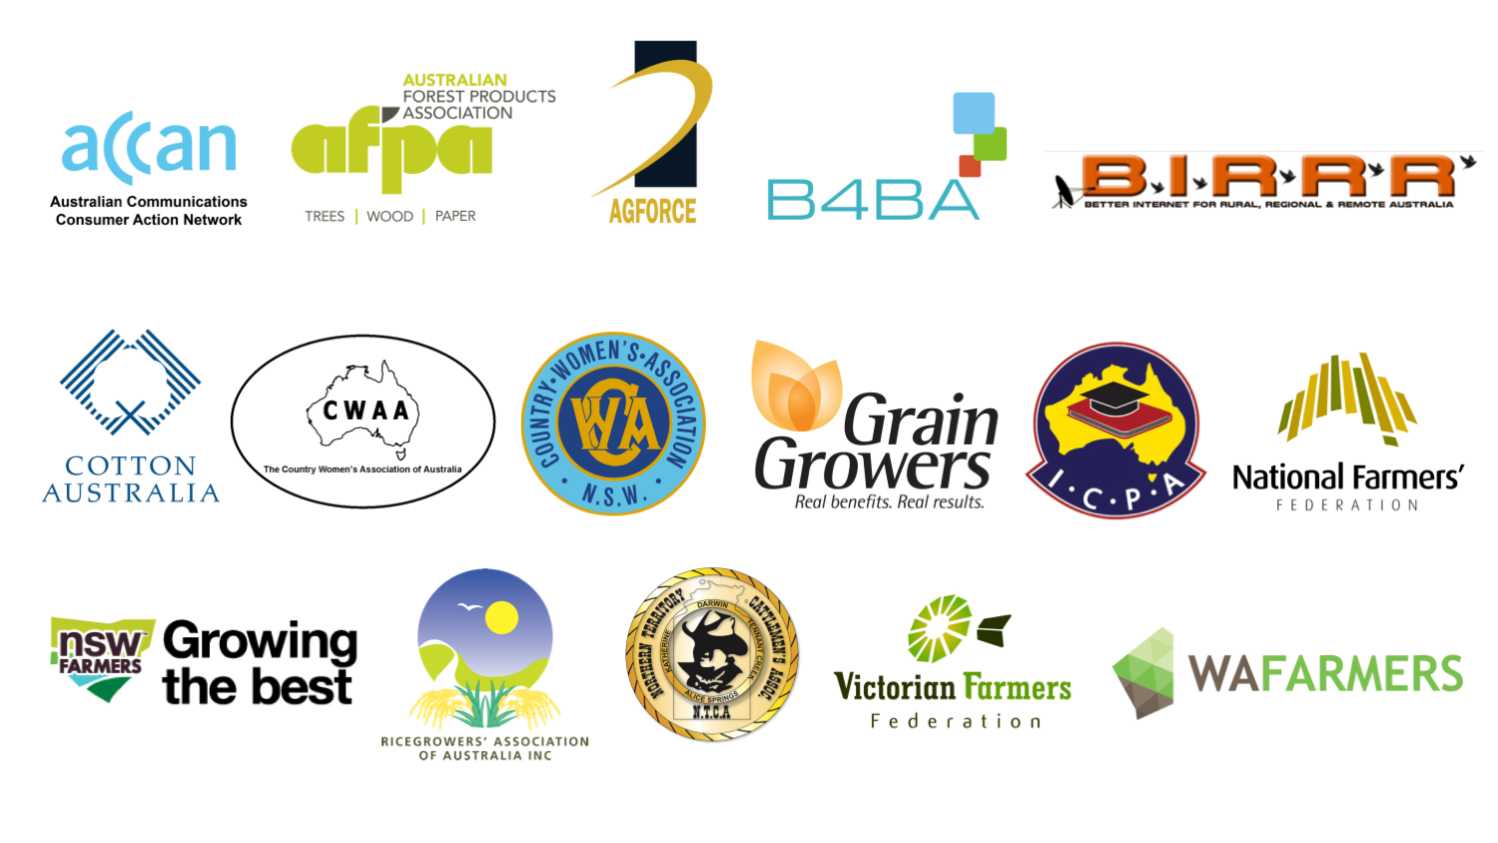

Member websites:
  - ACCAN
  - National Farmers’ Federation
  - Broadband for the Bush Alliance
  - NSW Farmers
  - Cotton Australia
  - Isolated Children’s Parents’ Association
  - Country Women’s Association of NSW
  - Country Women’s Association of Australia
  - Better Internet for Rural, Regional & Remote Australia
  - AgForce Queensland
  - GrainGrowers
  - Northern Territory Cattlemen’s Association
  - Victorian Farmers Federation
  - Ricegrowers’ Association of Australia
  - Australian Forest Products Association
  - WA Farmers

Media contact details:
ACCAN: Luke Sutton, luke.sutton@accan.org.au or 0409 966 931
NFF: Alison Penfold, media@nff.org.au or 0408 448 250
NSWFA: Kathleen Curry, curryk@nswfarmers.org.au or 0429 011 690
AgForce Queensland: Scott Whitby, whitbys@agforceqld.org.au or 0418 733 102
Cotton Australia: Samuel Evangelinos, samuele@cotton.org.au or 0421 761 336
Country Women’s Association of NSW: Danica Leys, d.leys@cwaofnsw.org.au or 0488 735 351
Isolated Children’s and Parents’ Association: Wendy Hick, fedpresident@icpa.com.au or 07 4995 3266
GrainGrowers: David Mckeon, David.McKeon@graingrowers.com.au or 0428 321 982
Australian Forest Products Association: Sara Bray, sara.bray@ausfpa.com.au or 0477 772 384
Better Internet for Rural Regional and Remote Australia: Kristy Sparrow, birrraus@gmail.com or 0429 853 482
Ricegrowers' Association of Australia: Leah Wythes, lwythes@rga.ord.au or 0488 071 165

