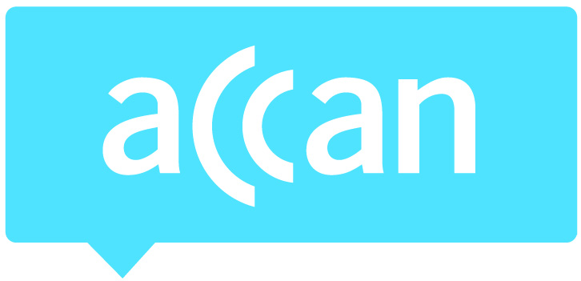
For immediate release 4 May, 2016

Free-to-air networks should use budget windfall for improved accessibility features
The Australian Communications Consumer Action Network (ACCAN) says that extra funding the free-to-air networks will keep from the 25 per cent cut to broadcast licence fees should be used to fund improved accessibility features such as better captioning and audio description. Funding these services would help to make free-to-air TV more accessible to consumers living with a disability. The 25 per cent reduction in licence fees announced overnight in the Federal Budget follows a 50 per cent decrease to the fees in 2013.
“The cuts to the broadcast licence fees are good news for the free-to-air networks,” said ACCAN Disability Policy Advisor, Wayne Hawkins. “This funding could be used to improve captioning on free-to-air TV for people who are Deaf or hard of hearing and to put in place technology that would allow the networks to introduce audio description for people who are blind or vision impaired.”
Currently free-to-air channels do not caption any additional programming on their multi channels other than repeated programs from their primary channel. Primary channels must caption all programming between 6am and midnight as well as all news and current affairs programs. There are no requirements for audio description to be included on free-to-air television and currently none of the free-to-air networks provide this service.
“We are calling on the free-to-air networks to commit to extra funding for these accessibility features on their TV channels so that all consumers can have equal access to content, news and current affairs programs,” added Mr Hawkins. “We would welcome the opportunity to work with the free-to-air networks to increase their accessible programming.”
The ABC has been running an audio description trial on its iView online catch-up service, however, ACCAN would like to see audio description introduced on the free-to-air primary channels so consumers who aren’t online can get access to audio described content. Recently the American Council of the Blind reached an agreement with Netflix which will see the online streaming service add audio description as well.
“Audio description on streaming services is a positive step for achieving equal access to content for consumers who are blind or vision impaired,” said Mr Hawkins. “However, ACCAN maintains that audio description should be available on free-to-air channels on television as not all consumers have access to internet services.”
For more information, contact Luke Sutton on luke.sutton@accan.org.au or 0409 966 931. For the latest updates, follow ACCAN on Twitter or like us on Facebook.

