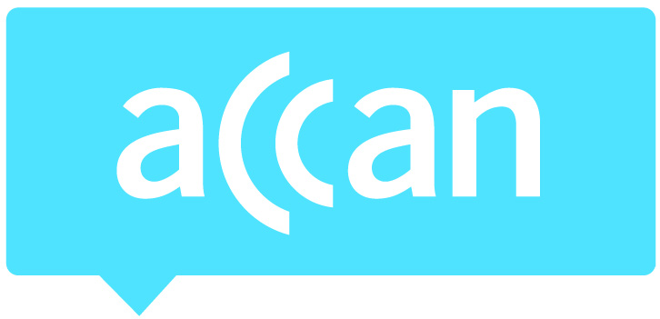
For immediate release 24 September, 2015

ACCAN calls on all telcos to introduce real time usage alerts
After a small but respectable drop in mobile bill shock due to usage notifications shown in the ACMA’s Spend Management Tools and Alerts Survey 2015, further gains need to be found through the introduction of real time notifications. Currently these warnings can be up to 48 hours out of date by the time consumers receive them. With high excess usage charges, you can rack up a significant debt without even realising it.
Currently Telstra is the only telco to announce real time usage notifications. The ACMA research showed that delays in receiving information are “the major cause for dissatisfaction with the alert system” and this is where consumers can get caught out. ACCAN is calling on all telcos to implement real time usage alerts so consumers know when they are approaching their limit and as soon as they have reached a limit. This would allow them to more easily manage their usage and avoid expensive excess charges.
The Telecommunications Consumer Protections (TCP) Code requirement to send SMS usage alerts only applies to residential consumers and some small businesses. ACCAN urges small business customers not receiving alerts to contact their telcos to see what usage tools are available to them to avoid bill shock.
For more information please contact Luke Sutton on luke.sutton@accan.org.au or 0409 966 931.

