Audio Description in Australia
Katie Ellis, Gwyneth Peaty, Leanne McRae, Mike Kent and Kathryn Locke
March 2019
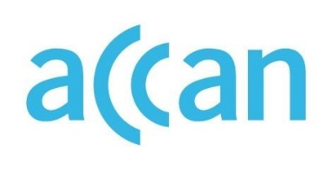
Audio Description in Australia
Authored by Katie Ellis, Gwyneth Peaty, Leanne McRae, Mike Kent and Kathryn Locke
Published in 2019
The operation of the Australian Communications Consumer Action Network is made possible by funding provided by the Commonwealth of Australia under section 593 of the Telecommunications Act 1997. This funding is recovered from charges on telecommunications carriers.
Curtin University
Website: www.curtin.edu.au
Email: Katie.ellis@curtin.edu.au
Telephone: (08) 9266 2509
Australian Communications Consumer Action Network
Website: www.accan.org.au
Email: grants@accan.org.au
Telephone: 02 9288 4000
If you are deaf, or have a hearing or speech impairment, contact us through the National Relay Service: www.relayservice.gov.au
ISBN: 978-1-921974-56-4
Cover image: created by Richard Van Der Male with images from Shutterstock
This work is copyright, licensed under the Creative Commons Attribution 4.0 International Licence. You are free to cite, copy, communicate and adapt this work, so long as you attribute the authors and “Curtain University, supported by a grant from the Australian Communications Consumer Action Network”. To view a copy of this licence, visit http://creativecommons.org/licenses/by/4.0/
This work can be cited as: Ellis, K., Peaty, G., McRae, L., Kent, M. & Locke, K. 2019, Audio Description in Australia, Australian Communications Consumer Action Network, Sydney.

Table of Contents
Table of Contents i
Figures and Tables iii
Acknowledgements 1
Executive Summary 2
Introduction 4
Background 6
A History of Audio Description 6
Audio Description Uses 10
Accessibility 10
Translation 11
Current and Potential Audiences 12
Blind and Vision Impaired Audience 14
Other Disability Groups and Mainstream Audience 14
Audio Description as a Human Right – The UNCRPD 16
Methodology 19
Findings 21
Phase I: Scoping Study – Audio Description in Australia 21
Availability of Audio Description in Different Formats 21
Availability of Audio Description at Cultural Events and Locations 32
Historical Free To Air Offerings of Audio Description – The ABC Trials 38
Legislation of Audio Description 40
Phase II: Scoping Study – Audio Description Around the World 45
Case Studies – An International Perspective 45
Barriers to Implementing Audio Description 56
Phase III: Focus Groups 60
Demographics 61
Lack of Awareness of Audio Description 62
Mainstream Benefits of Audio Description 63
Importance of Quality in Audio Description Production 65
Perceived Barriers to Accessing Audio Description 67
Demand for Audio Description 68
Conclusions 70
Recommendations 72
Authors 74
Appendix A: Focus Group Forum Questions 75
Glossary 77
References 78

Figures and Tables
Figure 1. Detailed timeline of milestones in audio description in the US since 1960 7
Figure 2. The long road to audio description in Australia 9
Figure 3. Timeline of more recent developments in audio description in Australia 9
Figure 4. EzyDVD audio description search webpage 22
Figure 5. Hoyts audio description search webpage 23
Figure 6. Village Cinemas audio description search webpage 24
Figure 7. Amazon Prime audio description search webpage 25
Figure 8. STAN email response re: audio description 26
Figure 9. BAM app preview 28
Figure 10. MovieReading app preview 29
Figure 11. Actiview app preview 30
Figure 12. Movies Anywhere app screenshot 31
Figure 13. Some audio described events at the 2018 Melbourne Fringe Festival 38
Figure 14. Facebook entry for the ACB’s Audio Description Project 46
Figure 15. Focus group forum introduction screenshot 60
Figure 16. Focus group demographics 62

Table 1. Benefits of audio description according to television genre 13
Table 2. Artback NT’s Disability Action Plan – Goal 1 35
Table 3. Ofcom’s UK targets for audio description 47
Table 4. Audio description targets in Irish television 2014-18 49
Table 5. Audio description targets in Irish television 2019-23 50
Table 6. Differing claims of implementation of the UNCRPD in Thailand 52
Table 7. The 5 year plan for the increase of airtime services for people with disabilities in Thailand 53
Table 8. Minimum audio description requirements on South African television 54
Table 9. Required bandwidth for the provision of audio description in India 58

Acknowledgements
This project was funded by an Australian Communications Consumer Action Network (ACCAN) research grant.
We thank ACCAN for seeing the value in this project and providing funding to see it go forward. We acknowledge the commitment of Tanya Karliychuk and Wayne Hawkins especially in providing valuable feedback and support throughout the duration of the project. Additional funding was provided by both Curtin University’s School of Media, Culture and Creative Arts and the Faculty of Humanities.
Our sincere thanks go out to all the people who participated in focus groups. It was a diverse group, with some having been advocating for audio description (AD) for almost 30 years and others only just hearing about it. Your enthusiasm for television, AD, and digital media was infectious!
A number of colleagues, community members and service providers have provided invaluable support and direction throughout the project, including Emma Bennison, Stefan Carey, Derek Otten, Alison Myers, Manisha Amin, Fran Mathey, Greg Madson and Erika Webb, as well as Rosemary Stevens, Kai-Ti Kao, Amna Siddiqui, Marissa Williams, and Andrew Maclean from Curtin University.
Ceridwen Clocherty’s assistance and attention to detail in preparing the final report has been of the highest quality. We also value the feedback from consumers and disability service providers who contacted us outside of the project to share their views about AD. The support of Curtin University and the Discipline of Internet Studies in particular has been integral in providing an energetic and supportive research environment.

Executive Summary
Audio description (AD) – also referred to as video description, video programming or descriptive video – is a track of narration which describes important visual elements of a television show, movie or performance included between the lines of dialogue. AD is broadly recognised as an essential feature to make television – as well as other visual media – accessible to audiences who are blind or vision impaired; however, it is increasingly being recognised as benefitting other disability groups as well as a more mainstream audience.
Australia is often described as the only English-speaking country in the OECD not to offer AD on free to air television, although it is available via some subscription services such as Netflix and some streaming and pay television providers. However, while a clear demand exists for this service, many Australians are unaware of how to access the limited services available. This demand led the Australian Federal government to convene an Audio Description Working Group to discuss options for implementing AD on free to air Australian television throughout 2017. In their final report the group suggested three delivery options – via free to air television, on catch-up online portals, or via a secondary app that could be synced with audio at the point of television viewing.
AD on television is vital for social inclusion for the blind and vision impaired community but also in order to raise understanding about what AD is within both this cohort and the wider community. The lack of AD is a Catch-22 situation – mainstream users don’t know what it is because it’s not on television, and it is not on television perhaps because people don’t know what it is or how to use it. This general lack of understanding about AD amongst the sighted community in Australia can in many ways be attributed to people never coming across it in their daily lives.
This report details the findings of the research project Audio Description on Australian television. The 9-month project reviewed the national and international availability of AD in telecommunications, art and culture, and conducted focus groups with both sighted and vision impaired television consumers to answer the following research questions:
- Where is AD available in the Australian telecommunications industry?
- How do consumers who could benefit from this service seek out information about it?
- What is the best way to communicate information about AD to consumers and broadcasters?
This report has three parts: Phase I reports on the availability of AD in Australian telecommunications, arts and culture via analysis of AD availability in different formats – in DVD releases, at cinemas, via video on demand (VOD) and online providers and as part of inflight entertainment, as well as which apps support the service and what illegal downloads are available. A state-by-state analysis of the provision of AD via significant cultural events is also included. The study also analysed historical offerings of AD on free to air television via the two trials conducted by the Australian Broadcasting Corporation (ABC) in 2012 and 2015-16. The section concludes with an overview of current legislation in Australia pertaining to AD.
Phase II focuses on the availability of AD in an international context. This study looks at the international availability of AD in a number of different countries, with reference to influences such as government policy, AD advocacy, international treaties regarding human rights such as the United Nations Convention on the Rights of Persons with Disabilities (UNCRPD), as well as accuracy of compliance reporting. Common international barriers to the implementation of AD are also discussed, focusing on copyright restrictions and cost.
Phase III of the report is concerned with the findings of, and offers discussion on, the results of the focus group stages of the research project. While people with vision impairments have been advocating for the introduction of AD for over 30 years, recently the mainstream benefits of this service are coming to light. This stage of the project supplanted insights obtained from people with vision impairments with research into the views of sighted people and other potential consumer groups who may also benefit from AD, including:
- Television fans
- Film students
- Parents of young children
- People with autism spectrum disorder (ASD)
- Audio book readers
To summarise respondents’ views on AD:
- A significant portion of sighted participants did not know what AD was;
- AD was seen to be useful to sighted people in a wide variety of contexts. For example, participants noted that due to an aging population, the mainstream need for AD is becoming more urgent as years pass. There were also a number of perceived benefits of AD, in particular in relation to increasing clarity and meaning of texts. Participants also claimed that AD has the potential to generate job opportunities in the entertainment and software industries;
- Both sighted and vision impaired participants believed quality of AD was very important. For example, the vast majority of participants preferred human AD to a synthetic voice and many participants suggested that successful AD needs to be integrated as part of the narrative, that is without interrupting the narrative;
- There were a number of perceived barriers to accessing AD. However, all sighted participants argued that AD should be available on television, regardless of whether they used it themselves;
- There was a high demand for AD among both vision impaired and mainstream television viewers, particularly once the latter group were aware of its uses.
The report concludes with recommendations that emerged from discussions with current and potential consumers of AD and analysis of international trends regarding advocacy and policy.

Introduction
On the 28 August 1929 the New York Times published an article about a recent cinema screening of Bulldog Drummond in which people who were blind and vision impaired were provided access to the visual image via audio description (AD). The article is reproduced in full below (“Blind and deaf at the movies” 1929, 58):

‘Blind and Deaf at the Movies.
One Hundred Applaud Talking Film at Special Showing.
More than 100 members of the New York Association for the Blind and the New York League for the Hard of Hearing attended a special performance of the talking motion picture “Bulldog Drummond” last night at the Theatre Moderne, in the Chanin Building.
An interlocutor explained the visual sequences for the blind when the dialogue was momentarily halted. Those without eyesight seemed to enjoy the performance, especially the humorous parts, and there was prolonged applause at the end of the film.
This performance is probably the first talking picture ever shown especially for the blind. Several theatres in and about New York have sound magnifying apparatus attached to the seats for the use of the hard of hearing during a dialogue picture. But to date no provisions have been made for “readers” to help the blind “see” a film.’

This was a significant moment in the history of access to audio-visual content for this group. Until then, this group had to rely on friends or family members to describe media events to them, be it in live performances or in the cinema. Indeed, it was the first time people who were blind or vision impaired were prioritised as an audience demographic in an audio-visual medium. Yet, nearly 90 years on, people who are blind or vision impaired still have to rely on the goodwill of family and friends to keep them up to date with visual events; this has been of particular note with the emergence of television. A more widespread provision of alternative modes of access such as AD would therefore offer improved opportunities for both media and social engagement for this group. However, despite much evidence to the contrary, there still exists a pervasive belief that this cohort does not watch television nor go to cinemas, and this in turn has led to a reluctance to promote such technologies.
AD – also referred to as video description, video programming or descriptive video – is a track of narration which describes important visual elements of a television show, movie or performance included between the lines of dialogue. AD is broadly recognised as an essential feature to make television – as well as other visual media – accessible to audiences who are blind or vision impaired (Utray, de Castro, Moreno, & Ruiz-Mezcua, 2012); however, it is increasingly being recognised as benefitting other disability groups (Garman, 2011) as well as a more mainstream audience (Mancuso, 2015).
Media accessibility approaches to AD recognise AD as essential to social inclusion and as a human rights issue. This is based on the understanding that television – as well as other media – has a social function of offering communities shared access to major events, news and popular culture. As will be outlined below, inaccessibility to television is a significant form of social exclusion, a denial of basic human rights. For example, the United Nations Convention of the Rights of People with Disability (UNCRPD) affirms the global disability community’s access to the media as a human right (see United Nations, 2006a, Article 30). Nevertheless, to date, it is not available on Australian broadcast television.

Background

A History of Audio Description
To better understand the reasonings for the comparatively slow uptake of AD as opposed to other accessibility features, it is important to first consider the historical timeline of AD technologies from both a worldwide and Australian perspective. Aside from the one-off 1929 cinema screening outlined in the introduction above, the first account of AD being made regularly available occurred in Spain in the 1940s when Gerardo Esteban, a radio presenter, began narrating films on the radio. Prior to this early AD, Esteban was known for narrating other forms of entertainment such as bullfights, theatre performances and football games (Orero, 2007). The radio service ran until the late 1950s. In the US, in 1964 US department of education administrator Chet Avery encouraged consumer groups affiliated with the blind and vision impaired to apply for funding to describe educational media, just as Deaf advocates were beginning to campaign for more accessible television through closed captions. Then, in the 1960s, in the continued absence of a formal AD service, communities of Star Trek fans began to share AD versions of the original television show on cassette tape (Cronin & King, 1998) – this became the first example of popular English-language media being made available to blind and vision impaired audiences through AD. Significantly, it was user-led and fan-based and began the development of more widespread AD provision (Figure 1).

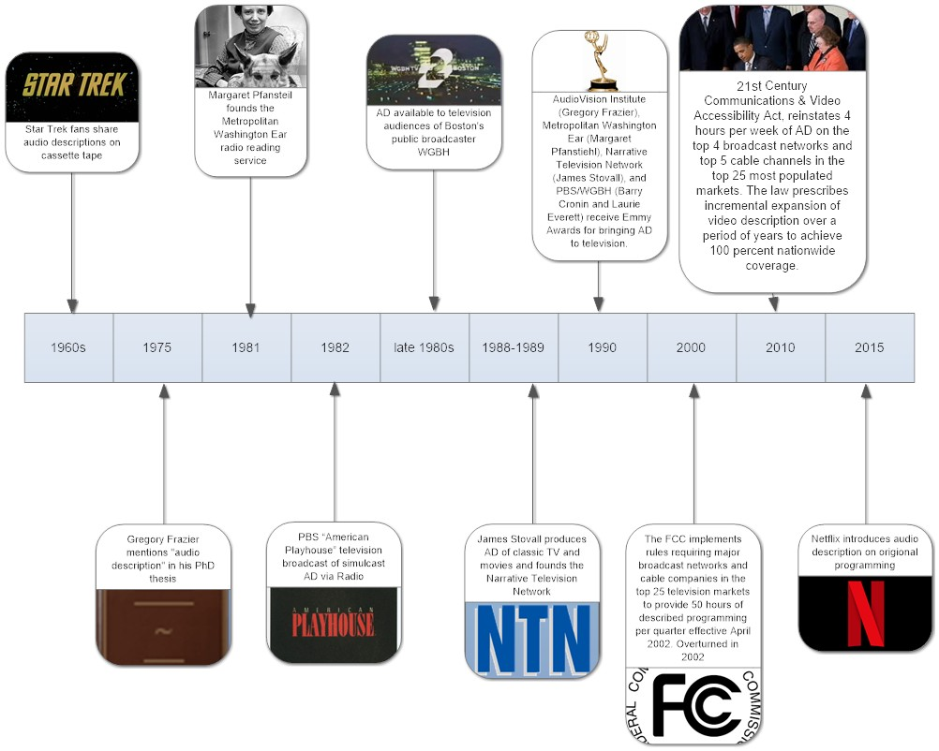
Figure 1. Detailed timeline of milestones in audio description in the US since 1960

In the 1970s, Gregory Frazier, a professor at San Francisco State University, began working on the concept of AD theatre. He founded AudioVision in 1972 to explore making media and live performances more accessible to people who are blind and vision impaired (DCMP, 2017). His 1975 Master’s thesis, ‘The autobiography of Miss Jane Pittman: An all-audio adaptation of the teleplay for the blind and visually handicapped’, was an AD adaptation of the television–film drama ‘The autobiography of Miss Jane Pitman’ (Frazier, 1975). The creative praxis explored historical attempts to entertain audiences of blind and vision impaired people, as well as an analysis of the teleplay itself to determine what information should be audio described to increase listener comprehension, and where this narration could be inserted. Finally, Frazier explored the creative approach to developing an AD television script. He concluded (Frazier, 1975):
“Although the all-audio adaptation appears successful in theory, the ultimate test of its validity lies in recording the drama for testing with a blind and visually handicapped audience.”
This then led, throughout the 1970s and early 1980s, to Dr Margaret Pfanstiehl offering Frazier’s “ultimate” test through her work with the Metropolitan Washington Ear Reading Service. Pfanstiehl worked with both theatre and public television officials to develop technology to facilitate the provision of AD to audiences who were blind or vision impaired. Just as Gerardo Esteban had in 1940s Spain, Pfanstiehl utilised a cross-technology AD simulcast using radio, albeit this time pared with television rather than cinema, of the PBS show American playhouse (Lewis, 2017). This radio–television simulcast arrangement was also used in Europe throughout the 1990s. Pfanstiehl was awarded an Emmy in 1990 for her work with the Metropolitan Washington Ear Reading Service to bring AD to television (Bernstein, 2009). Three other organisations facilitating AD on television also received Emmys that year – Gregory Frazier’s AudioVision Institute, James Stovall’s Narrative Television Network and Barry Cronin and Laurie Everett from PBS/WGBH (Lewis, 2017). Throughout the 1990s these four organisations developed initiatives, conferences and best practice guidelines for the provision of AD while offering AD movies, television shows and theatre performances.
Indeed, it is these guidelines and policy changes which are now advancing the provision of AD in many countries. According to Media Access Australia, in 2017 AD was available on broadcast television services in the UK, US, Canada, New Zealand, Ireland, Germany, Spain, Italy, Poland, France, Portugal, the Czech Republic, Korea, Thailand, Austria, Switzerland, Belgium and a number of other European countries (Figure 2). However, the timeline of AD provision in Australia has been longer than that of many other countries, and continues to lag behind (Figure 3).
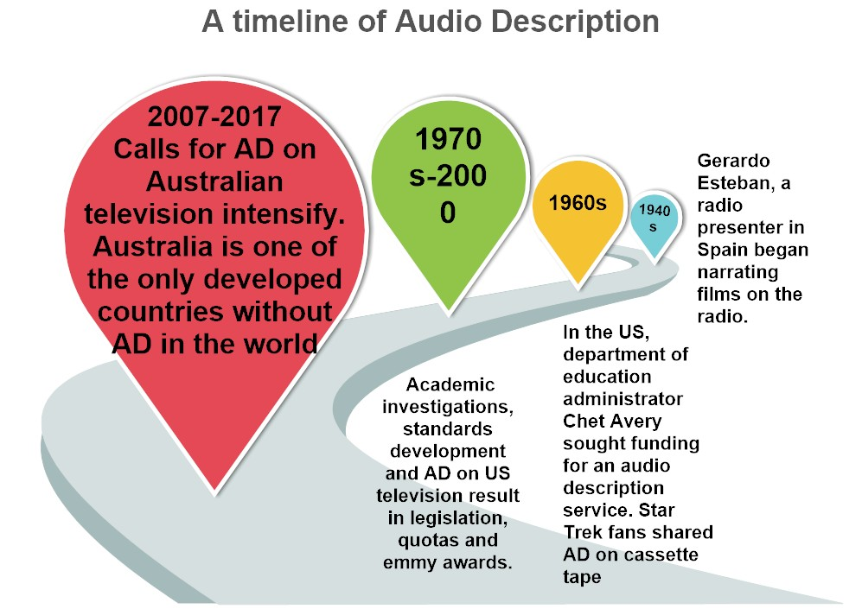
Figure 2. The long road to audio description in Australia
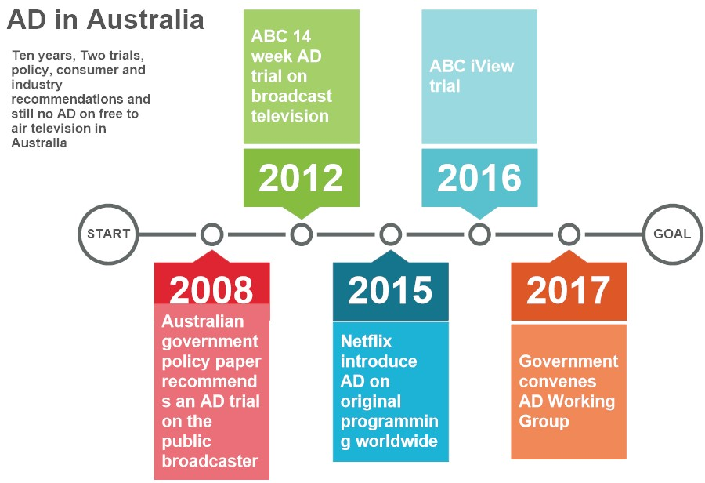
Figure 3. Timeline of more recent developments in audio description in Australia
This shortcoming was despite the hope that, from 2012, during the transition from analogue to digital television broadcasting in Australia, things would start to change. Government policy documents predicted a more widespread availability of AD as a result of increased bandwidth available via digital television (Ellis, 2014a), and the importance of industry competition and innovation were also highlighted as a potentially positive move. Further, advances in technology meant that most smart television sets began to also include the ability to broadcast AD, and AD formats such as apps were beginning to become more accessible and user-friendly. Indeed, the optimism regarding these predictions paved the way for a 14-week AD trial on ABC1 in 2012, and a second trial on ABC’s catch-up portal iView in 2015-16.
In addition, following several years of delay, subscription VOD was launched in Australia in 2015 with the introduction of Netflix, Stan and Presto within several months of each other. Netflix began offering AD on original programming within 1 month of launching; this was the first time Australians had access to a reliable and ongoing AD service. In turn, Netflix’s success with AD led to the further introduction of the service via other subscription services – such as through the BAM (Big Access Media) app integration with Foxtel Nickelodeon and Discovery channels – as well as some availability via iTunes.
However, this, albeit limited, success in subscription services was not reflected in free to air services. The ABC trials were not continued and, despite both advances in technology and repeated calls to remedy this situation, at present AD is not available at all via broadcast television in Australia. Even more troubling is the fact that AD tracks have been created but there is no mechanism to broadcast them in this country. Popular Australian soaps Neighbours and Home and Away, for example, are produced with AD for overseas release in the UK where AD is ubiquitous on broadcast television, yet the content is not available here. Indeed, issues remain regarding access to AD in a number of different formats – on overseas content imported into Australia (despite it having AD content when distributed elsewhere), on Australian television drama AD content only being available for international distribution, as well as regarding the back catalogue of AD content created with funding from the Australian screen funding agency Screen Australia that has never been made available to local television audiences.

Audio Description Uses
While AD may have received limited attention in the Australian context, internationally there are two clear academic research approaches taken to AD uses – accessibility and translation. These approaches are closely tied to the history of AD – as well as the prevalence of English language-based media – in different parts of the world. For example, whereas US and UK research proceed from an accessibility perspective, in Europe AD is considered a form of translation rather than as an activist issue (Szarkowska, 2011). This report’s focus is primarily on AD as an accessibility issue.

Accessibility
Media accessibility approaches to AD recognise AD as essential to social inclusion and as a human rights issue. This is based on the understanding that television – as well as other media – has a social function of offering communities shared access to major events, news, and popular culture. As will be outlined below, inaccessibility to television is a significant form of social exclusion, a denial of basic human rights.
Elizabeth Ellcessor’s notion of the “preferred user” as a way to consider “specific arrangements of bodies, technology, culture, and power” (Ellcessor, 2016) offers important foundational insights to the provision of AD as a media accessibility issue. When it comes to technology, Ellcessor explains, the preferred user is typically white, affluent, and able-bodied, - an image or representation that comes to stand in for the “default experience of a medium” (Ellcessor, 2016, p. 63). A consideration of a disabled user, however, reveals “actual uses and user positions” that undermine the normative assumptions that surround users of technology. Ellcessor (2016, p. 77) identifies the preferred user of television as similarly able-bodied:
“A television set assumes an audience capable of receiving audiovisual material; captions are opt-in, and video description is only rarely available. Such technologies maintain the hegemony of the preferred user position through their materiality and their status as a default; in doing so, they uphold an able-bodied norm regarding media and society more broadly.”
Further, Ellis, Kent, and Locke’s recent article about potential mainstream users of AD represents a new approach within the academic literature in which technological innovation and user engagement could result in a new market for AD (Ellis, Kent, & Locke, 2018). Proceeding from the social construction of technology (SCOT), the authors interrogate Ellcessor’s notion of the preferred user as it disregards disability. They posit that different interpretations of how AD can be delivered – determined through a process of user engagement as well as continued industry creativity and innovation – may finally shift the stagnating discussions around AD provision, and thus ultimately change the accessibility of television for the blind and vision impaired. Their approach is firmly located within an increasing tradition of digital flexibility whereby adaptations made to assist people with disability are actually of benefit to the mainstream population (Bownlee, 2016; Reena, 2009).

Translation
Two key areas of concerns arise in the European literature regarding the provision of AD. Firstly, the impact of cultural differences in its provision and, secondly, the absence of guidelines or standards. Orero’s 2008 research into the differing approach taken by audio describers in America, Spain and Greece reveals significant cultural differences. For example, while describers in Spain and Greece focus on vivid descriptions of action, the US describers insert cinematic descriptions of camera movements. In addition, Greek describers include the perceived emotions of characters in their descriptions, while US describers focus on the technical features of the film. Differences in tense are also apparent, with Spanish and Greek describers communicating in the past tense with US describers generally adopting present tense descriptions.
In addition, there is currently no official international standard for the provision of AD (Fryer, 2016); this could be seen as one reason that different countries take different approaches to both the creation of the script and the technological means of delivery (Orero, 2008). This lack of international standard was highlighted in Australia’s recent Audio Description Working Group’s Final Report as a barrier to the implementation of AD in Australia (Department of Communications and the Arts, 2017a). For example, proceeding from a translation perspective, Orero (2008, p. 191) highlights the importance of guidelines to facilitate greater access to AD across the world:
“Notwithstanding the obvious cultural differences among the many European languages and cultures, some basic, common framework may be agreed upon and applied. Descriptive guidelines will prove useful for the creation of AD scripts which could then be translated, and perhaps even stored in a data-bank from which broadcasters could download them. This way, the few available resources for media accessibility will be optimized, giving rise to a more systematized and better-quality audio description.”
Yet the need for a both guidelines and the creation of a repository of AD continue to be discussed a decade later with little action. This is despite the fact that, with the increasing internationalisation of television, the availability of AD created in different locations could be of great benefit to people in other locations where AD is not as widely available such as in Australia.
AD guidelines around the world similarly take a differing approach to AD and who requires it. For those countries which have guidelines in place, a number of core themes for the provision of AD can be identified, including what is described, objectivity and delivery technique. Yet there are also many differences. For example, while AD is intended primarily for people who are blind or with some vision loss, in some guidelines it is expected that most users may have partial sight or will have had sight previously (American Council of the Blind [ACB], 2010, 2017a and b; World Blind Union, 2016). Some standards also recognise that other people may also benefit from AD’s “concise, objective ‘translation’ of the key visual component of [a media text]” (ACB, 2010, p. 8). For example, the French charter on AD includes the elderly, sick people and people learning the language (Rai, Greening, & Petre, 2010). There are also differing guidelines offered for the type of text, for example performing arts or visual art.

Current and Potential Audiences
Prior research conducted in the Department of Internet Studies at Curtin University identifies three clear audiences for AD in Australia:
- People who are blind or vision impaired.
- People within other disability groups, such as those with autism spectrum disorder (ASD) or an intellectual disability.
- Mainstream audiences who wish to individualise their television experience.
This section of the report discusses both the current – and, importantly, potential – audiences for AD in Australia. Table 1 outlines the benefits of AD to these three broad groups.

Table 1. Benefits of audio description according to television genre
Genre | Examples of benefits to different audiences:
 | Blind and visually impaired | Other disability groups | Mainstream
News /  current affairs / documentaries | Identified by Vision Australia clients as top three genres they want audio described (Vision Australia, 2014). Documentaries were the most sought after genre in the 2015-16 iview trial (ABC, 2016) and in the 2012 trial was in the top two genres (ABC, 2012). However, other studies suggest it is inappropriate to audio describe the news (Fryer, 2016). | Helps people with ASD understand human emotion and engagement (Garman, 2011). | Visual indexing for thematic information retrieval is useful in media education, newsrooms (Turner & Mathieu, 2007) and creating a television database (Caldera-Serrano, 2010).
Cooking | Identified as a highly visual genre (Sueroj & Sarakornborrirak, 2016). | Teaches people with intellectual disability important life skills (Mechling, Ayres, Bryant, & Foster, 2014).
Drama | Findings from the ABC trials suggest drama is best suited to AD (ABC, 2012, 2016). Drama was in the top two genres of the 2012 free to air trial (ABC, 2012). | Helps people with ASD understand human emotion and engagement (Garman, 2011). | For fans / those interested in the show by offering another layer of information (Mancuso, 2015) as well as for people multitasking (Mills, 2015).
Kids’ television | Promotes literacy, social skills and comprehension, vital on children’s television which tends to be very visual (Kleck, 2015). | Helps people with ASD understand human emotion and engagement (Garman, 2011). | Acquisition of vocabulary for all children (Peskoe, n.d.).
Educational television | Promotes literacy, social skills, and comprehension (Kleck, 2015). | Students with ASD indicate a preference for audio (Bennett, Gutierrez, & Honsberger, 2013). | Improved comprehension (Hoffner, Baker, & Quinn, 2017), multimedia literacy (Mills, 2015), acquisition of new vocabulary (Peskoe, n.d.) and video-based medical education (Mills, 2015).

Blind and Vision Impaired Audience
As Lauren Henley from Blind Citizens Australia (BCA) explains, access to television is integral to social inclusion in Australian society (Henley, 2012):
“You might think that missing out on television is no great loss, but it’s about more than watching the latest episode of Days of our Lives. Like the rest of my friends and family, I want to have choice about what I watch and have the ability to be informed about what is going on in the world. I lost many things when I lost my sight, but one of the things that I lost was social inclusion.”
As can be seen from this quote above, inaccessibility to television is a significant form of social exclusion for everyone in society. However, because television is a visual medium, there is a pervasive cultural assumption that people who are blind or vision impaired do not engage with television and therefore do not require any assisted access (Cronin & King, 1998; Social_Darianism, 2015) – this contrasts greatly with popular acceptance of the need for closed captioning for d/Deaf and hard of hearing audiences. Despite this, several surveys since the 1960s show that people with vision impairment do in fact watch television and appreciate the social nature of television viewing (American Foundation for the Blind [AFB], 1997; Cronin & King, 1998; Ellis, 2014a). For example, a US study of AD during the 1980s cites a viewer with vision impairment’s description of the experience of watching television with AD (Cronin & King, 1998):
“…. [It was] very emotional. I found myself pacing the floor in tearful disbelief. It was like somebody had opened a door into a new world, in which I was able to see with my ears what most people see with their eyes.”
For people who are blind or vision impaired, gaining full access to television programming – therefore permitting this social inclusion – requires AD on both drama and documentary programming, audio navigation of interactive services such as an electronic programme guide (EPG), and access to graphical user interfaces for people with residual vision (Utray et al., 2012). While historically these affordances have been technologically challenging, the introduction of digital forms of television now offers an opportunity to make these features more available. For the more than 575,000 people in Australia reported to have vision impairment (National Disability Insurance Scheme [NDIS], 2015), any increased availability of AD could result in a considerable audience.
However, cost is a significant factor for this community. With AD only available via paid subscriptions or purchases, people with blindness and vision impairment are being left behind; even the costs associated with the internet connections and hardware required to access VOD are prohibitive. Pedlow therefore recommends a broader universal design approach to accessibility to make technology accessible and useable for all with varied needs (Pedlow, 2008).

Other Disability Groups and Mainstream Audience
The digital media environment is characterised by choice – people can employ a variety of tools to find the content relevant to them. Indeed, television producers are increasingly recognising the importance of smaller niche audiences and, as Napoli argues, despite content at times only attracting a small audience, “when these audiences are aggregated, they are quite significant” (Napoli, 2011, p. 59). For example, Netflix targets specific and niche audiences through targeted recommendations.
However, difficulty in accessing the back catalogue of AD content suggests a lack of knowledge amongst the industry, particularly from broadcasters and producers, about the importance of AD and its potential to attract new audience sectors, both mainstream and those with other disabilities. While AD would be of most benefit to audiences who are blind or vision impaired, increasing advances in technology – and associated increase in user engagement – are resulting in the emergence of an unexpected audience demand for AD content. Indeed, research by Judy Garman and 3Play Media note that the benefits of AD extend beyond the vision impaired community (Garman, 2011). That is, as its advantages become more known, others are embracing its features, including people with intellectual disabilities, people whose first language is not English, the elderly, as well as the non-disabled mainstream audience. These groups can be expanded to also include:
- People with an intellectual disability in an educational setting who benefit from receiving both visual and audible information (Mechling & Collins, 2012);
- People with ASD who may have difficulty deciphering facial expressions and emotion (Garman, 2011; Mills, 2015). This group also report educational benefits as students with ASD have a strong preferences for voice-over narration on instructional videos (Bennett et al., 2013);
- Children in an educational setting. The development of literacy and vocabulary and the development of descriptive writing skills can be improved through modelling using AD (Hoffner et al., 2017). The International Literacy Association describes AD as an instructional tool that can help “students improve their writing abilities and their attention to details while experiencing a new technology” (Hoffner et al., 2017). The association shows an example whereby students’ comprehension of a video scene is compared – students watch a lesson without, and then with, AD – and suggests AD offers the opportunity for increased comprehension;
- People who need to access video-based education. For example, audio described videos have been advertised as aids for multimedia literacy, for “eyes-free viewing” by sighted people (e.g. while driving) and as a benefit in video-based medical education (Mills, 2015);
- Those wanting another tool in which to create more easily accessible transcripts and image databases (Turner & Mathieu, 2008);
- People who need to switch focus between watching television and other tasks (Udo, Acevedo, & Fels, 2010);
- Fans of particular programmes who wish to find out more information about the content of television shows (Mancuso, 2015).
This last bullet point is one which is gaining a lot of interest and one which is already being used by the mainstream population. For example, viewers of Sense 8, a Netflix series well known for its convoluted storyline, note the usefulness of the AD track (Mancuso, 2015), and Netflix now promote the entertainment potential of their AD service to augment consumer experience of such shows. As communities of fans converge online to discuss key moments of popular television programming, the increased information about the programmes via AD can be seen as offering an important fan resource. There is even the opportunity for newsrooms to create image databases to enable them to respond more quickly within the 24-hour news cycle. Indeed, the benefits go beyond just an improved user experience for everyone – technology companies such as Apple and Google recognise that solving accessibility problems will also result in a commercial advantage (Bownlee, 2016; Reena, 2009).
Finally, the increasing personalisation of television – both through an increase in programming options such as VOD and due to the rise in the preference for individualised devices – offers an opportunity to introduce accessibility features as an option for all (Ellis, 2014b, 2015; Ellis & Kent, 2015). These personalised accessibility options are not just for their ‘obvious’ markets – it is also predicted that AD will become increasingly mainstreamed as the general population discover, and embrace, its convenience. As such, when Netflix introduced AD on their original programming in 2015, they also recognised its more mainstream benefits and normalised the feature, describing it as “just like choosing the soundtrack in a different language” (Wright, 2015). Such an approach has also been embraced by Apple TV which is marketed as being accessible ‘out of the box’, with an audio remote control being one of its main features.

Audio Description as a Human Right – The UNCRPD
While it can be seen that Australian free to air television still features no AD content, advocates are looking to change this, citing access to television via AD as a basic human right. Two key human rights documents – the United Nations (UN) Universal Declaration of Human Rights (UDHR) (UN, 1948) and the UNCRPD (UN, 2006a&b) – support this. While not mentioning AD specifically, these advocate fundamental equal access to all forms of media and can therefore be taken to also include access for the blind and vision impaired via AD.
For example, Article 19 of the Universal Declaration of Human Rights (UN, 1948) establishes the right to freedom of expression:
“Everyone has the right to freedom of opinion and expression; this right includes freedom to hold opinions without interference and to seek, receive and impart information and ideas through any media and regardless of frontiers“(Article 19).
Further, the media in general and television in particular have a key role in realising Articles 22 and 27 (Ellis & Goggin, 2015; UN, 1948):
“Everyone, as a member of society… is entitled to realization, through national effort and international co-operation and in accordance with the organization and resources of each State, of the economic, social and cultural rights indispensable for his dignity and the free development of his personality” (Article 22).
“(1) Everyone has the right freely to participate in the cultural life of the community, to enjoy the arts and to share in scientific advancement and its benefits” (Article 22).
Article 21 of the UNCRPD (UN, 2006a&b) extends the 1948 Declaration’s focus on the right to freedom of expression and participation specifically to people with disabilities:
States Parties shall take all appropriate measures to ensure that persons with disabilities can exercise the right to freedom of expression and opinion, including the freedom to seek, receive and impart information and ideas on an equal basis with others and through all forms of communication of their choice, including by:
- Providing information intended for the general public to persons with disabilities in accessible formats and technologies appropriate to different kinds of disabilities in a timely manner and without additional cost;
- Accepting and facilitating the use of sign languages, Braille, augmentative and alternative communication, and all other accessible means, modes and formats of communication of their choice by persons with disabilities in official interactions;
c) Urging private entities that provide services to the general public, including through the Internet, to provide information and services in accessible and usable formats for persons with disabilities;
d) Encouraging the mass media, including providers of information through the Internet, to make their services accessible to persons with disabilities;
e) Recognizing and promoting the use of sign languages – Article 21.
The UNCRPD sets out the fundamental human rights of people with disability such as access to education, the community and media. Significantly, the UNCRPD recognises access to television as a human right in the same way access to appropriate health care is a human right. For example, Article 30 focuses on “participation in cultural life, recreation, leisure and sport” (UN, 2006a), again referring back to the concerns of the 1948 Declaration:
States Parties recognize the right of persons with disabilities to take part on an equal basis with others in cultural life, and shall take all appropriate measures to ensure that persons with disabilities:
“a) Enjoy access to cultural materials in accessible formats;
b) Enjoy access to television programmes, films, theatre and other cultural activities, in accessible formats;
c) Enjoy access to places for cultural performances or services, such as theatres, museums, cinemas, libraries and tourism services, and, as far as possible, enjoy access to monuments and sites of national cultural importance” (Article 30).
Again, while there is no specific mention to AD within the articles, the UNCRPD has prompted an increased awareness of all forms of access amongst accessibility policies and protocols both in Australia and around the world. As of 2018, it has 162 signatories and 177 ratifications and accessions. Its impact has particularly been seen in the medium of television and significant changes have been initiated in many national policies to change broadcast media laws.
However, there still exists a trend of gaps and absences in the policy rhetoric and real-life conditions for people with disabilities with reference to AD, even within those countries that have signed and ratified the UNCRPD. A 2013 review of the implementation of protocols related to assistive technology, information and communications revealed that while there were high levels of commitment (64%), there were much poorer rates of implementation (29%) (Gould, Leblois, Cesa Bianchi, & Montenegro, 2014, p. 3). Only 36% of countries have actual laws and legislation that define accessibility for electronic media (Gould, Leblois, Cesa Bianchi, Montenegro, & Studer, 2012, p. 14). Many countries have fallen dramatically short on providing real and tangible legislative and regulatory procedures for ensuring the integration of accessibility within broadcast media and online sites. Surprisingly, there were some large disparities between the level of commitment and the capacity for implementation. For example, North America rated a 90% commitment to the UNCRPD with a 56% capacity for implementation; however, the implementation and impact level was 96%. In contrast, Oceania only registered a 57% commitment with a 30% capacity for implementation but had a 62% implementation and impact score (Gould et al., 2014, p. 3). In many circumstances, these variable outcomes verify an external commitment to equal rights for people with disabilities but also highlight a lack of political will to enact legislation and compliance to enshrine those principles.
Further details on how all aspects of media are legislated both in Australia and overseas – including any specific reference to AD – are outlined in the legislation section of Phase I and within the international case studies in Phase II of this report.

Methodology
The project adopted a qualitative approach in order to answer the following research questions:
- Where is AD available in the Australian telecommunications industry?
- How do consumers who could benefit from this service seek out information about it?
- What is the best way to communicate information about AD to consumers and broadcasters?
The project adopted a multi-modal methodology across two phases:
Phases I and II: Scoping Studies
Two scoping studies were undertaken. The first looked into the availability of AD in Australia in order to gain a comprehensive overview of the factors contributing to the current situation. This stage encompassed analysis of AD availability in different formats – in DVD releases, at cinemas, via VOD and online providers and as part of inflight entertainment, as well as which apps support the service and what illegal downloads are available. A state by state analysis of the provision of AD via significant cultural events is also included. The study also analysed historical offerings of AD on free to air television via the two trials conducted by the ABC in 2012 and 2015-16. The section concludes with an overview of current legislation in Australia pertaining to AD.
A second scoping study was held to establish the availability of AD on free to air television throughout the world. This study focused on the international availability of AD in a number of different countries, with reference to influences such as government policy, AD advocacy, international treaties regarding human rights such as the UNCRPD, as well as accuracy of compliance reporting. Common international barriers to the implementation of AD are also discussed, focusing on copyright restrictions and cost.
Phase III: Focus Groups
While people with vision impairments have been advocating for the introduction of AD for over 30 years, recently the mainstream benefits of this service are coming to light as has been outlined in the previous section. This stage of the research supplanted insights obtained from people with vision impairments with research into sighted people and other potential consumer groups who may also benefit from AD, including:
- Television fans
- Film students
- Parents of young children
- People with ASD
- Audio book readers
Focus groups were held in a secure, accessible online forum. Participants were asked to view a clip and then respond to questions. Their responses were then summarised into five main themes – the lack of awareness of AD, the mainstream benefits of AD, the importance of quality in AD production, their perceived barriers to accessing AD and, finally, how these all affected their demand for the feature.

Findings

Phase I: Scoping Study – Audio Description in Australia
AD is now available via broadcast television in the UK, US, Canada, New Zealand, Ireland, Germany, Spain, Italy, Poland, France, Portugal, the Czech Republic, Korea, Thailand, Austria, Switzerland, Belgium and a number of other European countries. Australia is the only English speaking nation in the OECD not to offer AD on television.
Although AD is not available on free to air television in Australia, there are many instances in which it is available in both the audio-visual and arts sectors. This part of the report outlines findings of the Phase I Scoping Study encompassing analysis of AD availability in different formats in Australia – in DVD releases, at cinemas, via VOD and online providers and as part of inflight entertainment, as well as which apps support the service and what illegal downloads are available. A state by state analysis of the provision of AD via significant cultural events is also included. The study also analyses historical offerings of AD on free to air television via the two trials conducted by the ABC in 2012 and 2015-16.

Availability of Audio Description in Different Formats

DVD Releases
DVDs are the most reliable way for Australians to access audio described film and television content. Following a 2005 government grant to the Australian Captioning Centre to audio describe 10 DVDs, the availability of AD has grown to about 25% of all DVDs released.
This availability of audio described DVDs has grown for two reasons. Firstly, the Australian screen funding agency Screen Australia requires all films that receive funding to create an AD track, and these are often released on DVDs, although not always. Secondly, the availability of AD worldwide has increased dramatically as a result of international legislation such as the 21st Century Communications and Video Accessibility Act (2010) in the US. With AD tracks being created for a significant amount of screen content internationally, these are added as extra features to DVDs imported into Australia.
In addition, audio described DVDs such as the international ones outlined above are now also readily available online. However, while individual titles can be searched for in any online video store catalogue this does not always result in a clear indication of whether AD is available, particularly because producers and distributors do not list the availability of AD consistently. For example, it may be called AD, audio description, descriptive video or English description, and may also be inconsistently recorded either in the language or audio field. EzyDVD is the only Australian DVD store that provides a complete list of audio described DVDs (Figure 4) (EzyDVD, 2018).
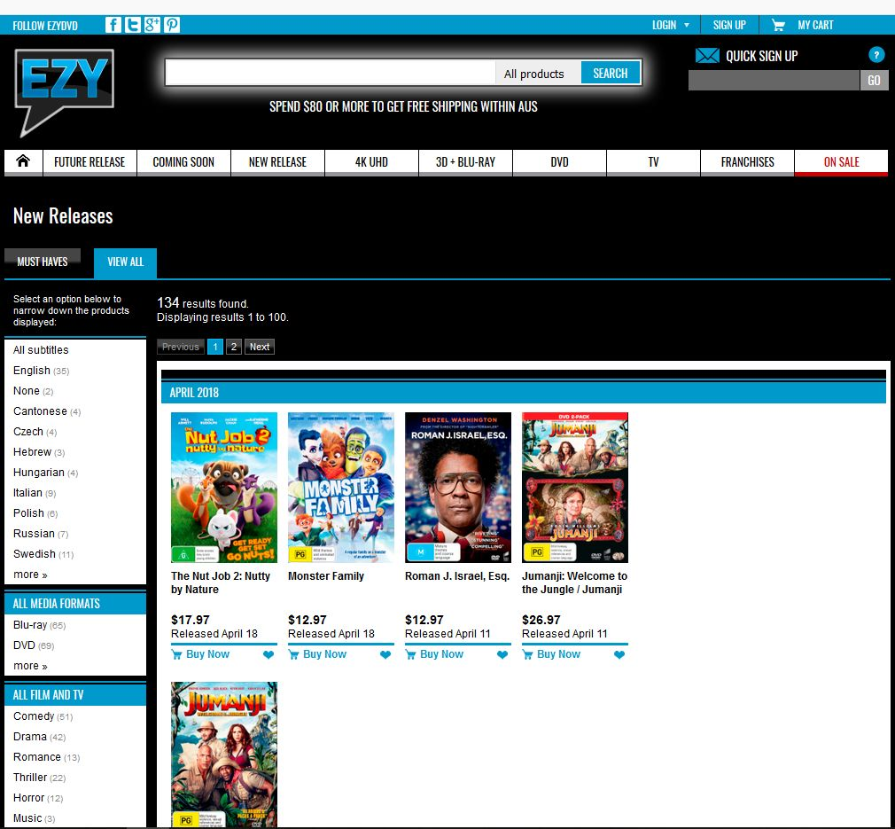
Figure 4. EzyDVD audio description search webpage
In addition, AD DVDs can also be borrowed from local libraries. Nearly all library cataloguing in Australia follows the same sets of rules to comprehensively catalogue audio-visual material; libraries follow a convention called MARC21 which is a set of agreed ‘tags’ that cataloguers use to allow uniformity and ease in description and access. In the case of AD, the tag is called 546 – Language Note. If AD is listed on the DVD a language note will be listed in the 546 tag. Searching for ‘audio description’ in library catalogues should therefore return a list of items with AD noted in the 546 tag.

Cinemas
Cinemas in Australia first began offering AD in 2009; however, the service was limited to 12 screens in remote Australian locations. As cinemas began to shift to digital technologies, the four major cinema chains – Hoyts, Village Cinemas, Event Cinemas (including Greater Union and Birch Carroll & Coyle) and Reading Cinemas – announced a joint commitment to rollout AD as part of the Department of Social Services funded Cinema Access Implementation Plan. They promised to provide AD on 242 screens in 132 cinema locations by 2014 to provide around 840 accessible movie sessions each week.
To date, Hoyts, Village Cinemas and Event Cinemas have made AD available at select locations and movie sessions (Figures 5 & 6). Accessible sessions are accompanied by the initials AD, and can be searched for via the dedicated AD search pages on their websites. Wireless headsets or neck loops are provided for the session. All Reading Cinema locations are equipped with CCAD which stands for Closed Caption & Audio Description Device available. Again, their website can direct audience members to which sessions are AD compatible – they also encourage users to contact the cinema directly if a suitable session cannot be found.
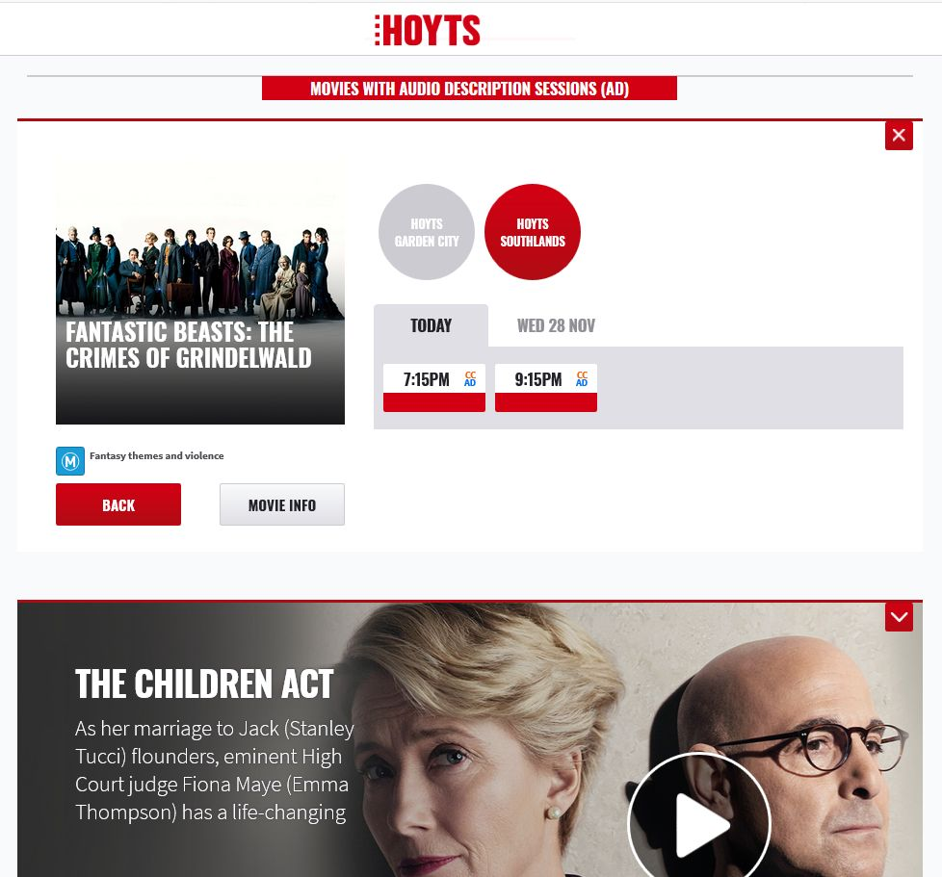
Figure 5. Hoyts audio description search webpage
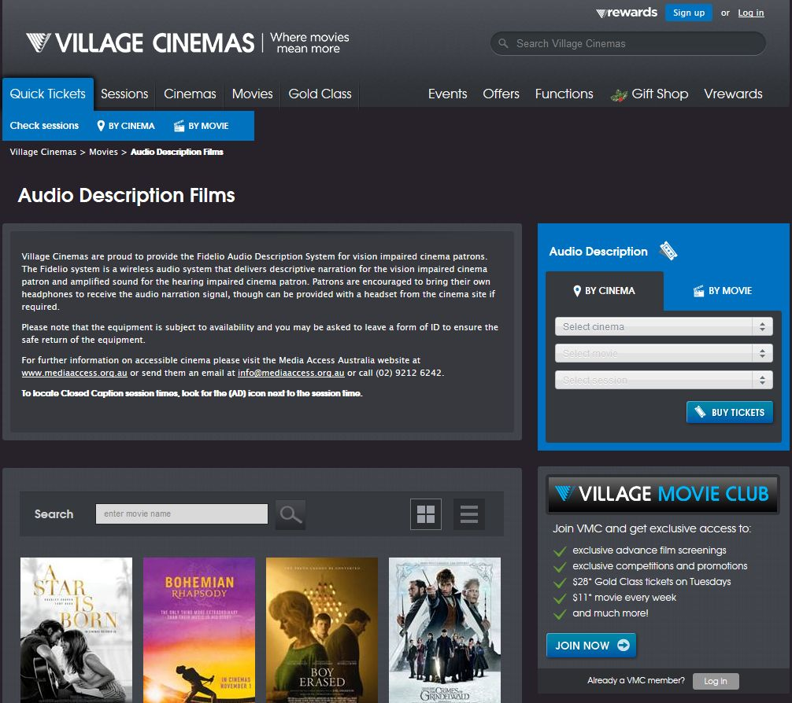
Figure 6. Village Cinemas audio description search webpage

Video on Demand and Online Providers
As mentioned above, AD is currently not available on free to air television in Australia. However, there is some limited availability in a subscription capacity via VOD and online services, including on Netflix, iTunes, Amazon Prime (Figure 7), Hulu and Stan.
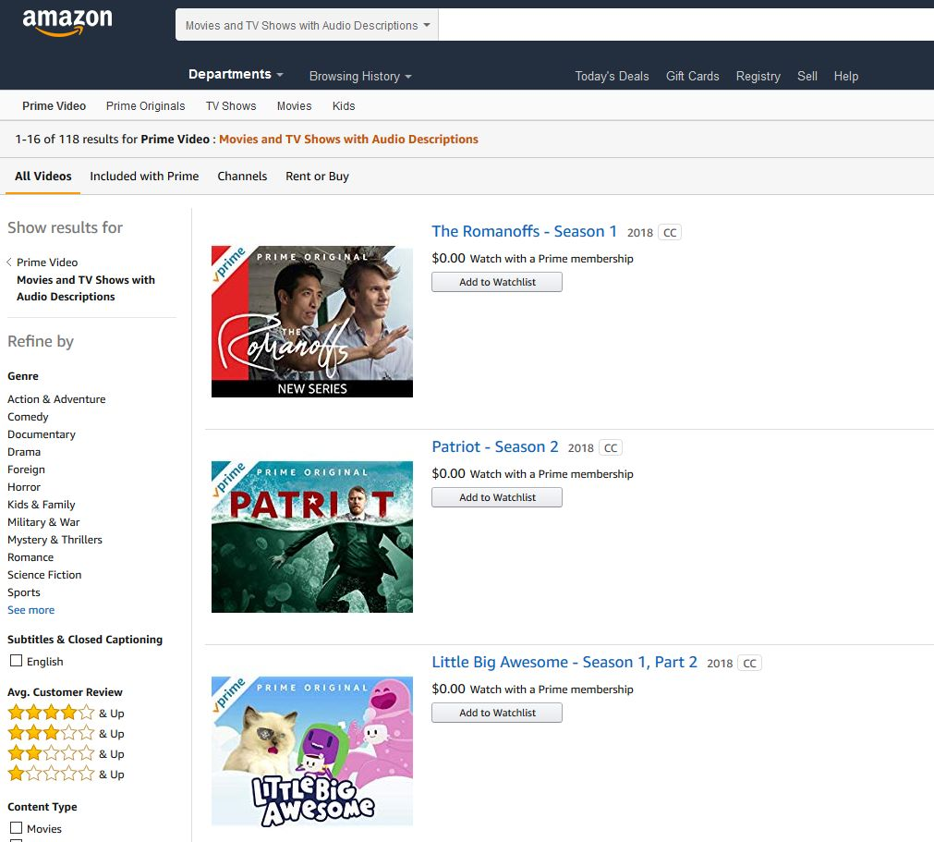
Figure 7. Amazon Prime audio description search webpage
AD is available for most Netflix original titles, as well as other select movies and television shows. Netflix report to be working with content owners to increase the availability of AD across a range of devices. Titles that currently have AD available can be found at netflix.com/browse/audio-description, although to use this function you must be logged in. However, Netflix also include the disclaimer that “… some TV shows may not have AD available for all seasons or episodes”. An increasing amount of content on the iTunes store is also audio described and Apple give detailed instructions as to how to access this via a simple search function (Apple Support, 2018).
Following in the footsteps of Netflix and iTunes, Amazon Prime introduced their own AD service in Australia in 2017. The inbuilt AD search function makes finding audio described films and television reasonably simple. In contrast, video streaming website Hulu has become somewhat notorious for being inaccessible and not providing AD. In late 2017 a class action lawsuit was filed against Hulu claiming that the platform “discriminates against those who are blind and visually impaired by not providing AD on any of their movies or TV shows”. Finally, the Australian streaming company Stan does not offer AD for its content; however, when contacted, they assure us they are “working on it” (Figure 8). If interested, we encourage you to contact them yourselves and express your desire for AD services.

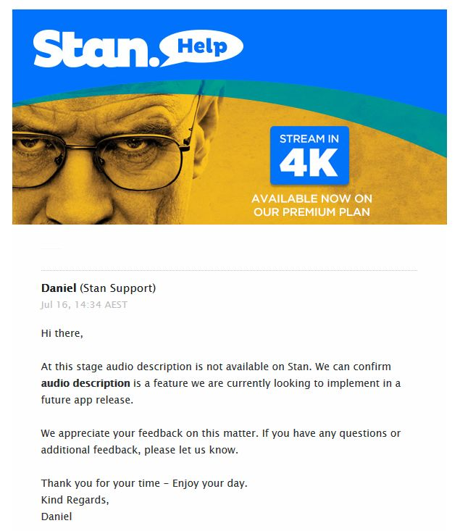
Figure 8. Stan email response re: audio description

Inflight Entertainment
Increasingly, AD is being offered as part of inflight entertainment. The two Australian airlines Qantas and Virgin take a different approach to the concept of accessible inflight entertainment
Qantas do offer AD on inflight entertainment; however, you may need to ask the cabin crew for assistance. The movies with AD soundtracks are clearly marked on the movie poster and in the title on the screen. Qantas also have a dedicated AD category which houses all new audio described movies in one place. In contrast, rather than providing AD films, Virgin inflight entertainment allows you to access sites where AD is available using their wireless services. Virgin also offer Wi-Fi on long haul flights, and select domestic aircraft, if you wish to access a site where AD entertainment is available.

Apps
AD content can also be accessed by a secondary app. This section identifies four such apps available throughout the world – Big Access Media (BAM), MovieReading, Actiview and Movies Anywhere. However, at the time of writing only two are available in Australia (BAM and MovieReading), and they offer limited content.
BAM is currently available in Australia. This app provides audio with AD for a range of children’s television programmes airing on Foxtel, including Discovery Kids and Nickelodeon children’s programmes. It is available on iOS, although an Android version is expected soon. It can also be used through a web browser, with Google Chrome currently the best option. The audio syncs with the ambient audio from the programme and, whilst advertisement breaks are usually included where scheduled, users can also re-sync the AD if unexpected breaks occur. BAM services can be played through the device speakers, so it is not necessary to use headphones (Figure 9).
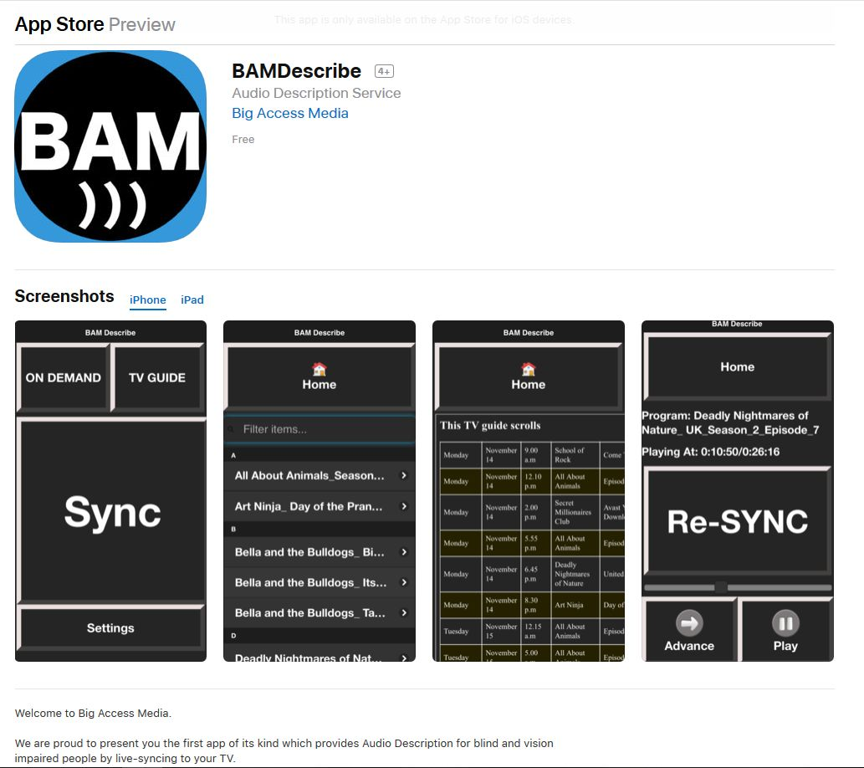
Figure 9. BAM app preview
The MovieReading app has limited content available in Australia. Originally designed for subtitles and captions, this app also features AD. It is available on Android and iOS, so is compatible with most tablets and smartphones, provided the device has a microphone. MovieReading auto-syncs AD and captions with the ambient film audio. It can be used in any setting, including a cinema, requiring only a smart device and headphones. The AD file is downloaded ahead of time, and the smart device can be used in airplane mode (Figure 10).
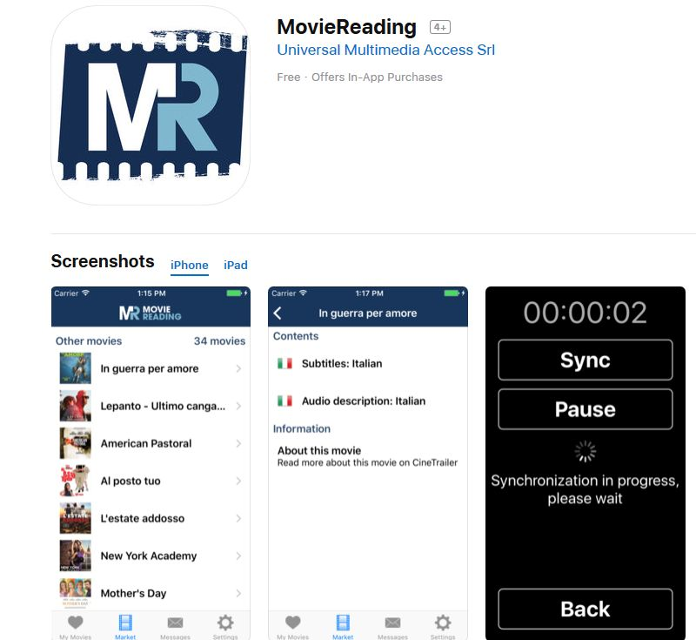
Figure 10. MovieReading app preview
The Actiview app is not currently available in Australia. This app offers features including AD, amplified audio, combined AD and amplified audio, and closed captioning. The access feature file is downloaded ahead of time. It requires wired headphones before it will play an audio file. It uses auto-syncing technology, using the ambient film audio via the device microphone (Figure 11).
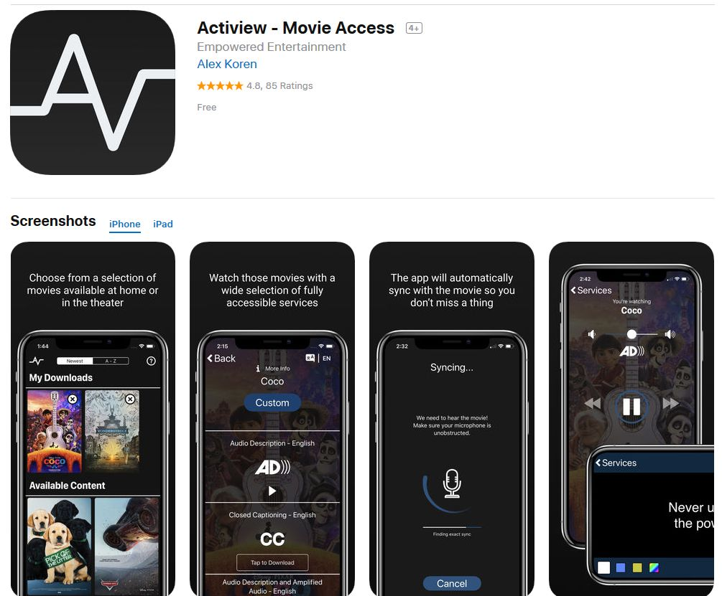
Figure 11. Actiview app preview
The Movies Anywhere app – previously Disney Movies Anywhere – is also currently not available in Australia. To access you must be 13 years of age or older and a resident of the US, all US territories, or the US associated states of the Federated States of Micronesia and Palau. This app is a cloud locker for Disney Pixar movies, with AD as a feature. The app itself is available on a range of platforms, but the AD feature is only available on iOS. It can be used with headphones in any setting, including the cinema, syncing with the ambient film audio (Figure 12).
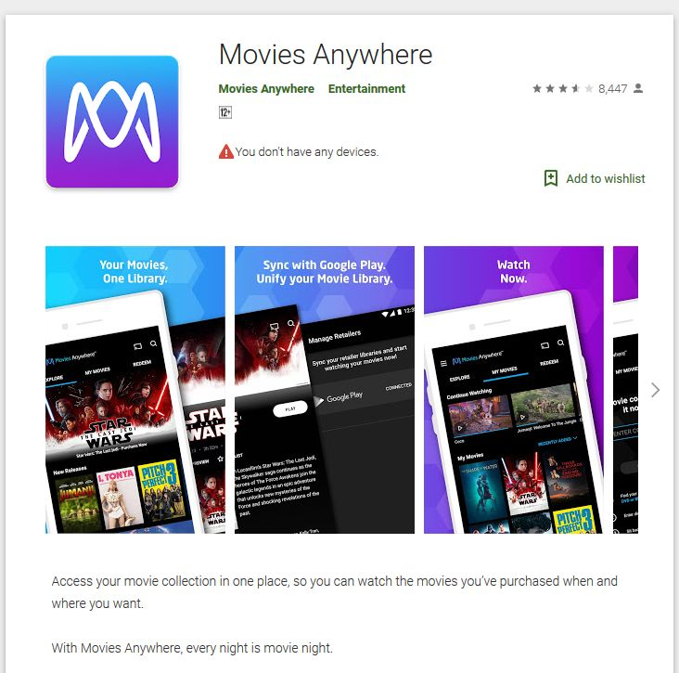
Figure 12. Movies Anywhere app screenshot

Illegal Downloads
For some time there have been whispers within the disability community about an underground and illegal search engine for audio described content. It was spoken of in hushed tones as users secreted their transgressions, but also sought to assist other people searching for audio described content in a country that does not have it on free to air television.
On Netflix, it has only been since the production of Daredevil in 2015 – a show which the main character would not be able to access without AD, which in turn encouraged widespread outrage from audiences – that the company committed to integrated AD protocols on all of its own products. However, despite this commitment, the majority of Netflix content is still sourced from other mainstream broadcasters; only about 8% of programming is Netflix originals (Wayne, 2017). As such, it becomes exponentially difficult for people who are blind or vision impaired to ascertain which programmes or films on the schedule have AD and, for people who live in places where AD is not mandated or is uncommon such as Australia, it is almost impossible.
A search engine known as uNoGS or the unofficial Netflix online Global Search (see http://unogs.com) was initially developed by ‘Brian’ for personal use. However, its searchable database has become incredibly popular for users to track what is available on Netflix in any market across the globe and has become a remedy to the search frustrations of Netflix users. Users can bypass market restrictions through the use of a VPN (virtual private network) to trick Netflix into thinking the user is from that national market. What is crucial about uNoGS is its highly customisable search engine. Users can simply click on the AD category to search for audio described content. uNoGS also assists users with suggestions about the best VPN or proxy service to provide access.
However, these kinds of activities are of course not strictly permitted. At best, this system is dubious and walks a thin line of legality. As such, in 2016, Netflix launched efforts to block customers who used the service at the behest of licensees. While Netflix’s commitment to tracking down and limiting so called ‘proxy-pirates’ appears a little lack-lustre, this effort to criminalise or demonise the users of uNoGS appears to unfairly target people with disability who lack not only a plethora of audio described content, but also the means to easily and effortlessly discern which texts have the description track available in an era where it is not always mandated that AD be provided. uNoGS walks this line, providing a service that is essential for people who need audio described content, but also potentially criminalising these people as they seek accessibility in an era where the UNCRPD affirms the global disability community’s access to the media as a human right.

Availability of Audio Description at Cultural Events and Locations
This section considers a state by state analysis of the provision of AD via significant cultural events and locations.

New South Wales
Sydney’s Vivid Festival began in 2009 as a festival of light. Celebrating its 10th anniversary in 2018, the event at the Sydney Opera House has expanded to become an annual celebration of light, design, technology and culture. With the Lighting of the Sails of the Sydney Opera House being the cornerstone of the event, the festival is typically very visual. Previously, people with vision impairment have had to rely on their imagination, or their friends and family, to describe the lights. However, in 2014 the festival made a change and began offering audio described sessions of the Lighting of the Sails.
People with blindness and low vision attending the festival are also given more information about the displays via tactile elements such as Opera House tiles to feel what the lights are being projected on and a miniature model of the Opera House itself. These AD and tactile features were part of the Sydney Opera House’s accessibility overhaul, a plan seeking to “provide barrier-free access, making the site, building and the experiences they offer accessible to all people” (Sydney Opera House, n.d.).
While Vision Australia volunteers provide the AD of the Lighting of the Sales, AD provider The SubStation audio describe the light installations (Accessible Arts provided the AD from 2014 to 2016 and The SubStation provided AD and text-to-talk in 2017 and 2018). They approach the task by considering both the artists’ intentions and the reality that audiences may be accessing the art and AD in the cold – they try to keep descriptions to less than a minute. Major installations can require descriptions of 2-4 minutes; however, the descriptions aren’t synced to the installation which allows the audience to visit at their own pace. Audiences can use The SubStation’s description, the artists’ description, plus their own experience of the installation to decide on the meaning of the artwork.
Much of the artwork is purely visual and as such the festival’s describers focus on conveying what the installation itself looks like. Alison Myers from The SubStation claims that although the describers try to stay neutral in their descriptions, the artists’ intentions are often outlined in their blurbs, so describers “… try to use language that matches their intent – for example, if their installation has a nautical theme, our descriptions will follow suit” (Audio Description Discussion in Australia, n.d.). For example, The SubStation described the 2018 installation HE’E NALU which is Hawaiian for ‘surf’ as (Audio Description Discussion in Australia, n.d.):
“Two undulating fences formed by sets of illuminated posts flank a footpath. The contours created by the different angles and heights of the posts resemble rolling waves. The vertical shape of the waves are created by arranging the posts in order of height, gradually rising then falling. The posts also stand at angles, their gradually increasing and decreasing steepness creating the horizontal curve of the waves. As visitors move between the waves, marine shades of blue and orange flow through the sinuous structures.”
Because most installations change in some way, The SubStation describers try to capture the nature of their visual change. Descriptions reproduce the physical nature of the changes, for example pulsing, flowing, weaving, spinning and twisting. Because most installations involve moving coloured light, the audio describers try to be imaginative with the descriptions they provide to ensure variety in the words they use. The installations are often interactive, so when necessary descriptions include details on how to interact with the installations.

Northern Territory
The Australian Bureau of Statistics (ABS) affirms that “… there are few data sources about vision problems among indigenous Australians” (ABS, 2005, para 84). For the Northern Territory, this is a significant gap in data as it possesses the highest proportion of Indigenous peoples, residing at 25.5% of the population (ABS, 2016). The National Eye Health Survey 2016 has reported that “more than 453,000 Australians are living with vision impairment or blindness” (Foreman et al., 2016, p. 12) and this includes “… up to 18,300 Indigenous Australians aged 40 years or older” (p. 12). It has been confirmed that “the Indigenous rate for blindness [is] … 3 times the non-Indigenous rate” (PMC, 2017). This suggests an urgent need for AD accessibility services in the Northern Territory.
In the Northern Territory, Artback is a small not-for-profit organisation devoted to supporting art and culture across all communities. The organisation holds an attention to remote, Indigenous and hidden artists, texts and forms of artistic production and reception. It receives funding from the Northern Territory government and from the Commonwealth government through the Australia Council for the Arts. According to Artback NT (2018a):
“Artback NT is the National Exhibitions Touring Support (NETS) agency for the Northern Territory and, in 1998, became the NT’s peak visual and performing arts touring organisation through an amalgamation with Circuit North. The unique environment of the Northern Territory resulted in the development of a touring model responsive to the cultural and geographic diversity of the region. The new model maximised the potential of alternative venues and called on innovative solutions to provide meaningful access to performing and visual arts for the remote communities we serve.”
These methods of providing meaningful access has involved AD to help service the high levels of Indigenous people (as well as non-Indigenous) in the Northern Territory with vision impairment. Along with a Reconciliation Plan, they also have a Disability Action Plan that has, as part of its first goal, “…to explore ways of increasing access to visual arts exhibitions for people who are blind” (Artback NT, 2018b) in which AD is highlighted as a significant and essential tool to facilitate this access (see Table 2 (Artback NT, 2018b)).

Table 2. Artback NT’s Disability Action Plan – Goal 1
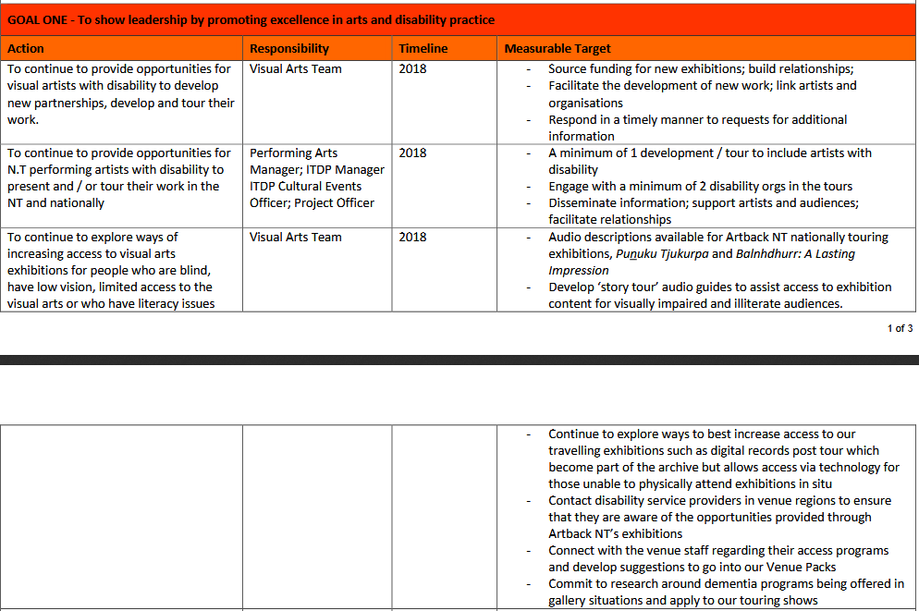

As part of this objective, the organisation has already supported the Colours of the Country III exhibition as part of the Alice Springs Beanie Festival by including an audio described track for selected works (Artback NT, 2018c). The Festival has been running since 1997 and is devoted to developing and promoting women’s textiles and culture.
In 2015, the Punuku Tjukurpa (WA Museum, n.d.) exhibition, created with support from Artback NT, was initially opened at the South Australian Museum. It has since gone on tour around Australia accompanied by an AD track and an app to facilitate audio interactions with the exhibition (iTunes, 2015). The exhibition explores and celebrates the stories and Law of the Anangu culture which is told through carvings on wood and other items (Artback NT, 2018d). This interaction has particular significance and meaning considering the prevalence of orality to Indigenous cultures across Australia. After touring to Canberra, Brisbane, Western Australia, and New South Wales, Punuku Tjukurpa is currently in Alice Springs in the Northern Territory at the Araluen Arts Centre (as at November 2018).
The reach of Artback NT across the country, not just the NT, and into remote and largely forgotten places of the Australian outback (Artback NT, n.d.) offers an exciting model for thinking about accessibility in places where resources are scarce but enthusiasm for creation, consumption and engagement with art and local content is strong.

Queensland
In conjunction with Access Arts and Vision Australia, the Queensland Performing Arts Centre (QPAC) offers live AD services for patrons who are blind or vision impaired. AD is provided via headphones which can be collected prior to the performance. The Queensland Theatre also offers AD services for five of their productions in 2018. The theatre explains that (Queensland Theatre, n.d.):
“This service allows blind and vision impaired people to enjoy our shows by having trained describers capture in live narration – without interrupting the dialogue on stage – the action, costumes, sets, transitions, gestures, facial expressions and lighting or special effects in a performance. This is transmitted via a discreet headset/earpiece worn by the client in the auditorium. Imagine your own personal “director’s commentary” but only when there is a pause in the dialogue.”
According to their website the Queensland Art Gallery and Gallery of Modern Art (QAGOMA, n.d.), both the Queensland Art Gallery (QAG) and Gallery of Modern Art (GOMA) also offer audio described tours which provide description of selected artworks, although advance booking notice of 15 days is required.

South Australia
The Art Gallery of South Australia provide audio described tours of their collection on the third Saturday of each month. Audio described tours for school class groups, children and teens, and tours of the permanent collection and temporary exhibitions, are also available by request (Art Gallery of South Australia, n.d.).

Tasmania
In Hobart, The State Cinema offers AD for select films and sessions. Audio described films are marked with the AD symbol on the session times page. Hovering the cursor over an audio described session will also result in a pop-up box stating that “Audio description for the vision impaired is available for this session” (Audio Description Discussion in Australia, n.d.).

Victoria
In the shift to creative industries, city imaging and the perceived importance of cultural events in creating dynamic and ‘liveable’ cities, fringe festivals have opened up a whole new realm of entertainment located in the traditions of the carnivalesque. The fringe festival as a central part of cultural excitement and activation for contemporary cities offer a new way of thinking with and about accessibility. For Melbourne Fringe, accessibility is taken very seriously. They have partnered with a number of accessibility organisations to ensure a central focus on accessibility in the production and reception of Fringe events (Melbourne Fringe, 2018a):
“As Victoria’s largest open-access Festival, we are committed to ensuring that people from all backgrounds and abilities can participate in our Festival – as artists and audiences. Our Access and Inclusion Program, delivered in partnership with Arts Access Victoria…aims to reduce barriers to participation across all areas of Melbourne Fringe and help make the Festival as accessible as it can be.”
In addition, Arts Access Victoria provide “inclusive arts experiences for people who are Blind or have low vision” (Melbourne Fringe, 2018a) and, along with other organisations partnered with Arts Access Victoria, including The Captioning Studio for example, provide a cohesive approach to accessibility across Festival events.
Events at the Melbourne Fringe Festival are encouraged to be created with accessibility in mind. Their website affirms their ‘open access’ policy by artists and community members and overtly encourages artists to create their events and works with accessibility in mind. To that end they have a series of guidelines for artists and creators to follow. Their resources page features an appeal for “artists to consider ways to make events more accessible” (Melbourne Fringe, 2018a) and provides an Art for Everyone: An Inclusive Practice Guide (Arts Access Victoria, n.d.) along with an Accessible Event Quick Guide. AD – along with sensory friendly performance, and Auslan interpreted performances – is featured prominently. The site also provides a comprehensive list of venues and their accessibility as well as performances which have accessibility protocols attached. A comprehensive list of access information is also provided (Melbourne Fringe, 2018a), see Figure 13 (see Melbourne Fringe, 2018b).
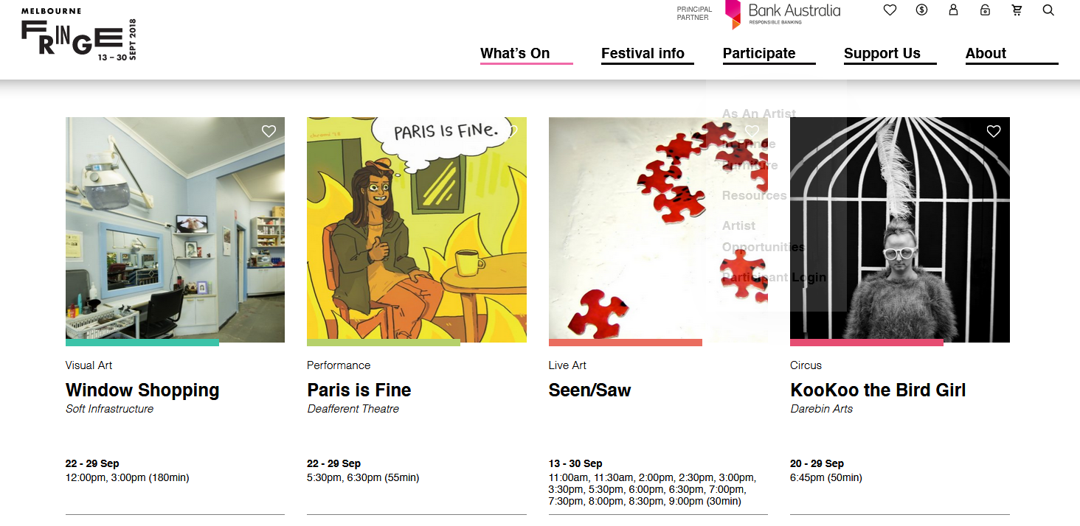
Figure 13. Some audio described events at the 2018 Melbourne Fringe Festival

Western Australia
In Western Australia, Disability in the Arts Disadvantages in the Arts (DADAA) provides live AD for 15 to 20 major arts exhibitions and events each year. As a non-profit organisation, DADAA promotes cultural participation for people who are blind and vision impaired by providing AD for live performance, festivals and theatre, including the Fringe World Festival, Sculpture by the Sea and hit musicals at Crown Perth and Perth Arena. Thanks to DADAA, the Australia Day fireworks over Perth were audio described in 2018. However, there can be limited places available due to budget restraints and only 25 AD headsets were available at this event (Vimeo, 2016).
Western Australia’s State Theatre also offers AD for live performances. According their website, it is essential patrons advise the booking agent that the audio described service will be required at time of booking tickets. The venue also offers captioning and wheelchair access (Perth Theatre Trust, n.d.).

Historical Free To Air Offerings of Audio Description – The ABC Trials
As can be seen from above, there is a strong commitment to AD in the arts. However, returning to the provision of AD in the medium of television in Australia tells a different story.
Typically, internationally, public broadcasters take the responsibility of providing AD on free to air television for audiences who are blind or vision impaired. Given access to television is recognised as a human right according to the UNCRPD (see United Nations, 2006a, Article 30), public broadcasters have a mandate to offer this service and have typically shown leadership in countries where AD is available. For example, AD was already provided on the public broadcaster in the US before quotas and legislation were introduced and public broadcasters are the main provider of AD in Canada, New Zealand and Italy. Indeed, a study of e-accessibility in 27 member states of the European Union (EU) in 2013 found it was the public broadcasters who most often provided AD and that AD became more available in countries in which legislation had been demanded (Kubitschke, Cullen, Dolphi, Laurin, & Cederbom, 2013).
However, Australia remains the only English-speaking country in the OECD not to offer AD on free to air television. In Australia the public broadcaster is the ABC. To date, two AD trials have been held on the ABC – one on free to air television in 2012 and one on their catch-up portal iview in 2015-16.
Analysis of the first trial on terrestrial broadcast television found that:
- AD results in a greater feeling of social inclusion;
- Despite a clear demand existing for AD in Australia, a large proportion of Australians with vision impairment were unaware of the trial nor the availability of AD.
The second trial of the provision of AD on the ABC’s catch-up portal iview discovered:
- Continuing demand and fewer technical barriers yet recommended further consultation with consumer groups;
- Again, the ABC was accused of not promoting the service widely enough.

The 2012 Free to Air Trial
An AD trial was undertaken on the ABC in 2012, providing 14 hours of AD content over 13 weeks. However, while the trial was considered successful, the benefits were short-lived. The ABC trial report, and feedback from disability groups, identified several technical impediments and limitations which affected the experience of AD content during the trial. These included the timing of the trial during a period in which the transition from analogue to digital television was still occurring (creating hardware compatibility issues for some consumers); the limitations of the ‘ad hoc’ approach undertaken by the ABC and manual implementation of AD, including its rollout on limited devices; and the need for upgraded digital receivers (Department of Communications and the Arts, 2014, p. 2). However, while advocacy groups acknowledged the technical complexities involved, the expected stakeholder discussions that were due to be held post-trial, in part to attempt to resolve the issues experienced, were never undertaken. The lack of subsequent commitments to providing AD resulted in BCA making a formal complaint of disability discrimination against the ABC and the Federal government in 2013 (Ellis, 2014a).

The 2015-16 iview Trial
More recently, there has been renewed interest in improving the accessibility of AD broadcast content. As the lines between primary and multi-channels continue to blur and the importance of catch-up television offerings improve online, new attempts to improve such accessibility have occurred, most notably the second trial of AD on the ABC’s catch-up portal iview in 2015. Over the 15-month trial, 1,305 hours of AD content was provided – this was played 158,277 times across multiple platforms, including iOS, Android, the Freeview app, and desktop computers (ABC, 2016). The trial further confirmed that AD held considerable benefits for people with a vision impairment and also, importantly, demonstrated that AD was technically feasible, with far less “technical difficulties” than the experience of the 2012 broadcast-based trial.

Analysis
Vision Australia presented a series of qualitative insights regarding the two ABC trials. Two key themes were clear across the compiled feedback. In 2012, the human rights issues and associated feeling of social inclusion were foregrounded, as these indicative quotes suggest:
“The trial has opened my eyes to the sheer impact that television has on people’s lives and the extent to which we are excluded by not having access to it.”
“I realised the worth of television as social currency. When I catch up with the family for example, we might talk about other things as well, but a fair chunk of the conversation seems to revolve around television programmes and I can finally participate in these conversations.”
While the importance of social inclusion remained, a new focus on the quality of the service and associated technological issues also became paramount after the 2015-16 trial:
“I attempted to access the iview audio description trial even though I realised it would be very limited because of my quite low monthly download limit. I had acquired an Apple TV and was playing the iview stream through my TV so I could sit comfortably on my lounge (not at my computer, and not listening through the tiny iPhone speaker). However, the stream invariably stopped half way through and I got tired of having to start it again only for the same thing to happen. Thus, because I could not get my iPhone to stream through my Apple TV to my main TV, and was not prepared to have an unrelaxing night at my computer just to get relaxing entertainment, I gave up.”
Significantly, the second iview trial occurred after Australians had access to AD via the 2012 trial, Netflix and iTunes’ AD VOD offerings, and a government-funded national upgrade of cinemas to be caption and AD compliant by 2013. All of this seemed to pave the way for more AD content across many platforms and, as such, the small trial on the national broadcaster perhaps seemed to make up only one piece of a bigger picture. Indeed, because the trial had an end date, some even refused to participate, knowing this was not a permanent AD service:
“I watched Rake during the 2012 trial and I was looking forward to watching it again thanks to audio description on iview, but then I realised that I wouldn’t enjoy it because it would always be in my mind that this was limited access and none of my friends would have the door closed on them [as I would] in July 2016 when the iview trial ended. So I didn’t watch it.”
These concerns over the lack of long-term change were valid – despite repeated AD trials and the lodgement of aforementioned discrimination complaints by BCA in 2013, there remains no notable AD service on Australian broadcast television.

Legislation of Audio Description
However, while guidelines and discussion around AD content and its provision seem to be on the discussion table in many countries, as will be discussed in Phase II of this report, to date this has not yet been the case in Australia. Indeed, whereas BCA policy advisor John Simpson recommended the full implementation of AD at the same time Australia transitioned to digital television, this did not eventuate (Simpson, 1999). Indeed, Media Access Australia note that the transition to digital television in Australia created some confusion because neither legislation nor standards were introduced to mandate that broadcasters provide AD at this crucial time (Media Access Australia, 2012). As such, it has long been argued that one of the main reasons for the lack of AD in Australia is a lack of regulation pertaining to it. Unlike provision of other accessibility options such as captions, there is currently no specific legislation in place in Australia mandating that either free to air broadcasters nor subscription streaming services make AD available to their audiences.
Australia adopted the UNCRPD in 2006 and it came into force in 2008. From 2012, Australia, as part of the Asia-Pacific region, has also been a signatory to the Incheon Treaty that seeks to launch a new Asian and Pacific Decade of Persons with Disabilities from 2013 to 2022. The Treaty specifically examines how to deploy and activate the UNCRPD in the Asia-Pacific region. There are 10 gaols and 26 targets. Goal number three is to “enhance access to the physical environment, public transportation, knowledge, information and communication”. However, yet again, AD is not mentioned. Instead, core indicators for goal number three include “proportion of daily captioning and sign language interpretation of public news programme” (Incheon Strategy, 2014).
At around the same time, the National Disability Strategy 2010-20 (Australian Government, 2011) was also implemented. This strategy was endorsed by the Council of Australian Governments in February 2011 and furthers the goals of the 1948 Universal Declaration and the 2006 UNCRPD to facilitate the inclusion of people with disability in Australian society. The strategy is described as “a coordinated plan across all levels of government to improve the lives of people with disability, their families and carers” (Australian Government, 2011). Within this strategy, access to television is again aligned with access to public spaces (Commonwealth of Australia, 2011, p. 30):
“Taking a universal design approach to programs, services and facilities is an effective way to remove barriers that exclude people with disability. Universal design allows everyone, to the greatest extent possible, and regardless of age or disability, to use buildings, transport, products and services without the need for specialised or adapted features. Some examples of universal design include:
- Light switches that can be reached from standing and sitting positions and which feature large flat panels instead of small toggle switches.
- Ramps that are incorporated into a building’s main entrance.
- Captions on all visual material such as DVDs, television programs and videotapes.”
However, this document focuses on the aforementioned more ‘accepted’ feature of captions rather than AD. The absence of a specific reference to AD can perhaps be explained because this strategy was written prior to the ABC’s 2012 AD trial. Nevertheless, it was published after the Australian government released a discussion paper regarding access to electronic media which included both captions and AD (Australian Government, 2008) and after the policy review’s final report on the matter in 2010 (Department of Broadband Communications and the Digital Economy, 2010). In that report, a total of 22 recommendations were made by the review – grouped into captioning, AD, UNCRPD, and social inclusion – thus suggesting that in 2010 the Australian government did recognise the human rights implications of access to television for people with disabilities, including those with vision impairment. Indeed, when the Audio Description Working Group was convened by the Federal government throughout 2017 they were tasked with exploring options for the delivery of AD on Australian television. However, the terms of reference encouraged the group to consider “alternatives to legislated requirements to provide AD services” (Department of Communications and the Arts, 2017b) and the Working Group was unable to make a clear recommendation in its Final Report (Department of Communications and the Arts, 2017a).
Indeed, the government and industry have, at several points since 2007, claimed that, in the Australian context, alternatives to regulation would be a more effective path towards the provision of AD in this country (Department of Broadband Communications and the Digital Economy, 2010; Department of Communications and the Arts, 2017b. This is in contrast to international research which shows that legislation better facilitates accessible television (Kubitschke et al., 2013). Similarly, Australian commentators have regularly called for the introduction of legislation (ACCAN, 2012, 2017; Ellis, Kent, Locke, & Merchant, 2016). This lack of policy has meant that the only AD available to Australian audiences is via DVDs or a few programmes on international subscription VOD services.
It is also in in stark contrast to the existence of guidelines pertaining to local screen production. For example, to coincide with a 2013 cinema upgrade, the Australian film and television funding agency Screen Australia announced that it would significantly improve the accessibility of Australian feature films for both the hearing and visually impaired so that “[financed] feature films… be captioned to provide access for the hearing impaired, and audio-described for the visually impaired” (Calder, 2011). CEO Ruth Harley said, “better and more equitable audience access to Australian films at a reasonable cost is a benefit for the industry and community as a whole” (Calder, 2011). While these Terms of Trade focus on feature films, they also encourage “producers of all non-feature film content to budget for captioning and audio description, and for accessible web design, to provide access to their projects for both hearing and visually impaired audiences” (Screen Australia, 2017). The policy is designed to bring the Australian industry in line with the US and UK requirements discussed earlier. Further, section 21.3.5 of the Core Conditions identify AD as a matter to be included in each funded television drama’s Marketing Agreement, stating (Screen Australia, 2013):
… an undertaking by the Marketing Licensee to use best endeavours to provide access for the hearing impaired and visually impaired by means of captioned and audio described theatrical screenings and DVDs.
However, to date, there remains a significant back catalogue of AD content created with Screen Australia funding that has never been made available to local television audiences.
Indeed, while the content and technology are available for the provision of AD in Australia, there seems to be a general reluctance from policy makers to acknowledge the importance of AD. That is, while, as is the case with Screen Australia, it is sometimes seen as worthwhile, the reluctance to fully embrace the technology – and, importantly, to mandate it – has been frustrating for Australian audiences with vision impairment.
This lack of perceived focus on the provision of AD from a governmental perspective perhaps stems from the pervasive attitude which exists within the Australian television industry that AD is not the responsibility of commercial providers yet, as a signatory to the UNCRPD, it is the government’s responsibility to compel the media to include people with disability. Further, while the UNCRPD imposes obligations on signatory governments, these can only be met if the private sector cooperates. According to Article 4 of the UNCRPD, State parties must “take all appropriate measures” to eliminate disability discrimination. Along with specific mentions of access to media and communications (Articles 4, 9, 21 and 30) and television specifically (Article 30), Article 9, Accessibility, addresses the dual responsibility of governments and business (UN, 2006b):
“2. States Parties shall also take appropriate measures:
a) To develop, promulgate and monitor the implementation of minimum standards and guidelines for the accessibility of facilities and services open or provided to the public;
b) To ensure that private entities that offer facilities and services which are open or provided to the public take into account all aspects of accessibility for persons with disabilities.”
This is supported by documentation released by the Australian Attorney General which says the government has a responsibility to compel and train businesses regarding their obligations under the UNCRPD (Attorney General’s Department, n.d.):
“Countries are also to take appropriate steps to set standards and guidelines for access to facilities and services that are open to the public, to make sure that private businesses that provide facilities or services to the public take into account access for people with disability, and to provide training for people involved with access for people with disability.”
Despite their resistance to providing AD, the commercial broadcast industry, via their industry body Free TV Australia, make overt claims that they include all Australians, including those with disability, as well as “delivering social outcomes” on their website. Free TV Australia has developed a Commercial Television Industry Code of Practice to ensure “Australia’s modern digital media landscape upholds community standards and ensures appropriate viewer safeguards” (Free TV, 2010). However, while this code includes notes around representing disability on television, it does not address television accessibility for people with disabilities. The Australian Department of Communications and the Arts (2017a, p. 39) notes that:
“Free TV considers that separate AD services (option 3) have potential to increase accessibility to AD more quickly and more economically than either the broadcast or online options considered.
Free TV contends that it is the role of the Government to fund programs that address social inequities and maximise social welfare. The Australian Subscription Television and Radio Association (ASTRA) also considers it appropriate for Government to subsidise AD via funding of a separate entity (similar to Able in New Zealand) or via direct funding of the national broadcasters to deliver AD. Foxtel’s preferred AD delivery option is online or a companion application (options 2 or 3).
Free TV and ASTRA do not support the introduction of mandatory AD targets via legislation or co-regulatory codes. Free TV does not consider that legislative or industry code requirements are an effective alternative to government funding and will not resolve the technical or cost issues involved with providing AD.
The national broadcasters, ABC and SBS, have advised that additional government funding would be essential to provide an AD service.”
As has been outlined above, the provision of AD is a fundamental human right and, as such, the delivery, format and, specifically, the legislation behind it needs to be carefully considered, particularly from an Australian perspective where such content is clearly lacking. However, Australia is not alone in resisting and diminishing the presence of AD. There is a global trend in offering significantly lower targets than for closed captions. This is mainly due to a lack of awareness of AD, as well as cost factors and a radical rethink about how media is broadcast and consumed. Effective integration of AD means taking media accessibility seriously, generating legislation in a national context that mobilises the intent of the international treaties being signed and ratified, deployment of effective compliance measures, and recognising that offering AD is not as costly as expected and “rarely leads to an increase in the production budget of more than 1%” (Looms, 2011, p. 11). Yet, at present, with AD only being available via subscription channels, people with vision impairments are being denied their human rights. Indeed, all of these issues make AD less present in accessibility tropes than closed captions and other forms of accessible media. It is both the navigation of these concerns to sit alongside the commitments to international treaties as well as a lack of awareness that often stall the full integration of accessible tools and outcomes within a specific national context.

Phase II: Scoping Study – Audio Description Around the World
Australia is the only English-speaking country in the OECD not to offer AD on free to air television. This section reports on the availability of AD in a number of different countries around the world, considering current government policies and AD advocacy as well as the accuracy of compliance reporting. The UK, the US, and Spain are cited as world-leading examples of best practice, followed by further case studies of the availability of AD in several other locations, noting where inconsistencies occur between the rhetoric of availability and actual availability of AD. This part of the report concludes with a discussion of common international barriers to the implementation of AD, focusing on copyright restrictions and cost. Throughout this part of the report the provision of AD is presented in the context of other accessibility priorities and frequently compared to the more widespread availability of closed captioning or subtitles to facilitate access for the d/Deaf and hard of hearing.

Case Studies – An International Perspective

The US
The US, while not ratifying the UNCRPD, has actually been at the forefront of legislation regarding AD. There are three legislative frameworks that cohere to ensure the provision of AD on broadcast television in that country – the 21st Century Communications and Video Accessibility Act (2010), the Americans with Disabilities Act (1990) (ADA), and sections 504 and 508 of the Rehabilitation Act (1973) – and, as such, the path toward AD on broadcast television has been complex. The ADA does not specifically mention AD and so other regulations have had to map out requirements and standards for its introduction onto US television.
At the turn of the 21st century, the Federal Communications Commission (FCC) in the US announced it intended to phase in video description for television. In their Notice of Proposed Rulemaking, they noted three main audiences for AD – people who are blind or vision impaired, people with learning disabilities, and people multitasking while watching television. The FCC actually reported that 60% of the audience mail received from the Narrative Television Network (NTN) was from sighted viewers who enjoyed the programming (FCC, 1996, 1999). The FCC’s description regulations came into effect in 2002 and required “The four big television networks and the 5 biggest cable networks to show 50 hours of AD programmes per quarter” (Mikul, 2010). However, the ruling was challenged by the Motion Picture Association, and overturned by the Supreme Court, although, ironically, the networks had already begun to comply with the FCC’s mandate. Further legislation to reinstate these rules were drafted and gained increasing support up until 2007 but could never progress beyond the Senate subcommittee stage.
In 2010 the 21st Century Communications and Video Accessibility Act (2010) restored the rules earlier set up by the FCC to mandate 4 hours of AD content per week (Media Access Australia, 2012). The FCC has committed to 100% of television programming being described by 2020. As of July 2018, “broadcasters and pay-tv providers carrying one of the top networks must provide 87.5 hours of described programming per calendar quarter” (FCC, 2017). This expands the types of programmes that will be described to build upon the prior requirement of 50 hours during prime-time or children’s programming; 87.5 hours per calendar quarter is equivalent to about 7 hours per week of audio described content. Enforcement is carried out by the FCC’s Enforcement Bureau which was actioned when fielding complaints from the public. Broadcasters are required to compile detailed records in case of investigation.
The strong advocacy of consumer organisations such as the ACB (2018a), the AFB (2018a) and the National Federation of the Blind provide rigorous and detailed information about AD as well as schedules for when programmes with AD will be broadcast. The Audio Description Project, for example, has been managed by the ACB since 2010. This website aggregates information about and for AD, providing information not just about television schedules, but also audio described titles available on DVDs, iTunes, in cinemas, as well as performing arts and museums. It also has an archive of education and training services, streaming sites and international organisations also promoting and advocating for AD. They maintain a strong presence in advocacy and not just information. Because the enforcement and regulation of US AD relies heavily on customer feedback and the complaints process, the Audio Description Project aims to raise awareness, provide training and advocacy to ensure AD is supplied consistently and coherently by broadcasters. One of their stated aims for 2018 is to “educate members regarding the FCC complaint process” (ACB, 2018b). They maintain a local and global outlook for the development, delivery and integration of AD as well as promote alliances with the World Blind Union which have initiated a global survey of international AD (ACB, 2018c; ACB Audio Description Project, 2018) (Figure 14).

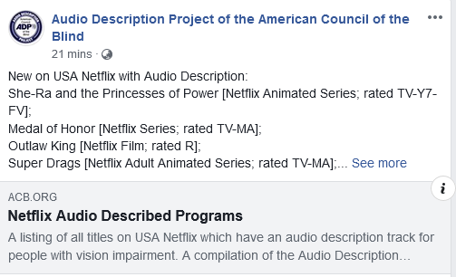
Figure 14. Facebook entry for the ACB’s Audio Description Project

The UK
In the UK, there is a cogent and strong accessibility narrative punctuating broadcast services dating back to 1996 with the Broadcasting Act which expanded in 2003 to become the Communications Act. Ofcom, the independent regulator and competition authority for the UK communication industries, was established as part of this Act and was allocated powers to, among other things, draw up and enforce a Code of Television Access Services (Ofcom, 2017a) to help encourage accessibility for people with vision impairments. Ofcom has set targets for all broadcasters in their provision of subtitling (captions), signing and AD; these are set at yearly increments and vary by type of broadcaster and accommodation (Table 3). The code stipulates AD targets up to a total of 10% of content after 5 years of broadcasting, while still allowing for some exemptions if audience share is less than 0.05, or where there are technical or financial difficulties (Ofcom, 2017a, 2017b). Following the introduction of this code, broadcasters began exceeding their minimum requirements, with some achieving 100% (Ofcom, 2013). The UK also requires obligations to be met by channels that target other countries but which are established within the UK’s jurisdiction.
Table 3. Ofcom’s UK targets for audio description
Anniversary of  relevant date or  notice date | Subtitling | Signing:  Relevant channels (monthly) | Signing:  Other channels (annually) | Audio description
First | 10% | 30 minutes | 1% of all non-excluded programmes | 2%
Second | 10% | 30 minutes | 1% | 4%
Third | 35% | 30 minutes | 2% | 6%
Fourth | 35% | 30 minutes | 2% | 8%
Fifth | 60% | 45 minutes | 3% | 10%
Sixth | 60% | 45 minutes | 3% | 10%
Seventh | 70% | 60 minutes | 4% | 10%
Eighth | 70% | 60 minutes | 4% | 10%
Ninth | 70% | 60 minutes | 4% | 10%
Tenth | 80% | 75 minutes | 5% | 10%

As is indicated above (Ofcom, 2015), subtitling or closed captions remain most prevalent in the consciousness of regulators – in both the US and UK, “requirements for AD are significantly below that required for subtitling” (Utray, Pereira, & Orero, 2009, p. 254). This is supported by data that suggests that while over two million people in the UK live with sight loss (RNIB, 2018), “it is estimated that there are about 9 million people in the UK who are Deaf or hard of hearing” (British Deaf Association, 2015). Further, a 2006 Ofcom report affirmed that in the UK d/Deaf and hard of hearing people watch television an average of 4.3 hours per day, above the 3.46 hours for the general population (DeafHear, 2012, p.8). This indicates that demand is activated on different axes, particularly in light of the, albeit inaccurate, perception that blind people don’t watch television nor other audio-visual media. However, the most common causes of sight loss are age-related and, as populations in wealthy national contexts begin to age, it is predicted that in the UK, for example, the numbers of people with sight loss will double to 4 million by 2050 (RNIB, 2018). People with vision impairment therefore are currently and further predicted to be an important disability cohort that requires nuanced policy to ensure access to digital media in all its forms, of which AD is an essential component.
There is also a strong tradition of meeting quotas in the UK, with broadcasters often surpassing the mandated quotas for subtitling and AD on television. This is due to a robust regulatory framework in the UK that enforces standards and penalties for broadcasters not abiding to the quotas. For example, “Ofcom imposed a GBP 120,000 fine on ESPN on 2 June 2014, after the sports channel failed to meet its targets for providing AD on its programmes” (Cooper, 2014, p. 34).

European Union
The European Convention on Human Rights dating back to 1950 establishes a precedent for the protection of freedom of speech and information through communication and media systems which is enshrined in the principles of ‘barrier-free accessibility’ which are essential to the operations of the EU as a cohesive and cogent entity. A secondary law includes The Audiovisual Media Services Directive (AVMSD) (2007) that “recognises the right of people with disabilities to participation in the social and cultural life of the Union” (Bachmeier, 2014, p. 17). However, this directive struggles to cohere and enforce the rights it seeks to engage due to tensions with other articles in the Convention which attempt to balance the rights of individuals with those of organisations and states. As such, “the EU cannot impose a direct obligation on providers of audiovisual services; it can do no more than make an appeal to the member states to facilitate carrier-free access for people with disabilities” (Bachmeier, 2014, p. 17). Therefore, “owing to the ‘soft law’ character of Article 7 AVMSD, member states have only partly implemented the provision and have done so in different ways” (Bachmeier, 2014, p. 18), leading to an ad hoc approach to media accessibility across the EU. For example, in Slovakia, “broadcasters formally declare that they meet current quotas” (Polak, 2014, p. 30) when in fact they are not being met. In other contexts, broadcasters meet demands but results may be skewed by local content laws and the import of foreign media.
Across the EU, a drive to standardise technologies in the shift from analogue to digital broadcasting has been structured with an attention to ensuring proper infrastructure to deliver AD. This requires ‘dual-channel sound’ along with other accessibility features; smart televisions and set-top boxes need to be fitted with these capabilities but also with remote controls and menu systems that are accessible. Perhaps the biggest barrier to accessing AD is an inability to navigate through complex menu systems on screens and via handsets that are not accessible to sight impaired users.
One response to this was the establishment of the European Commission project Digital Television for All (DTV4All) (2008-11). This aimed to audit, test and implement technological infrastructure for accessibility to ensure best practice for people with disabilities in the switch from analogue to digital television. Four countries were involved in the pilot – Italy, Denmark, Spain and the UK – which offered ‘mature’ subtitling, AD, audio subtitling and signing services for at least 12 months with the aim of “extend[ing] the provision of existing mature access services to European countries that do not currently provide them, and opportunities to provide new kinds of access services know as emerging access services” (DTV4All Project, n.d., p. 4).
The important outcome of the project is that it has established the key “enablers that will allow a core set of access services to be provided by all EU member states in the near future” (Bachmeier, 2014, p. 12) including digital video broadcasting (DVB) subtitle design variants, barrier-free teletext, signers and clean audio process. These protocols are tethered to EU regulations and standards for broadcast media and the rights of people with disabilities, such as the Council of Europe Action Plan 2006-15 to promote the rights and full participation of people with disabilities in society. This aimed to improve the quality of life of people with disabilities in Europe and outlines specific actions by member states, including “to encourage their broadcasting and related creative industries to ensure that people with disabilities can access broadcasting, film, theatre plays and other arts-related activities in accessible formats which may include captioning, subscript, audio description and sign language” (Council of Europe, 2006, p. 14).

Spain
Spain’s heritage with accessibility in the media is well established and functions, along with the UK, as an exemplar of effective and integrated approach to the establishment, regulation and integration of AD on audio-visual media (Utray et al., 2009, p. 250):
“TV broadcasting of closed commercial audio description began on the Andalusian TV channel, Canal Sur, on 22nd February of 1995. It was broadcast until the end of 1996 and 76 films were aired. The broadcast system was on radio and TV simultaneously. Those who wanted to listen to the AD version had to tune into Canal Sur Radio as well as the TV visual programme.”
Yet, despite this heritage, standards were only introduced for d/Deaf and hard of hearing audiences in 2003 and for AD services only since 2005 (Orero & Wharton, 2007). Data indicates that there has been no legal provision requiring broadcasters to have subtitling in their television programmes in Spain. Despite this, many of the public broadcasters have transmitted programmes with subtitling and audio description (European Commission, 2012). This is due to a strong civic and academic milieu devoted to accessibility across cultural events.

Ireland
In Ireland, the 2012 switch over to digital television sparked a flurry of debates and public consultancies around the delivery of accessible tools for broadcast television. The 2012 consultancy was also a long-delayed review of the 2005 Access Rules which were supposed to occur every 3 years. However, this consultancy caused enormous consternation when it was seen to reduce rather than increase targets. This retraction of subtitling targets was, however, accompanied by incremental AD targets (Broadcasting Authority of Ireland [BAI], 2009, p. 11) (Table 4).
Table 4. Audio description targets in Irish television 2014-18
 | 2014 | 2015 | 2016 | 2017 | 2018
RTÉ One and RTÉ 2 | 1.5% | 1.75% | 2% | 2.25% | 2.5%
RTÉ Jr |  | 2% | 3% | 4% | 5%
RTÉ Plus One |  | Any AD carried out on the main RTÉ One television service will be made available on this service

However, unlike many other national contexts, these targets are only applied to public broadcasters; no other broadcast services are included. Nonetheless, Ireland sets a target range for its broadcasters, allowing a degree of wriggle room for the delivery of accessible programmes. These are regulated by internal audits where “all broadcasters are requested, twice per year, to submit details of the quantity of access services that they have provided for the previous 6-month period” (BAI, 2017, p. 9). They are also required to notify consumers and promote programmes that contain AD through the use of the international AD icon.
In 2018 another consultancy period was initiated which solidified these regulatory protocols while also confirming that broadcasters must deliver quality subtitling, Irish Sign Language and AD. There was also an obligation to consult with access users and appoint an access liaison officer who can deal with enquiries and complaints. Accompanying these compliance proposals are new targets for 2019 and 2020 (BAI, 2018a, p. 13) (Table 5).
Table 5. Audio description targets in Irish television 2019-23
 | 2019 | 2020 | 2021 | 2022 | 2023
RTÉ One and RTÉ 2 | 5% | 7% | Consult | Consult | Consult
RTÉ Jr | 6% | 7% | Consult | Consult | Consult
TV 3 | 0% | 2% | Consult | Consult | Consult
+1 and HD channels | Any AD carried out on the main television service will be made available on the +1 / HD channels

However, these targets are well below comparable broadcasters in other countries in the EU. Further, broadcasters who do not have a mandatory obligation to provide AD may voluntarily provide AD and offset their subtitling targets (BAI, 2018b, p. 14) This flexibility is also enshrined in ‘carry-over targets’ where broadcasters may increase or decrease their access provisions the following year depending on whether they met their target or not. The broadcasters also have access to User Consultative Panels to facilitate greater connection between access users, broadcasters and the BAI.

Italy
In addition to these examples of successful legislation, some countries have effectively embraced a non-legislative approach. For example, despite the lack of official legislation, AD is available on the Italian public broadcaster Radiotelevisione italiana (RAI) and airs on a total of 13 channels across RAI1, RAI2, RAI3 and RAIPremium. The number of AD hours available has been steadily rising since 2012 (RAI, 2014). In addition to local programming, some international television series and movies are audio described. The RAI receives funding for this and other services via the Canone RAI, an annual fee of €90 (approximately $AUD143) charged to citizens via their electricity bill (Agenzia Entrate, 2016).

New Zealand
New Zealand/Aotearoa has also chosen a non-legislative approach to AD on television whereby, instead of the government legislating and requiring broadcasters to meet quotas as part of licensing agreements, the government provides funding for an AD service on three channels provided by Television New Zealand. The money is managed by Able – a federally funded charitable trust – and, in consultation with NZ On Air, decides which programmes are audio described. NZ On Air is a separate government body that was funded by the annual television licensing fee paid by households in New Zealand with a television but is now directly funded by the government. Its aim is to support locally produced content that affirms the principles of public good, diversity and quality content. The service began in 2011 with 2 hours a week. In 2013, this was up to more than 20 hours a week. By 2015, this increased to 31 hours (Media Access Australia, 2015) and currently 40 hours of AD is available across three channels (TV ONE, TV2 and TV ONE plus 1). Able also supplies listings of audio described content in the programming schedule (Able, 2018). In addition, Able both source existing AD content and create their own tracks. To simplify the process, the same person scripts, voices and mixes the AD track. The service, which is used by 3% of all New Zealanders and 72% of that country’s blind and vision impaired community, is offered only on terrestrial broadcast television.

Canada
In Canada, there has been a mixed approach to the provision of AD. By 2006, the major television; groups were required to provide 4 hours of audio described programming per week. Specialised (cable) AD channels (AMI) are carried by distributors with more than 2000 subscribers. The Accessible Channel was launched in 2009 and in 2014 launched a French language version that offers all content with open described video and closed captioning. In 2010, the Canadian Radio-Television and Telecommunications Commission (CRTC) required all Canadian television broadcasters to increase AD to 4 hours per week. Beginning in 2019, some broadcasters will be required to have AD for all of their content broadcast between 7pm and 11pm. In addition, consumers can access a Described Video Guide either via the phone or online (Accessible Media Inc., 2018).
These legislative efforts come off the back of the failure of the CRTC, up until 2008, to not cohesively require broadcasters to offer AD. It was also framed by a lack of compliance or enforcement, meaning there was little motivation for broadcasters to provide accessible programming. These conditions have led to the creation of the Access 2020 Coalition made up of a number of consumer and advocacy groups lobbying for 100% accessible content broadcast by 2020. They are pushing for funds from the Canadian government to support the production of AD content on Canadian television.

Japan
Japan is often cited as the country that broadcast the very first audio described programme on their screens in 1983 yet, despite this, “few studies cover the current state of AD in Japan” (Martínez Sirés, 2016, p. 38). As of 2017, the Japanese Ministry of Internal Affairs and Communications had the aim of 10% of programmes audio described on Japanese television. This stands in contrast to closed captions which the Ministry has indicated must be on 100% of applicable television shows by 2017 (Martínez Sirés, 2016, p. 34). In addition, recent data is difficult to source; in 2010, five key commercial stations in Tokyo only had 0.6% of their programming audio described. The state of AD appears to have stalled (Martínez Sirés, 2016, p. 38):
“According to a survey of the implementation of AD carried out by the Ministry of Internal Affairs and Communications of Japan published in May, 2012, the quota of total audio described time within the total broadcasting time in 2008 was: NHK General TV, 5.6%; NHK Educational TV 10.0%; and the average rate of the five key commercial stations in Tokyo was 0.4%. In 2010, the audio described rate was: NHK General TV, 5.9%; NHK Educational TV, 10%; and the average of the five key commercial stations in Tokyo, 0.6%. This shows that there was no significant change over this time span.”
Despite Japan’s jump on most nations, there appears to be limited growth in AD on domestic screens. Their targets are not any more robust than other nations, and it appears as if AD has not evolved organically to be an essential part of accessible terrestrial broadcasting.

Thailand
Thailand was an early signatory to the UNCRPD, ratifying it in 2008. In 2007, the Thai government signed into law the Persons with Disabilities Empowerment Act which explicitly holds the objective to enact “support for full and efficient social participation under accessible and barrier-free environment for persons with disabilities” (National Office for Empowerment of Persons with Disabilities, 2008, p. 2), thereby contributing to a wide and diverse social and governmental structure that supports people with disabilities in Thailand. However, connecting these two legislative frameworks has proven challenging. Thailand has a large and diverse institutional, community and NGO network of support for people with disabilities which perhaps masks the impact and real-life outcomes of these policies. In a review of the implementation of the UNCRPD in Thailand by the Committee on the Rights of Persons with Disabilities, “out of the total 33 Articles reported by the [Thai] Government, the Committee raised issues in 25 Articles” (Srisuppaphon, Sriboonroj, Riewpaiboon, & Tangcharoensathien, 2017, para. 17). These were “mostly about the mechanisms and measures of implementation … especially in avoiding substituted decision-making, and the level and channels of participation of PWD [persons with disabilities]”.
Disabilities Thailand (DTH) offered an alternative report disagreeing with the State Party report. This identified “four critical issues of concern: the elimination of discrimination against PWD, accessibility, the management of the Fund for Empowerment of PWD and the establishment of Civil Society Organization-based disabilities service centre” (Srisuppaphon et al., 2017, para. 19). In a comparison between the two reports, a startling trend emerges of contradiction between the views of the state government and alternative perspectives (DTH and other organisations). Under accessibility, the government claims it complies to this objective, yet alternative organisations state they do not comply. Table 6 shows a comparison between the state government of Thailand claims of levels of implementation of the UNCRPD as measured by the Deming Concept (Plan-Do-Check-Act) versus alternative reports from the DHT and the NHRCT (National Human Rights Commission of Thailand). The same disconnect between government self-reporting and actual compliance is apparent under another UNCRPD criteria of Freedom of expression and opinion, and access to information (Table 6).
Table 6. Differing claims of implementation of the UNCRPD in Thailand
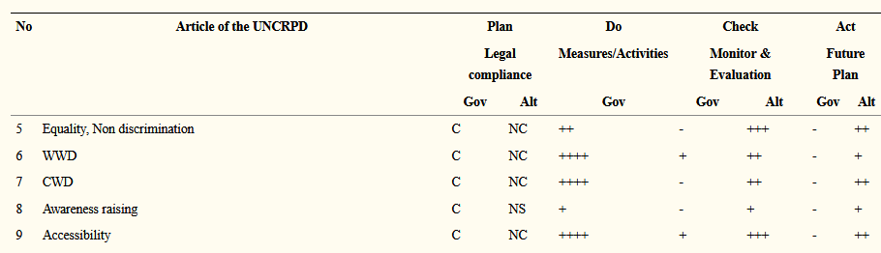
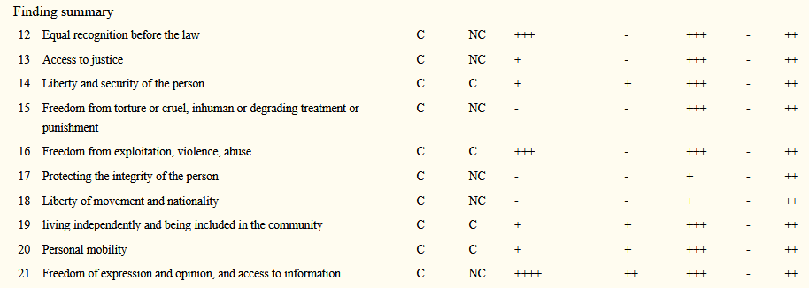
These results are particularly startling considering the long heritage of identifying and addressing the rights of people with disabilities in Thailand dating back to 1998 and the Declaration on the Rights of Persons with Disabilities. For blind and sight impaired individuals this advocacy extends to the 1960s when “The Bangkok Association of the Blind, the first Disabled People’s Organization (DPO) in Thailand, was established in 1967 with support from international volunteers and the Thai Royal Family” (Srisuppaphon et al., 2017, para. 4). Regulations for media accessibility for people with disabilities deploying AD, closed caption and sign language appeared in the Thai Broadcasting and Television Businesses ACT section 36 in 2008 which affirmed the need for ‘suitable services’ including “a sound broadcasting service that broadcasts a full time book reading programme or a television service that provide sign language interpreter, scrolling display or AD for the public news programmes” (“Thailand’s Broadcasting and Television Businesses Act”, 2008, p. 20). However, it was not until 2013, and the integration of digital television, that formal targets were contrived and announced (Sueroj & Sarakornborrirak, 2016, p. 208) (Table 7).
Table 7. The 5 year plan for the increase of airtime services for people with disabilities in Thailand
Types of services | Year 1 (%) | Year 2 (%) | Year 3 (%) | Year 4 (%) | Year 5 (%)
Sign language interpreter | 5 | 5 | 7 | 7 | 9
Closed captioning | 40 | 40 | 50 | 50 | 60
AD | 5 | 5 | 7 | 7 | 10

These measures – as well as those released in 2015 that have required digital television licensees to provide at least 60 minutes of AD per day (Sueroj & Sarakornborrirak, 2016, p. 208) – are applied to “informative and news programmes” (Sueroj & Sarakornborrirak, 2016, p. 208) which are not ideal for AD due to the heavy emphasis on speaking with limited space to insert description:
“Normally, news and information TV program genre is already full of the verbal speech making them lack of the space [sic] for describing or, to say, unsuitable programs for being made [sic] audio description because the audio description making process always requires the “sound gaps” to be fulfilled with the pictorial-described speaking words giving the space for visually-impaired audiences to imagine the frame (Janevatharauk, 2017, p. 59).”
This means that despite Thailand’s excellent record in community and government support for people with disabilities there remain some gaps and absences in the policy rhetoric and real-life conditions for people with disabilities. Rates of AD on television remain modest at best, with no real innovative push to accelerate its integration.

South Africa
In South Africa, the White Paper on the Rights of Persons with Disabilities 2015 holds a core outcome as “all persons with disabilities, irrespective of their age, gender, type of disability, race and economic status; participate fully and equally in mainstream social and economic life” (p. 42). To specifically address Article 9 of the UNCRPD, the White Paper seeks to introduce a series of directives, listed as (Republic of South Africa Ministry of Social Development, 2015, p. 56):
“Promote access for persons with disabilities to new information and communications technologies and systems; provide captioning on all television station programmes; ensure equal access to information and communication platforms; promote South African Sign Language (SASL) and train SASL interpreters; develop and regulate braille standards; provide access to print mediums for persons with print disabilities; and provide accessible emergency and disaster management information.”
However, AD is not mentioned, even though in 2013 the Electronic Communications Amendment Act affirms “access to broadcasting, postal and electronic communications services for persons with disabilities that include, but are not limited to, services designed to improve accessibility for persons with disabilities, such as videotext, subtitling, audio description and sign language” (Republic of South Africa, 2014, p. 12). This amendment established targets for universal access and by 2017 these had been formalised (Republic of South Africa, 2017, p. 10). Table 8 shows the minimum audio description requirements on public, commercial, subscription and community television in South Africa (Republic of South Africa, 2017, p. 10). Note that the figure listed for Year 5 public is perhaps a typo or other anomaly.
Table 8. Minimum audio description requirements on South African television 2017-2026
 | Public | Commercial  free to air | Subscription | Community
Year 1 | 2% | 1% | 0.5% | 0.4%
Year 2 | 4% | 2% | 1% | 0.8%
Year 3 | 6% | 5% | 1.5% | 1.25%
Year 4 | 8% | 3% | 2% | 1.6%
Year 5 | 20% | 4% | 2.5% | 2%
Year 6 | 10% | 5% | 2.5% | 2%
Year 7 | 10% | 5% | 2.5% | 2%
Year 8 | 10% | 5% | 2.5% | 2%
Year 9 | 10% | 5% | 2.5% | 2%
Year 10 | 10% | 5% | 2.5% | 2%

These targets are situated within a context of uneven growth of the broadcasting market. The only public broadcaster, the South African Broadcasting Corporation (SABC), is required to provide its service throughout South Africa. However, due to technological limitations it is not clear the extent to which it has met these goals (Lloyd, Duncan, Minnie, & Bussiek, 2010, p. 66):
“In an interview in August 2008, the SABC General Manager in charge of facilitating universal access … Lynn Mansfield, stated that about 3.6 million South African households did not at that time have access to television and a further 5.4 million did not have access to a radio service.”
The coverage of the 2011 World Football Cup served as a significant boost to this coverage, despite it being cobbled together via low power transmitters and “exploiting cellular phone networks” to achieve this. The switch to digital broadcasting, also in 2011, spurred on accessibility initiatives.

Uganda
The above story – of signing up to the UNCRPD but lacking the resources for an effective and cohesive integration of broadcasting accessibility – is not a unique one. In Uganda, for example, which in 2018 held their first Symposium on Disability and Media, radio remains the mostly deeply penetrated media in the country. It currently “does not have in place a television/video programming accessibility policy framework” (Republic of Uganda, 2017, p. 15) although the Draft Policy affirms the need to ensure “licensed service providers deliver… access services such as audio description, audio subtitles, closed captions and signing” (p. 16). Accessibility, instead, is mostly focused on ensuring regular and consistent electricity supply.

Mongolia
Similarly, in Mongolia – also a signatory to the UNCRPD – its accessibility rhetoric focuses on infrastructure as covered in Article 9 of the Convention. The Law of Mongolia on Human Rights of Persons with Disabilities, enacted in 2016, provides the legislative framework for meeting the outcomes of the UNCRPD; however, “inadequate implementation persists because the rules, regulations and relevant laws that are necessary for implementing the law have not been amended” (Disabled People’s Organizations of Mongolia, 2015, p. 15). There is now a strong advocacy for consultation with persons with disabilities to be involved in forming and ensuring regulations. Under Information Accessibility, the concern is with ensuring people with disabilities in Mongolia have access to emergency services. Additionally, the Law of Mongolia on Communication maps out further actions that in the future will build upon this foundation for media access (Government of Mongolia Ministry of Labor and Social Protection, 2017, p. 49), including to:
“Develop an application to convert typed information on screen into sound in Mongolian language; develop standard for websites that are publicly accessible, elderly, and disabled friendly equipment and devices; ensure that the Mongolian National Radio and Television translate the broadcasting into sign language; develop special needs application that reads screen in Mongolian language and recognizes colour, image, heat and currency bills; ensure that government and private entities make their web pages accessible to persons with disabilities; and ensure that ATM and information kiosk machines are accessible to persons with disabilities (braille lettering dots, audio instructions).”

India
In India, the Accessible India project also focuses heavily on accessible places, spaces and buildings. One key outcome has been the development of an app (Accessible India Campaign, n.d.) that clients can use to map and log places that are inaccessible with a view to improve this infrastructure. This initiative is supported by the Rights of Persons with Disabilities (RPWD) Act 2016 which “has mandated that all public buildings … should be made accessible” (National Disability Network and National Committee on the Rights of Persons with Disabilities, 2017, p. 12). However, there remains little development of accessibility on television. According to the Parallel Report of India on the UNCRPD (National Disability Network and National Committee on the Rights of Persons with Disabilities 2017, p. 14):
“Visual media remains largely inaccessible. As a result of sustained advocacy by the disability sector, the Ministry of Information and Broadcasting finally issued a Circular in 2015 regarding the captioning and audio description of television/news programmes. However, there has been no progress (as on February 2017) as far as implementation is concerned.”
This is supported by the Persons with Disabilities Act of 2011 which states that “all content including publications, periodicals, journals, educational materials, text books, multimedia materials, internet and electronic formats shall be made available to persons with disabilities in accessible format”. The Disabilities Empowerment Act chapter 5, section 29, states that the government and local authorities will undertake to “ensuring that persons with hearing impairment can have access to television programmes with sign language interpretation or subtitles” (Government of India Ministry of Law and Justice, 2016, p. 12). However, there is no equivalent statement for AD. Similarly, there is attention to web accessibility and the principles of Web Content Accessibility Guidelines (WCAG), but the nation’s film industry – Bollywood, “the world’s most prolific film industry producing around 700 films every year” (Rai, 2009, p. 3) – is not produced with AD. Instead, interest in describing these films has come from the diaspora living in the UK where, as previously discussed, the availability of AD is more robust. As such, the integration of AD in the Indian film industry looks like it is more likely to come from partnerships with UK audio describing companies seeking to fill a market in the UK.

Pakistan
Pakistan also has introduced The Sindh Empowerment of Persons with Disabilities Bill in 2018 which mirrors the language in the Indian Disabilities Empowerment Act with “ensuring that persons with hearing impairment can have access to television programmes with sign language interpretation or subtitles” (Provincial Assembly of Sindh, 2018, p. 14) but has no accompanying statement for AD. Currently Pakistan has no television nor multimedia policy for AD.

Barriers to Implementing Audio Description
In this final section, further common international barriers to the implementation of AD are also discussed, focusing on copyright restrictions and cost.

Copyright restrictions
One major problem for the effective integration of AD in free to air broadcasting in a global marketplace has been copyright protections for creative output. Similar to the case of audio books where the audio track produced can be construed to violate the original copyright of the written work, the verbal AD track can also be framed as a copyright violation of the original creative artefact. This is why much AD has to date been only been engaged by specialist providers of cultural artefacts for people with sight impairments. Organisations such as the Royal National Institute of Blind People in the UK, for example, and the ACB in the US have become powerful advocates in forwarding legislation and are often excepted from digital rights management in distributing audio described materials to their members/clients within the context of ‘fair use’ and exceptional circumstances.
For example, in 2009 when the Kindle 2 was released with text-to-speech software, publishers argued that this was a violation of copyright. To date, various digital rights management software tools still restrict access to copyrighted material, meaning audio books cannot be played on everyday devices like iPhones or tablets but must be played on specialised hardware obtained from a (disability specialist) library or organisation, or be individually purchased for upward of US$300. Currently, the ad hoc and inconsistent approach to the law means that a whirlwind of absurdity surrounds how blind people might ‘read’ a book (Lee, 2018, para. 9):
“… if you’re a blind person who would like to read a copy-protected e-book, it’s legal under the Library of Congress rules if you write your own software to strip out the DRM [Digital Rights Management]. But if someone else writes screen-reading software that circumvents DRM and sells it to you, they’re still committing a federal crime.”
Such insecurity plays out internationally, yet there are moves to change this. For example, the Marrakesh Treaty to Facilitate Access to Published Works for Persons Who Are Blind, Visually Impaired, or Otherwise Print Disabled (2013) is specifically aimed at creating a standard set of limitations and exceptions to copyright rules in order to permit the reproduction of published material (including audio books) and, importantly, to allow that material to be exchanged across borders. The Marrakesh Treaty specifically addresses the potential copyright concerns and waives them for people with disabilities, particularly blind people wanting access to print material. It enables copyrighted works to be produced in other formats for accessibility and to permit the transmission of those artefacts across national borders and boundaries. However, this does not cover general broadcast operations, but rather those that specifically service people with vision impairment.
Indeed, while organisations that service the blind and vision impaired community are permitted to produce these materials there are ramifications for AD which may be produced by a third party, and may be transmitted across national borders with the import of foreign television programmes and films into domestic markets. The US for example, which has only signed but not ratified the Marrakesh Treaty, has provided the Chafee Amendment to the Copyright Act which facilitates “third party production of accessible format copies of literary works without the delays and uncertainty of securing copyright permissions” (AFB, 2018b). The question is whether AD can be classified as “fair use” and if the audio described track is a violation of copyright? The answer appears to hinge on the language of the Act which states that such modifications can be for an ‘exclusive’ audience – those with vision impairment – which diminishes the opportunities for AD to exist as an everyday and normalised option on broadcast television. This notion of the importance of language can be seen in other jurisdictions. In Europe, for example, the Berne Convention (1986) classifies AD as a derivative work requiring a special law provision of “fair use”. However, there is a strong implication that this “fair use” must be non-commercial for it to qualify. For commercial broadcasters this is problematic and nations may need to provide their own special exceptions in ‘fair use’ for it to be part of the broadcast milieu.
Internationally, the Marrakesh Treaty is adopted with varying degrees of success due to a number of socio-economic and legislative factors. In 2017 no country from the EU, nor China or Russia, ratified the Treaty. The EU ratified as a bloc in October 2018. China remains a signatory only and Russia acceded in February 2018. An audit by the International Federation of Library Associations and Institutions 2018 praised Australia for not requiring copyright payments to publishers of books and audio books, but criticised the lack of availability of already existing copies of accessible material. (International Federation of Library Associations and Institutions, 2018). In less affluent national contexts, like Ghana which ratified in May 2018, it is next to impossible to gather such information. In contrast, Germany rates ‘bad’ in five out of the seven categories, demonstrating the nuances in national contexts that limit, frame and define the ways in which materials are made available to people with vision impairment. While these laws are for the conversion and distribution of print-based texts, they demonstrate the confusion and incoherence of the legal frameworks that govern accessibility.
In order to address these conflictions the EU has created Regulation 1563 (approved in 2017) which verifies the ability to share accessible materials in a multinational context. However, AD is not mentioned in the language. The Regulation retains an emphasis on print sources, including “Braille, large print, adapted e-books, audio books and radio broadcasts” and defines ‘works’ as “in the form of a book, journal, newspaper, magazine or other kind of writing, notation, including sheet music, and related illustrations, in any media, including audio form such as audio books and in digital format” (European Commission, 2017). As such, AD remains abstractly codified and largely excluded from the accessibility narratives pertaining to people with vision impairment.

Cost
In the Australian context, cost is frequently cited as a barrier to the availability of AD. According to a Canadian study, currently, it costs CAD$125-$400 (AUD$133 –$426) per broadcast hour to close caption a television program, while describing the same programme costs CAD$1,800 (AUD$1,918) an hour (Milligan, 2011). According to the American company 3PlayMedia (Edelberg, 2017), it costs between USD$15-75 per minute for AD. Furthermore, AD requires a significant amount of bandwidth (Vaidyanathan, n.d., p. 10) (Table 9).
Table 9. Required bandwidth for the provision of audio description in India
Access service  (examples are for  services in one language) | Mean bit rate per channel | Effective peak bit rate per channel | Effective peak bit rate per multiplex (4 television channels the simultaneously offering the access service in question)
Closed captions (bit maps) | <10 kbit/s | 25 kbit/s | 100 kbit/s
Closed captions (teletext) | 40 kbit/s | 40 kbit/s | 160 kbit/s
AD (receiver mix) and spoken captions | 64 kbit/s | 64 kbit/s | 256 kbit/s
AD (broadcast mix) and spoken captions | 128-256 kbit/s | 128-256 kbit/s | 500-1,100 kbit/s
Visual signing (quarter-screen video overlay) | 2.5 Mbit/s | 2.5 Mbit/s | 10 Mbit/s (not feasible)
Visual signing (extra video sharing same audio) | 2.5-4.5 Mbit/s | 4.5 Mbit/s | 18 Mbit/s (not feasible)

Phase III: Focus Groups
This section discusses the findings of the focus groups involved in this research project. It is concerned with understanding how different groups of people may benefit from AD, including those without vision impairment or disability. The assumption has been that AD primarily benefits those with vision impairment; however, our results show that a variety of sighted people find AD useful once they have been familiarised with its function.
Recognising that some respondents would be unfamiliar with AD prior to this study, a definition and explanation of AD was provided to all focus groups along with a variety of video examples (Figure 15).
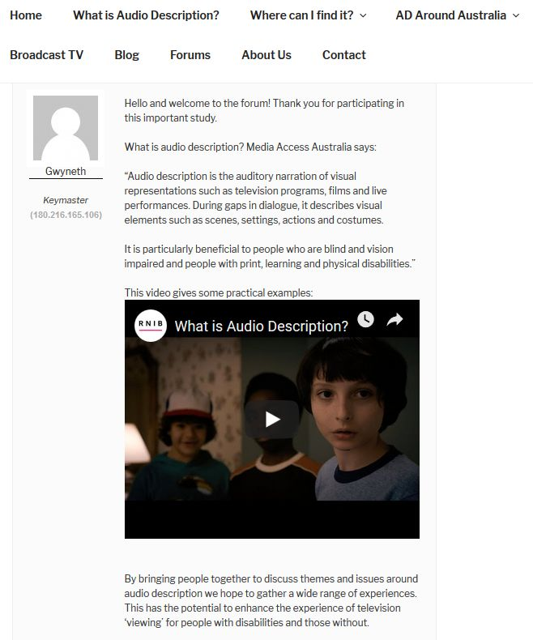
Figure 15. Focus group forum introduction screenshot
Once participants were familiar with the concept, they were asked a series of questions relating to the utility, quality, style and nature of AD as an assistive tool (included as Appendix A). The opinions of various groups were sought, including television fans, parents of young children, people with ASD, audio book readers, film students, as well as people with vision impairment. Their responses were then summarised into five main themes – the lack of awareness of AD, the mainstream benefits of AD, the importance of quality in AD production, their perceived barriers to accessing AD and, finally, how these all affected their demand for the feature.
To summarise respondents’ views on AD:
- A significant portion of sighted participants did not know what AD was.
- AD was seen to be useful to sighted people in a wide variety of contexts. For example, participants noted that due to an aging population, the mainstream need for AD is becoming more urgent as years pass. There were also a number of perceived benefits of AD, in particular in relation to increasing clarity and meaning of texts. Participants also claimed that AD has the potential to generate job opportunities in the entertainment and software industries.
- Both sighted and vision impaired participants believed quality of AD was very important. For example, the vast majority of participants preferred human AD to a synthetic voice and many participants suggested that successful AD needs to be integrated as part of the narrative, that is without interrupting the narrative.
- There were a number of perceived barriers to accessing AD. However, all sighted participants argued that AD should be available on television, regardless of whether they used it themselves.
- There was a high demand for AD among both vision impaired and mainstream television viewers, particularly once the latter group were aware of its uses.

Demographics
A total of 44 people participated in the study, which was divided into five focus groups – television fans, parents of young children, people with ASD, audio book readers and people with vision impairment (Figure 16). Across the whole group, 28 sighted people took part, representing the majority (63%) of the participants.
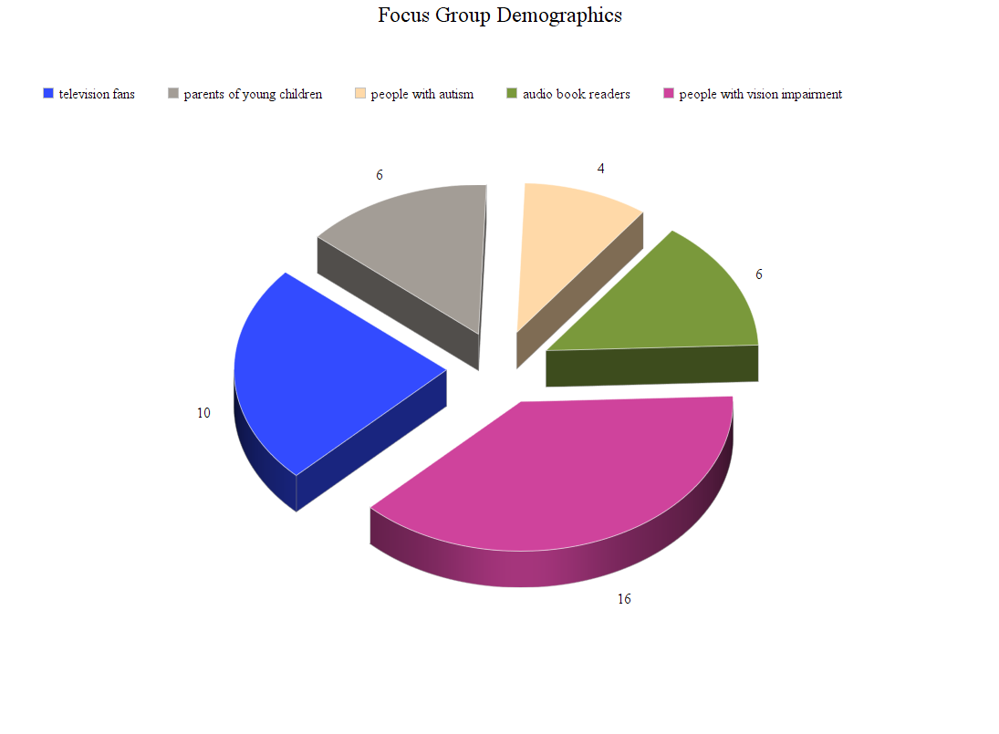
Figure 16. Focus group demographics

Lack of Awareness of Audio Description
Our results indicated that a significant portion of sighted people did not know what AD was. In the focus group survey and discussions, many people were being introduced to the feature for the first time. Even those sighted participants who had heard of AD were often unclear regarding its function, or associated it with captions:
“I heard about audio description through this study, and had never used it before now.”
“I was vaguely aware of descriptive audio as I’ve seen it listed along commentary tracks on DVDs. I have more experience with descriptive closed captioning, which I used to use when attempting to watch a movie and listen to music at the same time.”
“I wasn’t aware of audio description before hearing about this study, so haven’t used it before.”
“I’d never really thought about audio description before this study, but I had a vague idea of it being something that people with visual disabilities would use. I had no idea it could also be of use to sighted people.”
“I had never heard of audio description before being asked to participate in the survey.”
Those who had encountered AD previously often described it as accidental (they “stumbled” upon it) and confusing:
“I actually stumbled upon audio description by accident, when my TV started recording things with audio description automatically enabled. Nobody in my family could work out what it was for a while.”
“I think I first stumbled upon it when I tried putting subtitles onto a DVD I was watching and an audio description started instead.”
Sighted participants who were familiar with AD credited word of mouth or random sightings. Rather than being introduced to AD through advertising, education or more formal avenues, participants listed informal encounters as their source of information:
“I first heard of audio description from my dad, who recorded Books for the Blind.”
“I first heard of audio description services when I saw it noted on the cinema movie times list for certain sessions.”
“I accidently turned the function on for a Netflix show.”
Perhaps even more surprisingly, a vision impaired participant also reported being unfamiliar with AD:
“I first heard about audio description through this study. I have never used AD services before. Yes I would watch a programme or subscribe to a service if it included audio description and was affordable!”
These findings indicated a distinct lack of mainstream awareness surrounding AD in the community. The participants themselves commented on this within the focus groups:
“I think that the availability of AD services needs to be better promoted. I wasn’t previously aware of AD, although I do use captions quite often. In fact, when discussing AD services with my family, I found that they also did not know about it and some even conflated it with captions.”
“Given that I wasn’t really aware of audio description media prior to this study it would definitely help to have more awareness around it.”
The results thus highlighted a widespread lack of publicity on the issues surrounding AD in Australia and its benefits for everyday television viewers. In addressing this problem, Australian broadcasters and legislators might consider the UK’s approach, where the BBC, ITV, Channel 4, UKTV, Viacom and Sky this year joined “a high profile advertising campaign aimed at helping people to use audio description on their televisions” (The Royal National Institute of Blind People, 2018).

Mainstream Benefits of Audio Description
The second major finding of this study was that AD can be useful to sighted people in a variety of contexts. As indicated by our focus group participants, these uses included:
- Multitasking during daily activities.
- Making television a more flexible medium of entertainment.
- Enhancing understanding and clarifying unclear content, particularly helping to identify culture-specific context and meanings.
Many of the sighted focus group participants highlighted the benefits of AD when multitasking during daily activities. Multitasking was described as being able to enjoy television when screen visibility is obscured or their attention is divided and was seen as a major benefit identified by sighted participants:
“For me personally it reduces the reliance on the visual aspect of the shows to follow what is going on, making it easier to follow when I’m trying to do things while watching.”
“I think it opens up more opportunities. Previously I would have only watched a show if I were able to actually give my attention to the screen, however this would allow me to divide my attention and multitask.”
AD was also seen as a way to make visual media more accessible when mobile and/or unable to reliably focus on a screen, for example during hands-on activities that required intermittent focused attention. These included cooking, practising a musical instrument, caring for children and crafting. Some of the participants’ explanations are listed below:
“When listening to the examples provided I found myself picking up my (much neglected) knitting. I was able to focus on my knitting while still following along with the video, which is something I would previously find difficult to do.”
“I could see myself using audio description enabled content while undertaking other tasks or where I know I’m likely to be interrupted, usually by a little one.”
“If I had the option to use audio description, I might well find myself listening more while cooking (because at the moment I try to watch some things while I’m chopping/stirring, and end up missing out on the action).”
“I think if I had the option to use audio description I would. I do a lot of drum practice while watching TV and as a result just end up listening to the programme so it would help fill in what I miss.”
“I can imagine using [audio description] while doing craft, to ensure I didn’t miss things while looking at my work.”
Television becoming a less stationary, more mobile and dynamic experience was another benefit highlighted by participants who claimed AD made television a more flexible medium of entertainment:
“Being able to consume media 24/7 makes it possible to watch or listen to a programme whatever we are doing. I would make use of the tedious hours commuting to and from work to listen or watch audio description on my phone.”
“I can see [audio description] being useful for being able to experience TV without having to sit down and watch, though (like I do podcasts, listening while travelling or doing chores around the house), or for being able to combine TV with activities that require visual focus.”
This attitude is aligned with the shifting nature of television as medium. No longer confined to a large heavy box in the lounge, digital television is becoming more mobile and dynamic each year. As Turner (2016) points out, “television is evolving”. AD offers a way of engaging proactively with these changes, making digital television accessible in a way that benefits a wide range of people.
AD was also seen to enhance understanding and clarify unclear content, particularly helping to identify culture-specific context and meanings. Sighted participants were asked “How does audio description change the experience of watching television?” and their responses were often related to this idea:
“I would perhaps considering using AD if I were to watch a film I was struggling to understand. For example, if the content was difficult […] using AD to help me to understand cultural specificities. I think AD should be made available to everyone.”
“AD might help convey cultural specificities, and might also help when content is confusing.”
“It did change [my] viewing experience. It almost helped validate how I was interpreting the scenes in the clips which was nice.”
For people with ASD, AD also has the potential to assist further. As participants in the ASD focus group explained:
“I think [audio description] could be a useful thing for some people on the autism spectrum who need help with deciphering the differences between facial expressions, and who may struggle to process written text but have it a lot easier when it comes to processing verbal language.”
“I am usually quite content with closed captions or subtitles. However now that I know of its existence, I may be inclined to use the service if there is a particular [sic] scene or moment I did not quite grasp or understand.”
“Some movies can be incredibly hard to follow when you can’t really tell characters apart, so a verbal description would be very helpful there. If the service had a button to easily switch between having an audio description and not, I would be much more likely to use it.”
Overall, sighted respondents agreed that AD has the potential to expand everyone’s viewing experiences by making diverse content more accessible in general.
“I think I would consider watching a lot of programmes I currently do not watch if I had access to AD as it provides a different entertainment experience.”

Importance of Quality in Audio Description Production
Our third major finding was that both sighted and vision impaired participants believed quality is very important, particularly in relation to style and tone, and that a ‘one size fits all’ approach to AD was therefore insufficient. According to the focus groups, there was need for variation in speed, tone, style and levels of emotion in AD tracks, depending on the genre of television being narrated:
“I was surprised by the different types and variety of AD services available. Not all are equal, and they do affect the viewing/listening experience.”
It was noted that AD that does not complement the style of television being shown cannot only distract, but also detract from a viewing experience:
“The emotion in the narration is important, if it doesn’t match the scene or is a little too much then it begins to detract from the description.”
“[W]hen done right I think that there is a potential to complement the film/show/clip rather than serving as an additional service that interrupts the flow (which is mainly what I got from it in the clips we saw).”
The issue of human versus synthetic voice was also highlighted. AD comes in different forms and, as such, some visual media is described by a human narrator, while other tools use an automated voice. In this study, sighted participants expressed a clear and unanimous preference for human voice:
“Audio descriptions are fantastic when they are done well, with a human voice reading creative and detailed content in an emotive way.”
“I prefer the more emotive, less robotic voices as they are easier on the ear and feel familiar to me. […] The robotic voices aren’t enjoyable and they remove an important level of connection with the audience.”
“I much preferred the human voice to the robotic voice. I think it’s essential to hear human emotion while hearing audio description.”
“I prefer the audio description with warmth and personality. The robotic voice can be jarring and doesn’t allow me to imagine what’s going on as clearly.”
“The smoothness and natural inflexions of the human voice […] are far easy to listen to and the narrator feels like they’re describing the scene. The synthetic voice does not have that natural feel to it, the tone, pace and inflexions are [sic] don’t fit with the description and seem to be devoid of emotion (i.e. more like reading a list than describing a scene).”
For some participants with ASD, examples of synthetic voice were more difficult to follow:
“Tone is something a lot of autistic people can struggle with; including myself, so I don’t feel like the distinction between the two is enough for me to clearly understand what is audio description and what is actually part of the trailer.”
“You would be focused on the screen trying to process all the visual information but also then bombarded with the Audio Description with very little pause between character dialogue and the synthetic Audio Description.”
“I find synthetic/computer generated voices a lot harder to process, because they come across more jagged and unclear. You can’t always clearly decipher or understand what they’re saying because they may pronounce letters or words differently.”
Interestingly, among vision impaired participants there was less consensus regarding preferences, but the human voiceover was still more popular. Although this group acknowledged the potential cost of organising human narration, the inadequacy of the synthetic voice was clear:
“I think it would be a shame if audio description were made with synthetic voices as a cost cutting measure since while describing the movie there is no emotion.”
According to our focus groups, AD worked best when it was integrated as part of the narrative. Participants argued that a qualified practitioner should be used to provide the service; someone who is trained to provide appropriate narration:
“The human voice used for AD should be that of a good actor who knows how to modulate her/his voice to express the variety of emotions suggested in the absence of dialogue and to bring to life the visual settings.”
University level education and training is already taking place overseas, so this is something to consider seriously in the Australian context. For instance, the Autonomous University of Barcelona (UAB) offers a specialisation course in AD. Similarly, in New Zealand, Able’s approach to AD uses the same person to script, record and edit the AD track. This opens a number of unexplored educational and career opportunities in the Australian media industries.

Perceived Barriers to Accessing Audio Description
A lack of knowledge regarding AD content – including associated publicity and resources – were cited as significant barriers to accessing AD for most participants. In general, sighted participants simply didn’t know how to access AD, nor where to start looking:
“I’ve never used audio description services before, nor do I know how to access them.”
“I don’t know how to go about accessing these services in the home (i.e. for watching television or videos through computers and smart devices).”
“I have never used audio descriptions, and I don’t know how to access them for personal use.”
Those who are familiar with AD still struggled to access it consistently due to a lack of reliable services. Their media consumption was therefore restricted to what others had bothered to audio describe:
“I make use of AD as often as I can, i.e. whenever it is available for something that I want to watch.”
“[R]ather than consulting a list of what is available and making a selection from that, my preference is to choose something I really want to watch and then find out if it has AD. This certainly does lead to disappointment and frustration at times.”
“I would like to use AD more but it is not that easy.”
In 2011, Screen Australia announced that all films applying for their investment must make captioning and AD available. However, even when AD is advertised as available, its implementation is not assured, resulting in ongoing difficulties and technical issues for people trying to access AD. As one participant explained:
“The frustration in Australia is Stan, Amazon Video, Telstra TV box and similar services do not provide Audio Describe on their apps or hardware devices. Even if the AD is already in the movie. For example, last night I tried to watch a movie with my wife called “Breathe” which was an Australian movie on surfing. The write up indicated it has close caption and Audio Describe. We hired the movie via Bigpond on our Telstra TV box. Guess what, the movie did not support AD.”
This notion of frustration was seen as an ongoing experience for Australians who depend on AD. Some participants described having to download international AD tracks illegally through secret online networks:
“I find shows through private ftp sites where people upload mp3 files of movies and TV programmes that are shown here but audio described in other countries like the UK or USA.”
The focus groups thus highlighted a need for industry standards regarding provision of AD in Australia, including regulation of quality, availability and the assurance of dependable ongoing services.

Demand for Audio Description
Studies indicate that people with visual impairment watch almost as much television as sighted people. In fact, 96% of visually impaired adults watch television on a regular basis (Boucher, 2018). For vision impaired viewers, it was noted that AD provided a way of enjoying television independently, without the assistance of others:
“AD allows you to follow along at the same time as others, allows you to not miss any information on what you are watching and you don’t have to ask someone what is going on.”
“I don’t have to ask my companions for interpreting or to compromise their viewing for mine.”
AD is well known to provide a very beneficial service for blind and vision impaired viewers. However, to date, the needs and wants of the sighted community have not been factored into this equation. Our study shows that both vision impaired and sighted participants expressed a strong desire for AD on television. Significantly, sighted people were unanimous in this, citing personal benefits in addition to a larger concern with equality and accessibility for all:
“AD is a beneficial resource for a wide range of people and should be wider known than it is in this country. Having experienced it, I wish it was more readily available and would seek out opportunities to engage with audio description.”
“I think every television show or film should have audio descriptions available. It’s hard to consider how someone who is visually impaired could ever enjoy a film or television experience without them.”
“I definitely think audio description should be available for all visual media (but especially content that’s publicly funded or has important public relevance) to make it more widely accessible.”
“I would also like to see audio description and Auslan interpreting be publicly funded by the government and mandated for all mainstream television productions and performances.”
As these quotes illustrate, sighted participants recognised the importance of having equal access to visual media in order to participate fully in public life.
Safety is another key issue, as emergency television broadcasts are not currently audio described. A significant portion of the community – estimated at over 575,000 people (NDIS, 2015) – is therefore not receiving crucial survival information as it becomes available (Ah Tong, Duff, Mullen, & O’Neill, 2015). Vision impaired participants were aware of this, and identified AD as essential for full engagement and inclusion in Australian public events, culture and community:
“[Audio description] would enable me to participate in conversation with others […] as very often we are excluded from discussions and conversations due to the lack of information which stems from a lack of details when we are consuming visual content without audio description.”
“It would make a massive difference to have audio description on TV with programmes spanning documentaries, news, other magazine type programmes. In particular sports is significantly missing audio description and is in great need given that we have a strong sports culture in Australia.”
At this point it is easier for Australians to access audio described Australian content in other countries than at home. BCA (2018) point out that, ironically, “iconic Australian programmes such as Neighbours and Home and Away are already audio described for overseas audiences, but are still not accessible to people who are blind or vision impaired in Australia”. Indeed, one participant rightly noted that the mainstream need for AD is only increasing as years pass:
“Whenever there is innovation around aids, equipment and addition support for PWD, the economic argument is used to counter progress. This is a redundant argument as we are an ageing population which will increase the amount of disability. We need to invest in this future.”
As these results show, the demand for AD is building yet Australians are still being left behind. Without urgent action to make AD available on television, the difficulties and inequalities will only grow. This will negatively impact an even larger portion of the community as time passes.

Conclusions
The countries and contexts that model best practice for the development and integration of AD onto broadcast television have a cohesive and cogent approach to disability rights, but also treat accessibility as an essential part of legislative, social and cultural outcomes. Spain, the UK and the US, for example, have in place robust community advocacy, comprehensive legislation as well as strong compliance measures. These spheres cohere to create contexts where disability rights are not only rendered and presented by signatures on important international documents, but are also activated in the conscious and clear trajectories of government policy and outcome, the rights of citizens and how to build a good society. The importance of accessibility as a human right is rendered in these examples that foreground disability and conceive of a diverse social framework where different ways of being, knowing and understanding are presented, accounted and activated.
This report has demonstrated that the two major models for AD – translation and accessibility – present different ways to consider the activation and integration of accommodations in the form of AD on broadcast television. Both assign legislative and compliance measures to ensure the delivery of effective and quality described content. The debates within the accessibility model are attractive in that they are located within the understanding of access to television as important for a sense of social inclusion. This is aligned with the UNCRPD that includes specific mention of accessibility to communications and information. Indeed, accessibility as a human right offers a powerful platform from which persons with disability – and their allies – can advocate for change. However, the resonance of this debate is often hampered by popular perceptions persisting around ideas that ‘blind people don’t watch television’ or that they do not want to watch television. These ideas do not take account of the ways that AD is of benefit to many people within a social framework – some sighted, others not.
The translation model, however, affirms AD as just another mode of accommodation among many in a diverse and complex environment, specifically defined by the make-up of the EU with its many countries, languages, peoples, identities and experiences. There is a fluidity to this model that implicitly assumes the importance of social inclusion and that television is an important part of that. The right to accessibility is assumed within this model and the core debates are had around not whether AD should be available but how to make it effectively available to the widest audience. The key tropes within the translation model tend to revolve around the design and designation of AD onto texts.
In Spain for example, a number of universities offer AD as part of ‘translation studies’. These courses are designed to not just raise awareness of AD on broadcast television but to also provide the appropriate skills to students so they may become effective describers. These skills are instrumental in supporting and affirming appropriate AD and accessibility policy governing targets on broadcast television. They also have the potential to avoid some of the difficulties outlined in Thailand for example, where the targets for AD have emphasis on news programmes which, due to their strong audio nature, many not need so much describing. Instead, AD might be better deployed on other types of programmes like dramas to add diversity to the texts available to persons with disabilities.
In summary, approaching AD as a logistical, expressive and translation ‘issue’ in combination with a legislative and compliance one might help avoid the ideologically dense associations and assertions about television and its role in a social framework in Australia, a framework tethered to a Reithian model of not lowering accepted ‘standards’. That is, while AD must be provided for emergency broadcasts in times of urgency or crisis, this does not mean that persons with disabilities should be subject to judgements about what types of television they ‘should’ have access to, the news versus Neighbours for example. Instead, entertainment must be seen as an essential social literacy that is fundamental to how inclusion is felt and understood, activated and exchanged.
The objective of this report has been to demonstrate the ways in which AD is a human right and how Australia might, with attention to international models, community arts initiatives, and feedback from a diversity of users of AD, become leaders in providing a cohesive and integrated approach to AD, one that leverages the benefits of both the accessibility and translation models to affirm the rights of persons with disabilities, enforce quotas on broadcast television, and deliver quality AD content across the programming landscape. This means taking into account international trends, affirming the responsibilities of broadcasters, and centring diversity in policy and legislation, best practice models and description standards.

Recommendations
We recommend that AD be introduced on Australian free to air television. This will require a whole of sector approach and include commitment from governments, the broadcasting industry and regulators, as well as audiences and the community. As we have discussed throughout this report, sighted people must be exposed to AD to find out what it is, how they could potentially benefit from experimenting with it and, finally, how it facilitates social inclusion for people who are blind and vision impaired.
AD on television is vital for social inclusion for the blind and vision impaired community but also in order to raise understanding about what AD is within both this cohort and the wider community. The lack of AD is a Catch-22 situation – mainstream users don’t know what it is because it’s not on television, and it’s not on television perhaps because people don’t know what it is or how to use it. This general lack of understanding about AD amongst the sighted community in Australia can in many ways be attributed to people never coming across it in their daily lives. However, as has been the case with other technologies such as captions, the mainstream audience are very willing to experiment with digital media and accessing audio-visual content in new ways.
Recommendations for government
As discussed in this report, the blindness sector have been advocating for AD on Australian television for close to 30 years. Conversations have been had and working groups convened while technologies and television itself have advanced and changed. It is time for action in the form of legislation. We recommend legislation that makes quality AD compulsory on free to air and catch-up television, with priority placed on those programmes that rely on unspoken visual elements to convey meaning and understanding such as drama.
While digital technology and smart devices have made it much easier to access AD, free to air broadcasters continue to resist providing it. It has therefore become necessary for the government to introduce regulation to ensure this essential service is available to all Australians.
Recommendations for industry
The industry must stop resisting this natural progression of inclusion and innovation. Although Australia is a relative latecomer with regards to AD content provision, it could be a world leader in a short space of time.
For example, quality AD requires skilled human vocalists who are sensitive to the speed, genre and tone of the visual events being described; automated synthetic voice tools are not sufficient. To ensure this is achieved, we recommend the creation of industry standards for audio describers, as well as formal training programmes that ensure actors and other presenters are fully prepared to create quality audio tracks. As the demand for AD increases, this opens up a new career path for actors, vocalists and other performers.
Penalties for not meeting mandated levels of AD must be enforced by the Australian Communications and Media Authority (ACMA) as the regulatory body. We recommend following the British Ofcom model whereby broadcasters are heavily penalised for not meeting requirements.
The media must likewise stop ignoring this issue and instead consider the ways AD could benefit them. With the ageing population and the mean age of free to air broadcasters ranging between 46 and 63, including AD on free to air has clear economic benefits, particularly in the current era of attracting niche audience demographics.
Recommendations for community
The blindness community are already heavily invested in this space and regularly conduct activism and lobby politicians to highlight the importance of legislating AD. We recommend the community continues these efforts and engages in coordinated activities that bring together a number of stakeholders, including both the tech community interested in digital innovation and sighted people. As our report highlights, sighted participants were largely unaware of AD and had “no idea” it could also be of use to sighted people. The benefits of AD for sighted audiences are drastically under-researched and under-publicised. Once they were made aware, sighted participants expressed interest in using the service and showed a preference for higher quality AD.
Accordingly, we recommend further research into mainstream uses of AD and proactive campaigning to increase general awareness of these benefits. Our report indicates that an increase in education, publicity and widespread discussion will generate greater mainstream demand for AD, thereby increasing existing pressure on government and industry to provide the service.

Authors
Katie Ellis
Dr Katie Ellis is Associate Professor in Internet Studies and Director of the Centre for Culture and Technology at Curtin University. Her research is located at the intersection of media access and representation and engages with government, industry and community to ensure actual benefits for real people with disability. She has authored and edited 13 books and numerous articles on the topic of disability and the media, including award-winning papers on television accessibility, e-learning, and access to the internet. Throughout 2017 she was a member the Department of Communications and the Arts Audio Description Working Group, advising the minister on how best to provide AD narration on Australian television to make it accessible for Australia’s blind and low vision community.
Gwyneth Peaty
Dr Gwyneth Peaty is a Lecturer in the Discipline of Internet Studies at Curtin University. Her research focuses on new media, popular culture and digital technologies, and she has published a range of journal articles and book chapters on these topics. She has conducted extensive research in the area of disability and digital media including a Curtin University funded Teaching Innovation project into the mainstream uses of captioned online lectures in higher education. Her current projects include a book on gargoyles and further explorations of captioning in entertainment and educational media.
Leanne McRae
Dr Leanne McRae is a Research Officer in the Internet Studies discipline at Curtin University. Her current research interests revolve around disability, digitisation and education, with special interest in the Internet of Things. Recent publications have focused on MOOCs, physical cultural studies and social media in education. Her book Terror, leisure and consumption: Spaces for harm in a post-crash era, was published by Emerald in 2018.
Mike Kent
Associate Professor Mike Kent is Head of School for Media, Creative Arts and Social Enquiry at Curtin University. His recent publications Manifestos for the future of critical disability studies and Interdisciplinary approaches to disability: Looking towards the future are both edited with Rosemarie Garland-Thomson, Katie Ellis and Rachel Robertson. Throughout 2017 he was a member the Department of Communications and the Arts Audio Description Working Group advising the minister on how best to provide AD narration on Australian television to make it accessible for Australia’s blind and low vision community.
Kathryn Locke
Kathryn Locke is a Researcher and PhD candidate at Curtin University. Kathryn has extensive research experience in researching issues related to disability and digital media and has been published in a range of disciplines, including sustainability and internet studies. Beyond her academic and research experience, Kathryn teaches externally for Curtin in the fields of internet studies, media and cultural studies.

Appendix A: Focus Group Forum Questions
Post One – Getting started: What is audio description?
Hello and welcome to the forum! Thank you for participating in this important study.
What is audio description (AD)? Media Access Australia says:
Audio description is the auditory narration of visual representations such as television programs, films and live performances. During gaps in dialogue, it describes visual elements such as scenes, settings, actions and costumes. It is particularly beneficial to people who are blind and vision impaired and people with print, learning and physical disabilities.
This video gives some practical examples:
https://www.youtube.com/watch?v=i_GrYOruY7w
By bringing people together to discuss themes and issues around audio description we hope to gather a wide range of experiences. This has the potential to enhance the experience of television ‘viewing’ for people with disabilities and those without.
Here are some more examples:
The Hunger Games clip – https://www.youtube.com/watch?v=B8BD9txkGL4
The Lion King clip – https://www.youtube.com/watch?v=7-XOHN2BWG4
Life story: Vanessa Vanuatu – https://www.youtube.com/watch?v=Ca7EqrqTgyY
Animated short: Out of Sight – https://www.youtube.com/watch?v=cQXD6jkv4hQ
Optional longer example [Full movie]: The silent film Nosferatu (1922) – https://www.youtube.com/watch?v=DySMmYH9yfI&t=
Once you have viewed the examples, please move on to the second forum thread, where we have a few questions for you. (And if you have any first impressions or thoughts about audio description from these examples – do post them below!)
Post Two – How do you use audio description?
Now that you’ve seen some examples of audio description, here are a few questions for you:
- How did you first hear about audio description?
- How often, if at all, do you use audio description services?
If you do:
- How and where do you find information about audio description services?
- Would the availability of audio description influence your decision to watch a programme or subscribe to a service?
Post Three – What kind of audio description do you prefer?
Not all audio description is the same. There is variation in style and quality. The amount of description can also vary, along with the level of detail and emotion conveyed through the recording. Consider the differences between these two audio described videos:
Star Wars trailer – https://www.youtube.com/watch?v=qeL1H2ILiNM
Flood: From the Sea (Part One) – https://www.youtube.com/watch?v=GftoCmfPTvk
- Which of these do you prefer and why?
Post Four – Human versus synthetic voice
Some audio descriptions are computer generated using synthetic voice, while others use human narration. Consider these two examples:
National Geographic sea lions – https://www.youtube.com/watch?v=Lw1bESPHAvY
National Geographic chimpanzees – https://www.youtube.com/watch?v=1cuwX0zPYLo
- Which of these do you prefer and why?
Post Five – Contrasting different styles of human audio description
Here are two different examples of audio description for the same scene in Tron: Legacy:
UK – https://www.youtube.com/watch?v=iSoWIgjI7SE
US – https://www.youtube.com/watch?v=LHkL0A4xi-I
- Which do you prefer and why?
- What are the most important elements of good audio description for you?
Please give as much detail in your answers as you can!
Final Post – How does audio description change the experience of watching television?
Our final set of questions asks you to reflect on audio description and consider its potential benefits.
- Does audio description change your experience of media? If so, how?
- How specifically do you (or would you) make use of the AD service if it is/was available?
- Should audio description be made available for all visual media?
- Are there any other issues you would like to raise, or ideas you would like to share?
Thanks so much for participating! :)

Glossary
ABC Australian Broadcasting Corporation
ABS Australian Bureau of Statistics
ACB American Council of the Blind
AD Audio description
ADA Americans with Disabilities Act
AFB American Foundation for the Blind
ASD Autism spectrum disorder
BAI Broadcasting Authority of Ireland
BAM Big Access Media
BCA Blind Citizens Australia
DADAA Disability in the Arts Disadvantages in the Arts
EU European Union
FCC Federal Communications Commission
UNCRPD United Nations Convention of the Rights of People with Disability
VOD Video on demand

References
Able.co. (2018). Audio described TV listings. Retrieved from https://able.co.nz/audio-description/audio-described-tv-listings
Accessible India Campaign. (n.d.). Participate campaign on mobile. Retrieved from http://accessibleindia.gov.in/content/innerpage/participate-campaign-on-mobile.php
Accessible Media Inc. (2018). DVD guide. Retrieved from https://www.ami.ca/dvguide
Agenzia Entrate. (2016). Television Legislation and Practice. Retrieved from http://www.agenziaentrate.gov.it/wps/file/Nsilib/Nsi/Home/CosaDeviFare/Richiedere/Canone+TV/Normativa+Prassi+Canone+TV/Articolo+1+comma+40+legge+232+%28legge+di+bilancio+2017%29/Legge+n+232+del+11+dicembre+2016.pdf
Ah Tong, B., Duff, G., Mullen, G., & O’Neill, M. (2015). A snapshot of blindness and low vision services in Australia, Vision 2020 Australia, National Disability Services, Australian Blindness Forum, Sydney. Retrieved from http://www.vision2020australia.org.au/resources/a-snapshot-of-blindness-and-low-vision-services-in-australia
American Council of the Blind. (2010). Audio description guidelines and best practices. Retrieved from http://www.acb.org/adp/ad.html
American Council of the Blind. (2017a). Streaming video services offering audio description. The Audio Description Project. Retrieved from http://www.acb.org/adp/streaming.html
American Council of the Blind. (2017b). FCC News: FCC increases amount of required video described programming on top-rated broadcast & nonbroadcast networks. Retrieved from http://www.acb.org/adp/docs/FCC%20Increases%20Hours%20of%20Video%20Description.pdf
American Council of the Blind. (2018a). Welcome to the Audio Description Project. Retrieved from http://www.acb.org/adp/
American Council of the Blind. (2018b). ACB-ADP objectives. Retrieved from http://www.acb.org/adp/docs/AD-ACB-ADP%202018%20Objectives.pdf
American Council of the Blind. (2018c). Audio description service. Retrieved from https://www.surveymonkey.com/r/6FNQGJ7
American Council of the Blind Audio Description Project. (2018). Updating films with audio description available on USA Netflix. In Facebook [Group page]. Retrieved November 15, 2018 from https://www.facebook.com/acbadp/
American Foundation for the Blind. (1997). Who’s watching? A profile of the blind and visually impaired audience for television and video. Retrieved from http://www.afb.org/section.aspx?FolderID=3&SectionID=3&TopicID=135&DocumentID=1232#frustrating
American Foundation for the Blind. (2018a). Described TV listings. Retrieved from http://www.afb.org/tv.aspx
American Foundation for the Blind. (2018b). The Chafee Amendment. Retrieved from http://www.afb.org/info/programs-and-services/public-policy-center/technology-and-information-accessibility/an-appropriate-copyright-of-way-for-people-with-disabilities-how-would-you-describe-it/introduction-6698/12345
Apple Support. (2018). Find audio described content in the iTunes store. Retrieved from https://support.apple.com/en-au/HT205742)
Artback NT. (2018a). Our history. Retrieved from https://artbacknt.com.au/about/our-history/
Artback NT. (2018b). Disability Action Plan 2018. Retrieved from https://477rmd19i7rx1xytsbs7x23e-wpengine.netdna-ssl.com/wp-content/uploads/sites/31/DAP-2018.pdf
Artback NT. (2018c). Colours of the country III. Retrieved from https://artbacknt.com.au/show/colours-of-the-country-iii/
Artback NT. (2018d). Punuku-tjukurpa. Retrieved from https://artbacknt.com.au/show/punuku-tjukurpa/
Artback NT. (n.d.). Coverage 1996-2012. Retrieved from https://www.abc.net.au/cm/lb/3823162/data/artback-nt-visual-art-coverage-map-australia-1996-2012-data.pdf
Art Gallery of South Australia. (2015). Access programs. Retrieved from https://www.artgallery.sa.gov.au/agsa/home/Events/Access.html
Arts Access Victoria. (n.d.). Art for everyone: An inclusive practice guide. Retrieved from https://www.artsaccess.com.au/inclusive-practice-guide/
Attorney General’s Department. (n.d.). Rights of people with disabilities. Retrieved from https://www.ag.gov.au/RightsAndProtections/HumanRights/Human-rights-scrutiny/PublicSectorGuidanceSheets/Documents/Rightsofpeoplewithdisability-guidancesheet.pdf
Audio Description Discussion in Australia: Words Becoming Pictures. (n.d.). New South Wales – Lights, movement, action. Retrieved from http://audiodescriptionau.com.au/?page_id=525
Australian Broadcasting Corporation. (2012). Audio description trial on ABC television. Retrieved from https://www.communications.gov.au/documents/audio-description-trial-abc-television-report%E2%80%94december-2012
Australian Broadcasting Corporation. (2016). ABC iview audio description trial: Final report to the Department of Communications and the Art. Retrieved from https://www.communications.gov.au/documents/final-report-trial-audio-description-abc-iview
Australian Bureau of Statistics. (2005). The health and welfare of Australia’s Aboriginal and Torres Strait Islander Peoples: Eye and “vision problems”. Retrieved from http://www.abs.gov.au/AUSSTATS/abs@.nsf/Previousproducts/6910DD97E582D744CA25709900031B61?opendocument
Australian Bureau of Statistics. (2016). 2016 census quick stats, Northern Territory, people, demographics and education. Retrieved from http://quickstats.censusdata.abs.gov.au/census_services/getproduct/census/2016/quickstat/7?opendocument
Australian Communications Consumer Action Network. (2012). Blindness sector report on the 2012 ABC audio description trial. Retrieved from http://accan.org.au/index.php/access-for-all/research-reports/524-blindness-sector- report-on-the-2012-abc-audio-description-trial
Australian Communications Consumer Action Network. (2017). Audio description policy position. Retrieved from https://accan.org.au/our-work/policy/1352-audio-
Australian Government. (2008). Access to electronic media for the hearing and vision impaired. Retrieved from http://apo.org.au/system/files/15754/apo-nid15754-15156.pdf
Australian Government. (2011). National disability strategy 2010-2020. Retrieved from https://www.dss.gov.au/sites/default/files/documents/08_2014/nds_fact_sheet.pdf
Bachmeier, C. (2014). Barrier-free access to audio-visual content: A fundamental human right. IRIS Plus, 3. Retrieved from https://rm.coe.int/1680783db1
Bennett, K. D., Gutierrez, A., & Honsberger, T. (2013). A comparison of video prompting with and without voice-over narration on the clerical skills of adolescents with Autism. Research in Autism Spectrum Disorders, 7(10), 1273-1281. http://dx.doi.org/10.1016/j.rasd.2013.07.013
Bernstein, A. (2009, October 4). A local life: Margaret Pfanstiehl, 76, blind activist. Washington Post. Retrieved from http://www.washingtonpost.com/wp-dyn/content/article/2009/10/03/AR2009100302661.html
Blind and deaf at the movies. (1929, August 28). The New York Times.
Blind Citizens Australia. (2018). Campaigning for audio description on Australian television. Retrieved from https://www.bca.org.au/adontv/
Boucher, A. (2018, 17 February). "Study: Blind people watch TV as much as sighted people." Retrieved 30 November, 2018, from www.thewrap.com/study-blind-people-watch-tv-about-as-much-as-sighted-people/amp/
Bownlee, J. (2016). How designing for disabled people is giving Google an edge. Retrieved from https://www.fastcodesign.com/3060090/how-designing-for-the-disabled-is-giving-google-an-edge
British Deaf Association. (2015). Fast facts about the Deaf community. Retrieved from https://bda.org.uk/fast-facts-about-the-deaf-community/
Broadcasting Authority of Ireland. (2009). Codes and standards, access rules. Retrieved from https://www.bai.ie/media/sites/2/2016/08/20160106_BAI_AccessRules2016_vFinal.pdf
Broadcasting Authority of Ireland. (2017). Report on the effect of the BAI access rules. Retrieved from https://www.bai.ie/en/media/sites/2/dlm_uploads/2018/05/20171220_AccessRules_MinisterReport_vFinal_DMcL.pdf
Broadcasting Authority of Ireland. (2018a). Draft revised access rules. Retrieved from www.bai.ie/en/download/132948/
Broadcasting Authority of Ireland. (2018b). Access rules review, public consultation, June 2018. Retrieved from https://www.bai.ie/media/sites/2/dlm_uploads/2018/06/AccessRules_Consultation_vFinal.pdf
Calder, T. (2011). Improved access means more audiences for Australian films [Press release]. Retrieved from https://www.screenaustralia.gov.au/sa/media-centre/news/2011/mr_110609_access
Caldera-Serrano, J. (2010). Thematic description of audio-visual information on television. Aslib Proceedings, 62(2), 202-209. http://dx.doi.org/10.1108/00012531011034991
Chettle, N. (2017). Sounds and touch bring Vivid Sydney light festival to vision impaired people. Retrieved from https://www.abc.net.au/news/2017-06-13/vivid-sydney-brings-light-festival-to-blind-people/8613170o
Commonwealth of Australia. (2011). 2010-2020 National disability strategy. Retrieved from https://www.dss.gov.au/our-responsibilities/disability-and-carers/publications-articles/policy-research/national-disability-strategy-2010-2020 l
Cooper, G. (2014). United Kingdom: Sports TV channel fined GBP 120,000 by Ofcom. IRIS Plus, 4. Retrieved from https://rm.coe.int/1680783da5
Council of Europe, Committee of Ministers. (2006). Council of Europe Action Plan to promote the rights and full participation of people with disabilities in society: improving the quality of life of people with disabilities in Europe 2006-2015 (p. 14). Retrieved from https://rm.coe.int/
Cronin, B. J., & King, S. R. (1998). The development of the descriptive video services. Retrieved from http://www2.edc.org/NCIP/library/v&c/Cronin.htm
Deafhear. (2012). DeafHear submission to the Broadcasting Authority of Ireland Access Rules Review. Retrieved from https://www.deafhear.ie/DHFiles/docs/DeafHear%20Access%20Rules%20Submission%20Jan%202012.pdf
Department of Broadband Communications and the Digital Economy. (2010). Investigation into access to electronic media for the hearing and vision-impaired. Media access review final report. Retrieved from https://www.abc.net.au/mediawatch/transcripts/1105_bcd.pdf
Department of Communications and the Arts. (2014). Audio description trial. Retrieved from http://www.communications.gov.au/television/audio_description_trial
Department of Communications and the Arts. (2017a). Audio Description Working Group: Final report. Retrieved from https://www.communications.gov.au/documents/audio-description-working-group-final-report
Department of Communications and the Arts. (2017b). Audio Description Working Group: Terms of reference. Retrieved from https://www.communications.gov.au/documents/audio-description-working-group-terms-reference
Described and Captioned Media Program. (2017). Description timeline highlights. Retrieved from https://dcmp.org/learn/193
Disabled People’s Organization of Mongolia. (2015). UN Convention on the Rights of Persons with Disabilities (CRPD). Implementation of the UNCRPD in Mongolia: Submission to the CRPD Committee for consideration of the list of issues on Mongolia. Retrieved from https://tbinternet.ohchr.org/Treaties/CRPD/.../INT_CRPD_CSS_MNG_19556_E.doc
DTV4All Project. (n.d.). Period 2 report. Retrieved from https://cordis.europa.eu/docs/projects/cnect/4/224994/080/reports/001-Period2reportPt2a.pdf
Edelberg, E. (2017). How much does audio description cost? Retrieved from https://www.3playmedia.com/2017/04/14/how-much-does-audio-description-cost/
Ellcessor, E. (2016). Restricted access: media, disability, and the politics of participation. New York, NY: New York University Press.
Ellis, K. (2014a). Digital television flexibility: a survey of Australians with disability. Media International Australia, Incorporating Culture and Policy, 150, 96.
Ellis, K. (2014b). Television’s transition to the internet: Disability accessibility and broadband-based TV in Australia. Media International Australia, Incorporating Culture & Policy, 153, 53-63.
Ellis, K. (2015). Netflix closed captions offer an accessible model for the streaming video industry, but what about audio description? Communication, Politics & Culture, 47(3).
Ellis, K., & Goggin, G. (2015). Disability and the media. New York, NY: Palgrave Macmillan.
Ellis, K., & Kent, M. (2015). Accessible television: The new frontier in disability media studies brings together industry innovation, government legislation and online activism. First Monday, 20(9). Retrieved from http://firstmonday.org/ojs/index.php/fm/article/view/6170
Ellis, K., Kent, M., & Locke, K. (2018). The preferred user: How audio description could change understandings of Australian television audiences and media technology. Cultural Science Journal, 10(1). Retrieved from https://culturalscience.org/articles/10.5334/csci.5105/
Ellis, K., Kent, M., Locke, K., & Merchant, M. (2016). Accessing subscription video on demand: A study of disability and streaming television in Australia. Retrieved from https://accan.org.au/files/Grants/VOD%20tip%20sheets/VOD%20Accessibility_report_web_accessible.pdf
European Commission. (2012). Audiovisual and media policies. Retrieved from http://ec.europa.eu/archives/information_society/avpolicy/docs/reg/tvwf/national_measures/es_impaired.pdf
European Commission. (2017). EC Europa. Retrieved from https://ec.europa.eu/newsroom/dae/document.cfm?doc_id=47217
EzyDVD. (2018). New releases. Retrieved from http://www.ezydvd.com.au/newreleases?q=&f=subtitle:88792&page=1
Federal Communications Commission. (1996). Closed captioning and video description of video programming. Retrieved from https://apps.fcc.gov/edocs_public/attachmatch/FCC-96-318A1.pdf
Federal Communications Commission. (1999). Notice of proposed rulemaking in the matter of video description of video programming. Retrieved from https://transition.fcc.gov/Bureaus/Mass_Media/Notices/1999/fcc99353.html
Federal Communications Commission. (2017). FCC increases amount of required video described programming on top-rated broadcast and nonbroadcast networks. Retrieved from http://transition.fcc.gov/Daily_Releases/Daily_Business/2017/db0712/DOC-345757A1.pdf
Foreman, J., Keel, S., Xie, J., van Wijngaarden, P., Crowston, J., Taylor, H. R., & Dirani, M. (2016). The National Eye Health Survey 2016 summary report. Melbourne: Vision 2020 Australia. Retrieved from http://www.vision2020australia.org.au/uploads/resource/250/National-Eye-Health-Survey_Summary-Report_FINAL.pdf
Frazier, G. (1975). The autobiography of Miss Jane Pittman: An all-audio adaptation of the teleplay for the blind and visually handicapped. Retrieved from https://www.acb.org/adp/docs/Gregory%20Frazier%20thesis.pdf
Free TV Australia. (2010). Commercial television industry code of practice. Retrieved from http://www.freetv.com.au/media/Code_of_Practice/2010_Commercial_Television_Industry_Code_of_Practice.pdf
Fryer, L. (2016). An introduction to audio description: A practical guide. London and New York: Routledge.
Garman, J. (2011). Autistic spectrum, captions and audio description. Retrieved from http://mindfulresearch.co.uk/2011/08/29/autistic-spectrum-captions-and-audio-description/
Gould, M., Leblois, A., Cesa Bianchi, F., & Montenegro, V. (2014). Convention on the rights of persons with disabilities, assistive technology and information and communication technology requirements: Where do we stand on implementation? Disability and Rehabilitation: Assistive Technology. http://dx.doi.org/10.3109/17483107.2014.979332 p. 3
Gould, M., Leblois, A., Cesa Bianchi, F., Montenegro, V., & Studer, E. (2012). G3ICT, Global Initiative for Inclusive Information and Communication Technologies, Convention of the Rights of Persons with Disabilities 2012 ICT accessibility progress report. available. Retrieved from http://g3ict.org/publication/crpd-2012-ict-accessibility-progress-report
Government of India, Ministry of Law and Justice. (2016, December 28). The Rights of Persons with Disabilities Act, 2016. The Gazette of India. Retrieved from http://disabilityaffairs.gov.in/upload/uploadfiles/files/RPWD%20ACT%202016.pdf
Government of Mongolia, Ministry of Labor and Social Protection. (2017). Disability in Mongolia 2017: Facts and figures, (E. Sharavdorj, Trans.) (p. 49). Retrieved from https://www.mlsp.gov.mn/uploads/news/files/2127ecb08d24cbce33fb2c4f8bf3511d37c17940.pdf
Henley, L. (2012). How audio-described TV has changed my world. Retrieved from http://www.humanrights.gov.au/how-audio-described-tv-has-changed-my-world
Hoffner, H., Baker, E., & Quinn, K. B. (2017). Lesson plan: Descriptive video: Using media technology to enhance writing. Retrieved from http://www.readwritethink.org/resources/resource-print.html?id=1116
International Federation of Library Associations and Institutions. (2018). Marrakesh ratification around the world. Retrieved from https://www.ifla.org/files/assets/clm/marrakesh_update_september_2018.pdf
Incheon Strategy. (2014). 10 goals to ‘make the right real’ for persons with disabilities in Asia and the Pacific. Retrieved from https://www.maketherightreal.net/incheon-strategy/goal-3
iTunes. (2015). Punuku-tjukurpa. Retrieved from https://itunes.apple.com/au/app/pu%E1%B9%89uku-tjukurpa/id1039700388?mt=8
Janevatharauk, T. (2017). Thailand’s current situation regarding audio description service on TV program: Policy and problem analysis. International Journal of Education and Research, 5(3), 55-64. Retrieved from http://www.ijern.com/journal/2017/March-2017/06.pdf
Kleck, H. (2015). Audio description for blind viewers. Retrieved from http://www.wonderbaby.org/articles/audio-description-blind-viewers
Kubitschke, L., Cullen, K., Dolphi, C., Laurin, S., & Cederbom, A. (2013). Study on assessing and promoting e-accessibility. Retrieved from http://ec.europa.eu/digital-agenda/en/news/study-assessing-and-promoting-e-accessibility
Lee, T. L. (2018). Why a random federal agency gets to decide which devices we tinker with: The Library of Congress expanded the types of DRM that can be legally broken. ARSTechnica. Retrieved from https://arstechnica.com/tech-policy/2018/10/feds-say-its-ok-to-jailbreak-alexa
Lewis, D. (2017). A brief history of audio description in the U.S. Retrieved from http://audiodescriptionsolutions.com/about-us/a-brief-history-of-audio-description-in-the-u-s/
Lloyd, L., Duncan, J., Minnie, J., & Bussiek, H. (2010). Public broadcasting in Africa: A survey, January 2010. Retrieved from https://www.mediamonitoringafrica.org/images/uploads/Annexure_D_-_Afrimap_Research.pdf
Looms, P. O. (2011). Making TV accessible. Retrieved from https://app3.rthk.hk/mediadigest/media/pdf/pdf_1404448458.pdf , p. 11
Mancuso, V. (2015, June 9). The descriptive audio narrator is the best part of Netflix’s ‘Sense8’. Observer. Retrieved from http://observer.com/2015/06/the-descriptive-audio-narrator-is-the-best-part-of-netflixs-sense8/
Martínez Sirés, P. (2016). Making the inaccessible accessible: A panorama of audiovisual translation, accessibility and audio description in Japan. Asiadémica, 7.
Mechling, L. C., Ayres, K. M., Bryant, K. J., & Foster, A. L. (2014). Comparison of the effects of continuous video modelling, video prompting, and video modelling on task completion by young adults with moderate intellectual disability. Education and Training in Autism and Developmental Disabilities, 49(4), 491-504.
Mechling, L. C., & Collins, T. S. (2012). Comparison of the effects of video models with and without verbal cueing on task completion by young adults with moderate intellectual disability. Education and Training in Autism and Developmental Disabilities, 47(2), 223-235.
Media Access Australia. (2012). Audio description on TV in the US. Retrieved from http://www.mediaaccess.org.au/television/audio-description-on-tv/audio-description-on-tv-in-the-us
Media Access Australia. (2015). New Zealand increases funding for captioning and audio description. Retrieved from https://mediaaccess.org.au/latest_news/tv-video/nz-increases-funding-for-captioning-and-audio-description
Melbourne Fringe. (2018a). Access and inclusion. Retrieved from https://melbournefringe.com.au/about/access-and-inclusion/
Melbourne Fringe. (2018b). What’s on. Retrieved from https://melbournefringe.com.au/whats-on/?fwp_filter_access=audio-described)
Mikul, C. (2010). Audio description background paper. Retrieved from http://view.officeapps.live.com/op/view.aspx?src=http%3A%2F%2Fmediaaccess.org.au%2Fsites%2Fdefault%2Ffiles%2FMAA%2520-%2520Audio%2520Description%2520Background%2520Paper.doc
Mills, M. (2015). The cine-files: Listening to images: audio description, the translation overlay, and image retrieval. Retrieved from http://www.thecine-files.com/listening-to-images-audio-description-the-translation-overlay-and-image-retrieval/
Milligan, B. (2011). A snapshot of descriptive video in Canadian broadcasting. Alliance for Equality of Blind Canadians, Canadian Blind Monitor, 32. Retrieved from http://www.blindcanadians.ca/publications/cbm/32/snapshot-descriptive-video-canadian-broadcasting
Napoli, P. M. (2011). Audience evolution: new technologies and the transformation of media audiences. New York, NY: Columbia University Press.
National Disability Network and National Committee on the Rights of Persons with Disabilities. (2017). Parallel report of India on the Convention on the Rights of Persons with Disabilities. Retrieved from https://www.ncpedp.org/sites/all/themes/marinelli/documents/CRPD%20India%20Parallel%20Report%2014%20June%202017.pdf
National Office for Empowerment of Persons with Disabilities. (2008). Persons with Disabilities Empowerment Act B.E. 2550. Retrieved from http://dep.go.th/sites/default/files/files/news/2.pdf
National Disability Insurance Scheme. (2015). A snapshot of blindness and low vision in Australia. Retrieved from http://www.everyaustraliancounts.com.au/research-reports/a-snapshot-of-blindness-and-low-vision-in-australia/
Ofcom. (2013). Television access services: Report for the first six months of 2013. Retrieved from http://stakeholders.ofcom.org.uk/market-data-research/market-data/tv-sector-data/tv-access-services-reports/access-q1q2-13
Ofcom. (2015). Code on television access services. Retrieved from https://www.ofcom.org.uk/__data/assets/pdf_file/0016/40273/tv-access-services-2015.pdf
Ofcom. (2017a). Ofcom’s Code on television access services. Retrieved from https://www.ofcom.org.uk/__data/assets/pdf_file/0020/97040/Access-service-code-Jan-2017.pdf
Ofcom. (2017b). Access services report: 2017. Retrieved from https://www.ofcom.org.uk/research-and-data/multi-sector-research/accessibility-research/tv-access-report-2017
Office of the Prime Minister and Cabinet. (2017). Aboriginal and Torres Strait Islander health performance framework 2017 report. Retrieved from https://www.pmc.gov.au/sites/default/files/publications/indigenous/hpf-2017/tier1/116.html
Orero, P. (2007). Pioneering audio description: an interview with Jorge Arandes. JoSTrans: The Journal of Specialised Translation, 7. Retrieved from http://www.jostrans.org/issue07/art_arandes.php
Orero, P. (2008). Three different receptions of the same film. European Journal of English Studies, 12(2), 179-193. http://dx.doi.org/10.1080/13825570802151454
Orero, P., & Wharton, S. (2007). The audio description of a Spanish phenomenon: Torrente 3. The Journal of Specialised Translation, I, 7, 166. Retrieved from https://www.jostrans.org/issue07/art_orero_wharton.pdf
Pedlow, R. (2008). How will the changeover to digital broadcasting in 2009 influence the accessibility of TV for Americans with disabilities? Disability Studies Quarterly, 28(4). Retrieved from http://dsq-sds.org/article/view/130/130
Perth Theatre Trust. (n.d.). Accessibility. Retrieved from https://www.ptt.wa.gov.au/venues/state-theatre-centre-of-wa/your-visit/accessibility/
Peskoe, M. (n.d.) Descriptive children’s television: Bridging the Gap for Blind Kids While Benefitting all Kids, Retrieved from https://dcmp.org/learn/static-assets/nadh237.pdf
Polak, J. (2014). Slovakia: Amendment of Broadcasting Act. IRIS Plus, 3. Retrieved from https://rm.coe.int/1680783db1
Provincial Assembly of Sindh. (2018). Empowerment of ‘Persons with Disabilities’ Act 2018. Retrieved from http://www.ndfpakistan.org/wp-content/uploads/2018/08/Sindh-Empowerment-of-PWD-Act-XLVIII-of-2018-june-11-2018.pdf
Queensland Art Gallery and Gallery of Modern Art. (n.d.). Access. Retrieved from https://www.qagoma.qld.gov.au/visit/plan-your-visit/access
Queensland Theatre. (n.d.). Accessibility. Retrieved from http://www.queenslandtheatre.com.au/Plan-Your-Visit/Accessibility#ad
Rai, S. (2009). Bollywood for all: The demand for audio described Bollywood films. Retrieved from https://www.rnib.org.uk/sites/default/files/2009_09_Bollywood_AD_report_0.doc
Rai, S., Greening, J., & Petre, L. (2010). A comparative study of audio description guidelines prevalent in different countries. Retrieved from http://audiodescription.co.uk/uploads/general/RNIB._AD_standards1.pdf
Radiotelevisione italiana. (2014). Bilancio sociale 2014. Retrieved from http://www.bilanciosociale.rai.it
Reena, J. (2009). How tech for the disabled is going mainstream. Business Week. Retrieved from https://www.bloomberg.com/news/articles/2009-09-23/how-tech-for-the-disabled-is-going-mainstream
Republic of South Africa. (2014). Electronic Communications Amendment Act, 2014. Government Gazette, 586, No. 37536. Retrieved from https://www.gov.za/sites/default/files/37536_Act1of2014ElecCommAmend7Apr2014.pdf
Republic of South Africa. (2017). Audio description targets. Government Gazette, 629, No. 41265. Retrieved from www.gpwonline.co.za/Gazettes/Gazettes/41265_20-11_ICASA.pdf
Republic of South Africa, Ministry of Social Development. (2015). White Paper on the Rights of Persons with Disabilities. Retrieved from https://www.ru.ac.za/media/rhodesuniversity/content/equityinstitutionalculture/documents/White%20Paper%20on%20the%20Rights%20of%20Persons%20with%20Disabilities.pdf
Republic of Uganda. (2017). Ministry of Information and Communications Technology, ICT for Disability Policy, second draft. Retrieved from http://www.ict.go.ug/wp-content/uploads/2018/06/ICTs-for-Disability-Policy-Draft.pdf
Royal National Institute of Blind People. (2018). How many people in the UK have sight loss? Retrieved from https://help.rnib.org.uk/help/newly-diagnosed-registration/registering-sight-loss/statistics
Screen Australia. (2013). Core conditions. Retrieved from https://www.screenaustralia.gov.au/getmedia/fbe48342-67aa-44b3-b9c7-d56ffad85788/CC0-TVdramaInvest-under1m.pdf?ext=.pdf
Screen Australia. (2017). Terms of trade. Retrieved from https://www.screenaustralia.gov.au/getmedia/2e7f34c9-1f1c-420e-a8d6-66e984ea3c92/Terms-of-trade
Simpson, J. A. (1999). When a word is worth a thousand pictures: improved television access for blind viewers in the digital era. Prahran, Vic: Blind Citizens Australia.
Social_Darianism. (2015, December 1). Do blind people “watch” TV? Retrieved from https://www.reddit.com/r/NoStupidQuestions/comments/3xa5n1/do_blind_people_watch_tv/
Srisuppaphon, D., Sriboonroj, A., Riewpaiboon, W., & Tangcharoensathien, V. (2017). Effective implementation of the UNCRPD by Thailand State Party: Challenges and potential remedies. BMC International Health and Human Rights, 17. Retrieved from https://www.ncbi.nlm.nih.gov/pmc/articles/PMC5445367/
Sueroj, K., & Sarakornborrirak, P. (2016). An overview of audio description on Thai television. In A. Matamala & P. Orero (Eds.), Researching audio description (pp. 204-224). London, UK: Palgrave.
Sydney Opera House. (n.d.) Accessibility. Retrieved from https://www.sydneyoperahouse.com/visit-us/accessibility.html
Szarkowska, A. (2011). Text-to-speech audio description: towards wider availability of AD. The Journal of Specialised Translation 15, 142-162.
Thailand’s Broadcasting and Television Businesses ACT B.E. 2551. (2008). Retrieved from http://www.krisdika.go.th/wps/wcm/connect/d51cc5004ba4484f9efcbf8b0853d392/BROADCASTING+AND+TELEVISION+BUSINESSES+ACT,+B.E.+2551+(2008).pdf?MOD=AJPERES&CACHEID=d51cc5004ba4484f9efcbf8b0853d392
The Royal National Institute of Blind People. (2018). RNIB joins with broadcasters to get more people using audio description [Media release]. Retrieved from https://www.rnib.org.uk/who-we-are/media-centre/latest-media-releases/rnib-joins-broadcasters-using-audio-description
Turner, A. (2016). The changing face of TV technology. The Sydney Morning Herald. Retrieved from https://www.smh.com.au/entertainment/tv-and-radio/the-changing-face-of-tv-technology-20160122-gmbzwj.html
Turner, J., & Mathieu, S. (2007). Audio description text for indexing films. Paper presented at the World Library and Information Congress: 73rd IFLA General Conference and Council Durban, South Africa.
Turner, J., & Mathieu, S. (2008). Audio description text for indexing films. International Cataloguing and Bibliographic Control, 37, 52-56.
Udo, J. P., Acevedo, B., & Fels, D. I. (2010). Horatio audio-describes Shakespeare’s Hamlet blind and low-vision theatre-goers evaluate an unconventional audio description strategy. British Journal of Visual Impairment, 28(2), 139-156. http://dx.doi.org/10.1177/0264619609359753
United Nations. (1948). The Universal Declaration of Human Rights. Retrieved from http://www.claiminghumanrights.org/universal_declaration.html
United Nations. (2006a). Convention on the Rights of Persons with Disabilities. Retrieved from https://www.un.org/development/desa/disabilities/convention-on-the-rights-of-persons-with-disabilities.html
United Nations. (2006b). Article 9 United Nations Convention on the Rights of Persons with Disabilities. Retrieved from https://www.un.org/development/desa/disabilities/convention-on-the-rights-of-persons-with-disabilities/article-9-accessibility.html
Utray, F., Pereira, A. M., & Orero, P. (2009). The present and future of audio description and subtitling for the deaf and hard of hearing in Spain. Meta, 54(2), 248-263. http://dx.doi.org/10.7202/037679ar
Utray, F., de Castro, M., Moreno, L., & Ruiz-Mezcua, B. (2012). Monitoring accessibility services in digital television. International Journal of Digital Multimedia Broadcasting, e294219. http://dx.doi.org/10.1155/2012/294219
Vaidyanathan, S. (n.d.). Making TV accessible in India: A report based on ITU’s “Making Television Accessible Report” prepared by the Centre for Internet and Society. Retrieved from https://cis-india.org/accessibility/blog/making-tv-accessible-in-india.pdf
Vimeo (2016) Access all arts: Take part in the fun. Retrieved from https://vimeo.com/175662087
Vision Australia (2014) Vision Australia position on audio description on Australian television. Retrieved from: https://www.visionaustralia.org/sites/default/files/doc/about-us/va-audio-description-policy-dec-2013-final.doc?sfvrsn=2
WA Museum. (n.d.). Punuku Tjukurpa education kit. Retrieved from http://museum.wa.gov.au/sites/default/files/PunukuTjukurpa_EducationKit.pdf
Wayne, M. L. (2017). Netflix, Amazon, and branded television content in subscription video on-demand portals. Media Culture and Society, 40(5), 1-17. http://dx.doi.org/10.1177/0163443717736118
World Blind Union. (2016). International toolkit on providing, delivering and campaigning for audio description on television and film. Retrieved from https://www.itu.int/en/ITU-D/Digital-Inclusion/Persons-with-Disabilities/Documents/International%20Audio%20Description%20Toolkit_updated%202016.pdf
Wright, T. (2015, April 14). Netflix begins audio description for visually impaired [Blog]. Retrieved from http://blog.netflix.com/2015/04/netflix-begins-audio-description-for.html

