Reducing Perceived Risk and Promoting Digital Inclusion for Older Australians
Bernardo Figueiredo, Torgeir Aleti, Mike Reid, Diane M. Martin, Larissa Hjorth, Mark Buschgens, Jozica Kutin, and Jacob Sheahan
Shaping Connections Research Program, School of Economics, Finance, and Marketing, RMIT University
August 2021

Reducing Perceived Risk and Promoting Digital Inclusion for Older Australians
Authored by Bernardo Figueiredo, Torgeir Aleti, Mike Reid, Diane M. Martin, Larissa Hjorth, Mark Buschgens, Jozica Kutin, and Jacob Sheahan
Published in 2021
This project was funded by a grant from the Australian Communications Consumer Action Network (ACCAN).
The operation of the Australian Communications Consumer Action Network is made possible by funding provided by the Commonwealth of Australia under section 593 of the Telecommunications Act 1997. This funding is recovered from charges on telecommunications carriers.
Shaping Connections Research Program
School of Economics, Finance, and Marketing, RMIT University
Website: https://www.shapingconnections.org/
Email: bernardo.figueiredo@rmit.edu.au
Telephone: 03 9925 5866
Australian Communications Consumer Action Network (ACCAN)
Website: www.accan.org.au
Email: grants@accan.org.au
Telephone: 02 9288 4000
If you are deaf or have a hearing or speech impairment, contact us through the National Relay Service: https://www.communications.gov.au/what-we-do/phone/services-people-disability/accesshub/national-relay-service/service-features/national-relay-service-call-numbers
DOI: https://doi.org/10.25916/nwc7-7b81
ISBN: 978-1-921974-69-4
Image credits:
Cover image and images pp 33, 47, 51-53, 55: Peter Kindersley, courtesy of Centre for Ageing Better, accessed 2021
Images of participants (pp17-22) were taken by the authors and are used with consent.
This work is copyright, licensed under the Creative Commons Attribution 4.0 International Licence. You are free to cite, copy, communicate and adapt this work, so long as you attribute the authors, RMIT University and University of the Third Age, supported by a grant from the Australian Communications Consumer Action Network. To view a copy of this licence, visit http://creativecommons.org/licenses/by/4.0/
This work can be cited as: Figueiredo, B., Aleti, T., Reid, M., Martin, D. M., Hjorth, L., Buschgens, M., Kutin, J., & Sheahan, J. 2021, Reducing Perceived Risk and Promoting Digital Inclusion for Older Australians, Australian Communications Consumer Action Network, Sydney.

Contents
i. Tables 4
ii. Figures 5
iii. Acknowledgements 6
iv. Glossary 7
v. Reading and Accessibility Guide 8
What makes a document ‘accessible’? 8
Changing the size of text in a Word document 8
Using a screen reader to explore a Word document 8
vi. Executive Summary 9
Overview 9
Methods 9
Findings 10
1 Introduction 11
1.1 Purpose 11
1.2 Background 11
1.2.1 Project Objectives 11
1.3 Research Partners 12
1.3.1 University of the Third Age (U3A) Network Victoria 12
1.3.2 RMIT Consumer Wellbeing Research Group 12
1.3.3 RMIT Consumer Culture Insights Group 12
1.3.4 RMIT Digital Ethnography Research Centre (DERC) 12
1.3.5 City of Whittlesea (CoW) 12
1.4 Context 13
1.4.1 Perceived Risk 13
1.4.2 Participatory Strategies 13
1.4.3 Digital Inclusion 14
1.5 Project Schedule 14
1.5.1 Explore and Quantify 14
1.5.2 Understand 15
1.5.3 Co-design 15
1.5.4 Disseminate 16
2 Methodology 17
2.1 Exploratory Interviews 17
2.1.1 Data Analysis 18
2.1.2 Sample Characteristics 18
2.2 Survey 18
2.2.1 Recruitment and Survey Distribution 18
2.2.2 Data Analysis 18
3 Results 19
3.1 Exploratory Interviews 19
3.1.1 Interviewee Profiles 20
3.2 Survey 24
3.2.1 Demographics 24
3.2.2 ICT Device Ownership and Use 27
3.2.3 Digital Literacy 29
3.2.4 Perceptions & Experiences of ICT Use 34
3.2.5 Influences on ICT Use 37
3.2.6 Risk 43
3.2.7 Exposure to Fraud & Scams 49
4 Conclusions 53
4.1 ICT Use of Older Adults 54
4.2 Perceived Risks of Technology in Older Adults 54
4.3 Digital Literacy of Older Adults 55
5 Recommendations 57
Recommendation 1 57
Recommendation 2 57
Recommendation 3 57
6 Authors 58
Appendices 59
Appendix 1. Device frequency of use (mean scores) 59
Appendix 2. Items and factors measuring digital literacy and internet skills 60
Appendix 3. Digital Literacy (mean scores) 62
Appendix 4. Results from a factor analysis of ICT activity engagement items 63
Appendix 5. Engagement factor mean scores 64
Appendix 6. Items and factors measuring the Technology Acceptance Model 65
Appendix 7. Technology Acceptance Model scores 68
Appendix 8. Results from a factor analysis of risk and fear items 69
Appendix 9. Perceived risk factor scores 71
References 72

Tables
Table 1. Online survey respondent demographics 24
Table 2. Income and education 26
Table 3. Types of ICT owned 27
Table 4. Experience of scams or fraud 49

Figures
Figure 1. Device use frequency scores (mean) 28
Figure 2. Device use frequency scores for people with high or low digital literacy 29
Figure 3. Digital literacy scores and age 31
Figure 4. Digital literacy scores and gender 32
Figure 5. Digital literacy scores and relationship status 33
Figure 6. Activity engagement factor scores (mean) 35
Figure 7. Activity engagement scores and gender 35
Figure 8. Activity engagement scores and age 36
Figure 9. Activity engagement scores and digital literacy 37
Figure 10. Technology Acceptance Model factor scores 38
Figure 11. Technology Acceptance Model factor scores by age 39
Figure 12. Technology Acceptance Model factor scores by relationship status 40
Figure 13. Technology Acceptance Model factor scores by digital literacy 42
Figure 14. Perceived risk factor scores (mean) 45
Figure 15. Perceived risk scores and gender 46
Figure 16. Perceived risk scores and digital literacy 48

Acknowledgements
We would like to thank our partners for their ongoing support: U3A Network Victoria and RMIT University’s Digital Ethnography Research Centre.
This project is proudly supported and funded by the Australian Communications Consumer Action Network (ACCAN) and RMIT University.

Glossary
Definitions of terms commonly used in this document:

ABS Australian Bureau of Statistics

ACCAN Australian Communications Consumer Action Network

ASCCA Australian Seniors Computer Clubs Association

CALD Culturally and Linguistically Diverse: a term often used to describe people living in Australia who were born overseas. They may also be people living in Australia who have parent(s) or grandparent(s) born overseas and are predominately from non-English speaking or non-Western countries.

COTA Council on the Ageing

COVID-19 Pandemic A worldwide pandemic of the coronavirus disease 2019 (COVID-19) caused by severe acute respiratory syndrome coronavirus 2 (SARS-CoV-2).

DERC RMIT Digital Ethnography Research Centre

ICT Information and Communication Technology

MARC Melbourne Ageing Research Collaboration

NBN National Broadband Network, an Australian national wholesale open-access data network.

RMIT Royal Melbourne Institute of Technology

TAM Technology Acceptance Model

Telstra An Australian telecommunications company that builds and operates telecommunications networks, and markets voice, mobile, internet and other products and services.

T-tests A type of inferential statistic used to determine if there is a significant difference between the means of two groups.

U3A University of the Third Age

Reading and Accessibility Guide

What makes a document ‘accessible’?
People with vision impairments can access the information and services we produce on an equal footing if documents are accessible for them. Documents are presented by screen readers as a list of sections, by heading, enabling the user to select which section to read, or more frequently, listen to.
To make use of the accessibility features for this report, we recommend reading it as a Word document, rather than in a PDF format. This will allow you full functionality of screen readers, alternative. text and Word functions such as Read Aloud. Below, we describe these functions and how to use them.

Changing the size of text in a Word document
To increase the size of the text, you can either increase the document size on the screen or the font size for the entire document.
- To turn on Magnifier, press the Windows logo key + Plus sign (+), or on a Mac device Option + Command + Equal sign (=). To turn off Magnifier, press the Windows logo key + Esc, or on a Mac device use Option + Command + 8 to toggle zoom on and off.
- To zoom in or out, on the status bar (bottom right) of your Office app, click the zoom slider.
- To change the font of an entire Word document, select all of the text, then under Home – Font, adjust the size of your text

Using a screen reader to explore a Word document
Use Word with your keyboard and a screen reader to explore and navigate the different views and move between them (Vision Australia recommends the following for Windows: NVDA, JAWS ; and for Mac: VoiceOver). For Word, Read Mode is designed to make reading text easier and includes reading tools such as Read Aloud, which can be used without a screen reader if necessary.
- To enable Read Mode, press Alt+W, F, or from the View menu in Word
- To access the Read Mode toolbar, press Alt, and then press the Tab key until you hear the name of the menu you want, and then press Enter to select it.
- Press the Down arrow key to move down on the list of available options, and press Enter to select an option.
- To use Read Aloud, press Alt+W, R. To access the reading controls, press the Tab key until you reach the option you want, and then press Enter to select it.
- To exit Read Mode, press Esc.

vi. Executive Summary

Overview
This report examines risk perceptions—that is, beliefs about potential harm or the possibility of a loss. It is a subjective judgment that people make about the characteristics and severity of a risk.
The report describes the outcomes of stage one of the project, Explore and Quantify. This includes an analysis of 22 exploratory interviews resulting in 22 video vignettes of older adults’ information and communication technology (ICT) risk perceptions (March 2021), and findings from a survey of approximately 400 members from the University of the Third Age (U3A) (June 2021)

Methods
The focus of this research is to understand how older adults perceive risk associated with ICT usage and ownership. We used two forms of data collection:
- Interviews: We conducted 22 interviews with older adults from urban and rural areas in Victoria, Australia. We asked them about the risks they associated with ICT. We analysed this data and sorted the answers into five broad categories. From there, we discovered a range of subcategories of risk perceptions and how these manifest in beliefs, feelings, and behaviours.
- Survey: We are conducting a survey (online and paper versions) with the U3A community and have collected about 400 responses to date.

Findings
The pandemic has highlighted and amplified the inequality of perceptions, access, and digital literacy around ICT practices.
Our recommendations are:
- Deeper investigation and co-design around digital literacy.
- More nuanced methods in understanding barriers in everyday life.
- More extensive exploration into the diversity of women’s digital practices.

1 Introduction

1.1 Purpose
Social exclusion is a significant threat to the wellbeing of older adults. As the COVID-19 pandemic has highlighted, digital engagement is crucial in fostering social inclusion. Perceived security risks are one critical demotivator for older adults’ engagement with information and communication technology (ICT) and the digital economy. While online threats exist, older adults often base security concerns on perceptions of risk. This project adopts an innovative, multidisciplinary approach that focuses on co-designing strategies with older adults to consider their lived experiences of ICT—connecting practice with perceptions. By managing perceived risks, older adults are better equipped to engage with the digital economy.

1.2 Background
This research is part of ‘Shaping Connections’—an ongoing research collaboration between the University of the Third Age (U3A) Network Victoria and RMIT University. Shaping Connections is a research program co-created by RMIT University’s School of Economics, Finance and Marketing, and the University of Third Age. The program seeks to investigate how technology use supports older adults’ connectedness and enhances social inclusion and participation. This program brings together academics and stakeholders with expertise in consumer behaviour, social marketing, consumer culture theory, and design innovation management.

1.2.1 Project Objectives
This project focuses on understanding older adults’ lived experiences, practices, and perceptions of risk around ICT use and intervening in current knowledge and implementation strategies. The multidisciplinary and multimethod project follows a four-stage process: Explore and Quantify, Understand, Co-create, and Disseminate (see 1.5 Project Schedule for details).

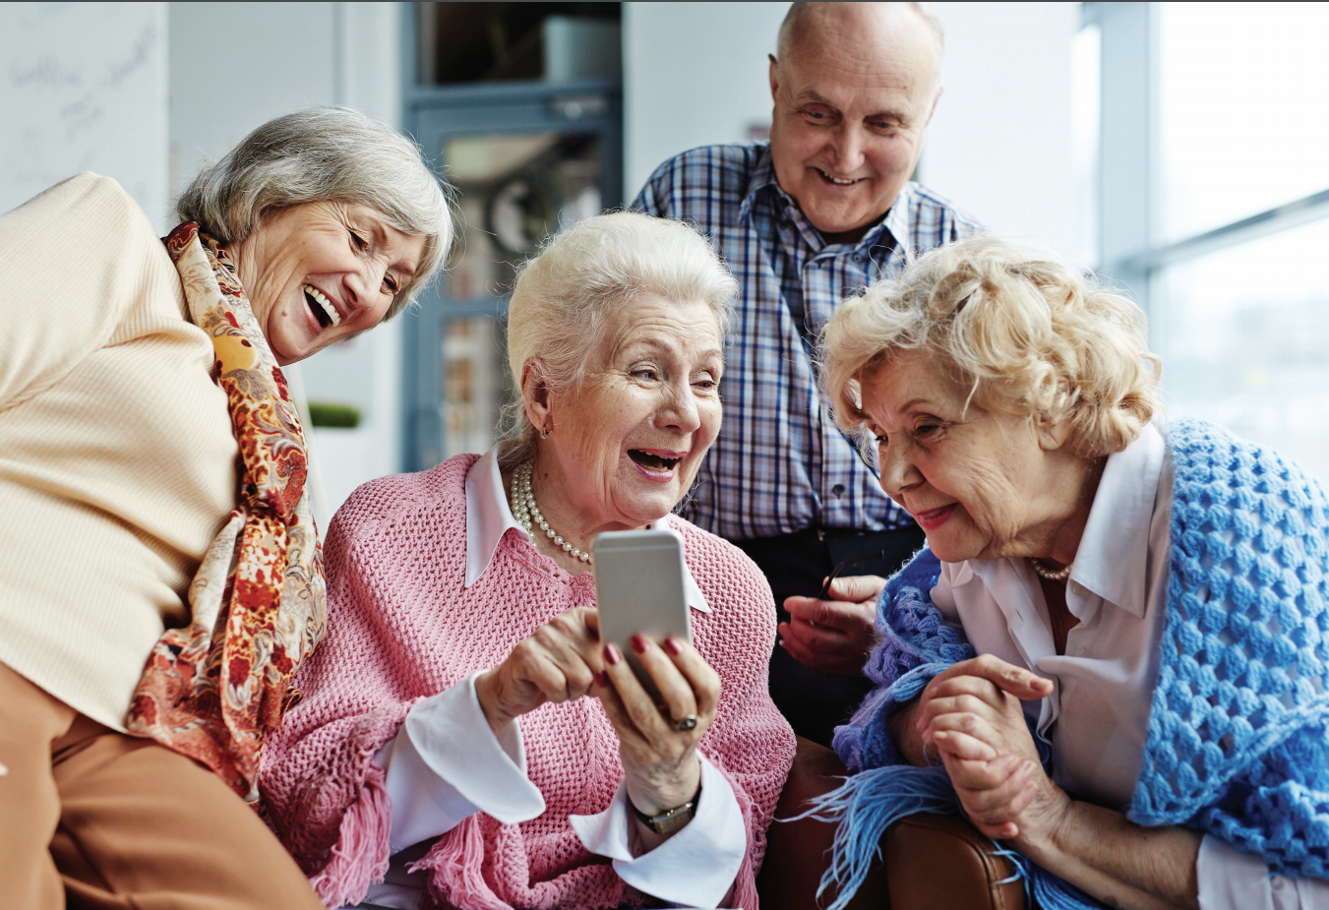

1.3 Research Partners

1.3.1 University of the Third Age (U3A) Network Victoria
U3As (Universities of the Third Age) provide lifelong learning to people who are retired or semi-retired. There are 104 U3As throughout Victoria, offering courses and activities to over 39,000 members who make up the U3A Network Victoria. U3As provide opportunities for retired or semi-retired people to engage in later life learning, meet new people and share their knowledge and skills with others. Offerings range from physical fitness to desk-based classes, language studies, art and craft classes, and social activities.

1.3.2 RMIT Consumer Wellbeing Research Group
The RMIT Consumer Wellbeing Research Group is a multidisciplinary group committed to providing research and insights into consumer behaviours and influences that facilitate or inhibit consumers’ health, wellbeing, and quality of life. The group’s mission is to address real-world issues primarily through a social marketing lens, using rigorous methodologies to produce insights, advice, and interventions that lead to positive economic, social, and environmental impacts. The group works in collaborative research partnerships with industry, health promotion agencies, government, and community groups.

1.3.3 RMIT Consumer Culture Insights Group
The Consumer Culture Insights Group (CCIG) is a group of scholars who study consumer behaviour and emerging markets using research methods based on interviews, observations, and focus groups. CCIG examines how lived experiences offer important insights into consumers' values, beliefs, behaviours, and identities, and the ways consumers buy and use products and services. The CCIG also investigates how changes in everyday consumer culture offer insights for the future. Innovative organisations, including firms, governments and non-profits, incorporate these insights into marketing-related decisions in a wide range of ways, including product development, traditional advertising, social media, and branding.

1.3.4 RMIT Digital Ethnography Research Centre (DERC)
The Digital Ethnography Research Centre (DERC) applies cutting-edge ethnographic approaches to better understanding how digital tech impacts our present lives and potential futures. DERC’s projects often involve local communities, with expertise ranging from studies of everyday lived experience, workplace and organisational analysis, policy and strategy analysis, design ethnography, co-design workshops, and creative collaborations with communities of practice. The centre has a strong international base and a mission that impacts people’s lives, governmental policies, and education methods globally. DERC maintains and develops partnerships with various institutions in Australia and globally, including other universities, companies, and not-for-profit organisations.

1.3.5 City of Whittlesea (CoW)
Through the City of Whittlesea Positive Ageing Strategy, the Ageing Well department promotes the many opportunities that an ageing population brings to society. In particular, it promotes the vast benefits for individuals and the community when people continue to be active, healthy and participate in the community as they age. It hopes to activate opportunities and choices to improve wellbeing for people as they age and to achieve a positive change in the way residents live their lives. The strategy has eight strategic focus areas: 1) Friends, connections and a welcoming community; 2) Active – socially, mentally, physically; 3) Learning and sharing knowledge; 4) Getting around; 5) Informed and having a say; 6) Feeling safe; 7) Housing, employment and financial security; 8) Health and support services when required Through a series of Action Plans, the City of Whittlesea aims to continuously improve the wellbeing of older people across these eight areas.

1.4 Context
Security concerns are critical reasons for older adults’ lack of engagement with ICT and the digital economy (Mitzner et al., 2010; Wu, Damnée, Kerhervé, Ware, & Rigaud, 2015). Existing research has identified and assessed risks involved in ICT engagement, and built programs that outline risks and help older adults grow skills for ICT engagement. Programs for older adults often focus on enhancing digital literacy. For example, ‘Be Connected’ encourages older adults to go online, offering resources and in-person support to develop digital skills and confidence. However, older adults often base their security concerns on perceptions of risk (Boise et al., 2013; Knowles & Hanson, 2018). Perceived risks pose barriers to engagement with ICT (Young, Willis, Cameron, & Geana, 2014). Existing programs have not acknowledged that perceptions of risk can be a significant barrier to participation.

1.4.1 Perceived Risk
Risk perceptions are beliefs about potential harm or the possibility of a loss. It is a subjective judgment that people make about the characteristics and severity of a risk. Consumer research has long demonstrated that perceived risks can inhibit the adoption and usage of products and services (e.g., Rehman, Baharun, & Salleh, 2020; Ross, 1975). Perceived risk manifests in many ways: financial, performance, physical, social, time-related, and psychological risk (Stone & Grønhaug, 1993). In an earlier study we conducted with U3A older adults about ICT use, stories about scams, cyberbullying, and general security threats supported various perceptions of risk, creating resistance to adoption in some (Aleti, Figueiredo, Reid, Martin, & Wall, 2019). This survey of older Australians also demonstrates a reluctance to engage with technology because of security concerns. According to the eSafety Commissioner, 72% of older adults are concerned with devices’ vulnerability to hacking, and 55% are concerned with having their details stolen when buying online. However, there are no programs to directly address seniors’ risk perceptions with ICT engagement.

1.4.2 Participatory Strategies
Ethnography and co-design are participatory approaches that engage and empower those being researched. Research respondents and stakeholders become collaborative experts in the outcomes. As a result, the project can offer deeper understandings, learnings, and enhanced uptake of interventions. Following a participatory approach, older adults will also collaborate with researchers to co-design solutions that will help them to manage perceived risk. Co-design increases the uptake of solutions as co-designers take ownership of solutions. This type of participatory design is vital to create solutions that are perceived as relevant, helpful, and valuable by end-users and stakeholders, building on their current efforts to engage older adults with ICT.

1.4.3 Digital Inclusion
Although the number of digitally connected people continues to rise, around 2.5 million Australians (13.5%) are not online (Thomas et al., 2020). Research from the UK, which has similar overall connectivity rates, reveals that 90% of those offline are seniors (Lloyds Bank, 2021). Lloyds Bank (2021) further suggests that the most common reasons for non-use related to concerns about identity theft, privacy and security, ICT being too complicated or too expensive. This suggests that seniors are likely to be amongst the most digitally excluded, and that their exclusion is related to perceptions of risk associated with ICT and the internet.
The Australian Digital Inclusion Index (ADII) (Thomas et al., 2020) measures inclusion based on three key dimensions: Access, Affordability, and Digital Ability. The ADII compiles numerous variables into a score ranging from 0 to 100. The higher the overall score, the higher the level of inclusion. The ADII score for the average Australian is 63. For Australians above 65 years, the score is 49.7 (13.6 points below the national average). Moreover, the ADII score for those aged 80+ is 39.2, which is 16.7 points lower than those aged 65-69 years (55.9). The ADII data also reveals that 28.7% of those aged 65+ feel empowered by ICT and only 13.3% feel they can keep up with technological changes. Thus, digital literacy, increased confidence and reduced perception of risk are essential aspects of older Australians increasing their online presence.
With the impact of the COVID-19 pandemic and the requirement of physical distancing, the importance of digital literacy and reducing barriers to ICT engagement has increased. The unevenness of older adults’ digital literacy is a crucial issue that will shape the future wellbeing of all Australians. The COVID-19 pandemic underscores the need for older adults to learn and engage with ICT in a safe environment. Non-price factors such as consumers’ lack of confidence and the perception of risks associated with privacy, security, and online safety create barriers for older adults’ engagement with ICT. The road to effective ICT engagement in older adults requires understanding the types and sources of perceived risk and developing strategies to mitigate them.

1.5 Project Schedule

1.5.1 Explore and Quantify
In this initial stage, we explore the language, contexts, and meanings associated with risk perceptions and ICT use, and quantify the types of perceived risks associated with ICT and their influence on ICT use and engagement in the digital economy. The exploration led to a survey instrument and 22 video vignettes, in addition to this research report:
Survey Instrument: The survey was designed to assess and report older adults’ ICT risk perceptions, motivations, and behaviours.
Video Vignettes: Remote video interviews have been recorded and edited into a series of video vignettes showcasing seniors’ perception and language usage around risk perception of ICT engagement. Transcripts accompany these vignettes for accessibility. The vignettes are valuable tools in the co-designing and dissemination stages.
Research Report: The current report explores the target audience’s language, experiences, quantified findings of risk perceptions, and influence on older consumers’ participation in the digital economy. This report shall be hosted at the Analysis & Policy Observatory (APO) website.

1.5.2 Understand
By understanding the lived experiences around ICT practices and risk perceptions through an ethnographic approach, we focused on uncovering discrepancies between practice and perception. Ethnography places a human face on data through rich real-life stories and emotional behaviour. In this stage, we reveal critical stories and insights and seek to share them with stakeholders through an academic paper, and an article for the general public.

1.5.3 Co-design
This stage focuses on developing co-design strategies with end-users and stakeholders to reduce perceived risk and improve senior’s digital engagement. Co-design sees research respondents as collaborators and ensures that the learnings and recommendations will be taken up in the end, supplementing ongoing stakeholders’ efforts to address security issues and improve consumer confidence. Workshops will result in a digital resource containing tools, including a risk assessment simulation, guidelines for understanding perceived risk, and a set of strategies.
Co-design Workshops: We will conduct three workshops with end-users and three workshops with stakeholders. End-users are older adults and users of ICT, and stakeholders are vital members of older adult networks such as U3A and local councils (including the City of Whittlesea), and other organisations for digital inclusion. The purpose is to work collaboratively to co-design strategies for reducing perceived risk and improving digital engagement. These strategies complement stakeholders with ongoing efforts to minimise security issues and enhance consumer confidence. Workshops will contain from 12 to 24 respondents depending on the type of group.
Digital Resource with a set of tools: This resource will have web pages targeting end-users and organisations working for older adults’ wellbeing and digital inclusion. The web pages will be hosted under the Shaping Connections website. They will outline approaches to including, engaging, and educating older adults and contain information and tools to overcome perceived risks associated with ICT use and how to derive value from participation in the digital economy. The tools will include:
- A risk assessment simulation for end-users that will be based on risk scenarios uncovered in all project stages. Users will respond with their risk perception to scenarios and receive direct, immediate feedback on the actual risk associated with the scenario and how their perceptions reflect this.
- A risk perception information digital booklet with guidelines for understanding and managing perceived risk for end-users.
- A strategy toolbox for organisations working with older adults’ engagement with ICT.

1.5.4 Disseminate
In this stage we will disseminate research findings, co-designed strategies, and the digital resource to end-users and stakeholders to guarantee the uptake and scaling of findings and strategies. This stage aims to educate key end-users, organisations working with older adults’ digital inclusion, and the academic community. Dissemination will happen through two seminars to stakeholders, two workshops, one webinar, and engagement with academic and partner networks.
Dissemination Seminars: We will invite key members of older adult networks, such as ASCCA, COTA, organisations for digital inclusion (e.g., Good Things Foundation), research organisations (e.g., MARC), local government authorities (e.g., the City of Whittlesea) and insurance organisations to participate in these seminars. We will embed an evaluation survey at the end to ensure that we can assess the project’s impact. We will invite up to 30 people to each dissemination seminar.
Implementation workshops with U3A computer mentors: The implementation workshops will be held with mentors who run computer courses at local U3A chapters. We will go through the digital booklet and the strategies to support the management of perceived risk. Up to 15 people will be invited to each implementation workshop.
Final Report: Overall report on risk perception. This report will build on the current report by containing the research’s complete findings and recommendations for organisations supporting older adults’ engagement with ICT and their inclusion in the digital economy. In addition, the information from the report will be compiled to help support the content presented in the digital resource. This report will be hosted both at the Shaping Connections webpage and ACCAN’s webpage.

2 Methodology

2.1 Exploratory Interviews
The initial phase of exploratory remote interviews was conducted from November 2020 to January 2021 and involved 22 respondents from the U3A Victorian Network. Respondents were recruited via email and phone and were first inducted and prepared in short pre-interviews, during which demographic and ICT perception data were collected. Subsequent semi-structured interviews focused on different types of perceived risks alongside topics of safety and care, and ranged from 30 to 90 minutes. Interviews were video recorded for data analysis purposes. The content was also used to produce vignettes to be deployed for the co-design workshop stage.
Given physical distancing regulations imposed during the COVID-19 pandemic, we designed all qualitative interviews to be done online or over the telephone (an alternative to include those unable or unwilling to go online). These semi-structured interviews were designed to explore pre-selected themes. Analysis of interview data provided respondents’ own language and meaning to the items operationalised for quantitative analysis in the survey (Stage 1b). Using appropriate language has been identified as a challenge in older adults’ uptake of ICTs (Maccora, Rees, Hosking, & McCallum, 2019). It assures the accuracy of shared meanings by using respondents’ language in the survey. In addition to language use, it is also vital to understand who (or what) influences perceptions of risk. Although risks are related to the degree of inter-family and inter-generational support for ICT use, negative stereotypes of older adults and technology are also commonplace. Older adults with access to younger family members may receive support, but the same family members may fuel insecurity through stereotyping and thus increase risk perceptions at the same time.

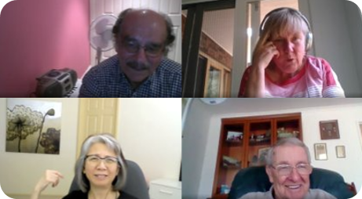

2.1.1 Data Analysis
Analysis of interview transcripts involved initial risk coding and later thematic categorising of responses. Categories based on the perceived risks were used to develop various subcategories that present barriers for older adults in making full use of ICT.

2.1.2 Sample Characteristics
The interviews of 22 Victorian U3A respondents were recorded and transcribed. Thirteen were women, and eight were men—four respondents self-reported as culturally and linguistically diverse (CALD) persons. The cohort was between 59 and 85 years old, with a mean age of 71.8 and a median of 71.

2.2 Survey

2.2.1 Recruitment and Survey Distribution
Members of U3A were emailed a link to and information about the ICT Survey. Three bulletin emails were sent to the 105 member U3As of U3A Network Victoria, as well as a bulk email system. In addition, notifications were placed in U3A Network Victoria publications (Network News, Facebook, Network Council papers). The survey was promoted through the Social Seniors programs, and we are aware of 10 U3As that had members complete the survey in Digital Literacy classes. U3A members were contacted via email, newsletter, and nominated courses to complete the online survey, with participation voluntary. It is important to note that some respondents did not answer all the survey questions. Incomplete responses were deleted if the demographics section was not attempted.
Over about 12 weeks, close to 600 surveys were registered. Removing duplicates and invalid responses yielded 426 valid surveys. This report is an interim report, and data collection will continue until the end of October 2021 to increase the number of surveys returned.

2.2.2 Data Analysis
The survey data is analysed and reported in several ways. First, frequencies and means are used to illustrate the usage and perceptions of respondents. Second, where items form composite variables, the items were subjected to factor analysis to determine dimensionality. Third, items associated with each factor were then assessed for reliability and validity. Fourth, composite variables were then computed and used for reporting. Finally, the factors and variables were subject to t-tests to assess differences between demographics characteristics of respondents.

3 Results

3.1 Exploratory Interviews
The interviews directly inquired into perceptions of ICT and resulted in detailed analysis based upon risk subcomponents. This analysis resulted in several vignettes for each, as several quotes were collected around a specific aspect of the risk type. Analysis of interview transcripts involved initial risk coding and later thematic categorising of responses. Categories based on the perceived risks were used to develop various subcategories that present barriers for older adults in making full use of ICT. These categories were formed from the initial literature review that highlighted the complexity of the concept of ‘risk’ and identified several subcomponents (Mitchell, 1999).
These are:
- Psychological risk (i.e., fear of making a wrong choice)
- Financial risk (i.e., fear of wasting money)
- Functional/Performance risk (i.e., fear of the product/service not working correctly)
- Social risk (i.e., fear of negative opinions from significant other individuals on the product/service)
- Physical risk (i.e., fear of the product/service being a threat to the individual’s health).
Based on the literature, the research team analysed these 22 exploratory interviews with U3A members and sorted their responses into the five broad categories of perceived risks associated with ICT. These have led to a range of risk perceptions subcategories developed into short, curated vignettes edited from recorded interview materials. Across the five risk perceptions categories chosen (Psychological, Financial, Functional/Performance, Social, and Physical), 22 distinct risk subcategories were identified, including the perspectives of three to four respondents in each.

3.1.1 Interviewee Profiles
Through this exploratory stage – the online and semi-structured interviews – we covered the different types of perceived risks alongside topics of safety and care. In framing these discussions, interviewees are introduced below alongside a notable comment from their interviews.
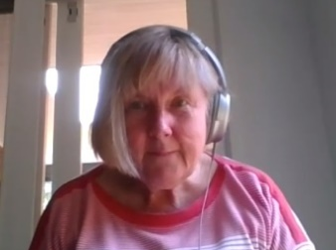 | Sue B. Aged 65, Female  “The one that I worry about failing when I really need it has been my phone running out of battery because I’ve had issues with my iPhones, the last one and this one, and I do use Google Maps as my sat map. ... My phone was running out of battery as well, so I was quite distressed by that.”
Greg B. Aged 68, Male
“I used to joke with other people that there’s no one single way you get into Zoom. You have to be flexible, and you can go in different pathways.
Jasmine T. Aged 66, Female
“I... took my grandson to the beach, and without knowing that my phone is in my jacket pocket, and it’s not waterproof jacket, and when the wave come through, gosh, it’s all wet, and that was just three days old.”
Peter G. Aged 69, Male
“I get the impression that people who do so badly (with social media) they’re retreating, and their whole life becomes their social media platform, which is dangerous”.
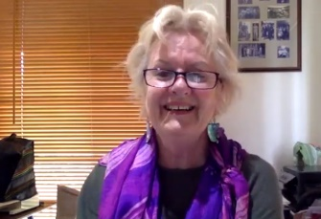 | Maggie L. Aged 70, Female  “We wonder about the phone thing in beside the bed and if it’s far enough away from our heads and all that sort of stuff. And I don’t know about that, but we understand it’s okay.”
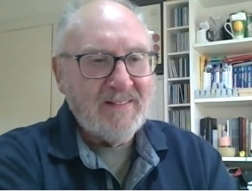 | Tony A. Aged 74, Male  “I only really interact with my bank on the internet. I think I’ve been to an ATM once in six months. I’m not using cash anymore.”
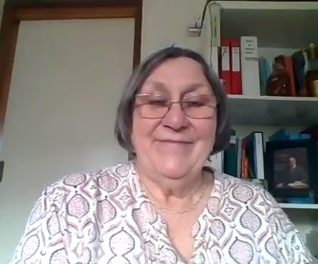 | Patsy M. Aged 74, Female  “I find that the people who program computers have a completely different thought process to me. It’s worse than even speaking a foreign language. I mean, it’s like I’m talking English, and they’re talking algebraic equations.”
Graeme G. Aged 76, Male
“It’s a bit like the smart TV; when you want to watch something, you have to work out how the damn thing works.”
Lee A. Aged 77, Female
“I think it is quite difficult to explain to people that are not really familiar or haven’t had enough experience. And if you try to give too much information too quickly, I think that’s confusing. So, I think you probably have to go step by step.”
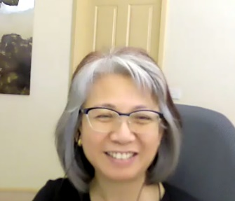 | Paulina C. Aged 59, Female  “But she refused to join my Zoom classes because even to press that link was difficult… until her daughter was there with her when we had a Zoom celebration with all my family. Then she was comfortable with someone there pressing it with her. But when that someone is not with her, she goes into panic mode again.”
Lindsay G. Aged 78, Male
“We have a couple of members who will call and say, ‘My computer’s gone down.’ And you usually have to go and just reboot it for them. There’s a couple of those, but that’s only a handful.”
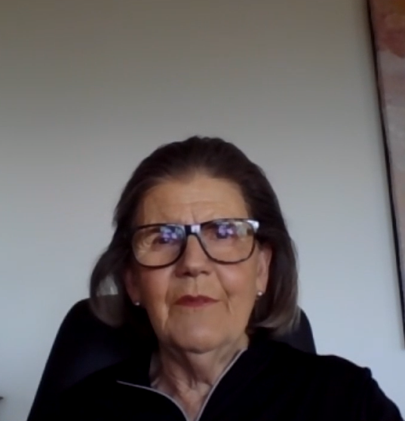 | Eda R. Aged 77, Female  “But I also think that there’s a lot more misinformation on some of the things I watch... So, I do worry about misinformation on that, and how if you say something often enough, people tend to believe it.”
Carl T. Male
”If you’re trying to use the phone, people don’t explore all the functions of the phone with you. They assume all you do is just talk with it. Nothing else.”
Sally C. Aged 85, Female
“If I can’t fix something, I’ve always relied on somebody else, yes. I have no hesitation in getting help, or inviting somebody, either friend or family, to assist if I can’t find my way through it.”
Noel W. Aged 70, Male
“Older people have an expectation that if you buy it, it works. And if it breaks, you get another one or you repair it. There's none of this, it's got a bit old, so I need a new one”
Helen B. Aged 70, Female
“The daughter who keeps an eye on my bank account, she told me recently I had to stop buying things online. I’m not buying a lot; I just buy ...”
Marilyn B. Aged 78, Female
“I don’t know what it is actually. I suppose it’s because I’m not at all confident, I don’t have a lot of self-confidence using technology, and I feel quite inferior because of it, which is mad, but I do.”
Dawood S. Aged 64, Male
“I have my own account online, go online, do it, and I feel safe. There is nothing to worry about. Some people say that ‘I don’t do it’, ‘I leave it to my son because I’m afraid I do a mistake, and my money will go to another account’ …”
Judy M. Aged 79, Female
“…as an older person, you can go one of two ways: you can take up technology and go with it and learn with it, or else you can hide from it. People like that don’t realise what they’re missing out in life.”

Framing the Survey data
Throughout the discussion of the risk (see 3.2.6 Risk) and fraud (section 3.2.7 Exposure to Fraud & Scams) in the survey results, perspectives and opinions from the exploratory interviews are used to support and enhance the insights gained. While the vignettes reflect the research team’s qualitative analysis of the interviews, the quotes integrated within the following survey discussion were instead compiled in response to the survey data itself. Considering the inherent limitations of interviews and survey methods, this approach intends to offer readers a unique and invaluable framing of the results.

3.2 Survey

3.2.1 Demographics
Four hundred and twenty-six people completed the online survey. Over two-thirds of the survey respondents were women (69%) and just under a third were men (30.8%). The larger proportion of women reflects the proportion of women in the U3A membership. In general, the older Australian population (65+) contains more women (60%) than men (40%) (ABS, 2020). Survey respondents were predominantly over 60 years of age (only 2.1% were 59 years or younger). 31.9% were in their 60’s, over half in their 70’s and 12.2% were aged 80 years or more (Table 1). For the purposes of analysis in this report, we have divided the survey cohort into two age groups: those 69 years or younger (34.0%) and people who are 70 years or older (65.7%).
Table 1. Online survey respondent demographics
Characteristic | Per cent
Gender
Female | 69.0
Male | 30.8
Other | 0.2
Age group
Less than 50 years | 1.2
50 – 54 | 0.0
55 – 59 | 0.9
60 – 64 | 8.0
65 – 69 | 23.9
70 – 75 | 35.4
75 – 79 | 18.1
80 – 85 | 10.3
85+ | 1.9
Prefer not to say | 0.2
Current relationship status
Never partnered and living alone | 3.3
Widowed and living alone | 17.1
Divorced and living alone | 12.2
Married | 46.5
Separated and living alone | 2.8
De facto / partnered | 11.7
Other | 3.1
Prefer not to say | 3.3
Current living arrangement
Live in own home | 87.1
Live in rental accommodation | 5.4
Live in a supported residential facility | 0.7
Live in a retirement home/village | 3.8
Other | 1.2
Prefer not to say | 1.9
Note. N = 426. Data from Older Adults and ICT Online Survey.

Most respondents were currently in relationships, either married (46.5%) or de facto or partnered (11.7%). Many respondents were living alone (35.4%) either because of separation, divorce, or widowhood. The majority live in their own homes (87.1%), with smaller proportions living in rental accommodation (5.4%) or retirement villages (3.8%) (Table 1). This data is largely in line with expected enrolments at U3A classes.
Respondents to the ICT Survey are highly educated: 59.3% have a bachelor's degree or above. A small proportion did not complete secondary school (10.8%), 6.6% completed Year 12, and a further 21.4% completed a post-secondary certificate or diploma (Table 2). Over half of the respondents are self-funded retirees (52.1%), 20.2% receive the full government pension, and 12.9% receive a part-government pension. A very small proportion are still working (3.3%). The median income category for the survey respondents is an income between $41,600 - $51,999 per year (Table 2).

Table 2. Income and education
Characteristic | Per cent
Highest level of education
Year 11 or below | 10.8
Year 12 | 6.6
Certificate I/II | 1.2
Certificate III/IV | 5.4
Advanced Diploma and Diploma | 14.8
Bachelor’s Degree | 21.8
Graduate Diploma and Graduate Certificate | 19.0
Postgraduate Degree | 18.5
Prefer not to say | 1.9
Individual Income
$7,800 - $15,599 per year | 4.7
$15,600 - $20,799 per year | 8.2
$20,800 - $25,999 per year | 11.0
$26,000 - $33,799 per year | 10.3
$33,800 - $41,599 per year | 8.9
$41,600 - $51,999 per year | 8.0
$52,000 - $64,999 per year | 6.8
$65,000 - $77,999 per year | 4.7
$78,000 - $90,999 per year | 2.6
$91,000 - $103,999 per year | 1.4
$104,000 - $155,999 per year | 1.9
$156,000 or more per year | 0.9
Prefer not to say | 30.5
Source of income
Salary or wages | 3.3
Full government pension | 20.2
Partial government pension | 12.9
Self-funded retirement income or pension | 52.1
Other | 4.9
Prefer not to say | 5.6
Note. N = 426. Data from Older Adults and ICT Online Survey. Demographic Items based on ABS.

3.2.2 ICT Device Ownership and Use
The types of devices owned are presented in Table 3. Almost all survey respondents had personal access to the internet (92%) or owned a smartphone (90%). A laptop (71%) or an iPad or tablet (69%) were the following most owned pieces of technology. Just over half owned an internet-enabled TV or a desktop computer. Wearable devices and the iPod Touch (digital music player) were not commonly owned items (24% and 13%, respectively).
Table 3. Types of ICT owned
Types of ICT owned | Ownership %
Internet | 92.0
Smartphone | 90.4
Laptop | 70.7
iPad/Tablet | 69.0
Internet-enabled TV | 57.5
Desktop computer | 57.0
Wearable devices (e.g., Apple Watch, Fit-Bit) | 24.2
iPod Touch or similar device | 12.7
Other | 6.6
Note. N = 426. Data from Older Adults and ICT Online Survey.

Respondents were also asked to rate how frequently they used each type of ICT device on a seven-point scale: 1 ‘never’, 2 ‘once every few months’, 3 ‘about once per month’, 4 ‘several times per month’, 5 ‘about once per week’, 6 ‘several times per week’, or 7 ‘daily’. Hence the higher the frequency of use score, the more frequent the device use. This included devices shared with others but not necessarily owned by the individual.
As shown in Figure 1, smartphones were on average used almost daily (a score of 7), and iPads/tablets or laptops were used on average about once per week. Desktop computers, laptops and internet-enabled televisions were used about once per week. Wearable devices were used much less frequently (on average once per month) and iPod Touch or similar music devices – once every few months.

Figure 1. Device use frequency scores (mean)

Figure note. N = 426. Maximum score is 7.

To further explore these ownership and usage scores, we assessed them against several respondent characteristics – age, gender, relationship status, and digital literacy (DL). There were no statistically significant differences in device use frequency by gender or relationship status. In terms of age group, desktop computers were more frequently used by older adults compared to younger adults. The detailed frequency scores are presented in Appendix 1.
However, levels of digital literacy did have an impact on frequency of device use. Device use was generally more frequent for people with high digital literacy compared to those with low digital literacy, except for desktop computers and other devices (see Figure 2).

Figure 2. Device use frequency scores for people with high or low digital literacy

Figure note. *T-test shows a statistically significant difference. N = 388. There were 175 people with ‘lower’ and 213 people with ‘higher’ perceived digital literacy (DL) scores. Maximum possible score is 7.

3.2.3 Digital Literacy
Digital literacy and internet skills form a crucial part of digital inclusion. We used scales developed by Van Deursen, Helsper and Eynon (2016). They propose five factors examining digital and internet skills within a broader framework that makes links between individuals’ skills, types of engagement with online services and activities, and the tangible outcomes achieved from this engagement.
Respondents were asked to rate their knowledge and skills associated with five factors including:
- Technical skills: download a photo, open a downloaded file, adjust privacy settings;
- Information and search skills: use of search keywords, finding websites, ease of using a search engine;
- Mobile device use skills: downloading apps, track usage cost, sync mobile device with other ICT;
- Social and sharing skills: what to share and not share online (and with whom), block people;
- Content and creative skills: design a website, manipulate images, music, or video, create content.
Using factor analysis (see Appendix 2), we assessed the reliability and discriminant validity of the digital literacy factors and found that each meets appropriate reliability and discrimination levels. Each item was measured using a 7-point agree-disagree scale. Hence, the higher the score, the higher the perceived skills of the respondent.
To explore these digital literacy factors, we assessed them against several respondent characteristics – age, gender, and relationship status (see also Appendix 3). Significant differences were found in digital literacy scores based on age, gender and relationship status.
Younger respondents (aged less than 69 years) felt they had a higher level of skill and knowledge across all factors than older respondents (70 years or older) (Figure 3).

Figure 3. Digital literacy scores and age

Figure note. *T-test shows a statistically significant difference. N = 425. Younger adults were aged 69 years or younger (n = 145), older adults were aged 70 years or older (n = 280). Maximum possible score is 7.

In terms of digital literacy by gender, male respondents felt they had a higher level of skill and knowledge than female respondents in technical skills, mobile device skills, and content and creative skills (Figure 4). There were no gender differences for social and sharing skill scores or information and search skills scores.

Figure 4. Digital literacy scores and gender

Figure note. *T-test shows a statistically significant difference. N = 425. There were 294 female and 131 male respondents. Maximum possible score is 7.

Finally, in terms of digital literacy and relationship status, respondents who stated they were in coupled relationships felt they had a higher level of skill and knowledge across all factors than those who were single (Figure 5).
Figure 5. Digital literacy scores and relationship status

Figure note. *T-test shows a statistically significant difference. N = 399. There were 151 single and 248 coupled respondents. Maximum possible score is 7.
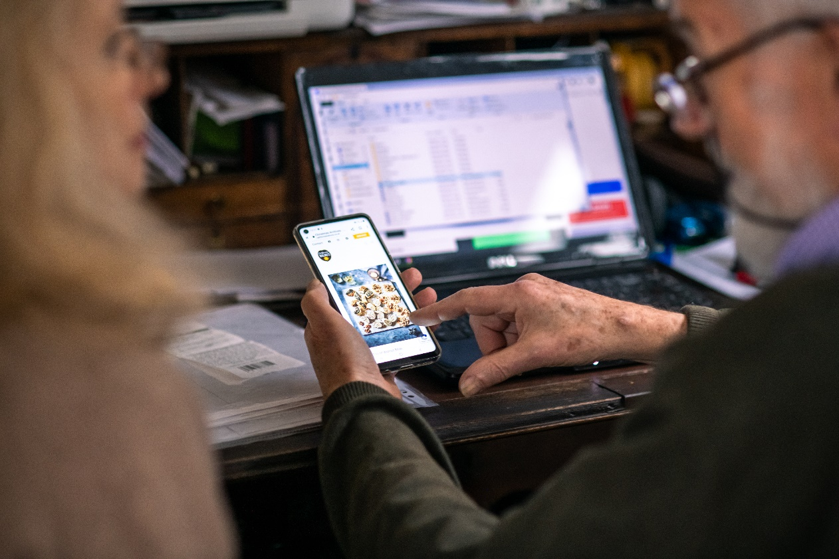

3.2.4 Perceptions & Experiences of ICT Use

Survey Items
Respondents were asked to indicate the frequency in which they engaged in 17 different ICT activities. Respondents were also asked to rate how frequently they engaged with each type of ICT activity on a seven-point scale: 1 ‘never’, 2 ‘once every few months’, 3 ‘about once per month’, 4 ‘several times per month’, 5 ‘about once per week’, 6 ‘several times per week’, or 7 ‘daily’. Hence, higher scores indicate greater levels of engagement.
Factor analysis was used to test whether there were underlying factors associated with engagement in various ICT-related activities. Each factor was then assessed for its scale reliability. In this case, factor analysis revealed four underlying factors. All activity engagement factors can be found in the appendix, including all survey items associated with each factor and their respective means and standard deviation (see Appendix 4).
The four factors discovered were:
- Everyday living: Google searching, emailing, banking/bills, reading news, Zoom or other video calls.
- Shopping and entertainment: various forms of online shopping, online books/magazines/movies/TV.
- Social networking: chatting on messenger apps, uploading content for friends and family.
- Gaming: playing standalone or connected/networked games online.

Activity Engagement scores
Overall, the survey respondents were somewhat engaged in ICT activities. For example, daily use would score a ‘7’ – and in Figure 6, the highest frequency score is ‘5’ – which represents ‘about once per week’ on average.
Survey respondents, overall, most frequently used ICT for Everyday Living activities – such as banking, communicating with friends and family, and reading news online. In addition, respondents engaged in social networking and online games about once or more times a month. The least frequent activity was using ICT for shopping and entertainment, reported as being engaged in once a month to once every few months. However, watching entertainment, e.g., movies, catch-up TV, or sports, occurred on average several times per month (see Figure 6).

Figure 6. Activity engagement factor scores (mean)

Figure note. N = 426. Maximum score is 7.

We explored engagement factors by age, gender, relationship status, and perceived digital literacy. We found that women engaged in social networking and gaming more frequently than men (Figure 7). Men and women engaged with ICT at the same rate for shopping and entertainment, and everyday living.
Figure 7. Activity engagement scores and gender

Figure note. *T-test shows a statistically significant difference. N = 425. There were 294 female and 131 male respondents. Maximum possible score is 7.

Younger respondents more frequently used ICT for shopping, entertainment, and social networking more than older respondents (Figure 8).
Figure 8. Activity engagement scores and age

Figure note. *T-test shows a statistically significant difference. N = 425. Younger adults were aged 69 years or younger (n = 145), older adults were aged 70 years or older (n = 280). Maximum possible score is 7.

However, adults with higher perceived digital literacy had a significantly higher engagement with all ICT activities (Figure 9).
Figure 9. Activity engagement scores and digital literacy

Figure note. N = 426. Data from Older Adults and ICT Online Survey. See Appendix 4 for factor analysis results. There were 175 people with ‘low’ and 213 with ‘high’ perceived digital literacy (DL) scores. *T-test shows a statistically significant difference.

There were no significant differences in engagement factor scores between people who were single or those that were in a couple. The frequency of ICT activities was not influenced by relationship status. (See Appendix 5 for all Activity engagement scores.)

3.2.5 Influences on ICT Use
To better understand the acceptance of ICT and things that shaped acceptance, we drew on the Technology Acceptance Model (TAM) (Bagozzi, Davis, & Warshaw, 1992). The TAM, originally proposed by Davis (1989), is a widely cited model that clarifies personal and facilitating conditions that influence individuals’ technology acceptance and use.
TAM is based on the theory of reasoned action (TRA) (Fishbein & Ajzen, 1972) and the theory of planned behaviour (TPB) (Ajzen, 1991). TAM proposes that actual use is anticipated by behavioural intention, determined by the attitude to technology. Attitude and behavioural intention are influenced by perceived usefulness and ease of use and external factors, including the expectations of others for using technology, the personal satisfaction gained from using, and facilitating conditions including knowledge, skills, and access to help and support.

Figure 10 shows the variables used for this analysis. Each variable is multi-item by nature, and the figure presents the means for the summated items associated with each variable (see Appendix 6 for individual items and average scores). In addition, each item was measured using a 7-point agree–disagree scale. Hence, the higher the mean score, the more respondents agreed with the item.

Technology Acceptance Model and respondent characteristics
Among the survey sample, the overall highest mean scores were recorded for perceived usefulness of ICT (M = 5.9) and positive attitude toward using ICT (M = 5.6). Other factors that older adults scored above 5 (the positive end of the scale) were self-satisfaction achieved through ICT use, social connection, skills and knowledge to use ICT, and perceived ease of use. In addition, the average score for the anxiety construct was low (M = 2.6) – on the disagree end of the scale – hence reporting low anxiety amongst this cohort when using ICT (Figure 10).
Figure 10. Technology Acceptance Model factor scores

Figure note. N = 426. Data from Older Adults and ICT Online Survey. See Appendix 6 for factor analysis results.
We also assessed the TAM scores against several respondent characteristics – age, gender, relationship status, and perceived digital literacy. Across all the TAM factors, there were no gender differences (see Appendix 7). However, when we compared older and younger respondents (Figure 11), their scores differed on two factors: intent to increase proficiency in ICT use (higher for older respondents) and perceived ease of use of ICT (higher for younger adults).
Figure 11. Technology Acceptance Model factor scores by age

Figure note. N = 425. Data from Older Adults and ICT Online Survey. See Appendix 6 for factor analysis results. Younger adults were aged 69 years or younger (n = 145), older adults were aged 70 years or older (n = 280). *T-test shows a statistically significant difference.

In addition, on average, participants who were in relationships had a more positive attitude to ICT than single respondents (Figure 12). There were no other differences by age or relationship status. (See Appendix 7 for all TAM scores.)

Figure 12. Technology Acceptance Model factor scores by relationship status

Figure note. N = 399. Data from Older Adults and ICT Online Survey. There were 151 single and 248 coupled respondents. See Appendix 6 for factor analysis results. *T-test shows a statistically significant difference.

As per previous analyses, we found greater differences between respondents with low digital literacy scores than those with higher digital literacy. People with higher digital literacy had higher average scores for perceived usefulness of ICT (M = 6.3); positive attitude toward ICT (M = 6.1); perceived ease of use of ICT (M = 5.8); achieving self-satisfaction through ICT use (M = 5.6); social connection through ICT use (M = 5.5); and having the skills and knowledge to use ICT (M = 5.8), compared to those with low digital literacy (Figure 13). Overall, people with higher digital literacy present a picture of confident, positive, and knowledgeable ICT use.
In comparison, people with low digital literacy were more likely to want to increase their use of ICT, but at the same time were more anxious about ICT use than people with high digital literacy. There were no differences between high and low digital literacy groups for average scores for intent to use more ICT, social influences, and subjective norms to use ICT, and access to help or mentoring in using ICT.
Figure 13. Technology Acceptance Model factor scores by digital literacy

Figure note. N = 388. Data from Older Adults and ICT Online Survey. There were 175 people with ‘low’ and 213 people with ‘high’ perceived digital literacy (DL) scores. See Appendix 6 for factor analysis results. *T-test shows a statistically significant difference.

All these factors are potentially important in predicting older people’s actual use of ICT. For example, Chen and Chan (2014) found that usage behaviour was predicted by self-efficacy, the level of ICT related anxiety and facilitating conditions (i.e., familial support), more so than perceived usefulness or perceived ease of use. Guner and Acarturk (2020) studied the interrelationship of these factors on older adults’ intention to use ICT compared with younger adults. They found that perceived ease of use positively impacted their perceived usefulness of ICT – if they thought it would be easy to use, they were more likely to see ICT as useful. Both these factors were associated with an increased positive attitude to use ICT, but it was not predictive of their intent to use ICT. Guner and Acarturk (2020) also found that external factors, such as social influence and facilitating conditions, positively influenced older people’s perception of ease of use.
We are interested in which factors influence actual behaviour, not just intent, attitudes, or perceptions. Future analysis will explore how these components of the TAM influence older adults’ frequency of use, proficiency, and ownership of ICT. Moreover, further analysis will investigate the relationship between these variables and our unique findings in this survey around risk perception.

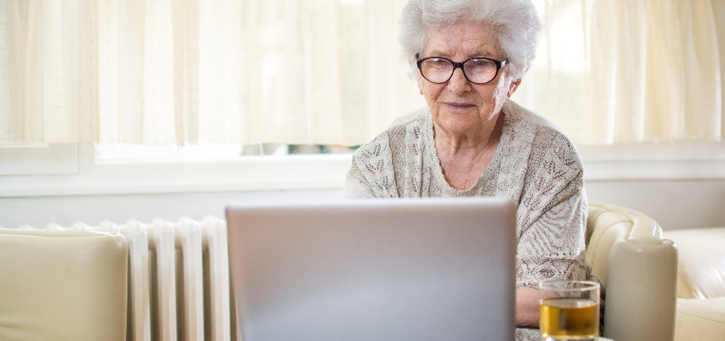

3.2.6 Risk
Forty-one items were developed for the survey based on the previous literature and our interviews with, and vignettes featuring, U3A members. These items drew on the five risk components identified in prior research and willingness to adopt IT products, and were added to and modified based on qualitative research.
Twenty items targeted people’s thoughts, feelings and expectations when using ICT. This section included statements such as ‘I fear I’ll forget instructions before I can use the device’ and ‘I fear wasting my time’. The next section of 15 questions in the survey addressed issues to do with risks associated with online transactions and the cost of using ICT, such as ‘I worry that people can see my personal details when I go online to transact’. The final section of 14 statements broadly addressed potential perceived personal risks such as ‘I fear confrontations on social media’ and ‘I fear making a fool of myself’. Respondents were asked to rate the extent to which they agreed with each statement from 1 ‘Strongly disagree’ to 7 ‘Strongly agree’. A higher score indicates greater ICT risk and fear.
We conducted factor analysis, discriminant validity assessment, and scale reliability analyses to test whether the survey items tap into these six constructs. All factors meet the criteria set for reliability and validity. Factor analysis assisted with summarising the survey items – it aimed to reduce our 41-item scale to a manageable number. In this case, our factor analysis revealed six risk categories—although somewhat different from previous literature. (See Appendix 8 for all risk and fear items, means and factor analysis results.)
The six risk factors from our survey were:
- Operational and Functional Risk: forgetting instructions or passwords, not keeping up, wasting time.
- Personal and Social Risk: being made fun of, feeling incompetent, getting frustrated, being overwhelmed.
- Privacy and Transaction Risk: online payments, losing privacy, identity theft, automatic payments.
- Purchase Transaction Risk: making transaction mistakes, not receiving goods, processing errors.
- Overspending Risk: buying too much online, increasing software upgrade or device costs.
- Physical Harm Risk: physical inactivity, becoming addicted to ICT, eyesight, or strain injury.

Risk factor scores
Overall, older adults’ perceived risks of engaging with ICT were relatively low – average scores were between 2.6 and 3.3 (Figure 14). Respondents to this survey overall have low risk and fear scores. This may reflect respondents’ higher levels of education and that they are engaged in ICT related learning through U3A. It is also important to note that their digital literacy and inclusion are already at a level to utilise email and complete an online survey. However, when we examine the average factor scores, the lowest scores (less perceived risk) were for emotional or personal risks: Physical Harm Risk and Personal and Social Risk factors. The highest average scores were for the factors Operational and Function Risk, Privacy and Transaction Risk, and Overspending Risk.

Figure 14. Perceived risk factor scores (mean)

Figure note. N = 426. Data from Older Adults and ICT Online Survey. See Appendix 8 for factor analysis results. Higher scores represent higher perceived risk.

To further explore these risk factors, we assessed them against several respondent characteristics – age, gender, relationship status, and perceived digital literacy (see Appendix 9 for all risk factor scores).
There were no significant differences in average scores between younger and older respondents for any of the six factors. However, based on the survey data, women had higher scores (more risk-averse) than men on five out of the six factors (Figure 15). This is consistent with previous research identifying women as more risk-averse and fearful when using ICT (Broos, 2005).
Figure 15. Perceived risk scores and gender

Figure note. *T-test shows a statistically significant difference. N = 425. There were 294 female and 131 male respondents. Maximum possible score is 7. Higher score represents higher perceived risk.

The current interviews also offer some indication of this difference between genders, and highlight potentially contributing factors. For example, Marilyn notes she has little self-confidence using technology, “I don’t know what it is actually. I suppose it’s because I’m not at all confident, I don’t have a lot of self-confidence using technology, and I feel quite inferior because of it, which is mad, but I do.” (Vignette: Risk of Embarrassment and Social Pressures). In another interview, Patsy explains how “I always felt really dumb, really stupid, and I’m not stupid, but I don’t connect with the concepts behind these things. And because I don’t understand the concepts, I don’t know how to manipulate them.” (Vignette: Risk of Embarrassment and Social Pressures). These technology issues cause her to feel “stupid” in front of others, reflecting her limited knowledge and not understanding technological concepts.
While some men also described similar anxieties around technology use, most men talked about the issue indirectly, preferring to explain the issues others had with technology. Many men who discussed other’s concerns were U3A tutors who observe these traits in their students. Noel, for example, reflected on how students in his class will “click on the wrong thing somewhere, they pick the wrong browser, and then they try to get out of it and at that point, panic sets in and that's where it goes south in a big way for those people.” (Vignette: Fear of Failing to Accomplish a Task). However, the group is diverse. Lindsay and Tony have backgrounds in technology sectors and report being comfortable taking risks (Lindsay: Risk of Addiction and Dependence/ Tony: Data Security).

Both women and men note how their work had required them to stay up to date and that in retirement, they lacked organisational support and drive to maintain such skills. However, Lee’s leadership role within U3A saw her maintain ongoing computer learning, leading her to perceive being far more comfortable and knowledgeable with technology due to the ongoing management of her skillset (Vignette: Fear of Failure to Accomplish a Task). When we compared single respondents with those who were part of a couple, we found significant differences in average scores for two related factors: Purchase Transaction Risk and Overspending Risk. Single people had higher risk perception scores than people who were part of a couple. These results suggest that there is perhaps an online shopping moderating effect of being part of a couple. Single people may feel more at risk of overspending or making errors when online shopping.
The interview data also suggested shopping risks for single older adults. Helen, retired, single and living in a rural area, describes how her daughter monitors her bank account, who “told me recently I had to stop buying things online”, as well as keeping an eye on Helen’s online purchasing habits and tightened budget in retirement (Vignette: Risk of Escalating Costs). While there was evidence of a lower likelihood of online engagement in some couples, this was not consistent across the board. For instance, Lee brought up her husband’s aversion to learning anything ICT related, which means she makes considerable effort to have him pay bills online and participate in online banking. By comparison, Dawood says, “I have my own account online, go online do it, and I feel safe. There is nothing to worry about” (Vignette: Risk of Making Online Banking Mistakes). Dawood also notes that he has a strong social network around him, his wife and sons and daughter, which may enable his sense of confidence online.
When we compare the risk factor scores between high and low levels of digital literacy, we found, as might be expected – adults with low digital literacy experienced significantly higher levels of perceived risk and fear for all six factors (Figure 16). Those with high digital literacy scored less than ‘3’ for all factors, while those with low digital literacy scored above ‘3’ for all factors, and over ‘4’ for the first factor (the highest risk score so far). In addition, people with low levels of perceived digital literacy experience significantly higher operational and functional risk levels (average score 4.3) than people with high digital literacy (average score 2.5).
Figure 16. Perceived risk scores and digital literacy

Figure note. *T-test shows a statistically significant difference. N = 425. There were 175 people with ‘low’ and 213 people with ‘high’ perceived digital literacy (DL) scores. Maximum possible score is 7. Higher score represents higher perceived risk.

Judy, a coordinator at her local U3A, describes how she sees older adults take one of two approaches to technology use “…you can take up technology and go with it and learn with it, or else you can hide from it.” (Vignette: General Fear of using Technology (Technophobia)). Noel, a U3A tutor, suggests that many “can’t be bothered learning a new thing; [they say:], I just want to stay where I am, and I want to it be simpler” (Vignette: General Fear of using Technology (Technophobia). However, for some, such as Lee, there is a perception that they can and have to learn and become comfortable with the risks and failures. She describes having to run a U3A annual general meeting via Zoom, for which she was, “… nervous that I would do something that didn’t work”, yet she took on the steep learning curve, asked questions and accomplished it (Vignette: Fear of Failure to Accomplish a Task). Our preliminary analysis of ICT risk perception and fear highlighted that women, especially those not in relationships and those with low levels of perceived digital literacy, are more likely to experience ICT related fears. Perceived digital literacy appears to have the greatest impact—identifying an opportunity for increasing digital literacy by focusing on decreasing risk and fear.

3.2.7 Exposure to Fraud & Scams
Older adults are particularly vulnerable to scams and fraud. Increasing age, lower income, lower cognitive and psychological health, and low digital literacy levels were associated with an increased risk of being a victim of fraud or scams (James, Boyle, & Bennett, 2014). In Australia, people aged 65 years and over reported higher losses to online scams in 2020 than any other age group, with almost $38 million lost (ACCC, 2021b; Scamwatch, 2021). Respondents were asked in the survey if they had ‘ever experienced or had been caught out by’ any of the 12 attempts of scamming or fraud scenarios presented to them (see Table 4 for the details of each scam type).
We have divided Table 4 into two sections: scams where the victim cost is undetermined and scams where the victim cost is explicit (e.g., paying for a product and not receiving it). Between 48.4% and 12% of respondents had been exposed to digital requests for personal information or money, where the victim cost was undetermined. Moreover, scams resulting in explicit victim costs were less common; between 11.3% and 3.1% of respondents had experienced explicit losses from scams. Overall, 70.7% of all respondents had been exposed to at least one scam or fraud experience. Of those who had been exposed, 36.5% experienced 1 to 2 types, 40.6% 3 to 4, and 22.9% dealt with 5 or more scam types. Only 29.3% did not report any exposure to scams or scam attempts.

Table 4. Experience of scams or fraud
Type of scam or fraud | % Exposed
Victim Cost undetermined
You were asked by email (or other online means) to provide (or confirm) personal information by someone pretending to be from a legitimate organisation such as a bank, telephone or internet service provider, or government department. | 48.4
You were approached by email (or other online means) and were informed that you had a computer or internet problem. Then you were asked for your personal details and your bank or credit card details to have the problem solved. | 46.0
You were contacted by someone pretending to be from a legitimate organisation, such as a bank, internet provider or government, who claimed there were problems with your account or other documentation and threatened you if you did not pay to resolve the problem. | 45.1
You received notification of a lottery win or a competition win but were informed you would need to pay a fee or buy a product in order to collect your prize. | 32.9
You were promised you would receive a good, a service, a rebate, or an important investment gain if you transferred or invested money. | 19.0
You accessed a website and were informed that you had a computer or internet problem. Then you were asked for your personal details and your bank or credit card details to have the problem solved. | 15.0
You received a fake invoice for products that you had not ordered, and you were asked to pay the cost. | 12.0
Victim Cost Explicit
You ordered free or relatively cheap products or services, but it turned out you had been tricked into a costly monthly subscription. | 11.3
You bought what you thought was a good deal, but the goods /services turned out to be fake or non-existent. | 8.5
You bought what you thought was a good deal, but you never received the goods/service. | 7.0
You bought tickets for an event, concert, or travel, but it turned out the tickets were not genuine and/, or you never received them. | 3.1
I have not experienced or been caught out by any scam or frauds of this nature | 29.3
Note. N = 426. Data from Older Adults and ICT Online Survey. Respondents could select more than one scam or fraud type.

The most common type of scam reported were email scams that purported to represent a legitimate organisation demanding personal details (48.4% of respondents had experienced this type), or had threatened and demanded payment to resolve account problems (45.1% of respondents).
Noel, a competent technology user and U3A tutor, describes the constant stream of scammers who take this approach. As he reflects, his favourite one is “Nicole from the NBN”, in which the caller threatens “to disconnect you unless you talk to our technicians now.” Similar scams from a fraudulent “technical department at Telstra” will threaten either immediate disconnection unless you talk to them to solve your problem, or they need “access to your laptop because you’ve been hacked.” (Vignette: Risk of Scams).
Similarly, 46.0% of survey respondents had experienced being approached via email to help rectify a computer or internet problem and requests for personal and banking information (Table 4 above). One such incident involved Graeme, who was contacted by someone reporting to be from Telstra. He describes that “They were so damn convincing I gave them my bank number”, but after finishing the call, he realised its fraudulence and reported it to his bank. (Vignette: Risk of Scams). Sally, a technology-savvy respondent, points out that not just those with low digital literacy are scammed in such ways. Her friend, who she sees as “so resistant to technology”, was also called by someone purporting to be a Telstra employee, who led her to share bank details and lose quite a lot of money. However, Sally also mentions another friend who “owned an IT business, who’s extremely technologically savvy, managed to lose $50,000 recently” under similar circumstances, reflecting on how it is not only technology averse older Australians who are being scammed (Vignette: Risk of Scams).
Over a third of U3A survey respondents reported receiving a notification that they had won a lottery or prize and needed to pay a fee to claim it (32.9%).
A smaller proportion of respondents had experienced investment type scams (19.0%) or internet problem scams after accessing a website (not by direct email or other online means; 15.0%). Very few had experienced scams or consumer issues related to online shopping, monthly subscriptions, fake or misrepresented products and bogus tickets.
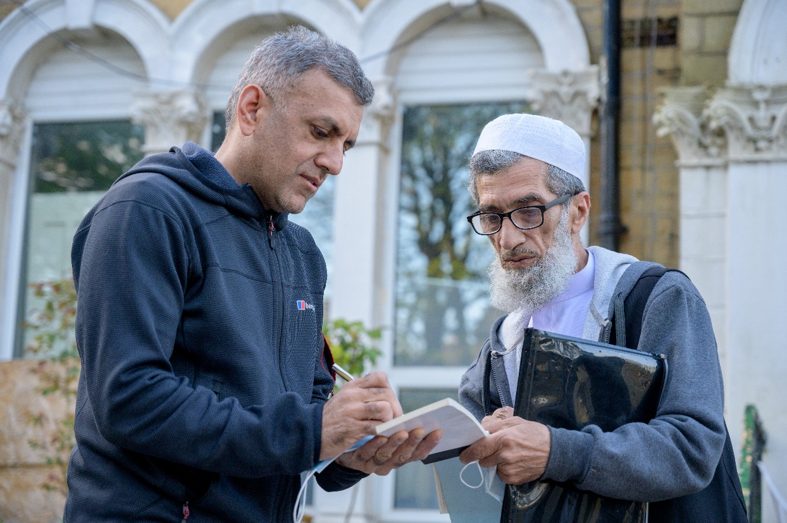
Many interviewees discussed general apprehensions around online services and transactions, though many framed it as a positive outcome rather than a scam. One such example is explained by Sue, who uses PayPal to reduce her risk for online purchases but was concerned during a recent transaction in which she “noticed the name of the bank account was my new branch”. Combined with the fact that “the name of the store was N-O-T-I-N-G, nothing without the H”, she was concerned about the potential to lose money; however, because it was a small amount, she proceeded. Ultimately it did arrive in the mail, and she mentions saying, “my faith in humanity has been restored”. (Vignette: Risk of Making Online Banking Mistakes).
It appears that older adults are more likely to be exposed to scams based on legitimate organisations—as opposed to being tricked or defrauded in the process of shopping online. Responses to internet usage in this survey highlighted the low rate of internet shopping among respondents, an effective protective factor. We know that older adults are more trusting of legitimate organisations than their younger counterparts and are more vulnerable to this type of scam.
Further information is warranted on the social and financial costs of these scams. We will also investigate the impact on older adults’ fear and avoidance in using ICT due to their experience of scams. In addition, the association between perceived digital literacy and experience of scams would be essential to explore—are people with higher digital literacy better able to detect fraud and scams and thus have higher experience rates? Or is the opposite true? Future analysis will explore these questions.

Limitations
The scam questions only asked for the lifetime experience of each of the scam types. The time frame of the responses is not known— thus, some of the scam experiences may not be recently experienced. Nor did the questions ask how often they experienced each type of scam. The scam questions did not distinguish between exposure to, and falling victim to the scams. The financial or social cost of scam exposure was also not measured—these issues were beyond the scope of this survey. Finally, the survey list of scams did not include questions about online dating scams. Romance baiting scams are, however, on the rise (ACCC, 2021a) and worthy of further investigation on its own.

4 Conclusions
This interim report presents the initial findings from the first stage of this project—Explore and Quantify—gathered from interview and survey data. The ongoing issues brought on by the COVID-19 pandemic have seen older Australians realise how crucial digital engagement is in fostering social inclusion. The initial exploratory interviews conducted with 22 respondents on different types of perceived risks, alongside topics of safety and care, formed an analysis covering several subcategories of perceived risk. These were created into vignettes edited from the interview materials, which were shared publicly to offer insights into the subcategories formed from the interviews and overarching perceived risk categories.
The current survey collection, which has so far yielded 426 valid surveys, is expected to be completed by October 2021. Primarily conducted online, the survey offered insights into demographic profiles, perceptions, and experiences of ICT and ownership and usage. These were framed by measures of the digital literacies of respondents, the influences on the ICT use and their perceptions of risk and experiences of fraud. Insights gained from this inquiry with members of the U3A community offer valuable early insights that have given rise to critical recommendations for the research going forwards (see section 5 Recommendations). As this phase is finalised, the findings will be beneficial toward conducting the Understanding phase of ethnographic activities. The research analysis forms into three subjects of impact and insight: ICT Use of Older Adults, Perceived Risks of Technology in Older Adults, and Digital Literacy.

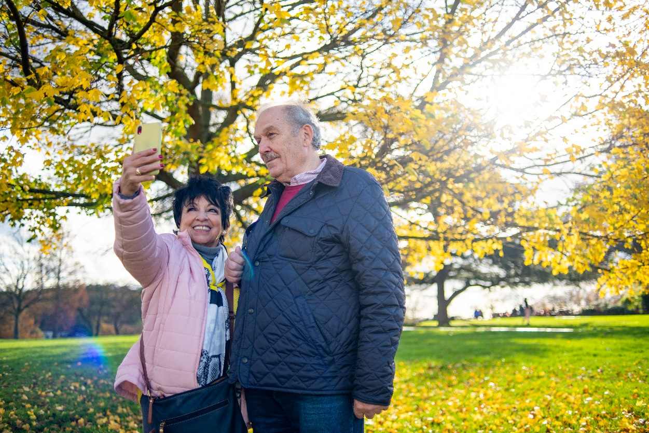

4.1 ICT Use of Older Adults
Using existing and well-known measures from literature, we articulated how seniors feel about ICT, what they think about it, how they view themselves as users and their concerns regarding usage. At this research stage, these notions were explored through the lens of ICT use to understand the practices and behaviours of older adults. This has formed the indications regarding perceptions and experiences of ICT use. The survey indicated that ICTs were most frequently used for Everyday Living activities, with social networking and online games used once a month or more, and less so for shopping and entertainment purposes (once a month to once every few months). In addition, when assessed through characteristics, women engaged in social networking and gaming more frequently than men, while younger respondents (those aged 69 years and younger) more frequently used ICT for shopping, entertainment, and social networking more than older respondents. Underlying these engagement factors, perceived digital literacy was directly linked to engagement with ICT.
When responding to their ICT device ownership and use, personal access to devices corresponded to the frequency of ICT use: almost all survey respondents owned a smartphone (90%) and on average used it daily, while those who owned an iPad or tablet (69%) used it on average about once per week. Digital literacy was also related to the frequency of device use; those with high digital literacy were significantly more likely to use more devices. This trend continued regarding the influences on ICT use, with those with higher digital literacy consistently more confident, positive, and knowledgeable of ICT. Notably, people with low digital literacy wanted to increase their use of ICT but were more anxious about usage. However, when low digital literacy respondents perceived ICT to be easy to use, they also had a more positive view of the usefulness of ICT. Still, a positive attitude towards ICT usage did not predict intent to use for low digital literacy respondents.

4.2 Perceived Risks of Technology in Older Adults
The investigation of perceived risks in this research is based on early signals from U3A membership concerning various perceptions of seniors’ risk about ICT use, and additional data that indicated their reluctance to engage with technology because of security concerns. Within these results, it was evident that perceived risk can be disaggregated into six types of perceived risks. Understanding the different types of risk is useful for researchers who can work on a more tailored approach to reducing risk and devising more effective strategies to overcome each type of risk. In addition, it was clear that U3A respondents had relatively low levels of perceived risks associated with engaging with ICT. At this stage, this low level of perceived risk can be partially attributed to U3A’s successful work with digital inclusion of its members through courses, workshops and peer-to-peer mentoring, reducing perceived risk. The lower level of perceived risk can be partially attributed to the survey’s digital data entry.
However, there was evidence of several factors that influence older adults’ levels of perceived risks across the characteristics collated. These formed the first analysis that indicated women were more fearful and risk-averse than men in five out of the six factors. Interview analysis also supports this finding. In addition, single respondents were more likely to struggle with purchase transaction risk and overspending risk than their counterparts in relationships, again, an insight also arising from interview data.
Alongside trends suggesting that exposure to fraud and scams is an ever-present concern for older adults, this data corroborates the extent of the issue. Nearly half of respondents had dealt with email scams that purported to represent a legitimate organisation demanding personal details, with the NBN and Telstra being the most commonly cited. Such scams demanded personal information (48.4%) or had threatened and demanded payment to resolve account problems (45.1%). Notably, the association between perceived digital literacy and the experience of scams was challenging to address. Those with both high and low literacies fall prey to scams. This finding would be essential to explore in the future. A low rate of internet shopping amongst respondents may indicate the experience of being tricked or defrauded in the process of shopping online. If online shopping increases, older adults may be more vulnerable to this type of scam due to being more trusting of legitimate organisations.

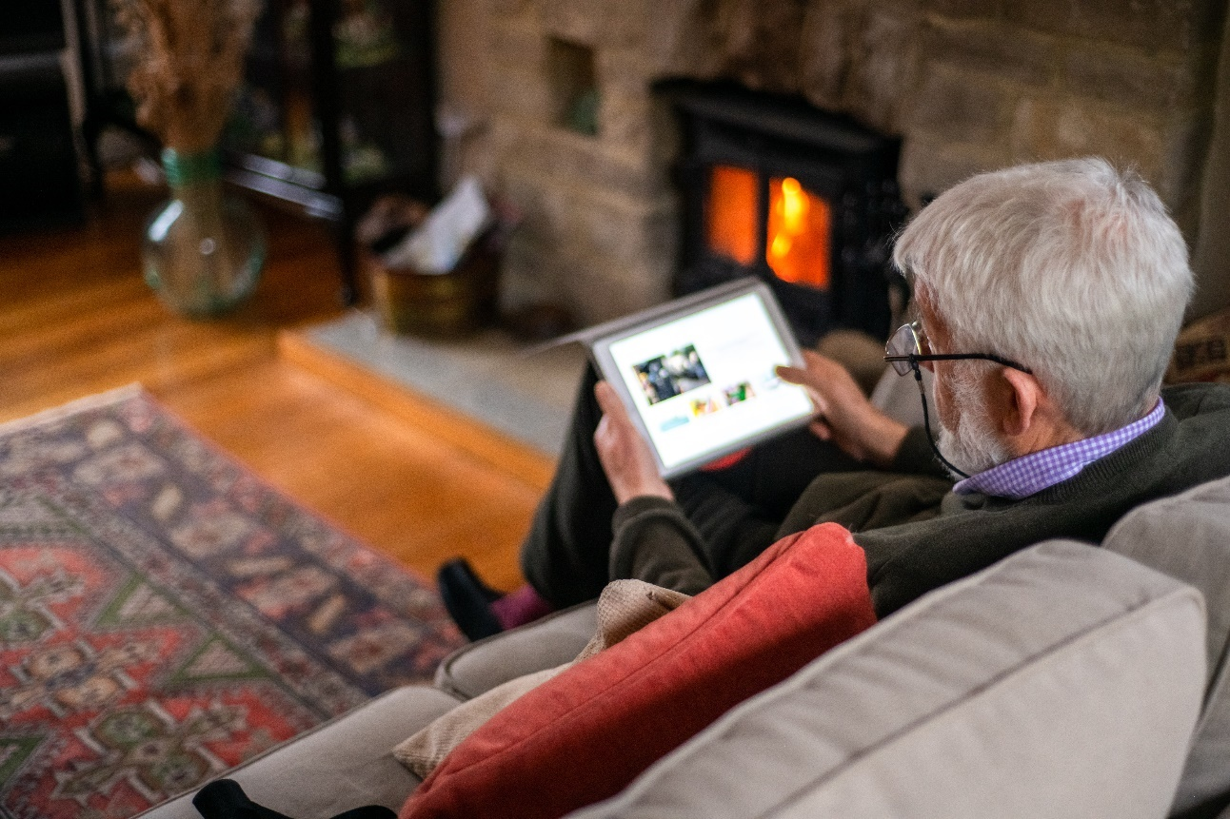

4.3 Digital Literacy of Older Adults
Results show that perceived risks of technology and digital literacy form a significant factor for older adults’ ICT use. Characterising those with self-reported higher levels of digital literacy, age, gender, and relationship status all played a role. Those under the age of 69 reported a higher level of skill and knowledge across all factors than their older counterparts. Male participants reported more comfort with technical skills, mobile device skills, and content and creative skills than female participants. Respondents defining themselves in coupled relationships felt they had a higher level of skill and knowledge across all factors compared to single older adults.
When considering how digital literacy influenced ICT use, these characteristics form a picture around those who have frequent device use and more devices in their ownership. While this sample did reflect a higher level of digital literacy across the board, women were more risk averse. Single respondents were more likely to struggle with risks in purchase transactions and overspending. An essential consideration to this research going forward, to reduce perceived risk and promote digital inclusion, is that people with low digital literacy want to increase their use of ICT but are more anxious about ICT use. So, it is important to consider how participatory strategies might support this uptake.

5 Recommendations
In reflecting on the findings of this research, we seek to position the recommendations as contributors to our study’s future stages and implications to be considered by researchers and stakeholders looking to understand the ICT use and perceived risks of technology with older adults.

Recommendation 1
The project has revealed the six types of perceived risk that exist among older adults. It has suggested that the efforts made by U3A to support and connect are working. The level of perceived risk among the group of participants seems to be lower than we initially expected for older adults, considering this is the most digitally excluded segment of the population according to the Australian Digital Inclusion Index. The following stages of this project will seek to uncover the strategies U3A are using to reduce risk perception among its members. By researching and making these strategies accessible, we hope to help disseminate peer-to-peer strategies that have been effective in promoting digital inclusion. Beyond this project and its focus on communities of older adults, the implications of how older adults perceive ICT risks and seek to improve their digital literacies should be of great interest to those investigating cybersecurity, product design and digital infrastructure.

Recommendation 2
Due to the restrictions and limitations of the COVID-19 pandemic, this research has had to use predominantly online and digitally based research methods. The interviews were conducted through Zoom video conferencing, and the survey, at present, is primarily accessed via a web-based survey tool, Qualtrics. While there are some limitations to digital-first research, such as a limited older adult cohort, the benefits of long-distance and instant communication and engagement should be noted. Future studies should consider how hybrid forms of research involving multiple media for methods such as interviews and surveys may encourage a wider array of participants through accessibility and convenience. Rather than limit or encourage studies to remain online or offline, we recommend the hybrid pathway to better facilitate and respond to the capacities of older adult participants, particularly in issues of ageing and technology.

Recommendation 3
In our current findings, the role of gender and partner support featured in perceptions of risk. Women and those living alone had a higher level of perceived risk. From an intersectional point of view, women living alone and without family had even higher levels of perceived risk associated with ICT. They also faced specific issues around digital literacy, which need to be explored. More extensive exploration into the diversity of women’s digital practices is required to uncover barriers and thus enhance opportunities moving forward. Further examination of differences between the digital contexts of single older adults versus those of partnered couples is also warranted.

6 Authors
Bernardo Figueiredo
Bernardo is an Associate Professor in Marketing in the School of Economics, Finance and Marketing at RMIT University. His current research projects focus on value creation, collaborative networks, technology, and ageing.
Torgeir Aleti
Torgeir is a Lecturer in Marketing in the School of Economics, Finance and Marketing at RMIT University. Torgeir’s research investigates social and relational aspects of consumption choices and behaviour.
Mike Reid
Mike is a Professor in Marketing in the School of Economics, Finance and Marketing at RMIT University. His research encompasses social marketing areas of food literacy, consumer food choice, obesity and behaviour change, and healthy middle-ageing.
Diane M. Martin
Diane is a Professor of Marketing in the School of Economics, Finance and Marketing at RMIT University. Diane’s expertise is in ethnographic and qualitative research in the areas of consumer behaviour, new market development and sustainability. Her award-winning scholarship is published in numerous journals in marketing and communication.
Larissa Hjorth
Larissa is Distinguished Professor and Director of RMIT’s Enabling Capability Platform, Design & Creative Practice. Hjorth is a digital ethnographer, creative practitioner, and media researcher. Hjorth has successfully led 20 international and national grants—projects which have focused on intergenerational and cross-cultural approaches to digital ethnography.
Mark Buschgens
Mark is a lecturer in marketing at Waikato Management School & a PhD graduate of RMIT University’s School of Economics, Finance and Marketing. Over the last 12 years, he has held academic and industry roles in creative design and marketing in various institutions in Australia, California, and the Middle East.
Jozica Kutin
Dr Jozica Kutin is a Senior Researcher at Victoria Law Foundation and RMIT University. Her research focuses on financial abuse, financial capability, survey methodology and access to justice.
Jacob Sheahan
Jacob is a PhD Candidate in the School of Design at RMIT University. A trained Industrial Designer with a design anthropology and interaction design skillset, his research practice focuses on the future of ageing, emerging technologies, and design for health and wellbeing.

Appendices

Appendix 1. Device frequency of use (mean scores)
Device type | Mean | Female | Male | Younger | Older | Single | Couple | Low DL | High DL
Smartphone | 6.6 | 6.7 | 6.4 | 6.7 | 6.6 | 6.6 | 6.6 | 6.3 | 6.9*
iPad/Tablet | 5.3 | 5.3 | 5.4 | 5.3 | 5.4 | 5.2 | 5.5 | 5.1 | 5.6*
Laptop | 4.9 | 4.8 | 5.2 | 4.9 | 4.9 | 4.8 | 5.0 | 4.7 | 5.3*
Internet-enabled TV | 4.9 | 4.9 | 5.1 | 5.2 | 4.7 | 4.8 | 5.0 | 4.5 | 5.4*
Desktop computer | 4.8 | 4.7 | 5.0 | 4.2 | 5.1* | 4.7 | 5.0 | 4.9 | 4.9
Wearable devices (e.g., Apple Watch, Fit-Bit) | 3.1 | 3.0 | 3.2 | 3.2 | 3.0 | 2.5 | 3.3 | 2.6 | 3.7*
iPod Touch or similar device | 1.9 | 1.9 | 2.0 | 1.7 | 2.0 | 1.8 | 1.9 | 1.7 | 2.3*
Other | 1.8 | 1.6 | 2.1 | 1.6 | 1.8 | 1.9 | 1.7 | 1.7 | 1.6

Note. N = 426. Data from Older Adults and ICT Online Survey. There were 294 female and 131 male respondents. Younger adults were aged 69 years or younger (n = 145), older adults were aged 70 years or older (n = 280). There were 151 single and 248 coupled respondents. There were 175 people with ‘lower’ and 213 people with ‘higher’ perceived digital literacy (DL) scores. *T-test shows a statistically significant difference.

Appendix 2. Items and factors measuring digital literacy and internet skills
Factor name and survey items (Ca) | Mean (SD)
Factor 1: Technical Skills (Ca, 0.91) | 5.71 (1.22)
I know how to download/save a photo I found online to my computer and mobile devices | 5.85 (1.46)
I know how to use shortcut keys on my computer and mobile devices (e.g., CTRL-C for copy, CTRL-S for save) | 5.34 (1.78)
I know how to open a new tab in my browser on my computer and mobile devices | 5.94 (1.38)
I know how to bookmark a website on my computer and mobile devices | 5.59 (1.74)
I know how to open downloaded files | 6.06 (1.25)
I know how to change my passwords on my computer and mobile devices | 5.87 (1.48)
I know how to adjust privacy settings on my computer and mobile devices | 5.02 (1.92)
In general, I often have difficulty when using my ICT | 2.37 (1.51)
Factor 2: Information and search skills (Ca, 0.82) | 5.00 (1.18)
I find it hard to decide what the best keywords are to use for online searches | 2.55 (1.60)
I find it hard to find a website I visited before | 2.41 (1.44)
I get tired when looking for information online | 2.83 (1.65)
Sometimes I end up on websites without knowing how I got there | 2.93 (1.73)
I find the way in which many websites are designed confusing | 3.70 (1.74)
I can easily tell the difference between what is real and what’s fake information | 4.47 (1.67)
Factor 3: Mobile device skills (Ca, 0.93) | 5.13 (1.64)
I know how to download apps to my mobile devices (e.g., phone, tablet) | 5.68 (1.68)
I know how to set up apps on a mobile device so that they work well for me | 5.30 (1.78)
I know how to keep track of the costs of mobile app use | 4.88 (1.89)
I know how to manage the relationship between my mobile devices and my other ICT | 4.68 (1.90)
Factor 4: Social and sharing skills (Ca, 0.89) | 5.67 (1.05)
I know which information I should and shouldn’t share online | 5.99 (1.00)
I know when I should and shouldn’t share information online | 5.96 (1.02)
I am careful to make my comments and behaviours appropriate to the situation I find myself in online | 6.12 (0.99)
I know how to change who I share content with (e.g., friends, friends of friends or public) | 5.55 (1.53)
I know how to remove people from my contact lists | 5.78 (1.45)
I know how to block people from seeing what I post online | 4.94 (1.87)
I feel comfortable deciding who to follow online (e.g., on services like Facebook, Twitter, or Instagram) | 5.36 (1.62)
Factor 5: Content and creative skills (Ca, 0.89) | 3.37 (1.65)
I know how to create something new from existing online images, music, or video | 4.00 (2.04)
I know how to make basic changes to the content that others have produced | 4.13 (2.03)
I know how to design a website | 2.65 (1.92)
I know which different types of licences (e.g., copyright) apply to online content | 3.26 (1.95)
I would feel confident putting video content I have created up online (e.g., on YouTube or Tik-Tok) | 2.84 (1.92)
Note. N = 426. Data from Older Adults and ICT Online Survey. Ca = Cronbach’s alpha.

Appendix 3. Digital Literacy (mean scores)
Factor | All | Female | Male | Younger | Older | Single | Couple
Technical Skills | 5.7 | 5.6 | 6.0* | 6.1* | 5.6 | 5.5 | 5.9*
Information and search skills | 5.0 | 5.0 | 5.0 | 5.3* | 4.9 | 4.9 | 5.1*
Mobile device skills | 5.1 | 5.0 | 5.5* | 5.6* | 4.9 | 4.7 | 5.4*
Social and sharing skills | 5.7 | 5.7 | 5.7 | 5.8* | 5.6 | 5.5 | 5.8*
Content and creative skills | 3.4 | 3.2 | 3.9* | 3.7* | 3.2 | 3.0 | 3.6*
Note. N = 426. Data from Older Adults and ICT Online Survey. See Appendix 2 for factor analysis results. There were 294 female and 131 male respondents. Younger adults were aged 69 years or younger (n = 145), older adults were aged 70 years or older (n = 280). There were 151 single and 248 coupled respondents. *T-test shows a statistically significant difference.

Appendix 4. Results from a factor analysis of ICT activity engagement items
Factor name and survey items (Ca) | Mean (SD)
Factor 1: Everyday Living (Ca, 0.73) | 5.42 (1.02)
Searching and checking information using a search engine, e.g., google searching | 6.32 (1.09)
Emailing friends and family | 6.01 (1.36)
Sharing information with friends and family | 5.14 (1.74)
Instant messaging, e.g., texting | 6.00 (1.48)
Online banking and bill payments | 4.78 (1.67)
Reading news online, e.g., online newspapers, ABC news online | 5.41 (2.22)
Making calls, e.g., skype, facetime, Zoom | 4.30 (1.83)
Factor 2: Shopping and Entertainment (Ca, 0.71) | 2.80 (1.08)
Online shopping for more advanced products and services, e.g., new technology | 2.15 (1.22)
Online shopping for service products, e.g., insurance, travel | 2.17 (1.08)
Online shopping for basics, e.g., food and groceries or items of clothing etc | 2.85 (1.69)
Reading online or downloaded books and magazines | 3.49 (2.33)
Blogging, vlogging, and other general online commentaries | 1.50 (1.22)
Watching entertainment, e.g., movies, catch-up tv, or sports | 4.70 (2.19)
Factor 3: Social Networking (Ca, 0.71) | 3.76 (1.96)
Social networking, e.g., chatting on messenger or another app | 4.23 (2.31)
Uploading content for family and friends to see, e.g., using Facebook, Instagram, YouTube | 3.30 (2.16)
Factor 4: Gaming (Ca, 0.43*) | 3.12 (1.97)
Playing standalone games on the device (i.e., competing with self or the device) | 4.01 (2.67)
Playing connected games online (i.e., competing with other people) | (2.24 (2.28)
Note. N = 426. Data from Older Adults and ICT Online Survey. *The Cronbach alpha (Ca) for ‘gaming’ was low, suggesting it is not a reliable factor. It has been retained for purposes of discussion.

Appendix 5. Engagement factor mean scores
Factor | Mean | Female | Male | Younger | Older | Single | Couple | Low DL | High DL
Everyday living | 5.4 | 5.5 | 5.4 | 5.6 | 5.4 | 5.3 | 5.5 | 4.9 | 5.8*
Shopping and entertainment | 2.8 | 2.8 | 2.9 | 3.0* | 2.7 | 2.7 | 2.9 | 2.3 | 3.2*
Social networking | 3.8 | 3.9* | 3.5 | 4.3* | 3.5 | 3.6 | 3.9 | 3.1 | 4.3*
Gaming | 3.1 | 3.3* | 2.7 | 3.1 | 3.1 | 3.3 | 3.1 | 2.9 | 3.3*
Note. N = 426. Data from Older Adults and ICT Online Survey. See Appendix 4 for factor analysis results. There were 294 female and 131 male respondents. Younger adults were aged 69 years or younger (n = 145), older adults were aged 70 years or older (n = 280). There were 151 single and 248 coupled respondents. 175 people with ‘low’ and 213 with ‘high’ perceived digital literacy (DL) scores. *T-test shows a statistically significant difference.

Appendix 6. Items and factors measuring the Technology Acceptance Model
Construct or factor name and survey items (Ca) | Mean (SD)
Intent to use more ICT (Ca:.94)
Over the next six months, I intend to use more of today’s ICT in my daily life | 3.88 (1.37)
Over the next six months, I intend to use more of today’s ICT to be socially connected | 3.95 (1.44)
I intend to increase my level of engagement with people using ICT | 3.90 (1.35)
I have plans to increase my level of engagement with organisations using ICT | 3.74 (1.36)
I would like to improve my engagement with people using ICT | 3.92 (1.41)
I would like to improve my engagement with organisations using ICT | 3.85 (1.38)
Intent to increase proficiency in using ICT (Ca: .91)
I would like to be more proficient at using my current ICT in my daily life | 4.60 (1.50)
I would like to be more technically proficient at using my ICT | 4.76 (1.44)
I would like to be more proficient at searching and navigating information using my ICT | 4.30 (1.61)
I would like to be more proficient at creative and content development using my ICT | 4.39 (1.62)
I would like to be more proficient in integrating my ICT (e.g., between my smartphone and computer) | 4.51 (1.58)
Attitude towards using ICT (Ca: .88)
Using today’s ICT is a good idea | 6.02 (0.99)
Using today’s ICT is enjoyable | 5.52 (1.26)
Using today’s ICT is infuriating (reversed) | 4.73 (1.62)
I like using today’s ICT | 5.69 (1.22)
Using today’s ICT is important | 6.11 (0.96)
Perceived Usefulness (PU) of ICT (Ca: .95)
Using today’s ICT enables me to accomplish my daily life activities more efficiently | 6.00 (1.13)
Using today’s ICT enhances my effectiveness in doing my daily life activities | 5.81 (1.22)
Using today’s ICT makes it easier to do my daily life activities | 5.80 (1.25)
Overall, I find using today’s ICT useful in my daily life | 6.14 (0.95)
Perceived Ease-of-Use (PEOU) of ICT (Ca: .95)
Learning to use today’s ICT is easy for me | 4.92 (1.50)
I find it easy to get today’s ICT to do what I want it to do | 5.00 (1.42)
I find it easy to integrate new ICT into my daily life | 4.99 (1.47)
Overall, I find today’s ICT easy to use | 5.09 (1.47)
Social Influence and subjective norm to use ICT (Ca: .86)
My family think that I should use today’s ICT | 4.43 (1.77)
My friends think that I should use today’s ICT | 4.33 (1.69)
Others, whose opinions are valuable to me think that I should use today’s ICT | 4.30 (1.66)
The organisations I transact with need me to use today’s ICT | 5.65 (1.42)
Self-satisfaction achieved through ICT use (Ca: .91)
Using today’s ICT helps me to keep pace with the times | 5.67 (1.10)
Using today’s ICT improves the quality of my life | 5.21 (1.42)
Using today’s ICT provides me with a sense of accomplishment | 5.21 (1.34)
Social connection achieved through ICT Ca: .90)
Using today’s ICT has made it easier for me to reach people | 6.06 (1.00)
Using today’s ICT contributes to my ability to stay in touch with people I know | 6.09 (1.00)
Using today’s ICT makes it easier to for me to meet new people | 3.88 (1.47)
Using today’s ICT increases the quantity of my communication with others | 5.25 (1.34)
Using today’s ICT makes me feel less isolated | 5.09 (1.45)
Using today’s ICT helps me feel more connected to friends and family | 5.56 (1.24)
Using today’s ICT increases the quality of my communication with others | 5.05 (1.43)
Anxiety in using ICT (Ca: .93)
I feel quite apprehensive about using today’s ICT | 2.55 (1.59)
It scares me to think that I could lose a lot of information due to a wrong operation while using ICT | 2.80 (1.72)
I hesitate to use today’s ICT for fear of making mistakes I cannot correct | 2.43 (1.51)
Using today’s ICT is somewhat intimidating to me | 2.58 (1.64)
Factor 1: Facilitating condition: Skills and Knowledge to use ICT (Ca: .82)
I have the money necessary to access today’s ICT | 5.51 (1.23)
I have the knowledge necessary to use today’s ICT | 5.40 (1.32)
I have the skills to use today’s ICT | 5.37 (1.34)
Today’s ICT is readily available for me to access and use | 5.62 (1.28)
I could easily increase my use of ICT if I desired | 5.09 (1.46)
I don’t need help with ICT | 4.24 (1.88)
Factor 2: Facilitating condition: Mentoring and help in using ICT (Ca: .74)
A formal mentor is available to give me assistance with using today’s ICT use | 3.33 (1.73)
An informal mentor is available to give me assistance with using today’s ICT use | 3.77 (1.84)
A family member is available to give me assistance with using today’s ICT use | 4.24 (1.95)
A friend is available to give me assistance with using today’s ICT use | 3.68 (1.74)
Note. N = 426. Data from Older Adults and ICT Online Survey.

Appendix 7. Technology Acceptance Model scores
Factor | Mean | Female | Male | Younger | Older | Single | Couple | Low DL | High DL
Intent to use more ICT | 3.9 | 3.9 | 3.8 | 3.9 | 3.9 | 3.8 | 3.9 | 3.8 | 3.9
Intent to increase proficiency in using ICT | 4.5 | 4.6 | 4.4 | 4.3* | 4.6* | 4.6 | 4.4 | 4.9* | 4.1
Attitude towards using ICT | 5.6 | 5.6 | 5.7 | 5.7 | 5.6 | 5.5 | 5.7* | 5.1 | 6.1*
Perceived usefulness of ICT | 5.9 | 5.9 | 6.0 | 6.0 | 5.9 | 6.0 | 6.0 | 5.5 | 6.3*
Perceived ease of use of ICT | 5.0 | 4.9 | 5.3 | 5.2* | 4.9 | 4.9 | 5.1 | 4.1 | 5.8*
Social Influence/subjective norm to use ICT | 4.7 | 4.7 | 4.6 | 4.8 | 4.6 | 4.8 | 4.6 | 4.6 | 4.6
Social connection achieved through ICT | 5.3 | 5.3 | 5.2 | 5.3 | 5.3 | 5.4 | 5.3 | 5.0 | 5.5*
Self-satisfaction achieved through ICT use | 5.4 | 5.4 | 5.3 | 5.3 | 5.4 | 5.4 | 5.4 | 5.0 | 5.6*
Anxiety in using ICT | 2.6 | 2.7 | 2.3 | 2.5 | 2.6 | 2.8 | 2.4 | 3.5* | 1.8
Facilitating condition: Skills and Knowledge to use ICT | 5.2 | 5.1 | 5.6 | 5.4 | 5.1 | 5.0 | 5.4 | 4.5 | 5.8*
Facilitating condition: Mentoring and help in using ICT | 3.8 | 3.8 | 3.6 | 3.7 | 3.8 | 3.6 | 3.8 | 3.7 | 3.8

Note. N = 426. Data from Older Adults and ICT Online Survey. See Appendix 4. Results from a factor analysis of ICT activity engagement items for factor analysis results. There were 294 female and 131 male respondents. Younger adults were aged 69 years or younger (n = 145), older adults were aged 70 years or older (n = 280). There were 151 single and 248 coupled respondents. There were 175 people with ‘low’ and 213 people with ‘high’ perceived digital literacy (DL) scores. *T-test shows a statistically significant difference.

Appendix 8. Results from a factor analysis of risk and fear items
Factor name and survey items (CA) | Mean (SD)
Factor 1: Operational and Functional Risk (Ca:0.95) | 3.34 (1.42)
I fear I won’t be able to find things I need on my device | 3.19 (1.78)
I fear I’ll forget instructions before I can use the device | 3.33 (1.82)
I fear I won’t know how to operate the device | 3.24 (1.74)
I fear I won’t be able to keep up with it | 3.37 (1.68)
I fear my content (files, photo’s, programs, etc.) won’t work across my different devices | 3.34 (1.66)
I fear using ICT will get too difficult as I get older | 3.50 (1.80)
I fear I won’t understand the language of new technology, e.g., Bluetooth, 5G | 3.46 (1.91)
I fear my device will crash | 3.17 (1.67)
I fear I’ll lock myself out of my device | 2.75 (1.66)
I fear I will forget my passwords | 3.65 (1.92)
I fear a malfunction will wipe out my data | 3.35 (1.80)
I fear wasting my time | 3.72 (1.68)
Factor 2: Personal and Social Risk (Ca:0.95) | 2.85 (1.37)
I fear making a fool of myself | 2.41 (1.52)
I fear being made fun of for my level of ability | 2.43 (1.51)
I fear bothering others with my questions | 2.98 (1.69)
I fear being overwhelmed | 2.93 (1.69)
I fear feeling incompetent | 2.98 (1.72)
I fear it will increase my stress and anxiety | 2.89 (1.67)
I fear I’m not going to be able to accomplish what I set out to do | 2.97 (1.67)
I fear I’ll get frustrated | 3.29 (1.79)
If I were scammed, my friends and family would think less of me | 2.66 (1.54)
I fear confrontations on social media | 2.97 (1.65)
Factor 3: Privacy and Transaction Risk (Ca:0.88) | 3.26 (1.27)
I feel there is a high level of risk doing transactions online (e.g., banking, shopping) | 3.73 (1.66)
I’m worried that people might be able to access my account or credit card information if I were to shop online | 3.68 (1.78)
I worry that people can see my personal details when I go online to transact | 3.28 (1.73)
I feel safe doing my transactions online (e.g., banking, shopping) (Reverse coded) | 2.63 (1.29)
I fear losing my privacy | 3.45 (1.78)
I fear buying ICT related products online without really understanding what I paid for | 3.49 (1.81)
I worry that I don’t know how to cancel my online subscriptions (e.g., magazine, antivirus service) | 3.15 (1.78)
Factor 4: Purchase Transaction Risk (Ca:0.87) | 3.23 (1.27)
I am often afraid I will make mistakes when transferring money online | 3.12 (1.59)
I worry my transactions and payments will be processed incorrectly | 3.16 (1.56)
I worry the goods I purchased online will not show up | 3.59 (1.59)
I worry that if transaction errors occur, I cannot get compensation from the company or person I paid | 3.77 (1.58)
I worry that friends and family would think less of me if something went wrong in any transaction I made | 2.56 (1.50)
Factor 5: Overspending Risk (Ca:0.79) | 3.34 (1.35)
Overspending is easier online than in a regular store | 3.49 (1.79)
I worry about spending too much when I’m shopping online | 2.61 (1.51)
I worry about the increasing cost of using ICT devices (software, subscriptions, internet connection) | 3.73 (1.73)
I worry that the cost of upgrading my ICT devices will become too expensive for me | 3.71 (1.82
Factor 6: Physical Harm Risk (Ca:0.77) | 2.64 (1.36)
I fear being too physically inactive | 3.28 (1.89)
I fear that I might become addicted to it | 2.41 (1.57)
I fear that it will do me physical harm, e.g., impact my eyesight or increase repetitive strain injury | 2.24 (1.41)
Note. N = 426. Data from Older Adults and ICT Online Survey.

Appendix 9. Perceived risk factor scores
Factor | Mean | Female | Male | Younger | Older | Single | Couple | Low DL | High DL
Operational and Functional Risk | 3.3 | 3.4* | 3.1 | 3.3 | 3.4 | 3.5 | 3.3 | 4.3* | 2.5
Overspending Risk | 3.3 | 3.5* | 3.0 | 3.5 | 3.3 | 3.6* | 3.2 | 3.9* | 2.9
Privacy and Transaction Risk | 3.3 | 3.4* | 3.1 | 3.2 | 3.3 | 3.4 | 3.2 | 3.9* | 2.8
Purchase Transaction Risk | 3.2 | 3.3 | 3.1 | 3.2 | 3.3 | 3.5* | 3.1 | 3.9* | 2.7
Personal and Social Risk | 2.9 | 3.0* | 2.5 | 2.8 | 2.9 | 3.0 | 2.7 | 3.7* | 2.1
Physical Harm Risk | 2.6 | 2.7* | 2.4 | 2.8 | 2.6 | 2.7 | 2.6 | 3.1* | 2.3

Note. N = 426. Data from Older Adults and ICT Online Survey. See Appendix 4. Results from a factor analysis of ICT activity engagement items for factor analysis results. There were 294 female and 131 male respondents. Younger adults were aged 69 years or younger (n = 145), older adults were aged 70 years or older (n = 280). There were 151 single and 248 coupled respondents. There were 175 people with ‘low’ and 213 people with ‘high’ perceived digital literacy (DL) scores. *T-test shows a statistically significant difference.

References
ABS. (2020). Twenty years of population change. Retrieved from Australian Bureau of Statistics website: https://www.abs.gov.au/articles/twenty-years-population-change
ACCC. (2021a). Romance baiting scams on the rise. Retrieved from https://www.accc.gov.au/media-release/romance-baiting-scams-on-the-rise
ACCC. (2021b). Targeting scams: Report of the ACCC on scams activity 2020. Retrieved from www.accc.gov.au
Ajzen, I. (1991). The theory of planned behavior. Organizational Behavior and Human Decision Processes, 50(2), 179–211. https://doi.org/10.1016/0749-5978(91)90020-T
Aleti, T., Figueiredo, B., Reid, M., Martin, D., & Wall, G. (2019). Consumer socialisation across the digital divide. In J. E. Richard & D. Kadirov (Eds.), Australia and New Zealand Marketing Academy (ANZMAC). Retrieved from https://confer.nz/anzmac2019/wp-content/uploads/2020/03/ANZMAC-2019-Final-Proceedings-23.03.2020.pdf
Bagozzi, R. P., Davis, F. D., & Warshaw, P. R. (1992). Development and Test of a Theory of Technological Learning and Usage. Human Relations, 45(7), 659–686. https://doi.org/10.1177/001872679204500702
Boise, L., Wild, K., Mattek, N., Ruhl, M., Dodge, H. H., & Kaye, J. (2013). Willingness of older adults to share data and privacy concerns after exposure to unobtrusive home monitoring. Gerontechnology, 11(3), 428–435. https://doi.org/10.4017/gt.2013.11.3.001.00
Broos, A. (2005). Gender and information and communication technologies (ICT) anxiety: Male self-assurance and female hesitation. Cyberpsychology and Behavior, 8(1), 21–31. https://doi.org/10.1089/cpb.2005.8.21
Chen, K., & Chan, A. H. S. (2014). Predictors of gerontechnology acceptance by older Hong Kong Chinese. Technovation, 34(2), 126–135. https://doi.org/10.1016/J.TECHNOVATION.2013.09.010
Davis, F. D. (1989). Perceived usefulness, perceived ease of use, and user acceptance of information technology. MIS Quarterly: Management Information Systems, 13(3), 319–339. https://doi.org/10.2307/249008
Fishbein, M., & Ajzen, I. (1972). Attitudes and opinions. Annual Review of Psychology, 23, 487–544.
Guner, H., & Acarturk, C. (2020). The use and acceptance of ICT by senior citizens: a comparison of technology acceptance model (TAM) for elderly and young adults. Universal Access in the Information Society, 19(2), 311–330. https://doi.org/10.1007/s10209-018-0642-4
James, B. D., Boyle, P. A., & Bennett, D. A. (2014). Correlates of Susceptibility to Scams in Older Adults Without Dementia. Journal of Elder Abuse and Neglect, 26(2), 107–122. https://doi.org/10.1080/08946566.2013.821809
Knowles, B., & Hanson, V. L. (2018). The wisdom of older technology (non)users. Communications of the ACM, 61(3), 72–77. https://doi.org/10.1145/3179995
Lloyds Bank. (2021). UK Consumer Digital Index 2021. Retrieved from https://www.lloydsbank.com/assets/media/pdfs/banking_with_us/whats-happening/LB-Consumer-Digital-Index-2018-Report.pdf
Maccora, J., Rees, K., Hosking, D., & McCallum, J. (2019). Senior Surfers: Diverse levels of digital literacy among older Australians. Retrieved from https://nationalseniors.com.au/research/social-connectedness-communities/senior-surfers-diverse-levels-of-digital-literacy-among-older-australians
Mitchell, V. (1999). Consumer perceived risk: conceptualisations and models. European Journal of Marketing, 33(1/2), 163–195. https://doi.org/10.1108/03090569910249229
Mitzner, T. L., Boron, J. B., Fausset, C. B., Adams, A. E., Charness, N., Czaja, S. J., … Sharit, J. (2010). Older adults talk technology: Technology usage and attitudes. Computers in Human Behavior, 26(6), 1710–1721. https://doi.org/10.1016/j.chb.2010.06.020
Rehman, Z. U., Baharun, R., & Salleh, N. Z. M. (2020, January 4). Antecedents, consequences, and reducers of perceived risk in social media: A systematic literature review and directions for further research. Psychology and Marketing, Vol. 37, pp. 74–86. https://doi.org/10.1002/mar.21281
Ross, I. (1975). Perceived Risk and Consumer Behavior: a Critical Review. Advances in Consumer Research, 2, 1–20. Retrieved from http://www.acrwebsite.org/volumes/display.asp?id=5741
Scamwatch. (2021). Scamwatch, ACCC (Australian Competition & Consumer Commission). Retrieved from https://www.scamwatch.gov.au/
Stone, R. N., & Grønhaug, K. (1993). Perceived Risk: Further Considerations for the Marketing Discipline. European Journal of Marketing, 27(3), 39–50. https://doi.org/10.1108/03090569310026637
Thomas, J., Barraket, J., Wilson, C. K., Holcombe-James, I., Kennedy, J., Rennie, E., … MacDonald, T. (2020). Measuring Australia’s digital divide: the Australian digital inclusion index 2020. https://doi.org/10.25916/5f6eb9949c832
van Deursen, A. J. A. M., Helsper, E. J., & Eynon, R. (2016). Development and validation of the Internet Skills Scale (ISS). Information Communication and Society, 19(6), 804–823. https://doi.org/10.1080/1369118X.2015.1078834
Wu, Y. H., Damnée, S., Kerhervé, H., Ware, C., & Rigaud, A. S. (2015). Bridging the digital divide in older adults: A study from an initiative to inform older adults about new technologies. Clinical Interventions in Aging, 10, 193–201. https://doi.org/10.2147/CIA.S72399
Young, R., Willis, E., Cameron, G., & Geana, M. (2014). “Willing but Unwilling”: Attitudinal barriers to adoption of home-based health information technology among older adults. Health Informatics Journal, 20(2), 127–135. https://doi.org/10.1177/1460458213486906

Please note the executive summary has a larger font and straight forward language to enable key stakeholders, such as older Australians and members of the U3A community, to easily read and review the contents.
Data collection and analysis are ongoing to reach our stated objectives of 20 remote interviews and over 1,000 completed surveys.
Critical survey items will be published in a peer review outlet to support validity and reliability, and the final instrument will then be made available for others to use.
Respondents were asked “Have you experienced or been caught out by any of the following SCAMS OR FORMS OF FRAUD? Check all that apply.

