Connectivity and digital inclusion on Northern
Gulf cattle properties:
Three case studies
Dr Amber Marshall
Professor Allan Dale

June 2019

Case Studies: Digital inclusion on Northern Gulf cattle properties
Authored by Dr Amber Marshall and Professor Allan Dale
Published in 2019
The project was funded by a grant from the Australian Communications Consumer Action Network (ACCAN).
The operation of the Australian Communications Consumer Action Network is made possible by funding provided by the Commonwealth of Australia under section 593 of the Telecommunications Act 1997. This funding is recovered from charges on telecommunications carriers.
The Cairns Institute, James Cook University
Website: https://www.cairnsinstitute.jcu.edu.au/
Email: cairnsinstitute@jcu.edu.au
Telephone: +61 7 4232 1888
Australian Communications Consumer Action Network
Website: www.accan.org.au
Email: grants@accan.org.au
Telephone: 02 9288 4000
If you are deaf, or have a hearing or speech impairment, contact us through the National Relay Service: https://www.communications.gov.au/what-we-do/phone/services-people-disability/accesshub/national-relay-service
ISBN: 978-1-921974-61-8
Cover image: Jürgen Freund
This work is copyright, licensed under the Creative Commons Attribution 4.0 International Licence. You are free to cite, copy, communicate and adapt this work, so long as you attribute the authors and “The Cairns Institute, James Cook University supported by a grant from the Australian Communications Consumer Action Network”. To view a copy of this licence, visit http://creativecommons.org/licenses/by/4.0/
This work can be cited as: Marshall, A. & Dale, A. 2019, Connectivity and digital inclusion on Northern Gulf cattle properties: Three case studies, Australian Communications Consumer Action Network, Sydney.

Table of Contents
Introduction 1
Case Study 1: Wetherby Station 2
Critical issues 2
Standout story 3
Recommendations 3
Case Study 2: Sugarbag Station & Yards 5
Critical issues 5
Standout story 6
Recommendations 7
Case Study 3: 8
Critical issues 8
Standout story 9
Recommendations 10
Authors 11

Introduction
The following three case studies form part of a broader research project to investigate digital inclusion - a combination of internet access, affordability and digital ability - in the Northern Gulf region in Far North Queensland (FNQ). The project aimed to understand how internet connectivity (or lack thereof) impacts the lives and livelihoods of cattle producing households and communities. These case studies should be read in conjunction with the participant-focused report which expands on the insights and recommendations.

Case Study 1: Wetherby Station
Wetherby Station is a stud cattle operation and family farm near Mount Molloy. Owners John and Kathy Colless are semi-retired and run a modest herd of 100 breeders on 4,000 hectares. The property is relatively close to civilisation: 5 minutes to the closest town (Mount Molloy), 30 minutes to a rural centre (Mareeba), and 90 minutes to a regional centre (Cairns). There are two dwellings on the property: the main homestead and a guest house.
Wetherby Station has access to a range of internet and telecommunications services including:
- Optus mobile (3G/4G) which provides reliable coverage when they go into town and at home, but slow speeds during peak times (schools hours)
- Telstra mobile (3G/4G) which until recently could not be accessed on most of the property
- Recently installed NBN fixed wireless tower in the nearby town of Julatten (not yet accessed)
- Telstra landline phone in homestead
- Now redundant ADSL to both dwellings, which was often interrupted by rain events and provided very slow connection (self-reported 2mbps).
John and Kathy (and their neighbours) expressed frustration that they seem to be surrounded by telecommunications services, yet they cannot rely on them to run their business and stay in touch with distant family. Hence, Wetherby is a classic example of a rural property experiencing the “layering up” phenomenon. That is, John and Kathy pay for several telecommunications services and devices in the hope that one will work at any given time.

Critical issues
Lack of reliable access to internet and phone services has technical, economic and social implications for the residents at Wetherby Station. Like many older rural people, John and Kathy struggle to troubleshoot connectivity issues themselves and have little success seeking help from service providers over the phone. They reported that it is particularly frustrating not being able to complete mundane tasks, such as paying a bill or sending an email, because they cannot get reception or a reliable internet service. As Kathy stated, “we can stand on our head somewhere and get it done.” Lack of reliable internet also limits the Colless’ ability to run and expand their business. In one case, John had arranged to bid for a highly sought-after stud bull via an online auction, but the ADSL connection dropped out at the critical moment and he missed the sale, which had long-term impacts on the business. Finally, this couple cannot enjoy the types of social interactions with their distant children and grandchildren (that city-dwellers take for granted) such as Skype calls and photo/videos sharing.

Standout story
The Colless’ have an adult daughter, Julia, who moved back to the family farm from Brisbane. She planned to continue to run her consulting business from home while enjoying the support of her parents. However, after moving herself and her furniture into the Wetherby guest house, Julia found that not only was the ADSL connection slow and unreliable, her mobile phone did not work in her house. Unable to connect to the internet and therefore unable to work from the guest house, the Colless family took drastic measures to set up an office for Julia; they hauled an old wagon on top of a hill with line of site to the mobile tower (and new NBN fixed wireless tower) in Julatten (see photo below). Julia avoided the peak periods by rising at 5am and going to her powerless and waterless “home office” to keep her business afloat. Much to her and her parents’ disappointment this arrangement was unsustainable, and Julia ended up returning to South East Queensland. The practical and emotional impact of unreliable internet access is reflected in Kathy’s comment that, “at the moment, technology is preventing us having our daughter live here”. Also, from an economic standpoint, business that could have been conducted in Far North Queensland has been moved back down to the South East.
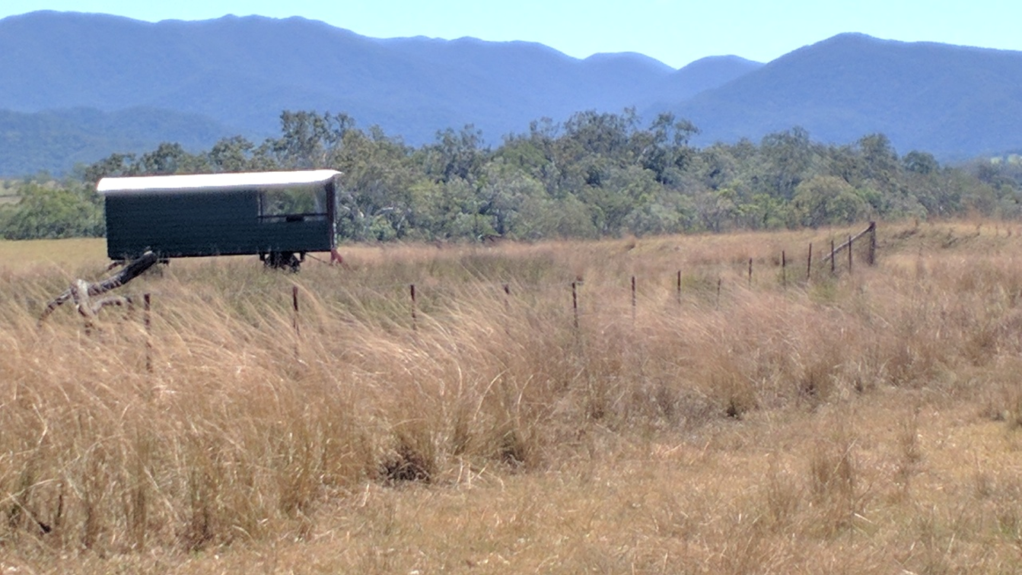
Image 1: ‘Home Office’ at Wetherby Station

Recommendations
This case study points to several recommendations for improving digital inclusion in agricultural communities in Far North Queensland, particularly by improving access to reliable and affordable internet.
- Redefine affordability: In undertaking research and formulating telecommunications policy, authorities should consider that the cost of internet is often much higher for rural consumers because they pay for several plans across different providers. Unlike city residents, rural consumers “layer up” on services.
- Maintain and improve basic infrastructure and services: Existing and new initiatives are needed to improve telecommunications infrastructure in rural and remote areas. This includes more comprehensive mapping of all services available to consumers to better identify service gaps.
- Deliver targeted digital ability programs: Rural residents with low confidence and ability to troubleshoot technical issues and employ digital technologies to their advantage could benefit from formal digital literacy programs tailored to the specific needs of cattle farmers.

Case Study 2: Sugarbag Station & Yards
Sugarbag is a family owned and operated cattle property. The business includes tick clearing, holding/ weighing for sale, live export/quarantine, and running cattle. Sugarbag is situated on the Savannah Way, about half way between Mount Garnet and Mount Surprise. Despite being located approximately 30 minutes from the closest town, Sugarbag enjoys fairly reliable mobile phone service by virtue of a Telstra tower within a few kilometres of the property. Nearby (within 150km radius) there is Optus mobile coverage in Mount Garnet, Telstra 3G in Chillagoe, and a 4G small cell in Almaden. Sugarbag also has ADSL connections.
Sugarbag is home to two generations. Robert and Lorraine Henry have owned the property for over 30 years; they run the cattle and reside in the main homestead. Their son Brian and his partner Tania are the “hands on” yard operators. They share the second house (of 3) with Brian’s sister Rebecca who “does the books” and has her own equestrian business. Brian and Tania are actively trying to develop their business on several fronts, including exporting cattle to niche markets in Asia from a port near Innisfail and establishing an onsite meat works. The couple has an ambitious vision that could be realised if there is sufficient connectivity, technological investment, and acquisition of relevant digital knowledge and skills.

Critical issues
The residents at Sugarbag acknowledge that they have it better than most when it comes to accessing internet and mobile phone services. They can make and receive calls and texts at various places along the main road between the property and townships; they can also call and text each other across most of the vast property. This network of connectivity is essential to the Sugarbag Yards business; specifically, Brian can receive calls from cattle truck drivers (at any time of the day or night) as they approach the yards to offload cattle. If connectivity were restricted to a single node on the property (as is often the case for others on NBN SkyMuster satellite connections, for example), it would be all but impossible to coordinate the trucks and yards. Furthermore, Brian, Tania and Rebecca say that their ADSL and mobile services are sufficient to perform basic business administration, such as emailing and banking, but concede that in peak hours (such as after school hours) the network is over-loaded and online work comes to a standstill.
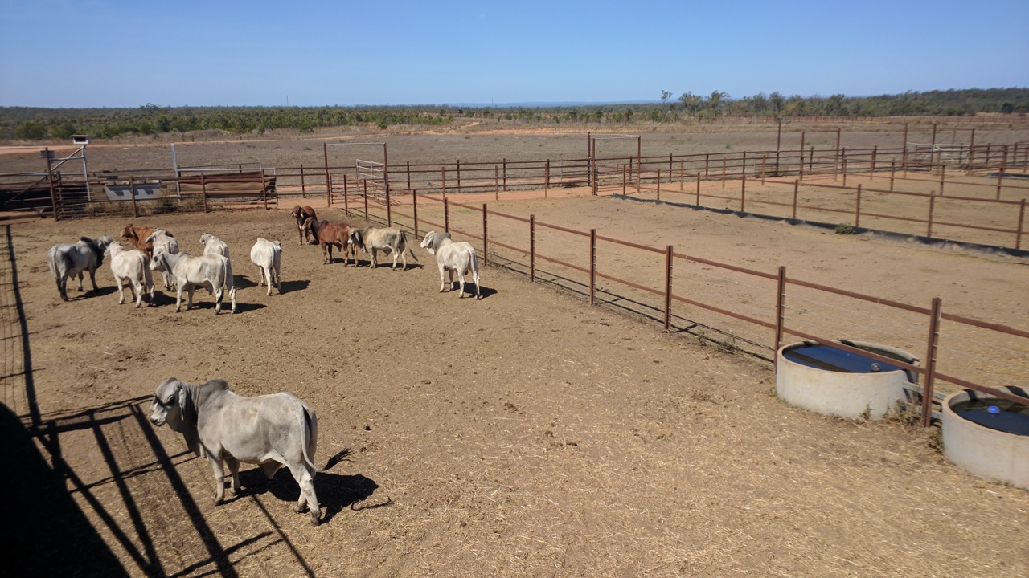
Image 2: Cattle in holding pen at Sugarbag Yards

Standout story
Brian and Tania are an entrepreneurial team who are actively trying to grow the Sugarbag Yards business, nationally and internationally. Their university education has exposed them to on-farm machinery and business development concepts that largely rely on digital technologies and connectivity to be executed effectively. While they say that poor connectivity “hasn’t cost them a business relationship,” access to high-speed, reliable internet would enable them to pursue many more opportunities, such as installing networked weighing equipment, building an international brand through digital marketing, and upskilling through online training.
There are the varying levels of interest in technology across the generations at Sugarbag. While the younger residents are confident with computers, mobile phones, hardware and software, “mum and dad” are from a different era. The Sugarbag residents concede that there are disagreements from time to time about where investment should be made. Brian has already implemented livestock RFID (radio frequency identification) for cattle tracking, but more could be done to network this technology so that data can be shared between devices and to the cloud. However, in tough economic times such as drought, sticking with the current setup instead of spending money on new hardware and software seems a sensible approach. In the long term, it will be difficult for businesses like Sugarbag to compete in the era of ‘agtech’ (agricultural technology), big data and ecommerce if they cannot embrace digital technologies and connectivity. In particular, Sugarbag’s competitiveness in international markets will depend on whether there is sufficient connectivity and acquisition of relevant knowledge and skills.

Recommendations
This case study points to several recommendations for improving digital inclusion in FNQ agricultural communities, particularly by supporting entrepreneurial activity through better internet and digital ability.
- Maintain and improve basic infrastructure and services: While mobile coverage is certainly welcome and necessary in remote areas, current mobile broadband services do not provide the data and speed necessary for growing agricultural businesses in the digital era. Mobile services must be complemented by more robust internet connections, including improved NBN and telecommunications offerings suited to remote conditions.
- Embrace alternative modes of digital connectivity: While investment in new and better connectivity infrastructure is essential in rural and remote, interim measures should be supported to get people connected across and between remote properties. Local Councils and State Government could fund or subsidise technologies that harness internet services from neighbouring towns and/or provide on-property networking of sensors, cameras, testers and devices, such as Long-Term Evolution (LTE) technology which distributes and amplifies existing connections (such as satellite) over greater distances. Such partnerships are already in place in other parts of Australia, including in Western Australia where 50 properties within a 100km radius have been connected to the NBN fibre optic network though a base station in a nearby town.
- Deliver targeted digital ability programs: Many in the agricultural sector share a desire for knowledge and skills so that they are not left behind in the digital age. Yet there are few programs or resources to support farmers to improve their lives and livelihoods through agtech and ecommerce. Programs need to be delivered in local places by local people to educate farmers about their digital options and possibilities, and to help them acquire relevant digital skills to put technology to work on the farm.

Case Study 3: Pinnarendi Station
Pinnarendi Station, owned and operated by Ron and Nadine Atkinson, is a cattle property situated between Mount Garnet and Mount Surprise, running approximately 180 head on 4000 acres and agisting a further 8000 acres. While the farm has been in the Atkinson family for five generations, Ron and Nadine have diversified the business in recent years to build up a successful Station Stay & Cafe. Their picturesque camping spots, airstrip, wood fired oven, espresso coffee, home cooked meals and desserts bring tourists and locals in from many hundreds of kilometres away, including for booked events.
The main house (attached to the Cafe) is home to the Atkinsons, including their three school-aged boys and a live-in governess. Ron’s mother lives in a granny flat and there is an empty house pad which they intend to build on for Nadine’s mother. Situated on the Savannah Way, Pinnarendi is fortunate to have 3G mobile phone service in many places on the property. They also have NBN SkyMuster hooked up in the house. These services largely meet the communications needs of the business, extended family, and visitors.

Critical issues
Notwithstanding common issues such as network congestion in peak times, the Atktinsons are in the coveted position of having access to relatively adequate, reliable and affordable internet. They also have the knowledge and understanding of technology and services to take control of them on site. Ron and Nadine are savvy consumers who shop around and change mobile plans to suit their needs (e.g. sharing data limits). Apart from having a mobile phone and plan each, they also opted to connect the NBN SkyMuster “for the kids” because they calculated it is more cost effective than signing up for more mobile broadband. Therefore, the Atkinsons spend appropriately $60/month for 55GB data in NBN SkyMuster (which is a good deal in the bush), along with two Telstra mobile contacts at approximately $70 each with unlimited data (shaped after 40GB is expended). In total, the Atkinsons spend at least $200/month on internet.
The Atkinsons understanding and active management of their internet options stands them in good stead to leverage telecommunications to be digitally included despite their remote location. Importantly, they are mentoring their young children to be able to participate in today’s digital economy. As is common in rural areas, children’s exposure to technology at school is minimal. However, Ron in particular shares his interest in technology with his sons, including using a 3D printer to make pool parts and flying a drone. The practical benefits of such technologies include less travel, safer farm practices, and time savings.
This is an example of an FNQ farming family that is motivated and proactive with digital technologies. It stands to reasons that if reliable telecommunications services were more widely available people would take up digital opportunities and organically pass on knowledge and skills to the next generation.

Standout story
Like many station women, Nadine does the administration for the on-property businesses, which demands computer-based work. She has also grown the Station Stay and Café business through their Facebook page, tourism website, Wiki Camps and word-of-mouth. While her command of relevant digital technologies is sufficient to get by, Nadine expressed some frustrations. For example, Nadine does her accounting using dated software which she is not prepared to upgrade because the new version would not be compatible with the operating system on her computer. Therefore, Nadine performs an elaborate work-around involving taking screenshots of invoices and attaching them to emails, instead of emailing invoices directly from the accounting program.
This may seem a minor inconvenience, but it speaks to a broader issue. Namely, cloud-based computing (where work is done and saved online instead of on a desktop or local drive) is now common place in urban areas with seamless connection to unlimited data with fast download and upload speeds. But in remote areas where connections are tenuous, data is capped and speeds are relatively slow, working online using cloud-based programs is fraught. These same constraints are responsible for consumers not being able to watch movies, make video calls, or play multi-player games via bush internet.
Pinnarendi Station Stay & Cafe is one example of how rural and remote businesses are increasingly using technology and communications to diversify their offerings into tourism and hospitality. Others are leveraging e-commerce to sell locally handcrafted goods. For example, Wood’n’Things is an on-farm business in nearby Einasleigh that produces children’s toys. Such businesses – which are popping up everywhere to supplement agricultural operations – would not be possible in remote areas without telecommunications.
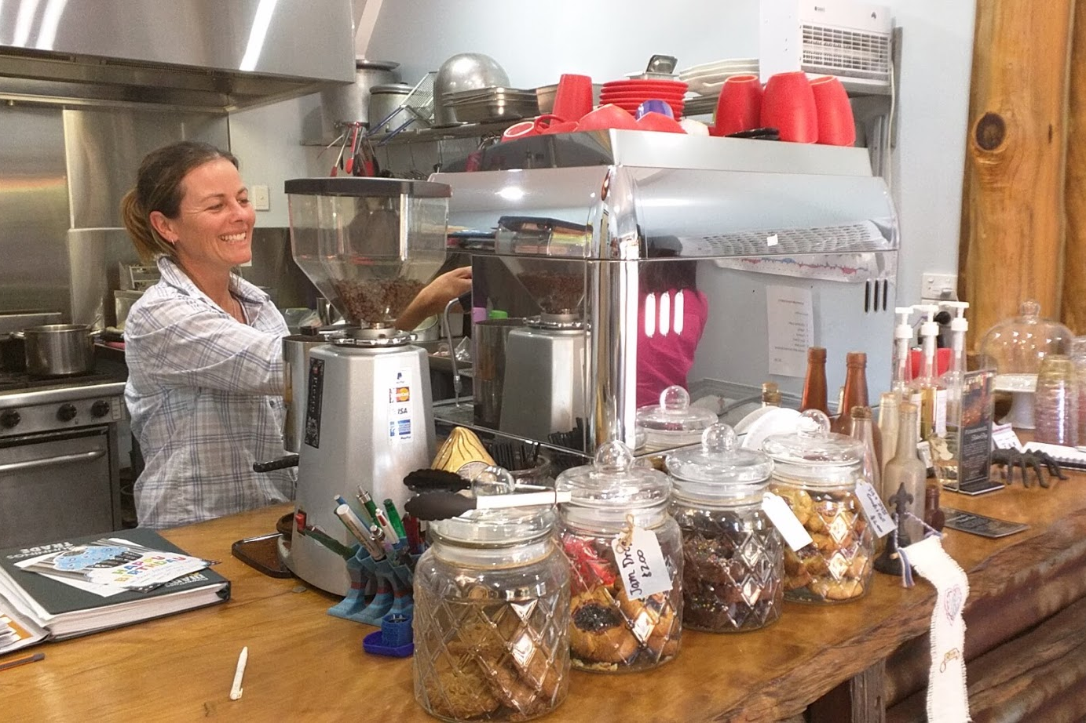
Image 3: Nadine Atkinson at Pinnarendi Station Stay & Café

Recommendations
This case study points to several recommendations for improving digital inclusion in agricultural communities in FNQ, particularly empowering rural households and communities to take charge of their digital opportunities.
- Maintain and improve basic infrastructure and services: While the residents at Pinnarendi said their internet is sufficient for now, current NBN and mobile broadband service offerings (in terms of data, speed, reliability, and cost) will not sustain their family or businesses into the future. More needs to be done to bolster current services and build new infrastructure in FNQ to cater for future demand in rural areas.
- Develop digital mentors & up-skill remote workers: People could be assisted to get online through deployment of digital mentors in communities (though local or state-level programs). Also, people who already work in remote areas (e.g. drought assistance, land care, health care, financial counselling) could be up-skilled to incorporate online activities into their services (e.g. online accounting).
- Empower local governments and organisations: While local councils and organisations are often the first port of call for assistance, remote shires like Mareeba, Etheridge and Croydon can lack the resources, knowledge and networks to provide meaningful assistance. A Rural and Remote Digital Inclusion Strategy could be devised to help local governments to link in with state and federal resources and support.

Authors
Dr Amber Marshall
Dr Amber Marshall is an Adjunct Researcher to The Cairns Institute. In June 2014, Amber (and her park ranger husband) relocated from Brisbane to Kings Canyon – a national park 350kms SW of Alice Springs – where she completed her PhD (Digital Communications) from UQ Business School via unreliable satellite internet. Her struggles to stay connected in the desert fuelled her passion for her current research track. More recently she lived in Chillagoe and Croydon (both in rural/remote Far North Queensland) where she built the networks necessary to undertake research on digital inclusion in regional, rural and remote Australia. Amber is now a Research Fellow at the Digital Media Research Centre (Queensland University of Technology) where she is helping to develop a national research agenda for digital inclusion, particularly in rural and remote areas.

Professor Allan Dale
Allan Dale is a Professor of Tropical Regional Development at The Cairns Institute, James Cook University and a University Fellow with Charles Darwin University’s Northern Institute. Allan has a strong interest in integrated societal governance, with a particular focus across the tropical world, northern Australia and the Great Barrier Reef. He leads JCU’s contributions to Queensland’s Rural Economies Centre of Excellence (RECoE) and the Clean Growth Choices Program, the Human Dimensions of the GBR, the Northern Development agenda and emerging approaches to Collective Impact. He has both extensive research and policy expertise in building strong societal governance systems, but particularly those related to regional economic development, social development and natural resource management.

A new Telstra tower installed under the Blackspot program could have improved coverage since data was collected.
See participant-focused report for more details about the “layering” up phenomenon.

