What is Accessible Telecoms and its purpose?
- Accessible Telecoms is a nationwide disability telecommunications information and referral service. It is a new service that aims to help you find the right device for yourself or someone you know.
- The service provides independent, up-to-date information about the accessible features available in products and equipment suitable for people with disability, and covers both mainstream and assistive telecommunication products.
- Accessible Telecoms covers telephone handsets (both landline and mobile), teletypewriters, and accessories to assist in using these handsets. It also includes information about where training for the equipment can be found, the National Relay Service and a range of useful information about disability access for telecommunications.
- Over time, the resources will be expanded to include information about tablets, mobile applications and software.
How to access the service
- Accessible Telecoms can be accessed across a range of platforms:
- Online - head to the IDEAS website at www.ideas.org.au and click on the Accessible Telecoms icon
- Phone - call IDEAS freecall on 1800 029 904 to speak to an information officer
- Text - send a text message to 0458 296 602
- Webchat - chat online at www.ideas.org.au
- Fax - (02) 6947 3723
- Phone, text, webchat and fax services are all available anytime Monday to Friday between 9am and 5pm (in all States and Territories).
About Accessible Telecoms
- Accessible Telecoms has been developed by the Australian Communications Consumer Action Network (ACCAN) and funded by a grant from the NDIA as part of the Nationwide Disability Telecommunications Information and Referral Service (NDTS) project.
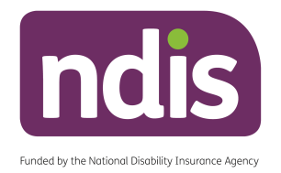
- The service is delivered by IDEAS through their existing call centre and hosted on their website www.ideas.org.au.

