The Kurrajong of Dharug

Reconciliation Week Activity 2023

Garmit are flying over me cattai - I can hear their screeches. Often I’m hoping they’ll land in our bunya, but they seem to prefer the ngarri.
I live and work in Kurrajong - the name of one of 14 clans on Dharug land. Aboriginal culture does not strongly separate nature from people and culture, so word meanings are often multi-layered, connecting natural, topographic and human dimensions.
Curry Jong (also Kurrajong, Kurrijong, Kurrajung, Currajong, Kurrayung, Gurrijung, Carrejun and Garradjang), meaning fishing line or string, also describes the different plants from which they were made (including kurrajong trees and brush kurrajong), and the place where they grew. Since making line and nets was women’s work, Curry Jong is also associated with women.
The Dyarubbin [also Dyirabun, Deerubbin and Durrubbin] and Colo Rivers flow through this area, meeting at the north eastern end of Dharug land, before heading out to sea. Colo (also Colomatta and Gulu-mada) means ‘koala’ in English - and is also the word for the sclerophyll forest hosting them.
Comleroy Road used to be the main track north to the Comleroi/Kamilaroi people of the Hunter. Another local road, Uralla, means ‘ceremonial meeting place’. Sadly, Hills Shire Council, whose local government area covers Dharug land, is the only Sydney local council to still not include an Acknowledgement of Country at its meetings.
Like so many First Nations languages in Australia, the Dharug language was long dormant and until recently, considered extinct. Check out these excellent resources reviving land, language and culture:
Dyarubbin: Mapping Aboriginal history, culture and stories of the Hawkesbury River, New South Wales
Dharug dictionary
Tanya K
3rd June 2023
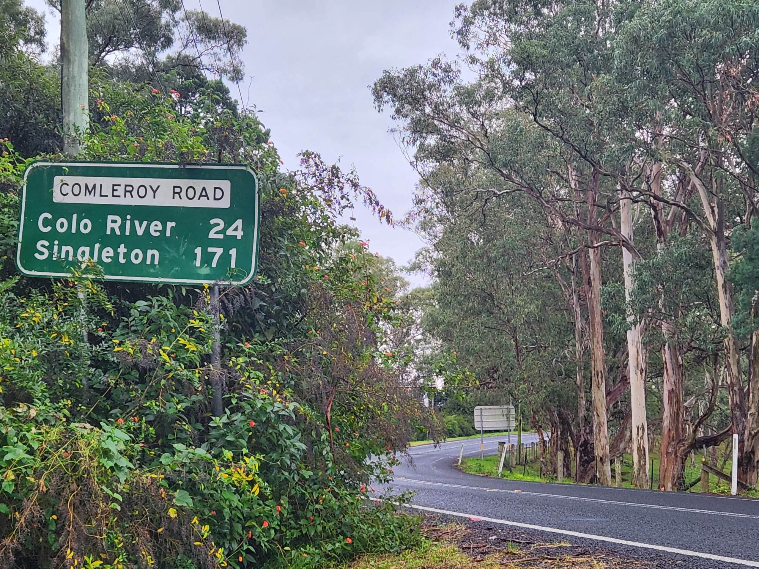
Comleroy roadsign, toward Colo, with fragments of sclerophyll forest in the background
The green roadsign shows Comleroy Road, with distances listed to Colo River (24km) and Singleton (171km). It is nearly engulfed with lantana. The road bends to the right around a stand of eucalypts.

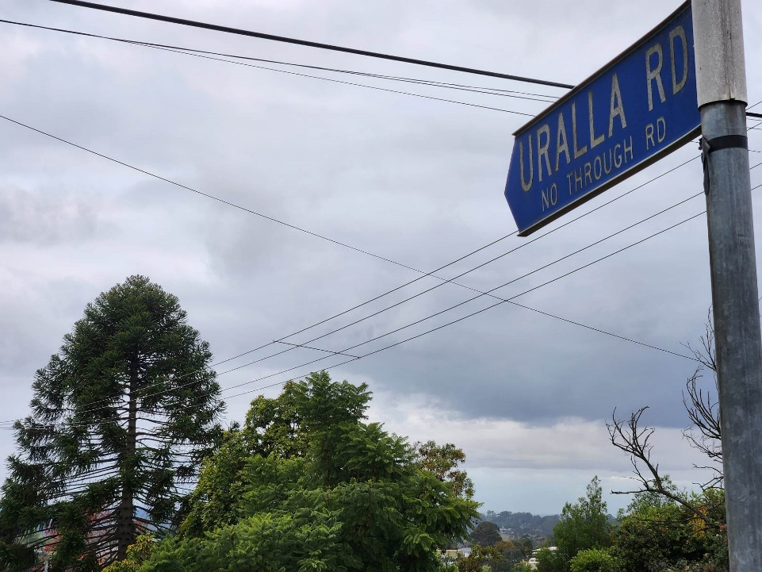
Uralla is a word from the Aniwan people in central west NSW, meaning ceremonial meeting place.
Blue roadsign against a cloudy sky and the distinctive shape of a Bunya pine in the background. Telephone wires crisscross the foreground.
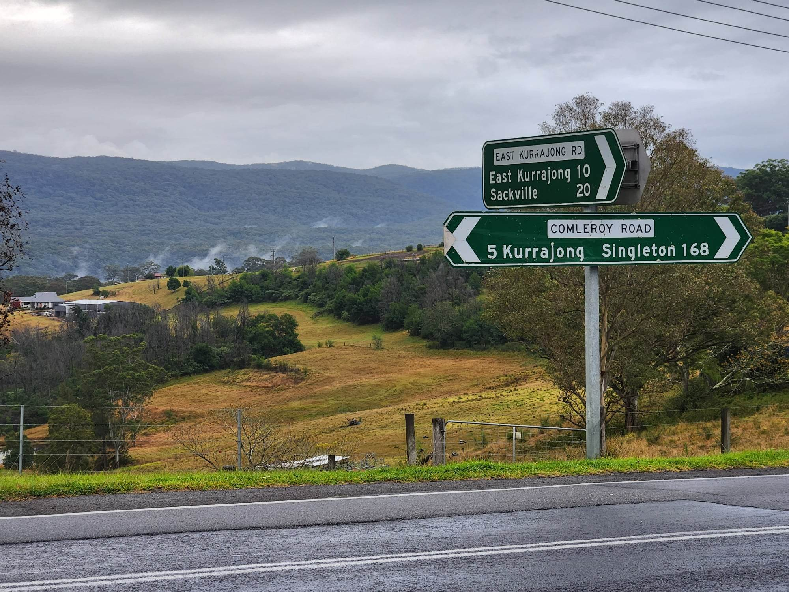
View over what was once called Comleroy, but is now Kurrajong.
Green road signs mark the intersection of Comleroy and East Kurrajong roads, with rolling hills behind, followed by a higher ridgeline heading up the Blue Mountains toward Bilpin.
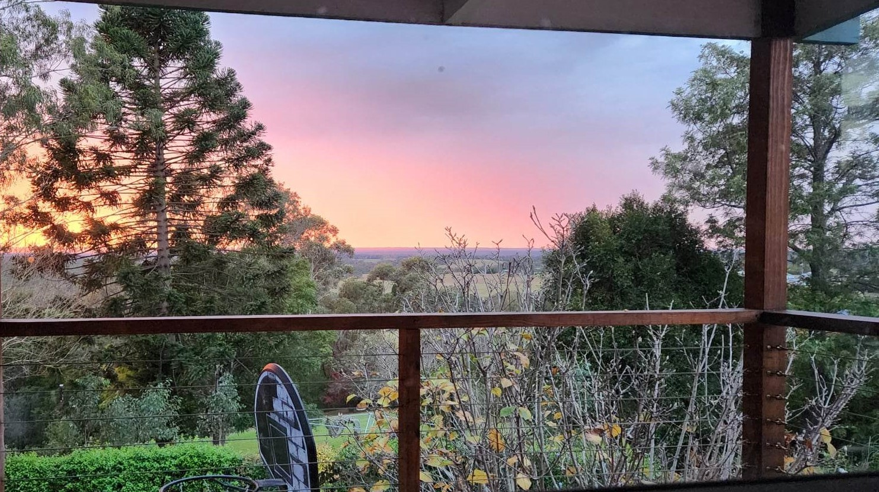
A bunya tree on the left, ngarri on the right, looking east toward the dyarubbin floodplains. The sky is pink with a sunrise.

Dharug. The English name for Garmit is ‘black cockatoo’
Dharug. In English, cattai is the name of a small town bordering the Hawkesbury and Hills LGAs, and also means ‘here, this place’
Kabi Kabi. A sacred tree for which many First Nations clans would gather for ceremony and months-long feasts. For some young men it was part of initiation to climb the incredibly spiky trunk to harvest the huge cones. English has taken the spelling 'Bunya'.
Wathaurong. The English name for Ngarri is ‘sheoak’.
From the Aniwan people.
In 2020, Hills Shire Council rejected requests to include acknowledgements of traditional owners at meetings.

