[Twitter Icon](https://twitter.com/ACCAN_AU)[Facebook icon](https://facebook.com/accanau)[Linked in icon](https://linkedin.com/company/accanau)[Instagram icon](https://www.instagram.com/accan_au)[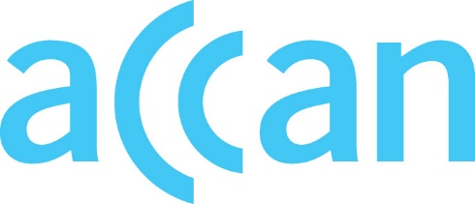](http://www.accan.org.au/)www.accan.org.au

info@accan.org.au

02 9288 4000

PO Box A1158, Sydney South NSW 123

Australian Communications consumer Action Network

ANNUAL GENERAL MEETING

RETURNING OFFICER’S REPORT

September 2022

In accordance with the ACCAN Constitution the ACCAN Board (the Board) will consist of nine (9) elected Directors for 2022 – 2023. There are five (5) members of the Board with continuing terms elected at last year’s AGM. There were four (4) vacancies declared on the Board. ACCAN called for nominations for the Board vacancies on 8th August, closing nominations on 23rd August 2022. After opening of the Board nominations, Gareth Downing was appointed as ACCAN’s Deputy Chief Executive Officer with effect from 13 September 2022. He subsequently resigned from the Board effective 26 August, and therefore the number of vacancies has increased to five (5).

Four (4) nominations were received from the following candidates.

* Chris Dodds
* Vince Humphries
* Scott Winch
* Keith Besgrove

As the number of nominees is less than to the number of vacancies there will be no ballot conducted and the election result will be declared at the AGM.

The terms for Directors elected at the 2022 AGM will conclude at the 2025 ACCAN AGM.

These four (4) new Board members join the four (4) continuing Directors below whose terms conclude at the 2023 & 2024 ACCAN AGM.

* Deirdre O’Donnell
* Holly Raiche
* Julian Thomas
* Victoria Rubensohn



Yuriko Hoshi

**Returning Officer**