

Telecommunications Universal Service Management Agency Bill 2011, Telecommunications Legislation Amendment (Universal Service Reform) Bill 2011 and Telecommunications (Industry Levy) Bill 2011

Submission to the Senate Environment and Communications Committee



November 2011

About ACCAN
The Australian Communications Consumer Action Network (ACCAN) is the peak body that represents all consumers on communications issues including telecommunications, broadband and emerging new services. ACCAN provides a strong unified voice to industry and government as consumers work towards availability, accessibility and affordability of communications services for all Australians.
Consumers need ACCAN to promote better consumer protection outcomes ensuring speedy responses to complaints and issues. ACCAN aims to empower consumers so that they are well informed and can make good choices about products and services. As a peak body, ACCAN will activate its broad and diverse membership base to campaign to get a better deal for all communications consumers.
Contact:
Elissa Freeman, Director, Policy and Campaigns
Jonathan Gadir, Senior Policy Adviser

Suite 402, Level 4
55 Mountain Street
Ultimo NSW, 2007
Email: elissa.freeman@accan.org.au / jonathan.gadir@accan.org.au
Phone: (02) 9288 4000
Fax: (02) 9288 4019
TTY: 9281 5322

ACCAN welcomes the opportunity to comment on the Telecommunications Legislation Amendment (Universal Service Reform) Bill 2011(the USO Reform Bill), Telecommunications (Industry Levy) Bill 2011 (the Industry Levy Bill) and the Telecommunications Universal Service Management Agency Bill 2011 (the TUSMA Bill). These Bills seek to ensure the continuity of universal services during and after the NBN rollout.
A principal goal of ACCAN is to bring universal service provision into the twenty-first century – a world where access to the internet has become a practical necessity in daily life. As we have said before, universal service must evolve in the context of dramatically changed usage patterns, new types of devices and, soon, ubiquitous high-speed broadband.
We continue to be frustrated that a broader conversation about the nature of universal service has been delayed until 2018 and that matters of public interest, such as the outdated definition of the Standard Telephone Service, have not been addressed in the policy processes that led to the development of these Bills.
Nevertheless, we do support the transition from universal service being the sole responsibility of Telstra to a universal service model which is open for new players to bid to supply services. This would include new types of services, for example innovative services for people with disabilities.
Unfortunately the legislative framework enacted by these Bills, which is indeed designed to facilitate the competitive supply of universal service, is accompanied by a policy that entrenches Telstra as the universal service provider for 20 years. There appears to be a mismatch between the stated legislative intention of transition to a competitive contractual approach, and the policy result that we have been presented with, that there will be no competitive supply of universal services – i.e. it will be Telstra for the foreseeable future.
Acknowledging that the Bills provide for the conferral of additional responsibilities on TUSMA (Clause 11(f)), and this is the path which we expect will be used to update and enhance the universal service regime, we have a number of recommendations below on the details of the Bills.
Enforcement and compliance

ACCAN has consistently been critical of the existing lack of enforcement and compliance action by the ACMA with respect to Telstra as the universal service provider. We are therefore concerned to ensure that there are commercially significant penalties in TUSMA contracts to provide sufficient incentive for contractors to perform their contractual obligations well. We are also concerned to ensure that TUSMA itself has a commitment to enforcement of contracts and the capability to do so.

These enforcement and compliance aspects are not sufficiently addressed by the Bills. Clause 12 of the TUSMA Bill provides that TUSMA must take all reasonable steps to ensure that the policy objectives are achieved, but the list of policy objectives in Clause 11 does not include enforcing compliance with contracts and penalising breaches.

Recommendation 1: Enforcing compliance with contracts and penalising breaches of contracts should be policy objectives added to Clause 11.

Transparency of contracts

Another aspect not addressed by the Bills is the transparency of the TUSMA contracts. We note in this regard the unsatisfactory situation that National Relay Service (NRS), contracts are not publicly available. We do not believe it is appropriate for services delivered in the public interest to be delivered under contracts which are commercial-in-confidence, either in whole or in part.

Recommendation 2: TUSMA contracts must be public and published in full, without commercial-in-confidence clauses. Any reporting data required of contractors under TUSMA contracts should also be published. Such transparency is important for public confidence in universal service provision.

Membership of TUSMA

Under Clause 38 of the TUSMA Bill, the Agency’s Members will include individuals with substantial experience or knowledge and standing one or more of five fields. It is concerning that experience or knowledge of low-income consumers, the needs of people with a disability or indeed of telecommunications consumers generally is not among these fields of expertise.

The choice of telecommunications industry operations, law, economics, business or financial management and public administration would appear to inappropriately skew the membership of TUSMA to reflect the outlook and experience of those who are delivering the services, as distinct from those receiving the services.

Recommendation 3: We submit that knowledge of telecommunications consumer affairs, knowledge of low-income consumers, knowledge of consumers with a disability and knowledge of Indigenous consumers be added to the fields of expertise from which agency Members can be drawn; and that at least half the members come from these fields of expertise.

Effective transition

We note that the Government’s intention is to reproduce USO legislative instruments made under the Telecommunications (Consumer Protection and Service Standards Act) 1999 as contract rules, standards or benchmarks, as provided for in Clause 15. ACCAN agrees that for the Bills to be effective in maintaining USO measures, at a minimum this will need to occur. Although over time we hope for continual improvement in consumer protections as technology, capacity and expectations change.

Additional TUSMA functions – an opportunity for a Disability Telecommunications Service
Under Clause 11 of the TUSMA Bill, the Agency would have the ability to take on additional functions. In this regard, it provides a framework for significantly improving the quality of universal services provided for people with disabilities.
The Department of Broadband, Communications and the Digital Economy (the DBCDE) is currently undertaking a review into the telecommunications needs of people with disabilities, older Australians and people experiencing illness. The aim of the review is to inform the next national relay service contract and to assess the adequacy of existing services for these communities under the current universal service regime. The review is currently underway and a large number of submissions have been made to the DBCDE.
In our submission to that review, ACCAN proposed a Disability Telecommunications Service (DTS) which would improve on the services currently provided by the NRS and through the Telstra and Optus disability equipment programs. The proposed DTS is explained in more detail in Appendix 1.
ACCAN’s proposal for improved service provision for people with disabilities is a key example of the types of new functions TUSMA can take on under the framework established by this Bill. Indeed, the proposals outlined in detail in our submission to the DBCDE review are examples of the essential USO reforms that are needed to deliver a relevant and useful universal service in the NBN environment. There is no reason why such proposals could not be adopted either immediately in these Bills, or subsequently through regulation as provided for under Clause 11.
Recommendation 4: ACCAN’s previously proposed Disability Telecommunications Service (DTS) should be adopted and its contracts managed by TUSMA within the framework established by the TUSMA Bill.
To achieve this a DTS Advisory Committee should be established as provided for by Clause 56 of the TUSMA Bill. It should be comprised of representatives of consumer/disability organisations and others with relevant expertise.
Appendix 1 – Disability Telecommunications Service

The DTS would:
- Maintain and enhance the existing National Relay Service (NRS).
Small but significant changes will remove problems associated with the service’s affordability, usability, availability, accessibility and efficiency. The NRS services provided to the Deaf, speech-impaired and hearing-impaired communities are vital but in need of a long overdue overhaul.
- Deliver a truly functionally equivalent communications service for NRS users.
This means funding three new services: next generation text relay, video relay service and captioned telephony. The entire Australian society and economy will benefit from services that bridge the digital divide.

- Expand to new consumer communities that have not been able to enjoy subsidised equipment and tailored services.

There is a need for new relay services for culturally and linguistically diverse consumers with disability, call assistance services for people with cognitive disabilities and call connection and directory assistance services for people with disability.

- Ensure that the assistive devices and technologies that people need to achieve functionally equivalent telecommunications are universally available.

In place of Telstra and Optus equipment programs must be an independent one-stop shop program providing the assistive technology needed to deliver functional equivalence for all telecommunications.
The graphic below compares the current NRS contractual model with ACCAN’s proposed contractual model for the DTS.

Contractual relationship models
Current model
ACCAN’s Proposed DTS model

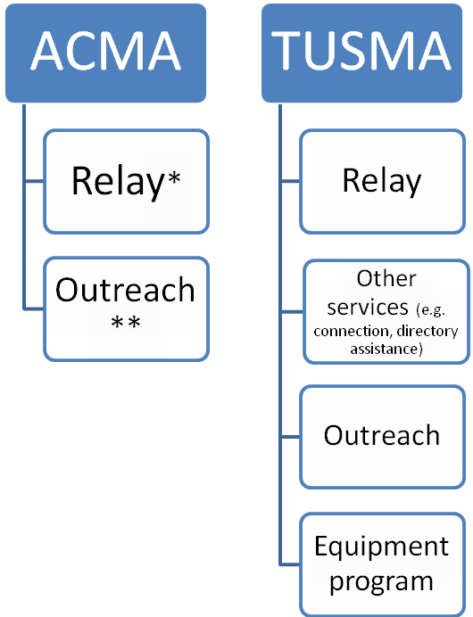
National Relay Service (NRS)
Disability Telecomms Service (DTS)
* Currently held by Australian Communication Exchange
** Currently held by WestWood Spice

Definitive Agreements with Telstra, June 2011. http://www.telstra.com.au/abouttelstra/download/document/2011-definitive-agreements-telstra-nbnco.pdf
TUSMA Bill, EM, p.41
Outlined in the ACCAN submission to the Review of Access to Telecommunication Services by People with Disability, Older Australians and People Experiencing Illness.
www.relayservice.com.au
A next generation text relay service comprises: “The introduction of simultaneous two-way speech with “live captions”. This will allow users to interject and would remove the need to say ‘go ahead’ after each part of a conversation, improving the flow of conversation (and the) use of mainstream equipment. This will allow users to access services either through existing relay equipment or through mainstream consumer electronics such as PCs and netbooks.” Ofcom plans to upgrade telecoms services for disabled people, July 28, 2011, http://media.ofcom.org.uk/2011/07/28/ofcom-plans-to-upgrade-telecoms-services-for-disabled-people/
http://www.aceinfo.net.au/index.php?option=com_content&view=article&id=5&Itemid=16
http://www.aceinfo.net.au/index.php?option=com_content&view=article&id=6&Itemid=17

