
- For immediate release 6th June 2013
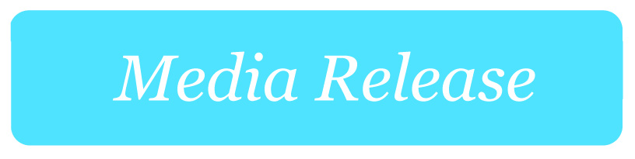

Reckless website blocks ‘like using a sledgehammer to crack a nut’
MEDIA
CONTACT
Asher Moses
Mobile: 0438 008 616
asher.moses@accan.org.au
Phone: 02 9288 4010
TTY: 02 9281 5322
The Australian Communications Consumer Action Network (ACCAN) is Australia’s peak communications consumer organisation. The operation of ACCAN is made possible by funding provided by the Commonwealth of Australia under section 593 of the Telecommunications Act 1997. This funding is recovered from charges on telecommunications carriers.
The Australian Communications Consumer Action Network (ACCAN) has serious concerns with the competency and transparency under which section 313 of the Telecommunications Act has been used by government agencies to block websites.
Revelations that ASIC recently used the powers to accidentally block more than 250,000 sites raises significant problems for consumers who may find themselves affected by a section 313 request.
The purposes for which ISPs are required to help law enforcement, as per the Act, are broad and open to interpretation. There are no requirements for transparency, checks and balances or reporting, and no requirements that the blocking request be based on hard evidence or supported by a warrant or court order.
"There may be consumer benefit in a fraudulent or criminal website being blocked, but consumers ultimately lose out when hundreds of thousands of legitimate websites are inadvertently wiped off the net," said ACCAN CEO Teresa Corbin.
"This could be disastrous for a small business operator who suddenly finds that their website is blocked with no notification.
"Blocking hundreds of thousands of sites when you intend to target a single offender raises questions of incompetence and is akin to using a sledgehammer to crack a nut."
Ms Corbin said that consumers attempting to access an incorrectly blocked website may find themselves unable to access important services such as online banking, account management, government resources, communication tools, information sources or other services generally available on the internet.
Communications Minister Stephen Conroy has said he is investigating transparency and accountability measures that can be implemented around section 313 requests.
In light of this, ACCAN believes blocking requests must:
- Require reasonable grounds that the blocked site is engaged in fraudulent, malicious or criminal activities.
- Be reported to an oversight body with detailed supporting information.
- Inform site owners of when and why their site has been blocked.

- Provide information to inform visitors to a blocked site why it isn't loading, or contact details for someone who can provide an explanation.
- Include a process for redress where mistakes have been made.
If information is put up on a holding page in place of the blocked website, protections should be put in place to ensure that there is no unwarranted reputational or other damage done, for instance when a small business's website is blocked with a notice saying it has engaged in illegal activity.
Australian regulators and law enforcement agencies already have the power to direct ISPs to remove Australian websites hosting illegal or prohibited material.
"Blocking is an extreme measure that should only be used to target international websites that are outside the jurisdiction of local law enforcement," said Ms Corbin.
Ends
Media contact: Asher Moses 0438 008 616 or asher.moses@accan.org.au

