Report authors: Fran Edmonds, Christel Rachinger, Gursharan Singh, Richard Chenhall, Michael Arnold, Poppy de Souza and Susan Lowish.
July 2014
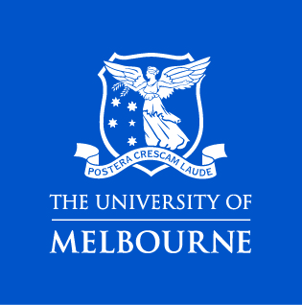
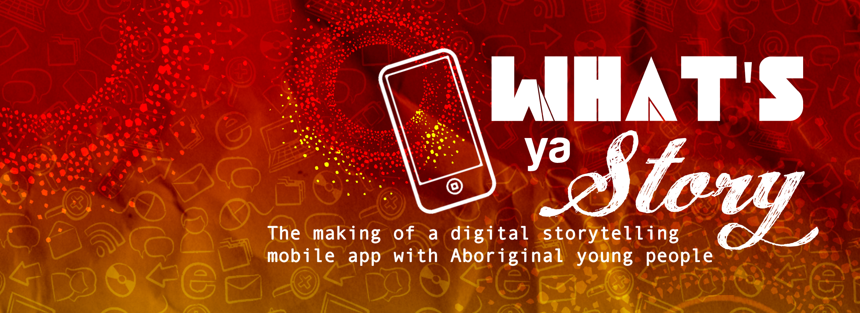
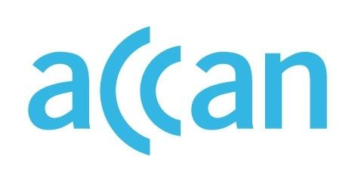
Report title: ‘What’s ya Story’: the making of a digital storytelling mobile app with Aboriginal young people
Authors: Fran Edmonds, Christel Rachinger, Gursharan Singh, Richard Chenhall, Michael Arnold,
Poppy de Souza and Susan Lowish.
Published: 2014
The operation of the Australian Communications Consumer Action Network is made possible by funding provided by the Commonwealth of Australia under section 593 of the Telecommunications Act 1997. This funding is recovered from charges on telecommunications carriers.
The University of Melbourne
Website: http://www.unimelb.edu.au/
Email: edmondsf@unimelb.edu.au
Telephone: 03 90359707
Australian Communications Consumer Action Network
Website: www.accan.org.au
Email: grants@accan.org.au
Telephone: 02 9288 4000
TTY: 02 9281 5322
ISBN: 978-1-921974-25-0
Cover image: Dixon Patten, 2014
This work is copyright, licensed under the Creative Commons Attribution 3.0 Australia Licence. You are free to cite, copy, communicate and adapt this work, so long as you attribute the authors and the “University of Melbourne, supported by a grant from the Australian Communications Consumer Action Network”. To view a copy of this license, visit http://creativecommons.org/licenses/by/3.0/au/
This work can be cited as: Edmonds, F., Rachinger, C., Singh, G., Chenhall, R., Arnold, M., de Souza, P., Lowish, S. 2014, ‘What’s ya Story’: the making of a digital storytelling mobile app with Aboriginal young people, Australian Communications Consumer Action Network, Sydney.

Acknowledgements
The research presented in this report was funded by the ACCAN Grants Scheme. The research team, which included the authors of this report, wish to thank ACCAN for their support.
University of Melbourne researchers wish to thank the Aboriginal young people and their mentors from the Korin Gamadji Institute, at the Richmond Australian Rules Football Club, who remained committed and insightful throughout the project and whose contributions have provided the main findings in this report. The participants were Jake, Jess, Nakia, Danae and Liam, with their mentors Alex Splitt and Neville Jetta. Luke Murray, the Indigenous Community Engagement Coordinator at Korin Gamadji Institute, was supportive and committed to the project from the beginning and was vital to its success.
The research was conducted in collaboration with researchers and technicians at the Institute for a Broadband Enabled Society, University of Melbourne. Their involvement in the project was essential to the development of the mobile application, as were the facilities and technological resources provided by the Institute. Dr Julien Ridoux, Ken Clarke and Dr Chamil Jayasundara provided technological advice to the Masters of IT intern, Gursharan Singh, whose skills in creating the app in collaboration with the KGI participants was central to the project.
The Australian Centre for the Moving Image generously offered their filmmaker Vincent’s time and their education space to provide young people and researchers with the opportunity to learn more about filmmaking and digital storytelling.
The Reference Group for the project, of whom there are many, are thanked for their generosity in contributing their time to meetings, as well as offering feedback via emails and phone calls. Particularly, Kimba Thompson from Sista Girl Productions, Peter Waples-Crow from the Victorian Aboriginal Community Controlled Health Organisation, Lyndon Ormond-Parker from the University of Melbourne, Nerissa Broben from the Koorie Heritage Trust and Jim Rimmer from VicHealth.
The graphic designer, Dixon Patten, provided support throughout the project’s planning phase and during the workshop. His graphic designs on the cover of this report and those on various websites related to the project are greatly appreciated.
The report’s authors also thank Associate Professor Scott McQuire from the School of Culture and Communication, University of Melbourne, for his academic mentoring throughout the project and commitment to collaborative research. Dr Angus Frith from the Melbourne Law School is also thanked for editing and proof reading sections of this report.

Executive Summary
In 2013-2014, the Australian Communications Consumer Action Network (ACCAN) provided funding for a multidisciplinary team of researchers from the University of Melbourne to collaborate with young Aboriginal participants (aged between 15 and 26) and their mentors from the Korin Gamadji Institute (KGI) at Richmond Football Club, Victoria. This collaboration led to the development and design of a prototype digital storytelling mobile application, or ‘app’, to be used by Aboriginal young people: the What’s ya Story app (the WYS app).
The project worked with Aboriginal young people aged between 15 and 26 years of age from the Korin Gamadji Institute (KGI). This is described in more detail later in this report. The majority of the Aboriginal population in Victoria is aged 25 and under; they are among the highest users of mobile phones, actively engaging in social media and other online platforms (Department of Education and Early Childhood Development (DEECD) 2010). With the advent of Web 2.0 technologies, Aboriginal youth throughout Australia are increasingly using digital technologies, especially mobile devices and the internet, to produce and tell their stories in ways determined by them (Kral 2010, Edmonds, Rachinger et al. 2012). Currently, the What’s ya Story app prototype (the WYS app) developed through this project provides a base for ongoing research concerning the uptake and management of digital technology by Aboriginal young people. The app project forms part of the larger Australian Research Council Linkage Project (ARC LP), ‘Create your Story: Aboriginal young people in Victoria and Digital Storytelling’ (2013-2016).
In this report we present the findings of the 2-day collaborative workshop that resulted in the development of the WYS app prototype. In addition, we describe the aims of the project; the methods adopted to achieve the research outcomes, including the workshop process; our research findings; as well as our recommendations for future approaches to the development of the WYS app.
The research comprised two teams of researchers from the University of Melbourne who worked together to create the first phase of the WYS app prototype: a humanities and social sciences team from the Faculties of Arts and Medicine, and an information technology team from the Institute for a Broadband Enabled Society (IBES). The researchers were encouraged in their endeavours by the enthusiastic support of the young participants from KGI in the project. Their expertise and knowledge in managing and manipulating digital technology for their own purposes was central to the development of an ‘app’ that responds specifically to their requests and needs.
The report highlights the significance of adopting a collaborative and interdisciplinary approach to this research process, where many fields of expertise came together and were crucial to the overall success of the first phase of the app’s development. Further, this report also highlights the way community-developed, culturally appropriate digital resources can support Aboriginal knowledge and knowledge exchange. By working with the Aboriginal community to develop avenues, including cultural protocols, that support Aboriginal control of Aboriginal knowledge in the digital age, it is possible to foster strong identities, which is a significant contributor to wellbeing among the Aboriginal community (Victorian Health Promotion Foundation (VicHealth) 2010).
While the WYS app prototype remains a work in progress, ultimately the project has enabled all those involved to explore, complement and extend their understandings of digital literacy from Aboriginal young people’s perspectives and to build on these in ways that harness and develop digital literacy skills, which support and promote Aboriginal young people’s connections to contemporary Aboriginal culture in the digital age.

Table of Contents
Acknowledgements i
Executive Summary ii
Table of Contents iv
Introduction 1
Background: Why make a digital storytelling app? 1
Aboriginal culture and the digital world 2
Project aims 3
Literature Review 5
What is digital storytelling? 5
Digital storytelling and southeast Australian Aboriginal young people 7
Co-creativity and mobile app production 8
Methodology 11
A Collaborative and Participatory Methodology 11
The Reference Group 11
KGI and project participants 12
The Research Teams 13
Working together as ‘experts’: knowledge partners 13
Interdisciplinary design collaboration: what did we learn? 14
Team Decision-making 14
Research ethics 14
Privacy and cultural considerations 15
The Blog and Facebook sites 16
Conducting the Research: ethnographic methods 18
Engaging participants in the project: the Think-Tank workshop 18
Day 1 19
Morning session: ACMI 19
Afternoon Session: the IBES Laboratory Workshop 20
Day 2 21
Evaluation and Feedback 23
Findings 24
Digital literacy and the storytelling app 24
What is a digital storytelling mobile application? 26
Conceptualising a ‘storytelling app’ as a cultural knowledge resource 29
Audiences, global networks and adaptation of culture 31
Intergenerational and peer-to-peer knowledge exchange 34
Community decision-making: managing knowledge exchange digitally 37
The WYS app and the creative capacity of digital technology 38
Affordances and Design 39
The User Interface 39
Usability: how does the WYS app work and what does it currently enable? 40
Adding the Title and Comments 41
Uploading stories on the WYS app and its mobility 41
Future app functions and design 41
Key features of the swipe menu 41
Indigitalising the app: Cultural considerations and identity building 44
‘Deadly ‘= ‘Like’ 44
Naming the WYS app: using Aboriginal language(s) 45
Location-specific stories 45
Creative approaches to storytelling 45
Conclusions 48
Recommendations 50
Authors 51
Appendix A: web resource table 52
References 61

Introduction

Background: Why make a digital storytelling app?
For Aboriginal people, storytelling has a central place in their communities and is a key factor in maintaining knowledge of culture and heritage. Stories reinforce the integration of all aspects of life in accordance with Aboriginal worldviews and include art, song, performance and other cultural expressions, assisting the transferal of cultural information from generation to generation, including connections to Country and kin (Janke 2007, Nakata and Langton 2007). In this project, the development of a digital storytelling mobile application, therefore, embraced the use of mobile devices by Aboriginal young people to facilitate new approaches to storytelling that would contribute to an Aboriginal idea of digital literacy and support contemporary Aboriginal youth identities in an online world. The development of a storytelling app was conceived as a way of allowing youth to further their knowledge of digital technology while diversifying their understandings of storytelling to engage with global audiences to assert their culture, while learning from their community about who they are and their place in the world.
The development of the storytelling app was, therefore, viewed as an opportunity to shift the emphasis away from the traditional first-person, autobiographical model of digital storytelling, which is described in more detail in the literature review, to a collaborative, community-centered approach. Making a mobile application in collaboration with Aboriginal youth was considered an opportunity to create stories through images, text and sound that would contribute to different modes of online representation, rather than relying on personal photographs or videos, which readily identify the maker and make little use of the creative capacity of new and emerging digital resources. Furthermore, rather than confining the production of digital stories to a computer laboratory or digital office, which relies on institutional resources, the uptake of mobile applications sees shifting parameters of control over self-representation, as digital technology firmly places the making of ‘stories’ in the hands of the user, enabling constant interaction between producers and consumers with minimal outside intervention.
The growth in the number of mobile applications has increased significantly since they began appearing in 2008, which correlates with the rising popularity and ubiquity of sophisticated smartphone technologies (Commonwealth Consumer Affairs Advisory Council 2013). The universal appeal of apps rests in their capacity to perform any number of digital functions, either free or for minimal cost. They provide the consumer with access to many products, which can be uploaded and shared across multiple networks. Mobile applications are ‘software programs that enhance the functionality of smartphones, enabling them to be constant sources of information, entertainment and interactive communication’ (Hides 2014).
Today, the development and function of a mobile phone application enables people to perform a range of tasks and gain instant information about many things; for instance the weather, music, art, GPS mapping, sport or public transport. Other apps provide access to and participation in activities including gaming, social networking and support for improving health and wellbeing. The diversity of mobile applications is also reflected in those developed in collaboration with Aboriginal communities (See Appendix A). Apps often feature high-end graphics and offer a range of functions, such as the capacity to upload images, sounds and text. The downloading of mobile applications by young people in Australia occurs at ‘a rate 30 per cent higher than older age groups’ (Hides 2014). This has prompted health researchers especially to explore the potential of apps to facilitate an increase in young people’s access to appropriate health care, particularly in regions where it may be hard to access (Hides 2014). The Young and Well Cooperative Research Centre (YAW CRC) also recognises the significance of apps for young people. The adolescent and child psychologist, Dr Michael Carr-Gregg, acknowledges the importance of working with technology, focussing specifically on the value of apps to support the mental health and wellbeing of young people:
Young people love technology. It’s low cost, which is important as young people tend to be price sensitive. Technologies enable me to communicate with young people and for them to communicate with me. Plus technology is a part of their world and what they are doing day to day. It’s the way it is and it’s how they communicate, and anyone working in adolescent health really needs to be thinking about working this way (Young and Well Cooperative Research Centre n.d.).
In this project, the development of the WYS app also engaged with young people’s capacity to control and creatively share information via digital technology. Studies reveal that young people’s uptake of digital tools can support the wellbeing of marginalised groups, including Aboriginal youth, by enhancing learning through informal and online interactive communications (Metcalf, Blanchard et al. 2010, Collin, Rahilly et al. 2011). Aboriginal youth in Victoria are prolific users of mobile phones, social networking and media sites, such as Facebook, Instagram and YouTube (Edmonds, Rachinger et al. 2012). These online resources enable youth to actively establish social networks, form relationships and define their individual and social identities in creative and independent ways (Metcalf, Blanchard et al. 2010, Third, Richardson et al. 2011). Young people are also experts in using digital technology, producing and consuming all kinds of information through digital media. Some commentators use the term ‘produsers’ to describe the creation of user-generated content and amateur cultural production, particularly young people’s prolific online and other digital engagements (Bird 2011, Collin, Rahilly et al. 2011). Despite this high uptake and usage there is no sustained study of the impact of this new media environment on the connectedness and creativity of young Aboriginal people in southeast Australia, specifically in relation to defining and understanding digital literacy from their perspectives.
The development of an app prototype in this project provided an opportunity for Aboriginal youth to explore and engage in a participatory media environment as responsible ‘produsers’ to increase opportunities for supporting Aboriginal youth culture and identity. This project also intersects with previous research, acknowledging that the creative and social activities enabled by small mobile devices ‘fosters self-expression, personal achievement, aspiration, connection, literacy and technical skills’ (Department of Communications Information Technology and the Arts (DCITA) 2005, Notley and Tacchi 2005)

Aboriginal culture and the digital world
From the early 19th century Aboriginal cultures and lifestyles in southeast Australia were severely disrupted. This region, and particularly the area now referred to as Victoria, experienced rapid and comprehensive colonisation, resulting in loss of land and aspects of cultural knowledge. Ongoing colonisation continues to impact on Aboriginal people’s wellbeing today and has resulted in many people struggling to assert and maintain their cultural connections and their identity (Carson, Dunbar et al. 2007, Commonwealth of Australia 2011).
For Aboriginal people, knowing who you are and your place in the community can have a powerful impact on health and social outcomes (Morrissey, Brown et al. 2007). For young Aboriginal people, specifically, promotion of culture is a key factor in building their resilience (Department of Education and Early Childhood Development (DEECD), Victorian Department of Human Services et al. 2010). Aboriginal health researchers confirm that storytelling supports Aboriginal health and wellbeing. By validating the experiences of Aboriginal people and their knowledge systems, it provides a means by which they can assert control over representations of themselves (Vickery, Clarke et al. 2005). In relation to this, Aboriginal youth are increasingly using digital technologies, such as mobile phones and the Internet, to tell their stories (Kral 2011, Edmonds, Rachinger et al. 2012). Recent evidence reveals the value of digital technologies and online communication in supporting the social and emotional wellbeing of marginalised youth (Stephens-Reicher, Metcalf et al. 2011).
The digital environment also provides Aboriginal young people and their communities with a creative space for articulating their voices without intervention by outsiders (Kral 2011). Practices that support cultural creativity, which intersect with storytelling, include Indigenous visual arts, which has generated economic and social advantages across Australian Indigenous communities for the last thirty years (Altman 2005). More recently, research has been conducted into Indigenous cultural festivals, which also have a positive impact on community health and wellbeing (Phipps and Slater 2010). Creative spaces that support Indigenous ‘ways of doing things’ can provide people with a sense of control over their lives, enabling them to define their own experiences on their own terms (Martin and Mirraboopa 2003). This also provides a space for challenging the way many non-Aboriginal people understand Aboriginal peoples’ lived reality, offering greater opportunities for social inclusion and more nuanced understandings of what it is to be an Aboriginal person (Morrissey, Brown et al. 2007).
This project was therefore developed to assist Aboriginal young people with opportunities to connect with and create stories about their culture by developing a custom made mobile application. The app was developed to further their digital knowledge and their digital literacy skills in ways that allow them to manage their cultural identity in the digital age.

Project aims
The aims of the project are based on understanding the centrality of ‘storytelling’ as a method for supporting youth’s expression of their Aboriginality and Aboriginal control of culture in the digital age. This includes re-examining digital literacy as a broad concept, which facilitates an integrated approach that progresses and encapsulates Aboriginal young people’s explorations of their identity, their cultural connections, and their control over their self-representations, alongside their knowledge and awareness of technology.

The aims of the project are to:
- Develop an open-ended conceptualisation of digital literacy as a skill that supports community engagement, interconnecting the technological and socio-cultural aspects of digital usage through an exploration of a mobile app design, which supports Aboriginal control of the production and consumption of information online, (thereby reducing the participation gap);
- Work with the Aboriginal community and Aboriginal young people to enhance the creative capacity of digital technology through their design of a mobile application, which facilitates expressions of their identity and provides opportunities for broader representations of Aboriginal youth culture;
- Engage with Aboriginal young people to harness their expertise in managing digital technology and expand their understandings of Aboriginal knowledge and representations in the digital sphere, including working with each other and their Elders to support cultural and social protocols, and address issues of cultural cybersafety;
- Create a digital network to enable information to be shared between the project’s current participants, future participants, the wider Victorian Aboriginal community; and
- Improve access to knowledge about Aboriginal culture globally to enhance social connectedness and knowledge exchange.

Literature Review

What is digital storytelling?
Emerging in the 1990s out of cultural democracy, community arts and popular education movements in the United States, digital storytelling has facilitated the social participation of groups at risk of cultural exclusion by providing opportunities to create and share personal images and identity narratives (Spurgeon, Burgess et al. 2009, Vivienne and Burgess 2013). Digital storytelling aims to build ‘community-based capacity for end-user engagement in digital media production’ (Spurgeon, Burgess et al. 2009: 276).
Traditionally, digital stories have been created in a workshop context over 3-4 days through the development of short autobiographical multimedia narratives in video form using text, photography, artwork, music and narration. They involve the digitisation of materials such as photos, videos and artworks, which are then personalized through the re-telling of the person’s association with the object(s). These stories may be shared with a wider public through various online platforms.
Digital storytelling has gone on to refer to a variety of different media forms and practices, including any interactive storytelling process that uses digital media and co-creative filmmaking practices (Burgess, Klaebe et al. 2010). In Australia and North America, traditional digital storytelling has been popular with community organisations that use digital tools to collect public histories of specific places and of community members. It has been argued that this ‘participatory public history’ builds capacity in digital literacy and enables the democratic access to and creation of knowledge (Klaebe and Burgess 2010: 3). Additionally, digital storytelling has gained increased currency within local and state agencies and community organisations as a strategy for community engagement across a broad range of policy agendas, including social inclusion, urban planning, community wellbeing and cultural diversity (Klaebe and Foth 2007).
Digital stories, in whatever form, are framed by a particular narrative, structure or form to communicate meaning. This narrative is socially and culturally encoded; it reflects specific power relations and cultural norms, articulating when and what stories can be told and by whom. Stories are told for specific reasons; an event or experience told carries particular significance for the storyteller. The narrative links this experience with an individual’s social role and place in society: their identity.
While digital stories enable their creators to develop agency and ownership over their self-representation, there are challenges in negotiating issues related to privacy and publicness. The images and other media that are created, edited, transformed and distributed are, as Vivienne and Burgess argue, ‘mediated by the realities of socially networked identity’ (Vivienne and Burgess 2013: 283). They suggest life stories then become a form of ‘digitally enabled citizenship’ (Vivienne and Burgess 2013: 284).
In Australia, the term ‘digital divide’ was originally used to describe the exclusion of different population groups from the information society (Lloyd and Bill 2004: 1). Factors such as Indigenous status, geography, educational attainment, income and disability status were identified as predictors of inequality in terms of access to the internet (Notley and Foth 2008). Digital inclusion, such as via digital storytelling, creates a space for public participation in digital literacy through the development of active content (Klaebe and Burgess 2008, Notley and Foth 2008). This moves the focus away from access to technology to the way ‘technology access and use can impact on different forms of deprivation and disadvantage’ (Notley & Forth 2008: 11).
The newer concept of the ‘participation gap’, alongside other terms such as ‘digital inclusion’, has replaced the older notion of the ‘digital divide’. Spurgeon and colleagues argue that technology cannot erase social participation gaps and that the ‘voices of excluded and marginalised people must find expression in order to enter into a dialogue with each other as well as those seeking to bridge participation gaps’ (Spurgeon, Burgess et al. 2009: 276). In this arena, digital storytelling has also been conceptualised as ‘co-creative media’ practice, recognising its potential to support an inclusive production process that can facilitate social participation across many contexts; and engages both research facilitators and various local voices (Spurgeon, Burgess et al. 2009). Spurgeon and colleagues have worked with various groups on the creation of personal digital stories through workshops that critically engage with ‘ideas, concepts, experiences and storytelling’ (Spurgeon, Burgess et al. 2009: 279). In their work with young people, the process of creating content and the digital stories themselves both assisted researchers to ‘understand how young people see themselves and the world around them’ (Spurgeon, Burgess et al. 2009: 279). They found the process of formulating the digital stories was both participative and shared among young people, expert facilitators, various stakeholders and the researchers. Participatory content generated through digital story workshops such as these hold the capacity to guide the efforts of the various stakeholders that seek to engage and assist these groups.
In another development, Bidwell and colleagues have discussed mobile digital storytelling in rural Africa, illuminating the importance of a ‘dialogical process’ in the design of digital stories between researchers/facilitators, participant storytellers and other stakeholders (Bidwell, Reitmaier et al. 2010). In designing a mobile digital storytelling application to suit the functions and qualities of storytelling in specific communities, Bidwell and colleagues found that local issues associated with cultural understandings of storytelling and of storytellers need to be coordinated alongside the researchers’ reflexive engagement with the process of designing how stories will be told digitally.
Ultimately, digital storytelling can provide an opportunity for youth to reconnect with stories about their culture and to share knowledge across generations and with the broader community. The anthropologist Inge Kral reveals that in Central Australia: ‘many young people are embracing global digital youth culture and exploring the generativity of multimodal forms of communication, while simultaneously acting as agents for the recording and transmission of cultural memory in new forms.’ (Kral 2014: 16). In addition, among Canadian Aboriginal youth, digital stories are one way that people can engage with the process of narrative decolonisation and representation; ‘digital stories are both aesthetic expression and form of resistance through a new narrative genre’ (Adelson and Olding 2013: 4). Stories such as these can contest and collide with the grand narratives created by traditional media, and when disseminated to a broader audience, can reframe the traditional gaze to raise awareness, address social issues, and communicate experiences from the perspective of those whose voices are excluded, marginalized or misrepresented. Stories, previously silenced, that tell of young people’s abuse in Canadian residential schools represent an alternative discursive space in which youth can reinterpret and reimagine their identity in opposition to the other more powerful discourses presented by the non-Indigenous society.
More broadly, digital stories enable young people to actively engage with culture, rather than being ‘passive recipients of history’ (Sabiescu 2009: 2). This has been highlighted amongst Canadian Aboriginal youth who participated in a project focusing on intergenerational abuse (Adelson and Olding 2013). The researchers argued that through the creation of co-constructed digital narratives, the five young people participating in the project renegotiated their Aboriginality and provided strategies for healing and decolonization (Adelson and Olding 2013).

Digital storytelling and southeast Australian Aboriginal young people
Few researchers have explored the impact of digital technology on urban and regional-based Aboriginal young people, specifically in southeast Australia. However, research concerning Aboriginal youth in Central Australia indicates the use of digital technology has the potential to affirm Indigenous identity and provide examples for meaningful adult occupations. These potentially include: supporting new approaches to learning; improving youth employment in arts and cultural centres, media and music production, and in researching archival material; and ultimately mediating their culture via new technologies, including ‘the transmission of cultural memory in new forms’ (Kral 2010, Kral 2010, Kral 2011, Kral and Schwab 2012). In the digital age, such skills are critical for Aboriginal youth, providing them with new opportunities to connect with and explore their culture and heritage, while engaging in the benefits of the digital economy.
Acknowledging the diversity of Aboriginality across the country challenges the homogenous stereotypes often associated with Aboriginal culture. These stereotypes tend to reinforce the authenticity of Aboriginal people in the more isolated regions of the country, compared to those from the southeast (Peters-Little 2002, Davis and Moreton 2011). This project therefore offered young people in southeast Australia the opportunity to voice their ideas for a mobile digital storytelling app and reveal how they use digital technology to manage and support their identities as contemporary Aboriginal youth.
In relation to this, digital technology can enable Aboriginal youth and their communities to articulate and display their worldviews and experiences when and how they choose, free from outsider interference. The digital realm offers control over self-representations giving young people platforms to perform and present Aboriginality from their perspectives. It also offers audiences new ways of seeing and interacting with Aboriginality and contemporary Aboriginal culture. For young Aboriginal people, creating, sharing and communicating content in the digital media environment can assist in developing their sense of identity (Department of Communications Information Technology and the Arts (DCITA) 2005, Notley and Tacchi 2005).
Digital technology has been used in multiple and dynamic creative forums by Aboriginal young people, artists and filmmakers to promote southeast Aboriginal culture. Projects such as BlakTracks and the Pitcha This: Digital Stories projects, used workshops to support participants to create and relay personal narratives, while coming to terms with the technology (Simondson 2009). The BlakTracks model has subsequently been adopted in a formal education context to support disengaged Aboriginal youth to come to terms with their identities using technology across a range of creative forums, including music, visual art and performance (Koorie Heritage Trust 2014). Pitcha This has become a model for promoting digital technology among the Aboriginal community as a storytelling device that supports cultural identity through oral histories (Davey and Goudie 2009). The Pitcha This project ‘aimed to inspire and give strength to the Indigenous population by promoting positive images of Victorian Indigenous communities’ (Thompson 2010).
While this project reflects the findings from previous research, it is more directly informed by work from a recent pilot digital storytelling project. In that project, young urban-based Aboriginal people in Melbourne were supported in learning about digital technology and short film production, using personal images and autobiographical stories to make their own short videos. As a co-creative method that pilot project highlighted a number of issues. Firstly, the co-creative approach to digital storytelling adopted in the pilot project relied on the use of expert facilitators to guide the participants in exploring their stories, using personal computers and the Final Cut Pro editing suite to produce digital stories. Secondly, while youth demonstrated their expertise in navigating the available technologies, which included small mobile media tablets used in conjunction with their own mobile phones, a better way of enabling self-determined storytelling would have been to upskill the participants in the use of readily available online resources to create a digital story. These included digital art programs and smartphone applications for filmmaking (Edmonds, Chenhall et al. 2014).
The third point relates to the limitations of the first-person, autobiographical format of traditional storytelling models, where the types of images that young people upload to tell their stories may have a range of unintended consequences, particularly if perceived as reinforcing negative racial stereotypes. This issue is also complicated by youths’ willingness to share material, which they might regret posting in the public/digital sphere in later years (Edmonds 2014 (forthcoming)). The possibilities for the remediation of personal and identifiable images of photographs, objects, sounds and so on is increasingly enabled through mobile applications and the number of creative functions offered, including graphic design work, photo and video distortion and digital drawing options (Vivienne and Burgess 2013). However, with respect to the current project there are further possibilities, which are yet to be explored. These include the use of material culture and collections from cultural institutions, which allow for alternative engagement with culture and assist explorations of cultural identity, yet offer the capacity for being reinterpreted through the eyes of youth in creative ways to tell stories that reinforce their identity in the digital age.

Co-creativity and mobile app production
Current generation digital and social media technology (Web 2.0 technology) and the accessibility of smartphones and other mobile digital devices are providing more and more people with the ability to make and manage their own films and narratives via digital media. Everyday smartphone applications and social media sites such as Instagram, Snapchat, Facebook and Youtube (to name a few), which are regularly used by young people, enable evermore diverse and participative co-creative approaches to digital storytelling. Opportunities for communicating, making stories, images and representational art through digital technology are not confined to the computer laboratory, but are increasingly facilitated by small mobile devices (Satchell and Connor 2010, Edmonds, Rachinger et al. 2012).
This project incorporates the process of co-creativity, directly involving youth in the design of digital media tools, alongside IT experts, researchers and Aboriginal community mentors, allowing them to create and disseminate information as ‘stories’ in ways controlled by them through a mobile ‘app’. While digital storytelling is a means for bridging ‘participation gaps’, enabling contributors to actively engage in learning digital and media literacy ‘through creative expression and storytelling’ (Klaebe 2010:6; Walsh 2011), this project expanded the digital storytelling concept by supporting Aboriginal youth to contribute their knowledge of social media and new technology, while exposing them to the language of IT experts and technologies to enable them to design a digital product that is controlled via personal mobile devices.
Today, young people are experts in managing and uploading images, videos, sounds and text and sharing them instantly across broad social networks. Thus, co-creative media making is increasingly an individual/personal endeavour driven by the range of accessible small media making devices. However, despite youth’s expertise in using and manipulating digital technology, as American social researcher S. Craig Watkins asserts, ‘not all media ecologies are equal’ (Watkins 2011). In this project, this also refers to the participation gap between opportunities for Aboriginal youth compared to non-Aboriginal youth to complete their education, to achieve active civic engagement (cyber citizenship), and to reap the benefits of the digital economy (Australian Insititute of Aboriginal and Torres Strait Islander Studies (AIATSIS) 2009, Biddle 2010). Without appropriate adult support, mentoring, or scaffolding of rich learning experiences, the potential benefits of digital technology for learning and empowerment are limited (Watkins 2011). This is particularly relevant among a community where the mainstream education system has been slow to embrace alternative approaches to learning that include culturally inclusive curriculum and learner-centred methods (that is, methods initiated by people themselves), which digital technology has the capacity to provide (Walsh, Lemon et al. 2011). The Young and Well-Cooperative Research Centre also recognises that without knowledge of the benefits of creative content production, including producing and sharing information to encourage learning, it is difficult to maximise the ‘innovative engagement and community building strategies’ that new digital technologies allow (Young and Well Cooperative Research Centre 2012).
Further considerations include the unintended effects that the increasing use of digital technologies to communicate and express new forms of identity can have amongst Aboriginal youth. Kral has shown the proliferation of smartphone film making and covert text based Facebook communication has had the unplanned consequence of challenging adult authority, disrupting adult-youth communication (Kral 2014). Nevertheless, such shifting identities represent the interweaving of culture, identity and digital technology and reveal the potential for people’s digital lives to resist and subvert colonising discourses that are often associated with Information Communication Technologies (ICT) (Christie and Verran 2013: 300). These technologies provide new ways for young people to communicate and to create an open dialogue within their own communities about issues that are significant for them, and to promote Aboriginality and community as sources of strength in addressing these issues (Adelson and Olding 2013). However, as a recent review of the literature on young people and mobile technology has shown, there is much work yet to be done in the field of ICT (Goggin 2013). Issues of safety and social control; the implications of mobile phone usage and generational shifts; and the need for better theories that shed light on relationships between youth cultures, the developmental transition, and the use of digital technologies have been identified as areas for future research (Goggin 2013).
While there is much work to be done in evaluating and understanding the long-term impact of apps and their usefulness and appropriateness for fulfilling ambitions for youth engagement, this project provides an insight into future possibilities where communities can contribute to the design outcomes of a mobile app. As such, it also hopes to provide a model of best practice for working collaboratively with Aboriginal young people in meaningful, culturally appropriate and community-driven ways to develop, design and test the use of a mobile storytelling app that is relevant to them and their community.
Thus, this project has sought to provide young people with the capacity to adapt and control their social media and digital online expertise, by supporting a co-creative approach to media engagement that is conceptualised, developed and managed by youth and their community in collaboration with the research team. By working with young people to design a custom-made mobile application, this project has also sought to understand how youth can continue to expand their digital literacy knowledge in ways that are determined by them. The process of co-creatively designing, developing, using and ultimately managing a digital application, facilitates the potential of Aboriginal youth to explore and make stories in ways that were relevant and meaningful to them, asserting expressions of their own identity and culture.

Methodology

A Collaborative and Participatory Methodology
This project adopted a collaborative and participatory methodology (MacLean, Warr et al. 2008) to create a digital story app, the ‘What’s ya Story’ app. This methodology was informed by a community-based approach to the research, which was incorporated in this project on a number of levels, enabling all those involved to provide their diverse expertise and experience to the design of an app that supports Aboriginal storytelling in the digital age. This community-based approach to learning took place in structured, yet informal settings involving young people, older community members and the research teams.
Adopting a community-based approach also supports ‘decolonising’ practices in research, which require a rethinking of the relationship between the academy and Indigenous people involved in research and acknowledging the importance of the Aboriginal voice and worldviews as critical to the conceptualisation of the research itself, as well as the way it is conducted (Smith 1999). Decolonising research practices shift the focus away from perceiving Indigenous people as the problem and emphasise their ‘strengths, capacity and resilience… including allowing the time and opportunity to develop relationships and trust’ (Sweet, Dudgeon et al. 2014: 626).
This style of learning aligns with Etienne Wegner’s idea of ‘communities of practice’ (Wegner 1998), which has largely developed from research about organisational change, and resonates with and supports a community-based Indigenous approach to learning (Nakata 2007). Communities of practice encapsulates situated learning and knowledge management, which support:
‘alignment between participants and tasks so that progress can be made on innovative solutions to difficult problems … [T]he community of practice enables all those concerned to work together and to be respected for [their] contributions’ (Hooley, Watt et al. 2013: 30).

The Reference Group
The project’s community-based approach incorporates those directly involved with the research and the development of the app, as well as supporters and advisers in the wider networked Aboriginal community in Victoria. Consulting broadly with the Aboriginal community is central to this approach, ensuring as many people as possible are aware of the project and its subsequent benefits for the community as a whole. This project was guided by a Reference Group (RG) of Aboriginal and non-Aboriginal people affiliated with key Aboriginal organisations and community groups in Victoria. The RG received regular updates about the project through email, informal/opportunistic face-to-face contact (for example at art exhibition openings, community gatherings etc), and at formal face-to-face meetings, where the RG received feedback from the researchers on the project’s progress, advised researchers on who to approach as potential participants, and discussed the project’s future directions. All Reference Group members had the opportunity to comment and contribute their ideas and perspectives about the project through these informal and formal engagements.

KGI and project participants
In early 2014, following recommendations from members of the RG, researchers from the University of Melbourne approached the Korin Gamedji Institute (KGI) to collaborate in a mobile app design workshop. Korin Gamedji Institute was founded in 2012 and is located at the Richmond Australian Rules Football League Club. The KGI supports Aboriginal young people mainly from across Victoria, with some young people recruited from interstate. The KGI provides opportunities for youth to engage in a range of programs that support career transition, further education and employment. The KGI provides a community engagement model, where young people are supported by Aboriginal professionals from backgrounds spanning education, Indigenous health, sports industry development, the arts, and cultural appreciation, and by football players and other members of the Richmond Football Club. The programs, which are designed to build youth confidence in their identity, are focused around the Richmond Emerging Aboriginal Leaders (REAL) camp, held during each school holiday throughout the year. The Institute caters to Aboriginal young people aged between 13 and 18 (The Korin Gamadji Institute (KGI) 2014). Thus, KGI were approached as potential project participants, as their philosophy aligned with the project’s intentions to engage young people in a creative workshop to enhance digital literacy and to support expressions of digital identities in positive ways.
The KGI’s philosophy also includes building a close and continuing network of alumni who can inspire and mentor other young Indigenous people who complete the REAL program. All participants in this research, apart from the youth mentors, were KGI alumni. Two of the young people were from regional New South Wales, the others were from Victoria. To protect the privacy of those under 18 years, their first names only are listed below:
KGI youth participants
Jake, 17 years
Nakia, 16 years
Jessica, 15 years
Danae, 16 years
Liam, 15 years

KGI youth mentors and project participants
Neville Jetta, 22 years: KGI youth mentor (and AFL player)
Alex Splitt, 26 years: KGI, Chief Operating Officer
KGI manager
Luke Murray: the KGI Indigenous Community Engagement Manager. Luke was central to the recruitment of young participants from KGI. His commitment to the project has ensured that the young people have remained engaged in the process of developing the app.

The Research Teams
The project also developed a working relationship between two teams of researchers: the Information Technology team, based at IBES and the Humanities/Social Sciences research team. The teams are listed below:
The IT team
Dr Julien Ridoux
Mr Ken Clarke
Dr Chamil Lakshan Jayasundara
Mr Gursharan Singh (IT intern)

The Humanities/Social Science team
Dr Fran Edmonds
Christel Rachinger (Research Assistant)
Dr Richard Chenhall
Dr Michael Arnold
Poppy de Souza (Research Assistant)
Dr Susan Lowish

An Aboriginal graphic designer, Dixon Patten, was employed as a consultant to assist in planning the app workshop and to contribute designs for the project’s blog and Facebook covers. The blog and Facebook site were established to enable participants to feedback ideas, disseminate information, and to be updated about developments in the project. Further discussion of the blog and Facebook sites are included below.
Adopting a collaborative and participatory methodology allowed all participants from the community organisation (KGI), members of the research teams and consultants to contribute their expertise to the research, the app design and the project’s outcomes. However, the young Aboriginal participants’ contributions to the project have determined its findings and final recommendations and their voice remains central to the ongoing development of the app.

Working together as ‘experts’: knowledge partners
Research has demonstrated the efficacy of including young people in the research process as ‘experts’ (Young and Well Cooperative Research Centre 2012). This project’s collaborative and participatory approach involved all the parties included in the research. While the young people remain the key creative contributors and principal users of the app, the collaboration between them, the research teams and the IT specialists, has enhanced the expertise of all groups so that the design ambitions of the app can be realised.
Everyone involved in the project was, therefore, regarded as a knowledge partner bringing his or her creative and innovative approaches to the research. This is consistent with the anthropologist George Marcus’s concept, which considers research participants as experts or ‘epistemic partners’ in the research process. This acknowledges their unique contributions to developing an inclusive and purposeful research agenda (Marcus 2007). Importantly for this project, the inclusive approach to research was informed by an Indigenous knowledge system (worldview), where all aspects of life are regarded as interrelated (Janke 2007).

Interdisciplinary design collaboration: what did we learn?
Design collaboration requires a higher sense of working together in order to achieve a holistic creative result. It is a far more demanding activity, more difficult to establish and sustain, than simply completing a project as a team. I suspect that we collaborate far less often than we pretend to (Kvan 2000).
In this project, there were a number of collaborative stages in the app development process. These stages intersect with the app design and are discussed in this methodology section.
Collaboration between the various academic disciplines was essential to the app’s technical construction and to social considerations arising from it. The success of the project relied on frequent consultation between the research teams.
IT intern, Gursharan Singh, was chosen by the IBES research team to collaborate with the Humanities/Social Sciences team and members of the Aboriginal community in the development of the digital storytelling app. Gursharan chose the app project as part of his assessment for his Masters degree in Information Technology.
The two research teams involved in the project, the Humanities/Social Scientists and the Information Technology experts at IBES, met weekly in the IBES laboratory to learn from each other and to plan approaches for designing the app and conducting the workshop with participants. Luke Murray from KGI attended a number of these meetings.

Team Decision-making
In this methodology section, documented material from the IBES team meetings has contributed to the writing. The Humanities/Social Science research team also met regularly (twice a month) to discuss workshop planning in more detail. These details were then disseminated during the combined team meetings at IBES allowing researchers to map out the future direction of the project.
Decisions were made at the weekly meetings that contributed significantly to the app’s development, the organisation of the workshop, and the collection of data from the KGI young people. At the meetings, Gursharan Singh, the IT Intern, also updated the Humanities/Social Science researchers about the development of the app, and any issues that arose were addressed prior to the next meeting.

Research ethics
As part of the University of Melbourne ethical requirements for conducting research with human subjects, an ethics application was lodged with the University’s Human Ethics Sub-Committee (HESC). Ethics approval was granted for this project through the HESC in March 2014 (Ethics ID number 1239142.3). Consent was obtained from all participants, including parental consent for those under the age of 18. Key to this project was the emphasis that it was conducted as a consultation process and all participants invited to attend the digital storytelling app development workshop and focus group discussion did so voluntarily. To allay potential parental anxieties concerning the fear of surveillance and/or unnecessary assessment of their children, a letter was included in the Plain Language Statement to clarify the project’s aims and intention in working towards ideas that would benefit Aboriginal youths’ digital literacy. It emphasised that their children were being asked to contribute their ideas and experiences of new technologies and to express these via a digital storytelling app workshop and focus group discussion. Their ideas about digital storytelling would contribute to recommendations in the report about the use of digital technologies and Aboriginal young people’s knowledge concerning its risks and benefits and its impact on cultural identity. They were assured that they had the capacity to withdraw their consent at any stage.
This project was aware of the necessity for assuring young people, their parents and mentors at KGI that all information provided by youth and the mentors would be protected by the researchers and would only be used in the report with their consent. This also included information shared online via the app throughout the course of the project.
The digital storytelling app workshop followed the plan outlined in the table below. This received ethics approval from the University of Melbourne HESC. The activities were planned to ensure the involvement of the youth and their mentors in the project. All participants were informed that the workshop would provide the main means of data collection for the project.
Table 1: Ethics approval for the ‘app’ workshop
Day 1 | On the first day participants will be involved in an educational tour at the Australian Centre for the Moving Image (ACMI), where they will be exposed to a number of examples of filmmaking and digital storytelling techniques. Participants will then return to the University to work with the Masters of IT student at IBES.
Outcomes | Using mobile devices and through researcher/mentor led discussions, participants will explore and contribute their ideas to a digital storytelling app throughout the day. These ideas will be recorded on a whiteboard and observations during the workshop will be written up as field notes.
Day 2 | Participants will contribute to a follow-up informal focus group discussion (1-1.5 hours). The researcher will lead the discussion. The discussion will take place 2 days following the ‘app’ workshop so that the IT student has time to take the participants initial ideas and feedback on board in the development of the ‘app’ prototype. The prototype will be available for use during the focus group discussion.  -The discussions will be tape-recorded and field notes will be taken, if permission is granted.  -The discussion will focus on the Theme List (see p.22 below).
Outcomes | Summaries of the session will be transcribed and returned to participants for comment. Transcriptions analysed for key themes, relevant comments will be taken into consideration and will appear in the final report.

Privacy and cultural considerations
In relation to ethical considerations, one issue arose early on in the workshop involving privacy and cultural cybersafety concerns about the management of information, including the digital stories, once shared on the blog and the app.
Currently, the IBES server controls the storage of data that is uploaded and shared on the app and the blog. Having one central server managed by the researchers enables the teams to decide if and how the app and its content are distributed on the web. The server also keeps an archive of the information uploaded by app and blog users and allows the analysis of the progression of that data over time by users.
To further ensure privacy, the general consensus was that, during the preliminary stages of the app development, its use would be restricted to those within the group (participants, researchers and KGI staff) to ensure privacy was respected. At this stage, limiting access to this group means that only they can interact with the stories, images, text etc. and provide comments. This reduces the risk of unwanted postings from unknown contributors. Participants logged into the app during the project, and the blog was enabled through an individual’s Facebook account (negating the need for account management by the administrators).
However, while this does not preclude implementing wider sharing through broader social networks, potential public access of the app requires a lot more work. While there is future potential for app users to share uploads through other social media sites such as Facebook or Instagram, such content sharing opens up a range of issues concerning cybersafety, privacy and cultural protocols, which will require more collaboration with consultants and advisory groups (the project Reference Group) to develop protocols and cultural safety features. Acknowledging the need for establishing cultural protocols for online dissemination of digital stories, responds to the cultural heritage rights determined by the Australian Indigenous Cultural and Intellectual Property (ICIP) agreement, which refers to ‘all the rights that Indigenous people have, and want to have, to protect their traditional arts and culture’ (Arts Law Centre of Australia 2011). This framework acknowledges the importance of community-control over issues of representation, where it is not always appropriate to digitally publish and share certain stories or audio-visual material within broader public contexts.

The Blog and Facebook sites
The initial meetings with the IBES team discussed the development of a WordPress blog. This was to be a platform for participants to share their thoughts and ideas on their experience of the project, to create announcements for other participants to engage with, to share ideas for the development of the ‘app’, and to ask questions and share stories about the creative process. The blog was to be a platform for information exchange about other digital storytelling projects; for interesting and inspiring websites; and to share news about upcoming events within the project.
The blog is currently backed up and managed on the IBES server, and is administered by the University of Melbourne IT intern, Gursharan Singh, Luke Murray from KGI and Fran Edmonds, University of Melbourne, who enabled only those directly involved with the project to access the site. Logging into the blog during the project, like the app, was enabled through an individual’s Facebook account.
While the Wordpress blog was intended to provide the participants with updates and the ability to engage with the researchers about the project, to post their ideas for the app and share designs, it remained under-utilised. Reasons for this are discussed in the Findings section of the report. Strategies to reverse this and increase activity include:
- Providing the group with more specific things to do with the blog, entailing more interaction which may improve its effectiveness, as its initial version was too open-ended;
- Using the blog to provide the participants with more exposure to explaining what a digital story is;
- Providing resources that point the participants toward particular examples, such as giving links to individual digital stories and then asking the young people to comment;
- Giving more focus to decision-making processes aligned with app development; and
- Sending questions through email, to be responded to via the blog.

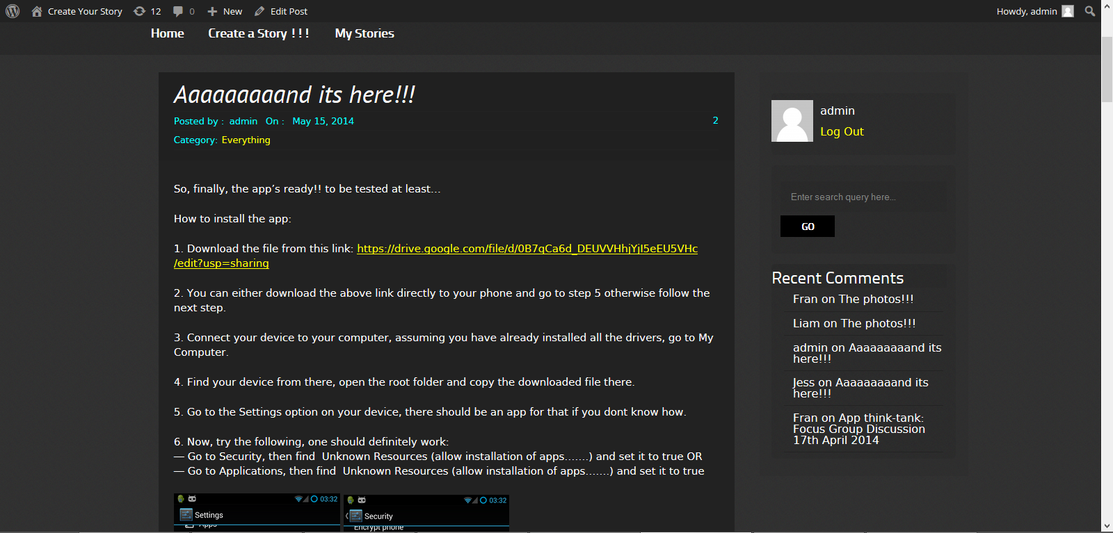
Image 1: Blog screen shot
A Facebook page was also established at https://www.facebook.com/createyourstory01 as a public space to advertise the project and connect with other Facebook sites that could contribute ideas for the app, especially those related to Aboriginal youth, the arts and culture. The Facebook site also remained under-utilised; this is also discussed later in the reporting the Findings section. Specified members of the research team administer the blog and the Facebook sites.

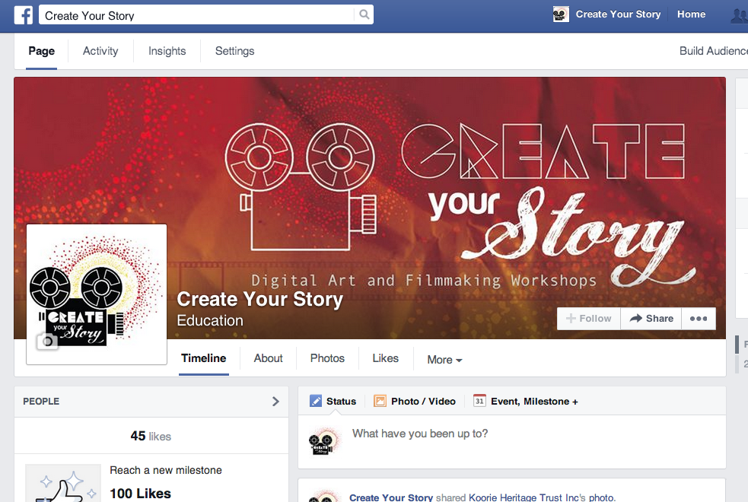
Image 2: Screen shot Facebook page

Conducting the Research: ethnographic methods
The researchers’ capacity to engage with the participants and to work with them in ways that allowed for the effective exchange of information was integral to the collaborative methodology. Indigenous academic, Martin Nakata’s idea of the ‘Cultural Interface’ proposes that the intersection between Western and Indigenous knowledge systems provides a dialogical space where cross-cultural learning can occur (Nakata 2007, Yunkaporta 2007).
A series of ethnographic methods were adopted that allowed the researchers and participants to work together, enabling cross-cultural knowledge exchange. These aimed to support participants to ‘share their knowledge and engage in equal dialogue with other cultures’ (Yunkaporta 2007: 44). These included:
- Working while learning with Aboriginal young people. In this project, researchers worked as ‘participant-experiencers’ (Adelson and Olding 2013). This included participating in and contributing to group work and discussions during the workshop sessions; being involved in creative planning; the design and trialing of the app and blog sites; and engaging in ongoing conversations through posts on the blog and app with participants. This process provided space for researchers to reflect on and observe the contributions made by everyone during the workshop.
- Holding a Focus Group discussion with participants on the second day of the workshop. This is discussed in detail later.
- Holding Face-to-Face feedback 3 months after the app prototype was created, which enabled participants to update the researchers about their use of the app. This is also discussed later.
- Holding and attending Reference Group meetings in Sept 2013 and June 2014, to consider strategies for the future direction of the project and to provide feedback.
- Attending community events, for example, a graduation lunch for REAL camp participants in April 2014. Researchers also attended the informal launch of the app at the July 2014 REAL camp, to engage with youth and to raise awareness of the app project.

Engaging participants in the project: the Think-Tank workshop
The concept of a Think-Tank was adopted as an important element of the project, acknowledging youth as the key contributors to the creative process. Engagement with the ‘app Think-Tank’ occurred through workshops and focus group meetings held on 14th and 17th April 2014. The Think-Tank generated ideas for the development of a functioning digital storytelling app – the ‘What’s ya Story’ app – named by the Think-Tank to differentiate the app from the overall name of the project, ‘Create your Story’.
The Think-Tank workshop intersected with the main aims of the project: broadening understandings of digital literacy from an Aboriginal perspective; encouraging a space for knowledge exchange and for exploring the creative capacity of digital technology; and considering issues of cybersafety and cultural protocols, including how to tell stories and to whom they should be told. These aims provided a framework for planning the workshop.
The overarching ambition of the first Think-Tank workshop was to allow participants to contribute their ideas about what a digital storytelling ‘app’ could incorporate. At that early stage, it was about letting the participants decide what they wanted in an app, centring their voice and creative input without imposing cultural imperatives, which might be restrictive and unreflective of youth’s perspectives of Aboriginality. In this respect, the workshop follows the philosophy of KGI, as their programs and camps ‘do not “teach” culture, but instead provide a positive and supportive environment through which culture can be affirmed and explored, and connections maintained or established’ (The Korin Gamadji Institute (KGI) 2014).
The Think-Tank also provided participants with information on the possible uses of technology to support their expressions of identity, as well as a forum for discussing cybersafety and cultural protocol issues. The goal was to apply the ideas and issues raised toward the development of the app itself.

Day 1
The first day of the Think-Tank workshop was held on Monday 14th April, 2014. Five KGI participants attended (3 girls, Jess, Nakia and Danae and 2 boys, Liam and Jake), Alex Splitt, the KGI’s Chief Operating Officer, Dixon Patten and IBES technicians Gursharan Singh and Chamil Lakshan Jayasundara, along with the researchers Richard Chenhall, Christel Rachinger and Fran Edmonds. In addition, the participants were provided an iPad each, supplied by IBES, to record images and sounds throughout the day.

Morning session: ACMI
The morning session of the workshop was held at the Australian Centre for the Moving Image (ACMI), which is the Australian Centre for Excellence for Digital Storytelling. ACMI is also the main collecting institution for film in Victoria and is an ‘internationally recognised national hub for screening and advocacy, screen education, industry engagement and audience involvement’(Australian Centre for the Moving Image (ACMI) n.d.).
The overall purpose of the ACMI visit was to expose participants to background information they required to understand storytelling through technology. This was planned to include discussions connected with Aboriginal filmmaking and production, for example, access to Aboriginal stories through film; background on Aboriginal filmmakers and actors; how films are preserved and archived; how films are distributed online; ideas for creating appropriate digital imagery; and sharing and unpacking some of the stories they would like to tell. Researchers were mindful that storytelling through multi-media was a new field for many of the participants, and that ACMI could provide that background.
Following the ACMI tour, participants expressed a desire for the introductory session on story making to be contextualised within the framework of Indigenous filmmaking, along with issues associated with Indigenous storytellers in film. While the participants enjoyed seeing the Indigenous exhibits in the Screen Worlds space, particularly those by contemporary Aboriginal artists, future visits to ACMI may provide opportunities for these exhibits to be positioned in relation to Indigenous multimedia production and filmmaking.

Afternoon Session: the IBES Laboratory Workshop
In the afternoon all participants and researchers returned to the IBES laboratory at the University of Melbourne. The creative process of the Think-Tank was expanded through the participants' collaboration with the IT intern, Gursharan, enabling them to express their creative ideas and receive feedback on the technical potential of the app development process.
The afternoon program focused on a discussion involving the IT intern, the researchers and the participants. This was to elicit information from the young people regarding their perspectives about mobile apps. This included sharing information about how they use apps and the potential for apps to tell stories. Gursharan presented on the IT components of the app, including the process for designing an app, what an app does, how it works, and explained features, such as buttons for sending and retrieving data and application layers, which ensure that effective communication with another application program in a network is possible, (i.e. that the necessary communication resources exist, e.g. a modem). Gursharan also introduced the concepts of cybersafety and privacy in relation to sharing information online. This discussion opened up a space for two-way dialogue between Gursharan and the participants, allowing all to contribute and share ideas, apply these ideas to their own app design process, ask questions, and provide feedback. Dixon Patten, the graphic designer, also contributed to the discussion, emphasising the importance of considering the app as a space for uploading and sharing stories in the first instance and then shifting to the design elements.
However, as the discussion was dominated by a design focus, largely a result of limited discussion about ‘what a story app’ could be, at the end of the day many of the features mimicked social network sites, such as Facebook, Instagram or Snapchat. These elements of the app, however, were considered in relation to the way Aboriginal people understand their place in the world and were deemed important for inclusion on an individual’s app ‘profile’:

  - Who’s your mob?
  - What’s your country (include maps)?
  - What are your common interests (for connecting with others with similar interests)?

Finally, their design ideas were recorded as a list of ‘app story’ and ‘app design’ likes and dislikes on a whiteboard.

Table 2: Design ideas for the app
App Story (features for uploading stories) |  | App Design (what the app looks like)
Likes | Dislikes | Likes/wants | Dislikes
Facebook:  Share feature  Profile  Favourite tags for people’s stories  Snapchat:  Quick and easy to create a story  View things (photos, videos, text etc) once then 10 seconds later they disappear  Instagram  Editing pictures  Templates for stories  Editing of everything (pics, videos etc)  Comments and privacy settings | Privacy Issues  What can and can’t be seen  Tags can’t be customised/categorised | Colour (blue)  Clear/strong images  Round edges on design  Choice of filters, eg. collage of images, comments  Login screen interactive  Scrolling menu from left  Instagram tool bar  News feeds (when you first open the app) | Not too many buttons

By collaborating with Gursharan, the IT intern, the participants were exposed to the technical skills involved in the development of an app. Having face-to-face contact, within a collaborative environment, enriched the learning process. In addition, the app Think-Tank created a supportive space for cross-cultural learning between the intern, the researchers and the Think-Tank participants. The participants also learned some of the technical aspects of app design and function, including exposure to the language and concepts associated with this process, which contributed to expressions of their own creative ideas for app design. Participants also had the opportunity to learn about and discuss issues of cybersafety, cultural protocols and positive representation with mentors.

Day 2
Day two of the workshop occurred two days after the lab workshop. The process entailed a focus group discussion with participants to elicit their feedback about the workshop process and generate further ideas that would contribute to the building of the story app. Over the two day interim Gursharan had developed a basic app prototype with some of the key features arising from the lab workshop. The focus group was attended by the KGI young people: two girls (Jess and Nakia) and two boys (Liam and Jake); Alex from KGI; and Neville (KGI mentor and Australian Rules Football player); Luke Murray from KGI; and researchers Scott McQuire, Mike Arnold and Fran Edmonds.
Following a presentation of the app prototype by Gursharan, a mind mapping (brainstorming) exercise was conducted to explore and inspire ideas for discussion about what the participants thought a story app should be, as opposed to concentrating on the design features of the app. The main themes and subthemes arising from the mind map were recorded on a whiteboard and written up and posted on the blog for people to view and add to as they saw fit.
The following table presents the themes and sub themes arising from the mind map: ‘What is a Story App?’:
Table 3: Mind Map - 'What is a Story App?'
Personal story | Ways to create a story | Artwork | Sound | Aboriginal storytelling
Something to share;  Imaginative;  A dream | Visually (through images);  Slide stories;  Movies;  Pictures; with background sounds | Drawings;  Graphics;  Photographs;  Symbols;  Patterns;  Iconography; | Music;  Dancing/performance;  Voice;  Nature  animals; wind/water;  Sounds of different places  cities; inside vs outside; travelling; sport/games/activities | Something with meaning and significance;  Dreamtime stories;  Maps  connection to country; stories about land;  History  reflections (of the past); family/friends/culture

The mind mapping exercise also contributed to the focus group discussion, which concentrated on the following themes:
- Unpacking what digital literacy is in the context of digital storytelling.
- Discussion of issues related to cultural sustainability in an online world.
- Discussion of the role and place of intergenerational knowledge exchange and peer-to-peer support in the context of digital literacy and cultural cybersafety
- Ideas about the creative capacity of digital technology and ways that accessing collections of Aboriginal material culture could assist in telling stories.

The themes that emerged from the focus group are discussed in the Findings section.
Issues that remain to be addressed in further iterations of the app will focus on enabling participants to comprehend the concept of a ‘story app’. Without experiencing storytelling within the context of an app designed specifically for their purposes, it was difficult for the participants to imagine what kinds of stories they would be able to create for use on the app. A digital art and storytelling workshop will be held at ACMI in October 2014 with participants to teach them the techniques that are involved in storytelling in a digital medium, particularly as a tool for asserting digital identities, and for its transference to a mobile application.

Evaluation and Feedback
In July 2014, three participants returned to the University of Melbourne to provide feedback about the app and to show researchers how they engaged with the app, including uploading images and text to tell short individual stories. The young people also had the opportunity to provide Gursharan with further information about what they considered would assist in the app’s functioning. These suggestions are outlined in the Findings section

Findings
In this section we discuss the findings from the Think-Tank. This is the term we used to describe the sessions conducted with the KGI participants during the workshop conducted in April 2014. The first day of the Think-Tank was conducted at ACMI in the morning and then in the IBES laboratory in the afternoon. The second day of the workshop included the focus group discussion. The participants’ contributions to the laboratory session and the focus group discussion provide the main body of findings in this section.
The findings reveal that for the participants in this project, the Think-Tank provided the opportunity to explore, conceptualise, design and contribute to discussions about the development of a mobile application, ‘What’s ya Story’ (the WYS app). The findings also reveal the potential of the WYS app to lead to design outcomes that support Aboriginal youth’s ambitions to contribute to and access stories that build confidence in understandings their Aboriginality, and to distribute this knowledge safely within and between cultures.
The following discussion outlines the development of the WYS app in accordance with the findings from the two-day Think-Tank. Themes were elicited from the findings, revealing the main concerns of the participants and they provide the main structure for this discussion.
- An exploration of Digital Literacy and its relationship to the storytelling app
- Audience participation within a globalised social network
- Intergenerational and peer-to-peer knowledge exchange and cultural cybersafety
- The creative capacity of app development and digital technology

Digital literacy and the storytelling app
This project takes a broad approach to digital literacy that encompasses the use of digital technology by Aboriginal young people to support and enhance their knowledge about who they are and where they come from. This focuses on the opportunity to engage with digital technology to support culturally inclusive approaches for learning and disseminating knowledge digitally.
In this context, digital literacy is therefore more than knowing how to use the technology (which youth are quick to adapt to and adopt in their everyday lives); it extends to developing skills that assist young people to discover, assert and define their social and cultural identities as contemporary Aboriginal youth. This also promotes opportunities for reinforcing the diversity of Aboriginality across the country and alleviates potential binaries concerning what is and is not ‘real’ or ‘authentic’ Aboriginal culture (Peters-Little 2002, Davis and Moreton 2011). Such misunderstandings can contribute to Aboriginal people’s experiences of racism, affecting mental health, social inclusion and wellbeing (Ferdinand, Paradies et al. 2012).
Preliminary research by the Young and Well Co-operative Research Centre (YAW-CRC) also acknowledges the unprecedented opportunities for digital technology to ‘support the creative potential and to build upon the social networking practices of vulnerable young people, including promoting social inclusion in a way and on a scale not currently offered by existing organisations and services’ (Young and Well Cooperative Research Centre 2013). This also includes promoting a ‘sense of community, belonging and connection’ (Edmonds, Chenhall et al. 2014).
In southeast Australia, most Aboriginal young people are active participants in digital and online activities, which extend across global networks (Eades, Simondson et al. 2011, Edmonds, Chenhall et al. 2014). Mobile devices with Web 2.0 capacity provide instantaneous connections with others via a range of media options. The young people in this project, like many Aboriginal youth in the region, were also seeking to sustain and expand their cultural connections and knowledge, while others were striving to learn more about their Aboriginality using digital technology as a means for doing so (Christie and Verran 2013). In this instance the digital story app was viewed as a device that could provide inspiration and knowledge to acquire skills in technology development, while enhancing understandings about their culture, both within and outside the Aboriginal community. The following quote articulates all these concerns.
Alex, 26:
… [this app workshop] it gives you inspiration to actually want to create something that’s unique and obviously individual to Aboriginal people in Victoria and across Australia to be able to really tell their stories. For a long time stories from Aboriginal people have been sort of kept a secret within family groups, so it would be good to be able to share some of that stuff, with other Aboriginal people but also with broader Australia. This will be a great tool for Aboriginal people to be seen and that we are still here and still relevant, because particularly in Victoria a lot of people think they don’t know an Aboriginal person, whereas one of their friends could be, it’s just that they’re fair-skinned or they’re not banging a drum about being Aboriginal, they just go about their business usually.
In this project, therefore, digital literacy was conceptualised as a space that fosters understandings of Aboriginal ontologies. In other words, designing and implementing an Aboriginal ‘storytelling app’ was conceived as a way of reinforcing a media ecology that could support Indigenous ‘ways of knowing and doing things’ (Martin 2003). Thus, developing the WYS app prototype was a means of encapsulating Aboriginal perspectives and expanding opportunities for Aboriginal youth to use technology in ways that sustain their ambitions and lifestyles.
For instance, opportunities for Aboriginal people to determine how they communicate and express their self-representations via technology are paramount to learning and connecting with culture in the digital age (Australian Insititute of Aboriginal and Torres Strait Islander Studies (AIATSIS) 2009, Bandias 2010 (April)). This is most evident in relation to the film industry (Davis and Moreton 2011). During the focus group discussion, one of the participants, Nakia, was adamant that for Aboriginal people the strength in stories comes from having members of the community articulate that knowledge:
Nakia, 16:
‘Like, when you’re relating to Aboriginal people, like making films, I reckon [when we were at ACMI] if we had somebody who was an [Aboriginal] filmmaker come in and talk about how they told their story [it would have been better]…’
Aboriginal representation in film (as a form of communication technology) provides a way of conceiving the possibilities for an Aboriginal-designed and managed storytelling application, to provide relevant and meaningful insights into the diversity of Aboriginal culture and histories (Notley and Tacchi 2005, Sabiescu 2009).
In relation to this, developing accessible, Aboriginal controlled, digital communications has the potential to assist in ‘Closing the Gap’, providing opportunities for Aboriginal people to achieve equality with their non-Aboriginal peers as determined by them, including in education, employment and health (Australian Human Rights Commission 2013). The significance of Aboriginal-enabled technology assists a rethinking of the ‘Closing the Gap’ policy from an Aboriginal perspective. This was clearly articulated by one of the young mentors in the focus group discussion:
Alex, 26:
This is a great opportunity to enable our kids to get into that upper end of people able to utilize this technology and that can only be a good thing. As technology evolves they evolve with it, they’re actually going to be up with the top end of the people who can use [IT]. So instead of having poor education outcomes, they’re actually going to be at the higher end. [This contrasts with the policy of] Closing The Gap for example, [which] is all about getting Aboriginal people to the lower end of wherever the worst results are for non-Aboriginal people, [for example] education outcomes ... To Close the Gap is not to get Aboriginal people up to the top of the results, it’s to get them to the bottom of what non-Aboriginal people are. Having at least the skill set where we’re leading the way is going to be beneficial to Aboriginal people.

What is a digital storytelling mobile application?
As previously discussed, storytelling is central to Aboriginal ‘ways of knowing’. It is integral to maintaining the connection between all aspects of life. The focus of this project was to design a digital storytelling app, which arose from the collaborative methods described in the previous section.
The Think-Tank workshop, held in the IBES laboratory, involved youth contributing their open-ended ‘wish-list’ of functions for a digital storytelling app. This included refining the specifications for a functioning prototype, such as the WYS apps features, including the apps colour (preferably blue), the ability to post comments, profiles, images, text and so on. This was then later opened up through a series of suggestions for affordances to be developed beyond the timeline and budget of the current project.
The Think-Tank’s initial ideas about what a story app could be reflected the most familiar online communication tools available, which are those that occur through social network apps. The WYS app at this stage was therefore conceptualised as similar to Facebook or perhaps Instagram. Its key function was social networking of a generic kind, and its audience was envisaged as a social networking site’s multifaceted and ill-defined network of ‘friends’.
However, during the focus group the participants steered away from the concept of the WYS app as a social media resource. The idea was to develop a tool that enabled stories to be told and shared in a way that was more akin to a blog site, with innovative functions designed by the participants for making and sharing their stories. Initially, this was complicated as participants expressed concerns about what a story app enabled. For instance they were not clear about the essential criteria that was expected for making their stories and how these would be delivered on an app. One young man suggested that the following would assist in the storytelling process:
Liam, 15:
…. What I thought we could have done … was bring in someone who has made their own story... It would really help us out [to] have an example to work on, so when we go and make our own stories we have a bit of an idea on what to do.
This response highlights the need for appropriate scaffolding, which would encourage youth to make stories that resonate with them and are deemed appropriate for transmission in the digital realm.
In response to this a mind-mapping/brainstorming exercise was conducted on the second day during the focus group discussion and enabled the younger members of the group to better articulate how the WYS app could be conceived as a tool for storytelling. Particularly as a means for conveying contemporary cultural understandings of their Aboriginality across a range of mediums including performance, sound, text and images. In this instance the relevance of the story to its authors and its audiences was considered integral to comprehending the value of the story and its potential to be enthusiastically shared.
Fran (researcher):
So, as an Aboriginal person, if you’re thinking about story… What is a story for you guys?
Jake, 17:
Something that has significance in our life. Or it also can be … something with meaning.
Jess: 15
Like the Dreamtime stories.
Fran:
What do you mean by that, Jess?
Jess:
Well… in Aboriginal culture the Dreamtime stories of how things were created is really important…
Fran:
What else does Aboriginal storytelling give us?
Jake:
A map.
Fran:
Great, a map. A map of what?
Jake:
Of movement.
Fran:
What do you mean by that?
Jake:
A lot of the stories they told would be, like, the migration of the kangaroos across the land and humans as well. [To] show the significance of certain, I guess, objects belonging to each tribe. So say, animals might be at different sacred levels compared to each mob.
Fran:
What else could you have on a digital map …
Jess:
Sites of relevance. Like, country or sacred places.
Later, Jake reinforced his idea of the map adding:
… in terms of the WYS app integration you could have a map…that [any] kind of story is specific to... you could link up as many mobs as you can… into different … parts of Australia, click on different mobs and see their story specific to that mob.
The personal aspects of stories and related images were also considered, including what could be created and shared via the WYS app, reinforcing what it means to be an Aboriginal youth today in comparison to the everyday popular postings found on social networking sites (SNS):
Jake:
This app will have more meaning from what you post. Cos you’re posting a story, you’re not just posting, you know, what you bought at the shops today. [Laughter]…
Liam:
History [is important]… Like some stories can be non-fiction as well and can be told as tales of the past. It can be around family and friends and your culture.

Nakia:
I think it would be more meaningful because usually most photos don’t have any meaning, but if you’re telling a story behind it I think that it’s more relevant. And when you’re posting your story other people can try to read it and then they can share your story.
Jess:
I think [the app’s] going to be different because it’s more culturally relevant. And I just think it’ll be different because you’re not posting… something … like … having breakfast. You’ll be posting about you and your story or about your family and you’ll connect with more people.
As indicated in the discussions above, some participants envisaged their stories as personal, sometimes autobiographical, but certainly expressive of the life and worldviews of the author. Other considerations were that stories could be broadly educational and historical, drawing on the particular experiences of family and language groups, of history, and of links to Country and events. Stories were also considered in terms of traditional culture. For instance, stories connected with the notion of the Dreaming were considered important for supporting intergenerational knowledge and for cultural information. This included stories that connected people to animals, places, language groups and the potential for these stories to offer insights into the young people’s cultural heritage.
As the conversations above also express, the stories youth focused on drew on their understandings of what they believed Aboriginal stories entailed and were viewed as distinct from the usual stories found on social network sites (e.g. Facebook or Twitter). They were judged to have meaning and significance, especially regarding connections to Country, kin and community, furthering knowledge of their histories and significant events. The Think-Tank was adamant that these kinds of stories were important for asserting their identities, while the utility of the WYS app in telling these stories was considered an advantage for connecting with others specifically about stories that were meaningful to them.

Conceptualising a ‘storytelling app’ as a cultural knowledge resource
For the older participants, Alex and Neville, they were convinced that the WYS app could provide more accessible avenues for extending knowledge of their Aboriginality among their colleagues, peers and broader social networks.
Alex, 26:
[For Neville] being a Nyoongah man [from WA], obviously coming across to where Koories are, it would be good for them to be able to see your story and not have to meet you and actually hear your story. They want to learn more about you, it actually gets your name into the community here. I mean, obviously you’re welcomed here … I came from South Australia originally … not many Victorian Aboriginal people would know even who I am, but having my story up on [the WYS app] they’d actually be able to see who I am, who my family is connected with and make connections that way rather than hearing directly from me.
For Neville, as an elite AFL player, the WYS app represented a device that could support knowledge of his culture among his peers and colleagues. It would operate on a number of levels, alleviating him of the pressure to perform and represent his Aboriginality in ways that may not always be easy to do so, particularly when time is an issue. The WYS app could also offer the potential to support a range of digital links that educate others about the diversity of Aboriginal culture.
Neville, 24:
That’s one of the hardest questions I get at the footy club. I work with forty-six other blokes, and they’re asking me my culture, my identity, and it’s so hard to sit down and talk to them within five minutes because we could be there for a week. If I can just show them a video, or tell them to download this video, or go on the [WYS] app and show them the video. I think that would give them a much better understanding than what I would, ‘cos I might miss some things or skip something, or don’t get the full story that I’d like to get out. Even if someone doesn’t know their story they could get someone to say, well this is my tribe, this is where I’m from, this is my people, this is how we go about stuff…
Neville also envisaged the WYS app as a way of supporting his connections to his family and Ancestors, furthering his knowledge of stories from the past.
Neville:
I sorta see this app as…connecting with the family, my background. Say, I didn’t get to meet my grandfather, grandmother, or the past Elders, and didn’t know their stories. And someone say, puts that story on. So, I’m sort of connecting with them without meeting them, if that makes sense.
This was also supported by Jake (the oldest youth participant), who recognised the potential of the WYS app for broadening his and others’ knowledge of Aboriginal histories and cultures by having it available literally in the palm of your hand.
Jake:
… I’d love to know more about different mobs and you know the stories they have to share. Instead of having to go to a museum or having to go to the [Koorie Heritage] Trust and listening to the stories there, I could do it on my phone and my iPad. It’d be more convenient and it’d just be a good way to share your own knowledge as well.
In relation to Jake’s suggestion, the younger participants were more intent on viewing the WYS app as a tool to assist them in investigating and learning about their cultural heritage (i.e. who they are), rather than a way to describe or discuss culture from their perspectives. In southeast Australia, many young Aboriginal people are in a process of connecting with their Aboriginality. In this respect the WYS app is a way for youth to negotiate questions about their Aboriginality and cultural issues that they have not had opportunities to learn about previously.
Jess, 15:
Yeah, I don’t know that much [about my Aboriginality]. So, I think an app like this would really open up a lot of [knowledge]… Like I could learn so much, especially about other people and I’d find that really interesting.

Nakia, 16:
… I’ve got a big family, but I don’t know them all. So, I reckon if I heard some of their stories I’d find it a bit easier to find out who I am.
Liam, 15:
… my dad’s side is the only side that [I know is]… Aboriginal. But my mum’s side we’re not so sure, so it would be good if we found a story that relates to my mum’s side of the family...
One of the youth mentors, Alex, however, demonstrated his capacity to identify the capabilities of the WYS app in promoting knowledge of Australia’s history since colonisation from an Aboriginal perspective. He also articulated the continuing impact of colonisation on Aboriginal people’s culture and identity. In this instance he combined his response of his own experiences regarding his exploration and ongoing education about his cultural heritage, with the difficulties of being confronted with ongoing discriminatory stereotypes, still widely expressed by non-Aboriginal people, surrounding the authenticity of fair-skinned Aboriginal people in southeast Australia (Lane 2014: 24).
Alex, 26:
Obviously being quite fair-skinned myself, it’s sort of hard for me to be able to justify being Aboriginal not having a great understanding of my culture before. My grand-mother was part of the stolen generation and is the reason why I look the way I look. And until I could articulate that, she didn’t feel comfortable for me to try to argue [in support of my Aboriginality]…. These kinds of [digital] tools help you to understand your story and people and to become more confident in being an Aboriginal person, and telling your story and taking ownership.
From the participant’s perspective therefore, the WYS app presents an opportunity for the Aboriginal community to produce and consume stories that were previously restricted in their own communities, where limited cultural information could only be covertly transmitted across the generations, including use of language, art practice and performance, and kept from the general public’s gaze (Edmonds and Clarke 2009). In the past, policies of assimilation also denied Aboriginal people opportunities to articulate and practice their culture, resulting in many continuing to struggle to assert their identities (Human Rights and Equal Opportunity Commission (HREOC) 1997).
As the young people’s stories reveal - the digital realm has dramatically changed the storytelling landscape, providing youth particularly with the opportunity to subvert the colonising restrictions of the past and to access and tell stories that are Aboriginal representations of Aboriginal knowledge.

Audiences, global networks and adaptation of culture
Different stories in different genres suggest a range of audiences will use the WYS app. In this project audiences were therefore viewed in different ways. The participants considered audiences’ interests in and their connections to the stories would be multifarious, leading to a range of situations where access and privacy issues surrounding content must be considered. For example, the audiences for some stories might only be family, the audience for others might be school groups, peers or work mates, and the audience for others might be global. This control over the representation and cultural ownership of stories positively impacts on health and wellbeing, as well as builds social capital and cohesion (Australian Insititute of Aboriginal and Torres Strait Islander Studies (AIATSIS) 2009, Mignone and Henley 2009).
Given the range of audience engagement, the Think-Tank participants were adamant that the WYS app was a suitable device for disseminating and sharing their stories. As an interactive tool it was seen as a way of providing multiple opportunities to post representations of their everyday lives and their histories in a forum controlled by them. Youth are already experts in making decisions, which determine what kinds of information they upload digitally to numerous social networking sites (Young and Well Cooperative Research Centre 2013). An app designed by Aboriginal young people, which resonates specifically with their lived experiences as Aboriginal youth, was viewed as a powerful way of expanding their knowledge about their communities and themselves in terms of their Aboriginality and disseminating this on a global scale.
Alex, 26:
This stuff really could go across internationally for other Indigenous peoples. I can really see it working in Canada for example. Canada have a very similar history to what Aboriginal people have, and as a result of that they have similar disadvantages in education, justice, employment and health outcomes. So this kind of thing is a way for Aboriginal people to have ownership of something and really feel proud about their culture.
Liam, 15:
…this would be a great app to introduce into the Indigenous program into my school or other schools in my area … it would be great to just show the other Indigenous kids in the school and how they can make their own story as well, so we can just spread it through different schools.
Jess, 15:
I just think it’ll be a really great primary source of information…
Alex:
… it’s just a great way of having a database of information, that … can’t be lost in history. It’ll be there and it will stay there because obviously it has to go on the Internet. So it stays on the Internet.
Liam:
… hopefully this will be a great app to get people into and see if they can put their own stories on and just share it with the rest of the world.
The above comments acknowledge the importance of sharing stories and the interactive participation that new communication technologies provide for engaging different audiences. This ever-increasing communication, across a range of networks and geographical borders, resonates with the advancements in Aboriginal supported and controlled media in remote Aboriginal communities from the early 1990s. At that time, improved technological interventions, including increased access to media such as television, radio, videos and networked video-conferencing, intersected with the growing influence of globalisation (Hinkson 2008).
In remote communities, improvements in Information Communication Technologies (ICTs), rather than reinforcing cultural maintenance, enabled those communities to reach out to a wider audience and disseminate information about their culture, including adaptations to culture in response to contemporary lifestyles. Anthropologists such as Jennifer Deger who worked with Yolngu in Gapuwiyak, Arnhem Land and Melinda Hinkson who worked with Warlpiri at Yuendumu, Central Australia, observed that the arrival of accessible electronic media not only enabled wider audience engagement and participation, but provided Aboriginal people with a means for asserting their presence, for making themselves visible to non-Aboriginal audiences, promoting intercultural engagements, and providing modes of exchange that could ‘generate relationships of reciprocity and regard’ between cultures (Deger 2006: :109, Hinkson 2008).
In the 21st century, the uptake of digital communication means Aboriginal youth culture is firmly embedded in the global (Kral 2010). Easily accessible global transactions enabled by convergent media, such as small, mobile digital devices and Web 2.0 technology, allow audiences to participate and interact with the story-makers, to see, hear and learn about contemporary Aboriginality as determined by Aboriginal people. Digital tools open up a range of communication possibilities that did not previously exist for Aboriginal communities or their prospective audiences (Kral 2014). The potential for these tools to promote social inclusion for Aboriginal people among broader social networks, also allows others to engage with and learn from Aboriginal people, emphasising the dynamic nature of contemporary Aboriginality as it adapts and changes in the digital age (Lane 2014).
For Aboriginal people, having control over the design and development of an app becomes a space that allows the rapid exchange of contemporary stories and knowledge to be retrieved by many, enabling information to be accessed globally, yet controlled specifically by Aboriginal people.
Alex, 26:
Logically it makes sense that if you look at how [technology] is evolving and how to actually learn – it was from a book to start with… People now don’t want to read a book to learn about things… Now with apps … you don’t even have to read it, you’ll just push a button and it will literally just tell you a story, rather than you having to go and do any research.
So people … want the information given to them rather than having to seek it out … it’s sort of an easier way to give a snapshot of the cultural side of Australia, rather than actually having to find out what happened during settlement. So [an app can provide information about] what current culture is, rather than thinking about all the way back to what the historical culture is.
From the discussions with participants, they determined that a digital mobile application designed by Aboriginal young people could support them in managing representations of themselves and their culture. Implementing and supporting appropriate strategies through knowledge exchange, in ways that are culturally appropriate, also holds the potential to encourage youth to negotiate their sense of self and learn in ways that are informed by an Aboriginal ontology, while engaging with various audiences across the globalised youth network.
For instance, using an app that is designed specifically for sharing information in ways that support Aboriginal knowledge requires an understanding of the changes and adaptations critical for supporting Aboriginal knowledge in the digital age (Kral 2014). One of the older participants, Neville, discussed the example of the transformation and ownership of Aboriginal languages across the country, particularly when exchanged via social media. Access to cultural information online, which is not subjected to the previous restrictions imposed by offline community protocols, means people are adapting and renegotiating cultural frameworks for sharing knowledge, and correspondingly ownership of that knowledge shifts across time and space.
Neville, 22:
… I’ll use Facebook as an example, when stuff gets put up [there is] a lot of positive and negative stuff towards whatever’s up. Could be with stories, people could be competitive, good and bad. So, especially Aboriginal people always want to [check up on] each other from different communities or different tribes ... So, a lot of people might not agree with what some tribes are doing, and might say [for instance] that they stole our language sort of thing.
Like, I’m Nyoongah and I’ve been in Sydney and there’re tribes in Sydney talking Nyoongah … So, I’m saying you’re talking my language and [they’re] saying it’s [their] own. And people might get up and talk about their language and they’re using different languages, which [is possible] now [because] there’re so many cross sections or cross languages … throughout Australia. Yeah, that could be positive or negative, could be positive people understanding each other more because of the language they’re using.
Thus, a digital storytelling app has the potential to embrace the rapidly expanding communication initiatives enabled by new technology, while incorporating and offering new ways of thinking about and negotiating cultural changes and decisions, which support the sharing of information with various audiences across broad social networks.

Intergenerational and peer-to-peer knowledge exchange
Cultural change is inevitable. However, Aboriginal people continue to assert their unique culture, transmitting information intergenerationally and through peer-to-peer networks. Issues arising in an online world include methods for establishing Aboriginal control of Aboriginal knowledge that is subsequently stored online forever, and cultural cybersafety. These considerations also formed part of the workshop’s agenda, providing a framework for youth to consider how their stories could be transmitted and interpreted across time and space.
A recent parliamentary inquiry found that Aboriginal young people have technology skills equivalent to those of non-Aboriginal children, despite many not having a computer at home. This has impacted on increasing levels of digital literacy, which can be related to the influx and routine use of mobile technology among the Aboriginal community (Commonwealth of Australia 2013). However, the broader definition of digital literacy adopted in this report also intersects with the ongoing concern of the ‘participation gap’, particularly the limited access to strategies and protocols that improve understandings of the way Aboriginal knowledge and cultural information is distributed online (Australian Insititute of Aboriginal and Torres Strait Islander Studies (AIATSIS) 2009). For minority groups, issues concerning the types of information and imagery people are willing to share online can be at odds with the way these representations are interpreted by audiences. For instance the advent of Facebook and other social media sites, which encourages the production and consumption of all sorts of everyday images and personal experiences, remains relatively uncensored compared to the restrictions imposed on images that have traditionally been filtered through the offline family photo album (Vivienne and Burgess 2013, Edmonds 2014 (forthcoming)). This widespread access to uncensored imagery and other types of information via social network sites can present real problems, particularly if they reinforce persistent negative stereotypes, which lead to cyber-bullying, online racism and lateral violence. All are ongoing concerns among the Aboriginal community (Australian Human Rights Commission 2011, Hogan, Rennie et al. 2013 , Edmonds, Chenhall et al. 2014).
Recently Aboriginal youth in Victoria have expressed concerns about online lateral violence and bullying, which can lead to extended family arguments in public cyberspace, affecting the wellbeing of the community and impacting the chances of youth suicide (Koorie Youth Council 2013). This suggests that the promotion of appropriate methods for understanding cultural cybersafety extends across and between generations. In the Aboriginal community, cultural cybersafety ‘incorporates a wide range of issues, including protecting sensitive cultural information…’ (Commonwealth of Australia 2013: 30) and promotes positive representations of Aboriginality.
One of the methods for distributing knowledge of cultural cybersafety and online cultural protocols is peer-to-peer learning (Walsh, Lemon et al. 2011, Edmonds, Chenhall et al. 2014). Peer-to-peer learning and positive online role modelling have been endorsed by Aboriginal young people as an appropriate method for transmitting information from older youth to younger youth to develop cyber-awareness, and in turn promote active youth engagement in leading awareness of the appropriate uses of technology throughout the Aboriginal community (Koorie Youth Council 2013). The storytelling app would present such an opportunity, which was reinforced by Jess
Jess, 15:
… If you see kids our age uploading stories and like kids younger than us watching them and seeing a good example, I think that would be good because then, I wouldn’t say role model but it would sort of be like that. They would want to set a good example as well. It could end up being a cycle, like by us being safe everyone will start being safer.
Strategies, such as peer-to-peer learning that effectively and safely support culture through appropriate dissemination and representations of Aboriginality online require an inclusive, community-based approach to learning (Nakata 2007). Intergenerational knowledge exchange also supports this approach. When youth and older members of the community come together to navigate the digital environment all generations can demonstrate their expertise and experiences to understand how digital technology and new media can enhance strong cultural connections (Secretariat of National Aboriginal and Islander Child Care Inc. (SNAICC) 2010).
Alex, 26:
I think it probably can work both ways. Obviously kids can teach their parents a lot about how to use the technology, but the parents have more of a world understanding of what can be the repercussions that can happen by using that technology.
Researchers from the Young and Well Cooperative Research Centre acknowledge the significance of intergenerational learning for the transferal of socio-cultural knowledge in ways that are ‘flexible and iterative so that [communities] can keep pace with the emergence of new online and networked media technologies and practices’ (Third, Richardson et al. 2011: 24).
The lab workshop phase of the WYS app development was also intended to provide the young Think-Tank members with opportunities to develop a degree of expertise in the language and practice of IT professionals. This also included broader considerations of how the WYS app might be a vehicle for improving the IT skills broadly among Aboriginal communities. Learning how to use an app in an intergenerational context potentially expands this knowledge as one of the Think-Tank members remarked.
Alex:
Well, there is a vast majority of the population who have poor IT literacy, and if they have that they’re going to obviously not have very good digital literacy... I’m talking about the older generation that didn’t grow up with this stuff. And fortunately with the people we work with and what this is designed for, is our kids already possess that without even really knowing that they do. It’s something they’ve grown up with. They’ve been able to go on there and pick up a [mobile] phone and actually use it for its functionality not just for a phone call or sending text. They’re able to actually use a phone the way that a designer of a phone actually had intended it…
As an ICT resource, the WYS app has the potential to assist in improving IT skills and the management of information in the digital realm. This however, also raises questions of cultural sensitivity and relates to issues of online cultural management. For example, if you don’t know how to use the technology in the first instance, then engagement with the opportunities offered by the digital world are limited. Conversely, if you are not aware of the pitfalls in sharing some types of information online – particularly culturally sensitive material, including information about deceased people, objects of cultural significance, Indigenous languages or stories without obtaining the appropriate permissions – then the repercussions can cause distress (Faulkhead, Evans et al. 2005). Providing appropriate scaffolding for users both in the technical use of digital technology, as well as providing avenues that encourage cultural awareness are strategies that were articulated by participants for ensuring the WYS app’s ongoing relevance among the Aboriginal community.
Alex:
I think, if you look at culture in the past, our culture, historically it’s the Elders’ responsibility to actually pass that on. Having an app like this, it actually has an ability to speak to a broader population of people. And generally you’ll have an Elder now who doesn’t know how to use this technology. They’ll talk to anyone who’s willing to listen, but that’s only ever going to be a small amount of people who physically get to be with them at that time. But having a story that can actually get posted up, that people can listen to, is reaching a lot more people and giving them an understanding of who they are as a person, their culture, their local community. It has an ability to go a lot further than just that one person’s voice in a room...
The kids have a responsibility to help their Elders be able to put their stories on this [app]… they could actually sit down with them; instead of their Elder typing it in on the phone, [kids] can type it in on the phone for them. And, having that digital literacy and supporting an Elder is probably a great benefit. [Kids] could actually sit down there and do it for [Elders] but [also] just listen to what their [Elder’s] story is and put it down for them. So that’s sharing the burden of being able to pass on that story and using two different generations to produce something that can go further.
Nakia:
Well I know that when my great gran passed away she had a lot of stories to tell, but we never really sat down and talked cos I was like little and didn’t really understand. But I reckon if I talked to my Elders, I’d try to share their stories even though I don’t have many of my own. So [this app would] encourage us to talk to family members and tell stories that are untold.

Community decision-making: managing knowledge exchange digitally
As Alex and Nakia agree, the WYS app could promote intergenerational knowledge exchange on a number of levels. However, the way particular stories are told, to whom they are told and when they are shared via an app raises issues of control and appropriate use. During the lab workshop the participants worked through options, considering a range of procedures for managing information exchange. These options included:
- Providing a set of culturally informed guidelines, and providing an online ‘terms of use’ agreement that users must abide by before using the WYS app.
- Each time an image is used in a story, the WYS app prompts an agreement from the author (the young participants) that the use of the image is appropriate.
- Each time a story is distributed or accessed, the WYS app will be designed to test the credentials of the author to distribute the story and allow the reader access.

Ultimately, however, these techno-centric responses to the complexities of negotiating sensitive cultural information were only considered achievable if they were managed through a system that provided the user with the capacity to make informed decisions about the uploading of information.
The Think-Tank, therefore, decided on practical approaches that would encourage the user to take responsibility for the production and management of their stories in the long run, by considering online cultural safety initiatives, which are part of the ongoing learning process in the development of the WYS app and the sharing of knowledge online.
In terms of the technical features of the WYS app, authorship credentials and audience distribution are currently controlled by an approach where the story’s author is identified and approved by authorised members of the Think-Tank (through a Facebook login). Distribution through the prototype app is restricted, at least in the short term, to the Think-Tank participants and to those authorised by the Think-Tank.
Currently, all information relevant to the project, either shared on the blog or the WYS app is stored on the IBES server. These options have been considered in terms of privacy arrangements, which have been established to protect the identity of the participants and the information they are collecting and disseminating on the WYS app during its trial phase. Further considerations for developing ongoing privacy agreements and data control in future iterations of the WYS app will be determined through discussions with participants and the Reference Group.
Overall, the participants’ responses recognised that cultural sensitivities must be managed through cultural means, not through technological fixes. This includes establishing protocols and guidelines that include young people conferring with their Elders and with their community to develop their knowledge and confidence in making digital storytelling decisions, as a practical response to the growing dissemination of information online. Engaging in a process of community decision-making for managing storytelling online also supports this project’s concept of digital literacy. This approach resonates with Indigenous pedagogies, where watching and listening before doing is important for promoting skills and confidence among learners, while supporting methods that integrate cultural protocols and understandings alongside the learning process (Yunkaporta 2007). For example, stories about family may require permissions from Elders before they are told, particularly if they are to be shared online.

The WYS app and the creative capacity of digital technology
For Aboriginal young people, cultural cybersafety is an important consideration if Aboriginal knowledge, cultural protocols and technical expertise are to be enhanced in the digital realm. Honing young people’s digital literacy skills and cultural knowledge through storytelling (i.e. what to tell and who to tell it to), alongside developing approaches for utilising the creative capacity of digital technology, presents alternative approaches for them to control the medium in which they choose to perform, share and create information.
Thus, the creative potential of the WYS app is considered as three-fold:
- Affordances and design (form and function)
- Cultural considerations and identity building (‘Indigitalising’ the app)
- Creative approaches to storytelling (connecting to culture via art practices)

Affordances and Design
Currently, for the purposes of the prototype, the IT team determined that the WYS app would be developed as an Android operating system, and to later incorporate the iOS (Apple) version. The Think-Tank took this decision on technical advice (the iOS is a ‘closed’ system and more difficult to work with than Android), and for social reasons (Android phones have a 58% market share in Australia, compared to iOS 34%) (Sadauskas 2014). In relation to this all except one participant in the project had an android smartphone. The participant who used an iPhone was supplied with a media pad provided by IBES to access and trial the app.
A few weeks prior to the Think -Tank, a blog site ‘Create your Story’ was set up initially for participant feedback and for posting ideas about the WYS app – it was envisaged as the first port of call for users to find out about the WYS app’s progress. Once the app was available for testing, the IT Intern, Gursharan Singh, provided instructions on the blog with screen shots of the WYS app (see Image 1). This blog post provided guidance to those participants on how to upload the WYS app to their android devices and to begin telling stories.
To create the WYS app in a way that reflected the young people’s ideas, the lab phase of the Think-Tank, largely determined the type of affordances offered by the WYS app. These have continued to be upgraded according to participant’s feedback following the testing of the WYS app. Limitations encountered are mainly to do with the extent to which the IT intern can integrate those ideas as functioning designs into the WYS app.

The User Interface
Once downloaded, access to the WYS app’s interface is prompted by authorisation using a Facebook account login. The user is then prompted to provide the name of the story with a ‘title’ (for story identification purposes). Once the title is included, the user can upload ‘content’. The content section provides a menu of possible media from which the story might be constructed – images, text, video and audio. A combination of media is possible, for example combining images with text and audio.Gursharan, the IT Masters intern, explained the WYS apps features during the focus group.

Gursharan, 23:
Let’s say there’s a screen or, like a home screen? And we have a link, which says create your story. Click that, you’ve got a title and the content. You start writing the content, and then it links for photographs, inserting pictures, videos, audio, and maybe a couple of other links for inserting drawings, customised drawing if you want to insert [them] yourself.
In providing for the capture and use of images, sound and text, a decision needed to be made on whether the storytelling app should leverage existing third-party apps, which are already installed on participants phones, or whether to develop these as custom-built affordances for the WYS app. While the WYS app operates using a touchscreen keyboard, other media requires that the WYS app uses the functions enabled by a standard smartphone or mobile device, such as a camera and recording devices. The WYS app, however, provides icons for creating images, videos etc in the apps contents section.
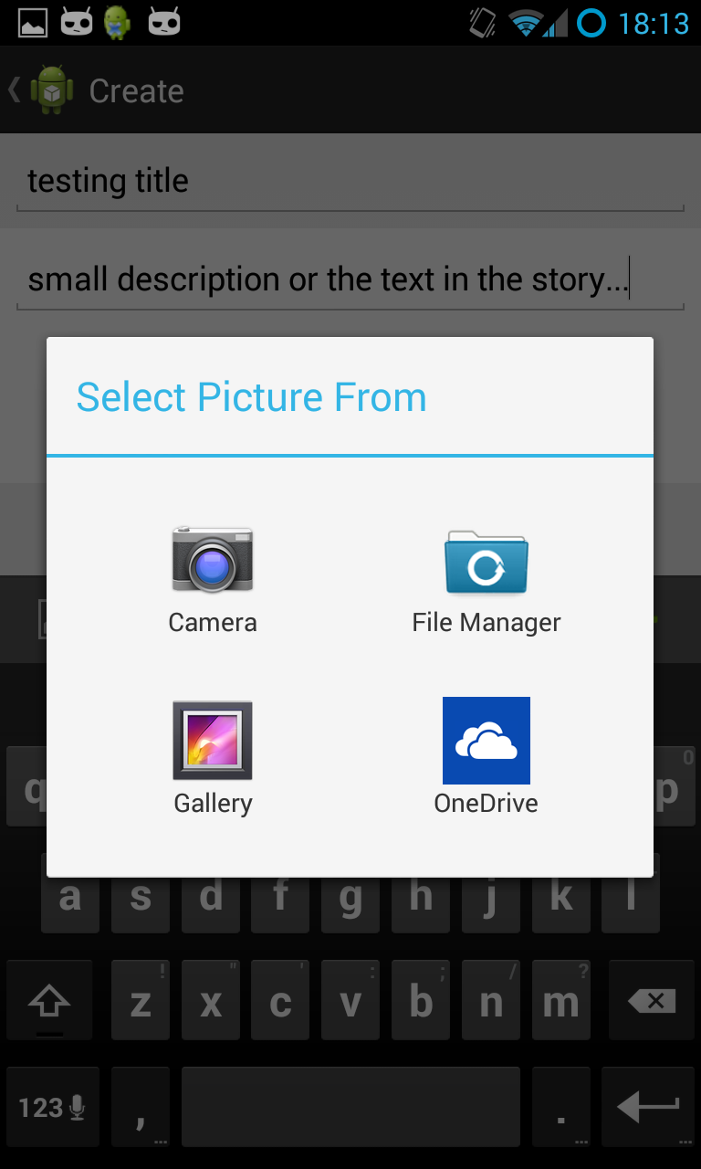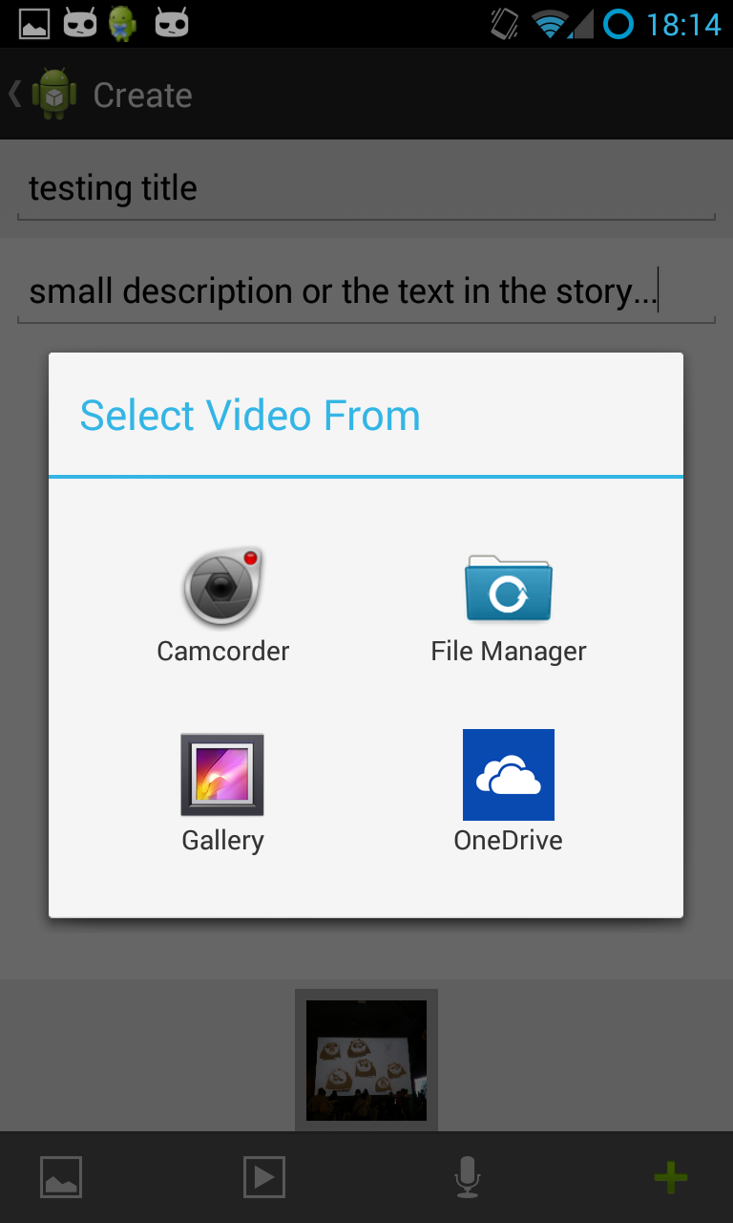

Image 3: App Camera and Video Icons
At the moment, the length of the recording and the number of images that an individual posts are restricted due to the amount of time needed to upload the data. Gursharan described these limitations during the focus group discussion:
Gursharan:
The basic camera app … like cameras today come in sixteen megapixels, thirteen megapixels, if someone is writing a story and puts … ten thirteen megapixel pictures in there, that story is worth around fifty to sixty MB. That’ll take like, ten to fifteen minutes to get up on the server and for people to see, that is if I use a camera app. But if I’m making my own apparatus for the camera, I can scale down that image from five MB to probably 15 KB. Those are the kind of things I have control over, the nitty-gritty of all the tiny modules.

Usability: how does the WYS app work and what does it currently enable?
During the participant feedback session held in July 2014, three of the original Think-Tank participants provided their ideas about their experiences of using the WYS app prototype, as well as providing comments about future functions for the WYS app. The participants’ comments from the feedback session also suggested that the WYS app is providing previously unaccessed potential for Aboriginal youth to control features that support their explorations of their culture and identity.

Adding the Title and Comments
During feedback, the participants commented that the requirements to provide a title prior to adding comments gave the WYS app a ‘personality’. Having this function available gave the participants the impression that the story was being written by a person – rather than being a standardised feature found on sites like Facebook.

Uploading stories on the WYS app and its mobility
Having a single app as a means for creating a story was viewed as one of the most significant affordances of the WYS app. Its mobility enabled it to be transported anywhere the user went. Participants commented that the accessibility of having one tool available on a mobile device to upload and share stories through multiple media (ie text, pictures, audio) was a key feature and eliminated the need to rely on multiple technologies, such as taking photos on a camera, uploading them to a computer and then sharing them via social media or email.
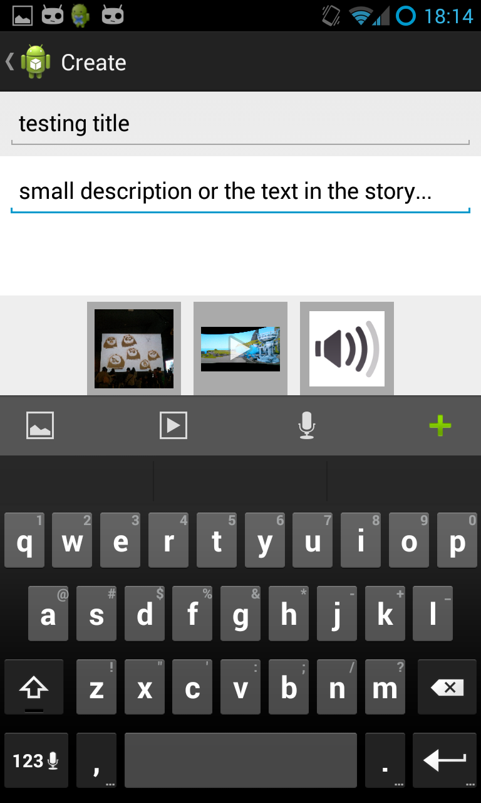
Image 4: App title and content

Future app functions and design
This section outlines future considerations in relation to the app function and design emerging from the focus group discussion, as well as recommendations from participants following their feedback session in July 2014. The participants also recommended that a number of additional functions and design elements would improve the WYS app.

Key features of the swipe menu
From the feedback session, among the participants’ main concerns were the current limitations to the swipe menu on the app. The app enables two swipe menus: one accessed from the right and one from the left. These allow users to swipe the menus across the face of the contents page.
The menu swiped from the right-hand side will eventually enable users to post information about themselves and others in the following categories:
- Stories
- People
- Videos
- Images

Currently, this feature is not operating. Further, the participants requested that they be able to organise their own stories, as well as those shared by others through this menu more efficiently. This included having specific categories for different story genres, eg comedy, drama etc. This would enable them to label, search and access the stories more readily.
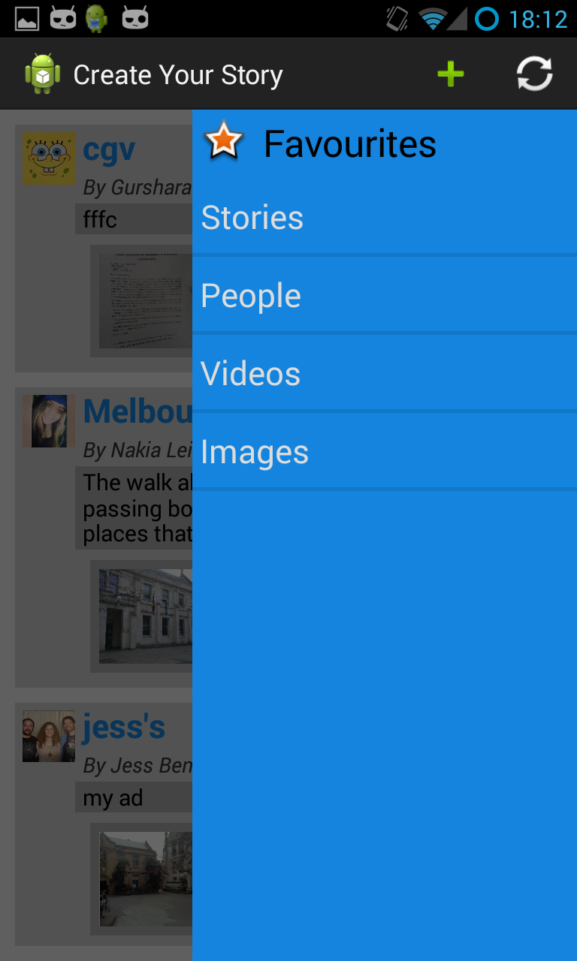
Image 5: App right hand swipe menu
Another menu is available to swipe from the left-hand across the contents page. This includes the following features:
- My Profile
- My Stories
- Need Help?
- About
- Log Out

At the moment, only the My Stories and the Log Out features are available. ‘My Stories’ provides a link back to the creators’ own uploads. During feedback, the participants were most concerned about accessing the My Profile feature. They emphasised the importance of being able to control what was known about them and suggested that the profile section should provide them with the capacity to upload their interests; to share details about themselves in ways determined by them. In this respect the My Profile feature was considered important to participants for building and asserting their identities.
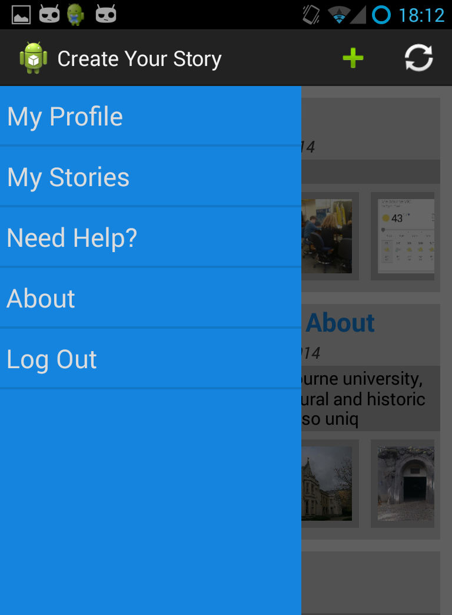
Image 6: App left hand swipe menu
Additional concerns and recommendations from participants are summarised below:
- Save feature: A ‘save’ feature for the stories was suggested so that stories could be saved before being submitted to the WYS app. This would also enable the user to edit the stories prior to uploading.
- Images and visuals: Currently, static images and video images are afforded and authors may use their own images or may download other images from the web. Once inserted, individual media can be re-ordered. More photographic filters were requested, particularly the capacity to take black and white photos, sepia images and photographic distortion filters.
- Flexible privacy and sharing knowledge/exchange settings:
Once the WYS app goes live, future considerations need to determine who can see the story and how best to control comments on stories.
- Graphics design, text and the WYS app’s aesthetic: During feedback participants suggested that the WYS app needs to be more aesthetically appealing. Participants commented that currently the WYS app ‘looks a bit like an old fashioned computer’. More relevant graphic designs, including logos, choices of font styles and different sizes for text, as well as colour choices were suggested.
- Combining Images with Text: Once the photos are uploaded, participants are keen for the text to be immediately visible below the image, so that the viewer can see the relation between the images and the text.
- Drawing onto the WYS app: This relates to the focus group suggestion that the WYS app could have the capacity to enable drawing directly into the story app, for instance, using a stylus that would enable the user to create images and designs for uploading onto the app.
- Sounds: The capacity to include audio was also a consideration for stories. Sound can be added in the form of audio files, these files would play just like regular music on a device.
- An app tutorial: Again, during the focus group discussion, participants suggested that they would like some guidelines, or a tutorial with sample stories to show them what could be achieved on the app. During the feedback session, this was also extended to include issues to do with the use of the Blog.
- Guidelines for using the ‘Create your Story’ Wordpress blog and linking it into the WYS app: Participants suggested that they needed more direction before using the blog. From the participants’ feedback it appears that the blog’s intention, i.e. to act as a site for posting ideas about what participants would like on the WYS app and suggestions relating specifically to future workshops, was not transmitted clearly to the participants. Future updates to the blog, however, will be enabled through a feature on the WYS app, providing a link to the blog through the WYS app and vice versa. Participants also commented that they found it difficult to find the weblink to the blog site, as most did not save the link to favourites. Access to the WYS app via the blog would eliminate this issue.
- The ‘Create Your Story’ Facebook site: Few participants in the feedback session realised that a Facebook site had been set up specifically for the project. Having a link to the Facebook site on the WYS app would alleviate this issue in future. The youth were interested in the Facebook site, and saw its potential for advertising the project more widely through peer and social networks. They envisaged it acting as an ‘ideas base’ where others from outside the project could post information about what they would like to see on the ‘app’ in terms of stories, thus creating an awareness of the WYS app and its future potential use among a wider audience.

Indigitalising the app: Cultural considerations and identity building
The participant’s feedback also touched on the personal and cultural considerations that the WYS app could provide in the future, particularly in relation to how they could customise the WYS app to support their identities (‘Indigitalising’). Their main considerations and concerns are discussed here.

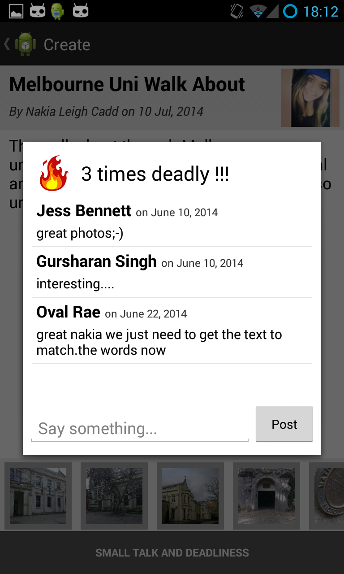
‘Deadly ‘= ‘Like’
The apps ‘comments’ feature, while providing users with the space to upload their stories, additionally enables those who are viewing the comments to click on the ‘Small Talk and Deadlines’ link and to ‘deadly’ the story if they like it. The ‘deadly’ feature also provides a space to ‘say something’ supportive of the story.
‘Deadly’ was a feature all the participants approved of. ‘Deadly’ is a common Australian Aboriginal word that is used to express a positive reaction to something that is considered really good. It replaces the ‘like’ feature on social media sites such as Facebook. In relation to this it was suggested that a notifications feature for stories could be devised so that you could ‘deadly’ (i.e. ‘like’) something immediately as it was uploaded by a ‘friend’. Practical considerations in relation to ‘friend’ notifications, however, were also discussed during feedback, as the numbers of eventual users of the WYS app may increase, making the number of notifications limitless. Therefore, devising a function that could limit the number of ‘friends’ you choose to have notifications from was considered essential.
Image 7: App 'Deadly' function
In relation to this, the capacity of the WYS app to provide the user with the ability to tag stories and to reply immediately to their ‘friends’ was recommended by participants. Anything that took too long to upload or search for was a ‘turn off’.
Furthermore, during the focus group discussion participants suggested that the WYS app could provide the capacity for co-authorship and group-authorship. This would also enable a number of users – particularly older generations – to interact and contribute to stories, perhaps providing additional cultural information to those created by younger people.

Naming the WYS app: using Aboriginal language(s)
During the feedback discussion participants were asked for their recommendations on naming the WYS app. The name ‘What’s ya Story’ was suggested, and like the word ‘Deadly’, is indicative of Aboriginal English, where Standard Australian English is adapted and reclaimed as a of way defining and expressing ones Aboriginality (Eades n.d.).
Options were also discussed for translating the WYS app into an Aboriginal language. As the workshop and construction of the WYS app took place on Wurundjerri country, it was suggested that the WYS app’s name – ‘What’s ya Story’ – could be translated into Woiwurrung language.
In Victoria, as Aboriginal languages are slowly being revitalised, the options for naming the WYS app in Woiwurrung must be considered by the local Wurundjerri council and translated by a community appointed linguist. A request to Wurundjerri council for this to occur has been issued.
It was recommended that eventually using Aboriginal language for items in the main menu alongside the English words would also assist in identifying the WYS app as an Aboriginal designed and accessible resource.
Further, the WYS app was also viewed as a tool for posting specific information about the local Aboriginal community, for instance NAIDOC week or other significant events or information that the users wished to share.

Location-specific stories
Drawing on the focus group discussion, recommendations for a GPS mapping feature to be integrated to the WYS app was suggested as a way of marking places that users visited or that relate specifically to the stories users were uploading. Key to this suggestion, as commented on earlier in this report, is the capacity for the map to designate Aboriginal connections to Country.

Creative approaches to storytelling
During the focus group discussion, participants were asked about the creative approaches to storytelling that the WYS app would provide. This focused on their access to collecting institutions such as the Koorie Heritage Trust or Bunjilaka, Museum Victoria, where there are opportunities to explore the material culture and contemporary and traditional artworks of their Ancestors.
In recent years southeast Australian artists have been major contributors to a public re-articulation of their Aboriginality, through the reclamation of art practices from that region (Edmonds 2010). This includes works that have revitalised understandings of cultural practices via contemporary reinterpretations of traditional culture, as well as incorporating new approaches to telling stories through artworks (Caruana 2014). In this project the digital medium is acknowledged as a creative space in which storytellers (authors/makers) can generate stories using a range of mediums. As discussed in the ‘What is a Story App?’ section above, participants’ ideas for the WYS app as a mobile resource for telling stories through photographs, videos, music, text and performance, etc. are connected with their capacity to envisage the design functions enabled by an app. This also includes its utility in enabling others to engage with their stories. However, there were limitations in participants’ imagining of stories through a more creative framework.
For example, while youth were able to articulate the benefits of visiting collecting institutions to inspire their stories, these were largely confined to the ideas that were generated during the mind mapping exercise undertaken at the beginning of the focus group discussion. These related to using photographs, videos, graphics, performance, sound and animations to construct stories, and in particular using maps in stories for revealing connections to Country. While there were discussions about the benefits of the WYS apps mobility to enable the user to share information from a cultural collecting institution (such as the Koorie Heritage Trust, the National Gallery of Victoria or the Melbourne Museum), there was little conceptualisation of the way that many items in collections and corresponding art practices (such as canoe-building, boomerang or possum-skin cloak-making to name a few), could be understood in terms of contemporary, innovative discourses that related to the individual storyteller and their cultural heritage.
As already discussed, participants suggested that other Aboriginal filmmakers would inspire them to tell their stories. Jess goes further in articulating how stories viewed in places like the Koorie Heritage Trust provide a way of revealing the past alongside contemporary Aboriginal issues, particularly stories that were hidden or are difficult to tell.
Jess, 15:
I like the room [at the Koorie Heritage Trust] where … people flash up and they’re talking [on a screen]…. I like that cos it’s interesting hearing about just them and their life ... I think that would be useful because it could inspire you to talk about yourself and your life…[this] kind of gives you the courage to tell your story because a lot of them are kept from everyone else.
While similar quotes, like the one above from Jess, were elicited from other participants, the idea that film, as the main creative practice for exploring stories, also provides an insight into the need for further scaffolding to enable youth to envisage how the diversity of art practices could initiate alternative ways of telling stories that connect them with Country and kin, but also with their everyday experiences of being a young Aboriginal person. This indicates that further interventions for working with a range of artists from digital, to visual and performance artists, as well as filmmakers, could promote alternative insights for storytelling options, particularly those that enable diverse and imaginative representations of stories. Understanding that art in all its manifestations enables another way of telling a story, would allow the user to take advantage of the creative capacity of digital devices and the affordances offered via the WYS app (Davey and Goudie 2009, Kral 2011).
The process of determining specifications for the WYS app hinged on the kind of the stories to be told, the distinctive significance of these stories for the participants, and the role of the WYS app in the storytelling process.
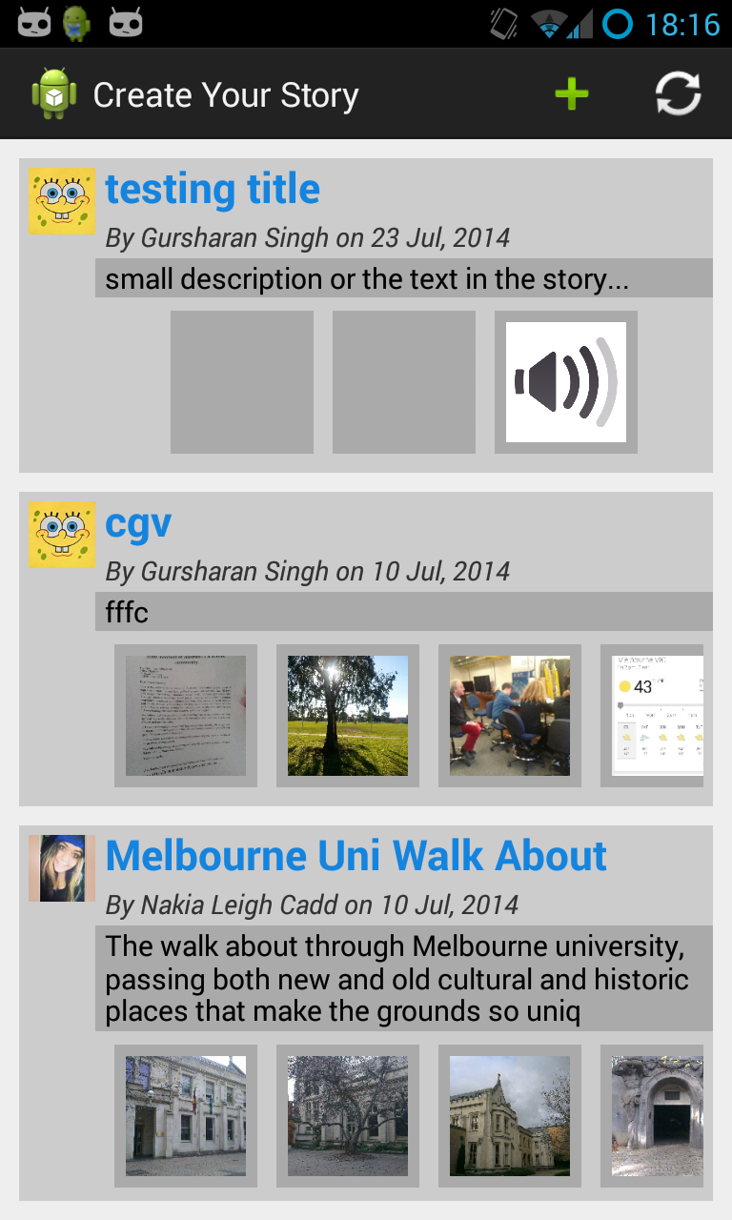
Image 8: App with uploaded content

Conclusions
This report has outlined the process of working with Aboriginal young people to develop a prototype digital mobile application. The process focused on working collaboratively with the Aboriginal community to understand how digital technology can assist Aboriginal youth in asserting representations of themselves, particularly as a way of reinforcing their identities in an online world.
Adopting a collaborative, community-based approach to the research responded to Aboriginal pedagogical approaches to learning, where older people and younger people were able to share experiences and learn from each other. By working with Aboriginal young people, their mentors and with the interdisciplinary research teams, the project adopted a broad interpretation of digital literacy, influenced by contemporary Aboriginal responses to knowledge exchange. These approaches recognised the importance of stories in Aboriginal culture to reveal Aboriginal knowledge, histories and the lived experiences of contemporary Aboriginal young people. Importantly, this project considered intergenerational and peer-to-peer knowledge exchange as vital in developing a storytelling app to support cultural connections and provide avenues for positive self-representations in the digital realm.
Further findings arising from the project included the importance of providing appropriate scaffolding that responds to and supports young people’s engagement with digital technology and online resources for creating and sharing knowledge through the digital medium. By adopting culturally inclusive and informal approaches to learning, the development of a digital storytelling app also responded to concerns for disseminating information in responsible and culturally safe ways. This included considerations for developing initiatives via the storytelling app that allowed users to move beyond the sharing of personal photos, videos and text recordings to provide alternative approaches for self-representation. Such processes expand on the first person, autobiographical approach to traditional digital storytelling models based on personal photos and videos, allowing for broader, creative storytelling frameworks that support Aboriginal worldviews. These worldviews integrate of all aspects of life and include art, song, performance and other cultural expressions, which support the transferal of cultural information from generation to generation.
These approaches were envisaged as part of an ongoing process for the development of a digital storytelling mobile application, which were considered simultaneously in line with the functionality and features of the app for determining the online cultural cybersafety of young Aboriginal people and their communities, as well as considerations for understanding the appropriate methods (or cultural protocols) for disseminating stories to audiences across global networks.
By centring the Aboriginal voice in the project, participants’ responses provided valuable information from their perspectives about the capacity for the storytelling app to reduce the participation gap, including approaches that enable Aboriginal people to engage with digital technology to achieve equality with non-Aboriginal Australians, particularly in education, employment, in reaping the benefits of the digital economy and in achieving active civic engagement as responsible cyber-citizens. Despite the WYS app being a prototype version it received positive responses from the young people involved in the project. Their ability to comprehend and envisage the app as the first step towards a fully functioning resource, designed and developed by them, attests to their commitment to having digital technology that can function specifically in ways that allow them to control technology for asserting their self-representations and for exploring their identities as contemporary Aboriginal young people.

Recommendations
The rapid uptake of mobile digital devices by Aboriginal youth is presenting new ways for youth to explore, produce and share information about themselves and their communities across broad social networks. The very nature of the online digital environment, which allows unlimited access to all kinds of knowledge, raises questions about how Aboriginal young people can safely engage in the digital realm to control and assert representations of themselves and their culture. Findings from this project suggest that by incorporating culturally inclusive approaches to understanding and improving digital literacy is necessary if Aboriginal people are to participate equally in and reap the benefits of the digital space. For this to occur the following points were considered important for the development of an Aboriginal-designed storytelling app:
- Collaborative and ongoing community consultations, with a range of experts including young people, are necessary to provide digital resources (e.g. a storytelling app) that reduce the ‘participant gap’ and assist in creating an equal media ecology.

- Appropriate scaffolding that supports culturally inclusive approaches to digital literacy is necessary, which includes adopting intergenerational and peer-to-peer knowledge exchange. This supports developing an awareness of cultural cybersafety for the responsible dissemination of information online.

- Initiatives that acknowledge the importance of Aboriginal cultural protocols for the production, dissemination and sharing of Aboriginal information online are necessary if Aboriginal people are to have control of their knowledge, including understandings of who they are and where they come in the online world.

- Enhancing knowledge of the creative capacity of digital technology to support Aboriginal self-representations, including those that support and promote the diversity of Aboriginality and contemporary Aboriginal youth identity.

Authors
Dr. Fran Edmonds is a collaborative researcher, whose work focuses on the anthropology of southeast Australian Aboriginal culture. Her research interests are interdisciplinary and include the intersection of Western and Indigenous knowledge systems, the reclaiming of Aboriginal material culture through digital technologies, the relationship between Aboriginal art and wellbeing, and the exploration of methodological approaches to cross-cultural research. Fran is the research fellow on the Australian Research Council Linkage Project ‘Aboriginal young people in Victoria and Digital Storytelling’.
Ms. Christel Rachinger is in her honours year in the Australian Indigenous Studies program at the University of Melbourne. She currently works as a tutor for the AIS program and previously worked as a research assistant on Keeping intouchable: A community report on the use of mobile phones and social networking by young Aboriginal people in Victoria (2012).
Mr. Gursharan Singh is a Masters student at the University of Melbourne, gadget lover and a tech enthusiast. An electronics engineer otherwise, with an interest in programming and computers, thus the switch to IT.
Dr. Richard Chenhall is a Senior Lecturer in Medical Anthropology in the Centre for Health and Society at the University of Melbourne. Richard teaches courses at the postgraduate level including Medical Anthropology and Social Science Research Methods. He is currently working on a number of projects focusing on the health of Aboriginal and Torres Strait Islander Peoples. Richard is a Chief Investigator on the Australian Research Council Linkage Project ‘Aboriginal young people in Victoria and Digital Storytelling’.
Dr. Michael Arnold is a Senior Lecturer in the History and Philosophy of Science Programme in the School of Historical and Philosophical Studies, at the University of Melbourne. His on-going teaching and research activities lie at the intersection of contemporary technologies and our society and culture.
Ms. Poppy de Souza has researched and written about audiovisual materials from a range of cultural institutions both as an educational writer for The Learning Federation and as a curator for Australian Screen (http://aso.gov.au) with The National Film and Sound Archive. She has also worked as a community-based digital storytelling facilitator in Canberra and Melbourne. She is currently completing her PhD at the Centre for Cultural Partnerships at the University of Melbourne.
Dr. Susan Lowish lectures in the School of Culture and Communication at the University of Melbourne. She has worked collaboratively with Indigenous organisations on digital archiving cultural heritage for over ten years, pioneered an innovative fieldwork subject involving partnerships with remote Indigenous communities in the Northern Territory, and co-ordinated one of the only University subjects on Indigenous New Media in Australia. Her recent publications include a co-authored chapter on digital archiving from AIATSIS Research Publications: Information Technologies and Indigenous Communities (2013).

Appendix A: web resource table
This table provides a list of websites, blogs, social media and mobile phone apps with Aboriginal and storytelling content. It is not a definitive list but rather provides a general survey of the diversity and range of media made by and about the Aboriginal community in relation to storytelling; and to storytelling sites in general.
Websites – Aboriginal Community
Name/ Organisation | Themes and Content | URL Link
Generator Indigenous Australian Voices / ACMI | Provides digital stories by Indigenous youth, filmmakers and other personal narratives exploring diverse themes surrounding Indigenous identity and perspectives. | http://generator.acmi.net.au/education-themes/indigenous-australian-voices-1
Namatjira Project / Big hART | Long term community development project that produced, theatrical work, exhibition, documentary film and iPhone App. The site provides digital stories on the project and additional resources. | http://www.namatjira.bighart.org/
Blacktracker App / ABC Heywire | Site provides a film of the Winners of the ABC Heywire Regional Youth Summit, presenting their idea for an app, which would provide information of local traditional owners, culture and history using GPS software. | http://www.abc.net.au/heywire/stories/2012/02/3438106.htm
Ngurra Kuju Walyja / Canning Stock Route Project | Presents Aboriginal artists’ connections to the Canning Stock Route through oral histories, painting stories, and digital film. Site presents background information on communities, contributors, histories, exhibitions, films, and links to digital archive resources. | http://www.canningstockrouteproject.com/about/
The Mulka Project | Showcases the latest new media, film, audio and archives produced by and added to the Yolngu community resource called ‘Mulka’, meaning sacred, by public ceremony, and to hold or protect Yolngu cultural knowledge in Northeast Arnhem Land under the leadership of community members. | http://www.yirrkala.com/themulkaproject/about
PAW Media | A website for one of the longest running Media Associations in Australia, Pintubi, Anmatjere and Warlpiri (PAW) Media, provides information and samples of their work in film, radio, and archiving, including a community video production on cyber safety. | http://www.pawmedia.com.au/library/cybersafety-1371
Twelve Canoes | A website that presents twelve linked short audio-visual stories, some companion short videos, 120 photographs and art pieces, and music files, of the people, history, culture and place of the Yolngu people of north-central Arnhem Land. | http://www.12canoes.com.au/
Gary Foley’s the Koori History Website | A website designed and operated by Gary Foley, containing essays, images, educational resources, archival documents. | http://www.kooriweb.org/foley/indexb.html
Warlpiri Education and Training Trust (WETT) Youth and Media Project | The WETT project provides youth services with a focus on media training and employment across the Warlpiri region, supporting Warlpiri youth to develop their sense of self, family and culture through diversionary programs with a special focus on media. | www.wettmedia.org.au
The Ara Irititja Project | A website showcasing the Ara Irititja digital archives in Anangu communities in South Australia, the Northern Territory and Western Australia, explaining that Anangu navigate the digital archive, write in information, stories and reflections, and use passwords to restrict access to specific items. | http://www.irititja.com/index.html
cyberTribe | cyberTribe is an online gallery that promotes the work of Indigenous Artists internationally. The first exhibition was launched in August 2000 and cyberTribe continues with support from the Arts, Technology and Indigenous Communities that it seeks to represent. | http://www.cybertribe.culture2.org/
Boomalli Aboriginal Artists Co-operative | Website for one of Australia's longest running Aboriginal owned and operated art galleries. Links to Facebook, Flicker, Blogspot and Wordpress. | http://www.boomalli.com.au/about.html
Mission Voices | A website developed in partnership with the Koorie Heritage Trust, Film Victoria, the State Library of Victoria and the ABC. Allows users to engage with first hand accounts of life on Aboriginal Missions in Victoria through a number of oral history recordings, combined with educational resources. | http://www.abc.net.au/missionvoices/general/about/default.htm
Websites – Mainstream
Name/ Organisation | Themes and Content | Link
Digital Storytelling / ACMI | Information on the ACMI Digital Storytelling Program for producing 3-4 minute films. The page provides a showcase of digital stories made in the program. | http://www.acmi.net.au/digital_stories.htm
Generator / ACMI | Provides creative resources for producing moving image work, including themes, video gallery and media library. | http://generator.acmi.net.au/resources
Creative Commons | Mission: “Creative Commons develops, supports, and stewards legal and technical infrastructure that maximizes digital creativity, sharing, and innovation. | http://creativecommons.org/about
DigCCMixer | Online resource that provides free sound and music for commercial use. | http://dig.ccmixter.org/
CourseWeb Illinois | Provides literature and resources for educators and users on how to create a digital story, as well as an extensive range of links to production resources and digital storytelling examples. | http://courseweb.lis.illinois.edu/~jevogel2/lis506/index.html
BBC Capture | Written manual “A Guide to Digital Storytelling” looking at story development, capture, editing and sharing. | http://www.bbc.co.uk/wales/audiovideo/sites/yourvideo/pdf/aguidetodigitalstorytelling-bbc.pdf
Digital Storytelling with the iPad. | A website promoting the use of digital story telling in the classroom, with links to many free and low cost digital storytelling apps: All-in-one, Audio, Images, Storyboarding, etc. | https://sites.google.com/site/digitalstorytellingwiththeipad/home
Educational Technology and Mobile Learning - 5 Good Digital Storytelling Apps for Android | A website maintained by a PhD student, Med Kharbach, that lists apps and has short posts that evaluate and describe various apps and technology for education and mobile learning. | http://www.educatorstechnology.com/2013/07/5-good-digital-storytelling-apps-for.html
Stories Project | An Australia Council funded initiative, recording digital stories from two diverse locations per year. Launched in 2010 and described as a mix between art and journalism. | http://thestoriesproject.com.au/about/
CuriousWorks | CuriousWorks enables communities to tell their own stories by providing training and mentorship in digital story production, including cultural leaders, community, and enterprise programs. | http://curiousworks.com.au/stories/our-purpose/
Co-Creative Communities: Storytelling Futures for Community Arts and Media | Website for ARC Linkage project that uses Digital Storytelling and similar co-creative media production methods to demonstrate how to improve the coordination of sustainable participation and innovation in digital content creation across the Australian community arts, community broadcasting and Indigenous media systems. | http://digitalstorytelling.ci.qut.edu.au/index.php/events
Interactive Sites, Blogs, Social Media – Aboriginal Community
Name/ Organisation | Themes and Content | URL Link
ABC Open - DreamBox | Developed for NAIDOC Week, an interactive site that uses photography to share the dreams and aspirations of Aboriginal people from throughout Australia. | https://open.abc.net.au/projects/dreambox-41gz2pv#/discover
IndigiTUBE | An online community resource for sharing and accessing media made by and for Indigenous people in remote Australia. | http://www.indigitube.com.au/
Community Stories | Community Stories internet database, which enables the community to establish a unique digital collection of local knowledge by creating, adding and repatriating content related to their own culture and history. | http://artsandmuseums.nt.gov.au/northern-territory-library/programs-and-projects/our_story_version_2_project
Yijala Yala Project | A multi-platform arts project based in Ieramugadu (Roebourne) focused on communicating the community’s culture, history and future in a range of media: theatre, film, games, iPad applications and music. | http://www.yijalayala.bighart.org/neomad/love-punks-2/
Indigenous Archives Network | An online forum for information exchange, collaboration and discussion around Indigenous archives, libraries, galleries, museums and keeping places. | http://indigenousarchives.net/
Ngaannyatjarra Media | A facebook site for NG Media, empowering Yarnangu to create and share their own stories through multi media activities including: training, recording, producing and broadcasting; IT training and access; tech services; archiving, website development and communications infrastructure. | https://www.facebook.com/NgaannyatjarraMedia
Talking Story / Mt Theo | A website detailing activities, achievements and initiatives of the Warlpiri Youth Development Corporations. This particular section of the much larger website includes: Red Sands Culture Clips. A seriese of short stories online. | http://mttheo.org/home/category/talking-story/
Ngapartji Ngapartji online language course / Big hART | This online learning site is a legacy aspect of the art-language project Ngapartji Ngapartji – a long-term, inter-generational language and arts project that was based on Arrernte country in Mparntwe (Alice Springs, Central Australia). | http://ninti.ngapartji.org/splash.php?welcome=you
Bunjilaka / Museum Victoria | A selection of blog posts detailing the work leading up to the opening of the First Peoples Exhibit, including photographs, short films, interviews and comments from community members. | http://museumvictoria.com.au/about/mv-blog/categories/bunjilaka/
Samia Goudie’s Hopevale digital storytelling blog site | “Blog is about stories and specifically the use of new media and Digital storytelling. I am interested in how using new technology, especially Digital storytelling is being used in Indigenous Communities. How do we bring our old ways and new ways together in ways that support our social, emotional, cultural and spiritual wellbeing !” | http://samiastories.wordpress.com/
Caning Stock Route: One Road Project | A visually stunning website, based on the National Museum of Australia exhibition held in 2008. It includes information on the collection of artworks associated with Aboriginal communities located along the Stock Route. There are also links to an ‘app’ developed for the project. It also contains links to a blog and various multimedia. | http://www.canningstockrouteproject.com/digital-futures/one-road/
Interactive Sites, Blogs, Social Media – Mainstream
Name/ Organisation | Themes and Content | URL Link
15 Second Place / ACMI | This site provides resources for users and educators, to create 15-second stories about place. The site provides access to the associated App. | http://15secondplace.acmi.net.au/
ABC Open | Digital stories from across Australia, with opportunities to develop skills and contribute content through regional producers. | https://open.abc.net.au/
Museum Victoria – Making History | Provides advice and examples to assist in making and uploading a personal digital history based on themes such as cultural identity, family and community life. | http://museumvictoria.com.au/discoverycentre/websites/making-history/
‘Free Technology for Teachers’ - 5 Fantastic Apps for Digital Storytelling on iPads | A blog post by Richard Byrne that shares and reviews free digital storytelling apps, describing their best functions, and how students might use them in the classroom. | http://www.freetech4teachers.com/2013/10/5-fantastic-apps-for-digital.html - .U6Fqu_aHq45
Apps for Smartphones and Tablets – Aboriginal Community
Name/ Organisation | Themes and Content | URL Link
Big hART – Watercolours of Namatjira | The app replicates watercolour techniques allowing the user to create unique desert landscapes. | https://itunes.apple.com/us/app/watercolours-of-namatjira/id511590761?mt=8
Indigenous Australian: Art Gallery of NSW | Allows the user to explore a range of Indigenous artists and artworks, including stories of the artists and the art. | http://www.artgallery.nsw.gov.au/visit-us/plan-your-visit/mobile-and-wifi/indigenous-app/
i-Stories NTLanguages – Anindilyakwa | Language: Aboriginal Language Flash Card App designed for as a bilingual literacy tool. Contains 20 everyday words and phrases in Anindilyakwa and English | http://artsandmuseums.nt.gov.au/northern-territory-library/programs-and-projects/flash-card-app
Legendary Pacific Coast App | Oral history: This app is for use whilst travelling the coast between Brisbane and Sydney. It includes a “Story Regions” menu to hear Aboriginal stories from particular regions. | https://itunes.apple.com/app/legendary-pacific-coast/id399378701?mt=8
Aboriginal Sydney – by AIATSIS | Provides information on the history & culture of Aboriginal Sydney with self-guided audio-supported tours, covering heritage & rock art sites, as well as contemporary Australian Indigenous places of significance. | https://itunes.apple.com/au/app/aboriginal-sydney/id589678908?mt=8
One Road Stock Route Project – Web App | Interactive Web App that enables the user to move around an interactive map with access to histories, photographic images, films and traditional languages connected to the region. | http://oneroad.canningstockrouteproject.com/#
The Yugambeh Language App | Queensland's first Aboriginal Language App for Apple and Android mobile devices, developed by the Yugambeh Museum. | http://thedrumleywalk.com/resources/HTML5_3/index.html
Ngurrara - Australian Aboriginal Interactive Storybook App | Developed by Weerianna Street Media, this App includes illustrations with sound, animation and voice overs, Ngarluma language with English translation, also rock art carving application | http://www.icampfire.tv/country-places/country/Ngurrara-iPad-App.Html
Warlu Song - Australian Aboriginal Interactive Storybook for iPad | Based on a story originally dreamt by a blind songsmith, sung in Yindjibarndi and spoken in English. This app includes a film of the late Ned Cheedy singing Warlu Song at a corroboree and a 'Learn the Song' feature where the user can tap the lines to hear pronunciation. | https://itunes.apple.com/au/app/warlu-song-australian-aboriginal/id660554154?mt=8
NEOMAD - an interactive iPad app | “Set over three episodes, follows the story of the Love Punks, a group of techno savvy young heroes from the Pilbara who speed through a digitised desert full of spy bots, magic crystals, fallen rocket boosters and mysterious petroglyphs. Initially released as an interactive iPad app, the series is now also available in book form.” | http://www.yijalayala.bighart.org/neomad/
Mukurtu CMS | Free, mobile and open source platform built with indigenous communities to manage and share digital cultural heritage | http://www.mukurtu.org/
Apps for Smartphones and Tablets – Mainstream
Name/ Organisation | Themes and Content | URL Link
15 second place / ACMI | App for creating and sharing 15 second stories. Resources and examples are provided for users and educators on the associated 15 Second Place website. | https://itunes.apple.com/au/app/15-second-place/id452161151?mt=8
StoryKit / ICDL Foundation | An iOS app that allows users to easily create an electronic storybook via illustrations by drawing on the screen, using pictures and text, and recording audio to attach to stories. | https://itunes.apple.com/us/app/storykit/id329374595?mt=8
i-Tell-a-Story / | This is a free app that allows users to narrate and record their stories with their own voice and language. | https://itunes.apple.com/us/app/i-tell-a-story/id420367212?mt=8
Audioboo / Audioboo Ltd | This app allows users to record and share their voice online. They can also add pictures, titles, tags before uploading it and sharing it via Facebook, Twitter and many other social networks. | https://itunes.apple.com/us/app/audioboo/id305204540?mt=8
Storyrobe / Storyrobe Inc. | An app for adding narration to photographs that can be sent to YouTube. Also, saves the story to the camera roll then you can import into iPhoto. | https://itunes.apple.com/us/app/storyrobe/id337670615?mt=8
Sonicpics / Humble Daisy, Inc. | App that can turn photographs into narrated slideshow movies to share as an enhanced m4v movie. | https://itunes.apple.com/au/app/sonicpics/id345295488?mt=8
Videolicious / | An app for tablet and phone that allows users to compile and edit video and still image footage, together with a selection of licensed music to create your own multimedia story. | https://videolicious.com/
Frameblast / | An app that combines recordings with screenshots, music and video. It comes with 10 different preset editing styles and filters. | http://www.frameblast.com/
Pinnacle Studio / Corel Inc. | An app that edits video, audio, and photos and arranges clips in Storyboard, for edits using Timeline, and add high-quality transitions, effects, and a soundtrack. And share movies directly to YouTube, Facebook, and Box. | https://itunes.apple.com/app/pinnacle-studio/id552100086?mt=8

References

Adelson, N. and M. Olding (2013). "Narrating Aboriginality On-Line: Digital Storytelling, Identity and Healing." The Journal of Community Informatics vol. 9(no.2).
Altman, J. C. (2005). Brokering Aboriginal Art: A critical perspective on marketing, institutions, and the state. Geelong, Deakin University.
Arts Law Centre of Australia (2011). Artists in the Black Information Sheet: Indigenous Cultural and Intellectual Property (ICIP). A. L. Centre. Wooloomooloo.
Australian Centre for the Moving Image (ACMI). (n.d.). "Our Story." Retrieved 29 July, 2014, from http://www.acmi.net.au/our_story.htm.
Australian Human Rights Commission (2011). Social Justice Report 2011. Aboriginal and Torres Strait Islander Social Justice Commissioner. Sydney, Australian Human Rights Commission.
Australian Human Rights Commission (2013). Social Justice and Native Title Report 2013. Aboriginal and Torres Strait Islander Social Justice Commissioner. Sydney, Australian Human Rights Commission.
Australian Insititute of Aboriginal and Torres Strait Islander Studies (AIATSIS) (2009). Developing Indigenous Social Capital and Opportunity in the Digital Economy: A Response by the Australian Insititute of Aboriginal and Torres Strait Islander Studies (AIATSIS) to the Digital Economy Future Directions Consultation Paper. Canberra, AIATSIS.
Bandias, S. (2010 (April)). "Building Indigenous Social Capital in an Online World." PLATFORM: Journal of Media and Communication ANZCA Special Edition: 38-51.
Biddle, N. (2010). "A Human Capital Approach to the Educational Marginalisation of Indigenous Australians." Centre for Aboriginal Economic Policy Research (CAEPR) Working Paper no. 67/2010.
Bidwell, N. J., T. Reitmaier, G. Marsden and S. Hansen (2010). Designing with mobile digital storytelling in rural Africa. 28th International Conference: Human Factors in Computing Systems, Atlanta, Georgia.
Bird, S. E. (2011). "Are we all produsers now? Convergence and media audience practices." Cultural Studies 25(4-5): 502-516.
Burgess, J., H. Klaebe and K. McWilliam (2010). "Mediatisation and Institutions of Public Memory: Digital Storytelling and the Apology." Australian Historical Studies 41(2): 149-165.
Carson, B., T. Dunbar, R. Chenhall and R. Bailie, Eds. (2007). Social Determinants of Indigenous Health. Crows Nest, NSW, Allen and Unwin.
Caruana, W. (2014). "Reflecting times." Artlink 34(2): 63-[65].
Christie, M. and H. Verran (2013). "Digital lives in postcolonial Aboriginal Australia." Journal of Material Culture 18(3): 299-317.
Collin, P., K. Rahilly, I. Richardson and A. Third (2011). The Benefits of Social Networking Services: A literature review. Melbourne, Cooperative Research Centre for Young People, Technology and Wellbeing
Commonwealth Consumer Affairs Advisory Council (2013). App purchases by Australian consumers on mobile and handheld devices: Inquiry Report. Canberra, Commonwealth of Australia.
Commonwealth of Australia (2011). 'Closing the Gap': Prime Minister's Report 2014. Canberra, ACT, Department of the Attorney General
Commonwealth of Australia (2013). Issues Surrounding Cyber-Safety for Indigenous Australians: Joint Select Committee on Cyber-Safety, Commonwealth of Australia
Davey, N. and S. Goudie (2009). "Hope Vale digital storytelling project using the camera: telling stories our way." Journal of Community, Citizen's and Third Sector(5): 28-48.
Davis, T. and R. Moreton (2011). "'Working in Communities, Connecting with Culture': Reflecting on U-matic to YouTube a National Symposium Celebrating Three Decades of Australian Indigenous Community Filmmaking." Screening the past(31).
Deger, J. (2006). Shimmering Screens: Making Media in an Aboriginal Community, University of Minnesota Press.
Department of Communications Information Technology and the Arts (DCITA) (2005). The social impact of mobile phone use in Australia: A review of data sources. Canberra, Commonwealth of Australia.
Department of Education and Early Childhood Development (DEECD) (2010). Teaching and Learning with Web 2.0 technologies: Findings from 2006-2009. Melbourne, DEECD.
Department of Education and Early Childhood Development (DEECD), Victorian Department of Human Services, Victorian Department of Health, Victorian Department of Planning and Community Development and Victorian Department of Justice (2010). The state of Victoria's children 2009: Aboriginal children and young people in Victoria. Melbourne, Victoria
Eades, D. (n.d.). "Language varieties: Aboriginal English." Retrieved 23 July, 2014, from http://www.hawaii.edu/satocenter/langnet/definitions/aboriginal.html.
Eades, J., H. Simondson and K. Thompson (2011). "Victorian Indigenous Communities and Digital Storytelling." Screening the Past(31).
Edmonds, F. (2010). "'We have survived': South-east Australian Aboriginal art exhibitions since 1988." reCollections: Journal of the National Museum of Australia 5(1).
Edmonds, F. (2014 (forthcoming)). Digital storytelling and Aboriginal young people: an exploration of digital technology to support contemporary Koori culture. Creative Mobile Media: Mobile Media Making In An Age Of Smartphones. M. Berry and M. Schleser. Melbourne, Palgrave MacMillan.
Edmonds, F., R. Chenhall, M. Arnold, T. Lewis and S. Lowish (2014). Telling our Stories: Aboriginal young people in Victoria and Digital Storytelling, IBES, The University of Melbourne.
Edmonds, F. and M. Clarke (2009). 'Sort of Like Reading a Map': A Community Report on the History of South-East Australian Aboriginal Art since 1834 Darwin, Co-operative Research Centre for Aboriginal Health, Darwin.
Edmonds, F., C. Rachinger, J. Waycott, P. Morrissey, O. Kelada and R. Nordlinger (2012). ‘Keeping Intouchable’: A community report on the use of mobile phones and social networking by young Aboriginal people in Victoria. Melbourne, Institute for a Broadband-Enabled Society (IBES), University of Melbourne.
Faulkhead, S., J. Evans and H. Morgan (2005). "Is technology enough? developing archival information systems in community environments." Journal of the Eastern and Southern Africa Regional Branch of the International Council on Archives. 24: 74-95.
Ferdinand, A., Y. Paradies and M. Kelaher (2012). Mental Health Impacts of Racial Discrimination in Victorian Aboriginal Communities: The Localities Embracing and Accepting Diversity (LEAD) Experiences of Racism Survey. Melbourne, The Lowitja Institute.
Goggin, G. (2013). "Youth culture and mobiles." Mobile Media & Communication 1(1): 83-88.
Hides, L. (2014) "Are SMARTapps the future of youth mental health?" Australian Psychological Society.
Hinkson, M. (2008). New media projects at Yuendumu: Towards a history and analysis of intercultural engagement. The Power of Knowledge, the Resonance of Tradition. G. W. Luke TAYLOR, Graham HENDERSON, Richard DAVIS & Lynley WALLIS (eds), Aboriginal Studies Press.
Hogan, E., E. Rennie, A. Crouch, A. Wright, R. Gregory and J. Thomas (2013 ). Submission to the Inquiry into Issues surrounding Cyber-safety for Indigenous Australians. . M. Swinburne University of Technology.
Hooley, N., T. Watt and E. Dakich (2013). Learning in Motion: Connecting Schools and Knowledge for Aboriginal and Torres Strait Islander Children
Investigating iPads for learning and literacy. Victoria University Melbourne.
Human Rights and Equal Opportunity Commission (HREOC) (1997). Bringing them Home. National Inquiry into the Separation of Aboriginal and Torres Strait Islander Children from Their Families. Canberra, Commonwealth of Australia.
Janke, T., Ed. (2007). Managing Indigenous Knowledge and Indigenous Cultural and Intellectual Property. Australian Indigenous Knowledge and Libraries, Sydney: UTSePress.
Klaebe, H. and J. Burgess (2008). Oral History and Digital Storytelling Review: A report prepared for the State Library of Queensland. Brisbane, State Library of Queensland.
Klaebe, H., G and J. Burgess, E (2010). A story worth telling : putting oral history and digital collections online in cultural institutions. 16th International Oral History Conference Between Past and Future (2010 IOHA) (Unpublished)]. Prague, Czech Republic
Klaebe, H. G. and M. Foth (2007). "Connecting communities using new media: The sharing stories project." Constructing and sharing memory: community informatics, identity and empowerment: 143-153.
Koorie Heritage Trust. (2014). "Blaktracks program." from http://www.koorieheritagetrust.com/training/accredited_courses/blaktraks.
Koorie Youth Council. (2013). "Young Koories say NO to racism and lateral violence online." Retrieved 20th December, 2013, October 2013, from http://viyac.org.au/kyc/what-is-kyc/news/.
Kral, I. (2010). "Generational Change, Learning and Remote Australian Indigenous Youth." Centre for Aboriginal Economic Policy Research (CAEPR) Working Paper 68/2010.
Kral, I. (2010). "Plugged in: Remote Australian Indigenous Youth and Digital Culture." Centre for Aboriginal Economic Policy Research (CAEPR) Working Paper(no. 69/2010).
Kral, I. (2011). "Youth media as cultural practice: remote Indigenous youth speaking out loud." Australian Aboriginal Studies(1).
Kral, I. (2014). "Shifting perceptions, shifting identities: Communication technologies and the altered social, cultural and linguistic ecology in a remote indigenous context." The Australian Journal of Anthropology.
Kral, I. and R. G. Schwab (2012). Learning Spaces﻿: Youth, Literacy and New Media in Remote Indigenous Australia, Australian National University. E Press.
Kvan, T. (2000). "Collaborative design: what is it?" Automation in construction 9(4): 409-415.
Lane, C. (2014). "Truth is better than fiction." Artlink 34(2): 26.
Lloyd, R. and A. Bill (2004). "Australia online: how Australians are using computers and the internet." Canberra: Australian Census Analytic Program, Australian Bureau of Statistics.
MacLean, S., D. Warr and P. Pyett (2008). Universities Working with and for Communities: Strategies for Collaborative Community Research and Knowledge Exchange. Policy Signpost #2. T. M. C. V. C. f. t. P. o. M. H. a. C. Wellbeing, University of Melbourne.
Marcus, G. E. (2007). "Collaborative Imaginaries." Taiwan Journal of Anthropology vol.5 (no.7): 1-17.
Martin, K. and B. Mirraboopa (2003). "Ways of knowing, being and doing: A theoretical framework and methods for indigenous and indigenist re‐search." Journal of Australian Studies 27(76): 203-214.
Martin, K. B. M. (2003). Ways of Knowing, Ways of Being and Ways of Doing: Developing a theoretical framework and methods for Indigenous re-search and Indigenist research. 'Voicing Dissent': Journal of Australian Studies. K. McWilliams, P. Stephenson and G. Thompson, St Lucia, Australian Public Intellectual Network and University of Queensland Press: 203-257.
Metcalf, A., M. Blanchard, T. McCarthy, L. Phillips, M. Hartup and J. Burns (2010). 'Bridging the Digital Divide': Engaging young people in programs that use information communication technology to promote civic participation and social connectedness. Melbourne, Inspire Foundation and ORYGEN Youth Health Research Centre, University of Melbourne. Report no. 3, May 2010.
Mignone, J. and H. Henley (2009). "Impact of Information and Communication Technology on Social Capital in Aboriginal Communities in Canada." Journal of Information, Information Technology, and Organizations 4: 127-145.
Morrissey, M., A. Brown and A. Latif (2007). Culture as a Determinant of Aboriginal Health. Beyond bandaids: exploring the underlying social determinants of Aboriginal health. I. Anderson, F. Baum and M. Bentley: 239-254.
Nakata, M. (2007). "The cultural interface." The Australian Journal of Indigenous Education 36(Supplement): 7-14.
Nakata, M. and M. Langton (2007). Australian Indigenous Knowledge and Libraries, Sydney: UTSePress.
Notley, T. and M. Foth (2008). "Extending Australia's digital divide policy: an examination of the value of social inclusion and social capital policy frameworks." Australian Social Policy Journal 7: 87.
Notley, T. and J. A. Tacchi (2005). "Online youth networks: researching the experiences of 'peripheral' young people in using new media tools for creative participation and representation." 3CMedia: Journal of Community, Citizen's and Third Sector Media and Communication,= vol. 1(no. 1): 73-81.
Peters-Little, F. (2002). "'Yet Another End Of An Aboriginal Film-Maker's Journey': A Personal Account of Aboriginal Documentary Filmmaking in the ABC." Hecate 28(1): 42.
Phipps, P. and L. Slater (2010). Indigenous Cultural Festivals: Evaluating the Impact on Community Health and Wellbeing. Melbourne, Globalism Research Centre, RMIT University.
Sabiescu, A. (2009). Collaborative digital storytelling as an intergenerational hub for cultural representation in traditional communities PhD Colloquium, 6th Prato Community Informatics & Development Informatics Conference 2009: Empowering communities: learning from community informatics practice. Monash Centre, Prato, Italy: 1-14.
Sadauskas, A. (2014). "Apple iPhone’s Australian market share falls to around 35%, as Android establishes a clear lead in most markets except Japan." Smart Company Retrieved 23 July, 2014, from http://www.smartcompany.com.au/technology/trends/35819-apple-iphone-s-australian-market-share-falls-to-around-35-as-android-establishes-a-clear-lead-in-most-markets-except-japan.html.
Satchell, C. and G. Connor (2010). "Conveying identity with mobile content." Pers Ubiquit Comput 14: 251–259.
Secretariat of National Aboriginal and Islander Child Care Inc. (SNAICC) (2010). Working and Walking Together: Supporting Family Relationship Services to Work with Aboriginal and Torres Strait Islander Families and Organisations. Melbourne.
Simondson, H. (2009). "Connecting through digital storytelling " 3CMedia: Journal of Community, Citizen's and Third Sector Media and Communication(5).
Smith, L. T. (1999). Decolonizing methodologies: Research and Indigenous peoples. Dunedin, N.Z., University of Otago Press.
Spurgeon, C., J. Burgess, E, H. Klaebe, G, K. McWilliam, J. Tacchi and M. Tsai (2009). Co-creative Media: Theorising Digital Storytelling as a platform for researching and developing participatory culture. ANZCA09 Communication, Creativity and Global Citizenship: Refereed Proceedings: http://anzca09.org. Brisbane, July 2009: 274-286.
Stephens-Reicher, J., A. Metcalf, M. Blanchard, C. Mangan and J. Burns (2011). "Reaching the hard-to-reach: how information communication technologies can reach young people at greater risk of mental health difficulties." Australasian Psychiatry 19(1).
Sweet, M. A., P. Dudgeon, K. McCallum and M. D. Ricketson (2014). "Decolonising practices: can journalism learn from health care to improve Indigenous health outcomes?" The Medical journal of Australia 200(11): 626-627.
The Korin Gamadji Institute (KGI) (2014). Richmond Emerging Aboriginal Leaders (REAL) Program Information Pack. K. G. Institute. Melbouren.
Third, A., I. Richardson, P. Collin, K. Rahilly and N. Bolzan (2011). Intergenerational Attitudes towards Social Networking and Cybersafety: A Living Lab. Melbourne, Cooperative Research Centre for Young People, Technology and Wellbeing,.
Thompson, K. (2010). "Pitcha This - Indigenous Deep Listening Project. ." Retrieved 10th November, 2013, from http://www.youtube.com/watch?v=csy1FdjOu8M.
Vickery, J., A. Clarke and K. Adams (2005). Nyernila Koories Kila Degaia. Listen up to Koories speak about Health. Melbourne, Koorie Heritage Trust Incorporated, Onemda VicHealth Koori Health Unit.
Victorian Health Promotion Foundation (VicHealth) (2010). Opportunities for social connection: A determinant of mental health and wellbeing. Summary of learnings and implications. Melbourne, VicHealth.
Vivienne, S. and J. Burgess (2013). "The remediation of the personal photograph and the politics of self-representation in digital storytelling." Journal of Material Culture 18(3).
Walsh, L., B. Lemon, R. Black, C. Mangan and P. Collin (2011). The role of technology in engaging disengaged youth: final report. Australian Flexible Learning Framework, Department of Education, Employment and Workplace Relations: 32.
Watkins, S. C. (2011). "Mobile Phones and America’s Learning Divide." The Young and the Digital http://theyoungandthedigital.com/2011/05/27/mobile-phones-and-americas-learning-divide/w 2013.
Wegner, E. (1998). Communities of Practice: Learning, Meaning, and Identity,, Cambridge University Press.
Young and Well Cooperative Research Centre. (2012). "Engaging Creativity Through Technology: Reaching, engaging and connecting vulnerable young people through digital media production." from http://www.youngandwellcrc.org.au/research/connected-and-creative/engaging-creativity-technology/ - sthash.FO9m3mIf.dpuf.
Young and Well Cooperative Research Centre. (2013). "Connected and Creative." Retrieved 5th October, 2013, from http://www.yawcrc.org.au/connected-and-creative/engaging-creativity
Young and Well Cooperative Research Centre (n.d.) "Psychologist Interview: Dr Michael Carr-Gregg on Great Tools to Use with Young People."
Yunkaporta, T. (2007). Aboriginal Pedagogies at the Cultural Interface. Draft Report for DET on Indigenous Research Project conducted by Tyson Yunkaporta, Aboriginal Education Consultant, in Western NSW Region Schools, 2007-2009: Aboriginal Pedagogies at the Cultural Interface, Department of Education and Training, NSW.

Also see the ‘Hoodies’ project at the KHT for youth reclaiming culture through art practice http://www.koorieheritagetrust.com/training/accredited_courses/kooriez_in_da_hood; and ‘Love Punks’, the Yijala Yala project at http://www.yijalayala.bighart.org/neomad/love-punks-2
Field notes were recorded throughout the day and have provided information for this section of the report (see field notes 24-4-2014)
An ‘affordance’ is a technical term used by IT and computer design professionals in relation to Human-Computer Interactions (HCI). It describes the design possibilities within the ‘physical constraints and cultural conventions, which will help determine the usability of an item…’. For example, a physical constraint ‘may be a computer’s screen width and designers often try to keep a screen design within the limits of the users’ screens sizes. An example of the influence of culture is using an envelope icon to allow a user to send an email. The envelope would mean little to someone who had no experience with receiving paper mail through a postal system’ http://www.wisegeek.com/what-are-affordances.htm
The Aboriginal and Torres Strait Islander Social Justice Commissioner, Mick Gooda explains that lateral violence is a process of ‘harmful behaviours that Aboriginal people do to each other collectively or as a group’. It is related to the effects of colonisation and is ‘often the result of disadvantage, discrimination and oppression, and that it arises from working within a society that is not designed for our way of doing things’ (Australian Human Rights Commission (2011). Social Justice Report 2011. Aboriginal and Torres Strait Islander Social Justice Commissioner. Sydney, Australian Human Rights Commission.).
For further information about language revival in the southeast go to the Victorian Aboriginal Corporation for Languages: http://www.vaclang.org.au/
Eg see Love Punks, Yijala Yala – http://www.yijalayala.bighart.org/neomad/love-punks-2/)

