Wednesday, 5th December 2018
Time is now for new investment in bush telecommunications
The Regional, Rural and Remote Communications Coalition (RRRCC) has welcomed the recommendations of the 2018 Regional Telecommunications Review: Getting it right out there.
The report is the culmination of submissions and consultative forums held across regional, rural and remote Australia to resolve the connectivity issues facing our communities now and into the future.
NSW Farmers President, James Jackson, said the 10 recommendations put forward in the report reflected the Panel’s genuine commitment and action to respond to the current inequalities faced by many in regional, rural and remote Australia.
“Recommendations for increased capacity through investment in telecommunications infrastructure, ensuring appropriate consumer protections and promoting digital inclusion through literacy were welcomed,” Mr Jackson said.
“The RRRCC now calls on the Government to support and implement all 10 recommendations to safeguard and deliver growth and prosperity to all communities and industries in regional, rural and remote Australia.”
The Coalition unequivocally supports the Independent Committee’s recommendations for improving digital literacy, to empower regional, rural and remote Australians to better use digital technologies and maximise the economic and social benefits.
AgForce Queensland Farmers General President, Georgie Somerset voiced strong support and said farmers needed targeted advice to get the full productivity benefits of connectivity.
“Online hubs, regional on-ground technical advisers and industry specific advice will go a long way to make that a reality.
"This will increase agricultural production and assist Australia to compete and connect with global markets.”
Better Internet for Rural, Regional and Remote Australia (BIRRR) cofounder, Kristy Sparrow, said digital literacy was increasingly challenging and complex due to the ever-changing telecommunications environment.
“BIRRR has voluntarily been filling this void of skills and digital literacy for the last four years.
“There is an urgent need by Government to address the lack of digital skills in regional, rural and remote areas so that all Australians can engage and participate in a digital society.
“After numerous submissions, reviews and reports, BIRRR is eager to see the Government commit to a change in policy and funding so that equity of service and consumer safeguards are applied to all bush telecommunication services.”
The recommendation calling for a Regional Connectivity Package to improve broadband and mobile services in regional areas is vitally important. However, ACCAN CEO, Teresa Corbin, stressed that this needs to be supported by adequate funding.

“Regional Australians deserve more than promises; while it’s fantastic that this need has been identified, it is important that the Government backs it up with timely and reasonable action,” she said.

Isolated Children’s Program Australia (ICPA) President, Wendy Hicks, said the recommendations addressed many of the issues most commonly raised by their members.

“We are hopeful that if accepted and initiated, these recommendations will make a significant difference to communication abilities for families living in rural and remote areas and in particular, rural students, their learning experience and outcomes.”

Newly appointed Country Women’s Association of Australia, National President, Tanya Cameron strongly supported the recommendations to undertake an audit focusing on repair times for landline services.

“Many of our members have been adversely impacted by a deteriorating landline service that is often not fixed within the specified Customer Service Guarantee timeframe.

“Shining a light on this issue and measuring the impacts of disruption through an audit will finally bring to the fore what many of our members have to put up with.”

The RRRCC also strongly welcomed the announcement by Minister for Communications and the Arts, Mitch Fifield, that existing voice and data services be maintained and included in the Universal Service Guarantee.

“The Government has listened and understands the importance of landline voice services, whether they be HCRC, NGWL or copper line, as an essential and sometimes only tool of communication for families in the bush, ” Mrs Hicks said.

As the Chair of the Review, Sean Edwards stated in his opening remarks of the report, ‘technology is constantly changing and the time for this new investment is right now’.

The Government can get it right by putting regional, rural and remote Australia first and supporting the report’s recommendations by investing in telecommunications services now.

Notes to the Editor

The Regional, Rural and Remote Communication Coalition firmly believe that access to better communications services across regional Australia will lead to better outcomes for the entire nation.

As a Coalition, we believe there are five fundamental outcomes that must be addressed to ensure equitable connectivity for regional and remote consumers. These are:

A universal service obligation that is technologically neutral and provides access to both voice and data

Customer service guarantees and reliability measures to underpin the provision of voice and data services, to deliver more accountability from providers and nbn.

Long term public funding for open access mobile network expansion in rural and regional Australia

Fair and equitable access to Sky Muster for those with genuine a need for the service, and access which reflects the residential, educational and business needs of rural and regional Australia

Fully resourced capacity building programs that build digital ability, and development of effective problem solving support for regional, rural and remote businesses and consumers

Member organisations:
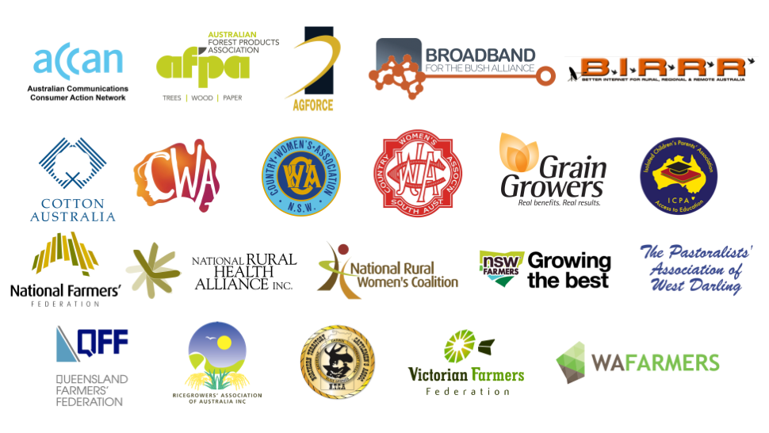

Members of the Coalition are:
  - ACCAN
  - AgForce Queensland
  - Australian Forest Products Association
  - Better Internet for Rural, Regional & Remote Australia
  - Broadband for the Bush Alliance
  - Cotton Australia
  - Country Women’s Association of Australia
  - Country Women’s Association of NSW
  - GrainGrowers
  - Isolated Children’s Parents’ Association
  - National Farmers’ Federation
  - National Rural Health Alliance
  - National Rural Women's Coalition
  - Northern Territory Cattlemen’s Association
  - NSW Farmers
  - The Pastoralists' Association of West Darling
  - Queensland Farmers’ Federation
  - Ricegrowers' Association of Australia
  - South Australian Country Women’s Association
  - Victorian Farmers Federation
  - WAFarmers

