Satellite
Sky Muster (or nbn’s Long Term Satellite Service) will provide fast broadband coverage to three per cent (or around 400,000) of homes and small businesses across regional and remote Australia and its islands.

Am I eligible for services?
Eligibility to obtain these services can be checked on the nbn.com.au
Consumers currently using satellite services (such as Interim Satellite Service (ISS), Australian Broadband Guarantee (ABG) or National Satellite Scheme (NSS)) will be able to switch to the Sky Muster service (some consumers may receive other technology such as Fixed Wireless). See ‘Switching from another satellite service’ for more details.

What if my address is not on the list but I think it should be?
Not all eligible addresses are currently on the nbn website, so you may still be eligible. You should contact a Retail Service Provider (RSP) and discuss your eligibility with them.

How do satellite broadband services work?
The Sky Muster satellite will provide a connection between customer houses and RSPs. When you request to access information from your premises, the request is sent from the dish on your roof to the satellite 35,786kms above the equator. The signal then travels to one of nbn’s ground stations which connect to your RSP and finally the internet. Information is then sent back to your device in the reverse direction.
To find out more information on what to expect from Sky Muster services see ‘What to expect from a Sky Muster broadband service’.
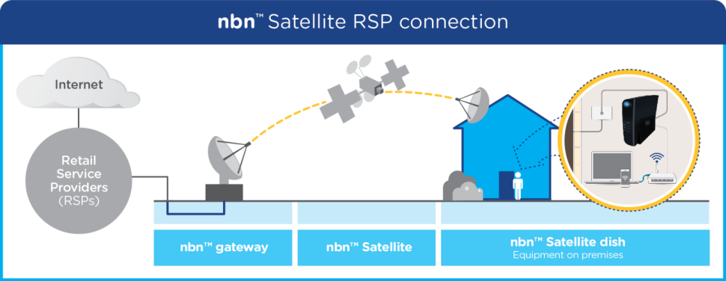
Figure courtesy of nbn

How do I order a service?
Services can be ordered now. To get connected:
- Check if you are eligible (nbn website)
- Choose a retail service provider (see ‘Choosing a retail service provider’) and plan that suits your needs (see ‘Choosing a plan that suits your needs’)
- Get Connected (see 'Getting Connected' for more information).

What services will work over Sky Muster?
Existing phone and internet services delivered over copper, radio and wireless technologies may continue to be offered in these areas.
In addition voice services may be offered over Sky Muster (called VoIP). See ‘Voice services’ for more details.
You should check if other services, such as medical alarms and EFTPOS machines will work.

IMPORTANT QUESTIONS TO CONSIDER AND ASK YOUR PROVIDER
- Can I use all my current services with this plan?
- How long will it take to get connected?
- What do I need to do to prepare my property for connection?
- Will my other satellite equipment be uninstalled at the same time?
- When will the billing start?
- What speed level will I get on average with this plan during peak and off peak hours?
- Apart from the monthly charge, what other fees do I need to pay?
- Do I need to purchase a new router?
- Can I get VoIP services? Is the router set to ensure quality voice services?
- How do I access my data tracking service?
- Will there be any additional charges for connecting or fault repairs?
- Is my property a standard installation? Can I cancel the service, without charge, if I am not a standard installation?
- Do you offer service guarantees for fault rectification and outages?

Will nbn be offering services for children’s education and community use?
Yes, nbn intends to offer a range of services. See ‘Remote and Isolated Communities and Distance Education’ for more information.

What do I do if something goes wrong?
See 'Interruptions, faults and repairs' for information on what to do if something goes wrong and 'Who to contact, complaints and further information for contact details.

I am due to get satellite, but I would rather have fixed wireless. What are my options for alternative nbn networks?
If you wish to consider an alternative technology rather than satellite, nbn offers a ‘technology choice’ program. There are two possibilities. The first is area switch. This is where a number of properties in an area collectively pay to receive a different technology. The second is individual switch, where one property pays to switch technology.
Both of these options can cost a significant amount of money. Costs range from a few hundred thousand dollars to millions of dollars, depending on the complexity and size of the switch required

