Indigenous community perspectives and experiences of digital inclusion
Research Report
Metta Young and Ben Smede
First Nations Media Australia and the inDigiMOB Project
February 2021
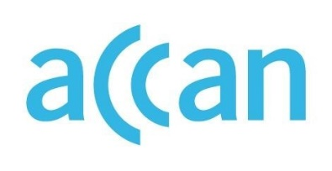
Indigenous Community Perspectives and Experiences of Digital Inclusion
Authored by Metta Young and Ben Smede
Published in March 2021
This project was funded by a grant from the Australian Communications Consumer Action Network (ACCAN).
The operation of the Australian Communications Consumer Action Network is made possible by funding provided by the Commonwealth of Australia under section 593 of the Telecommunications Act 1997. This funding is recovered from charges on telecommunications carriers.
First Nations Media Australia and the inDigiMOB Project
Website: www.firstnationsmedia.org.au www.indigimob.com.au
Email: info@firstnationsmedia.org.au
Telephone: 08 8952 6465
Australian Communications Consumer Action Network
Website: www.accan.org.au
Email: grants@accan.org.au
Telephone: 02 9288 4000
If you are deaf, or have a hearing or speech impairment, contact us through the National Relay Service: https://www.communications.gov.au/what-we-do/phone/services-people-disability/accesshub/national-relay-service/service-features/national-relay-service-call-numbers
ISBN: 978-1-921974-66-3
Cover image: Design by Richard Van Der Male with image from inDigiMOB
This work is copyright, licensed under the Creative Commons Attribution 4.0 International Licence. You are free to cite, copy, communicate and adapt this work, so long as you attribute the authors and “First Nations Media Australia and the inDigiMOB Project, supported by a grant from the Australian Communications Consumer Action Network”. To view a copy of this licence, visit http://creativecommons.org/licenses/by/4.0/
This work can be cited as: Young, M. & Smede, B. 2021, Indigenous community perspectives and experiences of digital inclusion, Australian Communications Consumer Action Network, Sydney.

Table of Contents
Table of Contents i
Figures and Tables iii
Preface 1
Acknowledgements 2
Executive Summary 3
Research Objectives 3
Method 3
Results 4
Discussion 4
Introduction 6
Research Objectives 6
Literature Review 7
Methodology 10
Survey and process 10
Distribution 11
Data Limitations 11
About the survey respondents 12
Results 16
Types of internet access 16
Device ownership and services accessed 20
Case Study 1 25
Issues experienced accessing the internet 25
Case Study 2 29
Experiences online 30
Digital access and use and the coronavirus pandemic 31
Case Study 3 38
Conclusion 45
Location and structural factors matter 45
Mobile traps 47
Risks of technology reliance 48
The importance of engagement 49
Authors 51
Appendix 52
The survey 52
References 63

Figures and Tables
Figure 1 Map of the 2016 Remoteness Areas Australia www.abs.gov.au 12
Figure 2 Location of respondents 13
Figure 3 Where respondents’ organisations operate 14
Figure 4 Sector of respondents’ organisation 14
Figure 5 Internet availability remote areas 16
Figure 6 Internet availability in urban areas and remote/rural areas 17
Figure 7 Internet type most used 18
Figure 8 Internet type used in urban and remote/rural areas 19
Figure 9 Type of digital devices accessed 20
Figure 10 Types of digital devices accessed in urban and remote/rural areas 21
Figure 11 What devices are used for 22
Figure 12 What devices are used for in urban and remote/rural areas 23
Figure 13 Social media apps used 24
Figure 14 Social Media apps used in urban and remote/rural areas 24
Figure 15 Frequency of issues when accessing internet 27
Figure 16 Cyberbullying and cybersecurity issues 30
Figure 17 Cyberbullying or cybersecurity issues by urban and remote/rural areas 31
Figure 18 How information about coronavirus is accessed 32
Figure 19 How information about coronavirus is accessed by urban and remote/rural areas 33
Figure 20 Main online platforms used to access information about coronavirus 33
Figure 21 Issues experienced accessing online services. 36
Figure 22 Has access to online services changed because of the pandemic 37
Figure 23 Experience of debt because of use of digital devices. 39
Figure 24 Online scams 41
Figure 25 Best ways to provide information about digital access and use 42
Figure 26 Access to information online in First Nations Languages 42

Table 1 Issues experienced with digital access and use 26

Preface
The report before you – Indigenous community perspectives and experiences of digital inclusion – offers some insights about digital access, digital use and digital ability in Aboriginal and Torres Strait Islander communities during 2020 – the first year of the coronavirus pandemic. The research was originally conceived as an in-depth exploration of what digital inclusion means to those living and working in small remote Aboriginal and Torres Strait Islander communities. The pandemic and associated lockdowns of regions and communities early in 2020 meant that the researchers were unable to travel to or spend time on community. The project had to adapt, and an online survey was developed and distributed to community-based organisations across the country, drawing on the networks and partnerships central to the work of First Nations Media Australia and the inDigiMOB project. These organisations were at the coalface in supporting Aboriginal and Torres Strait Islander people during the first wave of the pandemic and the essential services they provide deserve both recognition and further investment.
Measures of digital inclusion are too often about deficits and disadvantage – of infrastructure, hardware and skills – and too little about what matters for communities and individuals as they navigate an increasingly digital world. This report draws from the on the ground experiences of those working with and in Aboriginal and Torres Strait Islander communities during 2020 and distils their knowledge of digital issues and challenges.
As the pandemic saw lockdowns and stay at home orders in force across the country, reliance on the internet and digital devices for information, entertainment and connection to others escalated. Social media use soared along with its light and dark sides - online support groups, and misinformation and conspiracy theories about the virus. Many services reverted to online only, leaving those with no internet access, no service at all. All of these issues played out across the country, in ways shaped by local contexts, cultures, histories, fear and need, during 2020.
As the digital transformation of government and private services accelerates, new forms of disadvantage and social exclusion begin to emerge. We believe it is critically important to document these experiences as without awareness, redress is not possible. Digital access and digital services exist to enhance the wellbeing and livelihoods of people, not leave people at the mercy of technology or poverty.
We hope this report offers insights that can shape what becoming a truly digitally inclusive community might require.

Metta Young & Ben Smede.

Acknowledgements
We would like to acknowledge and thank the Elders, Traditional Owners and residents of the remote communities we work with for their contribution to this research and for welcoming us to their Country. We also extend our sincere gratitude to the many organisations and individuals that contributed their time and knowledge to this research.
Many thanks go to the founding inDigiMOB partners, First Nations Media Australia and Telstra, for their ongoing support of our work.
Finally, we would also like to thank the Australian Communications Consumer Action Network (ACCAN) for supporting this research.

Executive Summary

This research has been supported by funding from the Australian Communications Consumer Action Network (ACCAN). It was undertaken by First Nations Media Australia, the peak body for the First Nations media and communications industry through the inDigiMOB project.
The research captures evidence about the perspectives and experiences of Aboriginal and Torres Strait islander people about digital inclusion, especially as experienced through the 2020 coronavirus pandemic. It canvases views from Aboriginal and Torres Strait Islander media and other organisations across the country about digital access, use and experiences.

Research Objectives
- Develop an understanding of the perspectives and experiences of digital inclusion for Aboriginal and Torres Strait Islander communities during the coronavirus pandemic, as reported by organisations serving those communities (e.g. access to relevant and timely information, access to communications, access to health or financial services).
- Contribute to the evidence base of the digital inclusion needs of Aboriginal and Torres Strait Islander communities. (for example; access issues including internet services, affordability issues and issues relating to digital ability).
- Develop a list of priorities for digital inclusion for Aboriginal and Torres Strait Islander communities going forward.

Method
Due to travel and contact restrictions imposed by the response to the coronavirus pandemic, visits to individual communities and interviews with residents and community based organisations were not possible. Instead, information was elicited via an online survey that was distributed to First Nations Media Australia member organisations, the inDigiMOB project partner and affiliate organisations and a selection of other organisations directly servicing Aboriginal or Torres Strait Islander communities. Respondents were therefore employees of these organisations and were asked to provide their thoughts and opinions about digital access and use issues affecting the communities with whom they work.
The survey was developed using Survey Monkey software and contained 27 questions. The questions were largely multiple response with additional comments sought. Topics covered included location, organization type, type of internet access, type of devices uses, type of usage as well as questions about cyber safety, the experience of debt and the impact of the pandemic. The survey can be found in Attachment 1.

Surveys were distributed to 252 organisations across the country. 43 complete surveys were returned indicating a response rate of just over 17%. The completion rate of those surveys returned was 100%.

Results
Twenty-seven respondents came from remote areas, eleven from urban areas and five from rural or regional areas. Sixty seven percent of organisations were located or operating in the Northern Territory with the remaining located or operating in South Australia, Western Australia, Queensland, New South Wales and Victoria. Respondents worked in organisations from a wide range of sectors with the Aboriginal community-based sector and the education sector the most commonly reported, closely followed by the Aboriginal media sector. Fifteen (35%) respondents identified as Aboriginal and/or Torres Strait Islander.
A detailed overview of results, including data charts by question and comments from the respondents are outlined in Section 5 of this report. This section covers the types of internet access available and used, the types of devices owned and/or accessed and the types of services accessed, the issues experienced when accessing the internet, experiences when online and digital access and use during the coronavirus pandemic. The section also includes three case studies developed through interviews with survey respondents who indicated their willingness to participate in follow-up discussions.

Discussion
This section draws together the survey results and comments, the case study interviews, the literature and the experience and insights from First Nations Media Australia’s work around digital inclusion in remote Aboriginal and Torres Strait Islander communities. It provides an interpretation of survey results to highlight key insights emanating from the data, the broader literature and the experience of an Aboriginal organisation working intimately at the interface of digital media and communications, digital access and use and Aboriginal and Torres Strait Islander communities. Key insights identified in the discussion are:
Key Insight 1: Where in Australia you live determines the type of access to the internet you have and the types of digital devices able to be accessed and used.
Key Insight 2: Access to the computers, laptops and the internet facilitated through community based organisations is the primary way people in remote communities can access devices, secure internet, and services online.
Key Insight 3: There is a lack of digital literacy educations programs especially in remote areas, and this is being exacerbated by the withdrawal of Vocational Education & Training (VET) programs and the absence of digital inclusion policy and investments at all levels of government. This increases the burden on individuals and community-based organisations.

Key Insight 4: Cyberbullying, especially through social media platforms, is a pervasive issue and implicated in the growing mental health issues and suicides amongst Aboriginal and Torres Strait Islander peoples.
Key Insight 5: The type of device you own, can access or use, can shape the type of social and economic activities available to you. The constrained access to or ownership of laptops and computers in rural/remote areas can prevent community members from becoming fluent and practised users of the key devices needed to engage with the worlds of work and study.
Key Insight 6: The reliance on digital devices and internet access to perform everyday activities such as shopping, banking or to access services introduces a suite of new dependencies and risks. From power supplies, to weather, to system faults or cyber-attacks, to pandemics and health orders, a breakdown in one element of these interdependencies can have significant consequences for individuals.
Key Insight 7: Digital skills and knowledge often infer English literacy fluency. Where digital and English literacy is an issue, access by alternative means such as phone are woefully inadequate due to long wait times, poor customer service or use of virtual assistants.
Key Insight 8: A dedicated effort towards the digital inclusion of Aboriginal and Torres Strait Islander people is needed. This effort would likely include campaigns on social media, radio, free to air TV and an ongoing program of in-community and face-to-face workshops.

Introduction
This project has been supported by grant funding from the Australian Communications Consumer Action Network (ACCAN). ACCAN is Australia’s peak body for consumer representation in communications. The project aligns with ACCAN's priority under the Research stream of the grants program - Access to communications in regional, rural and remote communities, including Indigenous communities. It has been undertaken by First Nations Media Australia, the peak body for the First Nations media and communications industry through the inDigiMOB project. The inDigiMOB project is a partnership between First Nations Media Australia and Telstra and aims to improve digital inclusion in remote Aboriginal communities in the Northern Territory.
The research captures evidence about the perspectives and experiences of Aboriginal and Torres Strait islander people about digital inclusion, especially as experienced through the 2020 coronavirus pandemic. It canvases views from Aboriginal and Torres Strait Islander media and other organisations across the country about digital access, use and experiences.

Research Objectives
The following research objectives guided this project:
- Develop an understanding of the perspectives and experiences of digital inclusion for Aboriginal and Torres Strait Islander communities during the coronavirus pandemic, as reported by organisations serving those communities (e.g. access to relevant and timely information, access to communications, access to health or financial services).
- Contribute to the evidence base of the digital inclusion needs of Aboriginal and Torres Strait Islander communities. (for example; access issues including internet services, affordability issues and issues relating to digital ability).
- Develop a list of priorities for digital inclusion for Aboriginal and Torres Strait Islander communities going forward.

The coronavirus pandemic has seen stay at home orders, social distancing requirements and travel restrictions in place across the country, as well as Biosecurity areas declared in some jurisdictions. Digital communications have become central to all for staying informed, accessing services, financial support, and personal communications. In remote Aboriginal communities, reliance on digital communications has also been necessary, highlighting ongoing issues with digital access, affordability and ability. The research presented here provides some insight into the issues foregrounded during the pandemic for remote Aboriginal communities as reported by key organisations working with these communities.

Literature Review
Digital infrastructure and technologies are often positioned as neutral (unbiased, apolitical) and useful, with the ability to maximise that usefulness a function of acquiring skills that can be taught. However, digital inclusion also requires attention to the new forms of inequality, exclusion, injustice and lack of diversity that can evolve through emerging technologies and their rapid application. Its flip side, digital exclusion, follows the fault lines of social exclusion - poverty, language and literacy, geographic location, identity, social and economic participation. Difference from the dominant culture in terms of language, location, educational opportunities, health and housing realities as well as distance from the urban concentration of Australia’s population often mediates digital discrimination especially when reliance on digital technologies become increasingly forced in order to access government and other services. Understanding the experiences of consumers in remote communities as change intensifies is critical to support just and effective responses to digital exclusion.
The literature on digital inclusion is clear that digital inclusion is more than digital access. Thompson (2014, p9) defines digital inclusion as “outreach as a means to empower underserved and marginalised populations”. More recent research focuses on concepts of “access, affordability and ability” (Thomas et al, 2020) and the resulting beneficial outcomes that can be derived from these (Park, 2017) as key elements of inclusion. What is apparent is that inclusion is not a state that can be reached but a process that evolves alongside technological change and the uses to which technologies are applied. The digital transformation of government services and its incorporation of artificial intelligence in mediating service access through voice recognition or avatar interfaces introduces some risks of further alienation and exclusion to the extent the assumptions intrinsic to the user design processes reflect particular colonial, gender or cultural assumptions (O’Sullivan and Walker 2018, Park and Humphry, 2019).
Much of the evidence available regarding the digital divide and digital access in Australia's Aboriginal and Torres Strait Islander communities is drawn from large scale quantitative surveys such as the Australian Household Use of Information Technology report (ABS 2018) and the research supporting the annual Australian Digital Inclusion Index (ADII) which to date has included two supplementary surveys of remote communities - Ali Curung in 2018 and Pormpuraaw in 2019. The ADII points to the persistence of the 'digital divide' in Australia, a divide that both follows and reinforces the parameters of social and economic inequality - age, geography, education, income and Indigenous status. The most recent ADII report identifies that the rate of improving digital inclusion across Australia is slowing and at risk of becoming further entrenched in some groups and locations (Rennie et al, 2020, p 5).
Research also highlights that the costs associated with accessing data intensive online services are prohibitive, particularly if access is mobile only. As well, the confidence and skill to use those services remain significant issues and negative individual and community effects of cyberbullying and cyber scams are widespread (Rennie et al 2019).

Some research foregrounds the 'repertoires of practice' employed by those on the 'wrong' side of the digital divide, exploring the innovative and creative appropriation of digital technologies by remote community residents and organisations, despite issues of access and affordability (Kral 2012, B4B - Indigenous Focus Day Communiques, 2017, 2018). Other research focuses on the impact of the digitisation of government social services with a focus on remote Aboriginal and Torres Strait Islander communities (O'Sullivan & Walker 2018). The latter highlighting a transition to e-government that is well underway, touching down in even the remotest communities, with benefits - in terms of costs and efficiencies - accruing to governments while significant burden falls on community organisations to support local residents with even the most basic transactions.
The coronavirus pandemic has accelerated a leap-frog in technology transformation towards the e-delivery of services and one that is unlikely to ever return to pre-pandemic conditions. For locations and people with limited, unreliable or costly access to the internet, or lacking the devices, skills and knowledge needed to connect, the impact of such transformation is yet to unfold.
Policy and programs around digital inclusion across the country reveal a patchy, announcement heavy and investment poor landscape, where risk is identified and quantified but mitigation minimal. Targeted Australian government programs that were a feature of the 1990s through to 2015 and encapsulated improved technology access, skills development and community hubs (for example, Broadband Access Programs, Backing Indigenous Ability and the Indigenous Communications Program) have devolved towards more market based and technology driven solutions (e.g. Mobile Black Spot Program, Regional Connectivity Program) over and above community participation and inclusion programs (Featherstone, 2020). Market based and technology driven solutions have seen the emergence of government and private sector partnerships in certain locations or with specific groups to address technology access and skills gaps and an increase in divergent programs and investments in each State and Territory, some supported by Corporate Social Responsibility initiatives. The Australian government commitment to digital inclusion for Aboriginal and Torres Strait Islander people and communities is largely on paper only, alongside some discrete department or agency activities such as the Be Deadly Online resource package managed by the Office of the eSafety Commissioner. Increasingly the emphasis is on developing online resources to support getting and being online, a somewhat ironic approach.
Despite the increased investment in technology solutions and the tailoring of these solutions to context, issues of reliable access and affordability loom large. Even before the pandemic there were ongoing reports of connection interruption in Aboriginal and Torres Strait Islander communities because of technical faults and or bad weather. Heat, rain and fire events caused lengthy outages across East Arnhem Land and the Utopia Homelands last summer (2020), preventing residents from accessing money, purchasing food or contacting services. The same events also prevented technicians from accessing the communities to resolve the issues (ABC 2020). Extensive disruptions to access were also experienced right down the east coast (QLD, NSW and Vic) due to the Black Summer bushfires and some outages due to power failures.
Recent research explores the focus on remediating structural inequalities of digital inclusion (beyond mere access) through individualised skills and empowerment actions. It highlights how individualising the problem can intensify structural inequalities whilst assigning blame and responsibility to those so excluded (Mariën et al 2014). Thus, those who have difficulty accessing or using technologies to do the things they need to do to maintain their income, work or health, carry both the burden and responsibility for their predicament.

Methodology
Due to travel and contact restrictions imposed by the response to the coronavirus pandemic, visits to individual communities and interviews with residents and community based organisations were not possible. Instead, information was elicited via an online survey that was distributed to First Nations Media Australia member organisations, the inDigiMOB project partner and affiliate organisations and a selection of other organisations directly servicing Aboriginal or Torres Strait Islander communities. Respondents were therefore employees of these organisations and were asked to provide their thoughts and opinions about digital access and use issues affecting the communities with whom they work.
The distribution of the sample was heavily weighted towards organisations associated with First Nations Media Australia and the inDigiMOB Project with a track record of engaging with issues of digital access and inclusion. As such the sample is not representative of all organisations working with Aboriginal and Torres Strait Islander communities across the country but reflects those with a known interest or involvement in the issues.
The survey was developed using Survey Monkey software and contained 27 questions. The questions were largely multiple response with additional comments sought. In some questions, respondents were asked to check all that apply, and this is indicated in the chart labels. Topics covered included location, organization type, type of internet access, type of devices uses, type of usage as well as questions about cyber safety, the experience of debt and the impact of the pandemic. The survey can be found in Attachment 1.

Survey and process
The online survey questions were developed based on extensive desktop research and by drawing on the experiences of the inDigiMOB project in delivering digital inclusion activities to remote Aboriginal communities.
The process was as follows:
- Questions were developed and reviewed by key First Nations Media Australia staff and ACCAN staff as well as piloted with partner organisations.
- Respondents were selected by drawing on the data base of First Nations Media Australia member organisations as well as data bases of partner and affiliate organisations developed through the inDigiMOB project and events such as the Broadband for the Bush and the Indigenous Focus Day.
- Respondents were assured of the confidentiality of their survey responses and all questions were designed with deidentification of organisations and individuals in mind. The AIATSIS principles for undertaking research ethically when working with Aboriginal and Torres Strait Islander communities guided the project. Whilst the principal researchers are non-Aboriginal, they work to and for an Aboriginal CEO and Board and are required to seek guidance to engage and understand cultural perspectives and experiences.
- The survey was distributed to organisations between mid-August 2020 and early October 2020. Follow up phone calls were made to some 20 organisations over this period to prompt their responses to the survey.
- The analysis of survey data was undertaken in both Survey Monkey and Microsoft Excel. Results show absolute numbers and percentages. Percentages are generally rounded up.
- Follow-up calls were also made to six organisations who indicated their willingness to discuss issues of digital inclusion further. These discussions form the basis of the three case studies included in this report.
- Many comments were also received to the questions and these have been included in the report to provide contextual and topic detail. Where comments explicitly identified organisations or communities these have been edited to exclude names and specific locations and ensure confidentiality of responses.

Distribution
Surveys were distributed to 252 organisations across the country. 43 complete surveys were returned indicating a response rate of just over 17%. The completion rate of those surveys returned was 100%. Given that some organisations targeted to receive the survey were in remote regions where internet reliability fluctuates, which may have impacted their ability to access and complete the survey, the response rate is very positive.

Data Limitations
As the sample size is small, the results presented in the report should be viewed with caution. This is consistent with much research conducted in remote areas and with small dispersed Aboriginal and Torres Strait Islander populations and organisations where the number of respondents leads to greater volatility in the data. The results should therefore be viewed as indicative of trends and possibilities, rather than definitive. However, whilst mindful of data limitations, the data and comments presented in this report provide deep and nuanced insights into the experiences of digital inclusion and the specific challenges encountered by community organisations and community residents.
The survey draws on the observations and experiences of employees of organisations working with Aboriginal and Torres Strait Islander people and communities. The results reflect the knowledge and opinions of these staff and will be influenced by the type of work they do and the regions in which they operate. As these organisations are at the front line in facilitating access to services and information for community people, the data also offers some insights into the nexus of services and support in an increasingly digitally mediated environment.
Aboriginal media and other organisations provide a unique window into the issues and challenges facing their communities. They are often involved in problem solving the information, communication and access needs of communities and in navigating the translation of funding and policies into actions and supports that make a difference on the ground.

About the survey respondents
The following charts provide further information about the characteristics of the survey respondents.
For most charts, the total number of respondents is 43. It is stated in either the chart or the associated text if respondents were able to select multiple responses to a question and therefore the total responses to that question are greater than 43.
Location is used as part of the survey. Respondents were asked if their organisations and the communities or regions in which they work are in Urban, Regional, Rural or Remote areas of Australia. This breakdown is based on the Accessibility/Remoteness Index of Australia (ARIA+) which classifies regions of Australia based on a measure of access to services. The map below depicts the remoteness regions of Australia as defined by the Australian Bureau of Statistics 2016.

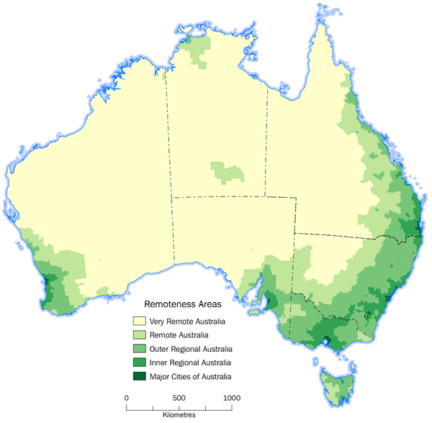
Figure 1 Map of the 2016 Remoteness Areas Australia www.abs.gov.au

Whilst ARIA+ identifies five categories of remoteness, for the purposes of this survey the categories of Very Remote and Remote were combined in the survey questions and the categories of Very Remote, Remote, Rural and Regional were combined in the data analysis.

Figure 2 Location of respondents

As is shown in Figure 2above, 27 (63%) respondents came from a remote region. Remote region for the purposes of this survey incorporates very remote areas such as East Arnhem Land, remote towns such as Alice Springs and Kununurra, and discrete remote Aboriginal communities. The next largest group of respondents came from urban areas defined as major cities in Australia. The fewest responses emanated from regional towns and rural areas. However, all respondents from rural or regional areas were also from the NT. Rural and regional NT is generally classified as per the ARIA+ index as being either remote or very remote. In this report where analysis uses location, rural and regional areas have been included in remote areas and the chart labels will read rural and remote region.
Respondents were also asked in which State or Territory their organisation or service operates, with some organisations operating in more than one jurisdiction. Figure 3 shows that more than half of organisational activity was in the NT, followed by SA and WA.

Figure 3 Where respondents’ organisations operate
Respondents worked in organisations from a wide range of sectors with the Aboriginal community-based sector and the education sector the most commonly reported closely followed by the Aboriginal media sector. The Other category included an Aboriginal owned and operated Small to Medium Enterprise, an Aboriginal Investment Company and a Tourism Visitor Centre. Figure 4 below shows the results in more detail.

Figure 4 Sector of respondents’ organisation
Respondents were also asked their gender, age and cultural background. Fifteen (35%) respondents identified as Aboriginal and/or Torres Strait Islander. The age of respondents was evenly spread between the ages of 25 and 64. Twenty-four (55%) respondents were female.

Results

Types of internet access
The following charts depict information from the survey relating to internet availability and the type of internet access used. Recognising that availability and access is often determined by location, the results are presented for all responses, followed by responses for remote /rural areas and urban areas. This is to assist in distilling some of the nuances of availability and access. Results are further contextualised through the comments made by respondents.

Figure 5 Internet availability remote areas

The main type of internet availability is via use of mobile data, closely followed by public WiFi and NBN fixed line. No access is also reported in 9% of responses. In some cases, organisations are based in the larger remote communities or remote towns servicing surrounding areas and there may be differences in internet availability between the larger towns or communities where they are based and the communities in the surrounding region where they also work.

“In my community all these technologies are available. But most of the 32 homelands around us do not have an internet connection. Two have an NBN satellite connection set up on one or two of the houses. Three have public WiFi set up on the Telstra payphone.”

“Some town camps only have mobile.”

“Fixed line NBN in communities north and south of our community – 4G mobile and Sky Muster. There is mobile in some smaller communities around us, otherwise they have none. Public WiFi available in town at the Hotel.”

Figure 6 Internet availability in urban areas and remote/rural areas

Figure 6 compares the type of internet available in urban areas with that in remote/rural areas. In urban areas 100% of respondents indicated that NBN fixed line services were available, with wide availability of both mobile and public WiFi access.
The type of internet access availability in an area provides a baseline of choice, but as previous research suggests, there are other factors, from affordability to convenience, to what it is used for, that affects usage.

Figure 7 below depicts the type of internet used most by community members across all locations. Over 90% use mobile. The use of public WiFi and internet access provided by services are the next most used (at 49%). The other category refers to internet used at a university or in a formal learning environment with respondents distinguishing this access from access through community organisations.

Figure 7 Internet type most used

Figure 8 below shows the use of mobile data for internet access is common in both urban and rural/remote areas. Urban areas however show an even spread of internet access types when compared to rural and remote areas with internet at home the next most common. In rural and remote areas internet access providers by service providers is the most used after mobile data. Such access would be facilitated by services such as Centrelink, Libraries, local councils, Arts Centres and others. The use of public WiFi is also prevalent underscoring the importance of this type of access especially in remote areas.

Figure 8 Internet type used in urban and remote/rural areas

The responses outlined above regarding type of internet available and used in remote and urban areas reflects much of what the broader literature reports – that geographic location has an impact on access type although mobile access is prevalent across locations. Mobile access is significantly higher in remote areas inferring attenuating issues of affordability and the types of activities that can be undertaken in the online environment.

Device ownership and services accessed
In this section we look at what respondents had to say about devices accessed and used and what they are used for. The analysis continues the breakdown between rural/remote and urban areas.

Figure 9 Type of digital devices accessed

Respondents report that most people (100%) in the communities in which they work have access to a personal mobile phone. There is a substantial difference between access to a mobile phone and access to any other type of device, with just 47% of community members accessing other devices through service providers and local organisations. In general, the devices able to be accessed at public internet access centres and local organisations are laptops and/or desktop computers.
Viewing the results for urban and remote/rural areas comparatively in Figure 10 below, some of the differences in what digital devices most people have access because of geographic location are revealed.

Figure 10 Types of digital devices accessed in urban and remote/rural areas
Most people in all locations have access to a personal mobile phone. However, in urban areas most also have access to a personal laptop or computer or a personal tablet. In remote/rural areas access to a personal laptop is extremely low and access to a personal tablet also very limited. The importance of local organisations in facilitating access to devices (most usually laptops or desktop computers) in remote areas is underscored by the data. It is also likely that some form of assistance or guidance regarding the use of these devices would be provided by these local organisations and include rules about what programs can be used and what internet activities (if any) permitted. They are also likely to facilitate access to online services.
The difference in device access by Aboriginal and Torres Strait Islander people in remote areas compared to urban areas is suggestive of the difference in socio-economic opportunities experienced by those who reside in remote communities and towns and those in cities. It also highlights that affordability includes not just the cost of connectivity but also the cost of devices.

Respondents were also asked what people in the communities in which they work mainly use their devices for. The most common use of devices was for social media, phone calls or texting. Entertainment and photo/video creating were also common. Searching for information online, online shopping or accessing services were the least common. See Figure 11 below.

Figure 11 What devices are used for

Figure 12 compares how Aboriginal and Torres Strait Islander people in urban and remote/rural areas use their devices. The use of devices for social media and entertainment is common across regions. People in urban areas were more likely to use video calling apps and search for information on their device. The most obvious difference between the regions is the preference for phone calls over texting in remote areas and the opposite in urban areas perhaps reflecting literacy levels and a preference to speak in language.

Figure 12 What devices are used for in urban and remote/rural areas

Respondents were also asked about the most common social media apps used. Figure 13 below shows the most common social media app used is Facebook.

Figure 13 Social media apps used

Figure 14 compares social media app use in urban and remote/rural area. In remote/rural areas the use of TikTok by community residents is much higher than in urban areas. In urban areas Instagram is as popular as Facebook whist in remote areas it is much less frequently used. Comments from respondents in urban areas also emphasised the extensive use of Twitter, LinkedIn and Pinterest by community members.

Figure 14 Social Media apps used in urban and remote/rural areas

The survey methodology also involved interviews with respondents who indicated their willingness to engage. These interviews have informed the three short case studies that are included in this report and inserted where the context described in the case study adds value and to the data being analysed and the topics under discussion.

Case Study 1
One small community has no mobile phone tower, although public WiFi is available in the community centre. Its location is in close proximity to a larger community with extensive mobile and WiFi access. The building of a Mobile Phone tower on this community is imminent. Community Elders are expressing deep concerns about what mobile access will do for the community, especially the increased use of Facebook.
They have witnessed deep community friction and bullying via the uploading of inappropriate images, videos and commentary via Facebook occurring in the nearby larger community. They are concerned about the unrest and family fights due to Facebook activities occurring on their community once the mobile tower is live. Elders are also concerned about the inappropriate posting of old photos and other images that may have cultural implications for those that view them who are not meant to. The word used is black magic.
Most of the images and videos being posted in the nearby larger community are selfies or sneaked pictures of others in compromising positions or undertaking illegal or criminal activities. This image shaming and image bullying is having repercussions across the community leading to issues with jealousy, fights and suicides.

Issues experienced accessing the internet
Respondents were asked to rate the degree to which people in the communities in which they work experienced certain issues with digital access and use. Table 1 below outlines both the issues and the ratings given by respondents.

Table 1 Issues experienced with digital access and use
 | NEVER | RARELY | SOMETIMES | OFTEN | ALWAYS | N/A | TOTAL
Difficulty accessing the internet | 2.33%  1 | 4.65%  2 | 46.51%  20 | 39.53%  17 | 4.65%  2 | 2.33%  1 | 43
Can only use some features of their personal devices (eg. calls and text) | 6.98%  3 | 13.95%  6 | 32.56%  14 | 39.53%  17 | 0.00%  0 | 6.98%  3 | 43
Sign up to contracts they can't afford | 0.00%  0 | 11.63%  5 | 23.26%  10 | 55.81%  24 | 2.33%  1 | 6.98%  3 | 43
Use a lot of data so run out of credit frequently | 0.00%  0 | 2.33%  1 | 6.98%  3 | 53.49%  23 | 32.56%  14 | 4.65%  2 | 43
Replace phones and numbers frequently | 0.00%  0 | 4.65%  2 | 6.98%  3 | 55.81%  24 | 27.91%  12 | 4.65%  2 | 43
Can't afford the internet | 0.00%  0 | 4.65%  2 | 30.23%  13 | 46.51%  20 | 13.95%  6 | 4.65%  2 | 43
Unreliable internet (poor connectivity or dropouts) | 2.38%  1 | 11.90%  5 | 42.86%  18 | 30.95%  13 | 7.14%  3 | 4.76%  2 | 42
Forgetting passwords | 0.00%  0 | 4.76%  2 | 38.10%  16 | 35.71%  15 | 16.67%  7 | 4.76%  2 | 42
No or forgotten email accounts | 0.00%  0 | 4.65%  2 | 27.91%  12 | 44.19%  19 | 18.60%  8 | 4.65%  2 | 43
Online bullying or threats | 0.00%  0 | 4.76%  2 | 47.62%  20 | 28.57%  12 | 9.52%  4 | 9.52%  4 | 42
Getting hacked or scammed | 0.00%  0 | 14.29%  6 | 47.62%  20 | 23.81%  10 | 4.76%  2 | 9.52%  4 | 42
Difficulty reading or writing English | 2.38%  1 | 11.90%  5 | 28.57%  12 | 42.86%  18 | 11.90%  5 | 2.38%  1 | 42

The data shown in Table 1 has also been plotted in the line graph in Figure 15 below, providing a visual representation of the frequency of issues experienced. Those issues reportedly encountered always, often or sometimes are quite pronounced.

Figure 15 Frequency of issues when accessing internet

The issues most often experienced by community residents were signing up to contracts they cannot afford (56%), using a lot of data and running out of credit frequently (53%) and replacing phones and numbers frequently (56%). Most responses are concentrated in the sometimes, often or always end of the rating scale highlighting that the type of issues presented are commonly experienced. If the rating categories of often and always are combined, using a lot of data and running out of credit is exceedingly common (86%), as is replacing phones and numbers (84%), no or forgotten email account (63%), and difficulty reading or writing English (55%).
Respondents were also asked to describe any issues with accessing the internet or using digital devices because of the coronavirus pandemic, associated lockdowns and public health requirements. As a result of services closing and measures such as early access to superannuation were introduced, the issues with online and device access became much more apparent.

“Increased pressure on service providers to support digital access for such purposes as accessing early release superannuation.”

“People couldn’t go shopping and didn't have access to online shopping. Lots of people don't know how or can't access services like Centrelink or banks online and so were cut off.”

In some remote communities public WiFi was cut off to deter people from congregating and potentially breaching social distancing requirements. Where there was still mobile access some respondents reported issues with overload and reliability.

“The increased use of the internet is affecting access.”

“Unstable internet connection.”

“Connectivity is never excellent, sometimes OK but always unreliable - can lose access for hours or days at a time for no apparent reason (like bad weather).”

“Public WiFi access was turned off”

There were a range of issues reported with banking including the ability to receive security codes via SMS.

“Limited access to face-to-face banking when community was in lockdown caused many barriers to online banking due to no mobile phone coverage.”

“Many of the government services, for example MyGov, Banks, ATO send a code for access however there is no mobile reception in our remote community, this has been extremely difficult.”

The closure of services also affected people in urban areas and education settings.

“People needing to share internet downloads/uploads and study spaces.”

“Unable to access university computers and internet.”

“Home internet usage has slowed, even with NBN.”

Respondents also reported a number of issues around mental health and online bullying.

“Sharing depressing/suicidal thoughts on social media.”

“Increase in online bullying and suicide threats.”

“Coronavirus related scams and negative and needlessly worrying social media stories.”

“Growing sense of isolation. Increase in online bullying. Mental health breakdowns.”

Other issues reported include the increased spend on new and expensive mobile phones as a result of the coronavirus supplement and stimulus payments for welfare beneficiaries (including Jobseeker), and ongoing issues with losing the accessories needed for digital devices to work such as phone chargers.

Case Study 2
People are buying phones, especially with all the extra money from the coronavirus supplement and stimulus money. But people still run out of money, so they are then on-selling the new phones for cash, complete with the phone number and sim card. This brings up the issue of SMS notifications, whether for two factor identification or for online banking transfers or bill payments. Service providers spend a lot of time fixing up this issue before any pressing issues are able to be dealt with.
Things can get very complicated as well. New SIM cards are in very high demand at the community store and the stock in the shop can be low. Whilst people are learning to remove the SIM card if their phone is broken, they often lose them before they have a chance to put them in a replacement phone. There is a constant churn of setting up accounts for banking.

Voice recognition technology is being increasingly used by banks, internet service providers and the NDIS. Most often the software does not recognise Aboriginal accents and more often than not, the same person saying their name again is not recognised. This often leads to the agent (service provider) setting up the system on behalf of their client. This is not technically legal but sometimes used as the need to access the service outweighs the issues with sorting through the recognition software or setting up alternative approaches to authentication that are time consuming.

Experiences online
This section explores responses to questions about issues experienced online. Figure 16 depicts responses about the type of cyberbullying or cybersecurity issues experienced.

Figure 16 Cyberbullying and cybersecurity issues

Teasing or bullying in the online environment is reported by 77% of respondents, followed by the posting of offensive images or videos on social media (63%) and problems with contracts (58%) such as not being able to afford the plan signed up to or being harassed by debt collectors. Figure 17 compares the answers for urban areas and remote/rural areas.

Figure 17 Cyberbullying or cybersecurity issues by urban and remote/rural areas

Teasing and bullying and image abuse issues are the most common issues in both urban and remote/rural locations. In remote/rural areas problems with contracts is more prominent than in urban areas. Issues with people being signed up to contracts which they don’t understand because of language or literacy issues and can’t afford because of their employment or income status is common. For example, Telstra has recently agreed to pay a fine of $50M for unconscionable conduct relating to contract sales to 100 Aboriginal people in 2018 and have initiated a range of customer service reforms to improve their engagement and sales practices (ABC 2020b).

Digital access and use and the coronavirus pandemic
Respondents were asked about how community members were getting information about the coronavirus and lockdown arrangements. As can been seen in Figure 18 the most common means of receiving or sharing information was word of mouth (79%) closely followed by community organisations and social media (each 70%). Information from Aboriginal and Torres Strait media organisations was more prevalent than that provided by mainstream TV & radio highlighting the sector’s importance.

Figure 18 How information about coronavirus is accessed

Figure 19 compares urban and remote/rural areas in terms of how people are accessing information about coronavirus. The reliance on social media is apparent in urban areas compared to remote/rural areas as is the role of Aboriginal media organisations. In remote/rural areas the role of community organisations and community meetings in facilitating information access is prominent. Whilst word of mouth information access is common in each location, it is not possible to accurately identify how or from whom that was occurring. However, the prevalence of the role of community organisations and community meetings for getting access to information in rural and remote areas provides some insights for that location.

Figure 19 How information about coronavirus is accessed by urban and remote/rural areas

Respondents were also asked about the main online platforms that community members were using to access information. Figure 20 highlights the prevalence of social media for information access in the online environment.

Figure 20 Main online platforms used to access information about coronavirus

There were also a number of comments about this question that reiterated the importance of community organisations and community meetings for getting information, over and above online platforms. Some online chat rooms with a specific focus on keeping up to date about coronavirus information were also established by local government organisations. Radio, often accessed via an online platform, was also noted as an important source of information. The additional police placed on or near remote communities during the lockdowns were also used as a source of information.
Respondents were also asked whether community members were receiving or sharing misinformation or conspiracy theories about the pandemic. Twenty-eight (65%) respondents indicated they were. Some of the comments provided are included below. A number of comments related to who was at risk of getting the virus:

“Young people immune.”

“The virus does not exist. Aboriginal people are immune.”

“A white man’s disease that can't hurt Aboriginal people.”

“Some think it's a hoax, some think it's not policed strongly enough with international travelers on planes and ships.”

There were also stories going around about the origin of the virus:

“The virus being fake and/or a ploy for the government to scare us.”

“That the government created COVID.”

“China made it to kill Aboriginals.”

As well as stories about what was going to happen and those interwoven with religious beliefs:

“Government going to test all community members. Spraying of communities with sanitizers by RAAF fighter planes to reduce the spread of COVID-19
They were praying and that had stopped the disease coming.”

“The second wave of the virus is being equated to the second coming of the Lord and there is a belief that Armageddon is approaching.”

“That the virus is completely gone. Or that it can be cured through more faith in God.”

“The main rumour was that it doesn't affect Aboriginal people, and that 5G networks are bad.”

There were also some comments about the impact of misinformation and strategies to limit this:

“There are so many fake stories and due to poorer English proficiency levels, community members are believing them, causing themselves and their families’ further problems”.

“There is conspiracy misinformation in the community that is being shared with our broadcasters in the hope to have it broadcast on-air. For the most part our broadcasters have skillfully and respectfully dealt with these issues.”

Whilst conspiracy theories were no doubt circulating, there was also concerted effort on behalf of First Nations media organisations to actively counter the spread of misinformation. An evaluation of the sectors efforts in keeping Aboriginal and Torres Strait Islander communities informed and safe is forthcoming and will provide further insights about the nature of misinformation and the effective counter measures deployed.

Respondents were also asked to select the issues community members experience with accessing online services. Figure 21 shows the breadth of issues reported across all locations. Of note is the high rate of digital literacy issues (91%) reported which includes the ability to use devices, apps and email. The overlap between digital literacy and ability with English literacy fluency is also apparent. Issues are encountered not only with online access to services but also with the alternative mechanisms to connect with services providers. Long wait times on phone calls (86%), not being able to explain the issue they need assistance with (86%) and not being understood (79%) are pervasive issues.

Figure 21 Issues experienced accessing online services.

There were also a few comments from respondents about these issues, providing some insight into the experiences on the ground.

“The government phone systems are deliberately designed to send you in circles, redirecting you to do self-service online. No matter what answer you give, you get a recorded message telling you how to deal with your issue online. It is very hard to actually get through to an operator for help. It is an obstructive system that is frustrating and demoralising.”

“I imagine all of the above issues would impact many Indigenous and other poor Australians due to financial disadvantage and inability to afford these types of services or maintain their knowledge as it progresses fast. Racial discrimination underlies it all.”

“All of the above are common, huge wait times for limited access in many communities, with some communities having no access at all to internet or WiFi. These issues are being compounded by regional councils removing access to services. Some communities are using their own income from land use agreements to try to provide access for basic services such as banking and accessing welfare, which are government responsibilities. This money could otherwise be better spent on providing training to people by these groups.”

Respondents were asked whether access to online services had changed because of the pandemic. As can be seen in Figure 22 approximately a quarter didn’t know, a quarter reported services were a bit better, a quarter reported service access was a bit worse and a quarter reported there had been no change. As the breadth and frequency of issues with online access to services were already significant prior to the pandemic, it is positive that only 28% of respondents reported issues had become worse, and 30% reported issues were a bit better.

Figure 22 Has access to online services changed because of the pandemic?

Case Study 3
In 2020 many community learning centres experienced a significant increase in demand by community members seeking support to access financial and other online services. This situation came about due to a combination of two factors, the first being that the national coronavirus pandemic policy response instigated a range of additional motivations for people to access financial and other online services, and the second being that some supports historically being provided by other service providers were reduced or closed during the period. In all centres the demand reached a level which was prohibitive of the centres delivering other forms of training or maximising the learning opportunities inherent in supporting people with online activities. Some learning centre staff have also commented that the shift in focus of the learning centre program delivery may have a negative impact on staff retention in the centres. Services in high demand included: setting up and accessing online banking; setting up and accessing a MyGov account including for taxation purpose; setting up and accessing Centrelink benefits; setting up and accessing superannuation.
There was a huge rush in the communities to access the coronavirus early release of superannuation. There was also an increased motivation to sign up to Centrelink due to the increased rates of jobseeker, especially for young people, many of whom had never received benefits before. Centrelink offices on communities were withdrawn from March 2020 and visiting services also ceased. Some Regional Councils in the NT withdrew their historic support for helping community members access banking services as the Councils were not funded to provide such services. This latter withdrawal of support has compounded issues with accessing ID documents (previously held by Councils) which are now being ‘held’ by the Learning Centres.
Other issues encountered included waiting times to speak with anyone at the ATO or a bank are usually in excess of an hour. When you do get through it is not uncommon for the customer service staff to hang up on community members sometimes because of cross cultural communication issues. Some communities still don’t have mobile access so banking or other services that require the use of SMS codes are very difficult. Often providing Proof of Identity is still done through the use of fax. Services providers are becomingly increasingly reluctant to prove identity based on faxes which can be of poor quality. Services providers such as Aboriginal Financial Counselling services are only funded to visit communities intermittently and most of these visits were suspended during the lockdown.

Respondents were asked about the experience of debt because of their use of digital devices. As shown in Figure 23, using too much data and topping up credit, signing up to contracts that are not affordable or replacing lost or broken phones are the main issues reported.

Figure 23 Experience of debt because of use of digital devices.

Some comments were received about the issues of debt and gambling.

“Family taking phones and using up data/credit on social media/YouTube without permission from the phone owner.”

“Online gambling e.g. TAB touch and more importantly the unregulated gambling games e.g. Pokies Parlour app.”

“Gambling”

There was also a question about whether issues with debt had changed because of the pandemic. Whilst nearly half reported they didn’t know, 23% reported debt was worse, 16% reported no change and 16% reported debt issues were improving. There were a number of comments about this issue and the pandemic highlighting the positive impact of the coronavirus supplement and stimulus payments for welfare recipients and superannuation access, and the growth in spending on items such as cars and phones.

“While debt and spending has gone up, for many the increases in pensions and jobseeker payments has meant that people are able to afford to spend more.”

“The small rise in social welfare income has had a positive effect on peoples’ lives.”

“Community members have never had so much affluence along with the coronavirus supplement many people have gained access to their super accounts and have bought cars, motorbikes and other home appliances.”

“People are spending more time on their phones due to lockdown.”

“Not spending as much.”

Respondents were also asked about online scams in the communities or regions in which they work. Figure 24 shows that the most common scams encountered are government impersonation scams (MyGov, ATO, Centrelink) and phishing scams (fake vouchers, update bank detail requests). These types of scams were also more prevalent in urban areas than remote/rural areas. Scratchie scams and rebate scams (claiming you are owed money from the government or the ATO) were more common in remote/rural areas that in urban areas.

Figure 24 Online scams

Respondents from urban areas also reported there were more online scams circulating since the pandemic (79%) compared to respondents from remote/rural areas (29%).
Respondents were questioned about the best ways to provide community members with information and skills about digital access and use. Figure 25 displays responses for urban areas and rural/remote areas. Social media is seen as an appropriate medium for both locations. Print media and posters are favoured more in remote /rural areas than urban areas whilst free to air TV and websites are considered better ways in urban areas. Workshops are reported as the best way in remote areas whereas they are secondary to social media and TV in urban areas. These responses perhaps reflect the social economic profiles of different regions and the range of services and information channels available and able to be used by community members. The ability to use interpreters whilst facilitating community-based workshops and share information in languages other than English may be an important factor.

Figure 25 Best ways to provide information about digital access and use

Respondents were asked to rate the importance of accessing information online in First Nations languages. As Figure 26 shows, nearly 80% of respondents rate this as Very High or High.

Figure 26 Access to information online in First Nations Languages

There were also many comments to this question that provide insights about the importance of this issue.

“Older people really struggle to understand questions about date of birth, address and other simple demographic information. This makes identifying themselves with banking, for example, almost impossible.”

“Although people in communities speak their own languages and not English so well, they generally are not literate in their own languages and it is easier for them to read basic instructions - like forms - in English. However, it would be good to have options that play audio to explain things in language.”

“So the community is able to understand the information they are receiving instead of making incorrect assumptions about what is being said and then spreading fake news.”

“Good for both older and younger generations to understand the information being told to them online.”

“It would have to be oral language rather than written language as the literacy rate for reading the language is low.”

“Respectful”

Respondents were asked if there was anything else they would like to say about the digital access and inclusion in the communities in which they work. Many responses emphasised the importance of digital access.

“Digital is the future and we need to ensure the community does not get left behind.”

“People have no choice but to survive in a world that is evolving towards exclusive online presence. It's considered a norm to be able to access the internet 24/7 and it is expected for people to own the technology and budget for it. The social norms in Aboriginal communities for lending or giving possessions to other family members often lead to expired credit, broken, lost or stolen devices. This gives people even more of a disadvantage than they are already in. When people rely on a system to survive, while it becomes increasingly digitised and predominantly guided in English, we're far from aiding the class/race based societal divide Australia is perpetuating.”

“Information by our mob for our mob in languages and expressions that we understand.”

“Notices need to be in language. There is no trust in the whitefellas words.”

“Needs to be tailored to the specific community in which it is implemented. No use having a 'one size fits all approach' this approach is outdated and only services those with financial and digital privilege.”

“We need more education in community about cyber safety and how to appropriately and correctly use the internet and government sites.”

“Reliable connectivity - both internet and phone - would go some way to redressing the inequality in a very remote community.”

Conclusion
This section draws together the survey results and comments, the case study interviews, the literature and the experience and insights from First Nations Media Australia’s work around digital inclusion in remote Aboriginal and Torres Strait Islander communities. It provides an interpretation of survey results to highlight key insights emanating from the data, the broader literature and the experience of an Aboriginal organisation working intimately at the interface of digital media and communications, digital access and use and Aboriginal and Torres Strait Islander communities. These are grouped thematically in the following discussion with key insights identified for each theme.

Location and structural factors matter
In line with the key findings of other research, particularly the Australian Digital Inclusion Index (2020), this research demonstrates that which part of Australia you live in determines the type of access to the internet you have and the types of digital devices able to be accessed and used.
The type of infrastructure being rolled out or planned for remote areas is primarily mobile towers (Featherstone 2020) and this in turn is limited to larger Aboriginal communities. NBN via satellite is available in remote areas and is usually accessed by community-based organisations rather than by individuals or families for an at home connection. Public WiFi is available in both urban and rural/remote areas but may have a suite of data use and access limitations. In urban areas, there is generally a greater range of choice in internet access than in rural/remote areas as well as greater access to and ownership of devices other than mobile phones. Mobile data is more expensive, particularly pre-paid, and whilst it is in theory possible to use a range of applications on mobiles, from email to word to banking apps, such use can be less secure especially when using public WiFi.
Accessing the internet via personal mobile phones (that may also be shared with family) and via public WiFi, rather than through ‘at home’ or ‘at work’ connections on one’s own device is more prevalent in rural and remote areas. This implies a suite of issues Aboriginal and Torres Strait Islander people living in rural and remote areas may experience, including less secure and less reliable internet access. The more extensive profile of socio-economic and educational disadvantage experienced by those living more remotely, (Productivity Commission 2020) as well as the prevalence of Aboriginal and Torres Strait Islander languages spoken highlights and adds further complexity to the geographical challenges of digital access and digital device use.
In both urban and rural/remote locations access to devices and the internet may be facilitated by organisations. In rural/remote areas such access is the primary way remote community people can access computers and different software as internet at home and computer ownership is minimal. Whilst affordability (of internet and devices) is no doubt a factor, it is likely that there are also structural determinants at play that are rapidly shaping the ‘what and how’ of access now and into the future. These can be inferred by some of the comments provided by respondents in the survey and discussed below.

Some services, such as access to computers, the digital storage of identification documents for the many without personal computers, and assistance with banking are being withdrawn in some rural/remote communities. This was beginning to occur even before the pandemic lockdown. This has led to greater pressure on remaining services. It is also of note that the learning centres picking up some of this service access work are funded through the redirection of community royalty monies from individuals to community initiatives such as adult education (for example the Warlpiri Education and Training Trust (WETT) – established to invest mining royalties for community benefit). The lack of community education about cyber safety and appropriate online behaviours was also a common theme, highlighting the lack of education programs supporting improved digital literacy in these contexts.
There are ongoing funding issues with TAFE and Vocational Education and Training (VET) and the steady withdrawal of entry level Certificate programs especially in remote areas. The National Centre for Vocational Education Research captures data about the delivery of VET programs, including non-accredited and more community development targeted programs, by location. Their data and research show an ongoing decline in Aboriginal and Torres Strait Islander participation in VET programs since 2012, primarily due to shifting policy and funding regimes. Adult community and VET education programs were once the life blood of cross-cultural learning on community, enabling second chance learning for adults failed by mainstream school systems and offering both ways pedagogies supporting literacy and language learning. In the second half of 2020, Charles Darwin University, the largest VET education provider in the NT, providing tailored services to remote Aboriginal communities for many years, cut 19 education programs (including training for Community Night Patrol) and plan to concentrate on growing the overseas student market post pandemic over and above serving remote based learners (ABC 2020b).
The focus on digital transformation across government and service sectors, both public and private – from health and disability, banking, education and job services agencies- is accelerating. The Australian Government’s Digital Transformation Strategy led by the Digital Transformation Agency is driving cross government adoption of digital platforms and digital service access. Key elements are digital identity, artificial intelligence and ‘smart ‘user design, data harvesting and analysis and cross agency data sharing. Government services are increasingly operating at a distance from place and people. It is telling that the Digital Transformation Strategy or Agency updates omit any reference to digital inclusion. Services once place-based, like Centrelink offices or disability support services are moving online or on call and deploying artificial intelligence and avatars as the interface between clients and service access (O’Sullivan & Walker 2018). This appears to be compounding the experience of socio-economic disadvantage and cultural or language difference. There is also a lack of policy, programs and investments by governments to underwrite and build the new digital capabilities people need to ensure digital transformation does not further increase marginalization.

Key Insight 1: Where in Australia you live determines the type of access to the internet you have and the types of digital devices able to be accessed and used.

Key Insight 2: Access to computers, laptops and the internet facilitated through community based organisations is the primary way people in remote communities can access devices, secure internet, and services online.

Key Insight 3: There is a lack of digital literacy educations programs especially in remote areas, and this is being exacerbated by the withdrawal of VET programs and the absence of digital inclusion policy and investments at all levels of government. This increases the burden on individuals and community-based organisations.

Mobile traps
This study shows the breath of engagement across locations with mobile devices and mobile data access. Even locations where people have no access to the internet, access to personal mobile phones is common. The ability to connect with family and services once in range is valued, and it is also apparent that access to offline functions (photo/image making) on phones is also valued. Social media engagement is strong and there are a range of risks and repercussions reported from that engagement. The most significant cyber safety and cyberbullying issues reported are teasing and bullying and image abuse enacted through postings on social media. This feeds great despair amongst community members about the family and community friction that can ensue, and the mental illness and suicides that can be a consequence of bullying and abuse. Suicide rates in Aboriginal and Torres Strait Islander communities are double that of the non-Aboriginal population and trending upward (AIHW: Kreisfeld & Harrison, 2020). There is an urgent need for Aboriginal led mental health support services and programs addressing cyberbullying In Aboriginal and Torres Strait Islander communities. Online bullying and suicide were raised repeatedly by respondents in their comments.
Many Elders want Facebook banned or are fearful about getting mobile access on their community. Some have learned to block posts or remove themselves from social media. However, the centrality of social media for connecting and for accessing information is also underscored by the data, although information access can also fuel the sharing of misinformation and conspiracy theories, as was noted during the pandemic lockdowns.
Mobile devices are used primarily for social engagement – Facebook and TikTok in rural/remote areas and Facebook and Instagram in urban areas. Respondents from urban areas also highlighted the use of LinkedIn and Pinterest. Photo and image making activities were also widespread, in many ways these activities being the tools of the trade for social media posts. The constrained access to or ownership of laptops and computers in rural/remote areas can prevent community members from becoming fluent and practiced users of the key devices needed to engage with the worlds of work and study. In this sense, digital exclusion constructs new forms of social and economic exclusion. Both work and study require familiarity with devices and applications far beyond that available on mobile devices. Community members need access to facilities, devices and learning supports to acquire the suite of knowledge and skills required to engage with study and work.

Key Insight 4: Cyberbullying, especially through social media platforms, is a pervasive issue and implicated in the growing mental health issues and suicides amongst Aboriginal and Torres Strait Islander peoples.

Key Insight 5: The type of device you own, can access or use, can shape the type of social and economic activities available to you. The constrained access to, or ownership of, laptops and computers in rural/remote areas can prevent community members from becoming fluent and practiced users of the key devices needed to engage with the worlds of work and study.

Risks of technology reliance
The study highlights the extent of issues experienced by Aboriginal and Torres Strait Islander people across the country in accessing and using the internet. These issues can be clustered as those relating to infrastructure and context, those relating to affordability and contracts and those relating to usage, awareness and skill. Internet in rural and remote areas is reported as unreliable, and vulnerable to both weather and distance.
Satellite connections and energy sources (particularly those that run off the community mains power) can be interrupted in bad or cloudy weather, and technical faults can occur. Mobile towers generally run off solar power and have at least 24-hour battery back-up, but this may be challenged with extended weather events. Roads can be impassable and distances large delaying repairs to services. Outages of days are not uncommon preventing community residents from accessing money, buying food or connecting with service providers. During the pandemic, respondents reported that public WiFi in some communities was turned off to stop people congregating in locations with a good signal to get access, and thus breach social distancing requirements. In urban areas service shutdowns because of the pandemic cut off internet access to those reliant on access through libraries and education institutions. The speed of NBN fixed line connections was reported to have slowed significantly during the pandemic lockdown due to congestion.
A range of issues with the costs of internet and devices were raised. Respondents reported that community residents were frequently using too much data and needing to pay to top up their access and were also often spending a lot to replace lost or broken devices. Problems with signing up to contracts that they don’t understand or can’t afford was reported as a very frequent issue.
Respondents reported that issues with accessing services online were extensive. Digital literacy – the ability to use and troubleshoot online platforms, forms and software to complete the activities needed was most commonly reported. Digital literacy also encapsulates a suite of interdependent skill and knowledge fluencies such as the ability to read, type and speak English, understand sector specific jargon and be confident. Many community members are relegated to using alternative means to contact services because of internet access, digital literacy or digital identity issues. These ‘back-up’ mechanisms are reportedly highly inadequate with long wait times for phone connections and poor customer service.

These issues highlight the inadequacies of technology driven rather than people-centred responses to an increasingly digitised world. It appears that the experiences of socio-economic disadvantage and racial discrimination are at risk of deepening as the conduits for information and communication between service users and service providers are digitized, use artificial intelligence (e.g. Virtual assistants) interfaces and require two factor authentication.

Key Insight 6: The reliance on digital devices and internet access to perform everyday activities such as shopping, banking or to access services introduces a suite of new dependencies and risks. From power supplies, to weather, to system faults or cyber-attacks, to pandemics and health orders, a breakdown in one element of these interdependencies can have significant consequences for individuals.

Key Insight 7: Digital skills and knowledge often infer English literacy fluency. Where digital and English literacy is an issue, access by alternative means such as phone are woefully inadequate due to long wait times, poor customer service or reliance on virtual assistants.

The importance of engagement
The study flags the importance of face-to-face engagement and connection in supporting the digital inclusion of Aboriginal and Torres Strait Islander people. For those in rural and remote areas this was reported as the best way to provide community members with information and support, augmented by print media, social media posts and local radio. Developing the skills and knowledge to use digital devices, online platforms and services safely are not necessarily activities that can be undertaken online, unless a threshold of physical access (to internet and devices) and skill has already been enabled. Direct face to face facilitation is needed by organisations via skilled practitioners. In urban areas respondents reported the use of social media posts, free to air TV and face to face workshops as the best approach. In urban areas the issues of language and the need for interpreters may not be as prevalent and free to air TV is more readily available.
Many respondents supported the dissemination of information and ideas in First languages (including Aboriginal English and Creole). This was important to support intergenerational knowledge and skill transfer and support older Aboriginal and Torres Strait Islander people. Using the capacities of digital applications to provide in language audio descriptions of forms and questions to ensure actions required and the reasons for them are understood was also reported. The attributes of digital applications (voice to text, audio recording, video recording) enable many ways to, creatively and appropriately, enhance skill development and knowledge. The assumptions and parameters underpinning the design of digital government services could be expanded to incorporate the use of First Nations languages audio and video. Whilst a language translator for Centrelink services is under development, it currently only focuses on the Chinese and Vietnamese languages. Such initiatives will require a greater commitment to funding, innovation, and overarching targets to achieve the digital inclusion of Aboriginal and Torres Strait Islander people.

Key Insight 8: A dedicated effort towards the digital inclusion of Aboriginal and Torres Strait Islander people is needed. This effort would likely include campaigns on social media, radio, free to air TV and an ongoing program of in-community and face-to-face workshops.

Authors
Metta Young
An experienced project manager and researcher with over three decades of experience working with Aboriginal organisations and communities in NSW, NT, WA and SA. Research projects include the analysis of VET delivery in remote and desert Australia, remote community telecommunications access, housing tenancy models in the NT, service delivery models in small communities and homelands as well as collaborations with Cooperative Research Centres and Universities. Metta has a Master of Education, is a 2005 Professional Fulbright Scholar and is currently completing her PhD on private sector collaborations in remote Australia through the University of South Australia.

Ben Smede
An experienced project manager and community development practitioner, working in Central Australia with remote Indigenous communities and homelands since 2012. Seven years’ hands-on experience with monitoring and evaluation of Central Australian community development projects. Nine years’ experience as a member of an international development projects assessment committee. Manager of the inDigiMOB project since 2017.

Appendix

The survey
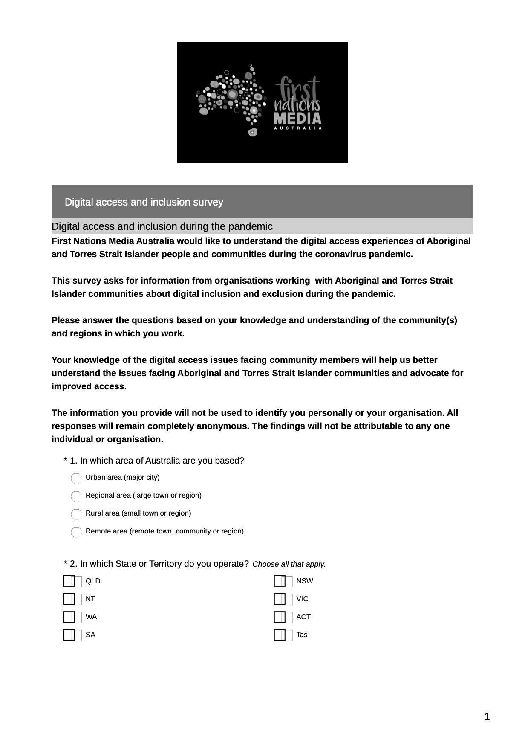
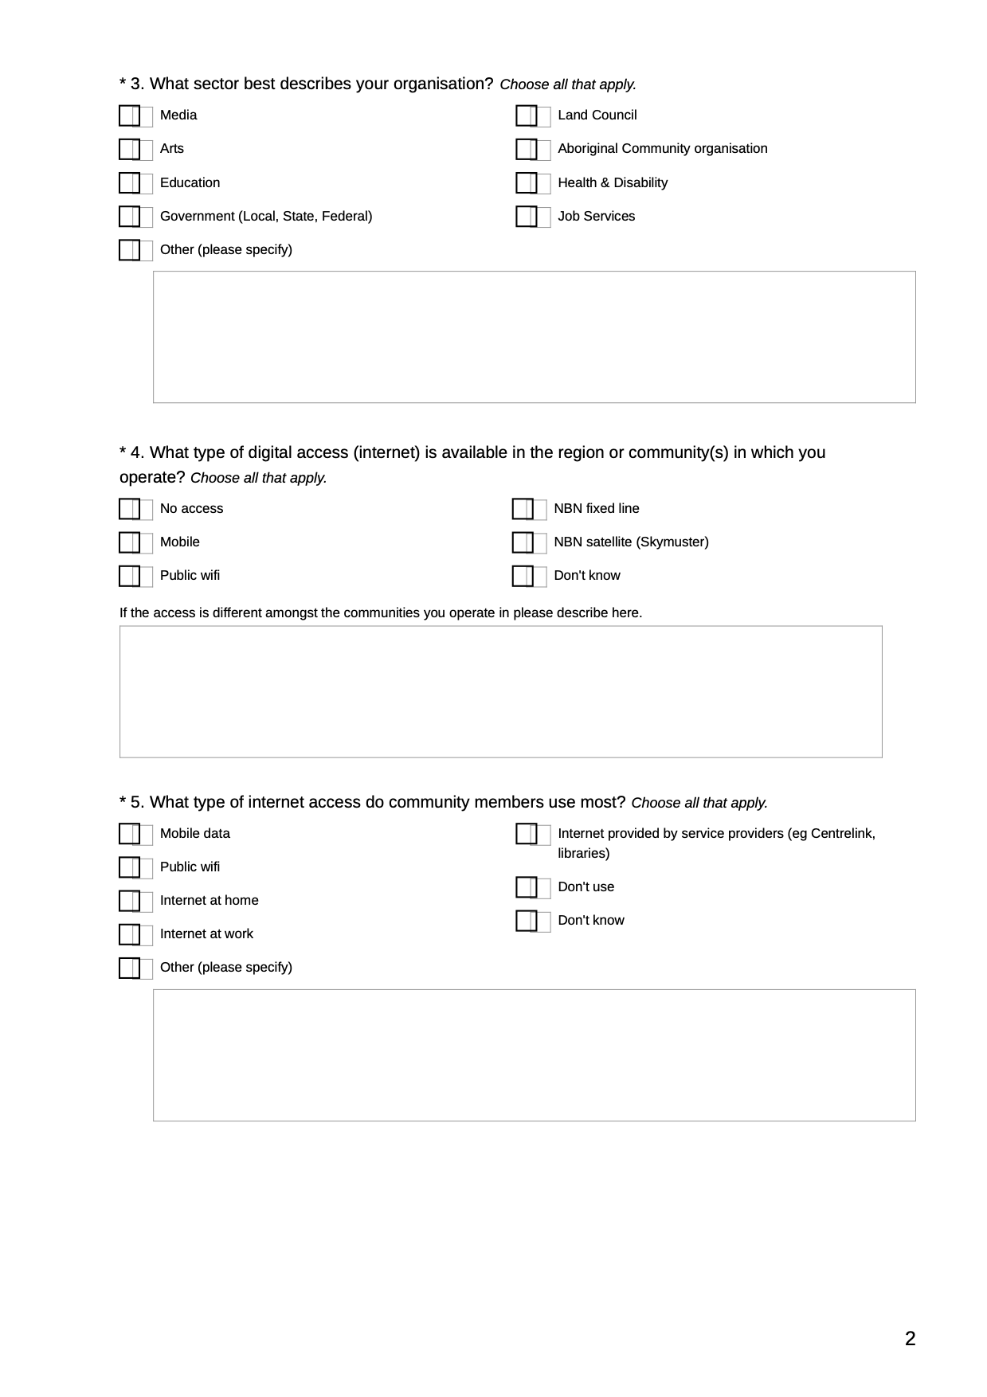
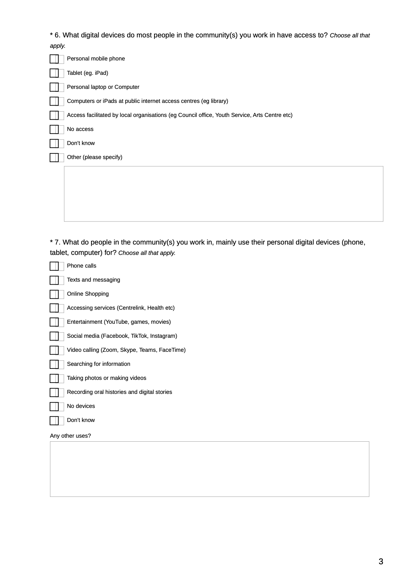

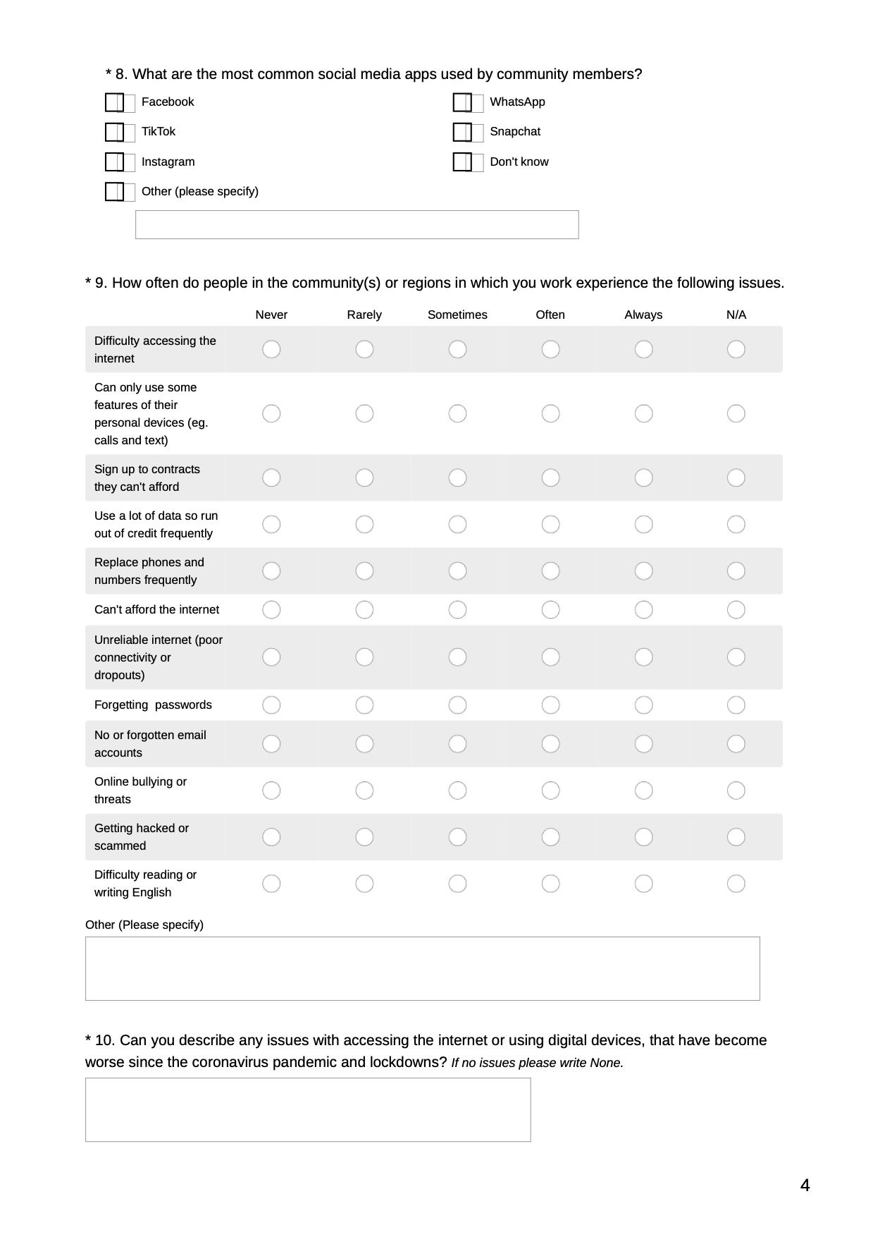

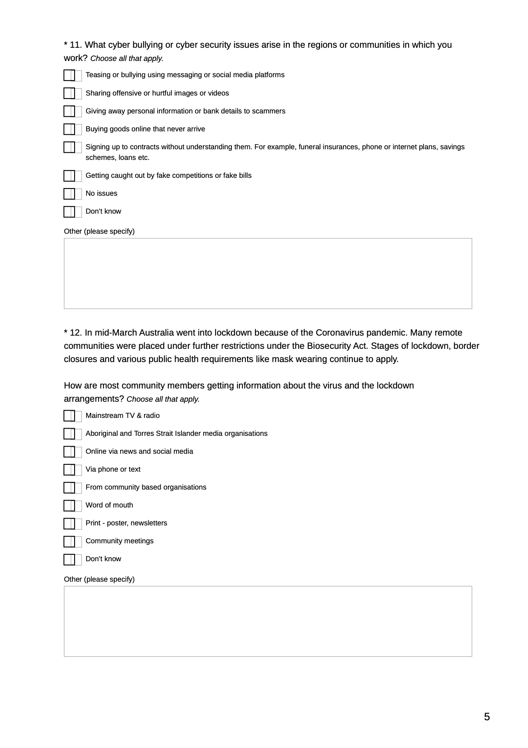

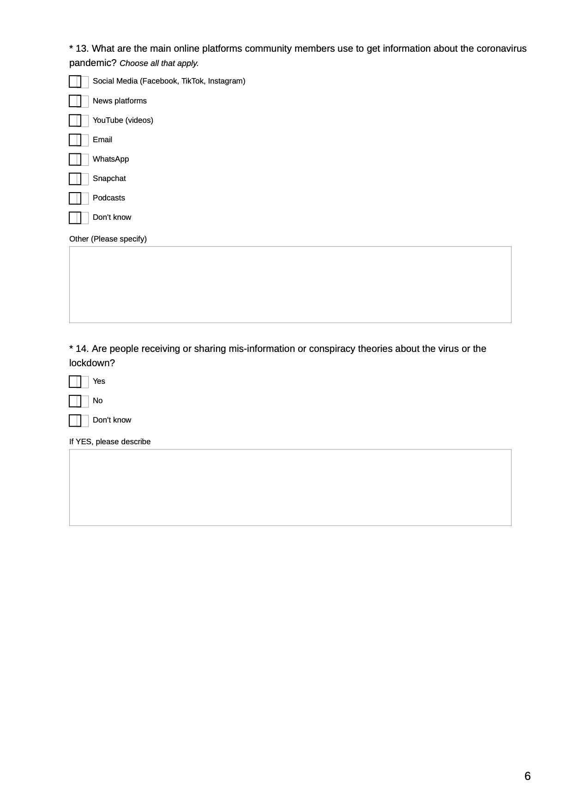

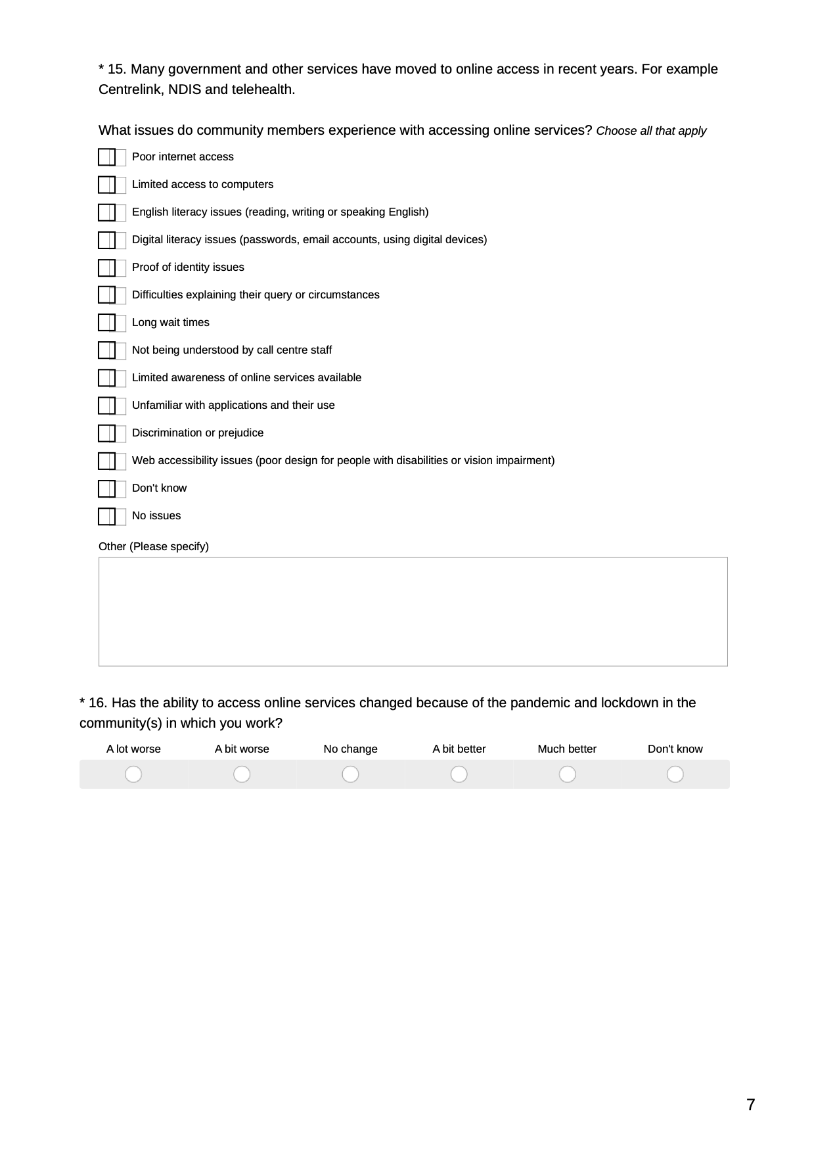

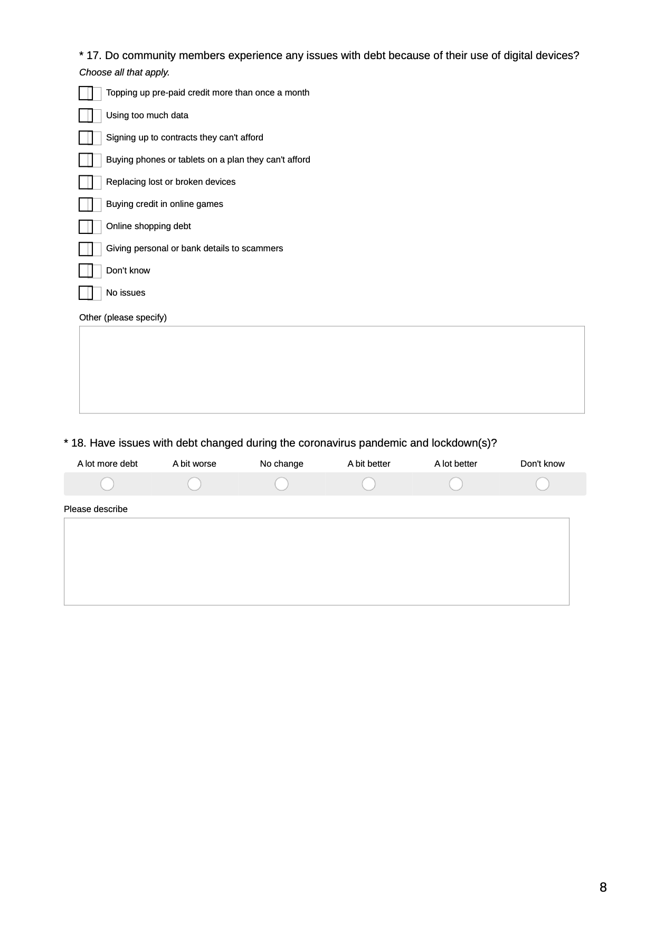

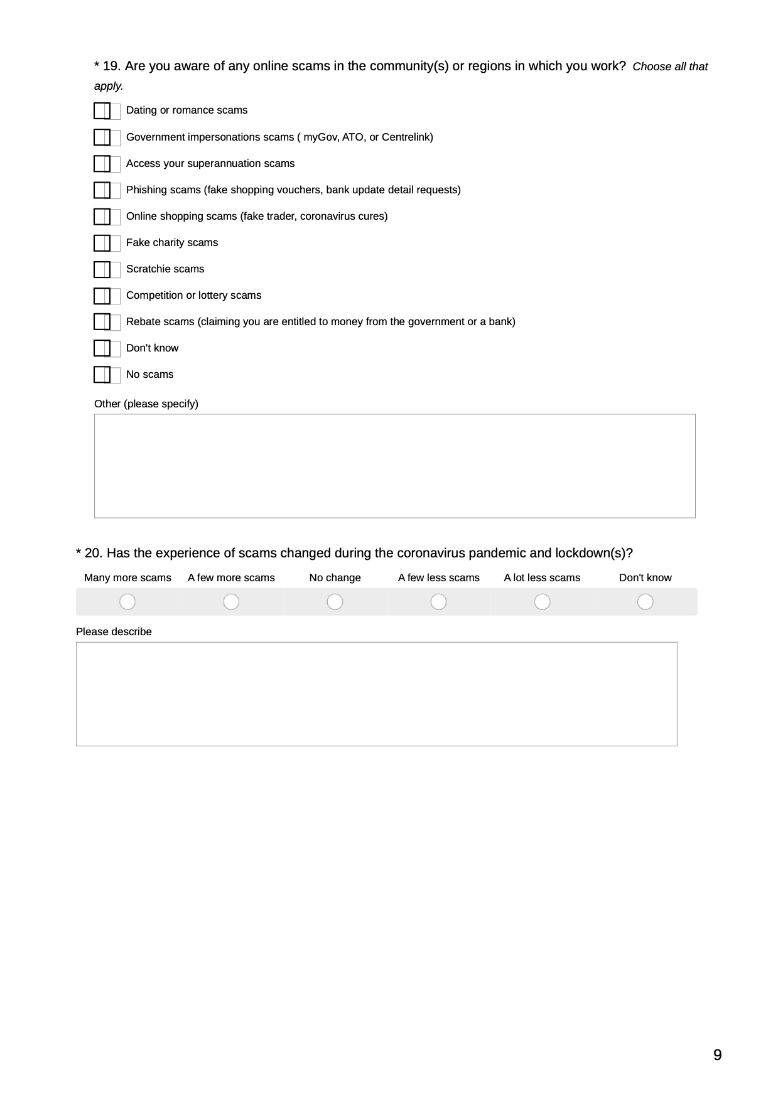

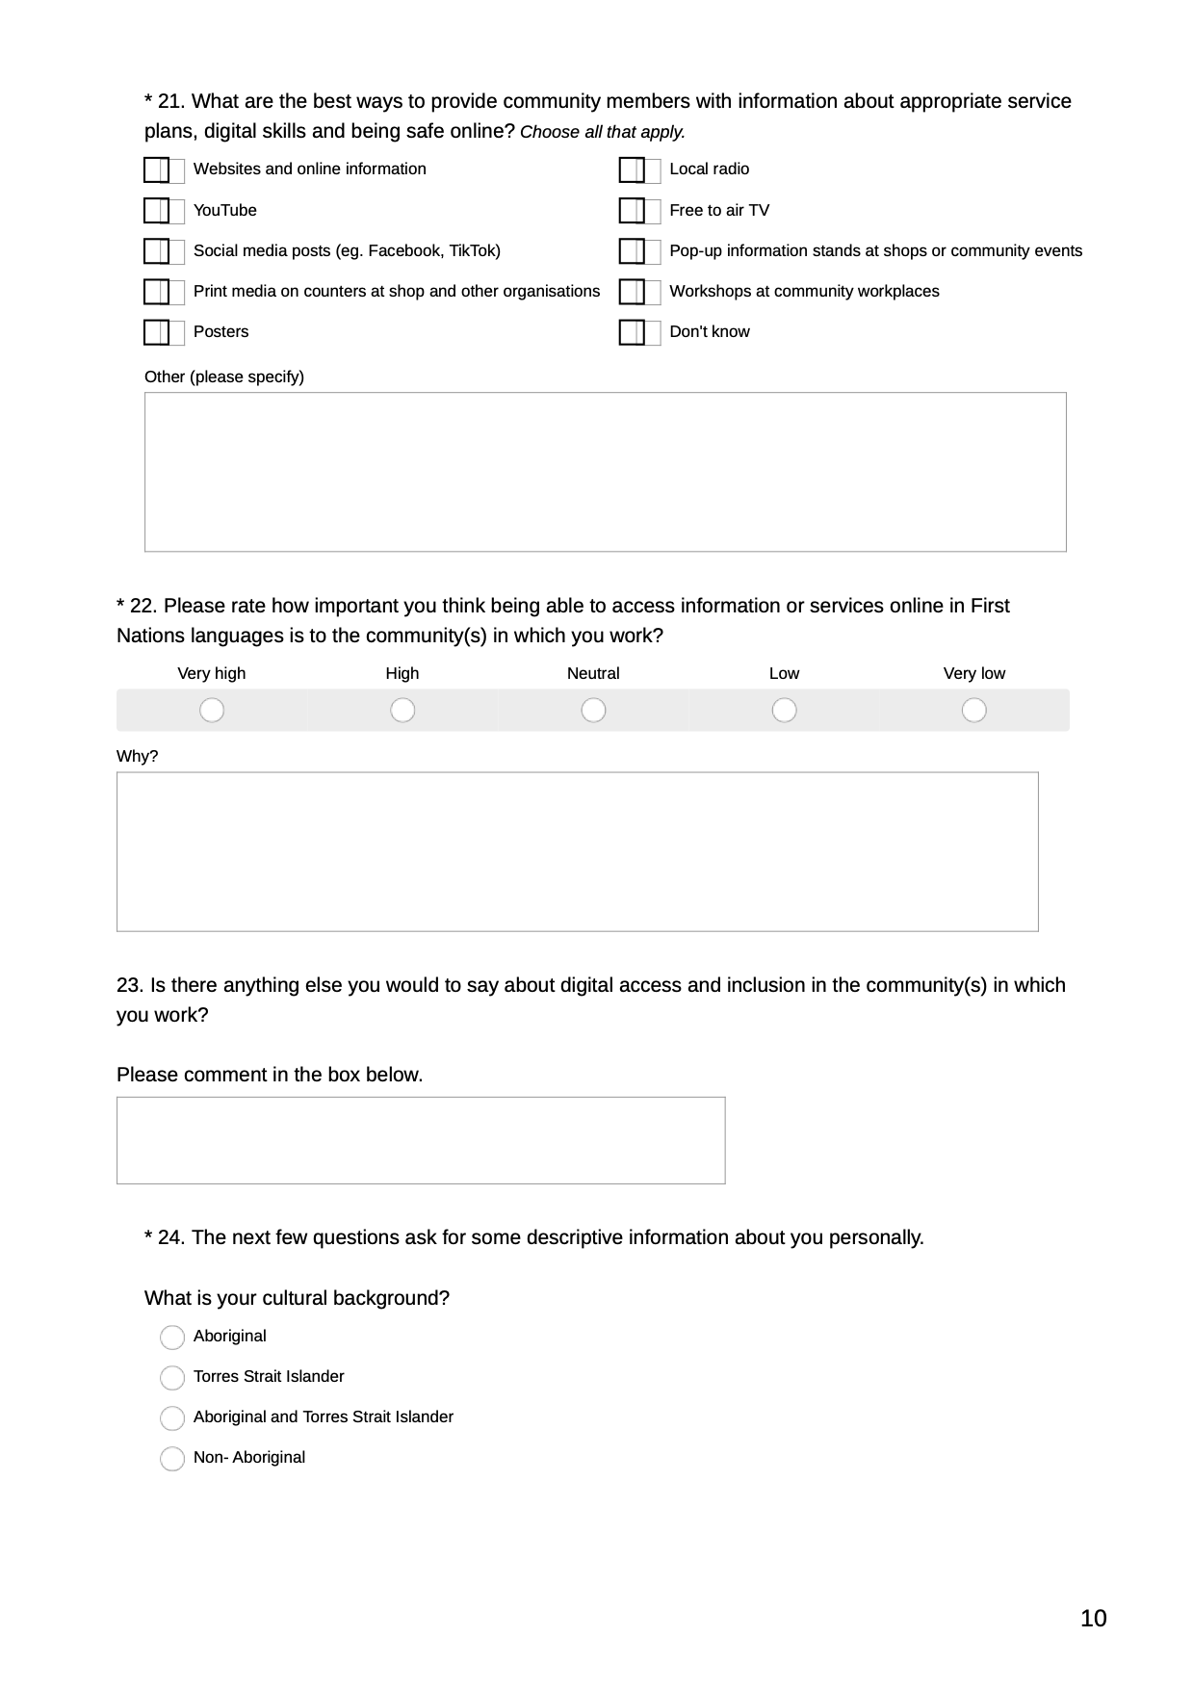

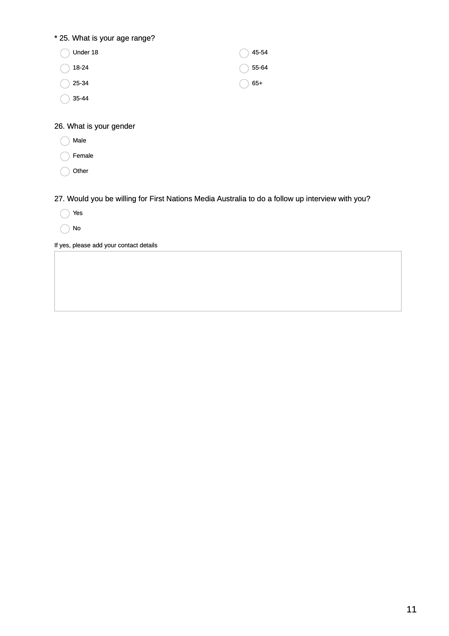

References
ABC(2020a). Telstra and NBN outages disconnect thousands across remote NT. By Matt Garrick and Samantha Jonscher, Monday 12 October 2020. Accessed 28 Nov 2020. https://www.abc.net.au/news/2020-10-12/telstra-nbn-outages-hit-remote-northern-territory/12758536
ABC (2020b). Charles Darwin University to cut 77 jobs, cancel 19 courses in merger of vocational and higher education. By Felicity James. Accessed Tuesday 29 September 2020. https://www.abc.net.au/news/2020-09-29/nt-charles-darwin-university-staff-cuts/12714374
ABS (2018) Australian Household Use of Information Technology report for 2016-17 Financial Year. https://www.abs.gov.au/statistics/industry/technology-and-innovation/household-use-information-technology/latest-release
AIHW: Kreisfeld R & Harrison JE (2020). Indigenous injury deaths: 2011–12 to 2015–16. Injury research and statistics series no. 130. Cat. no. INJCAT 210. Canberra: AIHW. Indigenous injury deaths: 2011–12 to 2015–16
Featherstone D (2020). Remote Indigenous Communications Review: Telecommunications Programs and Current Needs for Remote Indigenous Communities, Australian Communications Consumer Action Network, Sydney. http://accan.org.au/our-work/research/1821-remote-indigenous-communications-review-telecommunications-programs-and-current-needs-for-remote-indigenous-communities
First Nations Media Australia, (2017). Indigenous Focus Day Communiques. https://firstnationsmedia.org.au/about/key-communications/indigenous-focus-day-b4b-forum
Kral, I. (2012). Talk, Text and Technology: Literacy and social practice in a remote Indigenous community. Bristol: Multilingual Matters.
Mariën, I., and Prodnik, A. J. (2014). Digital inclusion and user (dis)empowerment: A critical perspective. Emerald Insight.
O’Sullivan & Walker (2018). From the interpersonal to the internet: social service digitisation and the implications for vulnerable individuals and communities, Australian Journal of Political Science, 53:4, 490-507.
Park, S. (2017). Digital inequalities in rural Australia: A double jeopardy of remoteness and social exclusion. Journal of Rural Studies, 54, pp. 399-407. https://www.sciencedirect.com/science/article/abs/pii/S0743016715300693?via%3Dihub
Park, S., & Humphry, J. (2019). Exclusion by design: intersections of social, digital and data exclusion. Information Communication and Society, 22(7), 934-953.
Productivity Commission (2020). Overcoming Indigenous Disadvantage; Key Indicators 2020. https://www.pc.gov.au/research/ongoing/overcoming-indigenous-disadvantage/2020
Rennie, E., Thomas, J. & Wilson, C. (2019). Aboriginal and Torres Strait Islander people and digital inclusion: what is the evidence and where is it? In: Communication Research and Practice, 5, 105 – 120. https://www.tandfonline.com/doi/abs/10.1080/22041451.2019.1601148
SMH (2020). ‘The worst we’ve seen’. Telstra faces $50M fine over ‘exploitative contracts’. By Zoe Samios and Emma Koehn. November 26, 2020. Accessed 16 December 2020. https://www.smh.com.au/business/companies/telstra-faces-fine-of-up-to-50-million-over-unconscionable-conduct-20201126-p56i4d.html
Thomas, J, Barraket, J, Wilson, CK, Holcombe-James, I, Kennedy, J, Rennie, E, Ewing, S, MacDonald, T, (2020). Measuring Australia’s Digital Divide: The Australian Digital Inclusion Index 2020, RMIT and Swinburne University of Technology, Melbourne, for Telstra. https://researchbank.swinburne.edu.au/file/3c9685ea-76a8-4a77-80bc-69c8b2c7c1c7/1/2018-thomas-measuring_australias_digital.pdf
Thompson, K., Jaeger, P., Taylor, N., Subramaniam, M., & Bertot, J. (2014). Digital Literacy and Digital Inclusion: Information Policy and the Public Library. Lanham, UNITED STATES: Rowman & Littlefield Publishers.
Windley, G, (2017). Indigenous VET participation completion and outcomes: change over the past decade, NCVER, Adelaide. https://www.ncver.edu.au/research-and-statistics/publications/all-publications/indigenous-vet-participation-completion-and-outcomes-change-over-the-past-decade

