Domestic Transmission Capacity Service
Submission by the Australian Communications Consumer Action Network to the Australian Competition and Consumer Commission
20 April 2018

About ACCAN
The Australian Communications Consumer Action Network (ACCAN) is the peak body that represents all consumers on communications issues including telecommunications, broadband and emerging new services. ACCAN provides a strong unified voice to industry and government as consumers work towards availability, accessibility and affordability of communications services for all Australians.
Consumers need ACCAN to promote better consumer protection outcomes ensuring speedy responses to complaints and issues. ACCAN aims to empower consumers so that they are well informed and can make good choices about products and services. As a peak body, ACCAN will represent the views of its broad and diverse membership base to policy makers, government and industry to get better outcomes for all communications consumers.
Contact
PO Box 639,
Broadway NSW, 2007
Email: info@accan.org.au
Phone: (02) 9288 4000
Fax: (02) 9288 4019
Contact us through the National Relay Service

Introduction
ACCAN would like to thank the ACCC for the opportunity to respond to its discussion paper reviewing the declaration for the Domestic Transmission Capacity Service (DTCS). ACCAN believes that the market for transmission services needs to operate fairly and is keen for further engagement with the ACCC on this issue.
DTCS is important for the supply of competitive services and without regulation some areas may see price increases or fewer competitors, meaning consumers have less choice. It is important that the ACCC continues to declare and regulate transmission in areas with limited or no competition, especially in regional and rural areas of Australia, so that all consumers have access to a range of service providers and services at competitive prices.
Lack of access to transmission and backhaul services is also a major barrier to co-location at mobile tower sites as there are fewer incentives for investment by providers if backhaul is not available.
This consultation is more suited to responses from service providers themselves. ACCAN lacks the data and on-the-ground technical knowledge necessary to comment on many of the issues raised by the consultation paper in detail, including on the state of competition at various NBN points of interconnect (POIs). However, as the peak national body representing telecommunications consumers, ACCAN would like to make some brief comments on the importance of competitive telecommunications services for regional and remote consumers.
This submission will not address the consultation paper questions directly but will comment on the importance of regulated backhaul for the delivery of competitive mobile and broadband services.

Background to the consultation
Under section 152ALA of the Competition and Consumer Act 2010 (CCA) the ACCC must run an inquiry into the declaration of the DTCS. The current declaration period ends on 31 March 2019.
The current consultation asks amongst other things, whether the declaration of the DTCS should be remade, extended, revoked, varied, allowed to expire, or extended and then allowed to expire.
The consultation also seeks to examine the effect that the rollout of the NBN is having on competition in the domestic transmission market in light of the impact it is having on the communications sector. It notes the essentiality of competitive transmission services in carrying traffic between NBN POIs and points of presence (POPs) on service providers’ networks for supply to end-users.

What is DTCS
Domestic Transmission Capacity Services (DTCS) are wholesale transmission services regulated by the ACCC that enable carriers to connect their core network to points of service delivery (such as exchanges, premises, and mobile towers). They can also be used to connect to other wholesale customers’ premises, who provide services to other end-users. Wholesale transmission services cover the provision of voice and data, including mobile services.
DTCS only regulates certain routes and DTCS services do not include selected inter-capital, regional, and metropolitan routes. As the ACCC notes, it regulates transmission services except for on routes where it deems competition is sufficient for market pricing.
In the past, high transmission prices represented a high barrier to competition in regional and remote areas of Australia. However, in 2016 DTCS pricing was reviewed and decreased by between 22% and 78%. When prices were lowered in 2016 Vodafone stated that it would lead to more competition and greater choice of provider for consumers. They also stated that the decrease in prices would enable them to invest more in the Mobile Black Spot Programme.

Additional comments on DTCS

Importance for mobile connectivity in regional, rural, and remote Australia
The DTCS regulates some of the connections between mobile towers and the rest of the network and is therefore critical to mobile coverage, particularly in regional and remote areas. Providers without their own networks need access to wholesale backhaul services to connect to networks in capital cities, and DTCS regulates the price that access seekers can be charged for transmission.
As stated in previous submissions to the ACCC’s inquiry into domestic mobile roaming, ACCAN believes there is scope to adjust existing regulatory settings around co-location, facilities access, and transmission services to improve the likelihood of competition in mobile networks in non-metro areas. ACCAN strongly supports measures that will promote competition and sustainability in mobile markets.
The importance of regulated backhaul is even more pronounced in extending regional coverage where MNOs without their own transmission must pay significant costs to move traffic from regional areas to the rest of their network. As the ACCC noted in 2015 backhaul is likely to be the most significant constraint to smaller MNOs competing in regional areas.

It will likely take several years to see the pricing reduction take full effect in transmission markets. However, it is likely that reduction in DTCS pricing is likely to extend coverage by the other providers who will be more able to justify investment in MBSP sites where they previously could not.

DTCS price reductions have also led to a change in thinking about deployment in regional areas. Providers are more likely to invest in building their own transmission infrastructure if they are first able to purchase access from another provider and establish a customer base in an area.
It is also important to note that the DTCS does not apply to all backhaul transmission. ACCAN is aware that Telstra has developed a specific product to offer other MNOs for backhaul from MBSP Round 1 sites to the local exchange. Given that prices for this new fibre is not regulated, Telstra is able to charge whatever amount it wishes, particularly in areas where it is the only backhaul provider. The Guidelines for Round 2 have been updated to say that MBSP backhaul must be provided at a price that is “more favourable than the regulated prices set under the ACCC Domestic Transmission Capacity Service Final Access Determination (DTCS FAD)”. One suggestion may be for DoCA to update the guidelines to say that the discount must be applied on a permanent basis and not as a once-off. There may also be scope for the ACCC to take other action, for example through ongoing monitoring of MBSP tower-to-exchange fibre pricing. Given that backhaul is the largest ongoing cost for a tower, it is important that the market operates fairly.
It is also useful to note other limitations in the scope of the DTCS in ensuring access to all potential transmission networks. For example ACCAN is aware that Optus leverages its ownership of core satellite assets to provide satellite backhaul, whereas Telstra only uses satellite backhaul in emergency situations. Other MNOs may not have similar access to other transmission networks so in such circumstances are more dependent on an access pricing regime to allow usage of a competitor’s transmission networks.
Based on discussions ACCAN has had with a large service provider, there are no issues with mobile DTCS as it is currently priced low enough that cost is not a barrier to entry for smaller players.
ACCAN would submit that DTCS is still an absolute necessity for competition in regional, rural, and remote Australia to ensure that low access pricing is maintained. The ACCC should extend the declaration of DTCS.

Effects of the National Broadband Network on DTCS competition
ACCAN is of the view that the NBN has not yet had a significant effect on the dynamic of the DTCS. Following discussion with industry, we are of the view that currently access seekers have a preference for transmission provided by Telstra, Optus, Vocus, or TPG rather than the NBN.
As the ACCC noted in its Draft Report on the Communications Sector Market Study, competition in supply of transmission services continues to develop particularly in light of the NBN rollout and in metropolitan areas. However there still exist regional transmission routes without adequate competition and this may be negatively affecting competition in the supply of downstream services such as voice and broadband. The report notes that such routes include Tasmania, Coastal Queensland, remote Western Australia, and Darwin. The case study below illustrates that there may be routes currently not declared that should be in order to stimulate competition and deliver better services.
Case Study: Gnowangerup, WA
ACCAN has been made aware of a case in Western Australia which we believe may highlight consumer detriment as a result of the impact of monopoly transit routes on wholesale pricing for backhaul.
The specific example is in Gnowangerup Shire, where there are concerns that monopoly transit routes have impacted on nbn’s decisions to deploy fixed wireless instead of satellite due to a lack of transit competition and subsequently high prices. The map below shows where nbn has deployed fixed wireless along the highway from Katanning. Because of this, towns such as Tambelup and Broomehill that are just a fraction of the size of Gnowangerup are covered by fixed wireless, whereas Gnowangerup only has satellite.
The concern is that smaller towns are getting superior fixed wireless services because they are close to NBN technology and competitive transit points, whereas larger towns with schools and hospitals are ending up on SkyMuster due to the high cost of backhaul on unregulated routes.
The case study suggests that a failing of the NBN is that many communities are put on satellite instead of more reliable fixed wireless because the cost of purchasing backhaul to connect the small towns to the NBN network is too high. Consumers are concerned that certain routes that are not regulated have transmission prices that are too high, and this is discouraging the nbn from providing fixed wireless services to certain towns.
The ACCC should investigate such cases to confirm the role that unfavourable access pricing may play in deterring the deployment of services and technologies in regional Australia, and consider extending the scope of the DTCS to such routes where there is evidence of consumer detriment.
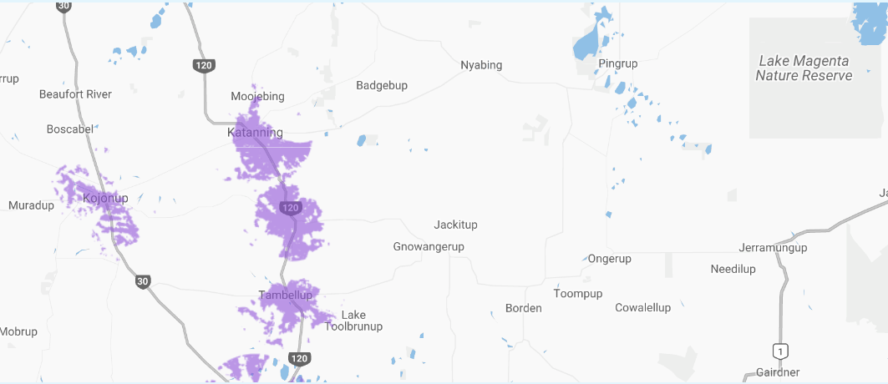
Figure 1: map showing fixed wireless coverage in regional WA

Australian Competition and Consumer Commission, ‘Domestic Transmission Capacity Service – Public inquiry into making a final access determination – position statement on pricing methodology, November 2014, at p.6
Australian Competition and Consumer Commission, ‘Public Inquiry to make a Final Access Determination for the Domestic Transmission Capacity Service FINAL Report’, April 2016, p. 11 at <https://www.accc.gov.au/system/files/ACCC%20final%20report%20%28public%29_0.pdf>
Simon Thomsen, ‘The ACCC's just opened the door for mobile from Optus and Vodafone in regional Australia’ Business Insider Australia, 21 April 2016, http://www.businessinsider.com.au/the-acccs-just-opened-the-door-for-mobile-from-optus-and-vodafone-in-regional-australia-2016-4.
ACCAN submission on the Domestic Mobile Roaming Declaration Inquiry, https://accan.org.au/ACCAN%20Submission%20on%20Mobile%20Roamingv2.pdf
ACCC, ‘Competition limits advice for 1800 MHz spectrum in regional areas’, May 2015 at para [3.4.2].
Department of Communications and the Arts, Mobile Black Spot Programme—round 2 guidelines, version 1.1 at p. 18 at para [5.4.4].
Telstra, Submission to the Productivity Commission Issues Paper on Natural Disaster Funding Arrangements, 6 June 2014, at p.8
ACCC, Communications Sector Market Study Draft Report, October 2017, at p. 98.
Ibid, at p. 94.

