Warrnambool Exchange Fire: Consumer and Social Impact Analysis
Final Report
Dr Mark A Gregory, Dr Kaye Scholfield
May 2014


Warrnambool Exchange Fire: Consumer and Social Impact Analysis
Authored by Dr Mark A Gregory, Dr Kaye Scholfield
Published in 2014
The operation of the Australian Communications Consumer Action Network is made possible by funding provided by the Commonwealth of Australia under section 593 of the Telecommunications Act 1997. This funding is recovered from charges on telecommunications carriers.
RMIT University
Website: www.rmit.edu.au
Email: mark.gregory@rmit.edu.au; kaye.scholfield@rmit.edu.au
Telephone: (03) 99252000
Australian Communications Consumer Action Network
Website: www.accan.org.au
Email: grants@accan.org.au
Telephone: 02 9288 4000
TTY: 02 9281 5322
ISBN: 978-1-921974-20-5
Cover image: Warrnambool Standard, 2012

This work is copyright, licensed under the Creative Commons Attribution 3.0 Australia Licence. You are free to cite, copy, communicate and adapt this work, so long as you attribute the authors and “RMIT University, supported by a grant from the Australian Communications Consumer Action Network”. To view a copy of this license, visit http://creativecommons.org/licenses/by/3.0/au/
This work can be cited as: Gregory, M. & Scholfield, K. Royal Melbourne Institute of Technology, Warrnambool Exchange Fire: Consumer and Social Impact Analysis, Australian Communications Consumer Action Network, 2014.

Acknowledgements
The authors would like to acknowledge project team members Mr James Williams, Dr Helen Marshall, Ms Dorothy McLaren, Ms Michelle Badenhorst, Mr Khandakar Ahmed, Mr Ken Howell, and Dr Sean MacDermott without whom the project could not have been successfully completed. Special thanks go to the research project participants who gave up their time and provided valuable insight through surveys, focus groups and case study interviews. RMIT University would like to thank the Hamilton Performing Arts Centre and Telstra for the use of their facilities for the research project presentations conducted on 15 November 2013. The Ian Potter Foundation’s support has also been significant for the development of the Potter Rural Community Research Network based at RMIT University in Hamilton. And finally the authors would like to thank ACCAN for the grant which enabled the research project to proceed and the valuable assistance provided by ACCAN staff, Narelle Clark, Katerina Pavlidis and Penney Wood.

Executive Summary
The project investigated the social impact of the Warrnambool exchange fire which occurred on November 22, 2012 at 4.35 AM in the vicinity of the Telstra Exchange’s Maintenance Control Room and quickly spread throughout the exchange causing immediate terminal damage to key telecommunications equipment, systems and 60% of the building. The fire caused a telecommunications outage that lasted for about 20 days during which services were progressively restored. The outage affected about 100,000 people in South West Victoria, a region covering approximately 67,340 square kilometers.
The project team conducted three surveys, interviews and discussion groups over a nine month period to ascertain the impacts of the outage from a range of perspectives including government, business and individual.
Telstra reported that there were 135 exchange services, 85 schools, 20 hospitals, 27 police stations, 92 fire stations and 14 SES services affected by the outage. The one remaining telecommunications service in the region, which was the Optus 3G mobile cellular network, was also affected during the outage by an unrelated lightning strike on a telecommunications tower. The financial cost to the region was estimated by the State Government to be at least $0.95 million a day, however the true cost may never be known.
Telecommunications are now an essential service and the research highlighted the lack of forward planning for the loss of single point of failure telecommunications infrastructure such as an exchange building. The analysis of responses showed recurring themes in relation to impacts on work, money in general, health and safety, communication and community life. Telstra and the Department of Communications should provide follow-up reports on whether the recommendations found in their earlier reports, completed in the aftermath of the telecommunications outage, have been implemented and to ensure the lessons learnt are not lost.
The extent of the telecommunications outage is illustrated by survey response statistics of the broad impact:
- 94.6% of respondents suffered some inconvenience related to a business transaction.
- 69.8% were unable, or found it difficult, to make vital purchases such as food or fuel.
- 86.5% were unable to communicate with friends or family.
- 24% were unable to conduct business and had to shut down (for some period of time).
- Over 60% felt that the outage had a negative impact on community life.
Recommendations:
- Telstra and the Department of Communications to implement the recommendations and suggested actions identified in their respective reports and publish the outcomes including the regular updates (Suggested action 1) being provided by Telstra to the Department of Communications.
- The Department of Communications in conjunction with Telstra and NBN Co carry out a study to improve resilience of telecommunications infrastructure including the increased use of mobile facilities that can be used to restore services quickly.
- Incorporate the lessons learnt from the Warrnambool exchange fire into federal, state and local government emergency management and disaster planning processes and publications.
- Raise awareness of the need for individuals, businesses, community organisations and local government to complete continuity planning that includes dealing with telecommunications outages.
- Expand the ABC Emergency Service to include warnings and emergency notifications covering telecommunications outages affecting more than 100 people (or communities of less than this number) for one or more weeks. The ABC Emergency service be promoted more frequently on ABC radio, television and online.

Table of Contents
Acknowledgements i
Executive Summary ii
Table of Contents iv
Introduction 1
Disaster context 1
Methodology 4
Report review 4
Report review steps 4
Surveys 4
Survey design 5
Interviews and focus groups 6
Interview and focus group design 6
Findings 8
Report review findings 8
Telstra report 8
Recommendations and rationale 9
Department of Communications report 13
Suggested actions and rationale 14
Overall conclusions on the report 18
Survey findings 19
Survey response 19
Social impact analysis 20
Work 20
Money 21
Health and safety 22
Communicating 24
Community life 25
Positive outcomes 26
How did people stay up to date? 27
Changes 27
Discussion and focus group findings 28
Response to a future telecommunications outage 28
Discussion and analysis 29
Social impacts 29
Perceiving risk and planning for the ‘next time’ 29
Conclusions 31
Recommendations 32
Recommendation 1 32
Recommendation 2 32
Recommendation 3 32
Recommendation 4 32
Recommendation 5 32
Appendix – Telecommunications Survival Plans 33
Authors 37
Glossary 38
References 39

Introduction
In the early hours of November 22, 2012, a fire in the Telstra exchange at Warrnambool in south western Victoria, Australia, resulted in the loss of internet, mobile and fixed line services to 60,000 residents in an area covering 26,000 square kilometres in south western Victoria. The Telstra exchange at Warrnambool houses transit and local telecommunications facilities for about 95% of the region’s telecommunications capability. According to the local Country Fire Authority (2012), five crews from Warrnambool, Koroit and Ballarat fought the fire which damaged 60% of the exchange. The incident affected every single customer connection that transits through the exchange to some extent for up to 20 days, and directly or indirectly up to thousands of other people including residents and non-residents. The total number of people affected is difficult to ascertain, but Telstra’s report into the exchange fire (Piltz 2013) states that over 100,000 people were affected in some way. The social impact of this outage was investigated by a research team located at a campus in Hamilton, Victoria, one of the affected areas, with data collected during, and immediately following, the outage.
The extent of the telecommunications outage is illustrated by survey response statistics of the broad impact:
- 94.6% of respondents suffered some inconvenience related to a business transaction.
- 69.8% were unable, or found it difficult, to make vital purchases such as food or fuel.
- 86.5% were unable to communicate with friends or family.
- 24% were unable to conduct business and had to shut down (for some period of time).
- Over 60% felt that the outage had a negative impact on community life.
Clearly, this was an incident of deep significance. Conkey (2004) stated that “there is an adage in crisis communications that at least 50 per cent of a response in an emergency is communications.” But what are the consumer related outcomes when telecommunications are lost due to a disaster such as a single point of infrastructure failure?

Disaster context
Municipalities affected by the crisis were: City of Warrnambool (population 35,000), Shires of Corangamite, Glenelg, Moyne, Southern Grampians and West Wimmera. This includes the sub-regional centres of Camperdown (3,463), Colac (10,857), Hamilton (10,135), Portland (9,360) as well as the towns of Edenhope, Port Fairy, Balmoral, Casterton, Cobden, Dunkeld, Mortlake and numerous other smaller communities. Municipalities and businesses outside of the region especially the neighbouring local government regions of the Rural City of Horsham, Golden Plains Shire, the Rural City of Ararat and parts of south-eastern South Australia experienced some impact. Business customers and suppliers, partner and parent agencies, franchises and tourist businesses, family members from well beyond the region, including internationally, were touched by the outage. According to Telstra’s report, there were 135 exchange services, 85 schools, 20 hospitals, 27 police stations, 92 fire stations and 14 State Emergency Service (SES) services affected (Piltz 2013).
The outage affected a very wide range of services and sectors from banking to schools, retail and tourism, emergency services, health services and business. All aspects of community life and all generations of people were affected: visitors, the elderly, school children, local government, fire service personnel, and the media. It is unlikely that anyone living in the region or who was visiting during that time was not affected in some way. The State Government estimated a loss to the local economy of at least $408,000 a day (DBCDE 2013).
For all of these communities the impact was either a total or partial loss of services including fixed line and mobile telephone services, business services such as electronic payment and cash withdrawals, internet access applications and emergency services (Piltz 2013).
The region affected by the outage is shown in Figure 1 and the impacted service exchange areas by population are shown in Figure 2 (DBCDE 2013). The local government and affected Telstra exchange service areas are shown in Figure 3 (Piltz 2013).
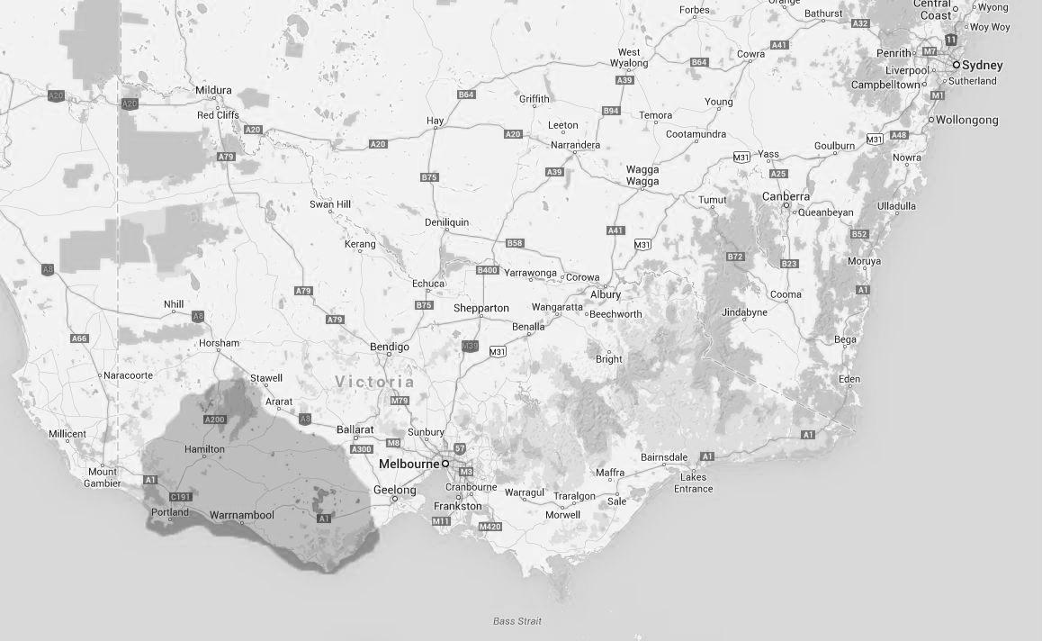
Figure 1 South West Victoria Affected Region
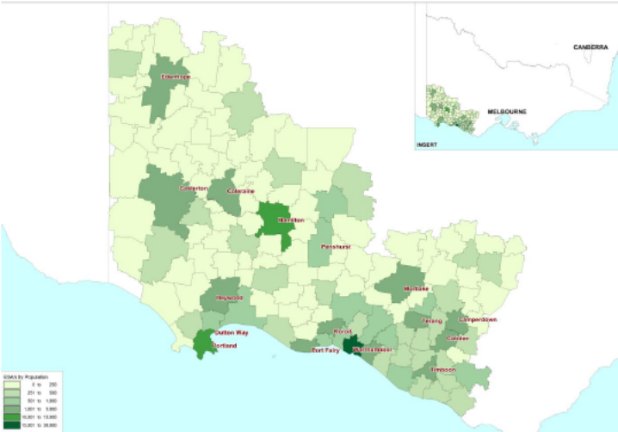
Figure 2 Map of impacted service exchange areas by population (DBCDE 2013)
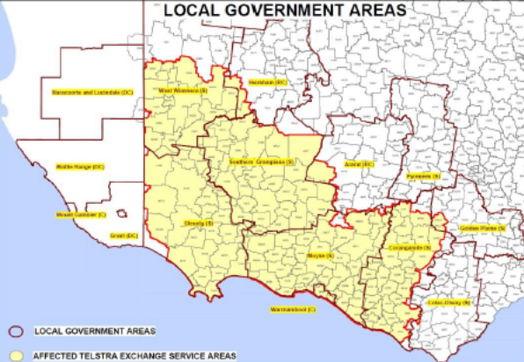
Figure 3 Map of local government and affected Telstra exchange service areas (Piltz 2013)
From the beginning, Telstra worked assiduously to deal with the urgent situation at the Warrnambool exchange, to try to reconnect people and to make redress for business losses. The problem was technological in nature. The social impact was significant and complex. Media coverage in the immediate aftermath of the fire dealt with the facts about the fire and its direct consequences. At the time it was reported that it would take ‘days’ for services to return to normal. However, in some cases the actual period without service (down-time) was nearly three weeks. During this time some people’s lives were severely impacted. The immediate consequences for individuals were not clear. There was an understanding that the business sector was likely to endure significant financial loss. The restoration of business services was a particular priority for Telstra. While the economic impact on the region was immediately obvious and gained considerable attention, a study of the social impacts of the outage did not fall within Telstra’s purview at that time. On the Monday following the exchange fire, it had become apparent that the resulting outage would have wide and far reaching consequences so a research team located in Hamilton, one of the affected regional cities, developed a survey designed to assess the social impact.

Methodology
The research project included a review of the Telstra (Piltz 2013) and Department of Communications (DBCDE 2013) reports on the Warrnambool Exchange fire, three surveys, group discussions and invited feedback.

Report review
Both the Telstra (Piltz 2013) and Department of Communications (DBCDE 2013) reports on the Warrnambool exchange fire made observations and recommendations regarding the fire, and the subsequent telecommunications outage and restoration process. The purpose of the report review was to identify if the observations and recommendations made provide a reasonable assessment of events that led to the fire, the aftermath and how to reduce the probability of a similar event or to minimize the effects of a similar event. In particular, the report review highlighted that a gap in the report was the absence of an understanding of the breadth of the social impact from the disruption to a major telecommunications service.

Report review steps
The Telstra and Department of Communications reports were reviewed from the context of the consumer and how the actions of Telstra and the Department of Communications affected consumers during the telecommunications outage.
The Telstra and Department of Communications reports include a number of observations and recommendations. The review sought to identify if there have been any tangible outcomes resulting from the observations and recommendations including public notification.

Surveys
A regional survey with 417 responses was carried out between the end of November 2012 and the end of January 2013 to gauge the initial impact of the exchange fire. Due to the lack of telecommunications capability as a result of the fire it was necessary initially to utilize paper based surveys which were printed, distributed and collected. There were limitations to the distribution of the paper based surveys beyond Warrnambool, Hamilton, and some other areas due to the distance involved and the difficulty of communicating with people, so the survey was constrained. The non-availability of email and internet was of course a limiting factor and a further indication of a growing reliance on telecommunications for an increasing range of human activity including research. In addition, cards with the survey address were printed and distributed widely inviting people to go online once their internet service resumed. Media and community partners, including local governments, assisted in raising awareness of the research.
The research team visited the Warrnambool exchange at the Telstra reopening event and carried out interviews and surveys with people visiting the Warrnambool exchange. The purpose of this activity was to gain valuable insight into the exchange fire from people who were interested in what had happened and were willing to take the opportunity to visit the Warrnambool exchange which is not normally open to the general public.

Survey design
The survey design included generic response categories such as personal, work, money in general, health and safety, communication and community life, and an opportunity to make comments. The survey design aimed to ensure respondents had an opportunity to provide a broad, unbiased and unrestricted response on the impact of the telecommunications outage.
Personal (non-identifiable) demographic and geographic information was collected, including a section that identified the response as being from the perspective of an individual, business owner/operator, community member or other (as specified). Those who wished to respond from more than one perspective were asked to fill in separate surveys for each category.
Length of disruption (in days) was canvassed for landlines, mobile phones and internet access, with capacity to nominate differing lengths of disruption per item.
The nature of communication disruptions was identified as either friends/family related or business related with the opportunity to comment further if desired.
Impact on business and commerce was surveyed with questions regarding retail and work related concerns. Respondents were invited to indicate if they found it difficult or impossible to make essential purchases (food and fuel), pay bills or make bookings. For those who were regularly employed, information was sought as to the impact on their usual place of work, particularly inability to conduct business (shut down), reduced ability to process orders, loss of customers or difficulty in conducting tasks (such as accessing email). In each case, additional comments were also invited.
Health and health-related concerns were canvassed, including both actual health emergencies and concerns for health and safety due to the outage, through specific questions and comment boxes.
General comments were also sought regarding impact on community life and any positive impacts arising from the lack of telecommunications.
Estimates of financial cost were sought with the option to specify dollar amounts and, again, the opportunity to comment more broadly.
Two questions invited comments on non-essential activities that people would have liked to have done but were unable to, and activities that people really needed to do but were unable to because of the outage.
Planning for the future was also investigated when respondents were asked to identify whether or not they had begun to think about and plan for the potential for other, similar, events in the future. This included an invitation to elaborate on alternative or future plans.
Finally, the opportunity to make other comments was offered.

Interviews and focus groups
Interviews were held with individuals throughout the survey period. Between October and November 2013 there was a series of focus groups. The purpose of the interviews and focus groups was to gain an insight into recollections of the Warrnambool exchange fire and to gauge if the earlier survey response data was reflected in data collected nearly one year later.

Interview and focus group design
The interviews and focus groups aimed to highlight reflections on the Warrnambool exchange fire and to identify if changes to the earlier survey responses had occurred, though it was anticipated that the respondents might not be the same people who completed earlier surveys.
The interviews were often short discussions regarding the Warrnambool exchange fire and the aftermath and as such the discussions would touch on one or more of the effects on work, money in general, health and safety, communication and community life.
Focus groups were scheduled in small regional towns in south western Victoria. Advertisements describing the time, location and nature of the group discussion points were posted on noticeboards at community halls, general stores, pubs, schools and placed in local press media. The advertising copy encouraged residents to attend and share their recollections of the outage incident as well as their current experience of telecommunications availability.
Eighteen attendees from eight towns in regional areas were recorded at focus groups: Camperdown, Casterton, Cavendish, Digby, Heywood, Mirranatwa, Mortlake and Nullawarre. A further 15 interviewees were drawn from these areas, as well as Balmoral, Edenhope, Hamilton, Merino, Portland, Warrnambool and Woorndoo.
The focus group questions were grouped into sections that covered targeted response categories. Attendees were asked how their approach to following key activity areas was affected by the outage incident: (i) Education, (ii) Business/Commerce, (iii) Health & safety, (iv) Community, and (v) Planning for future outages.
General comments and observations were sought on whether telecommunications services had returned to the same level (or better) and whether the respondents’ living or work area generally enjoyed reliable telecommunications.
How the telecommunications outage affected every day activities including shopping, banking and education was discussed and examples sought.
The effect of the telecommunications outage on community organisations and activities included questions on how the community was affected and whether individuals were involved with community organisations and activities that were affected.
Personal communication is an important daily activity which was explored to identify the health and stress issues surrounding not being able to quickly and easily communicate with others. This category included identifying how individuals communicated during the telecommunications outage.
People were asked if they had thought about preparing for a future telecommunications outage and if they had what they would do.

Findings
This consumer and social impact analysis of the Warrnambool exchange fire found that the telecommunications outage did have an effect on residents within and beyond the region and the risk of future telecommunications outages has not diminished significantly as a result of the lessons learnt from the Warrnambool exchange fire due to the ongoing threat of fire, flood, and extreme weather.

Report review findings
The Telstra and Department of Communications reports provided significant detail about the Warrnambool exchange fire, the immediate aftermath and the service restoration process. Observations and recommendations were provided but there appears to have been a need for a wider perspective. In the future, consumers may be faced with a lengthy telecommunications outage resulting from a disaster, and a broader analysis of the Warrnambool exchange fire should have identified the need for single point of failure telecommunications facilities to be either duplicated, made more robust or replaced effectively with mobile drop-in facilities in the event of facility failure.
Almost immediately after the incident, people commented on feeling isolated, cut-off from the rest of the world, that little information went out around the country, and that there was a sense the impact was ‘quarantined’ to the region to minimise the import of the crisis. The continual reference to the ‘Warrnambool Exchange’ may have given unaffected parties the impression that the impact was confined to Warrnambool itself, and not to the exchange’s full service area. The impression held by respondents was that people outside the region therefore didn’t appreciate that the fire affected a significant area of the state. Should the government and Telstra have kept the issue in front of the wider public through national awareness and community service announcements? Had they done so, a greater awareness, across the wider Australian community, may have alleviated some of the issues that occurred.

Telstra report
The Telstra Warrnambool Exchange Fire Investigation report (Piltz 2013) included 22 recommendations that were grouped according to “observations [Piltz] made and major risk reduction opportunities.” They also cover “operational improvements possible in a wider network perspective that are based on the lessons learnt”.
The Telstra report demonstrates that a lot of effort has gone into the report and some valuable recommendations have been made. However, a scan of the Department’s website and Telstra’s website highlights that there continues to be an apparent lack of information on whether any of the recommendations in the report have or will be acted upon. The report should have included a recommendation that a follow-up review occur that would report to consumers whether the Warrnambool Exchange Fire Investigation recommendations were acted upon and what was found nationally as a result.

Recommendations and rationale

Building Fabric
A series of recommendations were made regarding improvements to the building fabric.
Recommendation 1 identified the need, at all Local Access Switch (LAS) / Key Transmission Points (KTP) / Ethernet Aggregation Points (EAP) sites in regional Australia, for an additional level of cabling checks to be carried out and smoke and heat detectors to be installed unless already fitted and tested.
Recommendation 2 and 3 identified the need for a review of the operation of air handling plant which continued to operate “until the Main Switch Board was switched to off AND the Emergency Power Plant was overridden and stopped.”
Recommendation 4 identified the difficulty that occurred when an effort was made to stop the Standby Generator Plant (SGP) and recommended a Stop Button be placed on the Main Switch Board (MSB).
Recommendation 5 highlighted that “fire pillows in the cable tray entrance points to the Maintenance Control Room were not evident or in place which could have mitigated the smoke penetration to other parts of the building.”
Recommendation 6 included a requirement for “clear instructions for local Fire Brigade staff to be able to isolate by operation of circuit breakers the telecommunications load from the DC Power system in the event of a fire.”
Recommendation 7 identified a requirement for lightning protection devices to be audited and recorded in the latest site electrical drawings.
Recommendation 8 called for verification that the facility is a safe place to work by suggesting “all LAS/KTP/EAP sites in regional Australia should continue to be audited for Network Building Safety and are to be audited in accordance with the Essential Safety Measures Schedule 8 (Fire Safety Installations).”
Recommendation 9 highlighted the benefit of reducing the effects of electrical faults including the possibility of fire. “All LAS/KTP/EAP sites in regional Australia with obsolete equipment or equipment no longer carrying live traffic should have the DC power disconnected from this equipment.”

Discussion and Analysis
The building fabric related recommendations provide important steps that should be taken at all LAS, KTP and EAP sites in regional Australia. The need, in 2013, for a recommendation that smoke and heat detectors be installed in all building spaces at critical single point of failure facilities is a concern.
The operation of the air handling plant during an external fire (such as a bush fire) may be necessary and recycle more internal to the building, but in the event of a fire inside the building, operation should not occur or, if necessary, operate in an air exhaust mode.
Telecommunications facilities are in a constant state of flux and it is necessary that staff working in the facility are trained in how to ensure fire suppression equipment and facilities including fire pillows are in place when work is completed. Recommendation 5 should be expanded to include a review of induction or staff training relating to work being carried out that might impact on fire suppression equipment and facilities. This should also include reinforcement of the duty of care held by staff in signing off on completed work: it is essential that work disrupting the fire suppression and prevention mechanisms are restored at the end of work.
When considering recommendations 6 to 9 a thread emerged on the need for a national key telecommunications infrastructure building and disaster code of practice. Whilst Telstra owns and maintains a considerable number of telecommunications single point of failure facilities, there is a growing data centre industry and other non-Telstra telecommunications facilities that may also fall into the category of vital single point of failure telecommunications facilities.
It was evident from the recommendations in the building fabric category that at the time of the Warrnambool exchange fire, Telstra did not appear to have implemented, or may have lapsed in the use of, “best practice” relating to fire events. This would therefore point to the potential need for broader industry work in the area of best practice with regard to building safety and exchange fire protection: particularly in this era of consolidated and shared exchanges.
Consumers need to be satisfied that the telecommunications industry has made every effort to secure and protect key installations and for this reason the telecommunications industry should get involved in the process.
Recommendation 9 could be construed as implying that there is a significant quantity of equipment located within Telstra exchanges that may be classed as obsolete, or not intended to carry live traffic, and as such represents an electrical safety hazard. It would therefore be in Telstra’s interest to remove such equipment; indeed the lessening of electrical power demand may cover the cost of the removal of such equipment.

Network Architecture
A series of recommendations were made regarding improvements to knowledge of aspects of the network architecture including diversity, failover and backups of critical network architecture and device configuration information.
Recommendation 10 identified that “all KTPs in regional Australia be subject to an audit of critical transmission link Diversity and the effectiveness of [circuit] failover.”
Recommendation 11 requires that “all LAS/KTP/EAP sites in regional Australia be subject to critical and complex configuration data backup in an offsite location for critical control elements in the network.”
Recommendation 12 calls for “an in building optical fibre diversity Network Deployment Standard be developed as part of the general exchange superstructure (CN1234) standard. This is to apply to new installations.”

Discussion and Analysis
The network architecture recommendations cover matters that should be routine activities and are more serious than may appear at first glance.
Recommendation 12 should not be for new installations but should be implemented at all facilities now – which is a serious and most likely costly undertaking for Telstra. This sort of program can be integrated into the ongoing upgrades that occur within telecommunications systems as a matter of course. If another disaster occurs at a single point of failure telecommunications facility and the optical cables connecting the external cables to the external trunk transmission equipment are all in the same cable trays then it must be assumed that considerable damage will occur that will negate diversity efforts. For this to occur consumers would be rightly concerned that having been made aware of the problem in existing facilities that Telstra would rectify the problem.
Recommendation 11 highlights how work practices that are not regularly checked can lead to unwanted outcomes, including the loss of vital configuration information. The recommendation should include a statement of responsibility within Telstra to ensure that offsite backups of vital configuration information occur. Whilst the extraordinary effort of Telstra staff in restoring the exchange to full service must be applauded, this recommendation highlights that routine telecommunications industry practice was not in place at the Warrnambool exchange, and as a result must have contributed heavily to the extensive delays in restoration of services to consumers.
Recommendation 10 is equally serious because resilience of networks below a disaster affected facility is vital for quick service restoration and a reduction in the overall effect of a disaster event.

Disaster Recovery Planning
A series of recommendations were made about disaster recovery planning including audits, knowledge of spares and their locations, and use of mobile facilities in the event of a telecommunications outage.
Recommendation 13 identified the need to have a “specific Disaster Recovery Plan (DRP) for all LAS node or host sites covering their specific geographical location including the transmission network configuration. This is in addition to the current documentation covered by reference DRP’s.”
Recommendation 14 states that “all EAP sites in regional Australia have a specific DRP covering their specific geographical location including transmission configuration. This is to be documented specifically in a new set of documents similar to those covering the PSTN.”
Recommendation 15 calls for “all LAS Node or Host sites in regional Australia [to] be subject to an audit of volumes of critical spares and their locations.”
Recommendation 16 identifies that the location of spares holdings should be reviewed including “critical spares holdings for the Business and IP based services should be reviewed in respect to the volumes and storage locations in Regional Australia and a critical IP Network and Transmission Network spares holding Plan is to be updated.”
Recommendation 17 highlights the value of the mobile facilities that were deployed to mitigate the telecommunications outage by restoring services utilising temporary mobile facilities. “A review of the number and location of Mobile Exchange on Wheels (MEOW) and Cell on Wheels (COW) and Satellite Cell on Wheels (Sat COW) in the Telstra emergency facilities fleet be conducted to ascertain if the fleet should be augmented.”
Recommendation 18 highlighted the need for “the Major Incident Management (MIM) operating procedure for incidents of this scale to be updated to include the early appointment of an Onsite Incident Controller. In addition the appointment of an Onsite Restoration Coordinator responsible for the complex restoration efforts needs to be included in the operating procedure. This update is to include hand over procedures.”

Discussion and Analysis
The disaster recovery planning category highlighted how bad a disaster can become if spares holdings are inadequate or in a location which can be affected by the immediate disaster. Telecommunications outages can also be exacerbated if there are inadequate mobile systems available to restore services quickly. The planning also highlighted the need for clear management lines of control during and after such an event.
The Warrnambool exchange fire highlighted deficiencies relating to disaster planning and recovery. The use of mobile facilities was extremely successful and provided a vital backup, however, the number and type of mobile facilities available should be reviewed and augmented.
As the National Broadband Network (NBN) expands and copper is replaced through the introduction of Fibre to the Premises (FTTP), Fibre to the Building (FTTB) and Fibre to the Node (FTTN) there is an opportunity to compartmentalise, containerise and mobilise Fibre Distribution Hubs (FDH), Fibre Access Node (FAN) and Point of Interconnect (PoI) equipment so that by careful design a single point of failure infrastructure facility can be quickly restored utilising mobile facilities. There is a need for Telstra / NBN Co to instigate a review of how the NBN can be made more resilient with the introduction of mobile facilities deployed around the nation that may be used for fixed infrastructure restoration.

Emergency Services Operations
Recommendation 19 identifies a need to improve diversity by providing an alternate transmission route to Warrnambool for the “Statenet Mobile Radio (SMR) and reduce the reliance on the single terrestrial transmission link to Warrnambool, a diverse transmission path from the SMR base is to be established using microwave radio via Tower Hill from the tower at Warrnambool.”
Recommendation 20 identifies the ongoing work required to complete the facility restoration process and recommends that “The Critical and Essential Repair Plan and associated works be completed as soon as practicable.”

Discussion and Analysis
The emergency services operations recommendations identify the need for a diverse path for the SMR and for facility restoration work, including repair of damaged fire detection equipment and the Fire Indication Panel. Improving emergency services operations resilience is important, and the question of whether a similar resilience is required at other single point of failure telecommunications facilities needs to be explored. More information needs to be provided on measures taken to ensure there is improved resilience.

General
Recommendation 21 calls for “a general awareness campaign (to) be conducted for Telstra employees and contractors relating to the requirement to close smoke and fire doors.”
Recommendation 22 identified the need for a “Global Operations Centre reviews [of] the Netcool Alarm buffering rules in relation to the presentation of the “Fire panel Fault” alarms for appropriateness.”

Discussion and Analysis
Telstra’s telecommunications facilities are busy places with large numbers of contractors and staff entering and leaving buildings. Fire doors were apparently left open in the Warrnambool exchange that “allowed the fire to spread.” Overall there appears to be a need for more oversight, training and possibly annual induction refresher sessions for Telstra’s facilities to ensure the earlier recommendations relating to work practices and actions such as fire doors being closed are carried out.

Department of Communications report
The Department of Communications published its report from the Inquiry to Learn Lessons from the Warrnambool Exchange Fire Report. It provides a review of the telecommunications outage, submissions and makes suggestions “to assist stakeholders with minimising the impacts of prolonged telecommunications outages.” The report “strongly supports the need for individuals, businesses and governments to consider telecommunications outages in their continuity plans, regardless of the likelihood that an event of this magnitude being repeated anytime soon.”
The report identifies “one key suggested action is that telecommunications service providers, governments and emergency services consider how to better provide timely and accurate information on the nature and extent of an event of this type, including the approximate recovery pathway and timing. This information is important to assist all stakeholders [to] respond to these types of events and to inform the broader population that their efforts to interact with the affected communities may be disrupted.”

Suggested actions and rationale

Suggested action 1
“The [Department of Communications] seek regular updates from Telstra on the implementation of the recommendations of its inquiry into the Warrnambool exchange fire.”

Discussion and Analysis
The Department of Communications does not appear to have made any information public about what it has learnt from Telstra from the regular updates identified in suggested action 1. It is important that consumers be provided with open and transparent updates on the actions carried out by Telstra, the telecommunications industry and the Department of Communications.

Suggested action 2
“While noting the importance of voice communications, telecommunications providers should consider as part of their mass outage business continuity planning, options for the provision of interim mobile broadband services for the community e.g. local wireless broadband access hubs (i.e. Wi-Fi).”

Discussion and Analysis
Australia has a growing public Wi-Fi presence in urban and regional centres so the suggestion that telecommunications providers might consider utilising Wi-Fi access hubs as part of a disaster recovery plan is telling. Facilitating broadband data connections utilising mobile facilities that can be deployed to affected regional areas (cities and towns) is a logical step that would provide consumers with some certainty about how they can gain access to data services, however it is arguable that Australian telecommunications providers have a preference for providing mobile cellular data services at high cost to consumers. It is therefore conceivable that telcos are utilising mobile facilities to restore mobile cellular services expecting consumers to pay for access to mobile cellular data.
There is a discrepancy in approach that does not provide fast restoration of public Wi-Fi in locations such as libraries, schools, shopping and community centres. The Department of Communications should revisit suggested action 2, identify how public Wi-Fi can be provided and restored as a priority service utilising mobile facilities and if necessary provide necessary guidance to the Australian telecommunications industry about the value of Wi-Fi during a telecommunications outage.

Suggested action 3
“[The Department of Communications] will work with the Communications Sector Group within the Trusted Information Sharing Network to develop best practice guidance for owners of critical communications infrastructure regarding public messaging during a prolonged telecommunications outage covering:
The provision of early and accurate advice to the community;
The dissemination of information to business, government, community service providers and critical industry sectors such as banks;
Engagement with emergency service providers and the appointed local incident manager;
Public communications over radio, by personal contact etc. - avoiding a reliance on phone and internet;
Communications with other wholesale providers including on matters dealing with compensation;
Public notices, such as the use of prominent notices on websites, explaining the outage to customers and clients outside the affected area; and
The use of recorded voice announcements to inform incoming callers of the outage.”

Discussion and Analysis
The best practice guidance identified in suggested action 3 does not appear to have been finalised nor publicised. Consumers need confirmation that suggested action 3 will be completed and a best practice guide published soon. There are points in the Australian telecommunications networks where single point of failure telecommunications facilities exist and the fourth point in suggested action 3 highlights the need to provide clear effective guidance to telecommunications providers on the need for alternate telecommunications capability to be available.
Information dissemination is vital to reduce the impact on consumers of a telecommunications outage. The Warrnambool exchange fire faded from the memory of people, organisations and government outside the affected area quickly due to the sparse reporting of the telecommunications outage after the first couple of days. It is important that, during a disruption to services of this magnitude, there are constant updates nationally including details on how to find out about the telecommunications outage and how to communicate with people, organisations and government within the affected area.

Suggested action 4
“Telstra and other service providers to consider improving processes to assist customers with setting up temporary call diversions during future outages.”

Discussion and Analysis
The suggested action 4 proposal should be picked up by the Communications Alliance and a process put in place across the industry for improved assistance and faster outcomes during telecommunications outages, particularly with important temporary services such as call diversions during the telecommunications outage.
Is there more that can be done in this regard? Automatic redirection automation for services including facsimile to email capability might assist a business that has lost their facsimile continue to receive messages albeit through a proxy outside the affected area.

Suggested action 5
“When businesses review their business continuity plans they should take into account the prospect of a major telecommunications outage that affects both mobile and fixed voice and data services.”

Discussion and Analysis
Suggested action 5 provides sound advice but as with most advice there is a need for it to be disseminated and regularly promoted to ensure individuals, business and government update their continuity plans. In the case of a telecommunications outage it is of no value for the advice to be available online as the lack of telecommunications capability will prevent access to the advice.
There was not sufficient appreciation of the breakdown of the card readers in every single business in the region and the substantial affect this had on consumers and small business. Many had little chance of recouping losses and this extended to a lack of information about how to effectively manually process credit transactions, even in corner stores. Small business should be surveyed to find out the full effects of the telecommunications outage as well as what can be done to assist small business during a telecommunications outage.

Suggested action 6
“[The Department of Communications] to work with the Trusted Information Sharing Network’s Communications Sector Group to develop general telecommunications continuity advice for businesses and individuals to assist in developing continuity plans.”

Discussion and Analysis
Suggested action 6 is an important outcome of the review process but it is also a difficult action to implement. The research project team developed simple one page guides that can be promoted and made available to individuals, business and government with the aim that the guides be used as a starting point for continuity plans to be updated to include provision for telecommunications outages.

Suggested action 7
“[The Department of Communications] to review the content of the Government’s digital business website at www.digitalbusiness.gov.au and liaise with the Department of Industry, Innovation, Climate Change, Science, Research and Tertiary Education (now the Department of Industry and the Department of the Environment), which manages the www.business.gov.au, to ensure these business advice sites provide appropriate information regarding business continuity planning in the event of telecommunications outages.”

Discussion and Analysis
A review of www.digitalbusiness.gov.au and www.business.gov.au did not find specific information dealing with telecommunications outages though business.gov.au does include a webpage on natural disaster assistance for businesses. It is important that suggested action 7 be implemented to ensure telecommunications consumers become aware of the need to update continuity plans to account for telecommunications outages.

Suggested action 8
“Community service providers consider updating their business continuity plans to take into account the possibility of a major telecommunications outage involving both fixed and mobile voice and data services.”

Suggested action 9
“Community service providers consider developing information and advice regarding telecommunications outages for clients managed remotely using telecommunications services, including personal alert devices.”

Suggested action 10
“Providers of personal alert devices consider telecommunications outages in their service continuity plans and provide clear advice to their customers regarding their options during a telecommunications service outage.”

Discussion and Analysis
Suggested actions 8, 9 and 10 provide valuable advice but it will only be through constant promotion that the seriousness of the suggestions will become known by the organisations identified. Community service providers could need assistance (possibly financial) when putting in place continuity plans for a telecommunications outage. There is no simple quick fix available for community and local government organisations and the potential for alert device operating failure is high during a telecommunications outage so there needs to be a government and industry approach implemented that should include guides, best practice guides and the opportunity to attract funding to implement the suggested actions.

Suggested action 11
“Community service providers consider, in consultation with relevant government authorities, reviewing their current privacy practices concerning personal information about vulnerable persons to ensure they are able to appropriately share information during major disruptive incidents.”

Discussion and Analysis
Privacy and security of personal information is an important legislative requirement, and it will be necessary for government to provide more input into how community and local government providers deal with the intricacies of privacy and security of personal information during telecommunications outages. The suggested action may also require associated law reform to allow for permissible breaches of privacy legislation in this eventuality. As the nation moves to eGovernment services there will be less and less data held locally and more will be held remotely in cloud services, meaning community and local government service providers will potentially be “blind” during a telecommunications outage. How this translates into continuity planning needs to be explained in detail.

Suggested action 12
“Community service providers consider in their business continuity planning how they could assist with facilitating access to telecommunications services for the public during mass outages.”

Discussion and Analysis
Suggested action 12 highlights the need for public Wi-Fi to become more of a reality than it is now, as community and local government service providers are often providers of limited public Wi-Fi facilities, but the public Wi-Fi is often tied to ADSL fixed telecommunications services. The telecommunications industry working with the Department of Communications needs to provide information on how community and local government (if any) public Wi-Fi will be quickly restored in the event of a telecommunications outage.

Suggested action 13
“Individuals without a mobile phone who are concerned about access to Triple Zero during a prolonged telecommunications outage could consider purchasing a low cost mobile phone with a charger to keep at home for use during such outages. Since mobile phones do not require SIM cards to make emergency calls (‘000’ and ‘112’), there will be no ongoing costs.”

Discussion and Analysis
Suggested action 13 implies that mobile cellular networks will not be affected by a telecommunications outage but as a result of the Warrnambool exchange fire all telecommunications services (except for a small Optus 3G network and a health services radio network) were affected. Whilst suggested action 13 may be feasible for some people there are socio-economic and other consumer groups that will not be able to afford handsets nor operate them. It is important that the Department of Communications revisits suggested action 13 and revises this action to be more inclusive. Possibly state or local government could be funded to have a pool of handsets available for distribution in the event of a telecommunications outage.

Suggested action 14
The Department of Communications “to work with the Triple Zero Awareness Work Group through ACMA’s Emergency Service Advisory Committee to review Triple Zero awareness messages with regard to telecommunications outages.”

Discussion and Analysis
The suggested action may not have been implemented as there does not appear to be publicly available information on the outcome following a review of media releases and reports. The issue of disaster alert messages should also be considered when there is a telecommunications outage as there could be no mobile cellular networks available to disseminate information using the disaster alert system.

Suggested action 15
“Governments and other stakeholders consider reviewing their existing emergency management arrangements to ensure public communications are clear and the public is kept informed of the incident response.”

Discussion and Analysis
Suggested action 15 should be completed and guidance made available on how a future telecommunications outage is to be handled. There are a lot of lessons learnt during the aftermath of the Warrnambool exchange fire, but as time progresses the lessons will be forgotten unless there is a move to act upon a review of emergency management arrangements at all levels of government.

Overall conclusions on the report
The Department of Communications report skirts around the issues surrounding single point of failure telecommunications facilities and correctly identifies that the existing telecommunications networks including the NBN could fail due to network design that incorporates single point of failure telecommunications facilities.
The Department of Communications report fails to address some of the more difficult questions such as the need for improved resilience, how this is to occur and what options exist for the government and the telecommunications industry to work together to develop best practice guides. It also does not go far enough in recommending the implementation of network design changes to remove single point of failure telecommunications facility dependency.

Survey findings
A regional survey carried out by the RMIT University research team between November 2012 and January 2013 highlighted the impact of the telecommunications outage on residents within the region and more broadly on inter-region and intra-region interactions carried out by individuals, organisations and government during the telecommunications outage.

Survey response
In general, the 417 responses received for the first survey conducted between November 2012 and late January 2013 reflected the geographic spread of the population across the affected region. No responses were received from the northern areas (West Wimmera Shire for example), perhaps demonstrating the media and social focus on the Warrnambool area. Approximately 50% of responses were from Warrnambool and Hamilton. 21% of responses were from rural communities and small towns of less than 1,000 residents. Just 1% of the responses were from people outside of the affected area. Colac and Portland provided 5% of total responses. Two thirds of respondents were female with the largest number (138) from females aged between 41 and 60.
Figure 4 Survey participant age relative to area population range
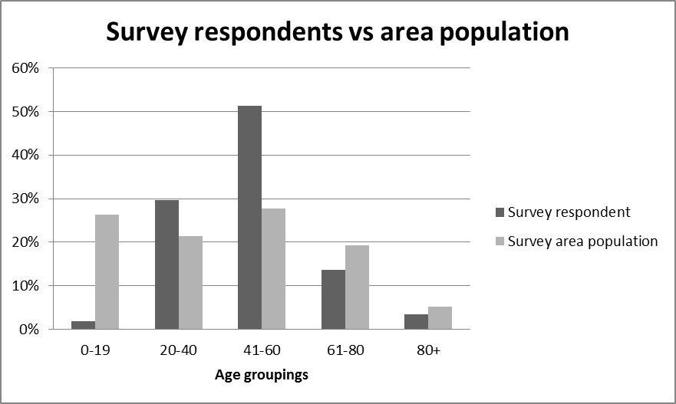
It is worth noting two anomalies in the sample relating to the age of respondents. A separate, age-specific survey focussing more on social media was released to 0-19 year olds and data from that survey does not form a part of this study. The proportionately high response from those aged 41-60 years and low relative response from those 61-80 and 80+ is notable. This region is characterised by a loss of younger people to other areas, especially metropolitan centres, and, therefore, has a disproportionately high population of those aged 60+. This has significance for community life and service provision in general and for the availability of those in a position to respond in an emergency situation.

Social impact analysis
A social impact analysis of the data collected was categorized into sections including work, money, health and safety, communicating and community. Individual concerns were found across a spectrum of issues and the focus for the data analysis was on the categories that received critical response.
The extent of the telecommunications outage is illustrated by survey response statistics of the broad impact:
- 94.6% of respondents suffered some inconvenience related to a business transaction.
- 69.8% were unable, or found it difficult, to make vital purchases such as food or fuel.
- 86.5% were unable to communicate with friends or family.
- 24% were unable to conduct business and had to shut down (for some period of time).
- Over 60% felt that the outage had a negative impact on community life.

Work
The surveys showed that the most often reported impact was interruption to work, inconvenience and impeded capacity to achieve core business. In all there were 52 comments about inconvenience and inability to work as usual and one comment about no impact on work at all. The outage caused organisations to adopt flexible solutions and the mobile network was restored first drawing this comment by one respondent who said:
We became very reliant on mobile phones, and communication between our organisation and other offices were rerouted to personal hand held devices.
The effect on business was wide ranging and for some the outage prevented normal work practices, for example a response from one person who was involved in the local government response to the outage noted that the outage prevented normal every day work. For others, the outage meant extra travel: ‘I travelled to Ballarat for several days to work from there.’ For another participant, the impact was larger:
Unable to conduct about 60% of my work tasks - as they involved communication with others, exchange of information and access to the internet
For others, work became impossible or unavailable. For example, a casual teacher who could not be contacted was simply unable to work. The frustration this degree of inconvenience caused is clear in the use of language used, scenarios described and even format, with some respondents resorting the use of capitals to emphasise their point.
As might be expected, the outage also had a financial impact on work. There were 27 comments on this in addition to the people who answered ‘yes’ to the question regarding financial impact. It is clear that people lost customers, experienced difficultly in invoicing, paying or claiming wages and other financial activities.
I couldn't do any of my work as everything I needed was attached to an email that I couldn't access. I have to put in a fortnightly pay claim online which I couldn't do. I had to borrow an Optus phone, call my sister-in-law in Melbourne and get her to log on as me to put in the claim, and also contact payroll to make sure I would get paid on time.
A small Optus 3G mobile cellular network was not affected by the telecommunications outage as it did not transit through the Warrnambool exchange. When people realised the Optus 3G mobile cellular network was operating there was a rush on pre-paid SIMs for this network and the network was overwhelmed during peak periods as it was unable to handle the call and data volume.
Twelve comments made this clear reference to alternate communications strategies. Some referred to existing contingency plans in their place of work. Other responses spoke of making use of mobile phones (including other service providers or satellite phones) or reverted to using the postal system:
Again, just reorganising and doing what you can. You just put emergency procedures in place; you knew it was going to end at some stage.
The impact on working life was stressful for some. There was mention of the need to respond to the needs of others, which were exacerbated by the outage, while coping with the effects of the outage in the workplace itself. Some comments indicated impacts on work potentially more serious than stress. An educator said that it ‘felt very unsafe without contact with families of the children we teach’. Health workers noted ‘concern about clients who may have been ill and unable to use their safety links.’ These are comments about stress related specifically to work. There are many more comments on stress explored in a later section.

Money
As might be expected from the discussion about work, there were many comments about the financial impact of the outage. Business owners noted a falloff in bookings, trade and conduct of business. Overall, there were 55 comments noting various effects on business, ranging from farmers who could not carry out activities such as organising transport for livestock or contacting stock agents or shearing contractors in what was a very busy season for pastoral industries.
For the service industry the communications disruption meant loss of bookings:
I am sure I lost bookings as I was unable to connect to the internet and the mobile phone was dropping out during a conversation then couldn't reconnect [and]: Simple things like ensuring the restaurant was informed of the final headcount for the reception meal became an issue.
For others, the impact on business was exacerbated by the effect of the outage on those travelling in the area:
Customers at our business were arriving with NO idea there was a problem in the area. Arriving with no money, no petrol in the car and no money for food. Internationals could not get money out of the banks! I was handing out my cash so families could eat and refuel!
As noted above, the lack of electronic banking affected businesses and individuals alike. While there was no direct question asked about access to automatic teller machines and electronic cash dispensing, there were 64 comments on electronic financing in response to other questions. This highlights a growing trend for use of EFTPOS to access cash rather than banks. They reveal a range of problems:
18 days without EFTPOS for our clients.
The costs were mainly associated with setting up alternate communication channels to enable the business to keep functioning. Sales revenue overall probably went up as a result of increased sales in the bottle shop because we had a seamless EFTPOS service.
The power outage definitely cost me in credit card charges because I was unable to pay for things via EFTPOS. I had to leave my credit card details with many service providers. I had to pay for an Optus SIM card.
I ran out of money and I could not access the ATM [Automatic Teller Machine] to get more cash. On the second week of the outage I had to travel to Camperdown Safeway where they were using an old fashioned card scanner so that I could buy much needed food and supplies. It was cash only in my home town of Terang, the local IGA was cash only. It was a very stressful time.
One participant summed up money related problems by saying ‘effect on my business and others has been huge.’
Emergent themes demonstrated that the true costs of the outage were in many cases incalculable. 19 comments related specifically to the impossibility of knowing how much potential business was lost and/or being unable to calculate time and effort spent finding alternate communication.
For a school it is really difficult to state that we were financially disadvantaged as a result of the outage.
Paying for telephone, internet accounts without use of phone or internet. Unable to order online for Xmas etc. Unable to contact family and friends except for mobile (so increased costs on mobile)...how do you put a price on it??
Many people routinely drive long distances in the Warrnambool area. The outage affected the ability to access fuel because of the impact on electronic funds transfer systems and 18 comments noted this difficulty.

Health and safety
Many people commented that being cut off from many forms of communication affected health and safety at work and in general. The most common comments (a total of 36) related to being able to contact people or services in an emergency situation. Fortunately, more people were fearful of health and safety emergencies than actually experienced them, like the parent who noted:
My toddler goes to daycare - they had an alternative phone, but had no way of contacting me (or me them) if an emergency happened. Some parents chose to keep kids at home. In my case, once we were there and realised what happened it would have upset him more to be taken home again. But me, and all my emergency contacts were all Telstra [customers] - so thankfully there was no issues that had to be communicated to me during the day.
Similarly, a reported potential risk situation was outlined thus:
While there was no mobile service we could not check on the welfare of each other when out moving cattle or riding the quad [motorbike] or horses. For a few days there was not even emergency service so if something had gone wrong we could not call an ambulance or rescue service.
In Australia bushfires are a major concern and the telecommunications outage occurred early in the bushfire season. During the outage at least one major bushfire was burning in the region and fire concerns were noted in 7 comments.
While there were 15 comments expressing fears that were not realised, the impact of the outage on some critical events were reported. For example:
I had heart surgery in Geelong Hospital [on a day preceding the fire] and was unable to communicate my condition to family and friends for 2 days until mobile phones came back on. I even had to change my next of kin on hospital records from my wife in Warrnambool to my sister in Melbourne, so someone could be contacted if my condition became serious.
Tragically, one family reported not being contacted in time to say goodbye to a dying mother. A total of fifteen comments were identified to be about real emergencies.
The next most common comment about health and safety (with 25 comments identified) was concern for people with isolation, disability, illness or age factors that made them especially vulnerable when telephone communication was not possible. Some people noted concerns on their own part:
I had recently had a heart attack and was still recovering and felt very vulnerable and isolated, concerned that if I became unwell there was no way of getting help.
Family members noted concerns for others:
...my elderly mother, and my husband’s elderly father who was in care and they could not contact us, so we had to leave town to get [mobile] coverage to ring and check his progress.
Professionals too had concerns about clients:
I work at an aged care facility and health and safety was a major issue. With frail residents and the need for daily medical tests, it was a difficult process as we could not use electronic means to communicate. Fortunately we are in a small town and we were able to drive to gain results, medications etc. However, it was an inconvenience and added to the normal problems.
There were 18 comments about difficulties with medical and health appointments during the outage, ranging from relatively minor inconveniences to more serious issues:
Went to doctor's appointment and it had been moved to an alternative address but I was not informed. Caused only a minor inconvenience as I had to drive to the other address…
I had an appointment for day surgery so I was worried they may have cancelled it and would have had no prior warning.
Of more concern were the 5 comments about difficulty accessing medication where prescriptions were normally transmitted by fax or other electronic means:
Had to do a 4 hour round trip to Ballarat to pick up a script because they couldn't fax it to a pharmacy in Hamilton.
I am currently taking medication that cannot be dispensed from my local pharmacist & must come from a Melbourne Hospital. Was unable to contact them for repeats.
There are 29 comments coded as ‘stress’, detailing impacts that are certainly more than the usual level of frustration when technology fails temporarily:
The lack of information provided to people as this unfolded was very frustrating and caused stress for family who are separated e.g. in Melbourne, trying to communicate with us was impossible and they didn't know why.
It was a stressful and frustrating time I could not use my PC [computer] to contact family and friends and my mobile phone would not let me into Facebook and the news. All I got was no contact could be made. My mobile is through Virgin. Also the food and medication was another stress because I had no cash and the ATM was down for 2 weeks.
I think it's very hard to quantify the impact of this in dollar terms. How do I know my business was not to receive a call in that period of time that would have drastically increased my income? How do I quantify the damage I have done to existing client relationships as I failed to meet several pre- determined deadlines? How do I put a dollar figure on the stress this has caused me and my family and that I now am going to cancel a camping trip because I have to take late delivery of a client's material? It's a shame this ever happened really.

Communicating
The general comments in response to the question on the impact of the outage on communication dealt with many issues. Most prominent was the impact on people's livelihoods and on their communication with family. Impact on family in terms of concerns about health and safety has already been noted, but it is worth stressing that this outage meant that people both inside the area affected and elsewhere faced worry about being out of contact with family and friends:
My family live in Mount Gambier and didn't know about the outage so my mum was extremely worried when she couldn't contact me and almost made the 2 hour trip the next day to check on me. I had no way of contacting them until the following day when I found a local family member (in-law) that had an Optus [mobile] phone. Aside from that it was just very inconvenient.
Brother in the UK was [very] concerned he could not contact us, couldn’t understand why.
For some, there was more than worry:
I was required to leave work and drive to my elderly mother’s house every three hours as she had no phone and no mobile coverage. She lives alone on the outskirts of town and this was a huge burden, the impact was so bad for her that she lost confidence in her ability to stay at home alone, something she had been doing well since losing her husband 30 years ago.
In all, there were 32 comments about the difficulties the outage caused for communicating with family or friends. The significance of the outage impacted on some family events. One participant noted that because so many of the service providers only had landlines, planning her wedding was made difficult. One older person mentioned that organising Christmas presents was made difficult and Christmas shopping (an important event to this person) was made frustrating and stressful and added to the anxiety of not being able to contact family and friends.
Aligned with this, there were comments about the way in which the outage was not widely understood outside the affected region. This meant that for some, there were added difficulties and stress. In addition to not being able to communicate, there was a fear that family or colleagues would not understand why there was no communication. Ten respondents mentioned the outage being not noticed elsewhere. These included:
Unable to complete a Landcare report for Canberra on time causing major stress at both ends – don't think the Canberra end believed that we were out of Comms!
My Major concern was contact with my Husband. He works in WA [Western Australia] - remotely. He had no way or knowledge of hearing about this hush-hushed issue. We usually talk several times a day (have young children in a new town so that contact is vital) and he rang on Thursday several times, appeared my phone was off, then rang again first thing Friday, my phone still appeared off. He rang my nearby Sister and my parents, who were also off the network and then he started to really worry. The only reason he found out what was going on was by contacting his parents in rural NSW [New South Wales], telling them he was worried about me, and they found out what was going on. So he was distressed, not knowing what had happened to us, and I was very anxious because I knew he wouldn't have any knowledge of why we'd all appeared to fall off the planet.
Our organisation was unable to contact members from across our district in order to complete our year end tasks and comply with the necessary objectives of the state government documentation - we were unable to contact the government department located in Melbourne to advise that we would not make the closure date. The department in Melbourne thought we were joking and had never heard of anything so ridiculous.

Community life
In all, fifty seven respondents reported that the outage directly affected community life. Only one participant said there were no particular difficulties noted as the community was small and the traditional 'grapevine’ continued to work. Others noted difficulties of various kinds, such as meetings and events being difficult to organise as notices and papers could not be sent electronically. People were unsure whether events would continue or be cancelled as a consequence of the outage. The following quotes illustrate the breadth of the impact across the community:
Trying to organise Working Bees for the Balmoral Rodeo. Not knowing if people had mobiles and if they did, not knowing their number.
The project we are running is community based. We have had no or very little contact with community members for approx. 2 weeks. Some were still offline this week (week ending 16/12/12).
Turned up to a few events that were cancelled because of no phone communications.
The Hamilton Street fair/late night shopping that was held on the Friday night after the outage first happened, affected business. Businesses closed early and takings were down as a result of people not being able to pay electronically, ATMs [automated teller machines] were also down which meant cash was difficult to obtain.
As part of [Country Fire Association] our yearly group exercise did not go well. Unable to contact members prior to event and service poor during exercise.
We had poor attendance to a youth event on the 23/11 that had been heavily promoted prior to outage, with feedback highlighting that young people were unsure this event was still going ahead as planned and/or didn't have $ as ATMs were down.
There was a sense of disconnection in the community, unable to share information and usual levels of support.
The analysis indicates a theme of irritation and frustration about the direct impact of the outage and the exacerbating factors caused by the lack of uniformity and unpredictability of both the outage and the response. There were seventeen such comments, including remarks such as:
Email communication was interrupted. Some emails missing. Not 100% outage, but sufficient to make use of this communication medium untrustworthy.
It has been very frustrating, when my services came back on it was hit or miss if the person I was trying to contact had any services.

Positive outcomes
There is little doubt the telecommunications outage was a significant inconvenience to thousands of people. While the overall financial impact, impact on the community and on individuals was negative - in some cases very negative - people were able to see positive aspects of the outage and listed them in response to a question about how the outage might have had positive outcomes.
The most common response to the question asking them to specify positive impacts highlighted personal interaction as people had to visit rather than telephone, email or text. There were 55 comments of this kind. As the comments below suggest people appreciated the chance to have more interaction with colleagues, neighbours and co-habiting family:
The outage forced me to return to some old fashioned ways of doing my job that are more face-to-face and also meant I saw my colleagues in Ballarat for the first time in about a year, so it actually improved the social aspect of my job.
Yes, it was great we had to talk to each other.
Got to speak to own customers instead of them ringing head office for orders.
My kids played board games with each other instead of being in their rooms on Facebook and Youtube!
Almost as many comments (48) suggested that the communications outage offered a chance for some peace and quiet. For some, this was a kind of enforced holiday. For others it offered a chance to catch up with a backlog of work and, for others, it was simply a relief to miss telephone calls. Comments included:
I enjoyed the peace of not receiving non-essential information.
Personally my own productivity increased as I was not constantly having to answer the phone or respond to emails!
The possibility that the outage saved some money has already been noted.
There were 14 comments suggesting that the outage led to an increased community spirit, as people helped each other. Two quotes expressed this well:
Neighbours and Community were in contact and regularly checked in on elderly clients within the community.
I was impressed in the views, a feeling of most of the community, in regards to the fire and Communications outage. I am proud to be a part of such an understanding community, that has banded together…
While all these are positive aspects of the event, there were 11 comments to the effect that the outage had only negative impacts. One said “I find this question insulting given the enormity of the negative impacts.”

How did people stay up to date?
In reply to the question about their sources of information and updates during the outage, many people found themselves relying on the print media and radio, especially local sources. There were 62 comments about print and radio media as a source of information.
Other sources were mentioned in 24 comments including workplace information sharing which was reported to have been important for information dissemination.
There was a degree of dissatisfaction with the relaying of information about the outage and the restitution of services. In total there were 21 comments on information that indicated dissatisfaction and 5 specifying Telstra as the source of dissatisfaction. Only 3 respondents seemed satisfied with information provision. A typical complaint was lack of specific information from Telstra:
Telstra did not establish an emergency call centre or hot line so people at the other end appreciated the problems people were having when they called and were not some routine outage. I reached the point where I would firstly ask the operator if they knew where Warrnambool was and if they did not then I would ask to speak to someone else.
Other sources of information besides Telstra were criticized when the information was inaccurate:
The radio was the first source of info about the outage, and was the lifeline for the first 24 / 48 hours. Unfortunately they had no preparation for the role… As I work close to the Lighthouse Theatre I was able to attend the community briefings. Foolishly I also tried to access information through the Telstra Business Centre but they put their most uninformed staff members in there and that created more stress and more disinformation. I also followed Telstra on twitter, and that helped, although they only published the spin. The local newspaper was also publishing the Telstra line so it was never on the pulse... I found Twitter generally to be the best source of information.

Changes
When survey participants commented on possible alternative plans for coping with future outages, the most common form of plan involved high technology solutions - especially switching mobile service providers, with 32 comments indicating a switch being planned or already made. A total of 68 comments were coded as concerning high tech alternative plans. Low tech planning like keeping some cash on hand for times when ATMs were inaccessible were slightly less common (22 comments) than responses that suggested that planning by individuals was not possible (27 comments). There were 20 comments to the effect that the service provider should be planning to prevent or mitigate future failures of this kind.
In response to the outage itself, people were most likely to say that they had changed or were thinking about changing their provider - there were 32 comments to this effect. But in the affected region, coverage is dominated by Telstra, so that 24 comments were classified as saying that change was not possible.
22 comments indicated that they would consider alternate technologies. This could be a change back to older methods, such as the paper based credit card machines, or towards newer technologies such as satellite phones. However it was clear that banks need to provide clear and up to date advice on applicability. A further 8 comments suggested that people were contemplating moving from landlines to mobile phones alone.
A substantial minority (13 comments) noted that they planned to keep more cash around in future. Of these, most noted carrying or storing cash. Some also suggested keeping more food in the house.

Discussion and focus group findings
The discussion and focus group findings reinforced themes elicited from the earlier survey and have added a more complete picture of potential responses to future telecommunications outages.

Response to a future telecommunications outage
The discussion and focus group findings highlighted the need for flexibility and durability during the telecommunications outage.
Estimated 70% of police officer time spent during outage on ‘welfare checks’. Relatives of Hamilton locals who lived interstate or internationally asked police to visit family members and report back on their health and safety. Relatives… had to call Melbourne/Ballarat/Geelong police stations to have messages relayed to Hamilton.
In older systems, more rural exchanges had the ability to switch their own calls. An example of this is Dunkeld, where an old switching exchange still stands. This meant that during the outage, Dunkeld residents could still call each other, but not communicate outside the town.
As an example of the potential for spiralling complexity, regional health services reported that they have their own networked telecommunications system that was independent of the Telstra network and did not transit through the Warrnambool exchange. In this telecommunications outage, the regional health services system worked well for the initial period of the outage. However, a lightning strike destroyed infrastructure which interrupted the regional health services closed system, forcing a return to limited Telstra services. If a major incident (such as a major fire or accident) had occurred during the telecommunications outage the outcome could have been detrimentally affected. After enquiries by the research team and a review of available publications it appears that a full review of regional incidents (health, fire, police) that occurred during the telecommunications outage has not been carried out.

Discussion and analysis
The research undertaken has been a unique opportunity to examine an event that is under-represented in the current literature about emergency and disaster situations. The findings from this data set represent a vital snapshot amenable for inclusion in existing discussions of the nature and measurement of social impacts, risk perception, and individual and community preparedness for emergency.

Social impacts
Importantly, it was not only those who lost telephone communication that were affected, but those they dealt with the area regularly, and those who simply passed through the area during the outage. As has been noted, the data collected in this study crosses social strata and domains and ranges from the very personal and individual to the systemic. Understanding the depth and complexity of the social impact of this outage will increase awareness of the risks and interruptions to individual lives and livelihoods. It also emphasises the effect on community safety and the need for preparedness for such an eventuality.

Perceiving risk and planning for the ‘next time’
A significant discrepancy in responses to a question about coping during and after the outage may have implications for changes in individual behaviours and planning for future events. Initial survey responses showed that only 3% of respondents felt they were coping, whereas a year later, 26% of respondents felt they had coped. Reponses about stress did not change over the same period of time. Additional comments made during the late 2013 data collection seem to indicate that the perceived level of coping may be symptomatic of a lessening of remembered impact. This has implications for individuals and policy-makers. As a recent study regarding bushfire preparedness in Australian communities has shown, risk preparedness shows positive correlation with increased perceived sense of risk and perceived personal responsibility (McNeill 2013).
Several other significant issues were exacerbated or affected by the outage. When the outage occurred a bushfire was burning out of control in Glenelg Shire in the far west of the region and in the immediate aftermath emergency services communications were non-functional as the exchange fire had affected radio transmissions as well. In addition, the region was also affected by a diesel fuel shortage (caused by a fire at the Shell refinery in Geelong). A lightning strike on an Optus communications tower at Hamilton occurred several days into the outage which interrupted service to Optus customers, particularly the regional health service and removed an alternate source of telecommunications to this part of the larger affected area. There was little awareness of this confluence of other events at the time.
There were many comments regarding the lack of understanding from central agencies and governments regarding the outage and its implications for those in the region. One comment included:
Victorian government department for health sent through a box of Optus phones to assist nursing staff and clients in this emergency, believing Optus customers to be unaffected by this outage. However, Optus provides no coverage in the local rural region.
Planning ahead for future outages is a key consideration for network planners, businesses and consumers because anticipating telecommunications failure will help to reduce the social impact of future outages. As can be seen from the disaster incidents described in this study, a telecommunications outage may well occur in tandem with other serious events. It makes sense to plan for complexity, for the unexpected.
Events in telephone exchanges affecting consumers do occur and the Warrnambool exchange fire should not be dismissed as a one off event. The recent flooding in the Wollongong exchange disrupted about 3500 ADSL connections and 1400 fixed line services and full service restoration was expected to take more than a week.
Media, including the Australian Broadcasting Corporation (ABC), fulfilled a vital role during the telecommunications outage by providing initial coverage of the Warrnambool exchange fire and daily updates on the recovery effort.
The ABC Emergency Service brings “warnings and coverage of emergencies to one place”, but does not include coverage of major telecommunications outages. Consideration should be given by the government for the ABC Emergency service to include major telecommunications outages, outages affecting more than 100 people (or a whole community) that are expected to be one or more weeks in duration. Loss of telecommunications access and capability is a major event for individuals and their communities.
ABC radio, television and online should provide regular (daily) reminders that current national warnings and emergencies are listed on the ABC Emergency website to ensure that there is a greater awareness of warnings and emergencies.

Conclusions
Telecommunications are now essential services and future network planning should account for telecommunications infrastructure that is a single point of failure for a regional network. Bushfire preparedness has become an important annual activity for many Australians and in a similar way preparing for the loss of telecommunications infrastructure should be a routine activity carried out by government, business, community organisations and individuals.
Understanding the far-reaching social impacts of a telecommunications outage must be central to impact assessment and to planning for risk mitigation in a society with an ever-growing dependence on telecommunications infrastructure.
Arguably, the social impact of a technology breakdown of the magnitude of the Warrnambool exchange outage is unlikely ever to be thoroughly quantified. What is clearly demonstrated in the data collected during and after the outage is the depth and breadth of the social impact. People were affected in all aspects of their lives. Distinct, though interconnected, important themes emerging from the data included the impact on work, money, health and safety, communicating, and community life. Important data was also collected on the positive effects of the outage. Information gathered regarding the usage of alternate media and information sources have immediate relevance for planning at individual, family, community, business and government policy levels. Analyses of the far-reaching social impacts of the outage have relevance to preparedness and risk mitigation for future telecommunications losses – incidents that will grow in impact as reliance on telecommunications infrastructure becomes ever more integral to individual, business and community life. The ramifications of the outage may continue for a long time yet.
There is a need for the Department of Communications and Telstra to provide further information about the ongoing work to restore the Warrnambool exchange, the audits, reviews, policy and process modifications identified by Telstra and the suggested actions made by the Department of Communications. Whilst the immediate effects of the Warrnambool exchange fire have now receded, the lessons learnt from the Warrnambool exchange fire should not be lost. There remains an unknown level of risk for other Telstra exchanges, particularly major urban facilities (including NBN Co’s facilities).

Recommendations
The Warrnambool Exchange Fire Consumer Impact Analysis identified concern within the community about the severity of the telecommunications outage. The effects of the telecommunications outage were widespread and the study found that the lessons learnt from the telecommunications outage should be incorporated into emergency management and disaster planning. Awareness of the potential for telecommunications outages should be raised with an approach and campaign similar to that taken for other disasters such as bushfires, floods and cyclones.

Recommendation 1
Telstra and the Department of Communications to implement the recommendations and suggested actions identified in their respective reports and publish the outcomes including the regular updates (Suggested action 1) being provided by Telstra to the Department of Communications.

Recommendation 2
The Department of Communications in conjunction with Telstra and NBN Co carry out a study to improve resilience of telecommunications infrastructure including the increased use of mobile facilities that can be used to restore services quickly. Industry organisations, such as Communications Alliance, also have a role to play to ensure that high levels of resilience are part of any network.

Recommendation 3
Incorporate the lessons learnt from the Warrnambool exchange fire into federal, state and local government emergency management and disaster planning processes and publications.

Recommendation 4
Raise awareness of the need for individuals, business, community organisations and local government to complete continuity planning that incorporates dealing with telecommunications outages.

Recommendation 5
Expand the ABC Emergency Service to include warnings and emergency notifications covering telecommunications outages affecting more than 100 people (or communities of less than this number) for one or more weeks. The ABC Emergency service be promoted more frequently on ABC radio, television and online.

Appendix – Telecommunications Survival Plans
Print ready versions of the Survival Plans are available on the ACCAN web site.

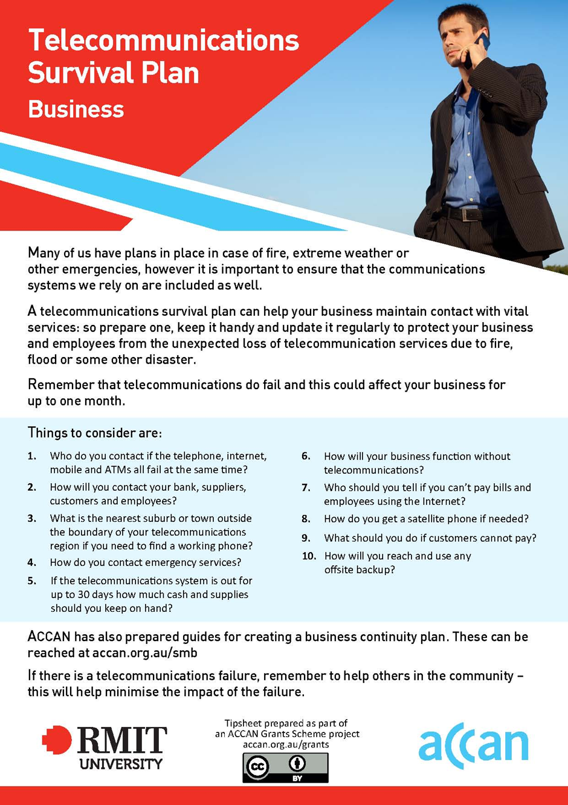

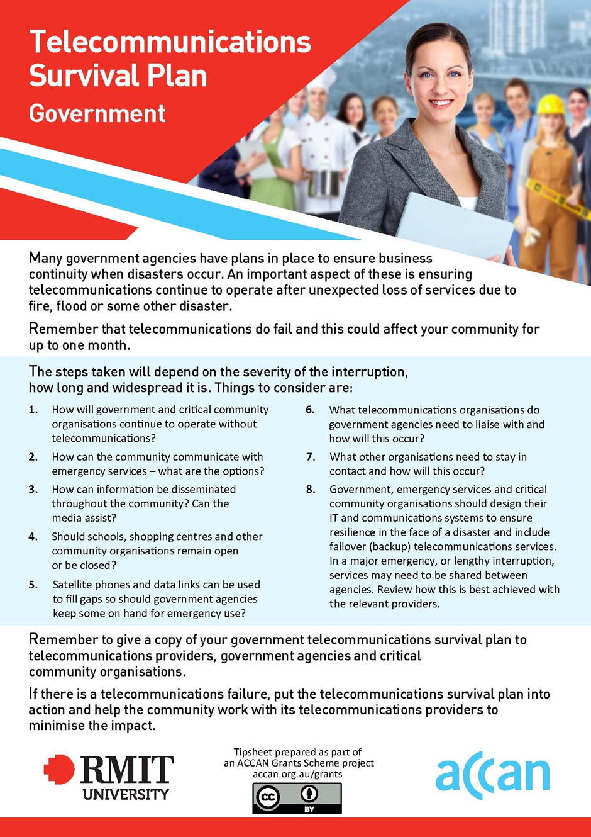

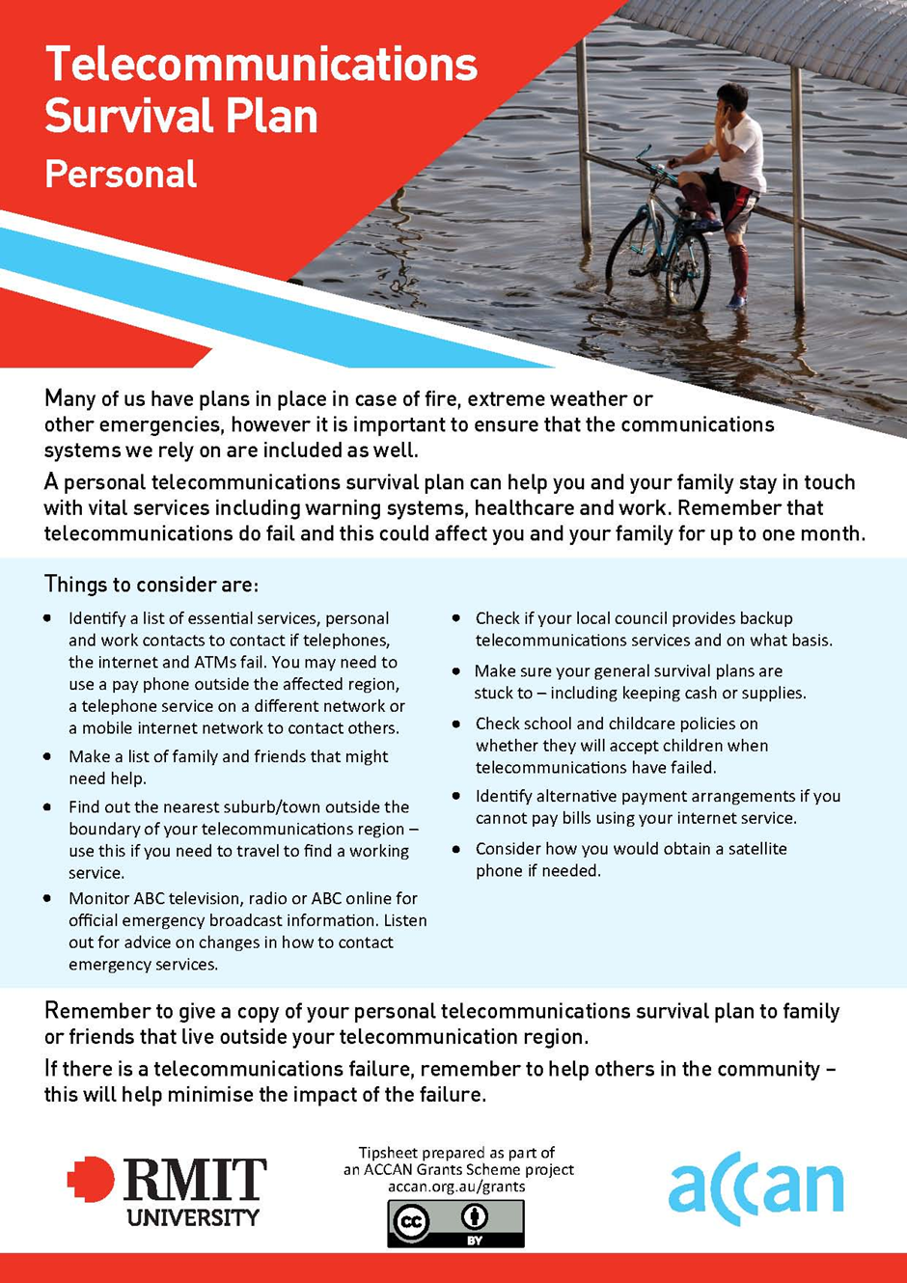

Authors
Dr Mark A Gregory


Mark Gregory was born in Melbourne, Australia. He graduated from the Royal Military College Duntroon in 1983 as an officer in the Royal Australian Electrical and Mechanical Engineers. He completed a BEng (Elec) in 1984 at the UNSW (Royal Military College), a MEng in 1992 at RMIT University and a PhD in 2008 at RMIT University. Mark is currently a Senior Lecturer focusing on Network Engineering and Internet security in the School of Electrical and Computer Engineering at RMIT University in Melbourne Australia. He has recently published the book ‘Security and the Networked Society’, Springer USA 2013, and published more than 70 refereed papers. Mark is a Fellow of Engineers Australia and a Senior Member of the Institute of Electrical and Electronics Engineers. Mark has been the founding director of several companies that provide IT services, systems and software development. Mark is currently a director of Agama Solutions and writes about telecommunications, privacy and security in Technology Spectator a News Limited publication.
Dr Kaye Scholfield

Dr Kaye Scholfield is the Senior Manager of RMIT University’s facility in Hamilton, part of the Southern Grampians Learning and Research Centre. The research group– The Rural and Regional Research group – has a strong focus on applied research in a range of issues that relate to rural community development.
Kaye’s research projects and publications include a review of the Potter Farmland Plan and related work in agriculture, education and environment. She has completed a number of research projects on rural youth and education. She is a member of many regional boards and committees including as a Board Member of Barwon South West Regional Development Australia. She has a particular interest in applied research in a rural context in times of transition.
Support from the Ian Potter Foundation established the Potter Rural Community Research Network in 2010. An advantage of an embedded research group in the region enables a timely response to issues such as the 2013 Telecommunications Outage in South West Victoria.

Glossary
Definitions of terms commonly used in this document are contained here.

ATM Automated Teller Machine
CFA Country Fire Authority
DBCDE Department of Communications (Formerly the Federal Government Department of Broadband, Communications and the Digital Economy)
DSL Digital Subscriber Line, a broadband technology typically used by telecommunications companies to access customers
EFTPOS Electronic Funds Transfer at Point of Sale
LAN Local Area Network, for computer-based networks generally within a premises
FTTP Fibre to the Premises
FTTB Fibre to the Basement
FTTN Fibre to the Node
NBN National Broadband Network

References
Conkey, H., 2004, 'National crisis communication arrangements for agricultural emergencies', Australian Journal of Emergency Management, vol. 19, no. 3, pp. 43-6
Country Fire Authority 2012, Fire at Telstra Exchange, 22 November 2012, http://news.cfa.vic.gov.au/news-in-brief/item/166-.html, Accessed online 20 December 2013
Department of Broadband, Communications and the Digital Economy, 2013, Inquiry to learn lessons from the Warrnambool exchange fire, Australian Government Department of Broadband, Communications and the Digital Economy (DBCDE), May 2013, http://www.communications.gov.au/__data/assets/pdf_file/0003/163920/Final_Report_-_Warrnambool_Inquiry.pdf, Accessed online 20 December 2013
McNeill, IM, Dunlop, PD, Heath, JB, Skinner, TC & Morrison, DL 2013, 'Expecting the Unexpected: Predicting Physiological and Psychological Wildfire Preparedness from Perceived Risk, Responsibility, and Obstacles', Risk Analysis, vol. 33, no. 10, pp. 1829-43
Piltz, D., 2013, Warrnambool Exchange Fire Investigation Report, Telstra Corporation, 27 March 2013, http://www.telstra.com.au/uberprod/groups/webcontent/@corporate/@about/documents/document/uberstaging_235046.pdf, Accessed online 20 December 2013
van Schooten, M., Vanclay, F. & Slootweg, R., 2003, 'Conceptualizing social change processes and social impacts', in Becker, H.A. & Vanclay, F., (eds), The international handbook of social impact assessment: conceptual and methodological advances, pp. 74-91
Vanclay, F., 2002, 'Conceptualising social impacts', Environmental Impact Assessment Review, vol. 22, no. 3, pp. 183-211

The ‘Department of Broadband Communications and the Digital Economy’ was renamed the ‘Department of Communications’ on 18 September 2013. For ease of use it is referred to as the Department of Communications in this document. Where reference is made to a specific publication issued under the previous name the former is used in the reference.
Optus, at the time of writing, is Australia’s second largest telecommunications provider, after Telstra.
‘Safety link’ here refers to a proprietary service that issues wearable panic buttons that trigger a response to nominated contacts.
EFTPOS is the acronym used in Australia to designate electronic funds transfer points where items may be purchased by electronic direct withdrawal to a bank account linked to a swipe card.
Virgin Mobile rivals Telstra and Optus, providing telecommunications services in Australia.
Humphries, G. “Still no Internet for Wollongong”, Illawarra Mercury, 7 April 2014, http://www.illawarramercury.com.au/story/2191210/still-no-internet-for-wollongong/?cs=300, Accessed online 7 April 2014
ABC Emergency, Australian Broadcasting Commission, http://www.abc.net.au/news/emergency/, Accessed online 1 February 2014

