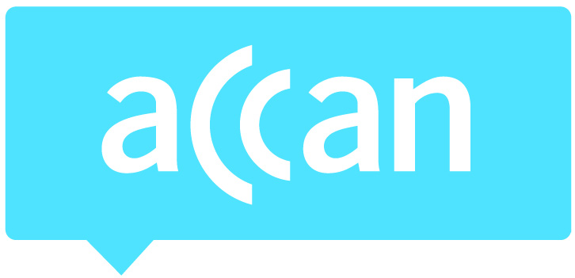
- For immediate release 12th November 2014

Real time data usage alerts a win for consumers: ACCAN
The Australian Communications Consumer Action Network (ACCAN), the peak body representing communications consumers in Australia, welcomes Telstra’s announcement of real time mobile data usage alerts as a win for consumers. ACCAN has been calling on the telcos to implement real time alerts for mobile data usage for a number of years.
Telstra is the first Australian telco to offer these alerts that notify consumers via text message within seconds when they have used 50, 85 and 100 per cent of their mobile data allowance.
“We’re glad to see Telstra implementing real time alerts for mobile data, this is a great win for consumers,” said ACCAN CEO Teresa Corbin. “Excess mobile data charges continue to be an issue for consumers with the latest Telecommunications Industry Ombudsman (TIO) Annual Report showing that the number of these complaints has grown by 27.2 per cent in the last 12 months. We hope the alerts help consumers more easily track their usage.”
While most consumers do already receive alerts regarding their data usage from their telco, the Telecommunications Consumer Protection (TCP) Code only requires these alerts to be delivered within 48 hours of the consumer reaching a limit. In that window of time there is the potential for consumers to go way above their data usage allowance and incur charges without being aware of it.
“Consumers not realising there can be a two day delay in the data usage notifications could easily use a gigabyte or two of data which would set them back between $50-$100. We’d like to see real time alerts being offered by all of the Australian telcos so all consumers can reap the benefits. Forty-eight hours is too large a gap to inform consumers they have reached their limit. We encourage the other telcos to follow suit and implement real time alerts as soon as possible,” added Ms. Corbin.
In addition to the alerts, there is also still a need for the telcos to inform consumers of how they can monitor their monthly usage because a number of telcos will automatically add extra data to a consumer’s plan for an extra cost if the monthly allowance is exceeded. This can result in consumers receiving bills which are higher than expected. Normally consumers can monitor their usage through apps or by logging into an online account.
Consumers can learn more about how to use less data on a smartphone by accessing our tip sheet.
Ends

