Review of sunsetting payphone instruments
Submission by the Australian Communications Consumer Action Network to the Department of Infrastructure, Transport, Regional Development and Communications
18 February 2022

About ACCAN
The Australian Communications Consumer Action Network (ACCAN) is the peak body that represents all consumers on communications issues including telecommunications, broadband and emerging new services. ACCAN provides a strong unified voice to industry and government as consumers work towards communications services that are trusted, inclusive and available for all.
Consumers need ACCAN to promote better consumer protection outcomes ensuring speedy responses to complaints and issues. ACCAN aims to empower consumers so that they are well informed and can make good choices about products and services. As a peak body, ACCAN will represent the views of its broad and diverse membership base to policy makers, government and industry to get better outcomes for all communications consumers.
Contact
PO Box A1158
Sydney South NSW 1235
Email: info@accan.org.au
Phone: (02) 9288 4000
Fax: (02) 9288 4019
Contact us through the National Relay Service

Contents
Introduction 4
List of Recommendations 6
Rules for the location, installation and removal of USO payphones 8
USO payphone standards and performance 13
Rules for consultation and complaints involving the location and removal of USO payphones 16
Appendix A. 21

Introduction
ACCAN thanks the Department of Infrastructure, Transport, Regional Development and Communications for the opportunity to comment on the consultation paper regarding the review of sunsetting payphone instruments. ACCAN has consulted with businesses and community organisations that operate in regional, rural and remote Australia to inform our response.
The COVID-19 pandemic has highlighted the importance of reliable telecommunications for accessing essential services including health, education, public safety services, and for maintaining social connections. Many of our conversations and consultations with communities about payphones in recent years, and particularly in recent months since free calls have been made available, have indicated that payphones are regarded as an essential public service. Indeed, Telstra’s decision to make standard national and mobile calls free of charge from all of their payphones was warmly welcomed by many charities working with people experiencing vulnerability. The review of these Instruments must be framed in this context to appropriately reflect community expectations.
Whilst the use of payphones has decreased over time, they remain an important and valuable service to many people in Australia. In particular, payphones are often used by people when they are in highly vulnerable circumstances, and in most need of an accessible form of communication, including people who are experiencing homelessness, survivors of family and domestic violence, communities during natural disasters, or people in emergency situations. ACCAN often hears from community organisations that when clients lose their phones or run out of credit, having access to a payphone allows them to maintain contact with service providers, and continue to access the supports they need. For residents in lower socio-economic areas, affordability of telecommunications services remains a barrier and payphones provide an important way for them to remain connected. Furthermore, it is not uncommon for residents in regional, rural and remote Australia to face communications outages due to weather events and electricity outages, and when this occurs, public payphones may represent the only form of communication available. In addition, areas within NBN’s satellite footprint and outside of mobile coverage are dependent on payphones as a reliable method to make phone calls.
As the consultation paper states, there were 76,000 genuine calls made from payphones to police, fire and ambulance services in 2020-21. Thus, the availability, reliability and accessibility of payphones is undoubtedly a matter of public safety, and regulatory obligations should appropriately reflect this. There is a great deal of concern regarding the removal of payphones from regional areas which needs to be addressed. ACCAN considers that the five existing instruments should be remade and refined to provide greater consumer protections and to meet the needs of local communities.
In this submission, ACCAN argues that:
- Decisions regarding payphone installation and removal should be based solely on community need as opposed to the commercial viability of providing the service.
- Installation and repair timeframes in regional and rural areas must reflect the heightened need for payphone services in these communities.
- Rules surrounding public consultation for payphone installation, relocation and removal need to be modernised in line with community engagement best practice.
- Increased oversight is needed regarding the assessments upon which payphone removals are based.
Furthermore, ACCAN provides in principle support for the consolidation of all five Instruments being reviewed, provided no obligations are lost in this streamlining process and ACCAN’s suggested changes are incorporated into the revised Instrument.

List of Recommendations
- Section 6(5)(a) and Section 6(5)(b) of the Telecommunications Universal Service Obligation (Location of Payphones) Determination 2011, which requires the USP to have regard to the commercial viability and projected revenues of maintaining a payphone in determining whether to install a payphone, should be removed.
- Section 6(5)(d) of the Telecommunications Universal Service Obligation (Location of Payphones) Determination 2011 should be amended so that when determining whether to install and maintain a payphone at a new location, the USP is required to consider the additional factors of on-ground experience of mobile coverage as well as the socio-economic status and risk of natural disasters of the surrounding areas.
- Section 9(1)(d) and Section 10(1)(d) of the Telecommunications Universal Service Obligation (Location of Payphones) Determination 2011 should be removed given the recent changes affecting the commercial viability of payphones.
- Community support for the location of a payphone should take into consideration the size of the local population.
- Section 12(b)(iv) of the Telecommunications Universal Service Obligation (Location of Payphones) Determination 2011 which requires a TTY payphone to be located in a place or area that is not at a high risk of vandalism or misuse of a TTY payphone, should be removed.
- Section 20(1)(b) of the Telecommunications Universal Service Obligation (Location of Payphones) Determination 2011, should be amended so that demonstrated community support takes into consideration the size of the local population, and the USP has determined that the removal of the payphone would deliver a net social benefit to the local community.
- Sections 20(2)(a) and 20(2)(c) of the Telecommunications Universal Service Obligation (Location of Payphones) Determination 2011, which allows the USP to remove a payphone having regard to the commercial viability of maintaining the payphone, and whether the revenues from the payphone will cover the depreciation and maintenance costs of maintaining the phone, should be removed.
- Section 20(2)(e) of the Telecommunications Universal Service Obligation (Location of Payphones) Determination 2011 should be amended to require the USP to consider the on-ground experience of mobile coverage, the socio-economic status of an area, and whether the location is at risk of natural disasters before removing a payphone.
- The USP should be required to notify the ACMA of any instances where they are reasonably unable to comply with the payphone performance standards.
- Section 8(4) of the Telecommunications Universal Service Obligations (Payphone Performance Standards) Determination (No.1) 2011 should be updated so that the operating instructions are provided in the most widely spoken languages in Australia, and accommodating language demographics in the local area.
- The timeframes for payphone installation in minor rural or remote areas in Sections 9(3)(b) and 9(3)(c) of the Telecommunications Universal Service Obligations (Payphone Performance Standards) Determination (No.1) 2011 should be reduced to a maximum of 3 months.
- The maximum timeframe to repair a payphone fault or service difficulty in Section 10(2) of the Telecommunications Universal Service Obligations (Payphone Performance Standards) Determination (No.1) 2011 should be set to a maximum of 10 days in all areas.
- The USP should be required to notify the ACMA of any instances where they are reasonably unable to comply with the payphone benchmark standards.
- Payphone performance benchmarks specified in Section 9 of the Telecommunications Universal Service Obligation (Payphone Performance Benchmarks) Instrument (No.1) 2011 should be altered so that the primary USP is required to comply with the benchmark standard 90% of the total number of times in all areas.
- The Public Consultation Rules should be modernised to reflect community engagement best practice and remove the discretionary and opaque processes surrounding payphone removal decision-making.
- The ACMA should expand and increase its oversight of net social benefit assessments and Public Consultation Documents produced for payphone removal.
- The ACMA should modernise the Net Social Benefit and Public Consultation Document Guidelines to reflect the essentiality of payphones as public interest services.
- Provisions relating to payphone location, relocation or removal complaints handling should be retained in their current form, either in the Telecommunications Universal Service Obligation (Payphone Complaint Rules) Determination 2011 or in another relevant Determination.

Rules for the location, installation and removal of USO payphones

Telecommunications Universal Service Obligation (Location of Payphones) Determination 2011
The purpose of this Determination is to set out rules determining where and when a primary universal service provider (USP) can locate, relocate or remove payphones, as well as the rules for installing a new payphone, the requirements for lodging an eligible payphone request and the decision-making process a primary USP must follow in assessing requests.

Rules regarding payphone locations
The Determination establishes the factors to be considered when deciding whether there will be a net social benefit from installing a payphone in the local community. These factors include the commercial viability of the payphone, whether the projected revenues will cover the depreciation and maintenance costs, the extent to which Commonwealth funding will cover the depreciation and maintenance costs, the benefit to the local community, and the adequacy of mobile phone coverage in the relevant area for emergency calling purposes. The USP must also have regard to guidelines issued by the ACMA when determining the issue of net social benefit.

Commercial viability and projected revenues
Currently the location rules and existing net social benefit criteria are not effectively balancing commercial and community interests. There would be benefit from simplifying and changing the Determination to reflect the fact that Telstra have now made payphones free of charge, meaning that any reference to revenue or commercial viability needs to be removed. The decision by Telstra to make the payphones free of charge reflects the fact that the overall payphone revenues did not cover the cost of collecting the payment. As Telstra no longer collects revenues from the payphones, there is a risk that payphones won’t be installed because the revenues do not cover the cost of maintaining the phone, despite the local community needing the service. Therefore Section 6(5)(a) and Section 6(5)(b) of the Determination should be removed.
- Section 6(5)(a) and Section 6(5)(b) of the Telecommunications Universal Service Obligation (Location of Payphones) Determination 2011, which requires the USP to have regard to the commercial viability and projected revenues of maintaining a payphone in determining whether to install a payphone, should be removed.
Indeed, Telstra benefits commercially to some extent from installing and maintaining payphones, through advertising, branding and the ability to offer Telstra Air to Telstra customers. In locations where Telstra is benefiting commercially in this manner, there needs to be consideration of the extent to which the installation of those payphones should be publicly funded.

Circumstances relating to the location of a payphone
In Section 6(5)(d), the Determination lists all the circumstances relating to the location of a payphone that the USP must have regard to in determining whether to install and maintain a payphone at a new location. The USP must consider the extent to which there is adequate mobile phone coverage in the relevant area. This requirement should be strengthened by requiring on the ground testing of mobile coverage, as opposed to using information on mobile coverage provided by predicted coverage maps which may not reflect the experience of end users. Some coverage maps may report external-antenna mobile coverage, rather than outdoor mobile coverage (i.e. regular street-level coverage able to be reached by a standard handheld device), meaning that relying on these maps to determine mobile coverage may not reflect the lived experiences of consumers in the area. Furthermore there needs to be consideration of the fact that Telstra intends to turn off 3G coverage in 2024, and the extent to which 3G coverage is a factor in installing and maintaining payphones should reflect this development.
Other circumstances which need to be considered are the socio-economic status of the population in the area in which the payphone is proposed to be installed, and the risk of natural disasters in the local area. Due to the effects of climate change, there will likely be a growing need for payphones as a back-up form of communication during bushfires.
- Section 6(5)(d) of the Telecommunications Universal Service Obligation (Location of Payphones) Determination 2011 should be amended so that when determining whether to install and maintain a payphone at a new location, the USP is required to consider the additional factors of on-ground experience of mobile coverage as well as the socio-economic status and risk of natural disasters of the surrounding areas.

New payphone locations

Commercial viability
Part 3 of the Determination sets out the eligibility criteria for the location of payphones at new places and areas by a USP. In Section 9(1)(d), a category 1 payphone location requires the USP to have determined that the place or area is commercially viable for the purpose of the installation of a payphone. Similarly, in Section 10(1)(d) a place or area is a category 2 payphone location if the USP has determined that the revenues from a payphone located at that place or area will cover the depreciation and maintenance costs of providing and maintaining a payphone on an annual basis. These sections need amending to reflect the fact that payphones will have limited commercial viability given that Telstra generally does not collect any revenue from them.
- Section 9(1)(d) and Section 10(1)(d) of the Telecommunications Universal Service Obligation (Location of Payphones) Determination 2011 should be removed given the recent changes affecting the commercial viability of payphones.

Community support
Sections 9(1)(c), 10(1)(c) and 11(1)(c) all require eligible payphone locations to have demonstrated community support for the location of a payphone at that place or area. Community support is taken to have been demonstrated if the place or area is the subject of an eligible payphone request that has been made on behalf of 100 or more adults. ACCAN considers this to be an unrealistic requirement given that in many areas which have the greatest need for payphones there will often be smaller populations and/or transient communities. Therefore we consider there needs to be more nuance in the requirement for demonstrated community support to reflect the population size of the area.
- Community support for the location of a payphone should take into consideration the size of the local population.

Telephone typewriter payphone locations
Section 12 gives meaning to a telephone typewriter (TTY) payphone location, which requires a TTY payphone location to be in a place or area that is not at a high risk of vandalism or misuse of a TTY payphone. The description of high risk of vandalism is broad and could lead to TTY payphones not being installed in areas with a perceived risk of vandalism such as public housing areas or low-income communities. People with disability are more likely to live in low-income communities and are more likely to live in public housing than the general community. TTY payphone locations should therefore be based solely on the needs of local communities.
- Section 12(b)(iv) of the Telecommunications Universal Service Obligation (Location of Payphones) Determination 2011 which requires a TTY payphone to be located in a place or area that is not at a high risk of vandalism or misuse of a TTY payphone, should be removed.

Removal of payphones
Part 4 of the Determination provides the rules regarding the removal of a payphone. It states that a payphone may only be removed if the decision to remove it has been made following public consultation, and one or more of the following applies: maintaining the payphone at the payphone site would not deliver a net social benefit to the local community, there is demonstrated community support for the removal of the payphone, the USP cannot reasonably operate the payphone at the site, or if the existing payphone is to be relocated to a new payphone site within that place or area.

Community support
We are concerned that the requirement in Section 20(1)(b)(ii), which states that a payphone may be removed if there is demonstrated community support for the removal, is too vague. For example, a petition for the removal of a payphone in Victoria only required 31 signatures. This is at odds with the requirement for community support to install a payphone which requires at least 100 people to provide support. Similar to our recommendation regarding community support to install payphones, we consider that demonstrated community support to remove payphones should take into consideration the size of the local population.
Furthermore, we are concerned that there is not a requirement to prove that the removal of a payphone would deliver net social benefit to the local community if there is an undefined level of community support. We consider that even if there is a reasonable level of demonstrated community support for the removal of the payphone from the payphone site, the USP should still be required to prove that maintaining the payphone at the payphone site would not deliver a net social benefit to the local community.
- Section 20(1)(b) of the Telecommunications Universal Service Obligation (Location of Payphones) Determination 2011, should be amended so that demonstrated community support takes into consideration the size of the local population, and the USP has determined that the removal of the payphone would deliver a net social benefit to the local community.

Commercial viability and revenue
The criteria for determining whether maintaining a payphone at a site would deliver a net social benefit to the local community needs to be amended so as not to consider the commercial viability or revenue gained from maintaining the payphone. As mentioned previously, the Determination needs to be amended to reflect the fact that payphones are no longer commercially viable or generate a revenue for Telstra, yet they should still be retained as they provide social benefit to local communities.
- Sections 20(2)(a) and 20(2)(c) of the Telecommunications Universal Service Obligation (Location of Payphones) Determination 2011, which allows the USP to remove a payphone having regard to the commercial viability of maintaining the payphone, and whether the revenues from the payphone will cover the depreciation and maintenance costs of maintaining the phone, should be removed.

Call usage patterns
The Determination should be amended to provide greater specificity in terms of call usage patterns to and from payphones being considered for removal. Whilst there may be a limited number of calls coming from a specific payphone, if that phone provides the only means of communication in an area, it could be required in an emergency and should therefore not be removed. Indeed, one recent consultation document showed that a decrease of 8 calls over a 24 month period meant that the payphone had a decreased likelihood of providing a social benefit outcome. This is only a slight decrease in call usage which could easily be due to the circumstances regarding COVID-19 lockdowns and border closures. As such, it is ACCAN’s view that call usage patterns should only be a relevant factor in the removal of a payphone in exceptional circumstances, and must be balanced against other factors, for example, the risk of emergencies.

Circumstances relating to the location of a payphone
In Section 20(2)(e) of the Determination, the USP must also have regard to the circumstances relating to the location of a payphone in determining if it should be removed or not, including the benefit to the local community, and the extent of adequate mobile phone coverage. The extent of adequate mobile phone coverage should consider Telstra’s upcoming 3G network service closure. As with circumstances to be taken into account during the installation of payphones, when considering their removal there needs to be consideration of the socio-economic status of the area and community in which the payphone is located, the on-ground experience of mobile coverage, and whether the location is at risk of natural disasters.
- Section 20(2)(e) of the Telecommunications Universal Service Obligation (Location of Payphones) Determination 2011 should be amended to require the USP to consider the on-ground experience of mobile coverage, the socio-economic status of an area, and whether the location is at risk of natural disasters before removing a payphone.

USO payphone standards and performance

Telecommunications Universal Service Obligations (Payphone Performance Standards) Determination (No.1) 2011

Compliance with payphone performance standards
This Determination requires that the primary USP must comply with the payphone performance standards except in circumstances or instances when compliance is not possible, for example during a natural disaster or extreme weather conditions as described in Section 5 of the Determination. ACCAN is concerned that there is insufficient oversight of when exceptions to meeting the standard occur. The USP should be required to notify the ACMA immediately of instances where they are reasonably unable to comply with the performance standards.
- The USP should be required to notify the ACMA of any instances where they are reasonably unable to comply with the payphone performance standards.

Supply of payphones
The Determination requires that payphones must provide operating instructions in three or more languages other than English, where the other languages must include three of the following; Mandarin, French, Spanish or Japanese. ACCAN considers it would provide greater benefit to require the operating instructions to be given in those languages which are more widely spoken in Australia and in the community in which the payphone is situated (including First Nations languages). The latest data from the ABS shows that the most spoken language after English is Mandarin (2.5% of the population), followed by Arabic (1.4%), Cantonese (1.2%) and Vietnamese (1.2%).
- Section 8(4) of the Telecommunications Universal Service Obligations (Payphone Performance Standards) Determination (No.1) 2011 should be updated so that the operating instructions are provided in the most widely spoken languages in Australia, and accommodating language demographics in the local area.

Maximum timeframes for supply, installation and maintenance of a payphone
Due to lower levels of mobile coverage, rural and remote Australians have a greater reliance on payphones. Despite this, the current Determination allows up to 9 months for payphone installation in remote areas if the site at which the payphone is to be installed is not readily accessible to telephone network infrastructure or there is insufficient network infrastructure capacity to effect service. In minor rural areas this timeframe changes to within 6 months of the date on which the payphone is first required to be located at the site. ACCAN considers that the Determination should reflect the greater need for reliable payphones in rural and remote areas through shortening the timeframes for installation. We would also assume that the number of new installations remains relatively low, and therefore there should be more resources available to meet quicker timeframes for installation compared to the situation 10 years ago.
- The timeframes for payphone installation in minor rural or remote areas in Sections 9(3)(b) and 9(3)(c) of the Telecommunications Universal Service Obligations (Payphone Performance Standards) Determination (No.1) 2011 should be reduced to a maximum of 3 months.
ACCAN is aware of community concerns about the maintenance of payphones, particularly in regional and remote areas. For example, the Tangentyere Council Aboriginal Corporation’s submission to the 2018 Regional Telecommunications Review highlights the need to repair public payphones in Alice Springs. The submission references a recent audit carried out by the Tangentyere Women’s Family Safety Group which found a lack of working public payphones in urban and town camp localities. The current timeframes to repair a payphone fault or service difficulty formalise poor service for rural and remote consumers despite these communities having the greatest need for payphones. Consequently, all payphones should be repaired within 10 days, regardless of where they are located.
- The maximum timeframe to repair a payphone fault or service difficulty in Section 10(2) of the Telecommunications Universal Service Obligations (Payphone Performance Standards) Determination (No.1) 2011 should be set to a maximum of 10 days in all areas.

Telecommunications Universal Service Obligation (Payphone Performance Benchmarks) Instrument (No.1) 2011

Compliance with payphone benchmark standards
This Instrument sets out instances and circumstances where a primary USP is exempt from complying with the payphone benchmark standard, such as circumstances beyond the control of the USP. Similar to our recommendation made in relation to compliance with payphone performance standards, the USP should be required to report to the ACMA any instances that may arise in which the USP is unable to meet the payphone benchmark standards.
- The USP should be required to notify the ACMA of any instances where they are reasonably unable to comply with the payphone benchmark standards.

Payphone benchmark standards
The Telecommunications Universal Service Obligation (Payphone Performance Benchmarks) Instrument (No.1) 2011 requires that the USP must rectify a fault or service difficulty within the following timeframes:
Area | Timeframe | Benchmark for the total number of times that a primary USP is required to comply
Urban | 1 working day | 90%
Rural | 2 working day | 90%
Remote | 3 working days | 80%
The above benchmarks do not adequately reflect community expectations when it comes to the reliability of payphones. In particular, having a longer timeframe in combination with lower benchmarks in remote areas poses a risk that payphones in these areas could be faulty for excessive amounts of times.
- Payphone performance benchmarks specified in Section 9 of the Telecommunications Universal Service Obligation (Payphone Performance Benchmarks) Instrument (No.1) 2011 should be altered so that the primary USP is required to comply with the benchmark standard 90% of the total number of times in all areas.

Rules for consultation and complaints involving the location and removal of USO payphones
ACCAN has serious concerns regarding the transparency and accountability of public payphone consultation and complaints processes. ACCAN believes there are grounds for the ACMA to conduct an audit into Telstra’s compliance with the Telecommunications Universal Service Obligation (Public Consultation on the Location or Removal of Payphones) Determination 2011 (the Public Consultation Rules) and the ACMA’s Payphone (Assessment of Net Social Benefit) Guidelines.
There are also grounds for a significant reworking of the Public Consultation Rules and the Telecommunications Universal Service Obligation (Payphone Complaint Rules) Determination 2011 (Payphone Complaint Rules) to ensure that processes surrounding payphone locations, removals, and complaints handling are in the public interest, and meeting community needs and expectations. As already discussed in this submission, public reliance on payphones is increasing, as is the severity of digital exclusion and communications affordability challenges. Therefore, it is more important than ever that decisions regarding payphone locations and removals are rooted in the public interest, rather than the USP’s financial interests.

Telecommunications Universal Service Obligation (Public Consultation on the Location or Removal of Payphones) Determination 2011
The Public Consultation Rules require Telstra to maintain and follow public consultation processes before it installs, moves, or removes payphones. It details the form and types of notifications and consultation required in different circumstances. These requirements are intended to ensure that consumers are provided with an opportunity to make a submission regarding the location, relocation or removal of a payphone.
While it is essential to maintain the Public Consultation Rules given the public interest status of payphones, the Rules themselves are outdated and do not reflect community engagement best practice. The Public Consultation Rules do not meet consumers’ expectations or permit a sufficient level of accountability relating to payphone removal. The current process is not easy for all consumers to engage with, especially those living in remote Indigenous communities. Under the current arrangements, the people who have the greatest need for payphones are the least able to provide input into their installation, relocation and removal.

Necessary improvements to existing arrangements
Telstra has advised that it typically receives low numbers of submissions to individual payphone consultations. It is likely that this is not a function of low levels of community interest, but rather a reflection of the unsuitability of current consultation processes, as there is considerable community concern at the availability of payphones, especially in rural and remote areas. Currently, for a consumer to be aware that a payphone is being removed from a location where there is no other payphone, and to make a submission to the consultation, they need to:
- Physically see or be shown the notice on or around the payphone during the consultation period, or
- See the notice posted in one selected local newspaper, or
- Be informed through another method by chance (e.g. local government notice), or
- Access Telstra’s website, locate the payphone consultation webpage, and locate the consultation documents, and
- Have the personal means to make a submission either online or via post within the consultation period.
ACCAN is concerned that there is a complex web of requirements for consultation and notification depending on the type of activity being proposed by the USP (installation, relocation or removal); the number of other payphones at the location; and the manner in which the proposal came about (whether there is consumer support, service delivery issues, and so on.)
Complex consultation processes that rely on consumers coming across information by chance about changes in the availability of an essential public service is not an effective way to engage the community. In fact, ACCAN has received feedback that some people in remote Indigenous communities have concerns that payphones are being removed by stealth, due to the lack of effective community engagement.
Consultation and notification processes must be improved, especially given recent increased demand for payphone services, and the lack of access to other communications services that many consumers face, whether it be due to mobile coverage issues, affordability challenges, or any other reason. In order to bring consultation processes for the installation, relocation or removal of payphone services in line with consumer expectations and needs, the Public Consultation Rules should undergo a detailed review, and the following changes should be made :
- In rural and remote communities, Telstra should be required to proactively and directly consult with a local health clinic, community service provider, or community-controlled corporation regarding a proposal to remove a payphone where there is no other payphone at the site. In these circumstances, a payphone should only be removed where there has been demonstrated and direct engagement with the affected communities, and community feedback indicates there is no ongoing utility of the payphone.
- In the case of payphone removals in remote Indigenous communities, payphone removal notifications should be translated into community language/s.
- Payphone installation, relocation and removal notifications and Public Consultation Documents (PCDs) should remain on Telstra’s website indefinitely to ensure there is adequate public visibility of changes in the availability of payphone services, and the basis on which these changes were made.
- The Public Consultation Rules should be modernised to reflect community engagement best practice and remove the discretionary and opaque processes surrounding payphone removal decision-making.

Possible compliance issues
The Payphone (Assessment of Net Social Benefit) Guidelines set the parameters for the net social benefit assessment required for the installation of payphones and their removal where there is no other payphone at the site. The Telecommunications (Payphone Consultation Document) Guidelines 2012 set out the contents of the Public Consultation Document (PCD) to be produced and published in circumstances where a payphone is proposed to be removed, and there is no other payphone remaining at the site. The Public Consultation Rules require Telstra to comply with any ACMA guidelines for PCDs. Consequently, failure to comply with rules surrounding the content of PCDs, or failure to complete an adequate net social benefit assessment, results in a breach of these payphone rules.
While the ACMA’s Net Social Benefit and PCD guidelines are out of scope for this consultation, ACCAN wishes to highlight concerns regarding the quality and impartiality of current consultation processes, and the contents of the documents currently being produced for public consultation. The PCD for the removal of Telstra Payphone 08992335X2 at Moonyoonooka outside Geraldton in Western Australia is an example of the lack of accountability surrounding payphone removal, to the extent that it may be non-compliant with the Public Consultation Rules. Under the Public Consultation Rules, Telstra is required to undertake a net social benefit analysis in this type of PCD.
Figure 1 in Appendix A shows an excerpt of Telstra’s PCD for the removal of the last payphone at the site. Under social benefit assessment no. 9, Telstra rated the criteria negative and stated there is ‘adequate mobile coverage of all carriers present’. Figure 2 in the Appendix shows that there is in fact patchy Telstra 3G and 4G coverage immediately around the payphone site. Concerningly, in this instance, Telstra has not reported the proximity of the closest payphone to the proposed removal site (3.9 kilometres away at Geraldton airport) nor the proportion of genuine emergency calls from the payphone in question. This appears to be in breach of the Public Consultation Rules. It is unclear the extent to which necessary information is not included in PCDs due to the fact that PCDs do not remain on Telstra’s website in perpetuity.
Figure 3 in the Appendix shows a different PCD where a proposal to remove a payphone is based on demonstrated community support. Telstra is not required to publish a net social benefit assessment to compliment a consultation about payphone removal if there is demonstrated community support to remove the payphone from the site. As mentioned above, ‘demonstrated community support’ can constitute as little as 30 signatures on a petition from a community of over 150,000 residents (See Appendix A, Figure 3).
The discussion paper suggests that the ACMA only reviews final decisions regarding the installation, relocation and removal of payphones if a complaint has been made. Due to concerns detailed below regarding Telstra’s compliance with payphone rules, ACCAN’s view is that the following needs to take place:
- The ACMA should undertake an immediate audit of PCDs to understand the extent to which Telstra currently complies with its obligations.
- The ACMA should review all PCDs prior to public consultation.
- Any final decision regarding payphone removal should be submitted to the ACMA for review and approval.
- The ACMA should use its powers to override a proposal about payphone removal where Telstra has not undertaken a sufficient level of community consultation, and has not undertaken an adequate net social benefit assessment where applicable.
- Net social benefit assessments should be included in all PCDs relating to a proposed payphone removal, including instances where there is ‘demonstrated community support’.
Furthermore, ACCAN believes priority should be given to amendments to the ACMA’s Payphone (Assessment of Net Social Benefit) Guidelines and Telecommunications (Payphone Consultation Document) Guidelines 2012, to provide greater consistency for the development of PCDs, and to remove the discretion with which Telstra may remove payphones.
- The ACMA should expand and increase its oversight of net social benefit assessments and Public Consultation Documents produced for payphone removal.
- The ACMA should modernise the Net Social Benefit and Public Consultation Document Guidelines to reflect the essentiality of payphones as public interest services.

Telecommunications Universal Service Obligation (Payphone Complaint Rules) Determination 2011
It is essential that processes for the handling of payphone location, relocation or removal complaints are maintained. There is no apparent reason to change the processes for payphone complaints handling, so the obligations should remain unchanged. ACCAN notes that while complaints to the ACMA relating to payphones may be low, this is likely in part a function of the inaccessibility of public payphone consultation processes, rather than a lack of community interest or concern.
- Provisions relating to payphone location, relocation or removal complaints handling should be retained in their current form, either in the Telecommunications Universal Service Obligation (Payphone Complaint Rules) Determination 2011 or in another relevant Determination.

Figure 1: Excerpt of Public Consultation Document for removal of Payphone 08992335X2
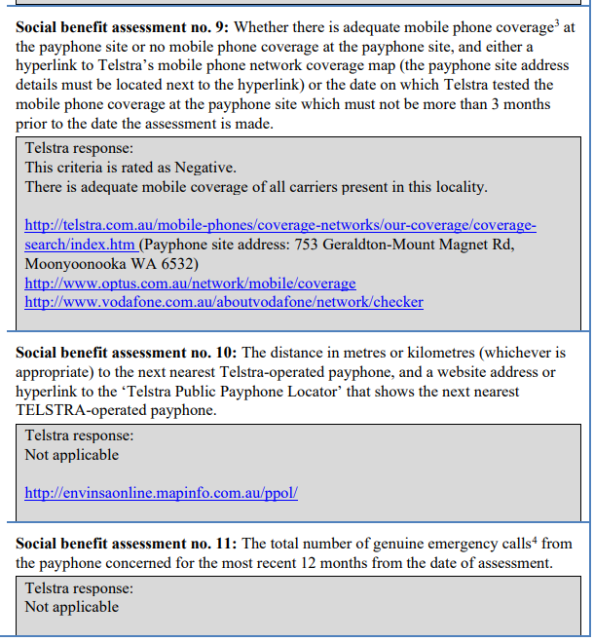
Image description: An excerpt of Telstra’s responses to Social benefit assessment criteria 9, 10 and 11 in its Public Consultation Document regarding a payphone removal in Moonyoonooka, WA. Telstra’s response indicates there is adequate mobile coverage around the payphone site, and under social benefit assessment criteria 10 and 11 regarding distance to the closest payphone and number of genuine emergency calls in the past 12 months, Telstra’s response is ‘Not Applicable’.

Figure 2: Patchy Telstra 3G and 4G mobile coverage around Moonyoonooka payphone site
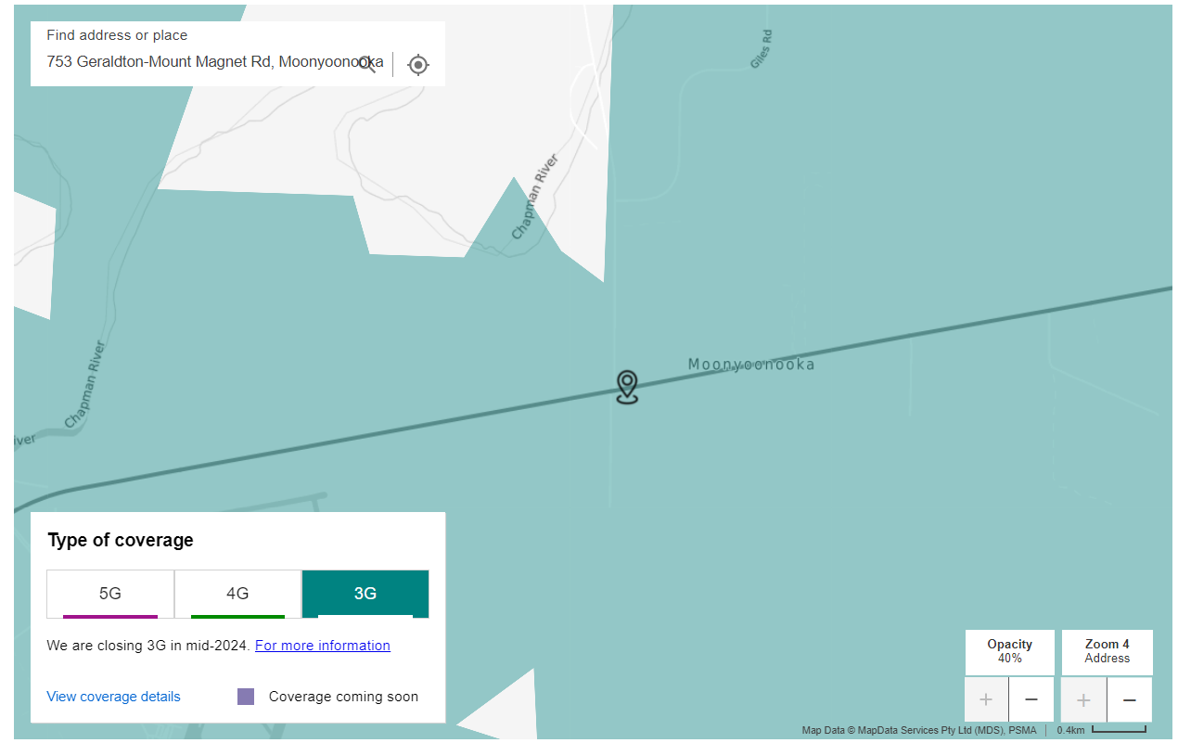
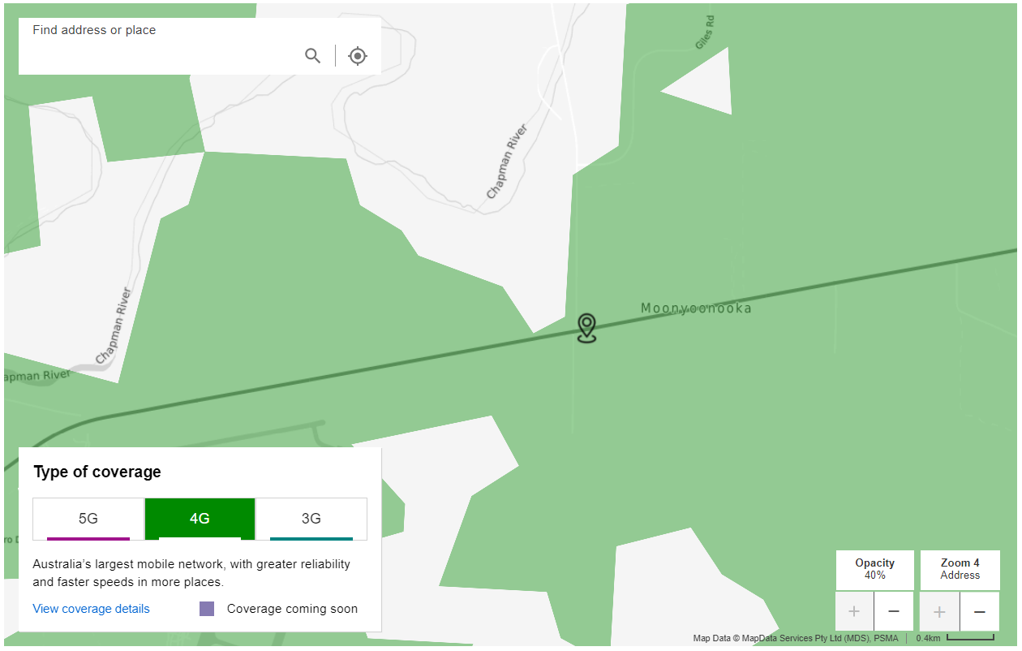
Image descriptions: A search of the Telstra mobile map for 753 Geraldton-Mount Magnet Rd, Moonyoonooka WA shows patchy 3G and 4G mobile coverage surrounding the payphone site.

Figure 3: Excerpt of Public Consultation Document for removal of Payphone 03979157X2
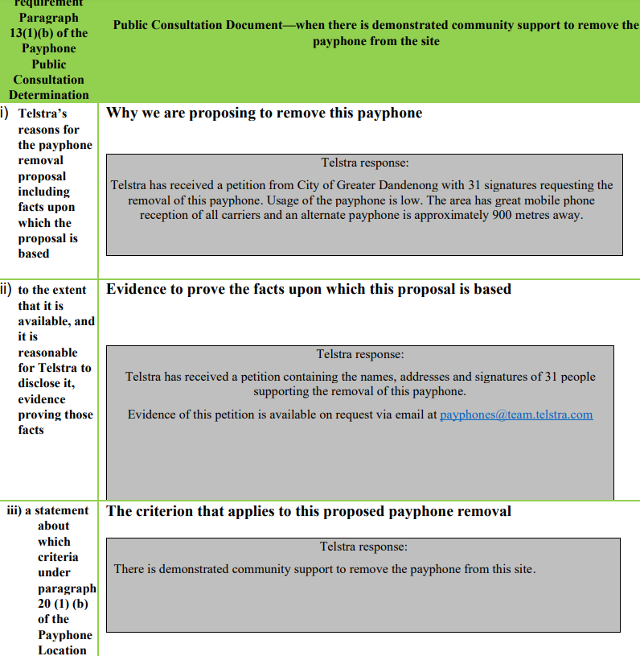
Image description: An excerpt from a Telstra Public Consultation Document for proposing the removal of a payphone outside 28 Heyington Crescent, Noble Park North, VIC 3174. It states that Telstra has received a petition from City of Greater Dandenong with 31 signatures requesting the removal of this payphone. It says that usage of the payphone is ‘low’, that there is ‘great’ mobile phone reception and an alternate payphone is approximately 900 metres away.

Joe Aston, 2021. Telstra saving money on free payphones, Australian Financial Review, 3 August. Available: https://www.afr.com/rear-window/telstra-saving-money-on-free-payphones-20210803-p58fhv
Evidence of Telstra using predicted coverage maps to assess the availability of mobile coverage can be found here: https://www.telstra.com.au/content/dam/tcom/personal/consumer-advice/payphones/publicconsultation/46031-pcd-753-geraldton-mt-magnet-rd-moonyoonooka-wa-6532.pdf and shown in Appendix A.
https://www.telstra.com.au/business-enterprise/support/3g-service-closure
https://www.telstra.com.au/content/dam/tcom/personal/consumer-advice/payphones/publicconsultation/46633-pcd-outside-28-heyington-cresent-noble-park-vic-3174.pdf
https://www.telstra.com.au/content/dam/tcom/personal/consumer-advice/payphones/publicconsultation/46031-pcd-753-geraldton-mt-magnet-rd-moonyoonooka-wa-6532.pdf
For example where there has been a sustained period of minimal usage due to the local population leaving the area.
Australian Bureau of Statistics, 2017, Census reveals a fast changing, culturally diverse nation. https://www.abs.gov.au/ausstats/abs@.nsf/lookup/media%20release3
https://www.infrastructure.gov.au/sites/default/files/submissions/tangentyere_council_aboriginal_corporation_tcac_1_of_3.pdf
Currently, the USP must rectify a fault or service difficulty within 10 working days if the payphone is located in an urban area, 15 working days if the payphone is located in a major rural area or a minor rural area, and 30 working days if the payphone is in a remote area.
https://www.infrastructure.gov.au/sites/default/files/documents/review-of-sunsetting-payphone-instruments--consultation-paper--december2021.pdf
https://www.infrastructure.gov.au/sites/default/files/submissions/tangentyere_council_aboriginal_corporation_tcac_1_of_3.pdf
http://www.nintione.com.au/resource/NintiOneResearchReport_70_DesertServicesthatWork.pdf
https://www.abc.net.au/news/2021-08-03/telstra-has-made-its-15000-payphones-free/100344664?fbclid=IwAR1av_KxTf3Oni9Gu2V84khUJ0fGAlH2KrlP_kF9Y1v2x7AQKeBNR6l3sio
Telecommunications Universal Service Obligation (Public Consultation on the Location or Removal of Payphones) Determination 2011, Section 9(2), https://www.legislation.gov.au/Details/F2011L02707
Telecommunications (Payphone Consultation Document) Guidelines 2012, https://www.legislation.gov.au/Details/F2012L01833
Subsection 20(9) of the Payphone Location Determination provides that the criterion relating to a net social benefit does not apply where a USP removes a payphone from a site where there is at least one payphone remaining after removal.
https://www.telstra.com.au/content/dam/tcom/personal/consumer-advice/payphones/publicconsultation/46031-pcd-753-geraldton-mt-magnet-rd-moonyoonooka-wa-6532.pdf
https://www.telstra.com.au/content/dam/tcom/personal/consumer-advice/payphones/publicconsultation/46633-pcd-outside-28-heyington-cresent-noble-park-vic-3174.pdf
This requires changes to the ACMA Telecommunications (Payphone Consultation Document) Guidelines 2012.

