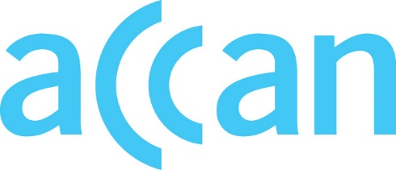
www.accan.org.au
info@accan.org.au
02 9288 4000

Submission 15 September 2022

Dominic Byrne
Manager
Infrastructure and Equipment Safeguards Section
Licensing and Infrastructure Safeguards Branch
Australian Communications and Media Authority

Via Email: techreg@acma.gov.au

RE: Proposed Telecommunications Mobile Equipment Air Interface Standard and
consequential amendments to associated instrument

The Australian Communications Consumer Action Network (ACCAN) appreciates the opportunity to contribute to the ACMA’s Proposed Telecommunications Mobile Equipment Air Interface Standard and consequential amendments to associated instrument consultation.
ACCAN supports the proposal to make a new Telecommunications (Mobile Equipment Air Interface) Technical Standard 2022. Australian mobile telecommunications consumers expect that any customer equipment used to access mobile networks in Australia must provide the greatest possible levels of safety, reliability and interoperability with public mobile telecommunications services.
As such, ACCAN supports the remaking of the Air Interface to incorporate the Communications Alliance’s new 5G industry standard and the latest industry standards that have replaced the applicable industry standards specified in the Air Interface Standard 2018.
Ensuring the legislative objectives of access to emergency call services, protecting the health and safety of persons, and protecting the integrity of, and interoperability of customer equipment with telecommunications networks is critical for consumer reliance and trust in the emerging mobile networks of 5G.
ACCAN recommends that in conjunction with the making of the new Air Interface Standard that the Australian Communications and Media Authority (ACMA) and equipment manufacturers and providers undertake broad consumer awareness initiatives to ensure that Australian consumers understand the new Air Interface Standard’s associated equipment labelling for mobile handsets and equipment capability with regard to access to Triple Zero (000) across the various iterations of mobile networks available in Australia - 3G, 4G and 5G. These consumer education initiatives must include information about any situations where equipment may not automatically roll-over to available networks for emergency calls to 000.
Yours sincerely,
Wayne Hawkins
Director of Inclusion
Australian Communications Consumer Action Network
The Australian Communications Consumer Action Network (ACCAN) is Australia’s peak communication consumer organisation. The operation of ACCAN is made possible by funding provided by the Commonwealth of Australia under section 593 of the Telecommunications Act 1997. This funding is recovered from charges on telecommunications carriers.

