1 November 2021
Senate Environment and Communications Legislation Committee
ec.sen@aph.gov.au

Re: Telstra Corporation and Other Legislation Amendment Bill 2021 Inquiry
The Australian Communications Consumer Action Network (ACCAN) thanks the Committee for the opportunity to comment on the Telstra Corporation and Other Legislation Amendment Bill (the Bill) currently under consideration by the Parliament.
ACCAN is the peak body representing all consumers on communications issues including telecommunications, broadband and emerging services. ACCAN provides a strong unified voice to industry and government as consumers work towards communications services that are trusted, inclusive and available for all.
ACCAN welcomes the Bill because it transfers important consumer safeguards that currently apply to Telstra to the restructured Telstra companies, and directs the obligations to the most appropriate entities within the group. It seeks to maintain ‘regulatory equivalency’ of obligations across the restructured Telstra group, to make sure that there is no lessening of Telstra’s public interest roles. This means that the following Telstra obligations will continue to apply to the restructured companies:

- The Universal Service Obligation to provide fixed voice services on request
- Telstra’s role as the Emergency Call Person under emergency call services arrangements
- The obligation to provide Priority Assistance, ensuring shorter repair times for customers with greater dependency on fixed voice services
- Customer Service Guarantee and Network Reliability Framework arrangements
- Facilities access sharing of transmission towers with other mobile network operators

If the Bill is not passed, then there would be a significant negative nationwide impact on consumers as it is reasonable to expect a progressive deterioration in Telstra’s performance of these important obligations. Any reduction in performance against the Customer Service Guarantee and Network Reliability Framework would disproportionately affect regional Australia, due to the increased reliance on Telstra’s voice services relative to urban areas and regional centres, where mobile coverage is available. Similarly, reduced sharing of mobile transmission towers with other network operators would dampen mobile competition, and further entrench Telstra’s dominance in the market, particularly in regional and rural areas.

We note that the Bill includes safeguards that would apply in the event of further Telstra restructures, such as requirements to advise the Minister of any such plans, and directions powers for the Minister and the Australian Communications and Media Authority that would apply the obligations to other entities within the Telstra group if required. These provisions are important as they build in flexibility, allowing the government to respond to conditions that potentially could reduce Telstra’s obligations.

We urge the Committee to support the smooth passage of the Bill, and would be happy to discuss the above points further at your convenience.

Yours sincerely
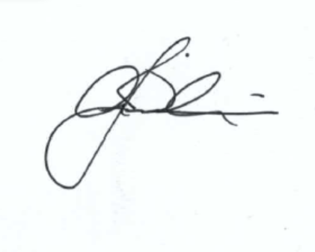
Andrew Williams
Acting Chief Executive Officer

