ACCAN Small business telecommunications survey 2016 – Report

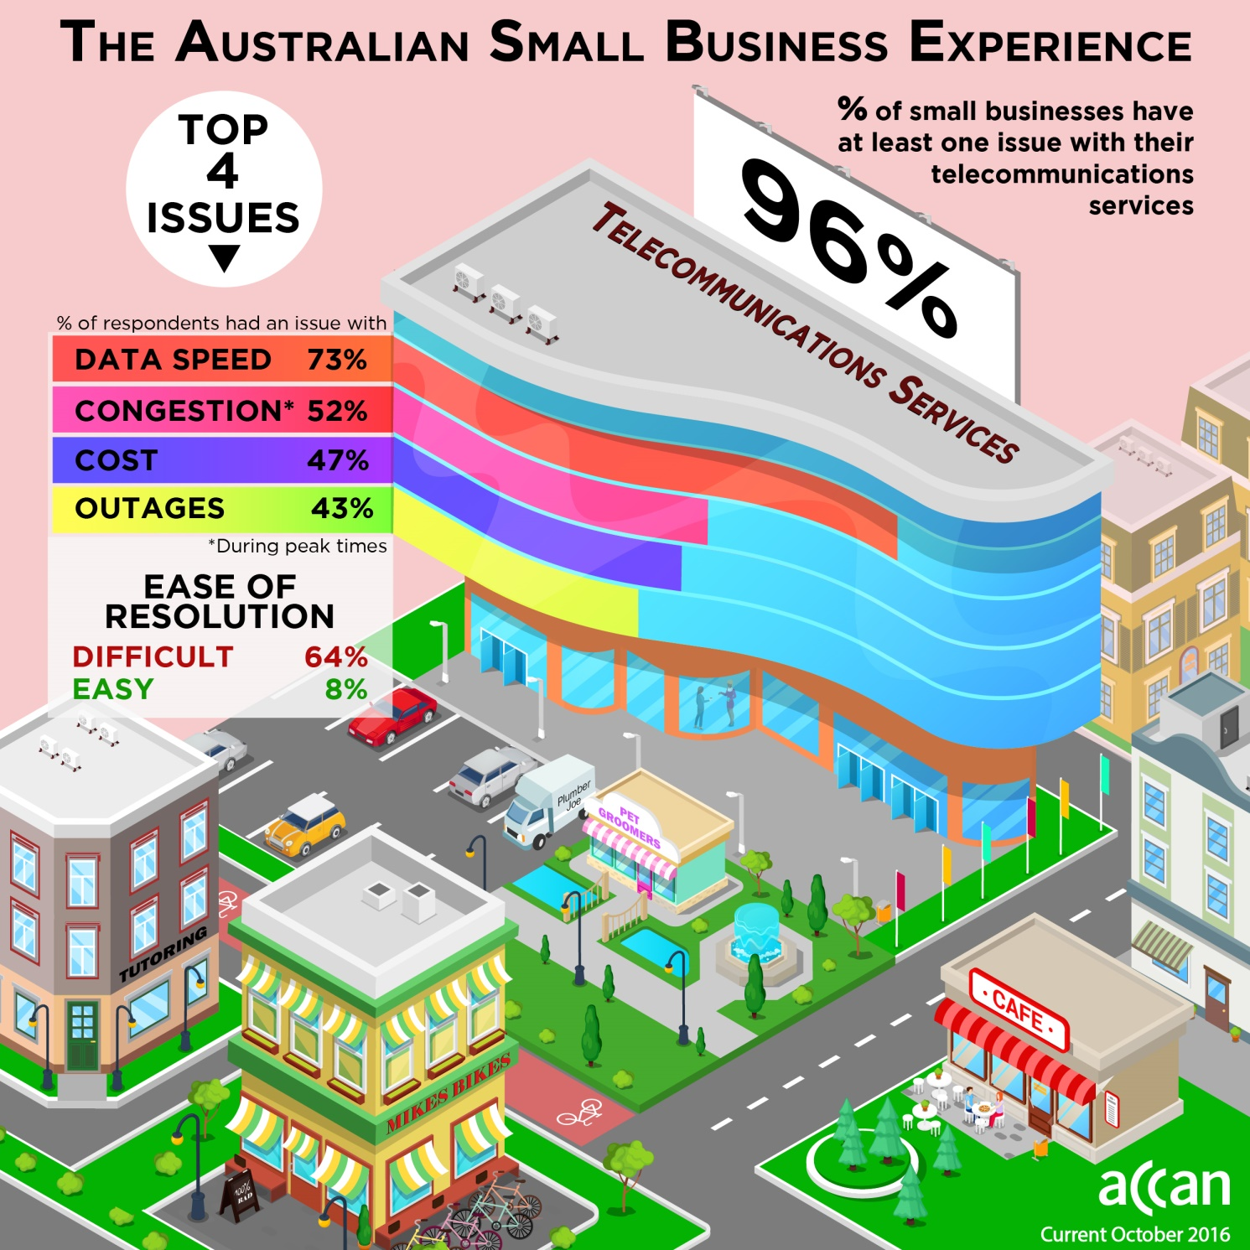

Background

This research was undertaken by ACCAN to collect information regarding small businesses experiences whilst using telecommunications to conduct their business. The survey was conducted using hard copy surveys at the NSW Farmers 2016 Annual Conference and also via an on-line survey targeting small businesses across Australia. 100 small businesses took part in the survey and it was active from August to October 2016.

Highlights from the survey

96 out of 100 small businesses surveyed stated that they have at least 1 issue with their telecommunications services.
Only 4 out of 100 respondents listed no issues with their telecommunications services.

Respondents could choose more than one issue.

Of 100 respondents, the top four single issues listed were:
- Internet Speed - 73 respondents
- Internet service congestion during peak times - 52 respondents
- Cost – 47 respondents
- Outages – 43 respondents
73 out of the 100 respondents surveyed reported slow data speed as an issue, making this the most prevalent single issue.
Many respondents reported multiple issues. The largest multiple was 48 respondents experiencing issues with both slow speeds and congestion at peak times. Almost ¼ of respondents (22) listed having all four of the top four issues!

64% of respondents indicated that it was difficult to resolving these issues
Unfortunately, 64% of respondents indicated that the issues with their service were difficult to resolve. Only 8% stated that it was easy to resolve.

The number of issues and the difficulties that small businesses are experiencing to get them resolved is very concerning. Several service providers over the past 2 years have issued media releases aimed at small business, stating that they are providing specialised business services and have a dedicated team of small business professionals to help navigate their telecommunications issues and solutions.
In May 2016, Optus issued a media release Optus sharpens focus on smbs that stated, Optus has announced it will refocus attention on delivering tailored solutions for Australia’s two million plus small business owners, supported by 126 new small business specialist stores, a dedicated Adelaide-based SMB call centre team, in addition to 26 existing business centres.

In July 2015, Vodafone issued a media release Vodafone launches mobile-centric retail outlets to better service Australian small business, promising Vodafone’s new VBC, located at 206 Greenhill Rd, at Eastwood in Adelaide, will offer the company’s extensive range of business plans, smartphones, tablet computers, mobile broadband products and accessories. In another first for the company, Vodafone will begin selling tailored machine-to-machine (M2M) solutions to small businesses from its business centres. Vodafone’s Executive General Manager Enterprise, Stuart Kelly, said the company wants to get up close and personal with small businesses. “Every business is different and needs tailored solutions to suit their needs,” said Mr Kelly.
The Survey results indicate that these service providers, and Telstra, could consider the opportunity to provide additional support for their small business customers and include a commitment towards a timely resolution of small business customer’s telecommunications issues as they occur.

Complaints

Whilst the number of issues is large, it is encouraging to see that 84% of respondents contacted their provider regarding their issues. 16% did not pursue the issue with their provider at all.

Despite this effort on behalf of the small businesses to resolve their issue, 64% of respondents reported that it was difficult to resolve. In 2013, ACCAN commissioned Market Clarity to undertake research about small business telecommunications use, Small Business Telecommunications Service Use and Experience. This research highlighted that an impact of a one-hour service fault varies by the type of service and a respondent’s business requirements. The results from that survey showed that 25% of fixed voice users reported that they would experience a serious or catastrophic impact; as would 32% of fixed broadband users; 24% of mobile voice users; 19% of mobile broadband users and 26% of EFTPOS users.
Further research is needed to ascertain the reasons for these difficulties to identify strategies for minimising the impact of these issues.

Percentage contacting the TIO
While 64% of respondents stated they had found it difficult to resolve their issues, 19% had contacted the TIO for assistance.

It is interesting to compare these results with those from an ACCAN Galaxy Survey conducted in 2015. The 2015 survey found that 46% of respondents had problems with their telco in the last 12 months. Of these, 64% had complained to their service provider, 38% were dissatisfied with the outcome, but only 5% of those dissatisfied pursued their complaint by taking it to the TIO.
It is encouraging that the small businesses participating in the current survey were significantly more proactive in pursuing their complaint with the TIO than general consumers surveyed in 2015.

Barriers to getting resolutions for small business

Respondents were asked to add comments to their answers concerning the level of difficulty in getting their issue resolved. After reviewing these comments individually, three common themes emerge:

Infrastructure
Many of the comments from respondents about the difficulties faced were about the telecommunications infrastructure experienced. Samples of the comments include;
Respondent No. | Comment
17 | adsl only option
18 | have to wait for nbn before any chance of improvement
19 | distance from exchange is approx. 15km
21 | Telstra knows we are in a black spot for mobile reception and we need more towers for nbn wireless Satellite is cheaper and faster when it is working (affected by weather) We pay $165/mth Telstra mobile broadband $55/mth to activ8 Huge cost relative to metro people and very average service ( can't watch movies/no internet tv and on occasions have to drive into town to submit bas returns and do Internet banking)
23 | Have had Telstra here on several occasions & the problem is never really fixed as its the old lines that get moisture in them. Lines need to be upgraded or we need to be on NBN list ASAP.
41 | Did apply twice for ADSL Internet on farm but was told there are not enough Telstra Internet Ports available in my area.
45 | Poor NBN and Telstra coverage. That said Optus coverage is worse and Vodo non-existent.
96 | Providers unable to provide fixed broadband due to insufficient capacity at the exchange (?) NBN have advised a significant delay to our address due to 'heritage' issues.

Committing Resources
There were several comments regarding the commitment of resources to fix the issues and the associated costs to business. Some of the comments include;
Respondent No. | Comment
26 | At times a private technician is required at great cost to fix the problem. The down time to the business is also an expense.
83 | Pay the $3000 they want to run a 6 foot cable to out building for NBN!!
94 | Up to about 30min to 3hrs on the phone too service provider to sort out issues each time called.

Frustration
A number of respondents expressed their frustrations in resolving their issues. These concerns include;
Respondent No. | Comment
36 | Telstra staff had difficult to understand Indian accents and had no understanding of our Australian rural situation, and kept offering deals on mobile phones, they couldn't grasp that we don't have mobile cover. We had the full run around until we were at length referred to a Melbourne telephone number from some belated and slow action was finally obtained.
85 | Phone can be out for days as there is no technician I. Our area 4 - 10 days. Internet can be very slow or all data eaten up? Not much help from company
86 | I couldn't resolve it - we get told it's the area... well know problem around here!
100 | Wait it out

These barriers can often lead small business operators to abandon the complaint, or to work around the issue. As Respondent 21 stated “on occasions have to drive into town to submit bas returns and do Internet banking”. This is not an ideal business practice, however the banking and BAS returns get done, at the expense of time and money that could have been better used on revenue earning activities.

Use of telecommunications

Respondents were allowed multiple responses.
Small businesses typically use a mix of telecommunications services to run their business. A notable outcome of the Survey is that there is a heavy use of mobile phone networks, with 93 out of 100 respondents indicating that they use a mobile phone for their business. This is not surprising given the important flexibility that mobile networks offer.
Despite this heavy mobile phone use, 76 respondents are still using a fixed line phone. One of the reasons for this is possibly a result of a trend by small businesses to use bundled services. The research report Small Business Telecommunications Service Use and Experience found that 54% of the sample (260 businesses), bundle their telecommunications services. Another reason could be that the largest single small business sector represented in the Survey is agriculture (47%). It is likely that these respondents experience patchy mobile coverage where they work and live, necessitating the use of a fixed voice service.

Telecommunications issues causing barriers to business

When surveyed about the limitations that these issues are causing, 91 out of 100 respondents highlighted issues that are disrupting best practice and innovation amongst small businesses.
These businesses are at a disadvantage when they are trying to participate or compete in a global digital economy due to barriers such as unreliable speed, connectivity or data restrictions. Of the small businesses surveyed, the top 3 services considered desirable but not currently possible were teleconferencing, professional development / training / study and the use of cloud services.

Respondents were allowed multiple responses.

Elements that are working well

The Survey asked small businesses what elements of their telecommunications services were working well for them. 61 respondents answered by using multiple choice options as represented in the chart below.

Respondents were allowed multiple responses.

With the sample group of respondents coming from urban and rural based small business operators in Australia, the Survey results indicate that there were some good experiences with network availability and reliability. Unfortunately, the number of issues being experienced with outages, congestion and speed identify that there are real problems in these areas amongst Australian small businesses.
The recent focus from some service providers to provide qualifying small business customers with dedicated small business telecommunications professionals may be having an effect. This might account for the 11% of respondents who have said that the customer service from their provider is working well.

Future work for ACCAN

Research
Further research is needed to find out, for example, why some small businesses did not contact their service provider about an issue (16%); why a majority of those who did had difficulty resolving the issue (64%); why 19% contacted the TIO despite 64% saying they had difficulty resolving their issue with their provider. This data will be important to assist small businesses in the future.
A further survey could assist in identifying suggestions for a more ‘small business friendly’ way to deal with these issues and to get them resolved in an efficient manner.

Consumer education

Awareness of the role of the TIO on behalf of small businesses
ACCAN will continue to work towards ensuring that small business consumers are aware that they can access the TIO and to continue to work with and support the TIO in providing practical information about the TIO complaints process.

https://accan.org.au/files/Market-Clarity-Small-Biz-Telecom-Service-Use-final.pdf
http://accan.org.au/files/Reports/ACCAN%20Galaxy%20Survey%20May%202015.pdf
https://accan.org.au/files/Market-Clarity-Small-Biz-Telecom-Service-Use-final.pdf

