Internet Scams:
How to Protect Yourself

A consumer research and education project
by the WA Deaf Society

Supported by a grant from the Australian Communications Consumer Action Network (ACCAN).

Published in 2010

This project is supported by the Australian Communication Consumer Action Network’s Grants Scheme. As the peak consumer representation body in communications, ACCAN awards grants each year to research and advocacy projects that align with its goal of available, accessible and affordable communications for all Australians. ACCAN’s activities are supported by funding from the Commonwealth Department of Broadband, Communications and the Digital Economy. Visit www.accan.org.au for more information.

The WA Deaf Society is a non-profit organization established in 1921 to provide services to Deaf and hard of hearing people in Western Australia. Our core business consists of 3 services. These are the Deaf Interpreting Service, DEAFinite Employment Service and Community Services.

WA Deaf Society Inc
PO Box 8558
Perth BC 6849
Western Australia
Telephone:
Voice: (08) 9441 2677
TTY: (08) 9441 2655
http://www.wadeaf.org.au

Australian Communications Consumer Action Network
Website: www.accan.org.au
E-mail: grants@accan.org.au
Telephone: +61 2 9288 4000;
TTY: +61 2 9281 5322
Published in 2010
Cover image: ©iStockphoto.com/accan

This work is copyright, licensed under the Creative Commons Attribution 3.0 Australia Licence. You are free to cite, copy, communicate and adapt this work, so long as you attribute the “WA Deaf Society”, supported by a grant from the Australian Communications Consumer Action Network”.To view a copy of this license, visit http://creativecommons.org/licenses/by/3.0/au.

This work can be cited as:

WA Deaf Society 2010. Internet Scams: How to Protect Yourself, Australian Communications Consumer Action Network, Sydney.

Overview
This Project Report comments on the background and activities of the Internet Scams: How to Protect Yourself project.

The main output of the project was a set of accessible consumer education videos to aid consumers in protecting themselves from Internet Scams.

The videos can be viewed at: http://www.youtube.com/user/internetscamsprotect. A DVD can also be obtained from the WA Deaf Society.

Background
Deaf people rely on multimedia communications for everyday life interaction, and yet cyber security information is not accessible to the Deaf community.

Public education through the SCAMwatch website and the “Little Black Book of Scams” by ACCC is an outstanding resource, however, Auslan is a visual language and this important information is only available in English and therefore not accessible to the Deaf community.

It is vital that information is distributed to the wider community, not only for Deaf people but for those who use English as a second language and people with disabilities. Information must be made available in Auslan, captioning, voiceover and visual aids to address these unmet needs.

This project target was predominately for the Deaf community across all life stages to educate the dangers of scams. There are many personal and social consequences associated with deafness mainly stigma and poor educational outcomes which lead to social isolation, utilising the internet is one way the Deaf community improve communication.

This project has helped the Deaf community to develop skills to become active, independent citizens who contribute positively, have the confidence and question strangers encouraging them to become involved in marriage, relationships and giving money.

The Deaf community use Australian Sign Language (Auslan) which was officially recognised by the Federal Government in 1987. Auslan visual language signs are related to concepts not words. It cannot be read, written or spoken like English. Due to language barriers Deaf community are prevented from participating in everyday events. This project has contributed to providing full and equal access to presentations and information and be able to respond to the information in their first language.

English as a second language is why scammers are successful ‘hooking’ the Deaf community despite many being from overseas with poor English. The Society has been inundated with distressed and embarrassed individuals and/ or their family, telling their scam, eg houses repossessed, house and cars sold, family members issuing restraining orders, stopping money been withdrawn/deposited to/from accounts. In the period leading up to the project, approximately $83,000 to date was scammed (See Appendix 1 for media reports); this is what has been declared, others to embarrassed to admit their financial loss.

Knowledge base:

The Society has worked in collaboration with the following groups for this project:

Australian Competition and Consumer Commission (ACCC), SCAMwatch resources – WA Deaf Society – Staff, members, donors, volunteers, WA Deaf Recreation Association, WA Association of the Deaf, Australian Sign Language Interpreters Association (WA), Deafness Council, Western Australian Institute of Deaf Education, WA Deaf Children’s Foundation, Deaf Seniors, Deaf 50+ Club, Better Hearing, Deaf and hearing families, Deaf and hard of hearing youth, Deaf Children Australia, Vic Deaf, Deaf Services Queensland, Police Major Fraud Squad

We first held 2 workshops in Visual presentations/information format these included:

- Informative resources via professional presentation from the ACCC using interpreters, Internet promotion - emails, Facebook

- Utilised visual resources specifically tailored for Deaf

- Workshops were very successful to demonstrate examples of what could occur and can be videoed.

We then undertook a comprehensive review of the ACCC’s SCAMwatch resources.

We then conducted a survey through our networks to further inform the production of the videos. The survey was hosted online using survey money and also available in print. The full survey is found below.

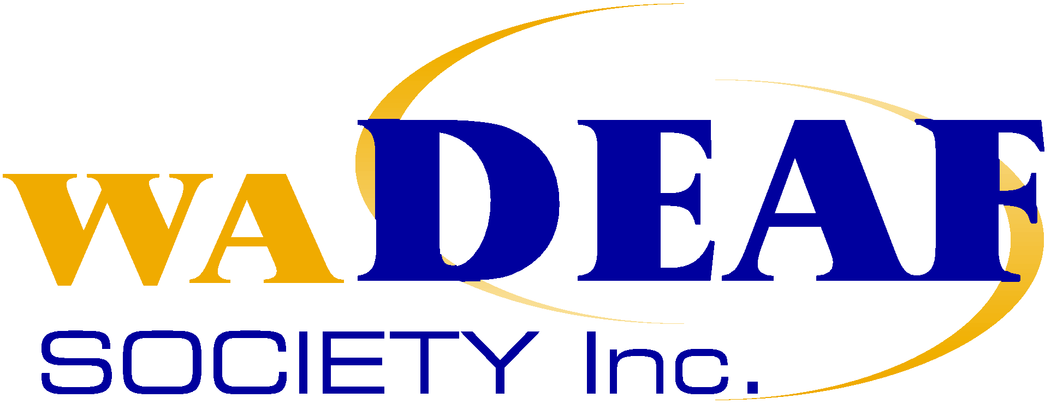


Internet Scams: How to protect yourself

Survey

- Your gender ◻ Male ◻ Female

- Your Age Group

◻ Under 18 ◻ 18-25 ◻ 26-30 ◻ 31-35 ◻ 36-40

◻ 41-45 ◻ 46-50 ◻ 51-55 ◻ 56-60 ◻ Over 60

- Your state of residence

◻ WA ◻ TAS ◻ NSW ◻ VIC

◻ QLD ◻ SA ◻ NT ◻ ACT

- What is a scam?

 | Yes | No | Don’t Know
Stealing | ◻ | ◻ | ◻
Lying | ◻ | ◻ | ◻
New friend | ◻ | ◻ | ◻
Fool | ◻ | ◻ | ◻
Fake | ◻ | ◻ | ◻
Pay money | ◻ | ◻ | ◻
Love | ◻ | ◻ | ◻
Bullying | ◻ | ◻ | ◻
Overseas | ◻ | ◻ | ◻
Local | ◻ | ◻ | ◻
True | ◻ | ◻ | ◻
Illegal | ◻ | ◻ | ◻
Legal | ◻ | ◻ | ◻
Make money | ◻ | ◻ | ◻

- Can scams occur through the following?

 | Yes | No | Don’t know
Email | ◻ | ◻ | ◻
Website | ◻ | ◻ | ◻
Facebook / My Space | ◻ | ◻ | ◻
Advertisements | ◻ | ◻ | ◻
Chat Forums | ◻ | ◻ | ◻
Twitter | ◻ | ◻ | ◻
MSN / Yahoo Chat | ◻ | ◻ | ◻
Internet Banking | ◻ | ◻ | ◻
SMS | ◻ | ◻ | ◻
Online Shopping | ◻ | ◻ | ◻
Telephone | ◻ | ◻ | ◻
National Relay Service | ◻ | ◻ | ◻
Mail / Post | ◻ | ◻ | ◻
Face to Face | ◻ | ◻ | ◻
Newspaper | ◻ | ◻ | ◻
Workshops | ◻ | ◻ | ◻

- Do you use the following for general day to day activities?

 | Always | Sometimes | Never
Email | ◻ | ◻ | ◻
Website | ◻ | ◻ | ◻
Facebook / My Space | ◻ | ◻ | ◻
Advertisements | ◻ | ◻ | ◻
Chat Forums | ◻ | ◻ | ◻
Twitter | ◻ | ◻ | ◻
MSN / Yahoo Chat | ◻ | ◻ | ◻
Internet Banking | ◻ | ◻ | ◻
SMS | ◻ | ◻ | ◻
Online Shopping | ◻ | ◻ | ◻
Telephone | ◻ | ◻ | ◻
National Relay Service | ◻ | ◻ | ◻
Mail / Post | ◻ | ◻ | ◻

- Have you bought something over the internet before?

◻ Yes ◻ No ◻ Can’t remember
- Do you know anyone who has lost money through a scam?

◻ Yes ◻ No

If you answered yes, what kind of scam was it?
◻ | Making Friend
◻ | Win Money
◻ | Lottery Sweep
◻ | Donation
◻ | Dating
◻ | Overseas marriage
◻ | Charity support
◻ | Online shopping
◻ | Other? ________________________ (please list)

- If you wanted to report suspicious behaviour or something that has happened over the internet, do you know who to contact?

◻ Yes ◻ No

If you answered yes, who would you contact?

________________________________________

- Have a look at the following examples; do you think it’s a scam?

 | Yes | No | Don’t Know
You have made a new friend online and you have been talking for a few weeks and that person asks for money to buy a passport to come and visit you. | ◻ | ◻ | ◻
A stranger sends you an email asking to help them distribute their money to victims of a natural disaster such as earthquake or tsunami. | ◻ | ◻ | ◻
You want to buy tickets online for a sold-out sport event, and you find a website that will sell tickets to you. You paid for the tickets, but you paid the money into a different website. | ◻ | ◻ | ◻
You want to start dating someone online, and you find a website and you start talking with someone and they tell you that they love you within a few days. | ◻ | ◻ | ◻
You get an email telling you that you have been chosen to take part in a great business plan and you can earn up to $5000 a month extra. | ◻ | ◻ | ◻
You find a great deal for a classic car online, and you want to buy it. But the car is overseas and the person asks for the money in advance so the car can be shipped over to where you are. | ◻ | ◻ | ◻
A friend that you have been talking with online asks if you would mind helping out, with some boxes of merchandise. You agree, and some boxes are delivered to your address and you have to send them to your friend overseas. You get a bill for the shipment. | ◻ | ◻ | ◻

A total of 82 people responded to the survey.

We had a good cross section of age groups take part. The surveys conducted produced some interesting findings; for instance
- 64% of people surveyed did not know who to report suspicious behaviour or something that has happened to them over the internet to.
- An average of 28% surveyed knew someone who has lost money through scams.
- 65% of people had bought something over the internet previously.
- 20% did not know through what channels scams could take place.

It is interesting to note that the people surveyed were suspicious of scams although not really sure of what a scam is.

Detailed information collected from surveys completed as below:

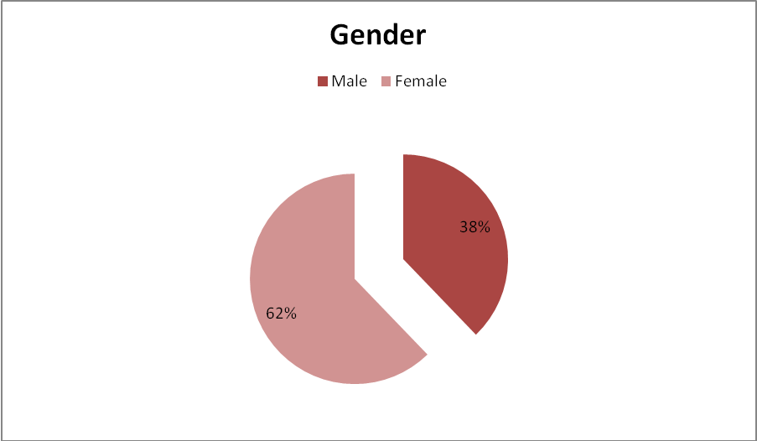
Caption: Gender – 62% of respondents were female, 38% were male.

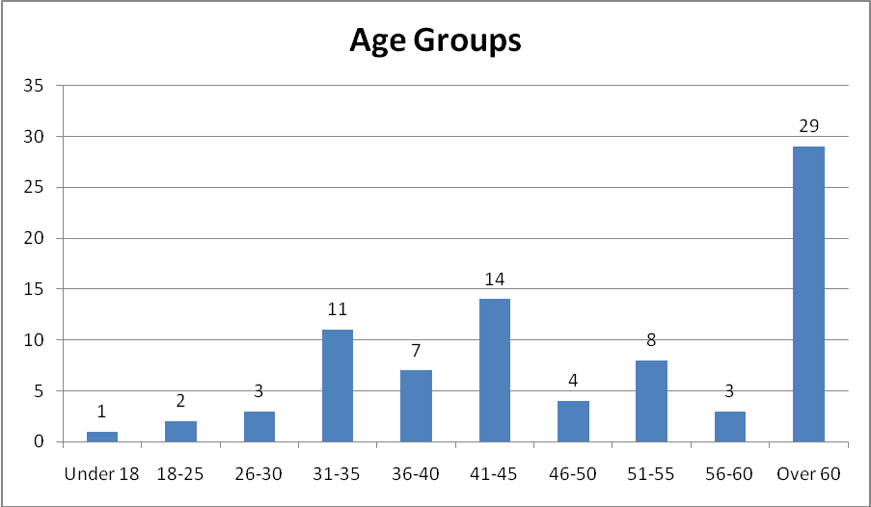

Caption: Age Groups
Respondents under 18 = 1
Respondents 18 to 25 = 2
Respondents 26 to 30 = 3
Respondents 31 to 35 = 11
Respondents 36 to 40 = 7
Respondents 41 to 45 = 14
Respondents 46 to 50 = 4
Respondents 51 to 55 = 8
Respondents 56 to 60 =3
Respondents over 60 =29

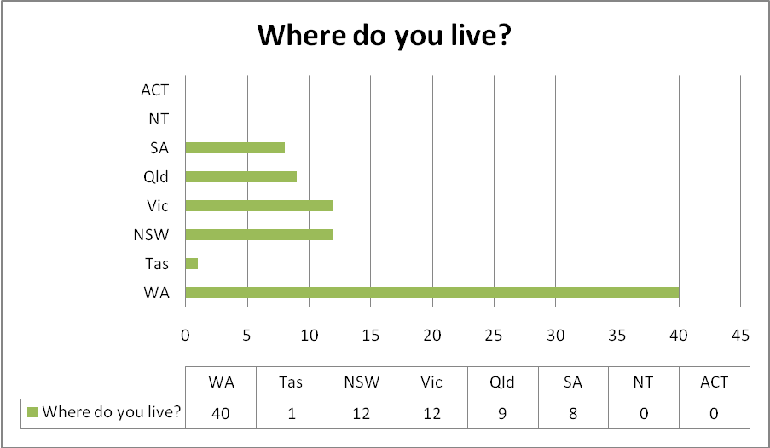
Caption: Where do you live?

WA – 40
Tas – 1
NSW – 12
Vic – 12
Qld – 9
SA – 8
NT – 0
ACT - 0

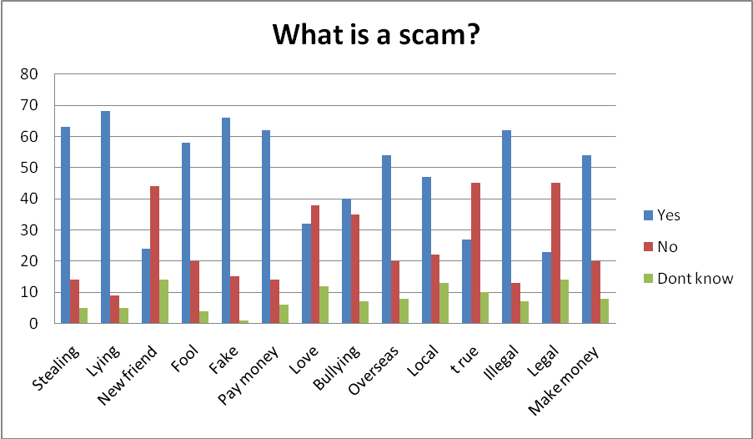
Caption: What is a scam?

Stealing -78% yes, 17% no, 6% don’t know
Lying - 82% yes,10% no, 8% don’t know
New friend - 30% yes, 53% no,17% don’t know
Fool - 70% yes, 25% no, 5% don’t know
Fake - 80% yes, 18% no, 2% don’t know
Pay money - 75% yes, 17% no, 8% don’t know
Love - 39% yes, 46% no, 15% don’t know
Bullying - 48% yes, 42% no, 10% don’t know
Overseas - 65% yes, 25% no, 10% don’t know
Local – 57% yes, 26% no, 17% don’t know
True - 32% yes, 54% no, 9% don’t know
Illegal - 75% yes, 15% no, 9% don’t know
Legal - 28% yes, 54% no, 18% don’t know
Make money- 65% yes, 25% no, 10% don’t know

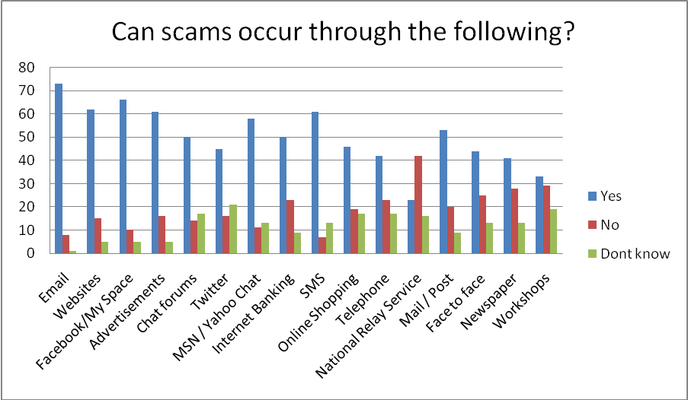
Caption: Can scams occur through the following?

Email -89% yes, 9% no, 2% don’t know
Websites - 75% yes, 18% no, 6% don’t know
Facebook/myspace - 80% yes, 10% no, 10% don’t know
Advertisements - 75% yes, 20% no, 5% don’t know
Chat forums - 60% yes, 20% no, 20% don’t know
Twitter – 56% yes, 20% no, 24% don’t know
MSN/Yahoo chat - 70% yes, 15% yes, 15% don’t know
Internet banking – 60% yes, 30% no, 10% don’t know
SMS - 75% yes, 10% no, 15% don’t know
Online shopping - 56% yes, 24% no, 20% don’t know
Telephone - 52% yes, 28% no, 20% don’t know
National relay service - 28% yes, 52% no, 20% don’t know
Mail/post - 64% yes, 26% no, 10% don’t know
Face to face -55% yes, 30% no,15% don’t know
Newspaper - 50% yes, 35% no, 15% don’t know
Workshops - 40% yes, 35% no, 25% don’t know

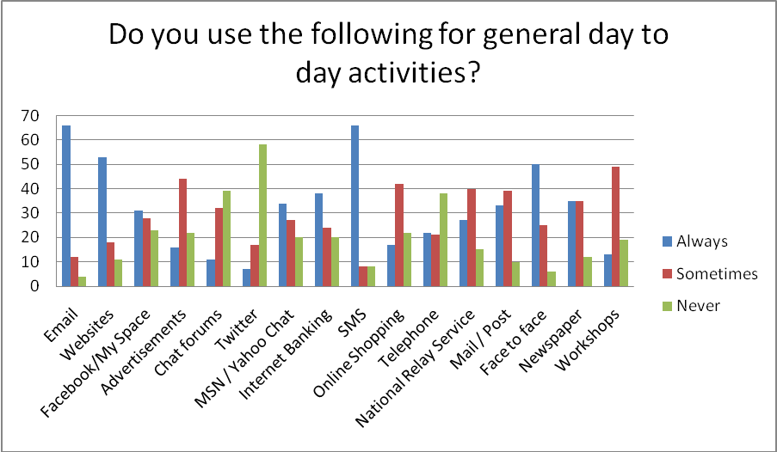
Caption: Do you use the following for general day to day activities?

Email -80% always, 15% sometimes, 5% never
Websites - 65% always,, 21% sometimes 14% never
Facebook/myspace - 37% always,, 34% sometimes 29% never
Advertisements - 19% always,, 54% sometimes, 27% never
Chat forums - 13% always,, 39% sometimes 48% never
Twitter – 8% always,, 22% sometimes,70% never
MSN/Yahoo chat - 41% always,, 32% sometimes, 26% never
Internet banking – 46% always, 29% sometimes, 25% never
SMS - 80% always,, 10% sometimes 10% never
Online shopping -20% always,, 51% sometimes 29% never
Telephone - 26% always,, 24% sometimes, 50% never
National relay service -32% always,, 48% sometimes ,20% never
Mail/post - 40% always,, 47% sometimes, 13% never
Face to face -60% always,, 30% sometimes,10% never
Newspaper - 42% always,, 42% sometimes, 16% never
Workshops - 15% always,, 60% sometimes, 25% never

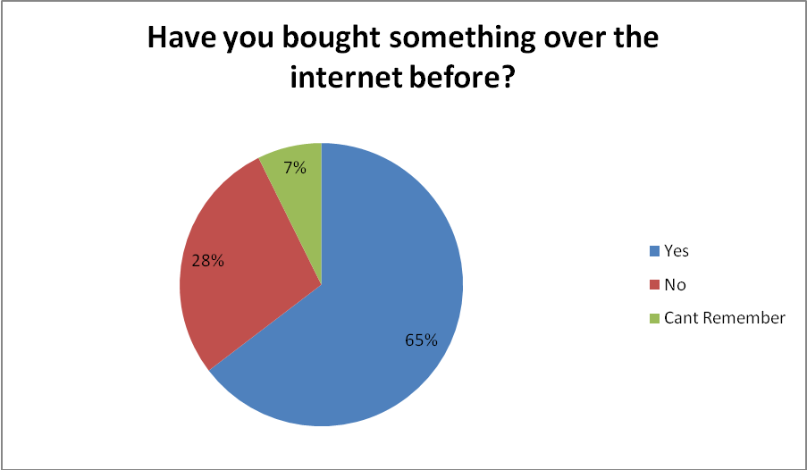
Caption: Have you bought something over the internet before?

65% yes
28% no
7% can’t remember

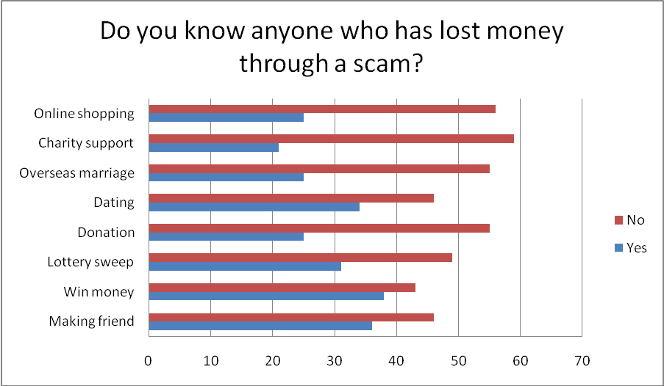
Caption: Do you know anyone who has lost money through a scam?

Making a friend – 44% yes, 56% no
Win Money – 48% no, 52% yes
Lottery sweep – 41% no, 59% yes
Donation - 33% no, 67% yes
Dating- 44% no, 56% yes
Overseas marriage - 33% no, 67% yes
Charity support - 29% no, 71% yes
Online shopping - 32% no, 68% yes

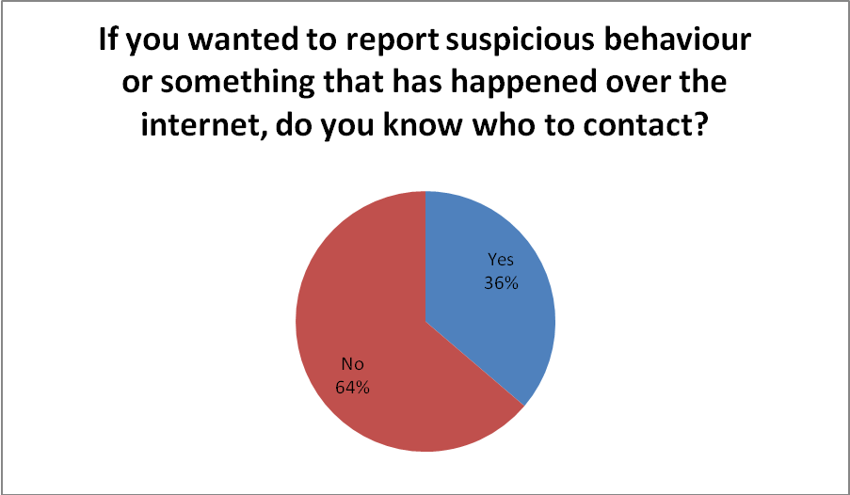
Caption: If you wanted to report suspicious behaviour or something that has happened over the internet, do you know who to contact?

64% no
36% yes

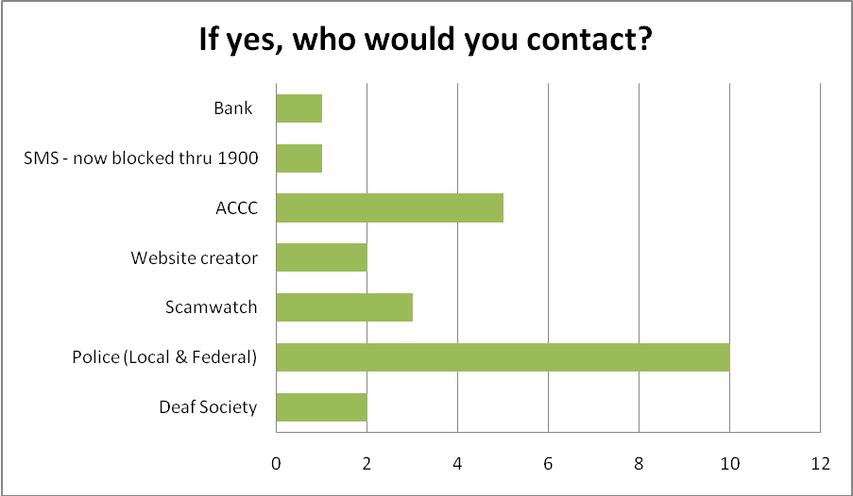
Caption: If yes, who would you contact?

Number of respondents who would contact;
Deaf society – 2
Police – 10
SCAMwatch – 3
Website creator – 2
ACCC – 5
SMS – 1
Bank- 1

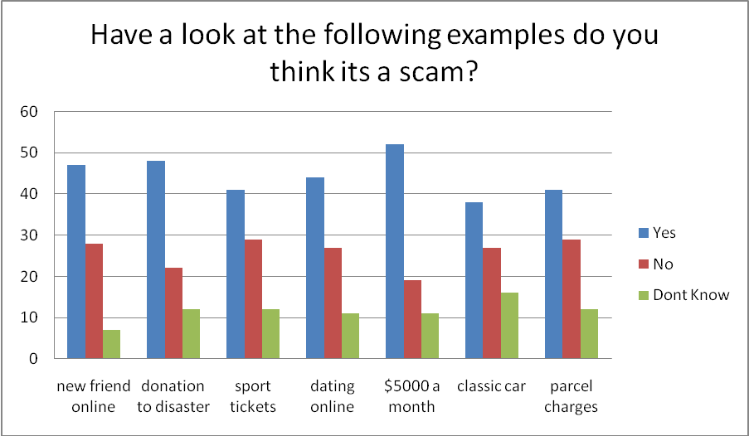
Caption: Have a look at the following examples, do you think it’s a scam?

New friend online - 57% yes, 34% no, 9% don’t know
Donation to disaster - 58% yes, 28% no, 14% don’t know
Sport tickets - 50% yes, 35% no, 15% don’t know
Dating online - 53% yes, 33% no, 14% don’t know
$5000 a month – 63% yes, 23% no, 14% don’t know
Classic car- 46% yes, 35% no, 19% don’t know
Parcel charges – 50% yes, 35% no, 15% don’t know

Video production
The process of making the videos was very complex; we needed to take into account the following
- Production process
  - Script writing
  - Consultation with Deaf person
  - Finalising the script
  - Team meeting with crew – to make sure all understand the process
  - Filming…..
  - Clips to be inserted into DVD with timer
  - Deaf person to view clips and select appropriate clips with timing charts
  - Voice over interpreters to get a copy to watch beforehand
  - Voice over’s
  - Captioning

Some useful tips for similar projects in the future:

- Make sure experienced Deaf people are involved in the pre production process
- Experienced Deaf coaches onsite when filming for Auslan prompts and discussions (the coach responsibility is to make sure that the information is viable for the Deaf community as its quite hard for the presenter to go from a English script (through autocue) into a 2nd language without dissecting themselves so that’s where the coach comes in)
- Always have autocue
- Always have a screen for the presenter to see themselves – so clips can be viewed back and forth
- Information – script writing… Best to be straight to the point and simple. Confusing messages or abstract concepts were to be avoided
- Emphasis on the message needs to be repeated throughout the production e.g. in bullet form, then again in a concluding message
- Message to be backed up by visual prompts such as pictures, role plays, examples etc
- Voice over interpreters had to be experienced and of quality to reflect the presenter. It does not have to be interpreters, but if using professional voice over – need to make sure timing for Auslan clips and voice over clips are almost on par with each other. Otherwise it will be a dud production if the Auslan clips are short and the voice over clips are longer or the other way around..
- Film crew had to be aware that the time taken to film a one page script is longer than normal.. As many get frustrated quickly when discussions start re: translation from English to Auslan.. Many think that Deaf people have come unprepared which is false, because Auslan is an unique language – it is quite difficult to “practice” beforehand as when arriving onsite, the signs – many stop and starts… with long pauses in between.. crew need to be aware
- Interpreters to be present at all events (meetings, script meetings, make up sessions, filming

Conclusions

The WA Deaf Society is very proud of the work and commitment of all who took part in the process of this project. We feel the DVD’s will enhance not only the lives of the Deaf Community in being appraised of the variety of scams out there; it will also prove to be a valuable tool for all.

The project was fully accessible via Auslan, captions and voiceover, this is of huge benefit to the Deaf community and the wider community in particular where English is their second language and those with disabilities eg National Disability Services. It is estimated that 1 out of every 6 Australian suffer from some form of hearing loss (approx 3.35 million). (VicDeaf Listen Hear! 2006).

The Deaf community come from a culturally and linguistic diverse backgrounds of all demographics, this project has enabled the Society to deliver, in Auslan, education, enhancing communication skills; creating safer environment; self esteem; social development; peer friendships; seeking professional advice, sense of identity and belonging. Wider community will benefit particularly people with disabilities to be able to access information visually, with captions and voiceover. The information will be disseminated via resources on Society website, linked to others eg YouTube, Society’s Facebook, also emailed to members and participants will advocate effectively through the development of their understanding, share knowledge with the wider community.

A major win for the project was the ACCC asking for the videos to become part of the SCAMwatch resources (http://www.scamwatch.gov.au).

This project is sustainable as the Society will continue to work with the Police and assist the Deaf and wider community with their issues in relation to internet scams.

