What to do if you get third party charges on your phone bill
Have you received a text message like the one below informing you that you’ve subscribed to a subscription service and will be charged a fee for that service?
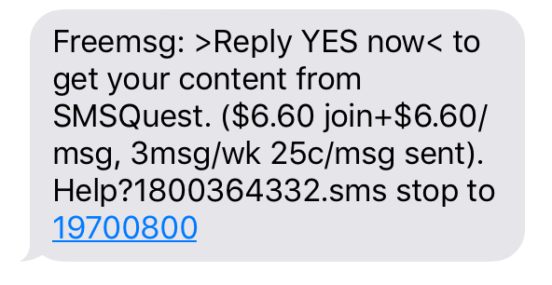
These types of messages don’t come from your telco and may result in charges being added to your phone bill. These charges are for third party services which means your telco is allowing another provider to sell content to you which you pay for on your phone bill. What you are buying can be phone apps, pay per view videos, games and other content. They can be one-off charges or ongoing subscriptions.
We recently ran a survey that found:
- 12 per cent of respondents experienced unexpected third party charges on their mobile phone bills in the last six months.
- When applied to the number of Australian adults who are with Telstra, Optus or Vodafone (the mobile providers that allow these services), this 12 per cent could mean as many as 1.9m adults received unexpected charges on their mobile bills and potentially were collectively charged as much as $20m.*
- Over a third (36 per cent) of these reported unexpected charges were for $10 or more.
There are three types of third party charges that consumers could find on their bill:
- Direct carrier billing – this is a service that allows you to charge the cost of content to your phone bill, and is available to Telstra and Optus customers only.
- Mobile Premium Services (MPS) – these are content services that consumers may subscribe to by calling or texting a 19X number or by subscribing on a website and arrive by SMS or call.
- 190 voice or video call services charged by the minute, or at a fixed rate.
The three mobile network operators have information on content and third party charges available online for their customers: Telstra, Optus and Vodafone.
The Mobile Premium Services Code, which regulates some third party charges, is available for public comment until 27 July, 2017. We encourage consumers to make a submission and have their say on the Code. ACCAN is calling for stricter controls on these third party charges.

What should you do?
To unsubscribe from these services:
- If you have a website link to the content, go to the website and cancel the subscription in the account or settings section.
- Reply ‘STOP’ to the number you are receiving messages from about the content.
- Call the content provider’s helpline. This should be listed in any messages you are receiving or on the provider’s website. If it’s a 19 number, you can find contact details on the 19 SMS website by entering the 19 number.
- Ask your telco to block ALL third party billing on your account to avoid further charges.
To get a refund:
- If you did not subscribe to these services, you should first request a refund from the content provider.
- If you are unable to get in touch with the content provider take your complaint to your telco.
- If you are unsatisfied with the response from your telco you can raise your complaint with the Telecommunications Industry Ombudsman.

Our advice
When you sign up for a new phone service, ask to block all third party billing on your account. If you already have a service, contact your telco and ask for these services to be blocked.
For many small businesses with multiple mobile phone accounts, these small charges can easily go unnoticed, as they are often only identified by the business manager looking closely at pages of monthly phone bills. For this reason, we strongly advise small businesses to bar third party billing on all their mobile phone accounts and avoid situations where employees mistakenly subscribe to services.
*Based on applying the survey results (12 per cent of respondents experienced on average charges of $12 in 6 month period) to adult mobile phone consumers using Telstra, Vodafone or Optus (combined market share 90 per cent).

