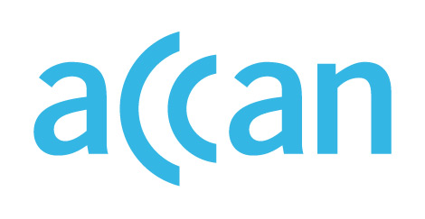

ONLINE LEARNING AND ACCESS TO DEVICES

DURING THE COVID-19 OUTBREAK

Device access programs in Tasmania
Online learning encouraged.
No device loan scheme in place.

Public schools
Public schools are open during Term 2 for children who cannot be supervised and supported to learn at home. The Tasmanian government has stated that every reasonable effort will be made to provide material to the students where appropriate.
The Tasmania Department of Education is working with the No Interest Loans Scheme (NILS) Network of Tasmania to provide interest-free loans to parents needing to purchase devices for students. Any parent receiving Centrelink benefit can apply for a loan.

Private schools
Like with public schools, non-government schools are to remain open for children who are unable to learn from home. No clear recommendations for the provision of devices to students without access.

Where to find out more

TAS Department of Education website
https://www.education.tas.gov.au/parents-carers/novel-coronavirus-covid-19/

https://publicdocumentcentre.education.tas.gov.au/Documents/Term-2-Arrangements-Fact-Sheet-Coronavirus-COVID-19.pdf
https://publicdocumentcentre.education.tas.gov.au/Documents/FAQ-for-Parents-Coronavirus-(COVID-19).pdf
https://www.education.tas.gov.au/2020/03/nils-tasmania-helping-parents-with-school-costs/

