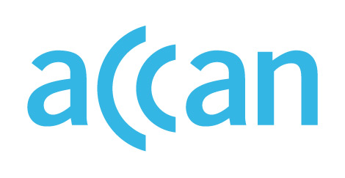

ONLINE LEARNING AND ACCESS TO DEVICES

DURING THE COVID-19 OUTBREAK

Device access programs in South Australia

South Australia
Online or face-to-face learning encouraged.
Device loan scheme in place.

Public schools
The SA Department for Education had recommended students attend school, but allowed parents to keep children at home. For students that are learning from home, the Department has committed to providing devices and SIM cards to students without access to a computer or home internet. If a school has existing devices able to be loaned, they are encouraged to do so. Information on how devices loaned from the Department will be delivered to students is not publicly available.

Private schools
Non-government schools are offering learning both in school and online. No clear public recommendations for device loan scheme from independent school peaks.

Where to find out more

SA Department for Education website
https://www.education.sa.gov.au/supporting-students/health-e-safety-and-wellbeing/covid-19-coronavirus

https://www.education.sa.gov.au/supporting-students/health-e-safety-and-wellbeing/covid-19-coronavirus/advice-families/frequently-asked-questions-about-covid-19-parents-and-carers
https://www.education.sa.gov.au/supporting-students/health-e-safety-and-wellbeing/covid-19-coronavirus/faq-covid-19

