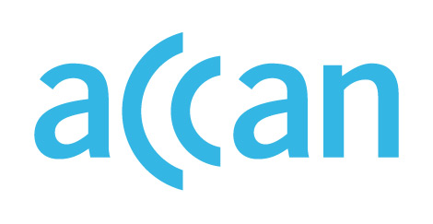

ONLINE LEARNING AND ACCESS TO DEVICES

DURING THE COVID-19 OUTBREAK

Device access programs in the Northern Territory
No device loan scheme in place.
Face-to-face learning strongly encouraged.

Public schools
From day one of Term 2 2020, all NT school students are expected to attend school. The NT Department of Education’s advice is that schools are encouraged to loan devices to students who are required to learn from home, but it appears there is no formal device loan scheme in place.

Private schools
Delivery mode of learning is to be determined by the individual non-government school. No clear recommendations for device loan schemes from independent peaks.

Where to find out more

NT Department of Education website
https://coronavirus.nt.gov.au/community-advice/schools

https://education.nt.gov.au/publications/information-for-parents-and-carers-about-ntg-schools-for-term-2-2020?SQ_VARIATION_814972=0
https://www.aisnt.asn.au/uploads/images/COVID-19-Update-090420.pdf

