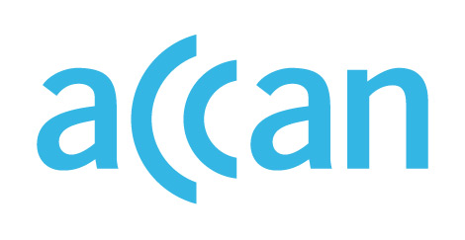

ONLINE LEARNING AND ACCESS TO DEVICES

DURING THE COVID-19 OUTBREAK

Device access programs in Australian Capital Territory
Device loan scheme in place.
Online learning encouraged.

Public schools
The ACT Department of Education is requiring all school students to transition to online learning for term 2. Only students granted an exemption may study at certain approved school sites. Students who don’t have access to a device or computer at home will be provided one via their public school, along with internet access.
Public school students in Year 7 through to Year 12 already receive access to a Chromebook device. Devices are available for students from K-6 during the home learning period, and families may procure these via their child’s school.
Telstra is working with the ACT government to provide internet access to all students who do not have access at home by providing SIM cards and mobile dongles to families in need.

Private schools
Private schools are predominantly delivering lessons online. Catholic Education ACT has stated its intention to deliver learning that is available both in class and online. No clear recommendations for device loan schemes from independent peaks.

Where to find out more

ACT Department of Education website
https://www.education.act.gov.au/public-school-life/remote-learning-in-term-2-2020

https://www.education.act.gov.au/public-school-life/remote-learning-in-term-2-2020
https://www.education.act.gov.au/__data/assets/word_doc/0008/1539593/FAQs-Families-and-Communities-24-April-2020.docx
https://www.canberratimes.com.au/story/6735489/students-hooked-up-ahead-of-shift-online/?cs=14225
https://cg.catholic.edu.au/covid-19-information-and-up/

