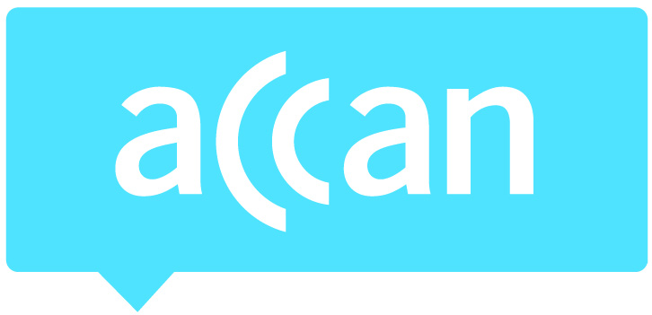
For immediate release 20 December, 2017

ACCAN welcomes Government response to USO

ACCAN has welcomed the Government’s response to the Productivity Commission report into the existing Universal Service Obligation (USO).
We are pleased that the Government’s response acknowledges that existing arrangements are out of date and in need of reform. We welcome the Government’s commitment to provide universal access to voice and broadband services through a new Universal Service Guarantee (USG) once the NBN rollout is complete.
“All consumers need access to reliable and affordable voice and internet services,” said ACCAN CEO, Teresa Corbin. “Guarantees underpinning access to vital voice and internet services are fundamentally important for areas where the market is not delivering adequately.”
“We look forward to working with the government on this in 2018 and beyond.”
ACCAN will work to ensure the new USG addresses the need for assurances that any new service delivery arrangements will take account of:
- The costs that may be borne by consumers themselves (for example, upfront equipment changes required or ongoing costs to use the proposed alternative voice services)
- The quality of voice services delivered by alternate technologies, which must be capable of supporting any to any voice calls
- The reliability of services in terms of expected and acceptable levels of outages and repair timeframes
- Fall back services in case one network is out, particularly for remote areas where there are no close neighbours, that are more vulnerable to adverse weather conditions and service disruption.
For more information, contact Luke Sutton on luke.sutton@accan.org.au or 0409 966 931. For the latest updates, follow ACCAN on Twitter or like us on Facebook.

