11 April, 2017
MEDIA RELEASE
Broadband speed report card welcomed by bush communications coalition
The Regional, Rural and Remote Communications Coalition (RRRCC) has welcomed a new broadband performance monitoring program to be administered by the Australian Competition and Consumer Commission (ACCC).
Announced last Friday, the program will see Australian consumers receive independent information about broadband speeds based on feedback from remote testing at more than 4000 households.
“This is a welcome measure and we congratulate the Australian Government on the initiative," Australian Communications Consumer Action Network (ACCAN) CEO, Teresa Corbin said.
“The top complaint about internet services to the Telecommunications Industry Ombudsman (TIO) is in relation to faulty services and slow speeds, indicating there is a gap between consumer expectations of how their services will perform, and actual performance.
"This program will provide consumers the needed information on average performance to make considered purchasing choices."
National Farmers’ Federation (NFF) President, Fiona Simson, said while the initiative was welcomed the monitoring program could go further.
“At the moment the program will only cover fixed line services, and it is fair to say that the majority of membership across the RRRCC accesses NBN services either through fixed wireless or the Sky Muster satellite.
"There is also a need for greater understanding and accountability around how these services are performing.”
“It is telling that even the ACCC Commissioner, Rod Sims, has acknowledged that the majority of complaints are coming from regional areas," Ms Simson said.
The Regional, Rural and Remote Communications Coalition is a group of like-minded organisations who have come together to end the data drought and champion better communications services for consumers and small businesses living in rural, remote or regional areas.
The RRRCC is calling on the Government to commit to five actions:
- A universal service obligation for both voice and data.
- Customer service guarantees to deliver more accountability from providers and nbn.
- Long term public funding for open access mobile network expansion (blackspots).
- Fair and equitable access to Sky Muster satellite for those with a genuine need for the service.
- Fully resourced capacity-building programs that build digital ability
Download the RRRCC’s latest submission to the Joint Parliamentary Committee on the National Broadband Network online.
Media contacts:
NFF: Laureta Wallace, 0408 448 250, media@nff.org.au
ACCAN: Luke Sutton, 0409 966 931, luke.sutton@accan.org.au

Member organisations: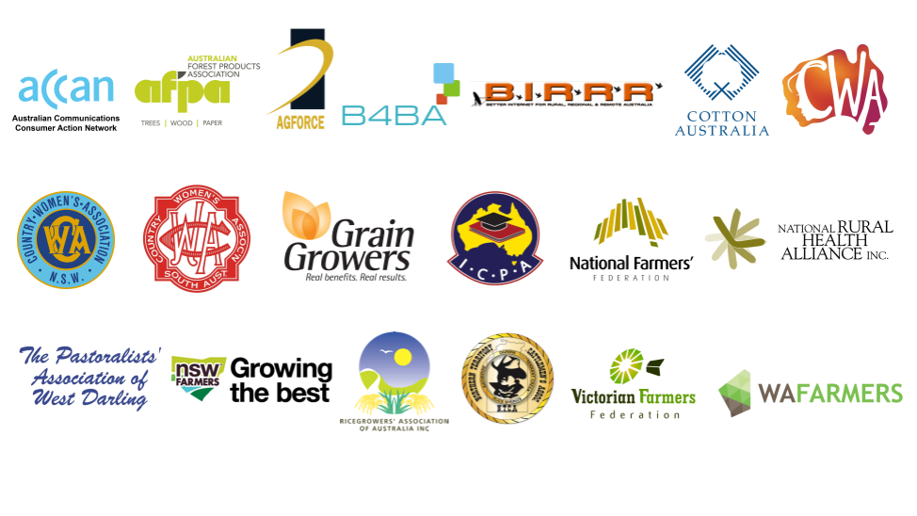

Members of the Coalition are:
  - ACCAN
  - AgForce Queensland
  - Australian Forest Products Association
  - Better Internet for Rural, Regional & Remote Australia
  - Broadband for the Bush Alliance
  - Cotton Australia
  - Country Women’s Association of Australia
  - Country Women’s Association of NSW
  - GrainGrowers
  - Isolated Children’s Parents’ Association
  - National Farmers’ Federation
  - Northern Territory Cattlemen’s Association
  - National Rural Health Alliance
  - NSW Farmers
  - The Pastoralists' Association of West Darling
  - Ricegrowers’ Association of Australia
  - South Australian Country Women’s Association
  - Victorian Farmers Federation
  - WAFarmers

