22 March, 2017
MEDIA RELEASE
Bush telecoms group tells Canberra it’s time for action
“We hear you and we want to help” was the majority message from politicians in Canberra this week when they met with the Regional, Rural & Remote Communications Coalition.
The Coalition met with more than 50 members of parliament over two days with the aim of highlighting the plight of telecommunications in the bush.
National Farmers' Federation President, Fiona Simson, said it was heartening that politicians understood the perils of an inability to access affordable and reliable telecommunications however action was what was needed now.
"Actions speak louder than words. Consensus by all politicians that this is a vital issue is yet another validation that now is the time for action towards solving the great #datadrought," Ms Simson said.
The Coalition is made up of 17 organisations with an interest in seeing telecommunications in the bush improved.
Members of the Coalition provided their personal experiences of living and doing business without reliable communications.
Annette Turner, President of the Country Women's Association of NSW, hailing from west of Broken Hill, told of a dangerous situation when communication networks failed last summer.
"We had a major bushfire during which landline and mobile services went down - as a result we had no idea where people fighting the fire were or if they were ok."
Grain farmer from Quambatook, in Victoria's Mallee, Brett Hosking, said the inability to connect was threatening to curtail agricultural productivity.
"Digital technology is the next frontier of productivity gains for farmers but without adequate access to reliable and affordable internet we stand to miss out on these new opportunities and the economic gains they offer."
During the two days the Coalition called on Government to commit to five actions:
- A universal service obligation for both voice and data.
- Customer service guarantees to deliver more accountability from providers and nbn.
- Long term public funding for open access mobile network expansion (blackspots).
- Fair and equitable access to Sky Muster satellite for those with a genuine need for the service.
- Fully resourced capacity-building programs that build digital ability.
Australian Communications Consumer Action Network (ACCAN) CEO, Teresa Corbin, said the Coalition would continue to fight to see telecommunications in regional, rural and remote Australia improved to a standard comparable to that enjoyed by urban consumers.
"We are committed to 2017 being the year better communications are delivered to the bush. There were lots of encouraging and positive words from the politicians we visited this week.
"Going forward from here we'll follow up on these meetings to work with politicians to ensure we get #betterbushcomms and put an end to the #datadrought."

Media contacts:
NFF: Laureta Wallace, 0408 448 250, media@nff.org.au
ACCAN: Luke Sutton, 0409 966 931, luke.sutton@accan.org.au

Member organisations:
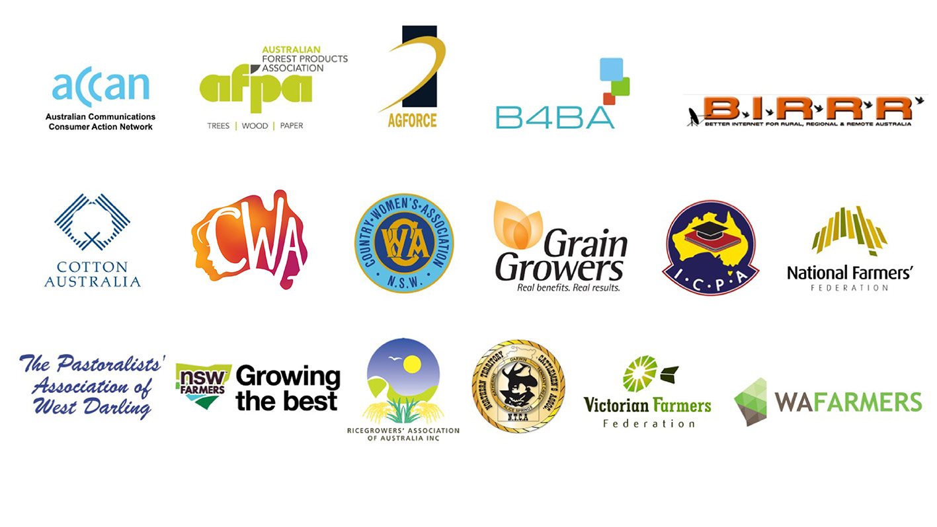

Members of the Coalition are:
  - ACCAN
  - AgForce Queensland
  - Australian Forest Products Association
  - Better Internet for Rural, Regional & Remote Australia
  - Broadband for the Bush Alliance
  - Cotton Australia
  - Country Women’s Association of Australia
  - Country Women’s Association of NSW
  - GrainGrowers
  - Isolated Children’s Parents’ Association
  - National Farmers’ Federation
  - Northern Territory Cattlemen’s Association
  - NSW Farmers
  - The Pastoralists' Association of West Darling
  - Ricegrowers’ Association of Australia
  - Victorian Farmers Federation
  - WA Farmers

