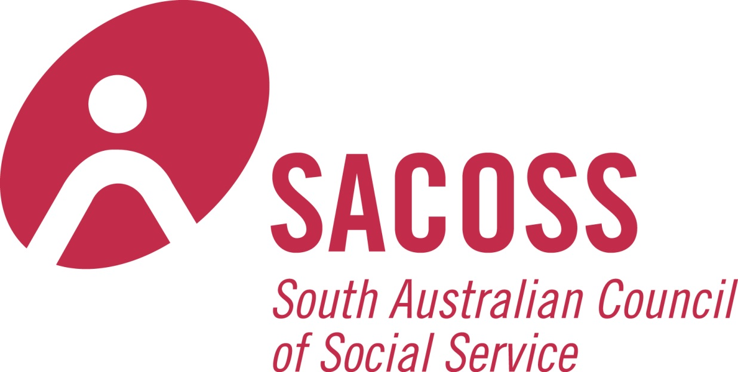
For immediate release 8 February, 2017

Productivity Commission needs to take affordability seriously in current telecommunications Inquiry

Key telecommunication consumer and social welfare groups today called on the Productivity Commission to consider more fully affordability issues in the Inquiry on the Telecommunications Universal Service Obligation (USO). The national peak body for communications consumers, the Australian Communications Consumer Action Network (ACCAN), backed the submission from the South Australian Council of Social Service (SACOSS) to the Inquiry. SACOSS argues that the Commission’s Draft Report and recommendations underestimate the challenges faced by many Australian households in paying for telecommunications. The Draft Report proposes incorporating broadband as a baseline universal service, but largely dismisses telecommunications affordability issues as limited in scope and relevance. SACOSS is highlighting these issues to the Productivity Commission at a public hearing for the Inquiry today.
“The Universal Service Obligation is a crucial element in ensuring that all Australians have access to modern communications which are necessary for commerce, education, social inclusion and dealing with government,” said ACCAN CEO, Teresa Corbin. “Affordable services must be a big part of that equation so that all consumers can access the benefits offered by being connected to the internet.
“The current Universal Service Obligation, which relates only to Telstra’s provision of standard telephone services, is out dated. We support the Productivity Commission’s inclusion of broadband as a baseline service for a revised obligation. However, we remain concerned about affordability of services, now and into the future, and the adequacy of existing low income measures such as the Centrelink Telephone Allowance.”
SACOSS and ACCAN research published late last year found that two thirds of low income Australians rated telecommunications among the top five factors in the household budget, but 62 per cent of consumers on low incomes reported that they had difficulty in paying for their telecommunications services or had to cut back or stop using them in the last 12 months.
“While telecommunications prices have not been increasing at the rate of other utilities, like electricity and water, the massive increase in demand for telecommunication services, brought about by new technologies and by government and businesses “going online”, has meant whole new expenditures for struggling households – especially those with kids,” SACOSS CEO, Ross Womersley said.
“Our submission suggests that the Productivity Commission’s analysis underestimates the importance of telecommunications in household budgets, and over-estimates the availability or effectiveness of government supports such as the Centrelink Telephone Allowance.”
“Our research clearly shows that the income support system is failing to make telecommunications affordable, both because the Centrelink Telephone Allowance is inadequate and poorly targeted, and because base level payments like Newstart and Youth Allowance are too low to ensure that recipients can afford telecommunications.”
The SACOSS submission to the Inquiry can be downloaded here.
ACCAN’s submission to the Inquiry can be downloaded here.
Media contacts:
ACCAN – Luke Sutton, 0409 966 931 or luke.sutton@accan.org.au
SACOSS – Tania Baxter, 0432 902 105 or Tania@sacoss.org.au

