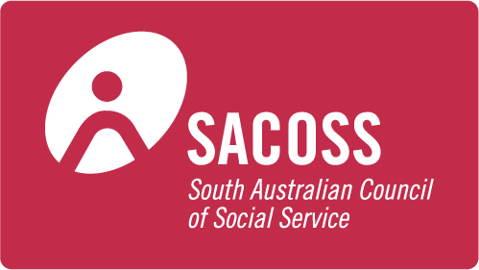



**For immediate release 17 June, 2016**

**New data highlights telecommunications exclusion**

A group of community organisations is calling the future Federal Government to increase assistance to people and families on low incomes in light of new data highlighting telecommunications exclusion.

The Australian Communications Consumer Action Network ([ACCAN](http://www.accan.org.au/)), the South Australian Council of Social Service ([SACOSS](https://www.sacoss.org.au/)) and Financial Counselling Australia ([FCA](http://www.financialcounsellingaustralia.org.au/Home)) are calling for a review of the [Centrelink Telephone Allowance](https://www.humanservices.gov.au/customer/services/centrelink/telephone-allowance) (CTA), pointing to the inadequacies of current entitlements in supporting low-income consumers to stay connected to phones and the internet. The CTA is a quarterly allowance designed to help consumers on income support payments to stay connected to telecommunications services.

“In our digital age telecommunications services are just as essential as water and energy,” said ACCAN CEO, Teresa Corbin. “Accessible, available, and affordable communications have the potential to increase the social, economic, and community participation of all Australians. It’s vitally important that all consumers have access to communication services that are affordable so they can take advantage of government services, education and employment opportunities.”

Initiatives are needed to support the uptake of telecommunications services among low-income consumers to reduce digital exclusion, and deliver cost savings for consumers as well as government. A 2015 [Deloitte report](http://www2.deloitte.com/au/en/pages/economics/articles/digital-government-transformation.html) estimated that overall savings in time and costs to consumers and government would amount to $8.7 billion and $17.9 billion respectively if 20 per cent more transactions were made online over the next 10 years.

ACCAN and SACOSS engaged Mint Research to conduct a survey of 523 low-income, Centrelink beneficiaries to explore their experiences of telecommunications and the role of current Centrelink payments in preventing exclusion. The survey summary results are available to download on the [ACCAN website](http://accan.org.au/our-work/research/1257-analogue-entitlements-in-a-digital-age). The survey found that many low income consumers are struggling to pay their telecommunications costs with 62 per cent of respondents either experiencing difficulty paying, having to cut back or stopping using one or more telecommunications services for financial reasons in the last 12 months. Half of respondents said they had difficulty paying their ongoing phone (50 per cent) and internet (49 per cent) bills.

“This research confirms the growing divide in our community between those who can afford to stay connected and those who can’t,” said SACOSS CEO, Ross Womersley. “It is clear that those who have the least ability to afford to get and to stay connected, will miss out in all sorts of ways. This research shows that not only must we urgently move to make this allowance fit for purpose and available to all those who really need it, we should also urgently enhance our income support payment system to ensure everyone has access to a basic level of income that enables them to get by. This research confirms yet again that base allowances like Parenting Payment, NewStart and Youth Allowance are simply inadequate. Given the growing expectations that we all operate in a world where it’s essential to have access to a wide range of telecommunications we cannot afford to allow the divide to keep growing.”

The survey is a part of a larger joint research project on the affordability of telecommunications for low-income consumers that is being conducted by ACCAN and SACOSS.

“Financial counsellors assist people who are struggling to pay their bills, often because they have lost their jobs, got sick or a relationship has broken down,” said FCA CEO, Fiona Guthrie. “For whatever reason, if you find yourself on Centrelink benefits it is almost impossible to make ends meet. We see too many people having to decide whether to keep the phone connected, pay the rent or buy food. This is Australia 2016 - it beggars belief that so many Australians are in this situation. An increase in the Centrelink Telephone Allowance would go at least some way to helping with day to day expenses."

All three organisations were signatories on a letter sent to the communications representatives for the major political parties (the Liberal Party, the Australian Labor Party, the Nationals and the Australian Greens) calling for the future Federal Government to review the CTA to ensure that low-income consumers can stay connected to vital telecommunications services.

**ACCAN media contact:** For more information contact Luke Sutton on [luke.sutton@accan.org.au](mailto:luke.sutton@accan.org.au) or 0409 966 931. For the latest updates from ACCAN, follow us on [Twitter](https://twitter.com/ACCAN_AU) or like us on [Facebook](https://www.facebook.com/accanau).

**SACOSS media contact:** Ross Womersley on [ross@sacoss.org.au](mailto:ross@sacoss.org.au) or 0418 805 426.