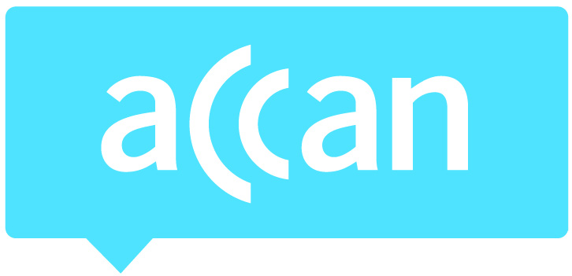
For immediate release 16th June 2015

2015 ACCAN Grants Scheme projects announced
The Australian Communications Consumer Action Network (ACCAN) has today announced the successful Grants Scheme projects for the 2015 Round. The ACCAN Grants Scheme funds projects which undertake research on telecommunications issues, represent consumers or create educational tools which empower consumers to derive the greatest benefit from telecommunications products and services.
The Grants Scheme is competitive and this year received 66 applications from a range of research, private sector and community organisations.
“This year’s applications represented a fascinating blend of emerging technology as well as long-standing consumer challenges,” said ACCAN Deputy CEO, Narelle Clark. “We congratulate the successful candidates and look forward to working with them on these tremendous projects.”
Research and outcomes achieved by Grants projects inform ACCAN’s work and contribute to the broader evidence base for consumers, regulators and service providers in the telecommunications market.
The successful projects are listed below. For more information on the below projects, visit the current Grants page.
- Our Phones, Our Rights: Translated and community-appropriate telecommunications resources for remote indigenous communities, Queensland Remote Aboriginal Media (QRAM)
QRAM will work with remote community members and design agency Gilimbaa to produce printed and audio resources in five key Indigenous languages.
- Affordable Access, Media Access Australia (MAA)
This project will produce a website that provides up-to-date information about what to consider when buying technology to ensure it meets a user’s accessibility needs.
- Connections and Disconnections: ICT access, usage and preferences in very remote Indigenous communities, The Indigenous Remote Communications Association Aboriginal and Torres Strait Islanders Corporation (IRCA)
This project will survey 300 people in 16 very remote communities on their ICT access and usage in order to develop the data sets and analysis needed to inform and guide policy for delivery of telecommunications and online services in very remote Indigenous communities.
- “Can I download a car?”: Emerging consumer issues for online access, communication and sharing of 3D printer files, Department of Media and Communications, the University of Melbourne
This project aims to improve consumer knowledge and protections around consumer issues regarding the sharing of 3D printable files.
- Accessing Video on Demand: A study of disability and streaming television, Curtin University
This will be the first Australian study to examine disability access to new subscription video on demand (VOD) services and evaluate it against Australian broadcasting legislation, online access recommendations and international services.
- Going Online on Behalf of Others - an investigation of ‘proxy’ internet consumers, Monash University
This research project will explore proxy internet users: who they are, the internet activities they conduct on behalf of others, the reasons and motivations for acting as a proxy internet user, the enablers and/or barriers faced by proxy users in providing effective assistance and how these proxy users might be supported (e.g. resources, training, support networks).
- Improving the Communication of Privacy Information to Consumers, The Communications Law Centre, UTS
This project will examine the problem of obtaining the informed consent of consumers for the privacy policies of consumer contracts.
For more information, please contact Luke Sutton on 0409 966 931 or luke.sutton@accan.org.au.

